Contrast enhanced MRI of human
knee meniscus and cartilage

Contrast enhanced MRI of human knee meniscus and cartilage
Ulf Sigurdsson, MD

DOCTORAL DISSERTATION
By due permission of the Faculty of Medicine, Lund University, Sweden.
To be defended at the Clinical Research Center Aula,
Skåne University Hospital, Malmö.
14 December 2017, 13.00.
Faculty opponent
Professor Jan Ekstrand
Supervisor
Professor Leif Dahlberg

Organization  LUND UNIVERSITY  Department of Clinical Sciences,  Malmö, Lund University, Sweden. | Document name  DOCTORAL DISSERTATION
 | Date of issue 2017-12-14
Author: Ulf Sigurdsson | Sponsoring organization
Title and subtitle: Contrast enhanced MRI of human knee meniscus and cartilage.
Abstract
Osteoarthritis (OA) affects approximately 10 % of the elderly and is a leading cause of disability. OA is suggested to be a whole-joint disease involving cartilage, ligaments, periarticular muscles, subchondral bone and menisci. The meniscus has a critical protective role for knee joint integrity by absorbing impact and distributing load. Overall, it is estimated that the knee meniscus carries 45 to 75% of the total joint load. Loss of meniscal function has been strongly associated with development and progression of radiographic OA. However, OA-related changes observed by radiography are late events in the degenerative process. Delayed gadolinium enhanced magnetic resonance imaging of cartilage (dGEMRIC) is an imaging technique that can identify pre-radiographic degenerative changes in articular cartilage. Since OA is considered to affect the whole joint and that the integrity of the meniscus has an import role to prevent OA, it is important to investigate the meniscus further. The purpose of the work presented in this thesis was to investigate if delayed gadolinium enhanced MRI of meniscus (dGEMRIM) was applicable on healthy meniscus (paper I) and meniscus with pathological changes (paper II). Futher dGEMRIC and dGEMRIM was applied on a cohort at risk developing OA (paper III). A two year follow up of this cohort was made to investigate if there were any changes (paper IV). Paper I showed that it is feasible to examine undamaged meniscus (dGEMRIM) and cartilage (dGEMRIC) simultaneously at 90–120 minutes after the injection of Gd-DTPA²⁻ at a dose of 0.2 mmol/kg body weight. The uptake of contrast agent differed both within the meniscus, and in the meniscus at different locations in the knee joint. Paper II suggests dGEMRIM to be a possible meathod to identify loss of meniscus integrity in early OA development. dGEMRIM and dGEMRIC was applicable to combine in vivo, preferably with one examination before and one 120 minutes after contrast injection. Possible different dGEMRIM patterns at different stages of meniscus lesion development must be taken into account when evaluating meniscus pathology. In paper III we found that elite football players seem to have more tissue injuries than non-players that appear to be unrelated to symptoms. Further, we found longer T1 (higher quality) and thicker cartilage on the medial side of elite football players compared to sedentary subjects. It may confirm that cartilage adapts to weight-bearing in the posterior, medial knee compartment in elite football players. Paper IV showed unchanged ΔR1 mean values of cartilage and meniscus tissue in 9 non-injured elite football players examined two years earlier. Results of four ACL-injured players, who sustained their injury during this period, do not suggest worse quality of cartilage or meniscus in the injured knee within 9 months after reconstruction of the ACL. This indicates that playing elite football over a period of two years does not affect the joint tissue quality in women, at least using contrast MRI technique.
Key words: dGEMRIC, dGEMRIM, knee, cartilage, meniscus, osteoarthritis, ACL injury, MRI, football.
Classification system and/or index terms (if any)
Supplementary bibliographical information |  | Language: English
ISSN and key title: 1652-8220 |  | ISBN: 978-91-7619-565-9
Recipient’s notes | Number of pages 136 | Price
 | Security classification

I, the undersigned, being the copyright owner of the abstract of the above-mentioned dissertation, hereby grant to all reference sourcespermission to publish and disseminate the abstract of the above-mentioned dissertation.
Signature Date 2017-11-08

Contrast enhanced MRI of human knee meniscus and cartilage

Ulf Sigurdsson, MD

Copyright Ulf Sigurdsson
Language revision by Alan Crozier
Department of Clinical Sciences, Malmö, Lund University, Sweden.

ISBN 978-91-7619-565-9
ISSN 1652-8220

Lund University, Faculty of Medicine Doctoral Dissertation Series 2017:183

Printed in Sweden by Media-Tryck, Lund University
Lund 2017

To whom it may concern…

Table of contents
Abbreviations 10
Original papers 12
Thesis at a glance 13
Swedish summary- svensk populärvetenskaplig sammanfattning 19
Introduction 23
Cartilage 23
Osteoarthris 26
Diagnostic tools in OA 30
Injury of the anterior cruciate ligament and osteoarthritis 36
Aims of thesis 39
Methods 41
Subjects 41
Contrast enhanced MRI 42
Statistics 45
Results 47
In vivo transport of Gd-DTPA²⁻ into human meniscus and cartilage assessed with delayed gadolinium enhanced MRI of cartilage (dGEMRIC) (paper I) 47
Delayed gadolinium enhanced MRI of meniscus (dGEMRIM) and cartilage (dGEMRIC) in healthy knees and in knees with different stages
of meniscus pathology (paper II) 51
Delayed gadolinium enhanced MRI of cartilage (dGEMRIC) and meniscus (dGEMRIM) in knees of elite football players and sedentary subjects (paper III) 54
Longitudinal assessment of knee joint cartilage and meniscus quality in female elite football players using contrast enhanced MRI (paper IV) 57

Discussion 63
Can contrast enhanced MRI be used to examine healthy and pathological changed meniscus? 63
Meniscus and cartilage quality of elite football players examined with contrast enhanced MRI 64
Limitations and considerations of these studies 66
Methological considerations 68
Clinical applications 70
Conclusions 73
Summary 75
Acknowledgements 77
Role of funding source 78
References 79

Abbreviations
2D-IR two-dimensional inversion recovery
3D-LL three-dimensional Lock-Locker
ΔR1 difference in R1, reflecting the Gd-DTPA²⁻ concentration
ACL anterior cruciate ligament
ANOVA analysis of variance
ARGS amino acids Alanine-Arginine-Glycine-Serin
B₀ static magnetic field
CI confidence interval
dGEMRIC delayed gadolinium enhanced magnetic resonance
imaging of cartilage
dGEMRIM delayed gadolinium enhanced magnetic resonance imaging
of meniscus
DMOAD disease-modifying osteoarthritis drug
EMA European Medicine Agency
FCD fixed charged density
FDA U.S Food and Drug Administration
FID free induction of decay
FOV field of view
GBCA gadolinium based contrast agent
Gd-DTPA²⁻ gadolinium diethylene triamine pentaacetic acid
GAG glycosaminoglycan
IFN interferon
IL interleukin
JSN joint space narrowing
M initial magnetization
MRI magnetic resonance imaging
MRT magnetisk resonanstomografi
NSF nephrogenic systemic fibrosis
OA osteoarthritis
qMRI quantitative MRI
R1 relaxation rate, reflecting the Gd-DTPA²⁻ distribution
RF radio frequency
ROI region of interest
ROM range of motion
T1 longitudinal relaxation time
T1_{pre} T1 relaxation time without Gd-DTPA²⁻ (pre-contrast)
T1_{Gd} T1 relaxation time after saturation with Gd-DTPA²⁻ (post-contrast)
T2 transverse relaxation time
TI inversion time
TR repetition time

Original papers
This thesis is based on the following papers:
- In vivo transport of Gd-DTPA²⁻ into human meniscus and cartilage assessed with delayed gadolinium enhanced MRI of cartilage (dGEMRIC). Sigurdsson U, MD, Siversson C, PhD, Lammentausta E, PhD, Svensson J, PhD, Tiderius CJ, MD, Ass Prof and Dahlberg LE, MD, PhD, Professor. BMC Musculoskelet Disord. 2014 Jul 9;15:226.
- Delayed gadolinium enhanced MRI of meniscus (dGEMRIM) and cartilage (dGEMRIC) in healthy knees and in knees with different stages of meniscus pathology. Sigurdsson U, MD, Müller G, MD, PhD, Siversson C, PhD, Lammentausta E, PhD, Svensson J, PhD, Tiderius CJ, MD, Ass Prof and Dahlberg LE, MD, PhD, Professor. BMC Musculoskelet Disord. 2014 Jul 9;15:226.
- Delayed gadolinium enhanced MRI of cartilage and meniscus in knees of elite football players and sedentary subjects. Sigurdsson U, MD, Besjakov J, MD, PhD, Siversson C, PhD, Svensson J, PhD, Tiderius CJ, MD, Ass Prof and Dahlberg LE, MD, PhD, Professor. Submitted for publication 2017.
- Longitudinal assessment of knee joint cartilage and meniscus quality in female elite football players using contrast enhanced MRI. Sigurdsson U, MD, Besjakov J, MD, PhD, Siversson C, PhD, Svensson J, PhD, Tiderius CJ, MD, Ass Prof and Dahlberg LE, MD, PhD, Professor. Manuscript 2017.

Thesis at a glance

Is dGEMRIM feasible as method to investigate healthy meniscus? (Paper I)
Subjects: 12 subjects with healthy knee joints.
Methods: Examined with contrast enhanced MRI before and after being given double and triple dose of contrast agent at 60, 90, 120 and 180 minutes, at two different occasions.
Conclusion: It is feasible to examine undamaged meniscus and cartilage simultaneously using contrast enhanced MRI at 90–120 minutes after the injection of Gd-DTPA²⁻ at a dose of 0.2 mmol/kg body weight. A triple dose of contrast agent yielded higher concentrations of Gd-DTPA²⁻ in the meniscus and cartilage than the double dose, without providing additional information.
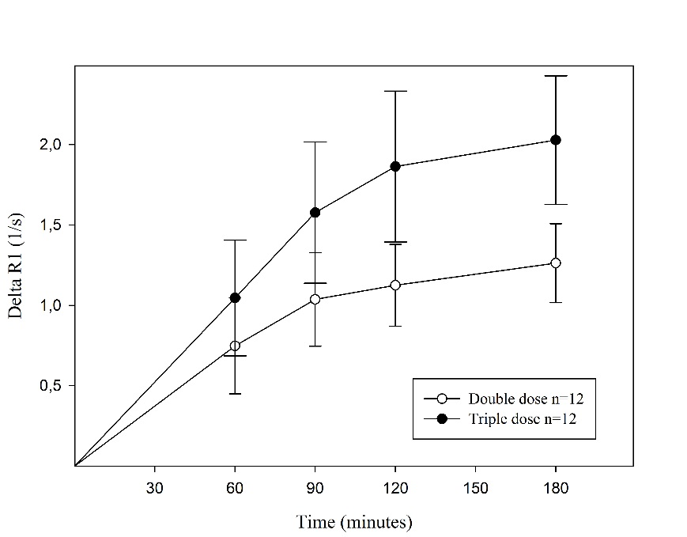
Figure 1.
Change in relaxation rate (ΔR1±CI) in the posterior medial meniscus, after injection of a double (ο) and a triple (•) dose of Gd-DTPA²⁻ (0.2 mmol/kg and 0.3 mmol/kg body weight, respectively). Significantly higher mean values were observed after injection of the triple dose (ANOVA, p<0.001).
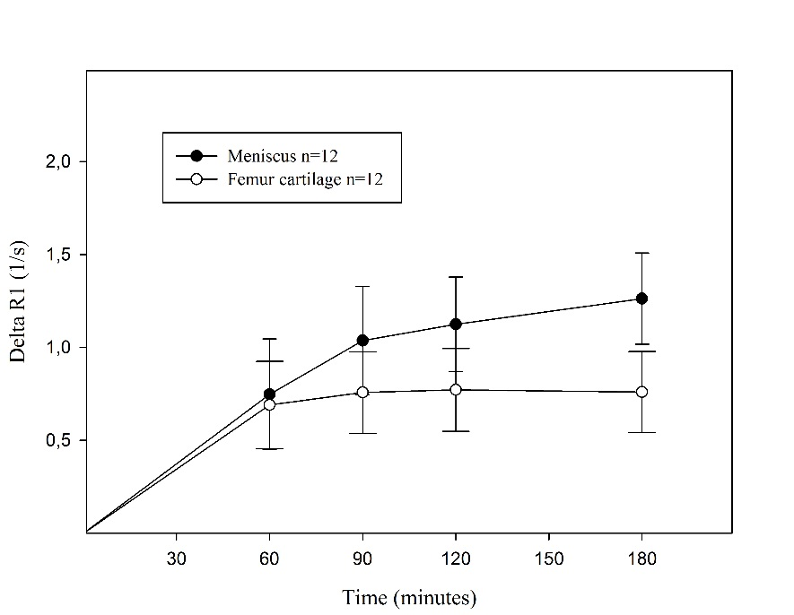
Figure 2.
Change in relaxation rate (ΔR1±CI) in the meniscus (•) and the femoral cartilage (ο) in the posterior medial compartment after injection of a double dose of Gd-DTPA²⁻ (0.2 mmol/kg body weight). The values were significantly higher in the meniscus than in the femoral cartilage 90–180 minutes post injection (0.001≤p≤0.017).

Is dGEMRIM feasible as method to investigate pathological changed meniscus? (Paper II)
Subjects: 12 subjects with healthy knee joints and 18 subjects with different stages of pathological changes in the posteromedial meniscus of the knee joint.
Methods: Examined with contrast enhanced MRI before and after being given double dose of contrast agent at 60, 90, 120 and 180 minutes.
Conclusion: It may be feasible to examine the pathological damaged meniscus using dGEMRIM at 120 minutes after the injection of Gd-DTPA²⁻ at a dose of 0.2 mmol/kg body weight.
Figure 3.
ΔR1 values in posteromedial healthy (n=12; closed circles), pathological grade 2 (n=11; open circles) and pathological grade 3 (n=7; closed triangles) menisci, after intravenous injection of Gd-DTPA²⁻ (0.2 mmol/kg body weight). The values were lower in the pathological grade 2 (ANOVA, p=0.046) and tend to show higher values in the pathological grade 3 (ANOVA, p=0.110) menisci compared with healthy menisci. ΔR1 was lower in pathological meniscus grade 2 comparing grade 3 (p=0.002).

Delayed gadolinium enhanced MRI of cartilage and meniscus in knees of elite football players and sedentary subjects (paper III)
Subjects: 30 elite football players (13 male and 17 female) and 18 sedentary healthy subjects, partly presented in paper I.
Methods: Examined with contrast enhanced MRI before and after being given double dose of contrast agent at 90 minutes.
Conclusion: Elite football players seem to have more tissue injuries than non-players that appear to be unrelated to symptoms. Further, the significance of longer T1 values in cartilage (higher quality) and thicker cartilage on the medial side of elite football players compared to sedentary subjects needs to be determined. It may confirm that cartilage adapts to weight-bearing in the posterior, medial knee compartment in elite football players.

Table 1.
Location and pathological findings in the right knee joint on diagnostic MRI in elite football players and sedentary subjects.
Elite football players (n=30) | Sedentary (n=18)
Ruptured medial meniscus, anterior/posterior horn n=0/4 | Ruptured medial meniscus, anterior/posterior horn n=0/1
Ruptured lateral meniscus, anterior/posterior horn n=6/3 | Ruptured lateral meniscus, anterior/posterior horn n=3/0
Chondral medial injury n=5 | Chondral medial injury n=1
Chondral lateral injury n=2 | Chondral lateral injury n=1
ACL-ruptures n=3

Longitudinal assessment of knee joint cartilage and meniscus quality of female elite football players using contrast enhanced MRI (paper IV)
Subjects: 9 non-injured and 4 ACL-injured female elite football players examined two years earlier (paper III).
Methods: Examined with contrast enhanced MRI before and after being given double dose of contrast agent at 90 minutes.
Conclusion: 9 non-injured elite female football players showed unchanged ΔR1 mean values of cartilage and meniscus tissue. Results of the four ACL-injured players do not suggest worse quality of cartilage or meniscus in the injured knee within 9 months after reconstruction of the ACL. This indicates that playing elite football over a period of two years does not affect the joint tissue quality in women.
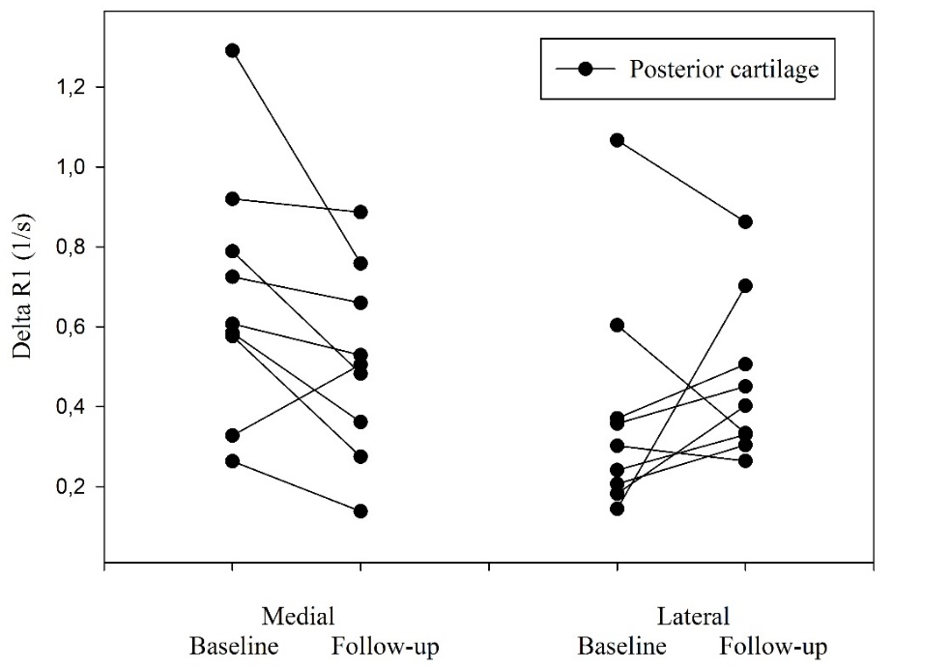
Figure 4.
ΔR1, n=9, in posterior medial (p=0.057) and lateral (p=0.376) femoral cartilage at baseline and follow-up study 2 years later.
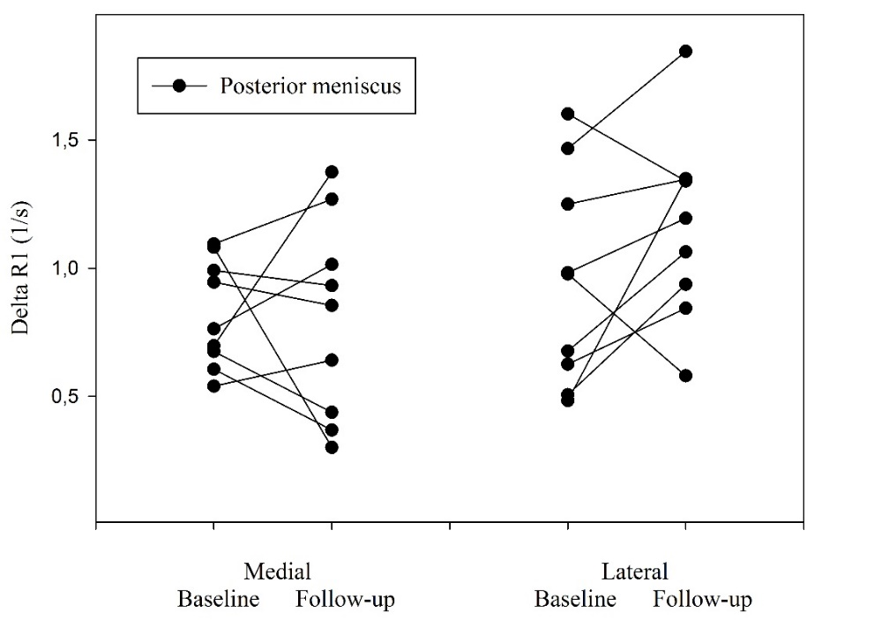
Figure 5.
ΔR1, n=9, in posterior medial (p=0.871) and lateral (p=0.127) meniscus at baseline and follow-up study 2 years later.
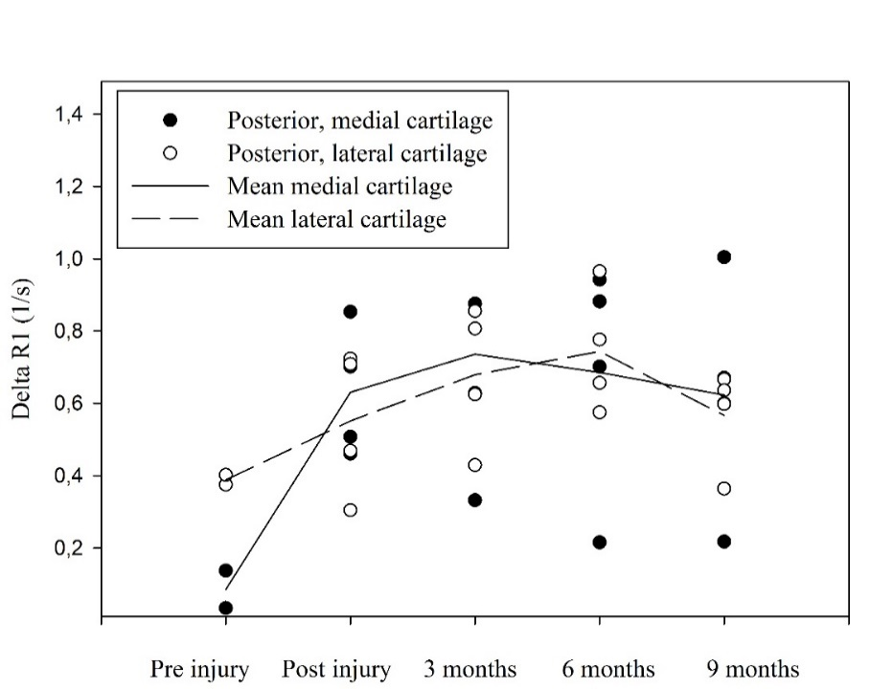
Figure 6.
ΔR1 in posterior medial (•) and lateral (o) femoral cartilage of four female football players with ACL-rupture. The following time points were analyzed: before injury (n=2), within two weeks after injury and 3, 6, and 9 months after surgery (n=4). Reconstruction of ACL was performed within two months after injury.
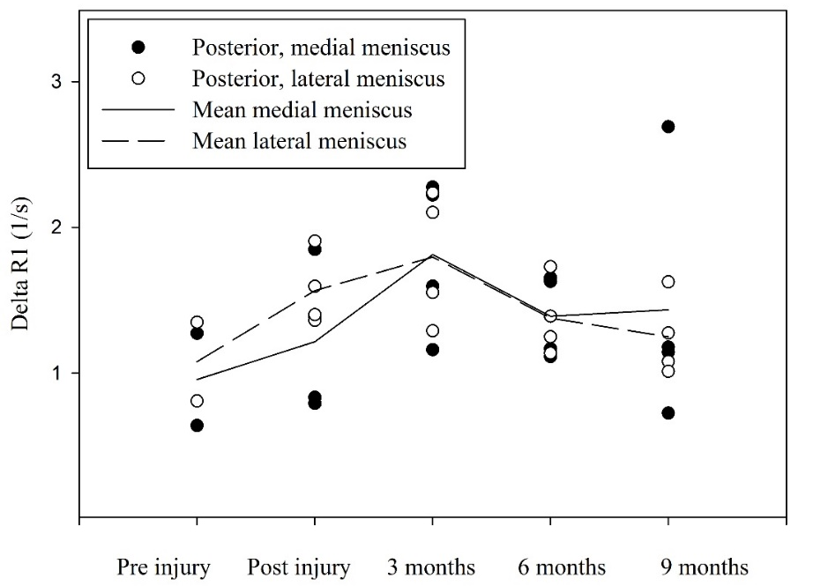
Figure 7.
ΔR1 in posterior medial (•) and lateral (o) meniscus of four female football players with ACL-rupture. The following time points were analyzed: before injury (n=2), within two weeks after injury and 3, 6 and 9 months after surgery (n=4). Reconstruction of ACL was performed within two months after injury.

Swedish summary- svensk populärvetenskaplig sammanfattning
Artros är vår vanligaste ledsjukdom och leder till att ledbrosket, meniskerna, benet under brosket, de led nära musklerna och ligamenten påverkas. Leden blir stel och smärtsam. I knäleden är den slutliga behandlingen kirurgisk med insättande av en ny knäled, knäplastik. Innan dess består behandlingen främst av information om sjukdomen, träning och viktkontroll samt vid behov medicinering med smärtstillande och antiinflammatorisk medicin. Ett stort problem med sjukdomen är dess diagnostik. Vanlig röntgen som är den traditionella diagnostiska metoden vid artros, kan ofta inte påvisa några förändringar förrän mycket sent i förloppet. Klinisk erfarenhet liksom vetenskapliga studier visar på dålig korrelation mellan röntgenologiska förändringar och symtom. Således har många patienter ont i sina knän utan synliga röntgenologiska förändringar liksom har många med röntgenologiska förändringar inga påtagliga symtom.
Under de senaste åren har vår forskargrupp och andra därför utvecklat en ny metod som genom en kontrastförstärkt magnetkameraundersökning- dGEMRIC (delayed gadolinium enhanced MRI of cartilage), gör det möjligt att studera broskets kvalité på molekylär nivå snarare än rent makrostrukturellt. Metoden är icke-invasiv och bygger på att ett negativt laddat kontrastmedel tas upp i vävnaden i relation till vävnadens innehåll av negativt laddade sockerkedjor (glukosaminoglykan- GAG) efter en intravenös injektion. GAG är avgörande för broskets mekaniska egenskaper och förloras tidigt vid artros. Tidigare har man framför allt använt kontrastförstärkt magnetisk resonanstomografi (MRT) för att mäta ledbroskets innehåll av GAG i knä- och höftleden. Endast ett fåtal artiklar är publicerade där man undersökt knäledens menisker med liknande teknik. Då man vet att sjukdomen påverkar hela leden är det viktigt att undersöka alla ledens vävnader för att exempelvis eventuellt kunna se var sjukdomen börjar. Vet man detta kan man i ett tidigare stadium av sjukdomsförloppet inleda botande eller förebyggande behandling. Syftet med den här avhandlingen var att undersöka om dGEMRIC som metod fungerar för att undersöka knäledens menisker (dGEMRIM) och på så sätt bedöma deras kvalité.
Man har kunnat särskilja flera riskfaktorer för utveckling av artros. Övervikt, försämrad muskelfunktion och vissa yrken är tydliga riskfaktorer. Även utövandet av vissa sporter har visat sig utgöra en riskfaktor för utvecklandet av artros i knäled. Man har föreslagit att en hög nivå av fysisk aktivitet med kronisk, repetitiv stress och överbelastning av leden är den huvudsakliga orsaken till utvecklandet av artros. Incidensen för utvecklandet av knäartros skiljer sig mellan olika sporter. Fotboll, ishockey och tennis visar en signifikant ökad risk medan friidrott, längdskidåkning och orientering ej visar detta. Vid jämförelse av skadefrekvens i knäleden mellan olika idrotter ligger idrotter med roterande rörelser i leden såsom fotboll, handboll och basketboll bland de främsta. I studier har man kunnat visa att förutom en hög nivå av fysisk aktivitet med kronisk, repetitiv stress och överbelastning är den sport-relaterade ökade risken för artros också relaterad till knäskador. En ruptur på det främre korsbandet och/eller skada på framför allt menisken på knäledens insida har visat sig predisponera för knäartros. Normal fysisk aktivitet såsom löpning, hoppning har inte visat sig utgöra en riskfaktor för utveckling av artros. Vid en undersökning av elitlöpares ledbrosk i knäleden, fann man att detta adapterar sig till belastningen och att innehållet av GAG ökar, och på så vis förbättrar broskets kvalité.
I delarbete I studerade jag tolv stycken försökspersoner med friska knäleder. Studien visade att det fanns ett upptag av kontrastmedel i meniskerna och att detta var högre än det i ledbrosket. Troligtvis beror detta på den lägre halten av GAG i menisken jämfört med ledbrosket. Vidare såg vi att upptaget av kontrastmedel sker snabbare initialt där menisken är blodförsörjd. Efter 90–120 minuter förändrades inte mängden kontrastmedel i menisken, vilket skulle göra tidpunkten 90–120 minuter efter givet kontrastmedel till en bra tidpunkt för undersökningen. I delarbete II undersöktes ytterligare 18 försökspersoner med olika grad av skada på bakre delen av menisken på knäledens insida. Vi kunde med dGEMRIM visa att menisk med mindre grad av skada (skada i meniskens inre utan ruptur till dess yta) innehöll ökad mängd GAG, vilket tidigare även visats vid histologiska undersökningar. Vidare fann vi att menisk med större skada (menisk med ruptur till meniskens yta) innehöll en minskad mängd GAG. Resultaten visade också på att den optimala tidpunkten för att undersöka en skadad menisk är 120 minuter efter givet kontrastmedel. Resultaten från delarbete I och II visar att kontrastförstärkt MRT undersökning fungerar som kvalitétsbestämmande metod på såväl frisk som skadad menisk och att undersökningen tills vidare bör innehålla en undersökning före givandet av kontrastmedel som utgångsvärde samt en undersökning 120 minuter efter givandet av kontrastmedel.
I delarbete III undersöktes och beskrevs knäledens brosk och menisker hos 13 manliga och 17 kvinnliga elitfotbollsspelare. Resultaten från dessa spelare jämfördes sedan med de undersökta personerna i delarbete I. Vi såg att elitfotbollsspelare verkar ha fler knäskador än mer stillasittande individer. Vidare såg vi en högre kvalité och tjockare ledbrosk på knäledens insida hos fotbollsspelarna. Detta kan tala för att brosket på knäledens insida adapterar sig till den ökade belastningen som fotbollsspel på elitnivå innebär. Denna möjliga adaptation kunde vi inte se i menisken. I delarbete IV följde vi efter två år upp resultaten från delarbete III genom att på nytt undersöka de kvinnliga fotbollsspelarnas knäleder med kontrast förstärkt MRT undersökning. Vi såg ingen försämrad kvalité av knäledens ledbrosk eller menisker. Under denna tvåårsperiod hade fyra av de kvinnliga fotbollsspelarna rupturerat främre korsbandet. Vi undersökte den skadade knäleden före och efter skadan samt gjorde upprepade undersökningar med kontrastförstärkt MRT undersökning var tredje månad till och med 9 månader efter operation där det skadade korsbandet ersattes med ett nytt. Vi såg inte heller här någon noterbar försämring av de ursprungliga värdena före skadan jämfört med 9 månader efter operationen.
Sammanfattningsvis visar resultaten ovan att det är möjligt att kombinera kontrastförstärkt MRT undersökning av brosk och menisk vid samma tidpunkt och att det bör ske med en undersökning före och en efter 120 minuter efter given dos kontrastmedel. Detta underlättar i den kliniska vardagen både för den undersökande personalen och patienten. Vidare visar undersökningarna av elit fotbollsspelare att det möjligen är bra för brosket att spela fotboll på hög nivå, då knäledens brosk på insidan adapterar sig och visar högre kvalité och tjocklek jämfört med brosket hos mer stillasittande individer. Man ser dock ingen ytterligare kvalitétsförbättring under en tvåårsperiod hos kvinnliga elit fotbollsspelare. Man ser inte heller någon kvalitétsförsämring under denna tvåårsperiod varken hos kvinnliga oskadade spelare eller hos kvinnliga spelare som ådragit sig en främre korsbandsskada och som följts upp under 9 månaders tid efter rekonstruktion av det främre korsbandet. Vid vilken tidpunkt som en kvinnlig elit fotbollsspelares broskkvalité i knäleden börjar försämras återstår att fastställa.

Introduction

Cartilage
There are three different types of cartilage in the human body. Each one with different chemical composition and therefore different biomechanics and locations in the body: elastic (ear, nose), fibrous (meniscus, intervertebral disc), and hyaline (end of bones in articular joints, nasal septum, larynx, trachea). In the knee joint the hyaline cartilage is represented by the femoral, tibial and patellar joint cartilage and the fibrous cartilage by the meniscus.

Hyaline cartilage- articular cartilage
The articular cartilage thickness in the knee varies between 1–6 mm with the thickest cartilage on the patella. On the femoral condyles the maximum thickness of the cartilage is approximately 4 mm (Faber 2001). Hyaline cartilage is a unique structure derived from a highly specialized cell, the chondrocyte. The chondrocyte is metabolic active and produces a matrix of collagen and proteoglycan aggregates (Mankin 1992). This matrix is extremely hydrophilic, which result in that the hyaline cartilage contents 80 % water by wet weight. This gives the hyaline cartilage its three main functions: to distribute and transmit high loads without deformation, to glide as a frictionless surface and to efficiently transport nutrients to the chondrocytes (Akeson 1995). The hyaline cartilage is avascular and the chondrocytes (about 1 % of the volume in human) is therefore dependent on diffusion of nutrients from synovial fluid and, to a lesser extent, from the capillaries of the subchondral bone (Buckwalter 1997).
Articular cartilage is histologically divided into laminar zones (Modl 1991, Akeson 1995, Waldschmidt 1997): the surface zone, making up approximately 10 % of the cartilage thickness, is called the superficial zone, in the middle is the transitional zone making up 40 % of the cartilage thickness, and in the bottom, next to the subchondral bone is the radial zone, which make up 50 % of the cartilage thickness. In each zone the chondrocytes and the extracellular elements differ in appearance: the chondrocytes become flatter and more widely spread as they approach the joint surface, the collagen fibers become thinner, more abundant and change from a perpendicular to a parallel course toward the articular surface and water is most abundant in the middle zone (Brocklehurst 1984, Akeson 1995, Resnick 1995).
Collagen accounts for approximately 60–80 % of dry weight of the joint cartilage (Akeson 1995). Type II collagen is the major form, which is high in hydroxylysine and glycosylated hydroxylysine (Akeson 1995). These amino acids have secondary amino groups, which react with the extracellular enzyme, lysine oxidase, to form a highly reactive intermediary, an aldehyde. This aldehyde spontaneously reacts with other lysine molecules to form strong covalent intramolecular and intermolecular bonds. These cross-reactions are responsible for collagen´s tensile strength and for collagen´s main function in cartilage to resist sheering force (Akeson 1995). The collagen´s arrangement in the joint cartilage, from a perpendicular to a parallel course toward the articular surface, allows transmission of loads to the underlying subchondral bone (Buckwalter1992, Akeson 1995).
Aggregated proteoglycans are the third major extracellular constituent in articular cartilage (Akeson 1995). Each of these molecules can reach a molecular weight of over 10 million Daltons. Aggregated proteoglycans have a central hyaluronic acid core to which are attached numerous proteoglycan side chains. These proteoglycan side chains consist of central protein cores, to which are attached glycosaminoglycan (GAG) molecules abundant in sulphate and hydroxyl side groups (Akeson 1995). These side groups confer an anionic charge to articular cartilage and also result in the cartilage being hydrophilic. Because of the extreme size of the aggregated proteoglycans, their movement is restricted by the collagen framework of the matrix. Thus, the hydroxyl groups and negative charges are functionally fixed (FCD= fixed charged density), which through osmotic, ionic and Donnan forces, results in high swelling pressure within cartilage, accounting for hyaline cartilage being 80 % water by weight. The swelling pressure provides the main resistance to compressive loading in hyaline cartilage (Buckwalter1992, Mow 1992, Woo 1992).

Fibrous cartilage- meniscus
The knee joint contains a medial and lateral wedge-shaped and semi-lunar meniscus structure situated between the corresponding femoral condyle and tibial plateau. The medial and lateral meniscus have different dimensions: medial meniscus is 40.5-45.5 mm long and 27 mm wide while the lateral meniscus is 32.4–35.7 mm in length and 26.6–29.3 mm wide (McDermott 2004). The menisci therefore cover different portions of the tibia plateau: 51–74 % medially in comparison to the lateral meniscus, which cover 75–93 % laterally (Wojtys 2005).
The meniscus withstands different forces such as shear, tension and compression. It also plays a crucial role in load-bearing, load transmission, shock absorption, as well as lubrication and nutrition of articular cartilage (Herwig 1984, Aspden 1985, Fithian 1990, Skaggs 1994).
The meniscus is a complex tissue comprised of cells, extracellular matrix molecules and region-specific vascularization. The vascularization is of high relevance. Two regions of the meniscus can be distinguished: the outer (10–25 % of the width) vascular region (red-red zone) and the inner completely avascular region (white-white zone) (Wojtys 2005). These two regions are separated by the red-white zone, which presents attributes from both the red-red and the white-white zone. The heeling capacity of each area is directly related to the vascularization, leaving damages to the white-white zone unhealed (Cheung 1987).
Also the extra cellular matrix of the meniscus contains of three main components: water, collagen and proteoglycans (Höpker 1986). The meniscus is like the articular cartilage highly hydrated (72 %) but the contents of collagen and proteoglycan differ from the articular cartilage (Höpker 1986). In the vascular red-red zone of the meniscus there is almost exclusively type I collagen, (80 % by dry weight). In the avascular white-white zone of the meniscus there is 70 % collagen (by dry weight), of which 40 % is type I and 60 % is type II (McDermott 2004). The proteoglycan content in the meniscus is about 15 % (dry weight) (Herwig 1984). The proteoglycans and their side chains with GAGs have the same function as in the hyaline cartilage, to absorb water into the meniscus. Regional variation of proteoglycans has been observed, with the inner white-white zone containing a relatively higher proportion of proteoglycans than the outer red-red zone (Shrive 1978). Notably, the glycosaminoglycan concentration in the meniscus is only 0.3 % (wet weight), compared with 2.0 % (wet weight) in articular cartilage (McNicol 1980).
The collagen fibers in the meniscus are organized to withstand the forces acting on and within the meniscus. When the femur presses down on the meniscus during loading, the meniscus deforms radially but is anchored by its anterior and posterior attachments of the horns. This generates tensile, compressive and shear forces on the meniscus (Ghosh 1987). Collagen orientation in the meniscus can be considered as circumferential, radial and random and arranged in three layers: superficial, lamellar and deep. Circumferential fibers are the most abundant and are found in the deep zone. Radial fibers are disperse throughout the deep zone and are present on the periphery and at the horns of the meniscus in the lamellar zone. Despite the presence of radial fibers, random fiber orientation dominates the lamellar zone. In the superficial zone, the fiber orientation is random in the superior region and more radially oriented in the inferior region (Ghadially 1983, Aspden 1985, Fithian 1990, McDevitt 1990, Skaggs 1994).
Also the cells in the meniscus vary between the red-red and white-white zone. In the red-red zone the cells have an oval, fusiform shape and display long cell extensions, which facilitate communication with other cells and the extracellular matrix. The expression of the cell and the extra cellular matrix in the red-red zone with collagen type I is similar to fibroblasts, why these cells in the outer meniscus are called fibroblast-like cells. In contrast, cells in the white-white zone appear more round and the extracellular matrix are comprised largely of type II collagen with a relative smaller abundance of type I collagen and there is a higher concentration of GAG than in the red-red zone. This environment in the white-white zone is more reminiscent of hyaline articular cartilage. Therefore, cells in the white-white zone are classified as chondrocyte-like cells (Ghadially 1983, Proctor 1989).

Cartilage response to loading
Human knee articular cartilage adapts to exercise by increasing the glycosaminoglycan content (Tiderius 2004, Van Ginckel 2010). Further, a study of patients at risk of knee osteoarthritis who begin exercising indicates that adult human articular cartilage has a potential to adapt to loading change (Roos 2005). These studies confirm the relationship between GAG content and mechanical load. Further, due to its wedge shape the highest compressive loading on the meniscus is borne by the inner portion and due to this need for compressive integrity, cells from the inner two-thirds of the meniscus produce more proteoglycans than the outer one-third (Tanaka 1999). Thus, a stiffer articular cartilage and meniscus due to increased GAG content may be the appropriate adaption to higher mechanical demands.

Osteoarthritis

The disease
Osteoarthritis (OA) is a chronic, non-inflammatory synovial joint disease, which gradually deteriorate joint tissues. It affects approximately 10 % of the elderly and is one of the leading causes of disability (Busija 2010). OA is now considered as a whole-joint disease involving not only the joint cartilage, but also the joint´s ligaments, periarticular muscles, subchondral bone and menisci (Brandt 2013). The cause of the disease is not fully understood but is a combination of genetic failure and overload by mechanical stress. In other words: 1) the biomaterials of the tissue are normal but the mechanical stress of the joint are excessive, or 2) the loads placed on the joints tissues are normal but the biomaterials abnormal. The heritable systemic metabolic disease ochronosis, is an example of osteoarthritis developing as a consequence of defective joint tissues. The disease causes a premature widespread osteoarthritis because the articular cartilage become brittle owing to the deposition of polymers of homogenetic acid (Schumacher 1992). Further, point mutations in the genes coding for type II collagen lead to cartilage damages and leads to widespread osteoarthritis (Ala-Kokko 1990, Eyre 1991). This tells us that osteoarthritis is not generally a rise from an underlying cartilage defect.

Cartilage
The primary changes in developing of OA, even if all the tissues that form the synovial joint are involved, are loss of articular cartilage, remodeling of subchondral bone and formation of osteophytes. The progressive loss of cartilage can be divided into three overlapping stages: 1) before or at the same time with fibrillation of the surface, the macromolecular framework of the matrix is disrupted and the water content increases. The concentration of type-II collagen is constant but the aggregation of proteoglycans and the length of glycosaminoglycan chains, decreases. This increase the permeability and decrease the stiffness of the matrix and may increase the vulnerability of the cartilage to additional mechanical damage (Buckwalter 1997). 2) the second stage may sustain over years. When the chondrocytes detect the disruption in the matrix they respond with increased synthesis and degradation of the matrix and by proliferating. The response may restore tissue, maintain tissue in an altered state or increase the volume of the cartilage. 3) caused by further mechanical damage to the cartilage or down-regulation of the chondrocytic response, leads to loss of articular cartilage (Buckwalter 1997).

Meniscus
Also the meniscus undergoes degenerative changes in the developing of OA. Pauli (2011) did histopathological evaluations of menisci from OA joints (Outerbridge grade III and IV, table 2) and found severe fibrocartilaginous separation of the matrix, extensive fraying, tears and calcification. Further, abnormal cell arrangements were seen, including decreased cellularity, diffuse hyper cellularity along with cellular hypertrophy and abnormal cell clusters. These findings were often seen close to degenerative parts of the meniscus.

Tabel 2.
Outerbridge classification (arthroscopically).
Grade 1 | Grade 2 | Grade 3 | Grade 4
Cartilage with softening and swelling. | Partial-thickness defect with fissures on the surface that do not reach subchondral bone or exceed 1.5 cm in diameter. | Fissuring to the level of subchondral bone in an area with a diameter more than 1.5 cm. | Exposed subchondral bone.

The meniscus has a critical protective role for the knee joint through shock absorption and load distribution (Ghadially 1983, Proctor 1989). Overall, it is estimated that the knee meniscus bears anywhere from 45 % to 75 % of total joint load (Shrive 1978). Loss of meniscal function has been strongly associated with development and progression of radiographic OA (Berthiaume 2005, Martel-Pelletier 2005, Neuman 2008). This leads inevitably to the question if the meniscal damage is a cause to or a consequence of knee OA? The meniscus is often torn or destructed in OA knees, which speak for an association between the disorder and the meniscus (Bhattacharyya 2003, Hunter 2006). Roemer (2009) showed that joint effusion appeared in a significantly higher degree in knees with meniscal damages but without OA (Kellgren/Lawrence grad 0, table 3), and Englund (2009) found that knees with meniscal lesion, but without cartilage lesion, in middle-aged or elderly persons, are at much higher risk of radiographic knee OA than knees with intact menisci. This speaks for the meniscus to be the “cause”.
Table 3.
Kellgren-Lawrence Grading Scale.
Grade 1 | Grade 2 | Grade 3 | Grade 4
Doubtful narrowing of joint space and possible osteophytic lipping. | Definite osteophytes,definite narrowing of joint space. | Moderate multiple osteophytes, definite narrowing of jointspace, some sclerosis and possible deformity of bone contour. | Large osteophytes, marked narrowing of joint space, severe sclerosis and definite deformity of bone contour.

However, the relationship between meniscal damage and knee OA is complex. A meniscal lesion in healthy knee may eventually lead to knee OA due to the loss of meniscal function. However, knee OA may also lead to meniscal tear that, in turn, may further accelerate the disease process (Roos 1995). Noble found in their macroscopic and microscopic evaluations of 400 menisci, that 29 % had a horizontal cleavage (Noble 1975). This cleavage is seen and accepted as of degenerative art. The incidence of horizontal cleavage lesion was found to increase with the severity of degenerative changes of the articular cartilage. 50 % of the compartments containing a normal meniscus also showed normal articular cartilage and only 17.7 % of the normal menisci were found in OA joints with grade II and III changes (table 2). This might be a direct relationship but further investigation showed that 15 of 39 compartments with grade III articular cartilage damages contained normal menisci. Further, 18.4 % of the joints with normal articular cartilage contained a meniscus with a horizontal cleavage lesion (Noble 1975). Further histological investigations of Sun (2012) have reported that proteoglycan content increased in OA menisci compared to normal menisci. The results might seem surprising because proteoglycan content decreased in human OA articular cartilage (Lahm 2010, Saarakkala 2010). Though, the results are consistent with earlier results. Peters and Smillie (1972) reported that proteoglycan content increased in sections of menisci with degenerative tears. Herwig (1984) reported that proteoglycan content (µg/mg dry weight) in menisci with meniscal tears, increased in relation to the severity of the meniscal degeneration. Further, Ghosh (1975) reported that proteoglycan content increased in degenerative areas of OA menisci, but not in degenerative areas of rheumatoid arthritis menisci, when compared to normal control menisci.
It seems that the degeneration of the meniscus and the articular cartilage in OA in the knee joint follow different pathways, where different enzymes in the degenerative process are active depending on tissue. The answer to the question above might therefore be to study the activity of collagen-degrading enzymes, then these are active in both articular cartilage and meniscus at the same time, in contrast with the proteoglycan-degrading enzymes which seem only to be active in the articular cartilage in a knee joint affected by AO (Sun 2012).

Risk factors
OA has a multifactorial ethology and can be considered the product of an interplay between systemic and local factors (Felson 2000). For example, a person may have an inherited predisposition to develop OA but may only develop it after an intraarticular fracture. The relative importance of risk factors may vary for different joints, for different stages of the disease, for the development of the disease and for radiographic versus symptomatic disease (Felson 2000).

Systemic risk factors
The cumulative exposure to various risk factors and biologic changes that occur with aging is probably one of the strongest risk factors for OA of all joints (Lawrence 2008). Women are more likely to have OA than men and they also have more severe OA. The difference increase with age, why the post-menopausal hormone deficiency by women might be a cause to OA. This has during the years been under debate and studies for and against have been presented (Hannan 1990, Nevitt 1996, Wluka 2000). Twin and family studies have estimated the heritable component of OA to between 50–65 % with larger genetic influences for hand and hip OA than for knee OA (Palotie 1989, Spector 1996).

Risk factors related to lifestyle
Obesity and overweight have long been recognized as potent risk factors for OA, especially OA in the knee joint (Felson 2000). Repetitive use of joints at work is associated with an increased risk of OA. The risk to develop OA was more than two times greater for men whose jobs required both carrying and kneeling or squatting than for those whose jobs did not require these physical activities (Felson 1991).
Consideration of the role of exercise in OA needs to pay heed to the potential overlap with sports injuries. The high incidence of knee OA in the years following anterior cruciate ligament (ACL) or meniscal injury is well-documented (Roos 1995, Englund 2009). Contact sports with acceleration-deceleration together with loaded, pivoting movements like football, ice hockey and basketball have a high percent of ACL and meniscal injuries, giving these sports a high risk developing OA (Kujala 1995). Further, you have to consider performance level, recreational vs. elite. Results have shown that individuals with normal joints and participating in low-impact, recreational exercises have not an increased risk of developing OA of the knee or hip joint (Sutton 2001). On the other hand, there is a well-documented increased risk of OA in former elite football players and weight lifters (Lindberg 1993, Kajula 1995). Summarized, not to increase the risk to develop OA, you should perform recreational sports without being injured.

Diagnostic tools in OA

Radiography
The radiographic hallmarks in classic OA include osteophyte formation, joint-space narrowing, subchondral bone thickening and cyst formation. These findings, in combination with the clinical criterion joint pain define knee OA. Kellgren and Lawrence and Ahlbäck are the two most commonly used radiographic classifications of OA today (Kellgren 1957, Ahlbäck 1968). There are several limitations to radiography in OA. A methodological problem is the fact that the extent of knee flexion during the examination has a major influence of the outcome (Buckland-Wright 1999). Further and the most important is that when the radiographic changes occur, it is already years after the onset of the disease and you have then lost that time for treatment. Therefore it is important to find and implement these diagnostic tools in the clinic, where you detect the disease at an earlier state.

Arthroscopy
The first known report of knee arthroscopy was presented in 1912 (Kieser 2001), but it was first in the 1970s and 1980s after advances in fiber-optic and video technologies occurred, arthroscopy became widely used for direct visualization and treatment of intra-articular soft tissues damages. Meniscal tears, articular cartilage lesions and ACL-ruptures, which are radiographically invisible, can now be seen and palpated. Palpated by the surgeon the articular cartilage softening represents the clinical sign of pre-OA changes known as chondromalacia (0 = firm cartilage, 1 = softening, 2 = fissuring of <50 % of cartilage thickness, 3 = fissuring >50 % of cartilage thickness, and 4 = exposed bone, tabel 1 (Outerbridge 1961)). The major problem with the arthroscopy as a diagnostic tool of OA is its invasiveness and the complications that may occur. Further the inter- and intra-observer variability is a problem (Ayral 1996) and still you do not see the damages under the cartilage and meniscus surface.

Magnetic resonance imaging- MRI
All atomic nuclei apart from hydrogen consist of neutral neutrons and positively charged protons, which possess a typical spin. In most nuclei the spins of all neutrons and protons cancel out, but with its single proton, the spin in hydrogen results in a net magnetic moment. This gives the nucleus to function as a miniature compass needle, a dipole. The nuclei in tissue are randomly arranged, when no external magnetic field is present. The magnetic moments then cancel each other out.
The natural spin of hydrogen makes it especially interesting for MRI purposes, when the human body consist of a large quantity of hydrogen, especially in fat and water. When placed in a static, strong magnetic field (B₀), the magnetic vectors of hydrogen nuclei turn in the direction (z-direction) of the applied B₀ to create a net magnetization (M₀) in the z-direction. The vectors themselves are not strictly parallel to B₀, but rotate at a characteristic frequency around an axis that is parallel to B₀.
The MRI signal can only be detected when it is perpendicular to the z-plane, why a radio frequency (RF) pulse is applied, which tilts the magnetization from the direction of the magnetic field. It can then be read in the xy-plane. This in turn results in a signal called the free induction of decay (FID). When RF is turned off, the magnetization vectors of the protons realign with the static B₀, i.e. return to equilibrium (regaining M₀). The time it takes for 63 % of the nuclei to realign is characterized by a time constant, T1 relaxation time. The FID signal decays simultaneously according to a second time constant, the T2 relaxation time or transverse relaxation time. T2 is the time required after a RF pulse for the transverse magnetization to decay to 37 % of the initial value.
T1 depends not only on the tissue, but also on temperature, magnetic field strength, and presence of paramagnetic ions. Paramagnetic ions are substances with unpaired electrons and small magnetic fields that shorten T1. Gadolinium ions (Gd³⁺) with their seven unpaired electrons are a potent shortener of T1, and make it useful for altering the contrast in MRI images. Gadolinium is toxic and must be bound to a carrier molecule to make it useful in the clinical setting.
The inversion recovery technique can be used to measure the values of T1. The measurements of T1 are performed by disrupting the magnetization with a 180° inversion pulse. The nuclei then recover (relax) for a specific inversion time, after which the amplitude of the magnetization is listed. This step is repeated for different inversion times, chosen to correspond to a recovery varying from a few to more than 70%. The amplitudes are then fitted to a known recovery curve, which gives the value of T1.
The measurements of the inversion recovery T1 technique are known to be both accurate and robust (Kingsley 1998). The downside of the technique is that it is relatively time consuming. Two-dimensional inversion recovery (2D-IR) was the T1 measurement method used in many of the early delayed gadolinium enhanced MRI of cartilage (dGEMRIC- see below) studies and is therefore often referred as the gold standard for T1 measurements (Bashir 1999, Tiderius 2001). In this thesis a three-dimensional Look-Locker (3D-LL) sequence was used to acquire the T1 measurements. T1 was calculated using the pre-calculated flip angle correction method and the associated flip angle slab profile was acquired from previous phantom measurements. This method was developed before and in parallel to this thesis (Siversson 2009, 2010, 2012). The advantages of the method is that 3D makes it possible to choose which slice you want to do the T1 measurements on. The later facilitates to examine a joint affected of OA.
MRI provide a non-invasive, direct image of all structures in the knee joint. For evaluation of pre-OA, conventional MRI permits morphological assessment of cartilage and meniscus. Though, changes in deep layers of cartilage and within meniscus, where highly organized and fixed collagen fibrils restrict proton mobility and cause rapid relaxation of the MRI signal, are challenging to measure by conventional MRI. Quantitative MRI (qMRI) includes volumetric measurement and physiologic MRI. These sequences can detect cartilage thickness and volume changes of a few percent (Eckstein 2009).
The main components in articular meniscus and cartilage are water, collagen and proteoglycans. The aim of qMRI are to detect biochemical spatial and relational changes of these components through quantifying MRI signal changes. The main qMRI techniques investigated clinically in pre-OA cohorts include dGEMRIC, T2 and T1rho mapping.

Contrast enhanced MRI of cartilage- dGEMRIC
The principle behind dGEMRIC is that the negatively charged contrast medium Gd-DTPA²⁻ (gadolinium diethylene triamine pentaacetic acid) distributes in cartilage inversely proportionally to the negatively charged GAG. MRI contrast mediums are macro-molecules that provide strong local magnetic moments which shorten the T1 relaxation. Gd-DTPA²⁻ (Magnevist®, Bayer Schering Pharma AG, Berlin, Germany) is one of the most common MRI contrast medium. Gd-DTPA²⁻ has a molecular weight of 548 dalton and is a highly stable and biochemically inert chelate complex. The contrast medium is distributed in the extracellular water and is eliminated through glomelular filtration with a plasma half-time of approximately 90–120 minutes (Weinmann 1984). The negative charge of Gd-DTPA²⁻ makes it useful for analyses of cartilage GAG. Consistent with the principle of electroneutrality, the concentration of Gd-DTPA²⁻ will be relatively low in normal cartilage and increase in cartilage from which GAG has been lost, i.e. pathological changed cartilage. Since Gd-DTPA²⁻ has a concentration dependent effect on T1, it is possible to estimate the GAG content in cartilage by quantitative T1-analyses.
dGEMRIC was introduced by Bashir and Burstein (Bashir 1996, Burstein 2001). Bashir compared the concentration of GAG in bovine cartilage with fixed charge density (FCD) calculated from Gd-DTPA²⁻ concentration after saturation of the cartilage with 1 mM Gd-DTPA²⁻. FCD calculated from Gd-DTPA²⁻ concentration was approximately 50 % lower than FCD computed from [Na⁺] but the correlation between the two methods was excellent (r²=0.94).
There is also a very strong correlation (r=0.98) between GAG content and T1_{Gd} (T1 in presence of Gd-DTPA²⁻) for a large range of different GAG concentrations. Burstein described the factors that have been found to be important for the practical implementation of the technique: 1) exercise immediately after intravenous contrast administration was necessary for effective penetration of the contrast into the articular cartilage. 2) double-dose contrast was better than single-dose. 3) after contrast administration, a time window of 30–90 min for the hip, and 2–3 hours for all compartments of the knee proved to be appropriate for assessing articular cartilage. 4) in some cases of hypointensities in the subchondral patellar bone, decreased penetration of the contrast agent into cartilage from bone was found.
The next step was taken by Tiderius (2003) who studied patients with arthroscopically verified cartilage changes (softening and fibrillations) in the medial or lateral femoral compartment, knee pain and normal weight-bearing radiography. It was identified a loss of GAG in femoral cartilage of knee joints with pre-OA with a higher sensitivity at 1.5 than 3 hours. These results were confirmed by Williams (2005) who found that compartments of the knee joint without radiographically joint space narrowing had a higher dGEMRIC index than those with any level of narrowing.
The T1_{pre} value has been considered relatively stable between patients in native joint cartilage and the effect of the T1_{pre} value for the calculation of [Gd] has been considered limited and has often been omitted since this simplifies the logistic of the examination procedure significantly (Bashir 1999, Li 2009). The T1_{Gd} value has often been used alone as the measurement of GAG concentration and denoted as “the dGEMRIC index” (Williams 2007).
Over the following years dGEMRIC has been used to evaluate the cartilage in the human knee-, hip- (Kim 2003), first carpometacarpal (Williams 2008), and finger joints (Miese 2011) and in lumbar intervertebral discs (Vaga 2009). One interesting study was presented by Tiderius (2004). They studied subjects with three different levels of physical exercise and found that the knee cartilage adapts to exercise by increasing the glycosaminoglycan content. These results were confirmed by Ginckel (2010) who found a positive change in the median dGEMRIC index in a female runner’s cohort when it was compared with a sedentary cohort before and after a ten weeks long training period. dGEMRIC has also been used to evaluate degenerative cartilage changes after anterior cruciate ligament rupture (Neuman 2011).

Contrast enhanced MRI of meniscus- dGEMRIM
Van Tiel (2014) was first to introduce the abbrevation dGEMRIM (gadolinium enhanced magnetic resonance imaging of meniscus) in literature, even if the concept was used earlier (Krishnan 2007, Mayerhofer 2011).
The meniscus is highly associated with OA but the highly structured matrix of the meniscus makes it difficult to visualize with contrast enhanced MRI because of the very fast relaxation time. Development of fast spoiled 3D gradient-echo T1 mapping pulse sequences for dGEMRIC resulting in echo times of only a few milliseconds, allowed visualization and calculation of the T1_{Gd} of the meniscus. With these sequences Krishnan (2007) evaluated the meniscus in the knee joints of asymptomatic subjects and subjects with self-reported OA and compared the results with the corresponding femoral cartilage. T1_{Gd} of the meniscus covered a wide range of values, which correlated to the femoral cartilage, potentially demonstrating parallel degenerative processes in the knee. By Krishnan the contrast enhanced MRI was performed 90 minutes after contrast agent administration, because this is the minimum time interval required to reach an equilibrium distribution between Gd-DTPA²⁻ molecules and GAG within articular cartilage. This equilibrium phase during which T1 mapping of the cartilage is optimal lasts up to at least 3 hours after contrast agent injection (Burstein 2001). In meniscus it is unclear whether such an equilibrium exists, how long it takes to develop and how long it lasts. Mayerhoefer (2010) therefore investigated the kinetics in the meniscus of the knee joint with contrast enhanced MRI in six healthy volunteers over a period of nine hours. Their results, suggest that the maximum of Gd-DTPA²⁻ uptake in healthy meniscal tissue of the knee joint occurs more as an enhancement peak between approximately 2.5–4.5 hours after contrast agent injection, and that this time window would be suitable for dGEMRIM. They also compared the values from the central (two thirds), avascular and the peripheral (one third), vascular meniscus and concluded that there was no significant difference, why the whole meniscus can be evaluated during this time window. They end up mentioning that larger studies are required to investigate the differences in Gd-DTPA²⁻ kinetics of healthy and degenerative menisci.
In a study of 17 subjects diagnosed with OA (Kjellgren & Lawrence grade 1 or 2, table 3), with knee symptoms and also by MRI verified pathology in cartilage and menisci, van Tiel (2014) showed a trend towards decreased T1_{Gd90} values (i.e. values obtained 90 minutes after injection of contrast agent) in pathologically changed meniscus compared to healthy meniscus within the same knee joint.

Considerations of dGEMRIC and dGEMRIM
It is important to acknowledge that other factors than GAG content may contribute to the distribution of contrast agent into a specific tissue. The fact that the wet weight GAG concentration in the meniscus is 0.3 % but 2.0 % in articular cartilage (McNicol 1980) and that collagen network differs between the two tissues (Akeson 1995, McDermott 2004), suggest that GAG content is not the only factor that determines the contrast distribution into the meniscus. Previous studies (Li 2010, 2011) addressed this issue in more details using both an ionic (inversely related to the GAG content) and a non-ionic (no known interaction with GAG content) contrast agent when investigating meniscus and femoral cartilage in knee joints with OA. Data from these studies demonstrated similar differences in T1_{Gd} values in meniscus and cartilage by subjects with OA and healthy volunteers, with both kinds of contrast agents, indicating that GAG is not the sole factor influencing the uptake of contrast agent. The authors of these studies speculated that the integrity of the collagen network may play a role, as well as increased diffusion due to degenerative changes of both the meniscus and cartilage.

T2 and T1rho mapping
T2 mapping is sensitive to tissue hydration and collagen matrix organization. T2 typically increase with cartilage degeneration. T2 has been shown to be increased in subjects with pre-OA and also in subjects at risk for developing OA (Mosher 2000). T2 has also shown to change with activity. In meniscectomy subjects at risk of developing OA, light exercise resulted in significantly lower T2 values compared with very low active or very highly active subjects, suggesting a cartilage-protective effect of low-intensity activities. It was also shown that female highly active subjects were associated with elevated T2 values, suggesting cartilage degeneration with more intense exercise (Hovis 2011).
Like T2, T1rho is thought to be sensitive to tissue hydration and matrix macromolecular architecture. Reports indicate that T1rho may be more sensitive to cartilage degeneration than T2 mapping (Li 2007). Further investigations are needed to evaluate the relative strengths and weaknesses of T2 and T1rho as qMRI techniques for evaluating pre-OA.

Molecular biomarkers of metabolism
Parallel to the development of radiographic techniques, there has been an increased interest in biochemical and imaging biomarkers in synovial fluid, serum and urine, that hopefully could identify patients at risk for progressive OA, identify molecular events that detect early pre-OA and act as clinical surrogates that could respond to candidates disease-modifying osteoarthritis drug (DMOAD). The developing and validation of biomarkers in traditional cohorts consisting of older individuals with clinical OA has been challenging, particularly due to variable disease state and multi-joint involvement. Further the validations of prognostic biomarkers that require longitudinal studies that demonstrate an association with development of OA documented by radiography, as defined by joint space narrowing (JSN) or change in cartilage volume by MRI, are other problems that have occurred. The problem has been the insensitivity of these techniques to structural and metabolic changes, as well as the poor correlation between clinical symptoms and radiographic changes, especially in pre-OA. The studies of biomarkers are promising but more longitudinal studies are needed for development and validation of biochemical and imaging biomarkers and for early intervention.

Injury of the anterior cruciate ligament and osteoarthritis
Football (soccer) is a high-speed, contact sport and the acceleration-deceleration together with loaded, pivoting movements puts maximal demands on the joints and is as mentioned before a risk factor for developing OA in knee- and hip-joint. At 14 years after an ACL-rupture, 70 % of male soccer players reported having significant symptoms affecting their knee-related quality of life. 78 % of the players had radiographic changes associated with OA (Lohmander 2004). ACL-ruptures occur with up to a 2-3-fold higher probability in female athletes (Prodromos 2007, Waldén 2011). At 12 years after an ACL-rupture, 75 % of female soccer players reported having significant symptoms affecting their knee-related quality of life. 82 % of the players had radiographic changes associated with OA (von Porat 2003).

When to return to sport after an ACL-injury?
An important question for the athlete after rupture of the ACL, is when you can be back to competition. Ardern (2014) found in their review article with 7556 participants that 81 % returned to some form of sport after surgery, 65 % returned to their previous level of sport and 55 % returned to competitive level. Several methods have been used to try to predict when it is safe to return to sports- to return without to risk development of OA in the future.
The rehabilitation programs after ACL-reconstruction (ACLR) have generally since the late 1990s become more rapid (Kvist 2004, Risberg 2004, Kruse 2012). Several criteria are high lightened- muscle strength and performance, no pain or effusion and full range of motion (ROM), functional knee stability, static knee stability and associated injuries- that should be evaluated and fulfilled before a safe return to sports. The time for rehabilitation is determined by these criteria and the time for return to sport become secondary and primary depends on the rehabilitation time it takes to achieve these criteria (Kvist 2004). This is in agreement with the review article of van Grinsven (2010) where a standardized rehabilitation protocol is presented with certain criteria to fulfil for the patient before moving to the next level of rehabilitation. Further the athlete can return to sport when full ROM is achieved, hop tests and strength of the hamstrings and quadriceps are at least 85 % and the difference in hamstrings/quadriceps ratio is less than 15 % compared to the contralateral side, and when sport-specific activities are tolerated without pain and swelling (van Grinsven 2010).
To detect and predict joint pathology and OA, biomarkers released from joint tissues into synovial fluid, serum and urine may be used (Kraus 2011). In a study samples of synovial fluid, plasma, serum and urine were collected from 121 subjects 0–6 weeks, two and five years after rupture of the ACL (Struglics 2015). Concentrations of proinflammatory cytokines (interleukin-1β (IL-1β, IL-6, IL-8, IL-10, IL-12p70, interferon-ɤ (IFNɤ), tumor necrosis factor (TNF)), who activate proteolytic pathways in chondrocytes and synoviocytes leading to loss of fragments of collagen type II and aggrecan from the joint cartilage into the synovial fluid and aggrecan ARGS neoepitope were measured in the synovial fluid (Goldring 2000). Also the concentration of C-terminal crosslinking telopeptide of type II collagen (CTX-II), associated with OA progression, loss of cartilage and knee pain, were measured in the urine. The concentration of proinflammatory cytokines, aggrecan ARGS neoepitope, and CTX-II were elevated short after and up to 30 weeks after the injury. TNF was elevated in synovial fluid during the entire study period of 5 years, indicating prolonged inflammation in the joint (Reijman 2004, Jordan 2006, Ishijima 2011).
Results based on MRI within 5 weeks after an ACL-rupture and further after 3, 6 and 12 months after the injury describe a gradually decrease of joint fluid and bone marrow volumes in and close to the knee joint. Further, the cartilage volume and cartilage thickness increased in the central medial femur (Frobell 2009). The two and five year follow-up of these findings showed an increased overall femorotibial thickening of the cartilage, especially in the medial compartment. This thickening of the cartilage was achieved mainly over the first two years (Frobell 2011, Eckstein 2015).
Neuman (2011) used dGEMRIC to evaluate the knee joint cartilage GAG content in patients with an acute ACL-injury. None of the patients were operated during the time of investigation and the results show that the estimated GAG content is partially regained in the lateral but not in the medial femoral cartilage over two years.

Aims of thesis
The general aim was to investigate the feasibility of using dGEMRIM as a method to examine the meniscus in the knee joint. The specific aims were to investigate:
- whether there was a difference between the distribution of contrast agent in the meniscus and femoral cartilage in the knee joint, regarding the amount and when after injection the maximum level was attained. Further, whether a triple dose provided any addition information, not provided by the double dose and whether there was a difference in the uptake of contrast agent within the meniscus and in the meniscus at different locations in the knee joint.
- whether there was a difference in the distribution of contrast agent in the healthy and the pathological grade 2 and grade 3 meniscus and when after injection of contrast agent the maximum level was attained in the pathological meniscus.
- and determine joint injuries and evaluate cartilage and meniscus quality in elite football players and to compare findings to sedentary reference subjects.
- whether there was a change of the femoral cartilage and meniscus quality using dGEMRIC and dGEMRIM in the female cohort investigated in paper III after two years and whether there was a change of the femoral cartilage and meniscus quality using dGEMRIC and dGEMRIM in a knee with an ACL-rupture, before and after the injury and before and after an ACL-reconstruction.

Methods

Subjects
Written informed consent was obtained from all subjects. All the studies were approved by the Ethics Review Board of the Medical Faculty of Lund University, Sweden.
- 18 asymptomatic healthy medicine students (9 males and 9 females), aged 23–28 years (mean 25 years) volunteered to participate in the study. Exclusion criteria were: 1) pathological changes on diagnostic MRI 2) history of injury or pain in the knee, 3) contraindications for MRI (i.e. metal prosthesis, claustrophobia, serious allergy to contrast agent), 4) abnormality at physical examination of the knee and 5) abnormality in renal function. 1 subject had an allergic reaction to the contrast agent and 5 subjects showed pathological changes on the diagnostic MRI. These 6 subjects were excluded, leaving 12 asymptomatic healthy medicine students (5 males and 7 females), aged 23–28 years (mean 25 years).
- In this study, we analyzed contrast enhanced MRI images of one knee of each of 30 volunteers. 12 of them were identified and included from the first study of the thesis (I). Further, 18 subjects with knee pain (˃2 months) that had appeared spontaneously or by a minor pivoting trauma and that had a MRI identified posteromedial meniscus injury were identified by reviewing medical records. Exclusion criteria for all 30 subjects were: 1) contraindications for MRI (i.e. metal prosthesis, claustrophobia), 2) history of previous reactions to contrast agent and 3) medical record of kidney pathology.
- All players in one male (23 players) and one female (20 players) football team playing in the Swedish first division were asked to participate in the investigation. 13 male (age 18–32, mean 20.6 years) and 17 female (age 16–27, mean 21.8 years) players volunteered to participate in the investigation. Exclusion criteria were contraindications for MRI (i.e. metal prosthesis, claustrophobia, serious allergy) and medical record of kidney pathology. The male players played 23–38 (mean 28) matches during the season. The female players played 17–26 (mean 22) matches during the same season. In the study, we compared results of the football players and 18 sedentary healthy subjects, partly presented in paper I.
- Seventeen female football players from the Swedish first division investigated two years earlier (III), were invited to participate in the study. Nine players without ACL-injury (age 18–34 years, mean 27.4 years) and four players with ACL-injury (age 22–35 years, mean 28.5 years) volunteered to participate in the investigation. Exclusion criteria were contraindications for MRI (i.e. metal prosthesis, claustrophobia, serious allergy) and medical history of renal dysfunction. The right knee joint of the non-injured football players was investigated. The non-injured subjects played 18–25 (mean 22) matches during each season and had not suffered any major knee joint injury or other injuries since the investigation two years earlier. Examinations for all subjects were carried out during the two months after the season had ended. All knees were examined clinically before the MRI. The ACL-injury in the four football players occurred within two years after the previous contrast enhanced MRI examination. Two right knees and two left knees were injured. Comparable values from the baseline study were only available for the right knee. Therefore, only two pre-injury values (right knee) were presented in the result section. The injured knee joint was investigated with contrast enhanced MRI within two weeks after injury and operated on within two months after the injury. Three subjects were reconstructed with a double-folded tendon of gracilis and semitendinosus (autograft) and the fourth patient which was a re-rupture of a hamstrings autograft, was reconstructed with a tibialis posterior tendon (allograft). All four patients were investigated between 2010 and 2012 with contrast enhanced MRI every three months after the operation. The last examination was performed 9 months after surgery.

Contrast enhanced MRI
Details of contrast enhanced MRI examinations are specified in table 4. Prior to the intravenous injection of contrast agent Gd-DTPA²⁻, given to all subjects (Magnevist®, Bayer Schering Pharma Ag, Berlin, Germany), a diagnostic and quantitative T1 measurement (T1_{pre}) examination was made at all occasions. Time-point zero was set to the end of injection contrast agent and the injection was given in an antecubital vein. After injection the subjects walked at a slow pace, to optimize the distribution of Gd-DTPA²⁻ into the meniscus and cartilage.

Table 4.
Details of the dGEMRIC and dGEMRIM investigations.
 | Paper I | Paper II | Paper III | Paper IV
Type of MRI scanner | Siemens MagnetomSonata | Siemens Magnetom Sonata | Siemens MagnetomSonata | Siemens Magnetom Sonata
Dose of Gd-DTPA²⁻ (mmol/kg body weight) | 0.2 and 0.3 | 0.2 | 0.2 | 0.2
Type of exercise and time | Walking 10 minutes | Walking 10 minutes | Walking 10 minutes | Walking 10 minutes
Post-contrast imaging time | 60; 90; 120; 180 minutes | 60; 90; 120; 180 minutes | 90 minutes | 90 minutes
Slice thickness | 3 mm | 3 mm | 3 mm | 3 mm
Side of examined knee joint | Right | Right and injured | Right | Right and ACL- injured
ROIs evaluated | Anterior and posterior femoral cartilage and corresponding meniscus | Posterior femoral cartilage and corresponding meniscus | Posterior femoral cartilage and corresponding meniscus | Posterior femoral cartilage and corresponding meniscus

Each subject in paper I was examined using both double (0.2 mmol/kg body weight) and triple (0.3 mmol/kg body weight) doses, administered on two different occasions separated by 5–6 months.
All imaging was performed on a Siemens Magnetom Sonata 1.5 T scanner with a CP extremity coil (Siemens Healthcare, Erlangen, Germany). Identical MRI protocols were used for all examinations with the exception of number of post contrast examinations in paper I–II compared with paper III–IV. Each examination post contrast injection included quantitative T1 measurements (T1_{Gd}).
A 3D Look-Locker sequence (FOV 160 x 160 x 90 mm, matrix 256 x 256 x 30 pixels, TR 2500 ms, flip angle 6°, 10 TIs), was used to acquire the 3D T1 maps for all examinations. The acquisition time was 10 minutes and 42 seconds. T1 was calculated using the pre-calculated flip angle correction method, and the associated flip angle slice profile was acquired from previous phantom measurements (Siversson 2009). All data were evaluated using software programmed in MATLAB (The MathWorks Inc., Natick, MA, USA).
In paper I two sagittal slices, one in the lateral and one in the medial compartment, were selected from the 3D volume to enable analysis of the weight-bearing parts of the meniscus and femoral cartilage. Regions of interest (ROIs) were drawn to cover the lateral and medial anterior and posterior regions of the meniscus, and the lateral and medial anterior and posterior femoral cartilage (figure 8), in accordance with a scheme partly derived from Eckstein (2006). The meniscus was also divided into a peripheral vascular region (the outer one-third of the meniscus) and a central avascular region (the inner two-thirds of the meniscus) to enable calculations of T1 in these parts of the meniscus (figure 8). To standardize the procedure, all ROIs were drawn by a single investigator (US).
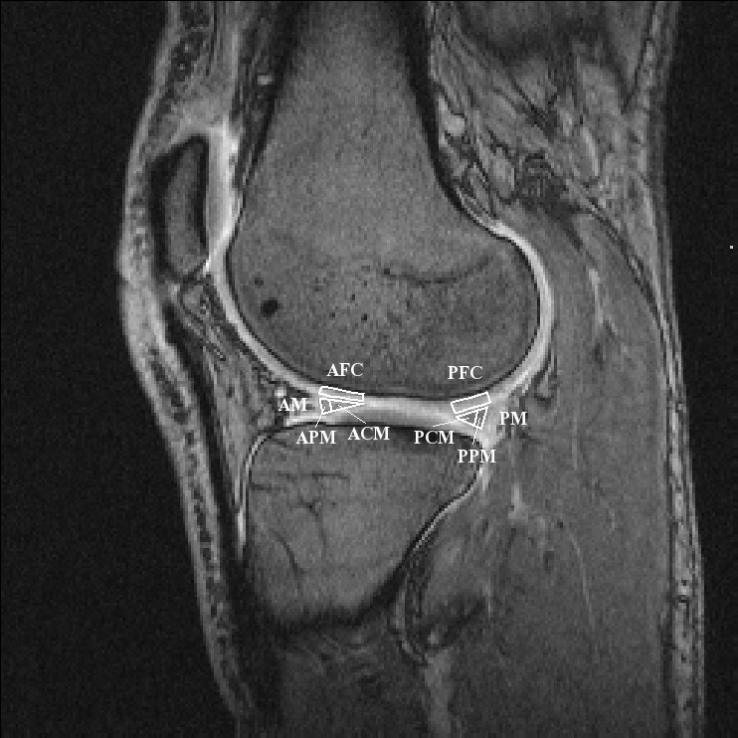
Figure 8.
An average T1 was calculated in Regions of interest (ROIs): AFC= Anterior Femoral Cartilage, PFC= Posterior Femoral Cartilage, AM=Anterior Meniscus, ACM=Anterior Central Meniscus (inner two thirds), APM=Anterior Peripheral Meniscus (outer one third), PM=Posterior Meniscus, PCM=Posterior Central Meniscus (inner two thirds), PPM=Posterior Peripheral Meniscus (outer one third).
The ROIs in paper II–IV were drawn in a similar way as in paper I with some exceptions. In paper II a radiologist used the pre-contrast MRI-examination to define the location of the pathological meniscus changes. From that location, two sagittal slices, one in the lateral and one in the medial compartment, were selected from the 3D volume to enable drawing of four ROIs and analysis of the damaged posterior horn of the medial meniscus and the corresponding posterior part of the lateral meniscus. The same slices were used to draw ROIs for the femoral cartilage (figure 8). In paper III–IV ROIs were drawn to cover the posterior, weight-bearing medial and lateral meniscus and overlying femoral cartilage.
An average T1_{pre} and T1_{Gd} value was calculated for each ROI. The ΔR1 value, which reflects the concentration of Gd-DTPA²⁻ in the tissue, was calculated using the formula ΔR1=1/T1_{Gd}-1/T1_{pre}.

Grading of pathological meniscus
In paper II the pathological meniscus changes were graded according to the classification of Lotysch (1986). Grade 1 changes represent one or several punctate signal intensities at one slice (3 mm between the slices), grade 2 changes represent a linear (i.e. observed in several slices) intrameniscal signal intensity without extension to the articular surface and grade 3 changes represent a signal intensity extended to at least one articular surface.

Statistics
For comparison of data involving T1_{pre}, T1_{Gd} and ΔR1 p-values were calculated, using Student´s t-test (paper I–IV) and the paired t-test (paper I and IV). One-way analysis of variance (ANOVA) (paper I, II) was used to evaluate changes of T1_{Gd} and ΔR1 over time. Chi2-test (paper III) was used to evaluate if there was a difference in number of tissue injuries between football players and healthy, sedentary subjects. To evaluate the correlation between cartilage thickness and ΔR1 (paper III) simple linear regression analysis were used. Multiple linear regression analysis with ΔR1 as dependent factor and cartilage thickness together with football players and sedentary subjects as independent factors (paper III), was used to correct for influence of cartilage thickness. A p-value <0.05 was considered to indicate statistical significant difference.

Results

In Vivo Transport of Gd-DTPA²⁻ into Human Meniscus and Cartilage Assessed with delayed Gadolinium Enhanced MRI of Cartilage and Meniscus (dGEMRIC, dGEMRIM) (paper I)

T1_{pre} of the meniscus and femoral cartilage
A difference was found in the mean value of T1_{pre} between the meniscus and femoral cartilage. Similar values of T1_{pre} were seen in each tissue on the two measurement occasions. The mean values of T1_{pre} over the four compartments of the meniscus using the double dose of contrast agent were 617±67 and 624±65 ms, on occasions one and two, respectively. The corresponding mean values of T1_{pre} in the articular cartilage were 662±75 ms and 655±57 ms.

Effect of contrast agent dose on meniscus image enhancement
The uptake of contrast agent was clearly visible in the meniscus after both double and triple doses. The triple dose resulted in higher values of ΔR1 than the double dose in all four compartments of the meniscus, as exemplified by the posterior medial compartment in figure 9. It can also be seen from this figure that ΔR1 increased until 90 minutes post injection (p<0.05). Evaluation with the paired t-test revealed no increase between 90 and 120 minutes (p=0.308) or between 120 and 180 minutes (p=0.085). The values at 90 and 180 minutes were, however, different (p=0.008). Similar patterns were seen in the other compartments (data not shown).
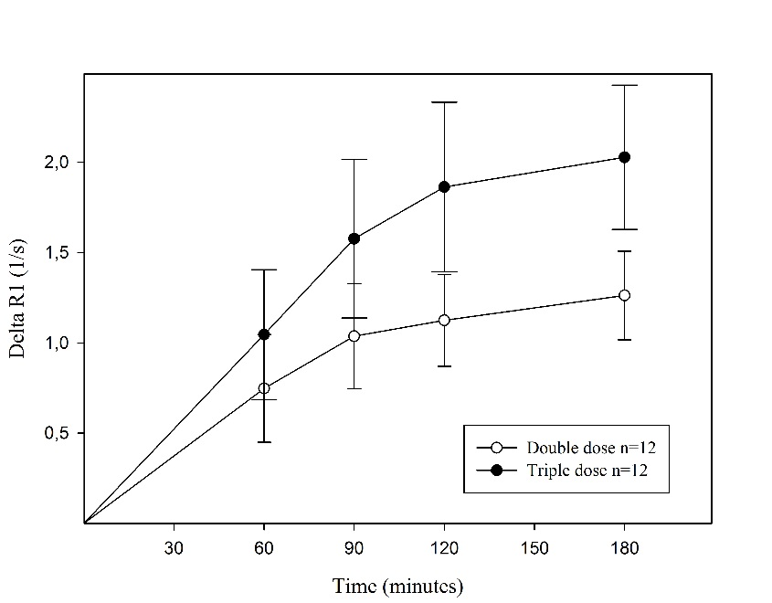
Figure 9.
ΔR1 (±CI) in the posterior medial meniscus, after injection of a double (ο) or a triple (•) dose of Gd-DTPA²⁻ (0.2 mmol/kg and 0.3 mmol/kg body weight, respectively). Higher mean values were observed after injection of the triple dose (p<0.001 ANOVA).

ΔR1 of the meniscus and femoral cartilage after contrast agent injection
The results in figure 10 show that the change of ΔR1 in the posterior medial meniscus was generally higher than in the corresponding femoral cartilage, at all times after the double dose injection (0.001≤p≤0.017). Similar results were seen in the posterior lateral compartment at all times post injection (0.001≤p≤0.008). In the anterior compartments, a difference was seen in the lateral (p<0.001) but not in the medial compartment (0.001≤ p≤0.720). Similar patterns were observed after the triple dose injection (data not shown).
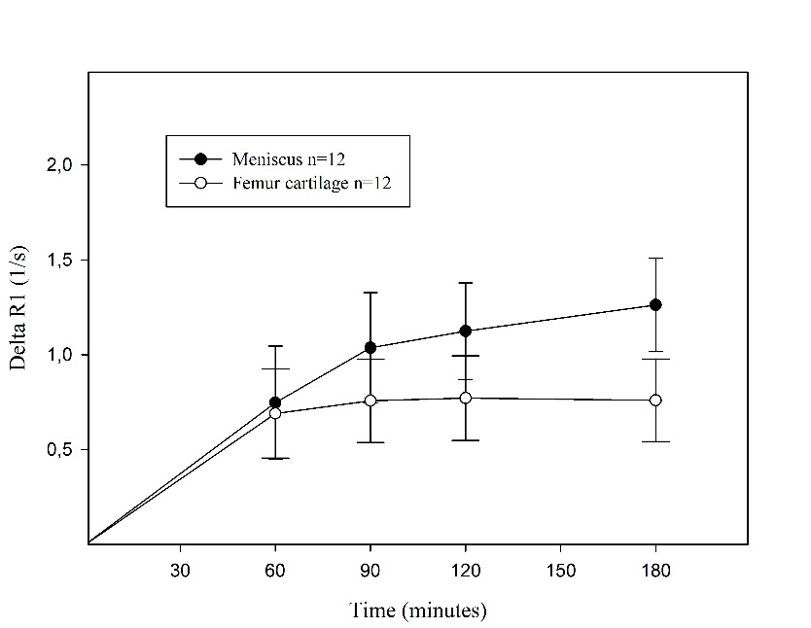
Figure 10.
Change of ΔR1 (±CI) in the meniscus (•) and the femoral cartilage (ο) in the posterior medial compartment after injection of a double dose of Gd-DTPA²⁻ (0.2 mmol/kg body weight). The values were higher in the meniscus than in the femoral cartilage 90–180 minutes post injection (0.001≤p≤0.017).

ΔR1 of different parts of the meniscus after contrast agent injection
Comparisons of different parts of the posterior medial and lateral meniscus revealed a faster increase in ΔR1 (i.e. steeper curve) during the first 60 minutes in the peripheral vascular region, than in the central avascular region (p=0.022 medial, p=0.007 lateral). This is illustrated for the medial meniscus in figure 11. Furthermore, the mean values of ΔR1 over time were significantly higher in the peripheral than in the central part of the posterior medial meniscus (p=0.024 ANOVA). No difference was seen in the lateral meniscus (p=0.175).
Comparison of ΔR1 in the posterior and the anterior horn of the meniscus showed a lower value in the posterior horn, reflecting a lower concentration of Gd-DTPA²⁻. Similar results were seen in the medial and lateral compartments (figure 12A) (p=0.015 in both compartments). ΔR1 was lower in the posterior medial meniscus than in the posterior lateral meniscus (figure 12B). Similar results were seen in the anterior horn of the meniscus, (p=0.049 and p=0.003).
Similar results were observed within and between different parts of the meniscus in different compartments after the triple dose (data not shown).
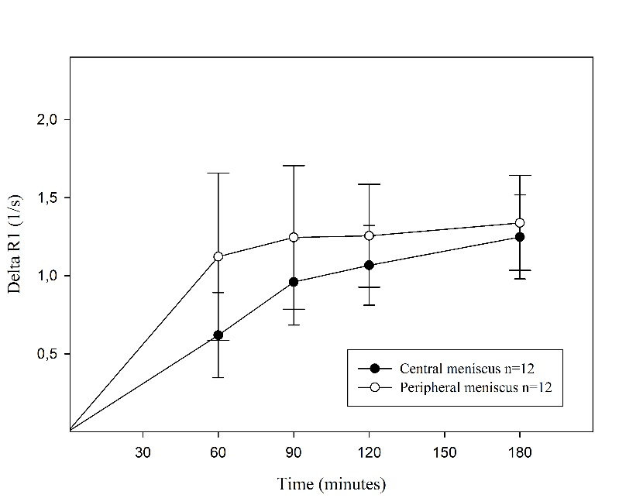
Figure 11.
ΔR1 (±CI) in the posterior medial meniscus after injection of a double dose of Gd-DTPA²⁻ (0.2 mmol/kg body weight). The mean values over time were significantly higher in the peripheral (ο) than in the central (•) part of the meniscus (p=0.024 ANOVA).
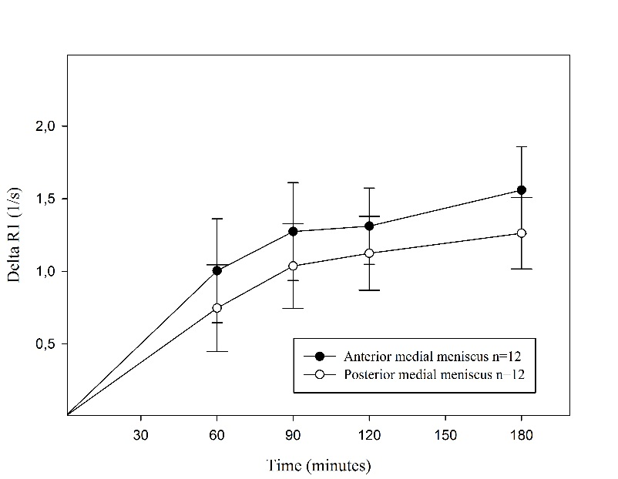
Figure 12A.
ΔR1 (±CI) reflecting the concentration of Gd-DTPA²⁻, after injection of a double dose (0.2 mmol/kg body weight) of contrast agent. The results for the medial meniscus, showing that the mean values over time were lower in the posterior (ο) than in the anterior (•) horn of the meniscus (ANOVA, p=0.015).
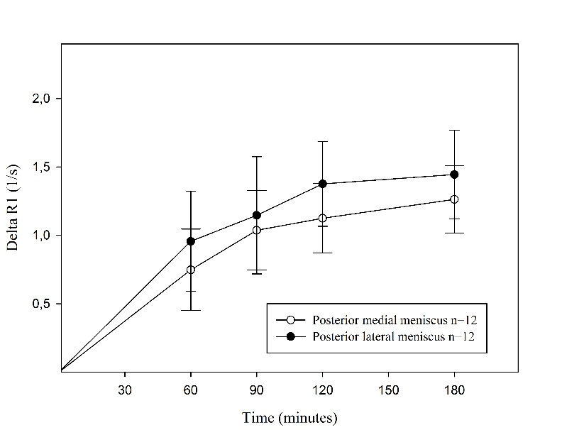
Figure 12B.
ΔR1 (±CI) reflecting the concentration of Gd-DTPA²⁻, after injection of a double dose (0.2 mmol/kg body weight) of contrast agent. The results for the medial and lateral posterior meniscus, showing that ΔR1 was lower in the medial (ο) than in the lateral (•) horn (p=0.049 ANOVA).

Delayed Gadolinium Enhanced MRI of Meniscus (dGEMRIM) and Cartilage (dGEMRIC) in healthy knees and in knees with different stages of meniscus pathology (paper II)
The pre-contrast diagnostic MRI identified two sub-cohorts within the 18 patients with meniscus injury:

- 11 subjects (7 males, age 31–52 years, mean 40 years) with MRI verified pathological intrameniscal changes (grade 2) in the posteromedial meniscus only and no obvious cartilage changes. The lateral meniscus showed no pathology.
- 7 subjects (5 male, age 36–63 years, mean 54 years) with MRI verified pathological rupture (grade 3) in the posteromedial meniscus and pathological changes in the lateral meniscus and/or medial and lateral joint cartilage.

T1_{pre}, T1_{Gd}, and ΔR1 values of healthy and pathological posteromedial meniscus
Subjects with grade 2 lesions showed no differences of T1_{pre} values compared with subjects with healthy meniscus (p=0.189). However, subjects with grade 3 lesions had longer T1_{pre} values than subjects with healthy meniscus (p˂0.001) (figure 13A, table 5).
The contrast medium diffused gradually into the menisci, with a maximum level observed after 180 minutes. The maximum level for grade 3 was 90 minutes.
Subjects with grade 2 lesions had longer T1_{Gd} values than subjects with healthy meniscus (p=0.027) (figure 13A, table 5). There was no difference in T1_{Gd} in the posteromedial meniscus between subjects with meniscus lesions grade 3 and subjects with healthy meniscus (p=0.315) (figure 13A, table 5).
The concentration of the contrast medium, reflected by ΔR1, was lower in meniscus with grade 2 lesion than in healthy meniscus (p=0.046). Meniscus with grade 3 lesions tend to have higher concentration compared to meniscus in subjects with healthy knee joints (p=0.110) (figure 13B, table 5).
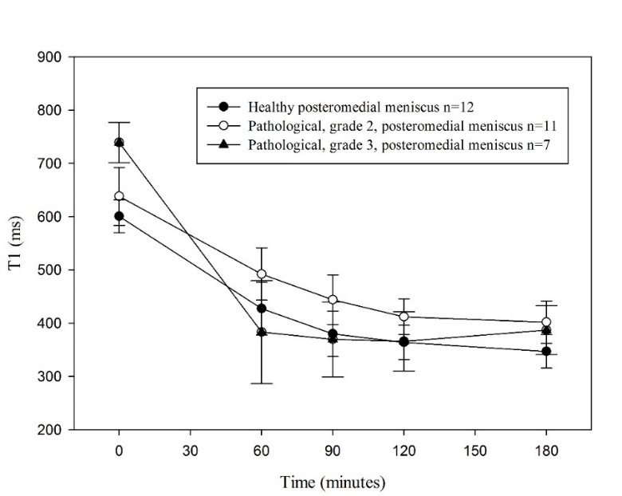
Figure 13A.
T1_{pre} and T1_{Gd} values after intravenous injection of Gd-DTPA2- (0.2 mmol/kg body weight), in posteromedial healthy (n=12, closed circles), pathological grade 2 (n=11, open circles) and pathological grade 3 (n=7, closed triangles) menisci. T1_{Gd} was longer in the pathological grade 2 menisci (ANOVA, p=0.027) and showed no difference in the pathological grade 3 menisci compared to the healthy menisci (ANOVA, p=0.298).
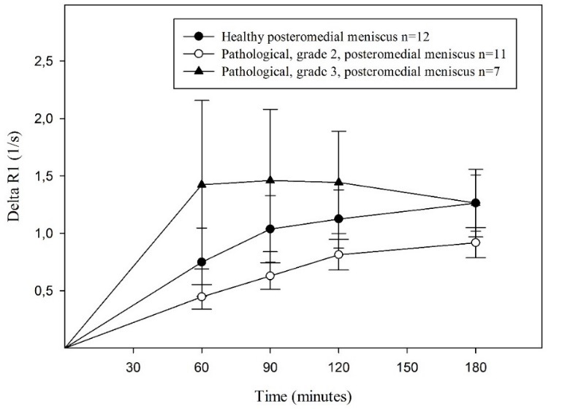
Figure 13B.
ΔR1 values in posteromedial healthy (n=12, closed circles), pathological grade 2 (n=11, open circles) and pathological grade 3 (n=7, closed triangles) menisci, after an intravenous injection of Gd-DTPA²⁻ (0.2 mmol/kg body weight). The values were lower in the pathological grade 2 menisci (ANOVA, p=0.046) and tend to show higher values in the pathological grade 3 menisci (ANOVA, p=0.110.
Table 5.
T1_{pre}, T1_{Gd} and ΔR1 values in posteromedial menisci. P-values and % of difference are between *Healthy-Grade 2 and **Healthy-Grade 3.
Time (min) | Precontrast Mean (CI) T1pre (ms) | 60 | 90 | 120 | 180
 | Healthy Grade 2 Grade 3 | Healthy Grade 2 Grade 3 | Healthy Grade 2 Grade 3 | Healthy Grade 2 Grade 3 | Healthy Grade 2 Grade 3
Mean (CI) T1Gd (ms) | 601±31 638±54 739±38 | 427±49 492±49 383±96 | 379±43 444±46 370±70 | 364±32 412±34 366±55 | 347±31 402±40 387±45
p-values | *0,189 **<0,001 | *0,052 **0,307 | *0,036 **0,761 | *0,032 **0,936 | *0,024 **0,106
% of difference | *6 **23 | *15 **11 | *17 **<1 | *13 **<1 | *16 **12
Mean (CI) ΔR1 (1/s) |  | 0,75±0,30 0,47±0,17 1,42±0,73 | 1,04±0,29 0,70±0,18 1,46±0,62 | 1,13±0,25 0,86±0,20 1,44±0,44 | 1,26±0,25 0,93±0,22 1,26±0,30
p-values |  | *0,099 **0,031 | *0,044 **0,120 | *0,089 **0,138 | *0,041 **0,997
% of difference |  | *60 **89 | *49 **37 | *31 **27 | *35 **<1

Temporal and spatial contrast distribution patterns of T1_{pre}, T1_{Gd} and ΔR1 values in posterior articular cartilage
The maximum level of contrast medium in the femoral cartilage was observed after 120–180 minutes (data not shown).
Within knees with a medial meniscus lesion grade 2, mean T1_{pre}, T1_{Gd,} and ΔR1 did not differ in medial and lateral femoral cartilage. Further, no difference in T1_{pre}, T1_{Gd,} and ΔR1 values was found in lateral femoral cartilage in subjects with a medial meniscus injury grade 2 and subjects with healthy knee joints (data not shown).
In the medial femoral cartilage, T1_{Gd}, but not T1_{pre} or ΔR1, was longer in subjects with meniscus injury grade 2 compared to subjects with healthy knee joints (p=0.027, p=0.159, p=0.280).
The compartments with grade 3 lesions had cartilage changes that were severe enough to compromise the T1_{Gd} calculations and were therefore not evaluated.

Delayed Gadolinium Enhanced MRI of Cartilage (dGEMRIC) and Meniscus (dGEMRIM) in knees of elite football players and sedentary subjects (paper III)

Clinical examination and diagnostic MRI
Pathological findings at the clinical examinations of the 30 included football players and 18 sedentary subjects were limited to minor skin bruises. The diagnostic MRI of the football players showed 23 injuries in 16 knee joints (table 6). There were thirteen sedentary subjects with healthy knee joints and five with six injuries (table 6). The difference in number of subjects with knee injuries between sedentary and elite football players was not significant (Chi2-test, p=0.084).

Table 6.
Pathological findings of diagnostic MRI by elite football players and sedentary subjects.
Elite football players (n=30) | Sedentary (n=18)
Ruptured medial meniscus, anterior/posterior horn n=0/4 | Ruptured medial meniscus, anterior/posterior horn n=0/1
Ruptured lateral meniscus, anterior/posterior horn n=6/3 | Ruptured lateral meniscus, anterior/posterior horn n=3/0
Chondral medial injury n=5 | Chondral medial injury n=1
Chondral lateral injury n=2 | Chondral lateral injury n=1
ACL-ruptures n=3

For the quality examination, the results of the diagnostic MRI were used to divide the subjects into an injured and a non-injured cohort. One of the non-injured sedentary subjects had an allergic reaction to the contrast agent and was excluded from the quality examination, leaving: 14 football players with healthy knee joints (9 females, 5 males, age 16–32, mean 22 years) and 16 with pathological findings (8 female, 8 male, age 18–32, mean 22 years) and 12 sedentary subjects with healthy knee joints (7 females, 5 males, age 23–28 years, mean 25 years) and 5 with pathological findings (1 female, 4 male, age 23–28, mean 25 years).

ΔR1 and T1_{Gd} values of cartilage and meniscus and cartilage thickness
When comparing football players and sedentary subjects with healthy knee joints, the mean ΔR1 was lower for the football players in the medial cartilage but not in the meniscus whereas there were no differences in the lateral compartment. T1_{Gd} values in both medial and lateral cartilage were longer whereas meniscus values were similar in football players compared with sedentary subjects (table 7).
Table 7.
Mean ΔR1 and T1_{Gd} in the posterior, medial and lateral compartments of football players and sedentary subjects with healthy knee joints and p-values between these two cohorts.
 | Elite football players n=14 |  | Sedentary subjects n=12
 | ΔR1 (1/s)±CI | T1_{Gd} (ms)±CI | ΔR1 (1/s)±CI | T1_{Gd} (ms)±CI | P-value ΔR1 |  | P-value T1_{Gd}
Posterior, medial femoral cartilage | 0.47±0.11 | 503±27 | 0.76±0.21 | 433±37 | 0.014 |  | 0.003
Posterior, medial meniscus | 0.81±0.22 | 414±36 | 1.04±0.28 | 380±41 | 0.179 |  | 0.185
Posterior, lateral femoral cartilage | 0.35±0.13 | 556±23 | 0.52±0.17 | 512±39 | 0.100 |  | 0.045
Posterior, lateral meniscus | 0.98±0.23 | 385±27 | 1.15±0.41 | 364±44 | 0.405 |  | 0.384

The dGEMRIC and dGEMRIM results of the sub-cohort of football players with pathological findings on diagnostic MRI were not possible to evaluate due to different locations and types of injuries resulting in a heterogeneous cohort. Similarly the sub-cohort of sedentary subjects with pathological findings on diagnostic MRI were too few (n=5) for meaningful further calculations.
Measurements of thickness of weight-bearing posterior femoral cartilage showed a thicker cartilage in elite football players than sedentary subjects in the medial compartment: 2.18±0.30 mm vs. 1.83±0.20 mm (p=0.023). In the lateral compartment the values were 3.19±0.35 mm vs. 2.72±0.40 mm (p=0.067).
Simple linear regression analysis demonstrated a negative correlation between cartilage thickness and ΔR1 (mean of medial and lateral cartilage) in both football players and sedentary subjects (p<0.001 to 0.013) (figure 14).
Figure 14.
Simple linear regression analysis of posterior medial and lateral femoral cartilage thickness and ΔR1 of elite football players (○, -, n=28, R-value=-0.52, p= 0.005), sedentary (•, -, n=24, R-value=-0.497 p=0.013) and football players and sedentary subjects together (-, n=52, R-value=-0.434, p=<0.001).
Multiple linear regression analysis with ΔR1 as dependent factor and cartilage thickness together with football players and sedentary subjects as independent factors showed, after correction of influence of cartilage thickness, higher ΔR1 values in sedentary subjects compared with football players: 0.30 (1/s) on the medial side and 0.11 (1/s) on the lateral side (table 8). Initial values, without correction for influence of cartilage thickness, were 0.29 (1/s) on the medial side and 0.17 (1/s) on the lateral side (table 7). Adjusted p-values were 0.019 (0.014, table 7) on the medial side and 0.287 (0.100, table 6) on the lateral side (table 8).
Table 8.
Values before and after multiple linear regression analysis with ΔR1 as dependent factor and cartilage thickness together with football players and sedentary subjects as independent factors.
 |  | Difference cohorts | p-value
Posterior, medial femoral cartilge | Initial values | 0.29 | 0.014
 | After correction of cartilage thickness | 0.30 | 0.019
Posterior, lateral femoral cartilge | Initial values | 0.17 | 0.100
 | After correction of cartilage thickness | 0.11 | 0.287

Longitudinal assessment of knee joint cartilage and meniscus quality in female elite football players using contrast enhanced MRI (paper IV)

Clinical examination and diagnostic MRI
No other pathological findings than minor skin bruises were present at the clinical examinations of included subjects. The diagnostic MRI of the 9 non-injured joints demonstrated 3 healthy knee joints and 6 with pathology. The injuries in the pathological knee joints were partial ruptures of the posterior medial meniscus (n=1), anterior lateral meniscus (n=3), posterior lateral meniscus (n=1), chondral pathological changes in the posterior medial (n=1) and lateral (n=1) femoral cartilage. Three players had two injuries each. One chondral damage in posterior, lateral compartment was the only new finding on diagnostic MRI compared with the baseline study two years earlier. The diagnostic MRI of the four knees with ACL-ruptures demonstrated, in addition to the ACL-injury, bone bruise in the lateral, femoral condyle.

ΔR1 and T1_{Gd} values of posterior, femoral cartilage and menisci, and femoral cartilage thickness at baseline and follow-up study in female, non-injured, elite football players
There were no statistically significant differences in mean ΔR1 values in posterior compartments between baseline and follow-up study (femoral, medial cartilage p=0.057, medial meniscus p=0.871, femoral, lateral cartilage p=0.376, lateral meniscus p=0.127) (figure 15 and 16). When further analysing the results, we found that the largest decrease (positive quality change) in individual ΔR1 values was in the two youngest (18 and 20 years) football players in the posterior, femoral cartilage in the medial compartment (decrease of ΔR1 0.53 and 0.31 1/s).
Figure 15.
ΔR1, n=9, in posterior medial and lateral femoral cartilage at baseline and follow-up study 2 years later.

Figure 16.
ΔR1, n=9, in posterior medial and lateral meniscus at baseline and follow-up study 2 years later.
The measured T1_{Gd} was lower at follow-up than at baseline in the posterior lateral meniscus (p=0.021) but not in the femoral cartilage in the same compartment (p=0.376) or in the medial compartment (cartilage p=0.152, meniscus p=0.888).
Measurements of thickness of weight bearing, posterior, femoral cartilage showed no differences in posterior medial or lateral compartment between baseline and follow-up.
Table 9 shows mean values of cartilage thickness, ΔR1 and T1_{Gd} of cartilage and meniscus.

Table 9.
Mean values of ΔR1, T1_{Gd} and thickness of posterior, medial and lateral femoral cartilage and mean values of ΔR1 and T1_{Gd} of posterior, medial and lateral meniscus in female football players (n=9) at baseline and 2 years follow-up study.
Female elite football players n=9, baseline | ΔR1 (1/s)±CI | T1_{Gd} (ms)±CI | Thickness (mm)±CI
Posterior, medial femoral cartilage | 0.68±0.24 | 469±46 | 2,00±0,32
Posterior, medial meniscus | 0.82±0.16 | 414±25
Posterior, lateral femoral cartilage | 0.39±0.22 | 533±30 | 2,70±0,38
Posterior, lateral meniscus | 0.95±0.32 | 387±32
Female elite football players n=9, 2 year follow-up | ΔR1 (1/s)±CI | T1_{Gd} (ms)±CI | Thickness (mm)±CI
Posterior, medial femoral cartilage | 0.45±0.27 | 509±30 | 2,01±0,26
Posterior, medial meniscus | 0.80±0.30 | 417±48
Posterior, lateral femoral cartilage | 0.46±0.15 | 512±20 | 2,75±0,39
Posterior, lateral meniscus | 1.17±0.28 | 337±24

ΔR1 and T1_{Gd} of posterior femoral cartilage and menisci, and femoral cartilage thickness of four female football players with ACL-injury
No notable change in quality in posterior femoral cartilage or meniscus was observed in this study after an ACL-injury, operation or rehabilitation. The results are presented in figures 17 and 18.
Measurements of thickness of weight-bearing, posterior, femoral cartilage showed no differences in posterior medial or lateral compartment between baseline and follow-up study (data not shown).
Tables 10 and 11 show mean values of ΔR1 and T1_{Gd} of each examination.
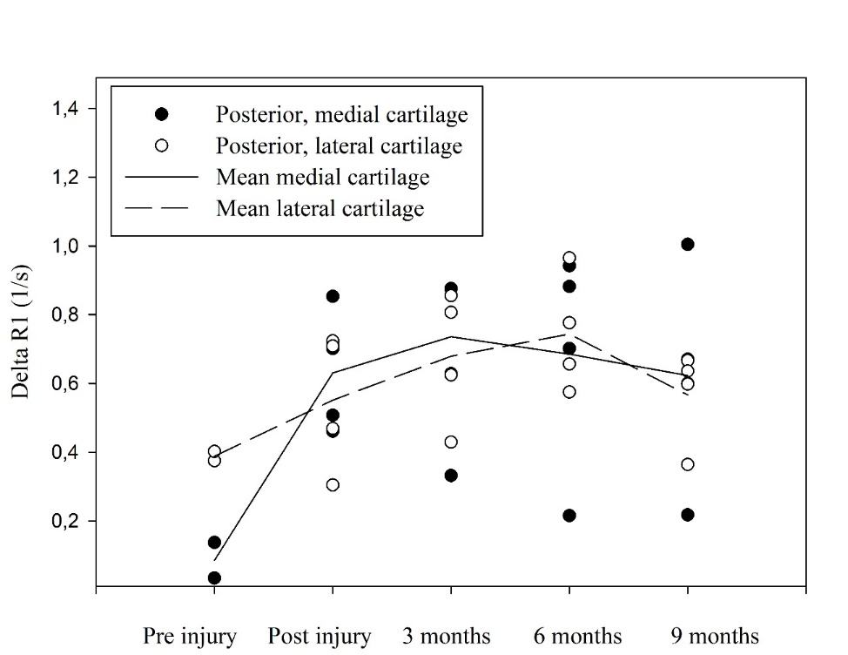
Figure 17.
ΔR1 in posterior medial (•) and lateral (o) femoral cartilage of four female football players ACL-rupture. The following time points were analyzed: before injury (n=2), within two weeks after injury and 3, 6, and 9 months after surgery (n=4). Reconstruction of ACL was performed within two months after injury.
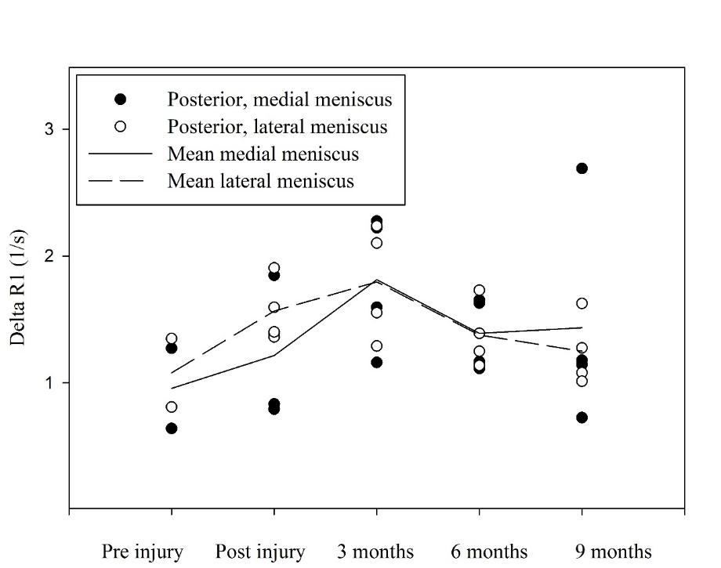
Figure 18.
ΔR1 in posterior medial (•) and lateral (o) meniscus of four female football players with ACL-rupture. The following time points were analyzed: before injury (n=2), within two weeks after injury and 3, 6 and 9 months after surgery (n=4). Reconstruction of ACL was performed within two months after injury.
Table 10.
Mean values of ΔR1 after injection of Gd-DTPA²⁻ in posterior medial and lateral femoral cartilage and meniscus of four female football players with rupture of ACL. The following time points were analyzed: before injury (n=2), within two weeks after injury and 3, 6 and 9 months after surgery (n=4). Reconstruction of ACL was performed within two months after injury.
ΔR1 (1/s)±CI of four female football players with rupture of ACL
 | Pre injury | Post injury | 3 months | 6 months | 9 months
Posteromedial, femoral cartilage | 0.09±0.45 | 0.63±0.25 | 0.74±0.46 | 0.69±0.46 | 0.62±0.45
Posteromedial meniscus | 0.96±2.88 | 1.21±0.68 | 1.81±0.73 | 1.39±0.40 | 1.43±1.19
Posterolateral, femoral cartilage | 0.39±0.12 | 0.55±0.27 | 0.68±0.27 | 0.74±0.24 | 0.57±0.19
Posterolateral meniscus | 1.08±2.43 | 1.57±0.35 | 1.80±0.62 | 1.38±0.35 | 1.25±0.38
Table 11.
Mean values of T1_{Gd} after injection of Gd-DTPA²⁻ of posterior medial and lateral femoral cartilage and meniscus of four female football players with rupture of ACL. The following time points were analyzed: before injury (n=2), within two weeks after injury and 3, 6 and 9 months after surgery. Reconstruction of ACL was performed within two months after injury (n=4).
T1_{Gd} (ms)±CI of four female football players with rupture of ACL
 | Pre injury | Post injury | 3 months | 6 months | 9 months
Posteromedial, femoral cartilage | 610±267 | 527±49 | 483±95 | 485±127 | 522±75
Posteromedial meniscus | 393±431 | 374±91 | 293±64 | 338±33 | 384±29
Posterolateral, femoral cartilage | 595±57 | 526±48 | 509±86 | 476±65 | 535±100
Posterolateral meniscus | 373±265 | 315±41 | 295±68 | 316±59 | 370±54

Discussion

Can contrast enhanced MRI be used to examine healthy and pathological changed meniscus?
Only few studies, have previously been published concerning the feasibility of contrast enhanced MRI of the meniscus. Krishnan (2007) demonstrated a correlation between pathological posteromedial meniscus and corresponding femoral and tibial joint cartilage. Van Tiel (2014) showed a trend towards the same result. Only Li (2011) has examined the subjects pre-contrast and published the data for ΔR1 (T1_{Gd} after 120 minutes). These studies of Krishnan and van Tiel together with paper II in this thesis show a wide range of T1_{Gd} values in meniscus with pathological grade 3 changes. Reliable T1 index seems unable to establish with this heterogeneous data. More information is necessary and more studies including T1_{pre} and T1_{Gd} to establish ΔR1 values are required to enable a more valid and interpretable assessment. This would make the results more reliable and for example enable multicentre studies. The reproducibility of individual meniscus ROIs has been shown to be good (van Tiel 2014), which further would advocate this. Further, when meniscus is studied in OA affected knee joints the pathological changes have to be graded to enable a subdivision and from there enable a correct comparison between different results.
In Paper I the triple dose (0.3 mmol/kg body weight) yielded higher concentrations of Gd-DTPA²⁻ in the healthy meniscus and cartilage than the double dose (0.2 mmol/kg body weight), but provided no additional information. The double dose of Gd-DTPA²⁻ was sufficient to detect all compartmental and regional differences, and appears to be adequate in contrast enhanced MRI analysis of both healthy meniscus and cartilage. This is consistent with previous results in articular cartilage (Tiderius 2001).
In this thesis a method to establish 3D data of the knee joint was used. The primary advantage of using 3D rather than 2D was to benefit from being able to choose the exact slice, on which the ROIs are placed, at a later time point than during image acquisition. This option is desirable when examine and compare the knee joint pre- and post-contrast, localize pathological tissue and doing several examination over time.
In paper I and II the maximum level of contrast medium in healthy femoral cartilage and in healthy and pathological meniscus occurred approximately 120–180 minutes after injection. This is consistent with earlier results for femoral cartilage (Tiderius 2001). Mayerhoefer (2011) advocate a time window of 150–270 minutes suitable for dGEMRIM. From a clinical point of view, it is advantageous to be able to examine the patient as soon as possible after injection. It is also desirable to be able to examine the cartilage and meniscus simultaneously. The wash out effect advocated by Hawezi (2011) (see below under “Methological considerations”) also needs to be considered in order to choose an optimal time point post contrast to investigate pathological menisci with dGEMRIM. From this, it can be concluded that 120 minutes post contrast seems optimal for the evaluation of both meniscus and cartilage tissue.

Meniscus and cartilage quality of elite football players examined with contrast enhanced MRI

Diagnostic MRI
The prevalence of pathological MRI findings in knee joints without any radiographic evidence of knee osteoarthritis in a population between 51–89 years (mean 62.3) was in the Framingham Cohort study 89 % (Guermazi 2012). The prevalence of radiographic knee osteoarthritis in former professional football players (mean age 62.7 years) without earlier diagnosed injuries was 11 % (Roos 1994). In paper III the prevalence of pathological MRI findings were 53 % (16 of 30 joints). Pivoting sports such as football, team handball, basketball and American football are known risk factors for knee injuries (Majewski 2006). This together with the high level of performance of the subjects in paper III might be the explanation to the high levels of pathological MRI findings.

Healthy meniscus and cartilage in elite football players compared with sedentary subjects and follow-up of female elite football players
In line with previous studies, the lower ΔR1 and longer T1_{Gd} values in the femoral cartilage in posterior medial knee joint in elite football players compared with sedentary subjects in paper III, suggests an exercise-driven adaptation in knee cartilage quality by increasing GAG content (Tiderius 2004, van Ginckel 2010). However, as shown by Hawezi (2011), cartilage thickness can be a confounding factor in T1 measurements of joint cartilage, due to the depth-wise variation in contrast distribution in femoral knee cartilage. The thicker the cartilage, the less contrast will distribute into the deeper regions giving a bias towards longer measured T1 values. The exercise-driven adaptation was not seen in the posterior meniscus in paper III. A likely explanation is the low GAG concentration in the meniscus (0.3 %, wet weight) compared with cartilage (2 %, wet weight) (McNicol 1980).
To examine if cartilage thickness may explain the decreased ΔR1 and increased T1 values in the exercising subjects we performed cartilage thickness measurements of weight bearing, posterior femoral cartilage in paper III. Indeed, we show a thicker femoral cartilage in medial femoral cartilage of football players compared to sedentary subjects with healthy knee joints. Furthermore, there was a correlation between thickness and ΔR1 and T1_{Gd}- the thicker the cartilage, the less concentration of contrast medium in the cartilage. The possible impact of cartilage thickness on ΔR1 and T1 values was determined by multiple linear regressions analyses. Results suggest cartilage thickness less important than increased cartilage quality to explain ΔR1 and T1_{Gd} values, and more so medially than laterally.
The cartilage thickness differences shown corroborates several previous studies (Culvenor 2017, Yilmaz 2016). However, the cause of this is unclear as is the significance of the finding. It is unknown if having thicker cartilage is advantageous with respect to performance or risk of future joint disease. If so, there may be a natural selection of individuals with increased cartilage thickness to high demanding sports at elite level. Another possibility is that exercising during adolescence, with remaining growth, may stimulate cartilage to be thicker.
No pathological changes predicting the development of OA were found in the two year follow-up study (paper IV). On the contrary, the ΔR1 values of the posterior, medial femoral cartilage suggested increased quality (p=0.057). Interestingly, the largest decrease in ΔR1 (positive quality change), were seen in the two youngest subjects in the posterior femoral cartilage in the medial compartment. This would be in agreement with an adaptation to higher quality of medial femoral cartilage due to intense training as suggested in paper III.

When to return to competition after a reconstruction of the ACL?
In paper IV there was no notable change of quality in the posterior, femoral cartilage or meniscus after an ACL-injury, reconstruction of the ACL and 9 months of rehabilitation. The subjects are relatively homogenous (gender, activity, age) in the study and the contrast enhanced methodology has been shown in previous studies to be sensitive to molecular GAG changes (Tiderius 2001, 2003, Owman 2008, 2014). However, the low number of subjects in this present study makes the conclusions uncertain and no general guidelines can be drawn from these values telling when the femoral cartilage and meniscus of the knee joint are ready for the increased load that playing football on elite level entails.

Limitations and considerations of these studies

dGEMRIC and dGEMRIM as method
Using gadolinium enhanced MRI as method you should always consider what you are measuring and then how to analyze the results. The main assumption in this thesis is that the T1 values are dependent on the GAG content in the tissue and that the content of GAG is a measure of the quality of the tissue. As mentioned under “Considerations of dGEMRIC and dGEMRIM” it is important to acknowledge that other factors than GAG content may contribute to the distribution of contrast agent into a specific tissue. Li (2010, 2011) highlighted this issue in more details using both an ionic (inversely related to the GAG content) and a non-ionic (no known interaction with GAG content) contrast agent when investigating meniscus and femoral cartilage in knee joints with OA. Data from these studies demonstrated similar differences in T1_{Gd} values in meniscus and cartilage by subjects with OA and healthy volunteers, with both kinds of contrast agents, indicating that GAG is not the sole factor influencing the uptake of contrast agent. The authors of these studies speculated that the integrity of the collagen network may play a role, as well as increased diffusion due to degenerative changes of both the meniscus and cartilage.
Using dGEMRIC, Hawezi (2011) showed a depth-wise variation in contrast distribution in femoral knee cartilage. The maximum concentration of the contrast agent was observed at different time points in different cartilage layers: at 120–180 minutes in the superficial layer and at 240 minutes or more in the deeper layers. Furthermore, the differences increased with cartilage thickness. The authors further discussed a wash out effect of contrast agent occurring after approximately 120 minutes. It has previously been demonstrated that following an intravenous Gd-DTPA²⁻ injection, the gadolinium concentration in blood plasma will reach its maximum and then decrease within 120 minutes (Weinmann 1984). Assuming similar concentration decay in synovial fluid, the gadolinium concentration of articular cartilage will be higher than that in synovial fluid and a wash out of gadolinium from the cartilage will start approximately after 120 minutes. The wash out effect needs to be considered in order to choose an optimal time point post contrast when investigating both healthy and pathological cartilage and menisci tissue with delayed gadolinium enhanced MRI.

Sample size
It can be argued that the cohorts studied in this thesis are too small for any reliable conclusions to be drawn. Though, the studies are hypothesis generating and in addition, previous results presented by our group advocate that only a limited number of subjects is needed to detect clinically and statistically significant differences using delayed gadolinium enhanced MRI in cartilage (Tiderius 2001, 2003, 2004, 2005, 2006, Neuman 2011). This is mainly due to the low variability of T1_{Gd} values measured in the examined cohorts. Healthy meniscus and meniscus with pathological changes grade 2 show equal low variability in the four paper of this thesis as in those studies of cartilage, why results of smaller groups using dGEMRIM also should be reliable. The results of the four ACL-injured subjects that are presented in paper IV are to be seen as isolated cases and no general conclusions are possible to draw from that material.

Adjusting for multiple testing
In paper II more than two cohorts are compared. An adjustment for multiple testing of p-values would then be in place. But since the investigations are of observational character without in advance specific end-points, the assessment is made that no such correction is necessary (Bender 2001, Ranstam 2016).

Measurements of anterior and posterior meniscus
In paper I results of both the anterior and posterior meniscus are presented, but in paper II, III and IV only results from the posterior part. In many ROIs, at different time points, of the anterior meniscus, the number of pixels were less than 30. This made the values of the anterior meniscus difficult to evaluate and therefore the results of the anterior meniscus were excluded from study II–IV.

Risks to consider using gadolinium as contrast agent
Gd-DTPA²⁻ (gadolinium diethylene triamine pentaacetic acid) was used and administered as intravenous injection to the subjects in the examinations included in this thesis. Gd³⁺ is toxic and therefore in clinical use encased in a chelate.
In 2001 there was a publication describing a new disease (Cowper 2001). Initially, the term nephrogenic fibrosing dermophaty was used but later it was changed to nephrogenic systemic fibrosis (NSF). The symptoms were lower extremity pain, paresthesias and pruritus. Findings included edema, hyperpigmentation, papules, subcutaneous nodules, or hardened or tethered skin. Grobner (2006) established an association between NSF and exposure to gadolinium based contrast agents (GBCAs) during MRI in patients with severe chronic or acute renal failure. However, after the introduction of clinical guidelines restricting the use of gadolinium in these patients, reports from several academic medical centers have been published indicating that no new cases of NSF have been observed among this category of patients (Martin 2010, Wang 2011).
It was previously believed that GBCAs were completely excreted from the human body in an intact state. However, in 2014, a relationship between repeated administration of GBCAs and high signal intensity in the brain on MRI, was reported (Kanda 2014). After this, several publications have reported an accumulation in the brain and also in the skin after repeated administration of GBCAs (Kanda 2015, 2015, Radbruch 2015). The accumulation seems to be dose dependent and is also seen in patients with normal function of the kidneys (Errante 2014). Prevalence and mechanism are unclear and the US Food and Drug Administration (FDA) reported no identified adverse health effects from gadolinium retained in the brain in their review from May 2017 (FDA 2017). However, the European Medicine Agency (EMA) has from July 2017 recommended restrictions for some intravenous gadolinium agents in order to prevent any risks that could potentially be associated with deposition of gadolinium in the brain (EMA 2017). For example, the recommendation for intravenous injection of Magnevist® (gadolinium diethylene triamine pentaacetic acid) used in this thesis, is suspension.

Methological considerations

The 3D Look-Locker sequence
The sequence used for 3D Look-Locker is in general sensitive for variations in the used flip angle. If the actual flip angle not correspond with the flip angle prescribed, it will result in incorrect T1 values. An incorrect flip angle may be present at two occasions:
- In 3D sequences the flip angle mostly decrease in the most peripheral slides of the 3D volume, which make these measured T1 values less reliable. In this thesis this is corrected to minimize this error.
- If the RF-pulse not is homogenous over the volume, the flip angle will alter over the picture and from that create locally unsure T1 measurements. With 1.5T and with the small volumes used in this thesis this should not be a significant issue.

Acquisition of 3D delayed gadolinium enhanced MRI
Factors that may affect the repeatability of longitudinal examinations and the following results from the calculations are:

- Is the knee joint of the subject in the same position at all examinations?
- Are the slices obtained at the same angle?
- Is the ROI drawn on an equal slice?
- Are the calculations done on an equal ROI?

The position of the subject and the position of the slices is done by the MRI operator performing the examination based on written guidelines. In all examinations in this thesis an identical protocol was used for the positioning of the knee joint of the subject and the positioning of the slices. There is still a risk of the positioning of the knee joint not being absolutely equal for each examination, due to both differences in subject positioning and to operator related issues. Siversson (2010) concluded that positioning of slices may introduce a source of methological error in the contrast agent enhanced MRI technique. The subject and the slices will inevitably be placed somewhat differently in different examinations, meaning that the ROIs included in the measurements at different time points and occasions will cover slightly different areas of the tissue. For OA subjects, this position malalignment might be even more critical, because the meniscus and cartilage quality of OA subjects might be more heterogeneous.
In paper II a radiologist used the pre-contrast MRI examination to define the location of the pathological meniscus changes. From that location, based on anatomical landmarks, a sagittal slice in the medial compartment, were selected from the 3D volume to enable analysis of the damaged posterior horn of the medial meniscus.
The ROIs of all examinations in this thesis were drawn by a single investigator (US). Tiderius showed a low intra- and inter observer variability with regard to the manual ROI drawing (Tiderius 2004).

BMI
A correction factor has been recommended for T1_{Gd} in dGEMRIC cross sectional studies with a large range of BMI (Tiderius 2006). The dose of Gd-DTPA²⁻ is administrated according to the bodyweight of the subject. Gd-DTPA²⁻ distributes in extracellular water only and hence not into adipose cells. Since an obese subject has relatively less extracellular water than a lean person this leads to higher concentration of Gd-DTPA²⁻ in the cartilage, and consequently shorter T1_{Gd}. Only cartilage has been investigated and recommendations for meniscus is not available. There are situations where this dose bias will not be an issue. It will not be a factor in longitudinal studies where BMI does not change significantly- the dose bias will be present at all examinations and percent changes with an intervention will not be affected (Roos 2005). Neither will, when different compartments are compared within a knee joint, the dose bias be an issue (Tiderius 2005). Further, no correlations between dGEMRIC and BMI were found in asymptomatic subjects (Tiderius 2006).
In this thesis, the range of BMI has only been a factor of substance concerning the cohort with pathological changes in the posteromedial meniscus (n=18, BMI 20.1–36.6, mean 28.1). When recalculating the values for cartilage in paper II where this cohort has been compared with other cohorts, there have been no significant changes of the earlier presented results.

Selection of cohorts
There was a difference in average age between the cohorts: subjects with healthy knee joints (paper I): 23–28 years, mean 25, subjects with pathological meniscus (paper II): grade 2: 31–52 years, mean 40, grade 3: 36–63 years, mean 54, football players (paper III): 16–32 years, mean 20.6 and female football players (paper IV): 18–34 years, mean 27.4. Pathological changes of the meniscus are often associated with older age (Englund 2009). It is therefore not possible to remove the potential confounding effect of age from the observed difference in the cohort with pathological meniscus compared with the other cohorts. Further studies with larger age matched cohorts may be warranted.

Clinical applications
From July 2017 the recommendation from EMA is not to use Magnevist® (gadolinium diethylene triamine pentaacetic acid) for intravenous injection. If there should be a change of recommendation in the future then dGEMRIC and dGEMRIM may be a valuable examination to advice and treat patients believed to be at risk of developing OA. To identify these patients at an early stage of disease would make it possible to initiate prophylactic and curative treatment much earlier than is possible today. dGEMRIC and dGEMRIM may also be useful to evaluate clinical trials on treatments or drugs affecting the joint. One application would be to follow sportsmen and women or employees with more burdensome work after an injury affecting a joint and from the results of the dGEMRIC and dGEMRIM recommend the patient when it is time to go back to sport or work.

Conclusions
- dGEMRIM and dGEMRIC may be feasible to combine in vivo, preferably with one examination before and one examination 120 minutes after injection of Gd-DTPA²⁻ at a dose of 0.2 mmol/kg body weight.
- Possible different dGEMRIM patterns at different stages of meniscus lesion development must be taken into account when evaluating meniscus pathology.
- The posterior femoral cartilage of the knee joint by elite football players adapts and increase in quality to the high load that playing football on high level means.
- No pathological changes predicting development of OA were seen in the two year follow-up study of nine non-injured or four ACL-injured female elite football players.

Summary
Osteoarthritis (OA) affects approximately 10 % of the elderly and is a leading cause of disability. OA is suggested to be a whole-joint disease involving cartilage, ligaments, periarticular muscles, subchondral bone and menisci. The meniscus has a critical protective role for knee joint integrity by absorbing impact and distributing load. Overall, it is estimated that the knee meniscus carries 45 to 75% of the total joint load. Loss of meniscal function has been strongly associated with development and progression of radiographic OA. However, OA-related changes observed by radiography are late events in the degenerative process.
Delayed gadolinium enhanced magnetic resonance imaging of cartilage (dGEMRIC) is an imaging technique that can identify pre-radiographic degenerative changes in articular cartilage. In dGEMRIC, the fixed charged density of GAG is studied in vivo through quantitative measurement of the longitudinal relaxation time (T1) of articular cartilage in the presence of the negatively charged contrast agent Gd-DTPA²⁻.
Since OA is considered to affect the whole joint and that the integrity of the meniscus has an import role to prevent OA, it is important to investigate the meniscus further. The purpose of the work presented in this thesis was to investigate if delayed gadolinium enhanced MRI of meniscus (dGEMRIM) was applicable on healthy meniscus (paper I) and meniscus with pathological changes (paper II). Further the method was applied on a cohort at risk developing OA (paper III). A two year follow-up of this cohort was made to investigate if there were any changes (paper IV).
Paper I showed that it is feasible to examine undamaged meniscus (dGEMRIM) and cartilage (dGEMRIC) simultaneously at 90–120 minutes after the injection of Gd-DTPA²⁻ at a dose of 0.2 mmol/kg body weight. The uptake of contrast agent differed both within the meniscus and in the meniscus at different locations in the knee joint.
Paper II suggests dGEMRIM to be a possible method to identify loss of meniscus integrity in early OA development. dGEMRIM and dGEMRIC was applicable to combine in vivo, preferably with one examination before and one 120 minutes after contrast injection. Possible different dGEMRIM patterns at different stages of meniscus lesion development must be taken into account when evaluating meniscus pathology.
In paper III we found that the posterior femoral cartilage of the knee joint by elite football players adapts to the high load that performance on this high level means.
Paper IV showed no pathological changes predicting development of OA in the two-year follow-up study of nine female elite football players. Further, there was no notable change of quality in the posterior, femoral cartilage or meniscus after an ACL-injury, reconstruction of the ACL and 9 months of rehabilitation.

Acknowledgements
I would like to start with to express my surprise that so many people have had the endurance to support, help and encourage me over the years and in this way contributed to making this thesis possible. This surprise makes my gratitude to all these people who feel involved even more sincere and intense. In addition, I would especially like to thank the following:

Leif Dahlberg, my main supervisor, who has introduced me to the field of osteoarthritis.
Carl-Johan Tiderius, my co-supervisor, who explained everything worth knowing about dGEMRIC.
Jonas Svensson, my co-supervisor. Thank you for your endless, positive and very friendly help with Mokkula and issues concerning MRI. Without you there had certainly been no thesis.
Carl Siversson, my first, second and third aid-kit for everything concerning Mokkula and MRI issues. Thank you for your help and endless patience.
Eveliina Lammentausta, thank you for letting me use Mokkula, and all your friendly answers about it.
Gunilla Müller, thank you for your collaboration during Paper II.
Jack Besjakov, thank you for your collaboration during Paper III and IV.
Pernilla, who coordinated and read all my sketches for the first paper. Thank you for helping me with all the research admissions.
Susanne, who coordinated and read the sketches for the second paper. Thank you for helping me with all the research admissions.
Johan, who coordinated and read the sketches for paper III and IV.
Jeanette, the spider in the web, thank you for all help with research admissions, finding articles, admissions for different courses and everything else…
Jan-Åke Nilsson, for all your help concerning statistical matters.
Jonas Ranstam, for all additional help concerning statistical matters.
Anetta Bolejko, for all your help coordinating the MRI surveys, despite your hectic schedule.
Marcus Hultgren, Mikael Hansson, Anna Okrajni and Edit Türi, thank you for your extra time during evenings taking care of the patients and carry out the MRI examinations.
All the patients in Study I and II.
FC Rosengård and Malmö FF for letting me use their players, who patiently implemented the examinations.
I would also like to give a collective thanks to all the colleagues at the Department of Orthopedics and especially to the colleagues at the Sport Section doing all the work during my time of research.
Gullevi and Birger, my parents, who gave me the opportunity to do what I wanted and what I do.
Gullan, play-grandma, taking care of us and my father.
Nicklas, Micael and Simeon for vital distraction with love and in this way giving me the possibility to fulfil my commitment.
The Axelsson-clan, who with their warmth and kindness let me in.
Virve, Tilde and Kasper and my Eva, who always compliment my days- I love you beyond measure.

Role of funding source
This thesis was supported by grants from the Swedish Research Council (VR), governmental funding of clinical research within the Swedish National Health Service (ALF), Skåne County Council´s Research and Development Foundation (FoU), the Swedish National Centre for Reasearch in Sports (CIF), The Swedish Rheumatism Association (RF), Skåne University Hospital funds, King Gustaf V´s 80-Year Fund, The Herman Järnhardt Foundation, The Alfred Österlund Foundation and Greta and Johan Kock´s Foundation.

References
Ahlbäck S. Osteoarthrosis of the knee. A radiographic investigation. Acta Radiol Diagn (Stockh). 1968:Suppl 277:7-72.
Akeson WH, Amiel DA, Gershuni DH. Articular cartilage physiology and metabolism. In: Resnick D ed. Diagnosis of bone and joint disorders, 3rd ed. Philadelphia: WB Saunders, 1995:769-790.
Ala-Kokko L, Baldwin CT, Moskowitz RW, Prockop DJ. Single base mutation in the type II procollagen gene (COL2A1) as a cause of primary osteoarthritis associated with a mild chondrodysplasia. Proc Natl Acad Sci U S A. 1990 Sep;87(17):6565-8.
Ardern CL, Taylor NF, Feller JA, Webster KE. Fifty-five per cent return to competitive sport following anterior cruciate ligament reconstruction surgery: an updated systematic review and meta-analysis including aspects of physical functioning and contextual factors. Br J Sports Med. 2014 Nov;48(21):1543-52. Review.
Aspden RM, Yarker YE, Hukins DW. Collagen orientations in the meniscus of the knee joint. J Anat. 1985 May;140 ( Pt 3):371-80.
Ayral X, Dougados M, Listrat V, Bonvarlet JP, Simonnet J, Amor B. Arthroscopic evaluation of chondropathy in osteoarthritis of the knee. J Rheumatol. 1996 Apr;23(4):698-706.
Ball, William L., 1995. “The theoretical Analysis of Policy Arguments”. http://www.trenton.edul-ball/personal/polarg.html. 18 augusti 1996. (Paper presented at Midwestern Political Science Association, 1992.).
Bashir A, Gray ML, Burstein D. Gd-DTPA2- as a measure of cartilage degradation.
Magn Reson Med. 1996 Nov;36(5):665-73.
Bashir A, Gray ML,Hartje J,Burstein D. Nondestructive imaging of human cartilage glycosaminoglycan concentration by MRI. Magn Reson Med. 1999 41:857-865.
Bender R, Lange S. Adjusting for multiple testing- when and how? J Clin Epidemiol. 2001 Apr;54(4):343-9. Review.
Berthiaume MJ, Raynauld JP, Martel-Pelletier J, Labonté F, Beaudoin G, Bloch DA, Choquette D, Haraoui B, Altman RD, Hochberg M, Meyer JM, Cline GA, Pelletier JP. Meniscal tear and extrusion are strongly associated with progression of symptomatic knee osteoarthritis as assessed by quantitative magnetic resonance imaging. Ann Rheum Dis. 2005 Apr;64(4):556-63.
Bhattacharyya T, Gale D, Dewire P, Totterman S, Gale ME, McLaughlin S, Einhorn TA, Felson DT. The clinical importance of meniscal tears demonstrated by magnetic resonance imaging in osteoarthritis of the knee. J Bone Joint Surg Am. 2003 Jan;85-A(1):4-9.
Brandt KD, Radin EL, Dieppe PA, van de Putte L. Yet more evidence that osteoarthritis is not a cartilage disease. Ann Rheum Dis. 2006 Oct;65(10):1261-4.
Brocklehurst R, Bayliss MT, Maroudas A, Coysh L, Freeman M, Revell P, Venn M. The composition of normal and osteoarthritic articular cartilage from human knee joints. With special reference to unicompartmental replacement and osteotomy of the knee. J Bone Joint Surg Am 1984;66:95-106.
Buckland-Wright JC, Wolfe F, Ward RJ, Flowers N, Hayne C. Substantial superiority of semiflexed (MTP) views in knee osteoarthritis: a comparative radiographic study, without fluoroscopy, of standing extended, semiflexed (MTP), and schuss views. J Rheumatol. 1999 Dec;26(12):2664-74.
Buckwalter JA, Mow VC. Cartilage repair in osteosrthritis. In: Moskowitz RW, Howell DS, Goldberg VM, Mankin HJ, eds. Osteoarthritis, 2nd ed. Philadelphia; WB Saunders, 1992:71-107.
Buckwalter JA, Mankin HG. Articular cartilage I. Tissue design and chondrocyte matrix interactions. J Bone Joint Surg Am 1997;79A:600-11.
Buckwalter JA, Mankin HG. Articular cartilage II. Degeneration and osteoarthrosis, repair, regeneration and transplantation. J Bone Joint Surg Am 1997;79A:612-32.
Burstein D, Velyvis J, Scott KT, Stock KW, Kim YJ, Jaramillo D, Boutin RD, Gray ML. Protocol issues for delayed Gd(DTPA)(2-)-enhanced MRI (dGEMRIC) for clinical evaluation of articular cartilage. Magn Reson Med. 2001 Jan;45(1):36-41.
Busija L, Bridgett L, Williams SR, Osborne RH, Buchbinder R, March L, Fransen M. Osteoarthritis. Best Pract Res Clin Rheumatol. 2010 Dec;24(6):757-68. Review.
Catterall JB, Stabler TV, Flannery CR, Kraus VB. Changes in serum and synovial fluid biomarkers after acute injury (NCT00332254). Arthritis Res Ther. 2010;12(6):R229.
Cheung HS. Distribution of type I, II, III and V in the pepsin solubilized collagens in bovine menisci. Connect Tissue Res. 1987;16(4):343-56.
Cowper SE, Su LD, Bhawan J, Robin HS, LeBoit PE. Nephrogenic fibrosing dermopathy. Am J Dermatopathol. 2001 Oct;23(5):383-93.
Cuellar VG, Cuellar JM, Golish SR, Yeomans DC, Scuderi GJ. Cytokine profiling in acute anterior cruciate ligament injury. Arthroscopy. 2010 Oct;26(10):1296-301.
Culvenor AG, Wirth W, Maschek S, Boeth H, Diederichs G, Duda G, Eckstein F.
Longitudinal change in patellofemoral cartilage thickness, cartilage T2 relaxation times, and subchondral bone plate area in adolescent vs mature athletes. Eur J Radiol 2017Jul;92:24-29.
Eckstein F, Ateshian G, Burgkart R, Burstein D, Cicuttini F, Dardzinski B, Gray M, Link TM, Majumdar S, Mosher T, Peterfy C, Totterman S, Waterton J, Winalski S, Felson D. Proposal for a nomenclature for magnetic resonance imaging based measures of articular cartilage in osteoarthritis. Osteoarthritis Cartilage 2006 Oct;14(10):974-83.
Eckstein F, Guermazi A, Roemer FW. Quantitative MR imaging of cartilage and trabecular bone in osteoarthritis. Radiol Clin North Am. 2009 Jul;47(4):655-73.
Eckstein F, Wirth W, Lohmander LS, Hudelmaier MI, Frobell RB. Five-year follow-up of knee joint cartilage thickness changes after acute rupture of the anterior cruciate ligament. Arthritis Rheumatol. 2015 Jan;67(1):152-61.
EMA EMA’s final opinion confirms restrictions on use of linear gadolinium agents in body scans EMA/457616/2017.
Englund M, Guermazi A, Roemer FW, Aliabadi P, Yang M, Lewis CE, Torner J, Nevitt MC, Sack B, Felson DT.Meniscal tear in knees without surgery and the development of radiographic osteoarthritis among middle-aged and elderly persons: The Multicenter Osteoarthritis Study. Arthritis Rheum. 2009 Mar;60(3):831-9.
Englund M, Guermazi A, Lohmander SL. The role of the meniscus in knee osteoarthritis: a cause or consequence? Radiol Clin North Am. 2009 Jul;47(4):703-12. Review.
Errante Y, Cirimele V, Mallio CA, Di Lazzaro V, Zobel BB, Quattrocchi CC. Progressive increase of T1 signal intensity of the dentate nucleus on unenhanced magnetic resonance images is associated with cumulative doses of intravenously administered gadodiamide in patients with normal renal function, suggesting dechelation. Invest Radiol. 2014 Oct;49(10):685-9.
Eyre DR, Weis MA, Moskowitz RW. Cartilage expression of a type II collagen mutation in an inherited form of osteoarthritis associated with a mild chondrodysplasia. J Clin Invest. 1991 Jan;87(1):357-61.
Faber SC, Eckstein F,Lukasz S,Muhlbauer R, Hohe J,Englmeier KH, Reiser M.Gender differences in knee joint cartilage thickness, volume and articular surface areas: assessment with quantitative three-dimensional MR imaging. Skeleton Radiol 2001;30:144-50.
FDA FDA Drug Safety Communication: FDA evaluating the risk of brain deposits with repeated use of gadolinium-based contrast agents for magnetic resonance imaging (MRI) issued on July 27, 2015.
Felson DT, Hannan MT, Naimark A, Berkeley J, Gordon G, Wilson PW, Anderson J. Occupational physical demands, knee bending, and knee osteoarthritis: results from the Framingham Study. J Rheumatol. 1991 Oct;18(10):1587-92.
Felson DT, Lawrence RC, Dieppe PA, Hirsch R, Helmick CG et al. Osteoarthritis: new insights. Part 1: the disease and its risk factors. Ann Intern Med. 2000 Oct 17;133(8):635-46.
Fithian DC, Kelly MA, Mow VC. Material properties and structure function relationships in the meniscis. Clin Orthop Relat Res. 1990 Mar;(252):19-31.
Frobell RB, Le Graverand MP, Buck R, Roos EM, Roos HP, Tamez-Pena J, Totterman S, Lohmander LS. The acutely ACL injured knee assessed by MRI: changes in joint fluid, bone marrow lesions, and cartilage during the first year. Osteoarthritis Cartilage. 2009 Feb;17(2):161-7.
Frobell RB. Change in cartilage thickness, posttraumatic bone marrow lesions, and joint fluid volumes after acute ACL disruption: a two-year prospective MRI study of sixty-one subjects. J Bone Joint Surg Am. 2011 Jun 15;93(12):1096-103. doi: 10.2106/JBJS.J.00929.
Ghadially FN, Lalonde JM, Wedge JH. Ultrastructure of normal and torn menisci of the human knee joint. J Anat. 1983 Jun;136(Pt 4):773-91.
Ghosh P, Ingman AM, Taylor TK. Variations in collagen, non-collagenous proteins, and hexosamine in menisci derived from osteoarthritic and rheumatoid arthritic knee joints. J Rheumatol. 1975 Mar;2(1):100-7.
Ghosh P, Taylor TK. The knee joint meniscus. A fibrocartilage of some distinction. Clin Orthop Relat Res. 1987 Nov;(224):52-63. Review.
Goldring MB. The role of the chondrocyte in osteoarthritis. Arthritis Rheum. 2000 Sep;43(9):1916-26. Review.
Grinsven S, van Cingel RE, Holla CJ, van Loon CJ. Evidence-based rehabilitation following anterior cruciate ligament reconstruction. Knee Surg Sports Traumatol Arthrosc. 2010 Aug;18(8):1128-44.
Grobner T. Gadolinium a specific trigger for the development of nephrogenic fibrosingdermopathy and nephrogenic systemic fibrosis? Nephrol Dial Transplant. 2006;21:1104–8.
Guermazi A, Roemer FW, Hayashi D, Crema MD, Niu J, Zhang Y, Marra MD, Katur A, Lynch JA, El-Khoury GY, Baker K, Hughes LB, Nevitt MC, Felson DT. Assessment of synovitis with contrast-enhanced MRI using a whole-joint semiquantitative scoring system in people with, or at high risk of, knee osteoarthritis: the MOST study. Ann Rheum Dis. 2011 May;70(5):805-11.
Guermazi A, Niu J, Hayashi D, Roemer F W, Englund M, Neogi T, Aliabadi P, McLennan C E, Felson D T. Prevalence of abnormalities in knees detected by MRI in adults without knee osteoarthritis: population based observational study (Framingham Osteoarthritis Study). BMJ 2012; 345:e5339.
Hannan MT, Felson DT, Anderson JJ, Naimark A, Kannel WB. Estrogen use and radiographic osteoarthritis of the knee in women. The Framingham Osteoarthritis Study. Arthritis Rheum. 1990 Apr;33(4):525-32.
Hawezi ZK, Lammentausta E, Svensson J, Dahlberg LE, Tiderius CJ. In vivo transport of Gd-DTPA2- in human knee cartilage assessed by depth-wise dGEMRIC analysis. J Magn Reson Imaging. 2011 Dec;34(6):1352-8.
Herwig J, Egner E, Buddecke E. Chemical changes of human knee joint menisci in various stages of degeneration. Ann Rheum Dis 1984 Aug;43(4):635-40.
Hollander AP, Heathfield TF, Webber C, Iwata Y, Bourne R, Rorabeck C, Poole AR. Increased damage to type II collagen in osteoarthritic articular cartilage detected by a new immunoassay. J Clin Invest. 1994 Apr;93(4):1722-32.
Hovis KK, Stehling C, Souza RB, Haughom BD, Baum T, Nevitt M, McCulloch C, Lynch JA, Link TM. Physical activity is associated with magnetic resonance imaging-based knee cartilage T2 measurements in asymptomatic subjects with and those without osteoarthritis risk factors. Arthritis Rheum. 2011 Aug;63(8):2248-56.
Hunter DJ, Zhang YQ, Niu JB, Tu X, Amin S, Clancy M, Guermazi A, Grigorian M, Gale D, Felson DT. The association of meniscal pathologic changes with cartilage loss in symptomatic knee osteoarthritis. Arthritis Rheum. 2006 Mar;54(3):795-801.
Höpker WW, Angres G, Klingel K, Komitowski D, Schuchardt E. Changes of the elastin compartment in the human meniscus. Virchows Arch A Pathol Anat Histopathol. 1986;408(6):575-92.
Ishijima M, Watari T, Naito K, Kaneko H, Futami I, Yoshimura-Ishida K, et al. Relationships between biomarkers of cartilage, bone, synovial metabolism and knee pain provide insights into the origins of pain in early knee osteoarthritis. Arthritis Res Ther 2011;13:R22.
Jordan KM, Syddall HE, Garnero P, Gineyts E, Dennison EM, Sayer AA, Delmars PD, Cooper C, Arden NK. Urin ary CTX- II and glucosyl-g alactosyl-pyridinoline are associated with the presence and severity of radiographic knee osteoarthritis in men. Ann Rheum Dis 2006;65:871–7.
Kanda T, Ishii K, Kawaguchi H, Kitajima K, Takenaka D. High signal intensity in the dentate nucleus and globus pallidus on unenhanced T1-weighted MR images: relationship with increasing cumulative dose of a gadolinium-based contrast material. Radiology. 2014 Mar;270(3):834-4.
Kanda T, Fukusato T, Matsuda M, Toyoda K, Oba H, Kotoku J, Haruyama T, Kitajima K, Furui S. Gadolinium-based Contrast Agent Accumulates in the Brain Even in Subjects without Severe Renal Dysfunction: Evaluation of Autopsy Brain Specimens with Inductively Coupled Plasma Mass Spectroscopy. Radiology. 2015 Jul;276(1):228-32.
Kanda T, Osawa M, Oba H, Toyoda K, Kotoku J, Haruyama T, Takeshita K, Furui S.High Signal Intensity in Dentate Nucleus on Unenhanced T1-weighted MR Images: Association with Linear versus Macrocyclic Gadolinium Chelate Administration. Radiology. 2015 Jun;275(3):803-9.
Kellgren JH, Lawrence JS.Radiological assessment of osteo-arthrosis. Ann Rheum Dis. 1957 Dec;16(4):494-502.
Kieser CW, Jackson RW. Severin Nordentoft: The first arthroscopist. Arthroscopy. 2001 May;17(5):532-5.
Kim YJ, Jaramillo D, Millis MB, Gray ML, Burstein D. Assessment of early osteoarthritis in hip dysplasia with delayed gadolinium-enhanced magnetic resonance imaging of cartilage. J Bone Joint Surg Am. 2003 Oct;85-A(10):1987-92.
Kingsley PB, Ogg RJ, Reddick WE, Steen RG. Correction of errors caused by imperfect inversion pulses in MR imaging measurement of T1 relaxation times. Magn Reson Imaging. 1998 Nov;16(9):1049-55.
Kraus VB, Burnett B, Coindreau J, Cottrell S, Eyre D, Gendreau M, Gardiner J, Garnero P, Hardin J, Henrotin Y, Heinegård D, Ko A, Lohmander LS, Matthews G, Menetski J, Moskowitz R, Persiani S, Poole AR, Rousseau JC, Todman M; OARSI FDA Osteoarthritis Biomarkers Working Group. Application of biomarkers in the development of drugs intended for the treatment of osteoarthritis. Osteoarthritis Cartilage. 2011 May;19(5):515-42.
Krishnan N, Sanjay KS, Williams A, Mikulis B, McKenzie C, Burstein D. Delayed gadolinium-enhanced magnetic resonance imaging of the meniscus: an index of meniscal tissue degeneration? Arthritis Rheum 2007 May;56(5):1507-11.
Kruse LM, Gray B, Wright RW. Rehabilitation after anterior cruciate ligament reconstruction: a systematic review. J Bone Joint Surg Am. 2012 Oct 3;94(19):1737-48. doi: 10.2106/JBJS.K.01246.
Kvist J. Rehabilitation following anterior cruciate ligament injury: current recommendations for sports participation. Sports Med. 2004;34(4):269-80.
Kujala UM, Kettunen J, Paananen H, Aalto T, Battié MC, Impivaara O, Videman T, Sarna S. Knee osteoarthritis in former runners, soccer players, weight lifters, and shooters. Arthritis Rheum. 1995 Apr;38(4):539-46.
Kujala UM, Taimela S, Antti-Poika I, Orava S, Tuominen R, Myllynen P. Acute injuries in soccer, ice hockey, volleyball, basketball, judo, and karate: analysis of national registry data. BMJ. 1995 Dec 2;311(7018):1465-8.
Laboute E, Savalli L, Puig P, Trouve P, Sabot G, Monnier G, Dubroca B. Analysis of return to competition and repeat rupture for 298 anterior cruciate ligament reconstructions with patellar or hamstring tendon autograft in sportspeople. Ann Phys Rehabil Med. 2010 Dec;53(10):598-614.
Lahm A, Mrosek E, Spank H, Erggelet C, Kasch R, Esser J, Merk H. Changes in content and synthesis of collagen types and proteoglycans in osteoarthritis of the knee joint and comparison of quantitative analysis with Photoshop-based image analysis. Arch Orthop Trauma Surg. 2010 Apr;130(4):557-64.
Lawrence RC, Felson DT, Helmick CG, Arnold LM, Choi H, Deyo RA,Gabriel S,Hirsch R,Hochberg MC,Hunder GG, Jordan JM,Katz JN,Kremers HM,Wolfe F. . Estimates of the prevalence of arthritis and other rheumatic conditions in the United States. Part II. Arthritis Rheum. 2008 Jan;58(1):26-35.
Li X, Benjamin Ma C, Link TM, Castillo DD, Blumenkrantz G, Lozano J, Carballido-Gamio J, Ries M, Majumdar S. In vivo T(1rho) and T(2) mapping of articular cartilage in osteoarthritis of the knee using 3 T MRI. Osteoarthritis Cartilage. 2007 Jul;15(7):789-97.
Li W, Du H, Scheidegger R, Wu Y, Prasad PV. Value of precontrast T(1) for dGEMRIC of native articular cartilage. J Magn Reson Imaging. 2009 Feb;29(2):494-7.
Li W, Scheidegger R, Wu Y, Edelman RR, Farley M,Krishnan N,Burstein D, Prasad PV. Delayed contrast-enhanced MRI of cartilage: comparison of nonionic and ionic contrast agents. Magn Reson Med. 2010 Nov64(5):1267-1273.
Li W, Edelman RR, Prasad PV. Delayed contrast enhanced MRI of meniscus with ionic and non-ionic agents. Magn Reson Imaging 2011 Mar:33(3):731-5.
Lohmander LS, Östenberg A, Englund M,Roos H. High prevalence of knee osteoarthritis, pain, and functional limitations in female soccerplayers twelvw years after anterior cruciate ligament injury. Arthritis Rheum. 2004;50(10):3145-3152.
Lotysch M, Mink J, Crues JV, Schwartz SA. Magnetic resonance imaging in the detection of meniscal injuries. Magn Reson Imaging 1986; 4.94.
Majewski M, Habelt S, Steinbrück K. Epidemiology of athletic knee injuries: A 10-year study. The Knee 2006 13: 184-8Mankin HJ, Brandt KD. Biochemestry and metabolism of articular cartilage in osteoarthritis. In: Moskowitz RW, Howell DS, Goldberg VM, Mankin HJ, eds. Osteoarthritis, 2nd ed. Philadelphia; WB Saunders, 1992:109-54.
Martel-Pelletier J, Raynauld JP, Berthiaume MJ, Beaudoin G, Choquette D, Haraoui B, Tannenbaum H, Meyer JM, Beary JF, Cline GA, Pelletier JP. Arthritis Res Ther. 2006;8(1):R21.
Martin DR, Krishnamoorthy SK, Kalb B. Decreased incidence of NSF in patients on dialysis after changing gadolinium contrast-enhanced MRI protocols. J MagnReson Imaging. 2010;31:440–6.
Mayerhoefer ME, Mamisch TC, Riegler G, Welsch GH, Dobrocky T, Weber M, Apprich S, Scheurecker G, Szomolanyi P, Puchner S, Trattnig S. Gadolinium diethylenetriaminepentaacetate enhancement kinetics in the menisci of asymptomatic subjects: a first step towards a dedicated dGEMRIC (delayed gadolinium-enhanced MRI of cartilage)-like protocol for biochemical imaging of the menisci. NMR Biomed. 2011 Dec;24(10):1210-5.
McDermott ID, Sharifi F, Bull AM, Gupte CM, Thomas RW, Amis AA. An anatomical study of meniscal allograft sizing. Knee Surg Sports Traumatol Arthrosc. 2004 Mar;12(2):130-5.
McDevitt CA, Webber RJ. The ultrastructure and biochemistry of meniscal cartilage. Clin Orthop Relat Res. 1990 Mar;(252):8-18. Review.
McNicol D, Roughley PJ. Extraction and characterization of proteoglycan from human meniscus. Biochem J 1980 Mar 1;185(3):705-13.
Miese F, Kröpil P, Ostendorf B, Scherer A, Buchbender C, Quentin M, Lanzman RS, Blondin D, Schneider M, Bittersohl B, Zilkens C, Jellus V, Ch Mamisch T, Wittsack HJ. Motion correction improves image quality of dGEMRIC in finger joints. Eur J Radiol. 2011 Dec;80(3):427-31.
Modl JM, Sether LA, Haughton VM, Kneeland JB. Articular cartilage: Correlation of histologic zones with signal intensity at MR imaging. Radiology 1991;181:853-5.
Mow VC, Ratecliff A, Poole AR. Cartilage and diarthrodial joints as paradigms for hierarchial materials and structures. Biomaterilas 1992;13:67-97.
Neuman P, Englund M, Kostogiannis I, Fridén T, Roos H, Dahlberg LE. Prevalence of Tibiofemoral Osteoarthritis 15 Years After Nonoperative Treatment of Anterior Cruciate Ligament Injury A Prospective Cohort Study Journal: The American Journal of Sports Medicine ISSN: 03635465 Year: 2008 Volume: 36 Issue: 9 Pages: 1717.
Neuman P, Tjörnstrand J, Svensson J, Ragnarsson C, Roos H, Englund M, Tiderius CJ, Dahlberg LE. Longitudinal assessment of femoral knee cartilage quality using contrast enhanced MRI (dGEMRIC) in patients with anterior cruciate ligament injury--comparison with asymptomatic volunteers. Osteoarthritis Cartilage. 2011 Aug;19(8):977-83.
Nevitt MC, Cummings SR, Lane NE, Hochberg MC, Scott JC, Pressman AR, Genant HK, Cauley JA. Association of estrogen replacement therapy with the risk of osteoarthritis of the hip in elderly white women. Study of Osteoporotic Fractures Research Group. Arch Intern Med. 1996 Oct 14;156(18):2073-80.
Noble J, Hamblen DL. The pathology of the degenerate meniscus lesion. J Bone Joint Surg Br. 1975 May;57(2):180-6.
Outerbridge RE. The etiology of chondromalacia patellae. J Bone Joint Surg Br. 1961 Nov;43-B:752-7.
Palotie A, Väisänen P, Ott J, Ryhänen L, Elima K, Vikkula M, Cheah K, Vuorio E, Peltonen L. Predisposition to familial osteoarthrosis linked to type II collagen gene. Lancet. 1989 Apr 29;1(8644):924-7.
Pauli C, Grogan SP, Patil S, Otsuki S, Hasegawa A, Koziol J, Lotz MK, D'Lima DD. Macroscopic and histopathologic analysis of human knee menisci in aging and osteoarthritis. Osteoarthritis Cartilage. 2011 Sep;19(9):1132-41.
Peterfy CG, Schneider E, Nevitt M. The osteoarthritis initiative: report on the design rationale for the magnetic resonance imaging protocol for the knee. Osteoarthritis Cartilage. 2008 Dec;16(12):1433-41.
Peters TJ, Smillie IS. Studies on the chemical composition of the menisci of the knee joint with special reference to the horizontal cleavage lesion. Clin Orthop Relat Res. 1972 Jul-Aug;86:245-52.
Poole AR, Rizkalla G, Ionescu M, Reiner A, Brooks E, Rorabeck C, Bourne R, Bogoch E. Osteoarthritis in the human knee: a dynamic process of cartilage matrix degradation, synthesis and reorganization. Agents Actions Suppl. 1993;39:3-13.
Proctor CS, Schmidt MB, Whipple RR, Kelly MA, Mow VC. Material properties of the normal medial bovine meniscus. J Orthop Res. 1989;7(6):771-82.
Prodromos CC, Han Y, Rogowski J, Joyce B, Ski K. A meta-analysis of the incidence of anterior cruciate ligament tears as a function of gender, sport, and a knee injury reduced regime. Arthroscopy. 2007;23:1320-5.
Radbruch A, Weberling LD, Kieslich PJ, Eidel O, Burth S, Kickingereder P, Heiland S, Wick W, Schlemmer HP, Bendszus M. Gadolinium retention in the dentate nucleus and globus pallidus is dependent on the class of contrast agent. Radiology. 2015 Jun;275(3):783-91.
Ranstam J. Multiple P-values and Bonferroni correction. Osteoarthritis and Cartilage 2016 May;24(5):763-4.
Reijman M, Hazes JM, Bierma-Zeinstra SM, Koes BW, Christgau S, Christiansen C, et al. A new marker for osteoarthritis: cross-sectional and longitudinal approach. Arthritis Rheum 2004;50:2471–8.
Resnick D, Niwayama G. Articular anatomy and histology. In: Resnick D ed. Diagnosis of bone and joint disorders, 3rd ed. Philadelphia: WB Saunders, 1995:652-71.
Risberg MA, Lewek M, Snyder-Mackler Lynn. A systematic review of evidence for anterior cruciate ligament rehabilitation: how much and what type?. Physical Therapy in Sport 5 (2004) 125-145.
Roemer FW, Guermazi A, Hunter DJ, Niu J, Zhang Y, Englund M, Javaid MK, Lynch JA, Mohr A, Torner J, Lewis CE, Nevitt MC, Felson DT. The association of meniscal damage with joint effusion in persons without radiographic osteoarthritis: the Framingham and MOST osteoarthritis studies. Osteoarthritis Cartilage. 2009 Jun;17(6):748-53.
Roos H, Lindberg H, Gärdsell P, Lohmander LS, Wingstrand H. The prevalence of gonarthritis and its relation to meniscectomy in former soccer players. Am J Sports Med. 1994 Mar-Apr; 22(2):219-22.
Roos H, Adalberth T, Dahlberg L, Lohmander LS. Osteoarthritis of the knee after injury to the anterior cruciate ligament or meniscus: the influence of time and age. Osteoarthritis Cartilage. 1995 Dec;3(4):261-7.
Roos EM, Dahlberg L. Positive effects of moderate exercise on glycosaminoglycan content in knee cartilage: a four-month, randomized, controlled trial in patients at risk of osteoarthritis. Arthritis Rheum. 2005 Nov;52(11):3507-14.
Saarakkala S, Julkunen P, Kiviranta P, Mäkitalo J, Jurvelin JS, Korhonen RK. Depth-wise progression of osteoarthritis in human articular cartilage: investigation of composition, structure and biomechanics. Osteoarthritis Cartilage. 2010 Jan;18(1):73-81.
Salo EN, Nissi MJ, Kulmala KA, Tiitu V, Toyras J, Nieminen MT. Diffusion of Gd-DTPA(2)(-) into articular cartilage. Osteoarth Cartil 20:117-126.
Schumacher JR Jr. Secondary osteoarthritis. In: Moskowitz RW, Howell DS, Goldberg VM, Mankin HJ, eds. Osteoarthritis, 2nd ed. Philadelphia; WB Saunders, 1992:367-98.
Shrive NG, O'Connor JJ, Goodfellow JW. Load-bearing in the knee joint. Clin Orthop Relat Res. 1978 Mar-Apr;(131):279-87.
Siversson C, Tiderius CJ, Dahlberg L,Svensson J. Local Flip Angle Correction for Improved Volume T1-Qantification in Three-Dimensional dGEMRIC Using the Look-Locker Technique. J Magn Reson Imaging 2009 30:834-841.
Siversson C, Tiderius CJ, Neuman P, Dahlberg L, Svensson J. Repeatability of T1-quantification in dGEMRIC for three different acquisition techniques: two-dimensional inversion recovery, three-dimensional look locker, and three-dimensional variable flip angle. J Magn Reson Imaging. 2010 May;31(5):1203-9.
Siversson C, Chan J, Tiderius CJ, Mamisch TC, Jellus V, Svensson J, Kim YJ. Effects of B1 inhomogeneity correction for three-dimensional variable flip angle T1 measurements in hip dGEMRIC at 3 T and 1.5 T. Magn Reson Med. 2012 Jun;67(6):1776-81.
Skaggs DL, Warden WH, Mow VC. Radial tie fibers influence the tensile properties of the bovine medial meniscus. J Orthop Res. 1994 Mar;12(2):176-85.
Spector TD, Cicuttini F, Baker J, Loughlin J, Hart D. Genetic influences on osteoarthritis in women: a twin study. BMJ. 1996 Apr 13;312(7036):940-3.
Struglics A, Hansson M, Lohmander LS. Human aggrecanase generated synovial fluid fragment levels are elevated directly after knee injuries due to proteolysis both in the inter globular and chondroitin sulfate domains. Osteoarthritis Cartilage. 2011 Aug;19(8):1047-57.
Struglics A, Larsson S, Kumahashi N, Frobell R, Lohmander LS. Changes in Cytokines and Aggrecan ARGS Neoepitope in Synovial Fluid and Serum and in C-Terminal Crosslinking Telopeptide of Type II Collagen and N-Terminal Crosslinking Telopeptide of Type I Collagen in Urine Over Five Years After Anterior Cruciate Ligament Rupture: An Exploratory Analysis in the Knee Anterior Cruciate Ligament, Nonsurgical Versus Surgical Treatment Trial. Arthritis Rheumatol. 2015 Jul;67(7):1816-25.
Sun Y, Mauerhan DR, Kneisl JS, James Norton H, Zinchenko N, Ingram J, Hanley EN Jr, Gruber HE. Histological examination of collagen and proteoglycan changes in osteoarthritic menisci. Open Rheumatol J. 2012;6:24-32.
Sutton AJ, Muir KR, Mockett S, Fentem P. A case-control study to investigate the relation between low and moderate levels of physical activity and osteoarthritis of the knee using data collected as part of the Allied Dunbar National Fitness Survey. Ann Rheum Dis. 2001 Aug;60(8):756-64.
Tanaka T, Fujii K, Kumagae Y. Comparison of biochemical characteristics of cultured fibrochondrocytes isolated from the inner and outer regions of human meniscus. Knee Surg Sports Traumatol Arthrosc. 1999;7(2):75-80.
Tiderius CJ, Olsson LE, de Verdier H, Leander P, Ekberg O, Dahlberg L. Gd-DTPA2)-enhanced MRI of femoral knee cartilage: a dose-response study in healthy volunteers. Magn Reson Med 2001 Dec;46(6): 1067-71.
Tiderius CJ, Olsson LE, Leander P, Ekberg O, Dahlberg L. Delayed gadolinium-enhanced MRI of cartilage (dGEMRIC) in early knee osteoarthritis. Magn Reson Med. 2003 Mar;49(3):488-92.
Tiderius CJ, Svensson J, Leander P, Ola T, Dahlberg L. dGEMRIC (delayed gadolinium-enhanced MRI of cartilage) indicates adaptive capacity of human knee cartilage. Magn Reson Med. 2004 Feb;51(2):286-90.
Tiderius CJ, Tjörnstrand J, Akeson P, Södersten K, Dahlberg L, Leander P. Delayed gadolinium-enhanced MRI of cartilage (dGEMRIC): intra- and interobserver variability in standardized drawing of regions of interest. Acta Radiol. 2004 Oct;45(6):628-34.
Tiderius CJ, Olsson LE, Nyquist F, Dahlberg L. Cartilage glycosaminoglycan loss in the acute phase after an anterior cruciate ligament injury: delayed gadolinium-enhanced magnetic resonance imaging of cartilage and synovial fluid analysis. Arthritis Rheum. 2005 Jan;52(1):120-7.
Tiderius C, Hori M, Williams A, Sharma L, Prasad PV, Finnell M, McKenzie C, Burstein D. dGEMRIC as a function of BMI. Osteoarthritis Cartilage. 2006 Nov;14(11):1091-7. Epub 2006 Jun 16.
Tourville TW, Johnson RJ, Slauterbeck JR, Naud S, Beynnon BD. Relationship between markers of type II collagen metabolism and tibiofemoral joint space width changes after ACL injury and reconstruction. Am J Sports Med. 2013 Apr;41(4):779-87.
Vaga S, Brayda-Bruno M, Perona F, Fornari M, Raimondi MT, Petruzzi M, Grava G, Costa F, Caiani EG, Lamartina C. Molecular MR imaging for the evaluation of the effect of dynamic stabilization on lumbar intervertebral discs. Eur Spine J. 2009 Jun;18 Suppl 1:40-8.
Van Ginckel A, Baelde N, Almqvist KF, Roosen P, McNair P, Witvrouw E. Functional adaptation of knee cartilage in asymptomatic female novice runners compared to sedentary controls. A longitudinal analysis using delayed Gadolinium Enhanced Magnetic Resonance Imaging of Cartilage (dGEMRIC). Osteoarthritis Cartilage. 2010 Dec;18(12):1564-9.
Van Tiel J, Kotek G, Reijman M, Bos PK, Bron EE, Klein S, Verhaar JA, Krestin GP, Weinans H, Oei EH. Delayed gadolinium-enhanced MRI of the meniscus (dGEMRIM) in patients with knee osteoarthritis: relation with meniscal degeneration on conventional MRI, reproducibility, and correlation with dGEMRIC. Eur Radiol. 2014 Sep;24(9):2261-70.
Von Porat A, Roos EM, Roos H. High prevalence of osteoarthritis 14 years after an anterior cruciate ligament tear in male soccer players: a study of radiographic and patient relevant outcomes. Ann Rheum Dis. 2004;63(3):269-273.
Waldén M, Hägglund M, Magnusson H, Ekstrand J. Anterior cruciate ligament injury in elite football: a prospective three-cohort study. Knee Surg Sports Traumatol Arthrosc. 2011 Jan;19(1):11-9.
Waldschmidt JG, Rilling RJ, Kajdacsy-Balla AA, Boynton MD, Erickson SJ. In vitro and in vivo MR imaging of hyaline cartilage: Zonal anatomy, imaging pitfalls, and pathologic conditions. Radiographics 1997;17:1387-1402.
Wang Y, Alkasab TK, Narin O. Incidence of nephrogenic systemic fibrosis after adoption of restrictive gadolinium-based contrast agent guidelines. Radiology. 2011;260:105–11.
Weiner E, Settles M, Weirich G, Schmidt C, Diederichs G. The influence of collagen network integrity on the accumulation of gadolinium-based MR contrast agents in articular cartilage. 183:226-232.
Weinmann HJ, Brasch RC, Press WR, Wesbey GE. Characteristics of gadolinium-DTPA complex: a potential NMR contrast agent. AJR Am J Roentgenol. 1984 Mar;142(3):619-24.
Williams A, Sharma L, McKenzie CA, Prasad PV, Burstein D. Delayed gadolinium-enhanced magnetic resonance imaging of cartilage in knee osteoarthritis: findings at different radiographic stages of disease and relationship to malalignment. Arthritis Rheum. 2005 Nov;52(11):3528-35.
Williams A, Mikulis B, Krishnan N, Gray M, McKenzie C, Burstein D. Suitability of T(1Gd) as the dGEMRIC index at 1.5T and 3.0T Magn Reson Med. 2007 Oct;58(4):830-4.
Williams A, Shetty SK, Burstein D, Day CS, McKenzie C. Delayed gadolinium enhanced MRI of cartilage (dGEMRIC) of the first carpometacarpal (1CMC) joint: a feasibility study. Osteoarthritis Cartilage. 2008 Apr;16(4):530-2
Wluka AE, Cicuttini FM, Spector TD. Menopause, oestrogens and arthritis. Maturitas. 2000 Jun 30;35(3):183-99.
Wojtys EM, Chan DB. Meniscus structure and function. Instr Course Lect. 2005;54:323-30.
Woo SLY, Kwan MK, Coutts RD, Akeson WH. Biomechanical conciderations. In: Moskowitz RW, Howell DS, Goldberg VM, Mankin HJ, eds. Osteoarthritis, 2nd ed. Philadelphia; WB Saunders, 1992:191-211.
Yilmaz B, Demir Y, Özyörük E, Kesikburun S, Güzelküçük Ü. The effect of knee joint loading and immobilization on the femoral cartilage thickness in paraplegics. Spinal Cord 2016Apr;54(4):283-86.

