Every picture tells a story: Peter W. James (1930–2014)

A picture can tell us so much, like this picture taken by Hannes Hertel during the first IAL meeting arranged as an excursion in the Austrian Alps in September 1973 (Fig. 1). It is a picture which embodies all of the excitement, curiosity, ideas, joy, and future of lichenology we have witnessed during four exciting decades of scientific development. On the left is Rolf Santesson, the doyen of international lichenology, then 57 years of age and respected for his cornerstone work on the foliicolous lichens from 1952, walking with bold steps towards his new career as professor and Head of Botany of the Natural History Museum in Stockholm. Santesson passed away early last fall, 97 years of age, after a long life and distinguished career based on lichenology.

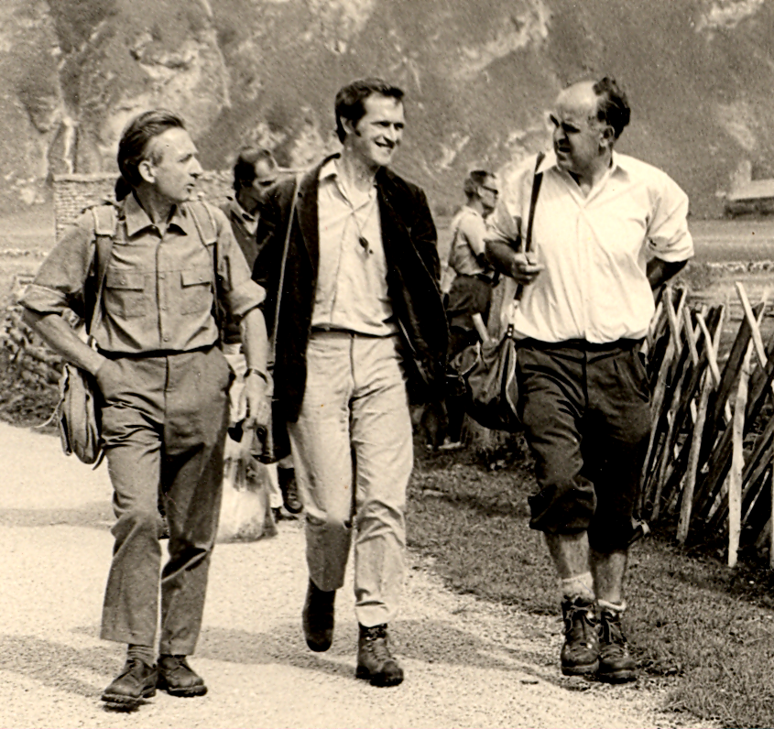

Figure 1. Peter James, the first President of IAL, together with Rolf Santesson and Josef Poelt, no doubt discussing lichens, during the first IAL excursion in the Alps, 1973. Photo: Hannes Hertel.

To the right is Josef Poelt then 49 years of age, the eminent lichenologist who at that time had recently started the last phase of career as professor of systematic botany in Graz, a position he would lead so brilliantly until his retirement in 1989. Poelt, who passed away in 1995, left us with an enormous amount of scientific material such as collections, publications and books, and above all his legacy via a number of now well-known pupils who have successfully carried on his mission.
In the centre of the picture is Peter James, then 43 years of age and on the peak of his career as an international lichenologist, being the first elected president of The International Association for Lichenology (IAL), and head of the lichen section in the British Museum (Natural History) at London. Peter, who began working there in 1955, was a founder member of the British Lichen Society in 1958, at which time he became the first Editor of The Lichenologist, continuing into the 1970s, and taking the journal from its humble beginnings to one of the leading international lichen journals of today. As editor he offered tremendous help to many authors, regarding both scientific content and the English language. Further evidence of his contribution to lichenology can be seen by turning to the acknowledgements of hundreds of papers by dozens of authors. Apart from the well-known New Checklist of British Lichens, his major contributions to Duncan’s Introduction to British Lichens and to both editions (1992 and 2009) of the Lichen Flora of Great Britain and Ireland, he has published on a wide range of topics, including cephalodia, the preliminary prospectus of lichen communities in the British Isles and monographs on Nephroma. Peter was primarily a taxonomist, but his enthusiasm for fieldwork, and field experience throughout the world, led to his involvement in much wider areas of lichenology, including ecology, phytosociology, lichen chemistry, pollution studies and conservation. He has always been a patient and effective teacher, not only to the several doctoral students that have come under his wing, but also to the scores of amateurs who have benefitted from his knowledge and enthusiasm during his many field courses and workshops at home and abroad. James was awarded the Acharius Medal in 1992, at the same time that Poelt and Santesson received theirs. On the occasion of Peter’s 60th birthday, he was honoured by his colleagues with a special volume of The Lichenologist edited by Dennis Brown. Peter James passed away in February, aged 83.
The first IAL meeting in the Austrian Alps became an historically important event in that not only were the three above-mentioned lichenologists present, but also many of those who attended, such as Irwin Brodo, Anna Crespo, David Galloway, Hannes Hertel, Klaus Kalb, Rosmarie Honegger, Marie-Agnes Letrouit-Galinou, Xavier Llimona, Claude Roux, Harrie Sipman, Ulrik Søchting and Volkmar Wirth, would in different ways contribute significantly to lichenology in the future.

Ingvar Kärnefelt

