THE ROLE OF TECHNOLOGY AND POWER IN ACHIEVING AGRICULTURAL CONVERSIONS TO SUSTAINABLE RICE TERRACE ECOSYSTEMS: A CASE STUDY IN BUAHAN KAJA, BALI
THE IMPLEMENTATION OF TECHNOLOGY BASED GOVERNMENT POLICIES AIDING IN AGRICULTURAL CONVERSIONS AND THE DEVELOPMENT OF AGRIBUSINESS

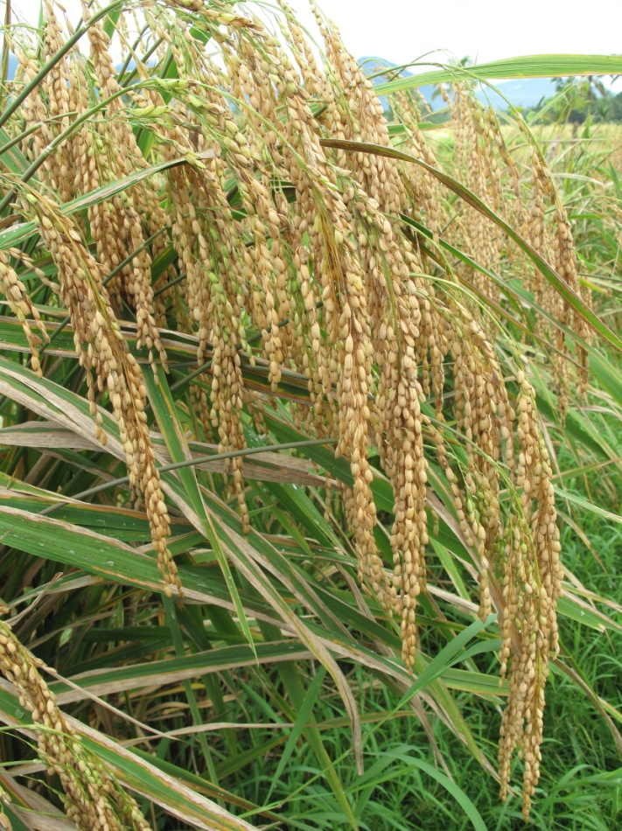
Degree of Master of Science (Two Years) in Human Ecology: Culture, Power, and Sustainability
30 ECTS

CPS: International Masters Programme in Human Ecology
Human Ecology Division
Department of Human Geography
Faculty of Social Sciences
Lund University

Author: Dani Elizabeth Craig
Supervisor: Ulrika Persson-Fischier
Term: Spring Term 2011

Human Ecology Division
Department of Human Geography

Address:
Geocentrum 1
Sölvegatan 12
223 62 Lund

Telephone: 046-222 8690

Supervisor: Ulrika Persson-Fischier

THE ROLE OF TECHNOLOGY AND POWER IN ACHIEVING AGRICULTURAL CONVERSIONS TO SUSTAINABLE RICE TERRACE ECOSYSTEMS: A CASE STUDY IN BUAHAN KAJA, BALI
THE IMPLEMENTATION OF TECHNOLOGY BASED GOVERNMENT POLICIES AIDING IN AGRICULTURAL CONVERSIONS AND THE DEVELOPMENT OF AGRIBUSINESS

Author: Dani Elizabeth Craig

Examination: Masters Thesis (Two Year)
Term: Spring Term 2011

Abstract

In, the Balinese Village of Buahan Kaja, BPTP (Assessment Institute for Agricultural Technology), a sector of the Indonesian concerned with research and technology, has implemented a program (Pri Mitani) which aims to (a) aid farmers in the conversion from conventional chemical based methods to organic, sustainable systems, (b) help farmers produce better quality produce that can be competitive on an international market, and (c) develop agribusiness and ecotourism to improve the village economy. The purpose of this study, using the framework of Political Ecology, was to explore the conflicting forces that affect farmers in their decision to convert to organic methods, the government’s motivations behind implementing such a program, the power structure upon which program is being implemented, and what this implementation structure means for agricultural sustainability, social organization. In doing so, this study answers the following questions: What are the goals of the current conversion program? Who are the actors involved in its development and implementation? What are the economic and ecological factors at play in terms of the farmers’ ability to convert to organic methods? How does the program attempt to account for these factors? How does this conversion program compare with that of the Green Revolution? Does the program promote agricultural sustainability? Data was collected through, interviews and review of government documents. By exploring the technology, power structure, and implementation strategies used currently and during the Green Revolution, this study has outlined the difficulty in making a distinction between local sustainable systems and modernized agricultural systems. This study found that (a) both local/sustainable systems and modernized systems require similar forms of technology (b) that technology that is necessary for farmers to convert to organic/sustainable agriculture and (c) the affect of technology on the sustainability of agricultural systems is influenced by the power structure on which the policy is implemented, the actors involved in its implementation, and the motivations of those actors. This study concludes that because (a) BPTP is proposing that it is through economic growth that technology can be developed and environmental issues be solved and (b) pressure to be competitive on the global market is allowing unsustainable values of consumerism to replace traditional sustainable human-environment relationships with unsustainable human-market relationships, the program will result in undesirable environmental impacts.

Table of Contents
- Cover Page ---------------------------------------------------------------------------------------------1
- Abstract -------------------------------------------------------------------------------------------------2
- Table of Contents -------------------------------------------------------------------------------------4
- Chapter 1: Introduction -----------------------------------------------------------------------------5
  - My Introduction to Bali
  - General Background
  - Research questions
  - Scope
  - Significance of study
- Chapter 2: Literature Review ----------------------------------------------------------------------13
  - The history of agriculture in Bali
- Chapter 3: Theory and concepts ------------------------------------------------------------------17
  - Ecological modernization
  - Technology and power
  - Sustainability
  - Political ecology: Theoretical framework
  - Research Methodology
- Chapter 4: Methods ---------------------------------------------------------------------------------23
  - Selection and description of site and participants
  - Data collection strategies: data needed and means of obtaining data
  - Data analysis strategy
- Chapter 5: Results -------------------------------------------------------------------------------------29
  - Implementation and Policy content
- Technology based on site specific economy and ecology
ii. Actors
iii. Technology
  - Forces influencing BPTP: Motivations behind the Pri Mitani Program
  - Adoption and diffusion
  - Demonstration plot: Difficulties with the program so far
- Chapter 6: Discussion --------------------------------------------------------------------------------39
  - Power structure
  - Implementation
  - Adoption and diffusion: The profit making motivation
  - Ecology
  - The role of rice in restructuring cultural and societal values
  - Conclusions
- References --------------------------------------------------------------------------------------------- 50
- Appendix 1: Tables and Figures -------------------------------------------------------------51
- Appendix 2: Photos ----------------------------------------------------------------------------52
Chapter 1: Introduction
a) My Introduction to Bali
I arrived in Bali from Canada in late October, 2010. The purpose of my visit was to intern at the Tri Hita Karana Permaculture Centre in Pajeng. Upon arriving, I met with Chakra Widia, founder of the centre and a permaculture specialist. As Chakra tourned the site with me, I shared my goals for the visit, learned more about the history of the Green Revolution in Bali, the principles of permaculture, and the organization’s projects. Chakra explained to me that the centre is named for an ancient Balinese philosophy, Tri Hita Karana or, three causes of goodness, which means to bring balance and harmony to our relationship with nature, others, and spirit (Chakra Widia, Personal communication, 2011). Chakra explained that by applying the ethics and technologies of permaculture to land use, social organization, and cultural events, the centre hopes to develop practical and balanced ecological and economic systems able to provide for human needs without harm to the environment. The goal of the organization, sustainable agricultural practices, is being realized in numerous projects that unite traditional Balinese knowledge and agricultural practices with permaculture –based technologies. Examples of these technologies and how the principles of permaculture have been applied to the centre’s land were seen as we walked the site. At Pajeng, a closed/sustainable system is supported by many elements. In this humid climate, nitrogen is sequestered from the atmosphere and fixed into plant matter. Fast growing nitrogen-fixing species are “chopped and dropped” directly into the garden and used as organic fertilizer. Biogas technology, whereby excess plant biomass is harvested and used for the production of cooking gas, is also utilized. One barrel, with a 1:1 ratio of water to biomass, produces gas for 8 weeks, after which the barrels contents can be used as fertilizer.

This was my first exposure to Balinese agriculture. I felt concerned to hear a rice farmer’s description of the harsh effects of the Green Revolution personally as well as on his community and how, at the same time, he had witnessed feasible and affordable solutions to the lingering problems of the revolution. This stimulated a lot of new questions for me: If there are feasible solutions available, why aren’t they being utilized? Is technology required for agricultural conversions? Why are chemical inputs still being used if traditional methods and seeds do not require them? Why do farmers, who are aware of the problems of chemical farming, still use HYVs and expensive chemicals?

I began my work with Chakra for on a project in Tabanan where an eco-resort was in the first stages of development and Chakra was working to apply permaculture technologies. These technologies included small micro hydro technologies, waste water gardens, aquaculture, and food gardens that will provide food, electricity, and waste recycling mechanisms to the resort. It is intended that a large percentage of profits from the resort will be given to the local village people. It was important to the project’s participants that the rice fields on the property be cultivated organically, and traditional rice strains be used. I worked with Chakra to conduct a seminar teaching farmers about the system of rice intensification (SRI). This system involves selecting the best seeds, planting fewer seeds further apart thereby reducing competition among plants and increasing production. Additionally, Chakra taught how fertilizer, termed MOL (local micro organisms), is made by fermenting plants that already existed on the property and so reduced input costs, and improved soil quality.

My experience with the project strongly influenced my thinking about sustainability in the intervening months it has become the basis of my own conceptualizations about effective sustainable systems. It also gave me a better understanding of the challenges that come with agricultural conversions and the oftentimes conflicting or competing interests and agendas of different actors that can inhibit change. Participating in these debates was important to my perceptions of rice farming in Bali and I noticed several common themes: (a) farmers had limited trust in western technology, (b) development goals, based on agro-business or eco-tourism were challenged by the conceptions of sustainability held by permaculturalists, (c) the Indonesian government was described as corrupt and open about their money making agendas and (d) technology plays an important role in current agricultural conversions in Bali.
As a result of my experiences with the Centre, my initial questions expanded and shifted: How do permaculture-based technologies differ from those being implemented by the government? Can a distinction be made between modern/technology based agriculture and sustainable or local agriculture? Is it possible for the government to have an honest and well intentioned program for improving the ecosystem and farmer’s livelihood? What is the role of tourism and agribusiness in funding conversion projects? I began to inquire about the government’s current role in rice farming in Bali. A review of the literature, the teachings of Chakra and roadside banners stating “Go Green 2010”helped to inform me of the government’s new interest in “green” agriculture. I wondered why, if the government was able to cause 90% of the island to convert to conventional methods in the 1960s, they couldn’t they do the same now with programs focused on sustainability? I also wondered at the basis for the government’s interest in organic agriculture; is it genuine or is it yet another scheme to achieve economic gain at the cost of environmental resources and farmers as was evidenced in the Green Revolution?

b) General Background for Study
Conceptually and empirically it is argued that the assumption of nature as a source of scarcity and technology as a source of abundance, leads to the creation of technologies which create new scarcities in nature through ecological destruction (Shiva 1993, 15).
Substituting nature with technology to produce growth that is not limited by nature’s thresholds has created new scarcities in Bali’s ecosystems. Seed technologies, developed by the International Rice Research Institute (IRRI) were implemented by the Indonesian government in the 1960’s and allowed rice production that surpassed limitations previously imposed in the paddy ecosystem. Instead of increasing the productivity of the land and strengthening the economy of Bali, the introduction of these chemically dependent “miracle seeds” deteriorated the ecosystem, social organization, and the culture-based land management institutions which were responsible for maintaining sustainable relationships between humans and their agricultural environment in Bali for the preceding 1000 years. The majority of Balinese farmers are still using the chemical requiring miracle seeds or high yielding varieties (HYVs) of rice since Padi Bali, the traditional strain of rice which only produces a single harvest per year, is not as profitable. They are struggling financially, however, because the price of chemicals has been increasing since 1990, and so has the amount they need to apply to maintain production.
Presently, the trend in Indonesian agricultural policy is the implementation of environmentally sound technologies (Mariyono et al. 2010, 134), moving towards organic practices and away from the conventional methods adopted during the Green Revolution. The use of technology to achieve agricultural conversion is a theme common to the goals of Tri Hita Karana, the Green Revolution, and to current government sponsored initiatives. The Green Revolution was utilized to “modernize” traditional agricultural systems so that farmers, governments, and fertilizer companies could make a profit at the expense of the ecosystem. Environmentally sound technologies are now being utilized to aid farmers in producing their own inputs and recycling outputs so that they no longer require damaging chemical fertilizer. The focus of this study will be the implementation of the Pri Mitani project in the Balinese Village of Buahan Kaja. Pri Matani is a program being implemented by BPTP (or in English AIAT, the Assessment Institute for Agricultural Technology) - a sector of the Indonesian Agricultural department in charge of agricultural research and policy on the island of Bali. This program aims to aid farmers in the conversion from chemical to organic farming, to “encourage the development of the village economy,” to “create a long term plan of village based agro business,” to “encourage investment in agro business and tourism,” and to “train farmers in how to promote produce and how to process the produce in a way that adds value” (BPTP Baseline document, 2010).
While Balinese farmers are open the help being provided by the BPTP program, they remain resistant to the conversion itself despite the poor quality of their soil and financial well being. The research questions in this study are designed to understand the conflicting forces that affect a farmer’s decision making trajectory: their motivations behind converting, and what holds them back from doing so. In a country where government corruption plays a obvious role in every-day life, I also wanted to discover the government’s motivations behind developing such a seemingly well intentioned program. The government receives a share of the profit made by Indonesian chemical fertilizer companies (Chakra Widia, Personal communication, 2010). I was constantly asking myself “What is in it for them? How could they promote organic farming and continue to make money from chemical fertilizer?” Lastly I wanted to learn from the farmer and government perspective, the experience of the Green Revolution. I wanted to understand the structure of power on which Green Revolution technology implemented, the role of technology in agricultural conversions, the role of technology in achieving unsustainable and sustainable systems, and how these characteristics of the Green Revolution compare to the Pri Mitani program.
A common theme that carries throughout this paper is that it is difficult to make a distinction between modernized agriculture and local/sustainable agriculture. In this case, the technology being implemented by BPTP and by Tri Hita Karana is almost identical to the traditional agricultural technologies used by the Balinese before the Green Revolution. Where these programs differ in part, is the power structure on which they are implemented and the motivations behind each program’s development. Both seem to be sustainable at the level of the ecosystem; however, when examined from political or economic perspectives, BPTP’s goals of sustainability and creating market opportunities and expanding the economy seem contradictory. I will thus focus on the close relationship between power and technology that first surfaced during the Green Revolution and remain to be influential, and what this means for farmers and sustainable agriculture.
c) The purpose of this study
Both the approach and topic of this study are relevant to the CPS program. The power of scientific discourse, government, and corporation in implementing agricultural policies has influenced social organization, cultural values, and changed the way this society interacts with the environment. These changes, in turn, have had consequences for sustainability. Instead of focusing on a single perspective or discourse based in agronomy or social science, this study will use a multi-disciplinary approach which allows analysis of the dialectic between political, ecological and social aspects of environmental change, and the way in which shifts in such dialectics transform the environment in different ways over time (Bryant 1992, 13). As Hajer describes:
We can differentiate between the features of environmental change that are problematized in distinct periods and try to explain these conflicts out of the interaction between physical change, changing social practices and specific social sensibilities. In that case we no longer analyze ecological problems but socio-ecological problems (Hajer 1995, 18).
The ecological affects of agricultural conversion has been the focus of a large number of agronomic studies, producing works which compare yield, soil quality, nutrient management, biodiversity, and greenhouse gas emissions between conventional and organic farms (Lamine and Bellon 2009, 97). As Lamine and Bellon explain, however, there are limits associated with comparative studies:
- “They do not really take into account either the interactions between management, crop varieties, and site specific effects, the externalities (environment, energy health), or the systemic properties (autonomy, resilience, stability)” (Lamine and Bellon 2009, 97).
- They fail to recognize the diversity of each unit of comparison which seems central to a subject that is influenced by so many factors such as government policy, ecological processes and social and economic motives (Lamine and Bellon 2009, 97)
Literature concerning the dynamics of the conversion process itself is scarce in the field of agronomy. Social scientists, on the other hand, have produced more on the process of conversion and farmer values/motives but often ignore the connection between farmers’ decision- making process, the functioning of the ecosystem (Lamine and Bellon 2009,102), and the forces which influence policy decisions on a larger spatial and temporal scale. The conversion to conventional methods in Bali has had direct and interconnected consequences on ecological, social, economic, and cultural systems and so understanding of it requires an interdisciplinary approach. New agricultural technologies must be implemented in a way that accounts for local agro-climactic and local cultural conditions, versus the universal adoption of conventional methods that was fostered in the green revolution. A single agricultural technology cannot be suitable for every economy, soil, culture or society. The purpose of this study, then, is to understand how and why agro-technologies are implemented and the consequence of these technologies on social, economic, and environmental systems over time.
d) Research Questions
This study explores the following questions:
1. What are the goals of the current conversion program?
2. Who are the actors involved in its development and implementation?
3. What are the economic and ecological factors at play in terms of the farmers' ability to convert to organic methods?
4. How does the program attempt to account for these factors?
5. Does the program promote agricultural sustainability?
6. How does this conversion program compare with that of the Green Revolution?
e) Scope
A case study of Buahan kaja will allow examination of the implementation of Pri Mitani, and role of biotechnology in agricultural policies and conversions. To understand the features of environmental change from a socio-ecological perspective, this study will examine the influence of political, ecological, economic and social forces on decision making on two scales: firstly the decisions made by the government and secondly the decisions made by the farmers. This method helps to account for the fact that decisions of this nature entail several related and interacting motivations, aimed towards the farmer’s rationale for their actions (Lamine and Bellon 2009, 102). Additionally it will contrast decision making on both scales for the agricultural transitions of the Green Revolution in the 1960’s, as well as the current agricultural transition occurring in Buahan Kaja. The findings of this study could be applied or are relevant to other Pri Mitani programs being implemented in Bali by BPTP. BPTP has other demonstration plots in Northern Gianyar and Tabanan which have been converted to organic fruit and vegetable production systems. The Indonesian government has provided funding for the development of 40 Pri Mitani programs in 2010, and hundreds in 2011 (Ketut, Personal communication, 2011). In addition, conversion and consequence of the Green Revolution remains relevant to the livelihood and land of most Balinese farmers.
f) Significance
Inquiries into historical and current agricultural conversion aid in an understanding of economic, ecological and social consequences resulting from technology-based policies and programs and how powerful institutions, using the discourse of ecological modernization, are able to replace traditionally managed systems and aid in the conversion to sustainable systems. Additionally, this study will contribute to understanding how such programs could be better implemented to improve the livelihood of farmers and the sustainability of the ecosystems upon which they rely. This analysis will help determine whether environmentally conscious technology based programs are an improvement over Green Revolution policies in achieving sustainable rice agriculture. It brings to question the distinction between modernized and sustainable agriculture.
Additionally, the urgency of current global environmental issues such as climate change and overconsumption of environmental resources require transformations of conventional agricultural systems, as they are major contributors to these issues. Conventional methods depend on externally sourced chemical fertilizers and pesticides, thus producing more environmental damage and fossil fuel emission than do organic or regenerative systems (Pearson 2007, 412). Using regenerative systems, the impact of agriculture can be limited to the farm: instead of extracting resources for fertilizers from external environments, importing them and applying them, energy for the system is provided by the system. This benefit is becoming increasingly essential due to the rapid development of tourism and the close proximity of agricultural and social systems. The conversion to organic based regenerative farming methods will create greater carbon sinks and so address climate change. They will also help to decrease the amount of chemicals in the ground water and irrigation systems thus decreasing the impact of agriculture on surrounding ecological and social systems (Pearson 2007, 412). Contribution to how this might be achieved, or to why it is not being achieved seems valuable.
Chapter 2: Literature review
a) The history of agriculture in Bali
The traditional management of rice agriculture has maintained sustainable production on Bali’s terraces for the past 1000 years. The Balinese 210 day calendar is based on social, cultural, and environmental cycles and helps to coordinate these cycles (Lansing 1991, 12). The calendar is designed for the planting of Padi Bali, the local strain of rice, which has a growing season of 6 months thus allowing up to two harvests a year. The most important ceremonies fall on the same days as rice planting and harvest; these days are selected by priests of water temples based on rainfall, lunar, and ecosystems. These priests are the coordinators of irrigation for every village, and must cooperate with one another to ensure that all subaks, groups of farmers who rely on the same water source, receive water on a day which compliments their stage in the harvest cycle. Cooperation between water temples and priests thus links every subak on the island, as almost all water is sourced from the volcanoes and must be efficiently shared as it flows to the sea. Steven Lansing describes the importance of irrigation coordination to the terrace ecosystem:
Controlled changes in water levels create pulses in several important biochemical cycles. The cycle of wet and dry phases alters soil ph, induces a cycle of anaerobic ad aerobic conditions that determines the activity of microorganisms, circulates mineral nutrients, fosters growth of nitrogen fixing algae, excludes weeds, stabilizes soil temperature, and over the long term governs the formation of a plough pan that prevents nutrients from being leached into the sub soil (Lansing 1991, 39).
Irrigation management is also important for pest control. Flooding, or fallowing fields to deter pests between harvests must be done over a large geographical area at a time which does not interfere with the harvest of neighbouring subaks. If this is not coordinated properly, all pests inhabiting flooded fields would simply travel to nearby fields where rice is ready to harvest and have large, undesirable effects on production.
Every farmer thus depends on water for the functioning of their terrace ecosystem, for irrigation and for pest control. All things have direct influence on the success of rice production and thus whoever has power over the temple has power over rice production. Lansing observes that this network of temples seems to function as institutional structure. Lansing also points out that water temples play an important role not only in water and biological management, but in maintaining the traditions and human-nature relationships (Lansing 1991, 125). A culturally based management system, then, has been the base of sustainable agriculture in Bali for centuries. Not only did Balinese society depend on rice production, but the terraces of rice production, being a constructed ecosystem, depend on the particular human labour provided by Balinese society and culture (Lansing 1991, 12).
Rice in Indonesia is thus more than an important staple food which provides subsistence for millions of people; Rice is the foundation of Balinese ceremonies, social organization and the base upon which sustainable human-environment relationships rely. Its importance to both the people and economy of Bali make rice a politically strategic commodity with the potential to create abundance or insecurity (Mariyono et al. 2010, 128). It the position and value of rice that stimulated government policies in the late 1960’s; policies that sought self sufficiency in grains in the hope that it would result in economic benefits for businesses in Indonesia (Lansing 1991, 111). This campaign, the Green Revolution, was an international campaign, developed by international research agencies and corporations to increase the productivity of land using western technology (Bardini 1994, 154). The actors included Daniels, the US ambassador to the government of Mexico, Henry Wallace, the Vice President of the USA, the Rockefeller Foundation, the Mexican government, and Norman Borlaug, the scientist who invented the miracle seeds (Shiva 1993, 37). Trans-national corporations (TNCs) played an important role as the producers and suppliers of fertilizers and machines: “Wherever the seeds went they opened up new markets for chemical fertilizers” (Shiva 1993, 105). Shiva provides the following quote by Borlaug which exemplifies the strength of cooperation between these institutions in a speech he gave to diplomats and politicians in the Indonesian government while promoting HYVs:
If I were a member of your parliament I would leap from my seat every fifteen minutes and yell at the top of my lungs: ‘Fertilizer! Give the farmers more fertilizers. (Borlaug cited in Shiva 1993, 43)
The strategy for implementation was based on three things:
- Replacing Padi bali with HYVs: HYVs have a shorter growing cycle can thus be harvested 2-3 times a year versus Padi Bali which produces 1-2 harvests per year. Additionally, genetic modifications allowed more energy to allocated to the grain that the stock.
- The implementation of BIMAS (Massive Guidance) funded by The Asian Development Bank: A program designed to increase rice production through improvement in irrigation management.
- Government subsidies provided by BIMAS to reduce the cost of fertilizers: Inputs of chemical fertilizer provided more energy to the soil for the plants to allocate to the rice grain.
After receiving profits from offshore oil in the 1960’s, The Indonesian government invested in development of bureaucracies that would soon function in implementing the Green Revolution policies (Lansing 1991, 111). Justified by the BIMAS program, bureaucracy took power away from water temples, considering them a primitive management system and recruited the help of hydrologists to improve irrigation management. Instead of using the traditional Balinese calendar and subak schedule to plan the best planting and harvesting dates, extension workers were employed to ensure that each subak was planting HYV’s continually (Lansing 1991, 3). By decreasing diversity in the terrace ecosystem and implementing centralized management systems the new technology of the Green Revolution had many unanticipated effects on social organization and ecological systems in Bali (Shiva 1993, 24).
In Globalisation and the Race for Resources, Bunker and Ciccantell (2005, 27) argue that new technologies require new forms of social organization in order to expand access to material and land. This point helps to explain why it was necessary for the government, in its “rehabilitation of bureaucracy”, to employ workers who would ensure that the farmers were cultivating the land in the most productive way possible. There were legal penalties for farmers in Bali who maintained traditional methods, and I heard many stories of farmers being killed in Java for failing to follow government direction. Through these workers, the government had control over each farmers land use. By taking power away from the water temples and giving power to international research institutes and corporations, the government denied a voice to the priests of the water temples and their culturally based knowledge because these priests could not communicate their understanding of nature, relationship with nature, or experience with nature in a language that the bureaucracy would understand (Lansing 1991). This, inevitably, had huge consequences to ecosystems and the relationship between the Balinese and their land.
While traditionally, excess or unused biomass was frugally recycled as fertilizer or livestock feed to naturally regenerate the agricultural system, externally sourced chemical inputs are now leaching into the water table and irrigation systems causing extreme environmental contamination (Pearson 2007, 409). Important food sources like fish and eels are no longer able to survive in this polluted ecosystem. Without organized irrigation schedules, farmers are left without their main method for pest control. Additionally, HYV’s are not resilient to local insects, and outbreaks of pests and disease caused considerable production losses shortly following the implementation of Green Revolution policies. Because the government continued to prohibit the planting of Padi Bali following these production losses, the farmers became dependent on the IRRI for developing new pest resistant strains following each new pest outbreak. Farmers also became reliant on the supply of inputs from chemical fertilizer corporations to support the production of their crops. Purchase of chemicals for inputs, and the latest in seed technology put financial strain on farmers. This impact could not be compensated by an extra harvest every year. Lastly, increasing chemical use is brining negative health effects to farmers and their families (Mariyono et al. 2010, 129)
This is the story of Bali: how the transfer of power from traditional institutions to bureaucratic systems led to damage of entire ecosystems and losses in production resulting from the implementation of western technology. Although farmers and the government may have received financial benefits after initial increases in rice production, this technology based policy implementation has resulted in extreme degradation in terrace ecosystems and social structure and the economy.
Chapter 3: Theory and Concepts
a) Ecological Modernization
In The Politics of Environmental Discourse: Ecological Modernization and the Policy Process Maarten Hajer (1995, 26) defines the discourse of ecological modernization as one that, through policy, is able to ‘internalize’ care for environment, conceptualizing problems in terms of monetary units and scientific knowledge. He also explains that this discourse relies on the concept that economic growth should not only continue, but the growth itself will aid in the development of green technologies that will solve environmental issues (Hajer 1995, 26). Hajer has also explained how this discourse has become the most dominant way of discussing environmental solutions through policy making. He theorizes the following:
Governments are well aware of their functional dependency relationship with business and generally realize that calling halt to environmental degradation would normally involve imposing restrictions on industry. Ecological modernization, however, uses the language of business and conceptualizes environmental pollution as a matter of inefficiency[…]ecological modernization suggests that recognition of the ecological crisis actually constitutes a challenge for business. (Hajer 1995, 32)
According to the discourse of ecological modernization discussed by Hajer, solutions for the crisis can open up new markets, and new demands through innovations in biotechnology and in so doing provide economic benefits to participating companies and governments. By implementing technologies and hoping to strengthen the economy by creating new eco friendly markets in Bali, the Pri Mitani program will likely provide benefits to the companies involved with agro business, to the government, and also to the farmer. Creating new markets and economic growth, however, will lead to further environmental resource extraction and detract from any sort of sustainable ecosystem the program result. The case of Pri Matani in Bali points to a contradiction that is central to the concept of ecological modernization.
b) Technology and Power
To understand how the discourse of ecological modernization has become dominant, Hajer looks to the relationship between science, politics, and power. In her book The Violence of the Green Revolution (1993, 21) Vandana Shiva provides fruitful insight into the applicability of Hajer’s theory to this study. Science, although socially constructed, is often considered to be politically and socially neutral. However, technologies are often produced, however, through the cooperation of research institutions and corporations who do have political agendas (Shiva 1993, 21). In other words, the agendas of corporations or government agencies, backed by the legitimacy of science, are given power which allows them to transform the organization of society and nature in a way that benefits their own needs; in the context of this study, through the use of ecological modernization. It is because of the power and hegemonic nature of this discourse that governments have been able to introduce technologies without taking responsibility for the consequences of such transformations or addressing the issues of sustainability which are affecting farmers or ecosystems directly (Shiva 1993, 21).
In terms of agriculture, technological changes have been made to facilitate increases in crop production by removing the limits to productivity imposed by the ecosystem and replacing ecosystem services (Cabezas et al. 2005, 280). Although technologies are capable of imitating or improving certain aspects of natural ecosystem services, replacement of natural systems with cost and resource requiring systems comes with consequences not only to the environment but to social organization (Cabezas et al. 2005, 280). Actors such as government policy makers often ignore traditionally produced management systems, and in so doing, allow negative unanticipated side effects of implemented technology to affect these local systems. By using technology governments can enhance their power over matter and space and as a result, enhance power over the groups and environment which encompass that matter and space (Bunker and Ciccantell 2005, 27) without having to take responsibility for such side effects.
A major technological innovation in the agriculture industry has been the genetic modification of crops. Hybrid varieties have increased production capacity (Sassenroth et al. 2008, 287). However, there are consequences to ecological and social systems, however, resulting from the utilization of such an approach which include the following: (a) An increase in energy and resources required to build and maintain the social organization which enables the technology to function(Cabezas et al. 2005, 280), (b) increased environmental degradation as a consequence of increased resource extraction (Sassenrath et al. 2008, 286), (c) increased dependency on those environmental resources (Sassenrath et al. 2008, 286), and (d) increased dependency on technology for production (Sassenrath et al. 2008, 286). The power of production is thus taken away from farmers and put into the hands of the corporations and research stations that have developed and implemented the technologies. Lastly, this approach does not, of course, address the structure and nature of capitalism that has caused the environmental crisis in the first place.
c) Sustainability
This study will use Pearson’s definition of regenerative, semi closed systems: those which are designed to minimize both external inputs and external impacts of agricultural practices outside of the farm. For example, an open system would use excessive amounts of fertilizer, which leaks into the subak and water table and creates health problems and effects downstream environments. A closed system would use on-farm biomass for fertilizer and recycle waste so that external impacts are minimal. I would also like to distinguish between two main conceptual paradigms of organic farming that have been developed in the literature: (a) An input substitution paradigm, and (b) a system redesign paradigm (Lamine and Bellon 2009, 103). The first step towards a stable conversion is increased efficiency of input use, followed by input substitution or the replacement of agrochemicals by less environmentally harmful ones. The final stage of conversion is system redesign which is a transformation of agro-ecosystem functions and structures so that all inputs required for the system are produced by the system itself (MacRae et al. 1990). Also relevant to this study is the definition of sustainability from a permacultural perspective. In A Permaculture Guidebook from East Timor, Lachlan McKenzie defines permaculture as the combination of permanent agriculture: “Agriculture and animal management that improves the land, provides income and produce,” and permanent culture: “Working with, protecting and encouraging strong culture […] working with nature and people, learning from them, not against or in competition with” (2002, 2).
d) Political Ecology: Theoretical Framework
In order to analyze the different actors, temporal scales, spatial scales, and incorporate the diverse disciplinary approaches required in the answering of these questions, this study utilizes a framework of political ecology. Blaike and Brookfield (1987, 17) define this field as follows: “The phrase political ecology combines the concerns of ecology and a broadly defined political economy. Together this encompasses the constantly shifting dialectic between society and land based resources, and also within classes and groups with society itself.” By tracing such dialectics through time, this framework is also able to (a) connect historically relevant processes with current ones in order to provide context to current environmental issues, and (b) to explain the consequences of these constantly shifting dialectics on natural resource use. Because of its inclusive nature, it will allow the identification of diverse forces acting on both farmers and the government in Bali, help to describe how these forces interact, and how this complex interaction changes over time to effect the environment and thus contribute to environmental change.
e) Research methodology
[C]oncepts and theories are constructed by researchers out of stories that are constructed by research participants who are trying to explain and make sense out of their experiences and/or lives, both to the researcher and themselves. Out of these multiple constructions, analysts construct something that they call knowledge. (Corbin and Strauss 2008, 237)
While considering my choice in methods, my goal was to collect stories from farmers and government members and express them in a way that showcased the complexity of issues in Balinese agriculture. Due to the number of actors, the diverse set of motivations from which each is acting, and the multi dimensional nature of the study questions, I feel that it is important to “recognize that the issue […] has many dimensions and layers, and so try to portray the issue in its multifaceted form” (Corbin and Strauss 2008, 237). It was this goal which led me to use a qualitative approach to answer my research questions. In the paradigm of qualitative research, epistemological conceptions are based on the idea that human phenomena are best understood by their observation in the context they occur. The construction of knowledge is then based on the interpretation of human phenomena by people living in the context under study. “These interpretive acts of meaning lie at the heart of what is to be understood through qualitative, interpretative research” (Piantanida and Garman 2009, 52). By interpreting knowledge claims, the researcher attempts to construct concepts or ideas that can be applied beyond the context of the case. Moving from the specifics of a given situation to developing concepts and theories requires the researcher to make assertions. Stake describes it this way: “For assertions, we draw from understandings deep within us, understandings whose derivation may be some hidden mix of personal experience, scholarship, assertions of other researchers” (1995, 12).
It is the interpretations of the claims made by participants in this study on which I develop my own assertions – assertions about the phenomena occurring in this case and what this case can contribute to understanding the role of technology in sustainable agriculture, the discourse of ecological modernization in a ‘third world’ context, characteristics of agricultural conversions, and the actors involved.
Concerns for objectivity challenge interpretive research. Although it was of benefit to me to gain insight into and sensitivity to the role of the government and of technology in Balinese agriculture through my work there prior to beginning work with my own case study, I also acquired a number pre-conceptions about interactions between farmers, technology and the government. I also felt predisposed to empathize with the situation of the farmers in Buahan Kaja and question the intentions and work of government officials. Although this observation is worrying, Guba and Lincoln (1998) make the following point:
Today we all know that objectivity in qualitative research is a myth. Researchers bring to the research situation their particular paradigms, including perspectives, training, knowledge, and biases. These aspects of self then, become woven into all aspects of the research process. (Guba and Lincoln 1998 cited in Corbin and Strauss 2008)

We rely on past experiences and knowledge to express ourselves, and as suggested by Hajer, these “images and discourses should themselves be included in our analysis” (1995, 16). In the opening chapter I describe my introduction to Bali: how I acquired knowledge of the issues addressed in this study, the actors who shaped my understanding of these issues, the progression of the development of my research questions, and the assumptions/biases I held before beginning my research. Experience with an issue, working with people who are concerned about an issue, and/or are invested in the outcome of an issue will inevitably generate bias ones perceptions while simultaneously generating a more intimate understanding of the issue itself.

Grounded theory, structured so as to begin from the data and build towards conceptual and/or theoretical levels, offered a means of stepping away from my preconceived notions. This is a form of instrumental case study (Stake 1995) such that the case is used to gain an understanding of something beyond the case itself and to inform as to a particular phenomenon, concept or theory. When used to construct theory, grounded theory methods guide “the investigator [to consider] the case as a device or set of findings to be applied beyond the case being studied” (Lapan and Quartaroli 2009, 167). Data collection relies on interview, observation, historical records, etc. and “the only restriction is that the data collection must include the perspectives and voices of the people being studied (Leedy and Ormrod 2010, 140). Grounded theory also provides methods of data analysis. Some experts argue that data analysis should be carried out using specific, structured steps while others take more flexible approaches. All grounded theorists share the common claim that the exploration of related literature should not be used to develop conceptual frameworks or theories. Instead it should be used to build rationale or describe a context. Only after theoretical concepts have been drawn from the data are related theories examined for comparative purposes and for their relation to the developed or emergent theory (Leedy and Ormrod 2010, 141-142). The theories and concepts in ecological modernization, sustainability and policy implementation outlined above are used in this study to outline and understand the issues of this case and will be applied in the discussion to relate the findings to what is known in the literature. It was important for me to develop a deeper understanding of my research questions through the voices of people embedded in the case. I will thus rely on the perspectives of the farmers in Buahan Kaja, members of BPTP and experts, like Chakra, to answer this study’s research questions.
Different forms of grounded theory method arise from two somewhat distinct approaches: objectivist and constructivist. The objectivist perspective sees data as a real and external entity, the meaning of which is inherent in the data and so is there to be revealed through data collection and analysis. As described by Charmaz “this perspective assumes an external reality awaiting discovery and an unbiased observer who records facts about it. Objectivist grounded theorists believe that careful application of their methods produces theoretical understanding (2003, 314). Alternatively, the constructivist approach views both data and analysis “as created from the shared experiences of researcher and participants and the researcher’s relationships with participants” (Charmaz 2003, 314). Charmaz’s view lies within the constructivist stance based on the assumptions that there are multiple realities, that the data are a result of mutual constructions between the researcher and participants, and that there is an interplay of affect between the researcher and participant. Charmaz states:

This approach explicitly provides an interpretive portrayal of the studied world… The researcher aims to learn participants’ implicit meanings of their experiences to build a conceptual analysis of them. A constructivist approach takes implicit meanings, experiential views, and grounded theory analyses as constructions of reality. (2003, 314)
A constructivist approach is particularly applicable to this study as it allows for a full and open hearing of all of the participants’ voices. Each participant’s reality is unique and each informs the whole picture.

Chapter 4: Methods
The methodological approach relied on is case study. It allows for the incorporation of a wide variety of evidence (documents, interviews, and observations) and to overlap with historical methods to provide full context to a contemporary set of events (Yin, 2009). I have focused on the use of two methods, interviews and document analysis. Semi structured interviews allowed participants, both farmers and government members, to describe current and historical agricultural issues. The examination of BPTP’s documents which explain and justify the Pri Mitani program, helped to clarify and substantiate the outcomes of the interviews. This was of particular importance because of the language barrier that influenced the interviews.
a) Selection and description of site and participants
Chakra Widia introduced me to the sites and participants relied upon in this study. Language and cultural barriers caused me to rely on Chakra to help me to identify important actors involved in this case. Whenever I asked Chakra to help me to locate particular actors, he did so without hesitation. At no time did I feel that he was coercing me in the process of identifying and interacting with the agents and actors I needed to best inform this case
.
Chakra began by introducing me to a member of BPTP named Ketut, who he had conducted a SRI training project the previous year. During my first interview with Ketut at the BPTP offices, I learned about the many Pri Mitani projects he implemented throughout Bali, one of which was the project in Buahan Kaja. BPTP began working with the farmers of Buahan Kaja in 2009 meaning that they were in the beginning phases of conversion. At that time, the members of the demonstration plot had reduced chemical use by 50%.

The participants that I selected for this study were members of this group of 120 farmers led by Made Jengut in the Balinese Village of Buahan Kaja, and a group of government officials, members of BPTP involved with this project. The unit of analysis used was the agricultural conversion of one group of 120 farmers based in a geographical area of 100Ha. These farmers are part of a single subak, an area in which farmers, influenced by a subak leader, share a single water source and thus follow the same schedule for planting dates, harvest dates, and use the same strain of rice. The embedded units, or sub units of this case are two groups of farmers distinguished by the level of government control/influence each is under. The first group of farmers have given control of their land (10ha and 20 famers) to BPTP who intends to help them convert from chemical to organic farming after four harvest cycles. This area has been named the demonstration plot, and BPTP hopes that it will function to show the effectiveness of organic farming to neighbouring farmers. Through successful transition, that is, one in which production is maintained at levels equal to or greater than pre-conversion production, BPTP hopes to stimulate conversion in neighboring farms. To aid farmers in this conversion they have built shelter for and purchased 20 cows which produce manure for fertilization, built technology for the processing of biourine to be used as an organic pesticide and liquid organic fertilizer, and built storage for the drying of cow manure. In times when the organic fertilizer produced on the farm is not sufficient, BPTP provides farmers with subsidized organic fertilizer. They have also provided these farmers with conferences to educate them in the application these technologies. The second group of 100 farmers, inhabiting 90ha of the subak, are in communication with BPTP but do not receive support in terms of financial aid and technology. This group of farmers continues to rely on chemical fertilizers to support rice production. Further embedded units for each group are the forces (ecological, economic, and political) which affect them.
c) Data collection strategies and sequence
I met with Ketut at the BPTP offices in Denpasar. During our first interview he described the project in Buahan Kaja. I learned from him that the aim of this program, I learned, is to aid farmers in the conversion to organic rice agriculture using technology. All members of BPTP seemed excited at my interest in their project and took a lot of time to speak with me and provide me with reports and documents about the site.
One week later, a member of the BPTP drove me to the village and introduced me to Made Jengut, the head farmers and subak leader for this village. Made worked closely with BPTP and the farmers on this project.
After this, interviews with BPTP and Made’s farmers were held separately. I travelled on my own with a translator to meet with farmers in a hut that functioned as the subak’s meeting place; here I presented my interview questions. Each group of farmers, members and non-members of the demonstration plot, were represented by a sample of five farmers selected by the subak leader. Group interviews were held with each sub unit separately. Interviews with the subak leader occurred on several occasions as well as with the leader of farmer meetings for this area. This helped me to gain an understanding of what other subak leaders in this region thought about the BPTP program and the state of rice farming in Bali. Whenever something was unclear or required verification, I would drive to the BPTP offices and meet with Ketut . All other interviews and data sources provide context. Interviews with Chakra were held at his home in Ubud. Depending on the nature of the communication, some interviews were recorded and transcribed manually, while others were roughly noted during the interview. This data is expressed as textual references to support other findings
The interview topics were aimed at addressing the following issues:
- In relation to BPTP: the motivation behind the program; progress of the program (stage of conversion, production results, etc.); their relationship with farmers; how they gain access to farmers land; site selection; BPTP’s present relationship with the farmers of Buahan Kaja; how they perceive government relations with farmers during the Green Revolution; financial benefits of the program; funding; technologies implemented; potential or current problems encountered;, and definition of successful implementation.
- In relation to the economic forces acting on them: costs of organic and inorganic methodologies such as fertilizer purchase, fertilizer production, labour hours, labour cost, seed cost; cost of rice on market; market or personal use (i.e.,whether the rice is sold or kept for substance); and cost of agricultural technology; animal husbandry; and, the trends of all forces from 1960 – present.
- In relation to the ecological forces acting upon farmers: soil quality, production trends, water quality, and ecosystem production (in terms of other food sources).
- In relation to the political forces acting upon farmers: regulations on rice strain and farming practice, subak restrictions, financial aid, and government-farmer relations
- In relation to historical forces: political policies, ecological systems, and economic events of the past that may influence farmer’s present decision making since the agricultural conversions that took place during the Green Revolution.
Other sources of data included a selection of newspaper articles in which farmers spoke about the effects of the Green Revolution on their land, society and culture; documents presented by BPTP describing the motives behind the project, policy statements, the types of technologies they planned for, their implementation strategy; and baseline statistics concerning the initial financial and ecological state of the village were translated by Chakra Widia and utilized to support and or dispute claims made by BPTP during interviews.
d) Limitations
The translator used on all occasions was Sangtu Patricia, who is a Balinese botanical specialist that I worked with during my internship. Sangtu is very informed on the topics of this study; however, his English is not fluent which led to difficulties in achieving in depth, detailed communications with the farmers. Additionally, Sangtu went into interviews with his own preconceptions concerning government programs and the state of agriculture in Bali and could have made selections on what was and what was not relevant enough to translate. Misunderstandings during interviews in English were avoided but inevitably occurred from time to time. The farmers selected for interviews were not selected at random. Rather, participants were selected by Made which may produce a biased expression of farmers’ opinions. Lastly, during group interviews it was common that certain farmers would be more vocal about their opinions while others would rarely contribute, thus complete representation of all voices was not achieved.
e) Data analysis strategy
In order to address the central questions of this study, it is important to use a framework which supports the analysis of policy implementation in environmental and social change. In Bali agricultural transformation is and has been closely tied to political agendas, and analysis of such issues requires an understanding of both political and ecological systems. Bryant (1992, 13) describes the features of applying political ecology in a so called third world environment: “the contextual sources of environmental change, conflict over access, and the political ramifications of environmental change.”
After developing a specific understanding of forces, such as technology, that have caused change in human-environment interactions in the context of Bali, research can expand in scale and address the role government program/ policy implementation influenced environmental change and the role of national and multi-national forces (Bryant 1992, 14).
Biotechnology is often researched and developed in this multi-national context, driven by profit seeking institutions on the stage of global capitalism. Cooperation between TNCs, research institutes and the state have had a strong hand in guiding state policies, especially when considering agri-business and its development of biotechnology (Bryant 1992, 17). Through promotion of the biotechnologies which do not respect ecological limits of agricultural systems, these multinational forces can be responsible a large portion of environmental change. It is thus important to identify and understand different pressures which are acting on the decision making process of actors involved in policy making, for present and previous policy implantations to understand, on a broader time scale, the different ways that policy has influenced agriculture over time (Bryant 1992, 17).
It is not only important to look at the forces responsible for a given policy or the content/type of technology associated with a given policy, but also to look at the structure through which a policy is implemented. In analyzing policy implementation, Bryant (1992, 19) suggests focusing on the following issues: the role of corruption, the achievement of bureaucratic structures on managing local systems, the pressures acting on local government officials, and the origin of these pressures. Lastly, in understanding the way a policy will affect an agricultural system, it is important to look at how the content of the policy, the technology, was adapted and diffused among farmers focusing on their own decision making trajectories over time rather than focusing singly on the government’s (Pray 1981, 126).
After developing an understanding of environmental change that has occurred in local system since the onset of the Green Revolution, this framework allowed for an expansion of scale in order to facilitate the understanding of how interactions between TNCs, research institutes, and national governments influence the content of government policy and its implementation structure. It also provided theory for understanding the role of technology in policy and the consequences of technology in ecosystems. Analysis of a variety of scales, and concepts supported this study to determine the success of the government program in Buahan Kaja. Focus on these scales and concepts also supported me to compare current policy decisions and implementation strategy with those used during the Green Revolution. In revealing the downfalls of the Green Revolution, a comparison helped to determine the potential successes or downfalls of the BPTP program in Buahan Kaja in terms of achieving sustainability. It also helped to showcase the history of forces that have affected agriculture in Bali for the past 5 decades and the ways these forces have transformed ecological and social systems. Lastly, this analysis helped to determine whether converting from policies implemented during the Green Revolution to environmentally conscious policies will result in sustainable ecological systems. Based on theories and concepts listed in previous sections, this study first looked at the main actors involved in the conversion in Buahan kaja including farmers, BPTP associates, the Indonesian government, and national and multinational companies. I then looked at the influences these actors had on the content of Pri Matani, the technology implemented, its implemented, and the adoption and diffusion of Pri Matani among farmers. I then compared these characteristics of Pri Matani with the policy content, implementation strategy and consequences of the Green Revolution.
Chapter 5: Results
The purpose of this chapter is to summarize relevant information collected in the field in order to understand how the implementation of government programs and policies affect agricultural conversions. Examine are the ecological and economic characteristics of Biahan Kaja Village accounted for by the Pri Mitani program, the project aims, the actors involved, the role of technology, motivations on BPTP’s behalf behind development of the program, and forces which influence adoption and diffusion of the program/agricultural conversion among farmers in this village.
a) Implementation
i. Technology based on site-specific economy and ecology
In 2007, BPTP first met with the farmers of Buahan Kaja to learn about their activities and problems that were happening with their land and with rice production and to see if there was potential here for developing Pri Mitani as a demonstration site. In a village-based survey, BPTP met 30 farmers and sought to understand how families live on ‘an economic and household level.’ They looked at things like the geologic profile of the location, the state of local resources, how farmers were trading and harvesting, sources of income, main expenditures, the dominant farming activities, the types of produce being sold (BPTP Baseline document, 2010).
In this study, BPTP notes some of the challenges predicted with implementing the project in this village. These include sandy soil, high elevation (slower growth), and sloped land (BPTP Baseline document, 2010). Justifications for selecting this village were that they have their own clean spring water source, and the soil has a high level of fertility that was not being maximized. The fact that every family owns at least 2 cows convinced BPTP that there was a very good potential for the integration of animals into the farming system.
BPTP then developed a policy and selected technologies to mitigate the problems that farmers in this area were encountering. As the main source of income for 90% of families is from rice production, the soil had potential to be cultivated more efficiently, and all families own livestock, BPTP decided that implementing organic fertilizer production technology would best develop the economy. BPTP and Penyuluh Pertanian Lapangan (PPL) - extension workers from the local government - were sent to train and support farmers in achieving the project aims.
According to BPTP’s baseline study, farmers in Buahan Kaja “have a weak bargaining position because[…] they are not interested in marketing aspects and the price of the commodity is fluctuating creating confusion among farmers” (BPTP Baseline document, 2010). In order for this project to be implemented properly, BPTP determined that farmers must improve their understanding of the market on a local and global scale so that the quality and price of their produce would be competitive. BPTP proposed to do so by holding farmers’ groups meetings, and so create a network to facilitate communication about growing and marketing Biofarmica products. Farmers’ groups are currently working in operation with a field trainer from BPTP leading the discussions.
In the policy description documents and in interviews, BPTP members and farmers have reiterated the importance of using a step-by-step process to avoid production losses. It was determined then that farmers in the demonstration would use HYVs and chemical fertilizers until their soil quality increased to the point where it could support production from organic input only. The plan was that after four harvests, HYVs would be replaced with Padi Bali and the inputs would become 100% organic ad support the village to develop eco tourism and agribusiness. The agribusiness and ecotourism was seen as important to both BPTP and farmers as a means for farmers to get higher prices for their products and stimulating the Balinese economy. The farmers of the five subaks in Buahan Kaja Village received subsidized organic fertilizer (Wayan Sandiasa, Personal communication, 2011) and BPTP provided information about each step of this process to all farmers of the subak.
Currently, the members of the demonstration plot are responsible for most aspects of production. BPTP hopes that the diffusion and adoption of Pri Mitani will be accelerated by their use of the demonstration plot because it is being implemented in such a way that farmers can avoid production losses and see the results first hand; “Technology that is generated at the farm level can be understood, internalized, and implemented” (BPTP Baseline document, 2010).
The 11 steps required in order to achieve the project aims are outlined in a document by BPTP as follows:
- Capacity Building: to create improved farming products and the efficiency of farming by increasing the skill of farmers while protecting the natural resources so that farming can become sustainable.
- To encourage use of the appropriate locally based technology which will add value to products
- To certify products according to Biofarmica standards so that they will be competitive on an international scale.
- To encourage farmers to have access to the market and create harmonious relationships with buyers on a local, national, and international level.
- To encourage the development of the village economy by developing a connection between farmers and what is happening in the rest of the world.
- To strengthen the community cooperative of farmers.
- To encourage agro business investment in farmers groups
- To create a long, medium and short term plan of village based agro business
- To create a plan for the investment in tourism
- To encourage NGOs and local leaders who care about farmers to give technical and developing support.
- To send trainers from the government to pioneer the development of the village.
ii. The Actors
My final interview with Ketut helped me to understand the full range of players involved in the project. He explained to me that Pri Mitani’s success requires cooperation between themselves, stakeholders, the local government, the sub-district and district of Gianyar, and extension workers, farmers, local business, and local government (Ketut, Personal communication, 2011). Ketut explained that the government of Indonesia provides money to these institutions which will fund certain aspects of farmers’ conversions. BPTP’s budget goes entirely to the demonstration plot. BPTP comes to the site once every two weeks to check up on farmers and to make sure everything is running smoothly. As project leader, Ketut’s role is not to provide farmers with money, but with guidance about how to be good organic farmers. The budget covered the purchase of 20 cows and the technology for fertilizer production from these cows. The local government’s budget is provided the subsidies for purchased organic fertilizers. PPL workers subsidize organic fertilizer for the farmers because at the moment they are not producing enough of their own. PPL is also working with farmers and BPTP to achieve Biofarmica certification. They regulate things like seed selection (for rice and perennial crops), soil preparation, weeding techniques, fertilizer production, and yield production. All activities must be recorded and there are punishments and fines for farmers who use chemicals, machinery, or anything that falls outsisde of Biofarmica’s guidelines for organic produce production. Once the produce is certified, interested businesses and investors can be recruited who are interested. In the later stages of the project, BPTP is anticipates the important role of LPD (the village credit institutions) who will be able to provide for farmers needs in agricultural business development.
iii. Technology
The technology BPTP has introduced to Buahan Kaja functions in the production of organic fertilizers. The concrete structures and machines for the mixing and storage of fertilizer and livestock was built in 2009 and cost BPTP 8 000 000IR. To make the organic fertilizer, manure from 20 cows is mixed with MOL (micro-organisms local) and is stored in a hut to dry. MOL is produced by fermenting different nitrogen fixing plants and nutrient rich sources of biomass that already exist on the land. Bio urine or liquid fertilizer is used both as a fertilizer and to deter pests. Urine from catchment troughs under the cow’s stall flows into a main mixing container. MOL is added and the solution is mixed by machine. If this does not produce enough fertilizer for rice crops, then farmers are able to buy organic fertilizer from Petroganic, and the local government subsidizes this purchase by 70%. This fertilizer production technology plays a central role in the success of this project. In BPTP’s words, it will function in the following ways:
- “Technology can improve production, technology can play a role for increasing welfare, and technology is the key to link local stakeholders with the government” (BPTP, Personal communication, 2011).
- “Technology is very strongly connected to the culture ad economy of the local community and local knowledge, and technology can improve or add value to local produce” (BPTP Baseline document, 2010).
- “Technology will increase productivity and encourage innovation in order to increase competition between products and be able to compete on and dominate the global market” (BPTP Baseline document, 2010).
- “Technology is used as capital to develop a better economy” (BPTP Baseline document, 2010).
b) Forces influencing BPTP: motivations behind the Pri Mitani Program
In my first interview with Ketut, I went to the BPTP offices intending to acquire a general idea of the government’s current role in rice farming. I began by questions that addressed Indonesian agriculture on a large scale. Ketut explained to me that he, and other members of BPTP have been concerned about organics since 2002 and as a consequence, has been encouraging the subsidization of organic fertilizers among his colleagues:
When I went to a seminar last year, I was a chairman and I said ‘you should change the way you subsidize organic fertilizer. In the future I think you should forget about chemicals! I said it like that in front of all these government officials!’ The head of agriculture services came to me and said ‘yes, that is a good idea.’ Now farmers groups just have to come to the local government and make a proposal of how much land, how many farmers, how much they need and it will be subsidized by local government. I am very concerned about organic farming. I have a vision with my farmers for agro tourism. Not just agro tourism, but ecotourism, because it is organic. (Ketut, Personal communication, 2011)
This initial conversation strongly influenced my opinion of this project leader and his motivations. I believed that BPTP is concerned about the livelihood of the farmers in Bali and that it is their job to improve the state of the ecosystem there. I agree that both the local government and farmers will benefit financially from the development of agribusiness and ecotourism in Buahan Kaja. This conversation points out that there is more to the story than just BPTP in Buahan Kaja: to get funding for this project required the convincing of higher ranking government officials, and that something about the Pri Mitani program must be beneficially economically on a national level. Surprised by the head of agriculture services’ response to Ketut’s proposal I asked him how this change would affect the relationship between the Indonesian government and chemical fertilizer companies. He explained:
Don’t forget, organic is still special. We have 250 million people in Indonesia. We cannot make everything inclusive. Bali, yes, because it is a destination; In Indonesia no, because people are depending on chemical fertilizer and also HYVs. Now the government has big plans for chemical fertilizer because most people still use it for production. What I am concerned about now are my farmers in Bali (Ketut, personal communication).
It seems that Bali, as a tourist destination, is the reason the Pri Mitani program is able to be profitable. Ketut also made it clear to me that this was a large motive behind aiding with the conversion and eventually returning to the planting of traditional varieties of rice. He needs this land to be 100% organic and be planted with Padi Bali in order to certify its products.
It is profitable for the government to aid farmers in the conversion to organics because this is what tourists in Bali want to see. When I was living in Ubud, one of Bali’s main tourist destinations, I was surprised by the number of organic restaurants in the city and by how many people travelling and living there expressed interest in healthy living and a healthy earth; this is the current direction of the market in Bali. In other areas of Indonesia, not frequented by tourists, it seems that conversions to organics are either possible or encouraged. Instead, the profits generated for the government and chemical companies through farmers’ use of chemical fertilizers, will remain a priority.
On several occasions, after seeing my initial optimism about this project, Chakra advised me to never trust a member of the Balinese government “because the entire system is based on corruption”:
The government is teaching people to grow organic, to go back to being organic, that’s a good step. But I also found out why. Because the fertilizer that they make is a lot more expensive outside Indonesia. So they are exporting it. They are selling it now to South Korea. The chemical companies that used to produce fertilizer for the farmers to use. Theres many many many companies. They sell it to South Korea because they make more money, then say “lets go organic!” They get more money by selling it abroad. The companies tell the government ‘we found out we can make a lot more money selling fertilizer outside rather than giving it to farmers, so what are we going to do? – lets go organic! (Chakra Widia, Personal communication, 2011)
Sending the synthetic fertilizers elsewhere, allows them to generate an increased profit from overseas markets and at the same time announce ‘Let’s go organic!’ to the Balinese tourism industry.
c) Adoption and diffusion
I know I get less fish and eels, I know chemicals kill the dragon fly and damage the soil. I know that organic is better for the environment, but I have a conflict (Chemical Farmers, Personal communication, 2011)
Damaged soils, contaminated water, the increasing cost of fertilizer, and the market value of rice has left farmers in this village and many others in need of a transition in the way they practice agriculture. In BPTP’s words, the main issue surrounding rice farming in Bali is as follows:
Farmers are and those involved with management are hoping that production is optimal with a good price thus receiving good income and profit. When farmers are introduced to synthetic chemicals which promise to increase production, of course farmers will follow this way without understanding the impact of chemicals. The farmers become so familiar with chemical use that they now depend on it. This could cause depletion of soil and fertility, increase contamination to environment, pest attack, increased plant disease and compromised production. (Ketut, Personal communication, 2011)
It is clear for both farmers and government members that there is a need and an openness to change. In addition to the damaged ecosystem, the farmers of Buahan Kaja provided me with several other reasons for changing. The economic benefits that came with harvesting HYVs on fertile soils when the Green Revolution first began have long since disappeared. As Wayan Sandiasa explained to me “when we are harvesting we get a really low price but to but fertilizer is a really high price” (personal communication, 2011). Another member of the demonstration plot added, “We apply more and more fertilizer because we have to keep production high” (Demonstration plot farmer, Personal communication, 2011).
Economically harvesting HYV’s is no longer efficient. Also, it is a convenient time to begin converting to organic agriculture because BPTP has already taught them how and provided them with technology. As the farmer described, conversion would not be possible for them without the aid of BPTP’s program:
If the government was not here, we would still use chemicals. But the government makes it easier for us by setting up the system…The government controls the organic fertilizer, the system with the cows and fertilizer production, and also control the health of the ecosystem. (Demonstration plot farmer, Personal communication, 2011)
This statement supports the idea that sustainability or agricultural conversion in the context of this study requires technology as well as funding. To build this technology costs 8 000 000IR, which regardless of how much trust farmers have in BPTP’s program, is not available to farmers as the government does not have the funding to invest so intensively in every Balinese subak, and thus conversions would only take place on a handful of farms. Neighboring farmers/those who are not part of the program will not be able to achieve a full conversion to agriculture without the type of intensive aid and support that participating members of the demonstration plot are receiving.
Working with the terrace ecosystem their whole lives, of course the farmers are aware of the economic and ecological problems caused by chemicals. That said, the damaged ecosystem, cost of fertilizers, and government support is not enough to stimulate farmers in this village to commit to converting to organics. Farmers have been dependent on the income produced through two harvests of HYVs per year. This dependency on high production, however, is in part due to the high cost of the fertilizers that maintain this production. The increasing cost of fertilizer, the factor that makes most farmers want to convert to organic farming, is the very thing that prevents them from doing so. 80% of families in Buahan Kaja receive their main source of income from rice harvest, and the average family has 0.62ha of wet rice paddy in production. From this amount of land, the average income per family for one year is 10,910,544 IR. Given that most farmers harvest HYVs twice a year, and average cost of fertilizer per harvest is 840,730 IR, the average cost of fertilizer per year is 1,681,460IR. This means that farmers are spending 15% of their yearly income on fertilizers alone (Table 1).
During my interviews the farmers helped me to draw figures 1 and 2 which demonstrate the trends of fertilizer and rice production. The first fertilizer promotion by the government in this village occurred in 1985. Prior to this time, traditional rice was grown and the farmers did not apply fertilizer. This first promotion lasted from 1985 to 2000 and subsidized on average 124kg of urea for 0.62ha of land, and production increased by 0.97tonnes/0.62 ha (Figure 1 and Figure 2). The second promotion by the government occurred in 2000: for one harvest season they would provide 250kg of chemicals composed of Urea, Tsp, and Kcl with no cost for farmers. After applying this composition, farmers saw an average increase in production of 1.55tonnes/0.62ha compared to production values following the first promotion. Without further subsidy, the Urea/TSP/KCl package became too expensive and farmers could no longer afford this. Production is now at 2.80tonnes/0.62ha and farmers apply on average 111kg of Urea and 35.6kb NPK /0.62ha. Farmers cannot afford the chemicals which support substantial increases in production as fertilizers become more expensive and the amount required to maintain production increases.
Another common theme discovered in the interviews with farmers and BPTP associates, was that lack of trust in western technology and theory is inhibiting farmers from converting to organic agriculture. Changes in attitude takes time and as Made explained to me the neighbouring subak leaders are interested in trying the organic system, but because of their responsibility to the rest of the subak, they need to show the yield versus “telling a story”. These farmers were told a lot of stories and given a lot of theories about new technologies that would bring them money and success and these stories failed them. The importance of seeing and touching these production results on the demonstration plot was expressed by both groups of farmers, Made, Wayan, and Ketut.
The chemical farmers of this subak and members of the demonstration plot also explained during their interviews the benefits that come with chemical fertilizers and the reason why both groups still rely on them. The chemical farmers explained: “The chemicals are more instant and it works faster. I get my harvest more quickly and I get more than when they use organic. It is also less work.” Made and a member of BPTP both explained to me that ‘ we cannot fully use organic because organic fertilizer has a slow release. When the hybrid rice is in the seedling stage, it needs chemical fertilizer so that it grows faster.
Also evident in the interviews was the idea that due to their dependency on the seed technology developed in the Green Revolution, farmers longer rely on traditional knowledge; Young farmers do not have access to traditional knowledge.
d) Demonstration plot: difficulties with the program so far
The main issue for farmers on the demonstration plot with is trying to make the organic fertilizer dry. In such a humid and rainy climate it is not easy to make it dry, and if it is applied when wet, it is burning the soil (Made, Personal communication, 2011). Farmers do not have enough dry stock that can be used on the field. Also, during the rainy season when I visited the farmers, they were having trouble with the heavy rain washing the fertilizer away from the field.
We understand how to use organic but we are running out of stock to use organic stuff. We would like less guidance on how to use organic and more guidance with connecting. Before they did promotion for chemicals and they were connecting, it was so easy to get access and support. They need to do the same thing with organic. (Made, Personal communication, 2011)
Made argues that it is the lack of stock that will hold neighboring farmers back from converting to organics when and if they see successful results on the demonstration plot. In addition to having access to more stock, Made Jengut suggested that the government needs to (a) “help make the prices high for our rice products” and (b) continue giving farmers support in training because “it is hard to make the transition and use organic in the right way” (Made, Personal communication, 2011). Chakra also emphasized this importance:
I taught to grow organic old rice in tarot village and its scary when they come to you and say okay, I have one tonne, now what do I do with it. The education is important but so is the marketing. It is what is missing from my projects... Farmers cannot just sell their rice the normal way to a middle man who is corrupt and exploits the farmers, we have to find a market. Everyone I know trying to grow organic is trying to find a market overseas. I always believe that if you can convince local business people, like hotels, then there is enough money. We need education on both sides, the consumers and producers. (Chakra, Personal communication, 2011)
Chapter 6: Discussion
The Green Revolution was necessarily paradoxical. On the one hand it offered technology as a substitute to both nature and politics, in the creation of abundance and peace. On the other hand the technology itself demanded more intensive natural resource use along with intensive external inputs and involved a restructuring of the way power was distributed in society. (Shiva 1993, 47)
Both the Green Revolution and Pri Mitani are similar in way they are paradoxical. Green Revolution technology sought to create abundance and self sufficiency in grains and instead created environmental degradation on a large scale. Pri Mitani seeks to create sustainable agricultural systems and value added products through the development of business and tourism. Because of similarities in power structure and the values that the programs stimulate in society, I will argue in this chapter that Pri Mitani has the potential to result in intensive and unsustainable resource use by supporting unsustainable societal values, increased reliance on the global market, and abandonment of previous cultural identities.
a) Power Structure
The restructuring of power during the Green Revolution is evident when we look at both irrigation management and seed technology. The power hierarchy, from government/TNC/IRRI to local government institutions to subak leaders to farmers was achieved by (a) taking the power of irrigation management from water priests and giving it to bureaucracy and (b) taking the power of seed selection and production from farmers and giving it to breeding specialists at the IRRI. The government of Bali is now a strong supporter of traditional water management and pest control techniques (Lansing 1991, 41). Although this power is, for the most part, back in the hands of the subak, the structure of this hierarchy continues to exist and the Indonesian government/BPTP are utilizing this structure for the implementation of Pri Mitani. In other words, or in Chakra’s words, the infrastructure already exists:
You have the local government, then the village leader, then the mayor of the town, then the subak who is strongly influenced by the local government. And they use that. If you are trying to go against the system, if you are trying to plant native rice rather than hybrid rice the subak will reject you from the community (Chakra, Personal communication, 2011)
PPL extension workers and members of BPTP are working together to subsidize and provide knowledge about technology that will develop the market they see fit by using this infrastructure. They give information to the subak leader, who passes knowledge on to his farmers. This structure is common to most Balinese villages: extension workers work with water priests to decide the best planting dates and the best seeds/crops from each subak’s economy and soil. The government still has a hand in controlling what is produced on Balinese soil according to what will be best economically.
b) Implementation
A policy’s impact may well derive more from the manner in which it has been implemented than from its content, thereby highlighting the important role of local officials. (Bryant 1992, 19)
In his paper Shifting to Environmentally Sound Policies: Technological Change in Indonesian Rice Agriculture, Mariyono et al. (2010) aims to identify the non-neutrality of technological change during the Green Revolution and in environmentally sound policies and focuses on the implementation of integrated pest management (IPM). There are many similarities between the implementation of Pri Mitani and IPM: Extension workers are responsible for training farmers groups, there is a focus on learning by doing, and the goal is to train a small number of farmers who will spread knowledge via farmer-farmer diffusion. In the Green Revolution strategy there was no focus on farmer training and most farmers did not have a choice in adopting the new seeds and planting schedule. Pri Mitani gives farmers a choice to convert or change their methods. By using the demonstration plot, farmers can physically see the results of technology rather than blindly being forced to adopt miracle seed technology. Similarity can be found in the use of extension workers to enforce/control farming methods so that they are in line with government agendas.
When we examine Buahan Kaja, the power/control over farming practices are intensified compared to the level of control officials have over land in most other villages in Bali. When the conversion is complete and farmers become certified by Biofarmica, they will be regulated by PPL workers in most every farming activity. Failure to follow these regulations, for any reason, will see them removed from the farmers group. If removed, these farmers will be unable to participate in the agribusiness set up by BPTP. BPTP has complete control over the demonstration plot now, and for three more harvests. BPTP’s access to land at this stage of the program is key to the development of business and tourism that they undoubtedly have a share in.
c) Adoption and Diffusion: The profit making motivation
There is an important question to be addressed which is why the government of a country decided to initiate a program of importing or developing HYV technology… The government’s decision was based on two general facets: the size of the expected payoff… and its determination to reach self sufficiency. (Pray 1981, 72)
Farmers have a desire for increased profitability and greater lifestyle security. Competition from global markets has facilitated adoption of new technologies as farmers recognize the need to remain competitive (Sassenrath et al. 2008). Profit making for greater lifestyle security was indeed a trend apparent in my field work and in my review of the green revolution. Both programs share a desire for profit, as the main motivation behind the development of the program by the government, and the adoption and diffusion of the programs by farmers. The development of seed technology happened at a time when population was increasing, land availability was decreasing and the cost of food grains was rising (Pray 1981, 70). Income could be increased by doubling production with an extra harvest per year. This made the Green Revolution viable for many farmers at the time. The revolution also meant more money for government officials in that institutions approached the Indonesian government and told them that they could have a share in the chemical companies and could develop many chemical companies in Indonesia (Chakra, Personal communication, 2010).
In Buahan Kaja farmers are promised the development of ecotourism and agro business as payback for their soon to be organic crops. The success of adoption and diffusion of Pri Mitani rests heavily on its ability to generate money for the village. Unless it is able to do so, it seems unlikely that the program will stimulate conversions in nearby villages and have an impact on a larger scale. The government stands to make profits from a share in ecotourism and business, and also by redirecting chemical fertilizers from Bali to overseas markets.
d) Ecology
The seed technology of the Green Revolution decreased genetic diversity and thus caused crops to be more susceptible to devastating losses from pests and disease. The soil is deficient in micronutrients which are important for production and can not be supplied by chemical fertilizer. Heavy fertilizer applications have caused the accumulation of toxic chemicals and micronutrient deficiencies (Shiva 1993, 110). The Pri Mitani program will bring many benefits for the terrace ecosystem: organic manure helps to build up crop resistance to disease (Shiva 1993, 97); when farmers in Buahan Kaja begin to grow Padi Bali, which has longer stalks and fewer grains, there will be more biomass available for compost and food for the cows (Shiva 1993, 111); and, manure and compost inputs will eliminate the problem of micronutrient deficiency and will also contribute to sustainable, closed system.
The conversion to organic farming will also have benefits in terms of climate change. ‘Nitrogen based fertilizers release nitrous oxide into the atmosphere which is one of the green house gases causing global warming (Shiva 1993, 119). Padi Bali requires less water, an important attribute for crops grown in Bali because it is affected by the southern El Nino oscillation that causes increasing weather extremes of drought and flood.
While technological change during the Green Revolution was mostly related to the development of seed technology, the use of chemicals, and saving labour while increasing production and profits, current environmentally sound policies are more about chemical saving technology and increased labour to maintain production at a moderate level along with the development of eco tourism and agribusiness (Maryiyono 2010, 140). While Green Revolution policies resulted in ‘increased reliance on natural resources and increased production inputs (Sassenrath et al. 2008, 286), Pri Mitani, if successful, will focus on increased recycling of onsite resources and decreased production inputs. Production on the rice terraces will be within the ecological limits of this man made ecosystem. The Pri Mitani program focuses on the development of industry, investors, tourism, and better quality produce which will bring greater returns for their products to farmers. This is not to say that this economic development is without ecological consequences.
Where conversion is successful, stimulation of the economy and further business and tourism development, would most likely create additional environmental impacts:
The role of appropriate technology in development will bring a significant impact to improve productivity and therefore encourage innovation in order to increase competition between products. [- - -] With globalization coming more and more close, there is no border from one country to another in terms of marketing and selling… only produce based on technology will be able to compete. (BPTP Baseline document, 2010)
e) The role of rice in restructuring cultural and societal values
The Green Revolution was not just a technological and political strategy. It was also a cultural strategy which replaced traditional peasant values of cooperation with competition, of prudent living with conspicuous consumption, of soil and crop husbandry with the calculus of subsidies and profits and remunerative prices. (Shiva 1993, 185)
Instead of producing seeds and crop inputs themselves, instead of sharing food crops in the village, the Green Revolution put farmers in direct contact with banks, and seed and fertilizer institutions (Shiva 1993, 171). After the seed and fertilizer promotions were over and subsidies dropped, many farmers had to take out loans from the bank. A moneyless society was transformed in to one based on credit and economic interest. Farmers will remain in closer contact with banks, businesses and the global market than they are with each other. It is not to say the responsbility of Pri Mitani to solve the problems inflicted by the green revolution. However, it is important to talk about the role of culture and society in sustainable agriculture. As discussed in Chapter Two, culture-based systems managed rice terraces on the island for about 1000 years. Culture cannot be separated from agriculture in the Balinese context. When discussing the viability of Pri Mitani to achieve sustainable rice production systems, it is important to talk about how the conversion to industrial farming systems has contributed to the restructuring of society and the value systems of individuals. Conversion to organic methods and growing old rice will not mean a restructuring of society to return to earlier values. Crops will be produced according to market demands in order to realize profit, not for sharing in the community. While it might be reasonable to predict that Pri Mitani will bring a sustainable agricultural system in terms of inputs and outputs, values and priorities of people in society are no longer sustainable. Chakra explained how the role of rice in society is changing:
The whole system is changing. Every house used to have rice storage. They are very sacred structures and they have to be placed in correct place because they have to preserve rice for years. Because of the hybrid system, the industrial system, the farmers harvest rice then it’s gone. They go to the shop to buy rice. It is not efficient… It is destroying the system – a culture trade system. When we had the rice storage we used to trade. If some people had excess rice then it could traded for the seed of the other thing, coconut or whatever. It is not happening anymore. (Chakra, Personal communication, 2011).
Money is thus becoming increasingly valuable in society, and with money comes status. Three times a day the Balinese give offerings to the gods of the temples in their homes or in the market. Chakra explained that before, people would give whatever they had: flower petals, a cigarette, some rice, a small coin. Now the offerings are getting more and more elaborate and expensive. People are no longer doing it for spiritual reasons but to build status in the village. There is a new desire in people to offer more than their neighbor and to have the latest fashion in ceremony apparel. People are spending money which they don’t have in order to do so. This means bank loans and a job that makes a lot of money. This does not mean being a rice farmer. The value of farmers in society, the centrality of rice in Balinese culture, the value of rice in shaping identity increasingly lost to new western values. Most people work in a field related to tourism and almost every market, hotel, item sold etc is designed for and aimed at tourists.
f) Conclusions
As I have came to understand through my conversations with Ketut at BPTP and government documents, the aims of Pri Mitani are as follows: to use locally based technology which will add value to products; to improve the efficiency of farming both ecologically and economically; to increase the quality of produce so it can be certified according to international standards and be competitive on global markets; to help farmers convert to methods more relevant on an international scale; to increase farmers’ knowledge of the local and global market; to create mutually beneficial relationship between farmers, agribusiness, tourism, and government agencies; and, to stimulate investors in business and tourism. The function of technology within these aims is to improve rice production, to add value to produce, to encourage innovation and thus encourage competition among products, and to link local stakeholders with the government. In other words, technology will function as a form of capital which serves to strengthen the economy. The men working at BPTP were passionate and excited about this project. My experience with them taught me that this excitement surrounded the notions of generating profits for the government and for farmer. In his constant reference to this group of men as “my farmers”, Ketut seemed to have a personal investment in the success of these farmers and a strong sense of responsibility for the program’s success. His goal was not to have all farmers in Indonesia convert to organic methods – Indonesian chemical fertilizer companies remain dependent on Indonesian farmers for income. His concern is focused on “his” farmers and developing agribusiness and tourism in his area.
The Pri Mitani program requires cooperation between BPTP, farmers, local business, and local and national government. The government of Indonesia provides funding to all of these institutions separately and each is in charge of specific aspects of program implementation: BPTP provides guidance and technology, farmers provide labour, the local government provides subsidies, PPL workers regulate farming practices, and businesses will provide a market. The implementation strategy, that of using a demonstration plot to showcase the program’s success to neighboring subaks and following a step-by-step process which carefully replaces HYVs and chemicals with Padi Bali and organic fertilizer and avoids production loss, allows BPTP to access to farmers’ land for the purpose of building agribusiness that will improve the Balinese economy according to the best interests of the Indonesian government.
Much like the conflicting agendas between permaculturalists, government institutions, local villagers/farmers, architects and project developers encountered during my internship, the farmers in Buahan Kaja are affected by conflicting economic and ecological forces. They have witnessed the deterioration of their ecosystem in the loss of fish, eels, fireflies, and Padi Bali: food sources and images from their traditional life. Their soil has turned to hard clay and their water has been contaminated. Production from HYVs is falling, price of fertilizer to support production is increasing, and continued chemical use continues to contribute to ecological degradation. There is an awareness and an openness among both chemical farmers and members of the demonstration plot that a change is necessary. Their livelihood depends on it but they are careful in approaching conversion for the reason that their livelihood depends on the conversion’s success. Their lack of trust in western knowledge and technology because of historic governmental pressure to apply technology, contributes to this hesitancy. Farmers are dependent on the income from two harvests of HYVs a year despite the inefficiency of the percentage of their income that goes to fertilizer. They have also become accustomed to the instant effects of chemical fertilizer and the decreased labour which conventional methods require. Organic methods require more patience as well as more work. As identified by Made, current issues on the demonstration plot such as difficulty in drying manure, and insufficient stock will be major contributors to resistance to conversion from farmers outside of the demonstration. Diffusion of the program outside of the demonstration plot will also depend on its production level and more importantly on BPTP’s ability to develop a market on which farmers can charge more for organic products.
By engaging farmers from Buahan Kaja village in a survey, BPTP learned about the village ecology and economy. In so doing they were able to design a program that accounted for the specific problems encountered by farmers and were able to introduce farmers to technology able to increase efficiency. According to BPTP, farmers are not making enough money because they have poor knowledge of the local and global market. Increasing knowledge in this area, creating farmers’ groups or a network for communication, and producing organic commodities whose quality can be competitive on a global scale, farmers can earn more for their rice. This is how BPTP proposes they will solve the economic problems at play in Buahan Kaja. In terms of the padi ecology, the eventual use of Padi Bali and strict use organic fertilizer produced on site, the on-farm ecosystem should rebound and once again become a habitable environment for fish, eels and fire flies. The unmet needs of the farmers are those of supply of stock and guidance in a strategy that helps them to dry manure more efficiently.
The Primitani program holds many similarities with the paradoxical nature of the Green Revolution as suggested by Shiva (1993). On one hand it offers technology which will provide a substitute for the damaging chemical inputs that current systems require. On the other hand, the development of agribusiness and tourism here will mean an expanding economy which will, inevitably, have ecological consequences on small and/or large scales. Both programs allowed the government to gain power over farmers’ land, over farmers’ methods, and the type of crop grown on their land; both do so with the use of technology. Although the implementation strategies differ greatly, the aims of both program are centered on the development of economy and government-business cooperation. The development of both programs was motivated by profit-making and the adoption and diffusion of both were motivated by profit making. The Pri Mitani program differs in that it will be beneficial for farmers in terms of profit making and the state of farmers’ soil. Also, it seems that farmers on the receiving end of the program have more of a voice in what they need and in modifying the program to suit those needs. Instead of implementing the same strategy universally as happened in the Green Revolution, BPTP’s program accounts for the local climate and economy.
As outlined earlier, this study defines a sustainable system as one which minimizes both external inputs and external impacts of agricultural practices outside of the farm. At present, the rice paddies in this village are at the beginning stages of conversion. Chemical use has been reduced by 50% and organic fertilizer both bought and produced is replacing it. Thus, the conversion is at the input substitution phase – the replacement of agrochemicals by less environmentally harmful ones. The re-design phase o the system is based on the foundation of animal husbandry use and fertilizer production technology. Assuming that the implementation of Pri Mitani goes according to plan and Padi Bali replaces HYVs entirely, the farmers on the demonstration plot at least, will have achieved a semi closed regenerative system. In which all fertilizer and pesticides are provided by manure and urine from their cows. From a permacultural perspective, however, sustainability not only means permanent agriculture but permanent culture and it is from this perspective that Pri Mitani’s potential to achieve sustainable systems is challenged. The compounded effects of globalization and the profit making mentality of the Green Revolution has replaced village based reciprocity/trade systems with a system where farmers are in constant contact with the market - a moneyless society has been replaced by a money based society.
This study shows how power and technology have historically and continue to be used as a means of accessing land and controlling land use to serve the government and the economy. Not only is technology necessary accessing land and developing agribusiness, it is necessary for farmers to achieve conversions to more ecologically sound practices. The project seems unsustainable on two levels:
- The approach of this program is based in the discourse of ecological modernization: BPTP is proposing that it is through economic growth that technology can be developed and environmental issues be solved. The government is dependent on business and restricting business or agribusiness is not in their interests nor is it in the interest of farmers.
- The stimulation of business and economy, pressure to be competitive on the global market, is allowing the unsustainable values of consumerism to enter this society and replace traditional sustainable human-environment relationships with unsustainable human-market relationships.
Instead of encouraging agricultural conversions in rice farming for profit, Tri Hita Karana is using biotechnology to aid farmers in developing farming systems that recognize the importance of culture and societal values and achieve sustainability. Instead of focusing on the development of new markets, Tri Hita intends to develop reciprocity systems within villages. One of the contributions of this work is the understanding that a clear distinction cannot be made between local sustainable agriculture and modern/technology based agriculture. Technology is being used in Bali to help farmers convert to farming systems similar to their traditional ones. It is the power structure on programs are implemented and the motivations of people with power that contributes to determining the consequences of technology based agricultural policy to sustainability, the economy, social organization and culture. The distinction that can be made in this context is the use of technology for access to land and economic development and the use of technology to create sustainable agricultural and cultural systems; from a permacultural perspective, only the latter will be successful in restoring sustainable human-environment relationships.
References

Bardini, T. 1994. “A Translation Analysis of the Green Revolution in Bali”. Science, Technology, and Human Values 19(2):152-168.
Blaike, P. and Brookfield, H. 1987. Land Degradation and Society. London: Methuen.

Bryant, R.L. 1992. “Political Ecology as an Emerging Research Agenda in Third World Studies”. Political Geography 11(1):12-36.

Bunker, S.G., and Ciccantell, P.S. 2005. Globalisation and the Race for resources. Baltimore, Maryland: The Johns Hopkins University Press.
Corbin, J., and Strauss, A. 2008. Basics of Qualitative Research: Techniques and Procedure for Developing Grounded Theory. Thousand Oaks: Sage Publications.
Cabezas, H., Pawlowski, C.W., Mayer, A.L.,and Hoagland, T.N. 2005. “Simulated Experiments with Complex Sustainable Systems: Ecology and Technology”. Resources, Conservation and Recycling 44:279- 291.

Charmaz, K. 2003. Constructing Grounded Theory: A Practical Guide Through Qualitative Analysis. London: Sage Publications.
Hajer, M.A. 1995. The Politics of Environmental Discourse: Ecological Modernization and the Policy Process. Clarendon: Oxford University Press.
Huesemann, M.H., and Huesmann, J.A. 2008. “Will Progress in Science and Technology Avert or Accelerate Global Collapse? A Critical Analysis and Policy Recommendations”. Environmental Development and Sustainability 10:787-825.

Lamine, C., and Bellon, S. 2009. “Conversion to Organic Farming: A Multidimensional Research Object at the Crossroads of Agricultural and Social Sciences. A review”. Agronomy and Sustainable Development 29:97-112.

Lansing, S.J. 1991. Priests and Programmers: Technologies of Power in the Engineered Landscape of Bali. New Jersey: Princeton University Press.
Lapan, S.D., and Quartaroli, M.T. 2009. Research Essentials: An Introduction to Designs and Practices. San Francisco: Jossey-Bass.
Leedy, P.D. and Ormrod, J.E. 2010. Practical Research: Planning and Design. New Jersey: Merrill.
McKenzie, L. 2002. A Permaculture Guidebook from East Timor. Indonesia: IDEP Foundation.

Mariyono, J., Kompas, T., and Grafon, Q. 2010. “Shifting from Green Revolution to Environmentally Sound Policies: Technological Change in Indonesian Rice Agriculture”. Journal of the Asian Pacific Economy 15(2): 128-147.

Pearson, C. 2007. “Regenerative, Semi-closed Systems: A Priority for Twenty-First-Century Agriculture”. Bioscience 57(5):409-418.
Pray, C.E. 1981. “The Green Revolution as a Case Study in Transfer of Technology”. The Annals of the American Academy of Political and Social science 458:68.

Piantanida, M., and Garman, N.B. The Qualitative Dissertation. Thousand Oaks: Sage Publications.
Sassenrath, G.F., Heillman, P., Luschei, E., Bennett, G.L., Fitzgerald, G. Klesius, P., Tracy, W., Willford, J.R., and Zimba, P.V. 2008. “Technology, Complexity, and Change in Agricultural Production Systems”. Renewable agriculture and food systems 23(4): 285-295.

Shiva, V. 1993. The Violence of Green Revolution: Third World Agriculture, Ecology, and Politics. New York: Zeds Books.
Stake, R.E. 1995. The Art of Case Study Research. New York: Sage Publications.
Yin, R. 2009. Case Study Research Design and Methods. Thousand Oaks, California: Sage Publications.
Appendix 1: Tables and figures
Table 1. The cost per harvest on 0.62ha of land for the demonstration plot vs chemical plots based on data provided by BPTP and farmers groups.
Farmer Group | Cost of fertilizer (Kg/0.62) IR | Cost of fertilizer production: labour ad cow fodder/harvest/0.62ha IR | Cost purchased organic fertilizer(Kg/0.62ha) IR | Total (IR)
Demonstration Plot | 91 760 | 533 312 | 186 | 647 096
Chemical Farmers | 840 730 | o | 0 | 840 730

Figure 1. Production (tones/0.62ha) for time intervals from 1985 to 2009 based on data presented by BPTP and farmers groups.

Figure 2. Amount of chemical fertilizer applied per harvest on 0.62ha of land based on data provided by BPTP and farmers groups.
Appendix 2: Photos
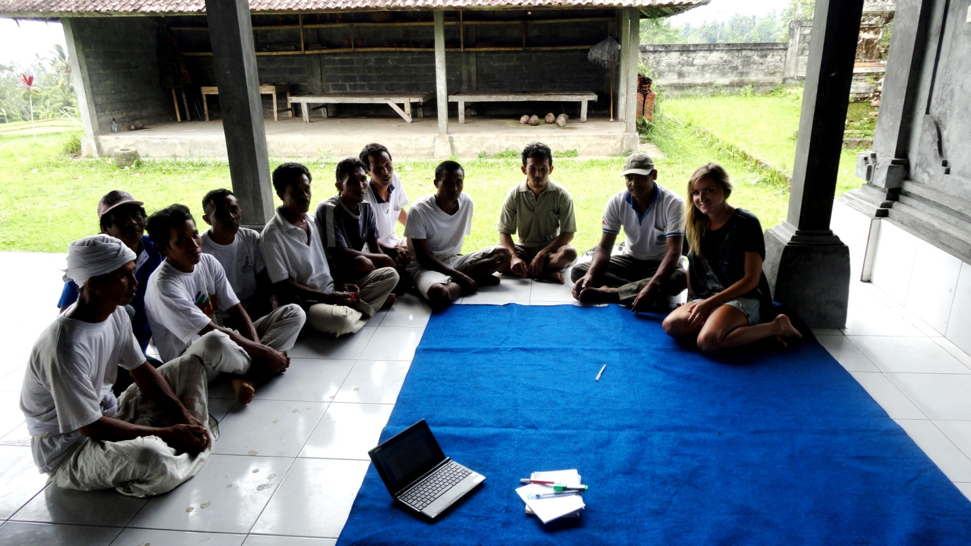
Photo 1 (By Dani Craig): Interview with demonstration plot farmers and Made Jengut
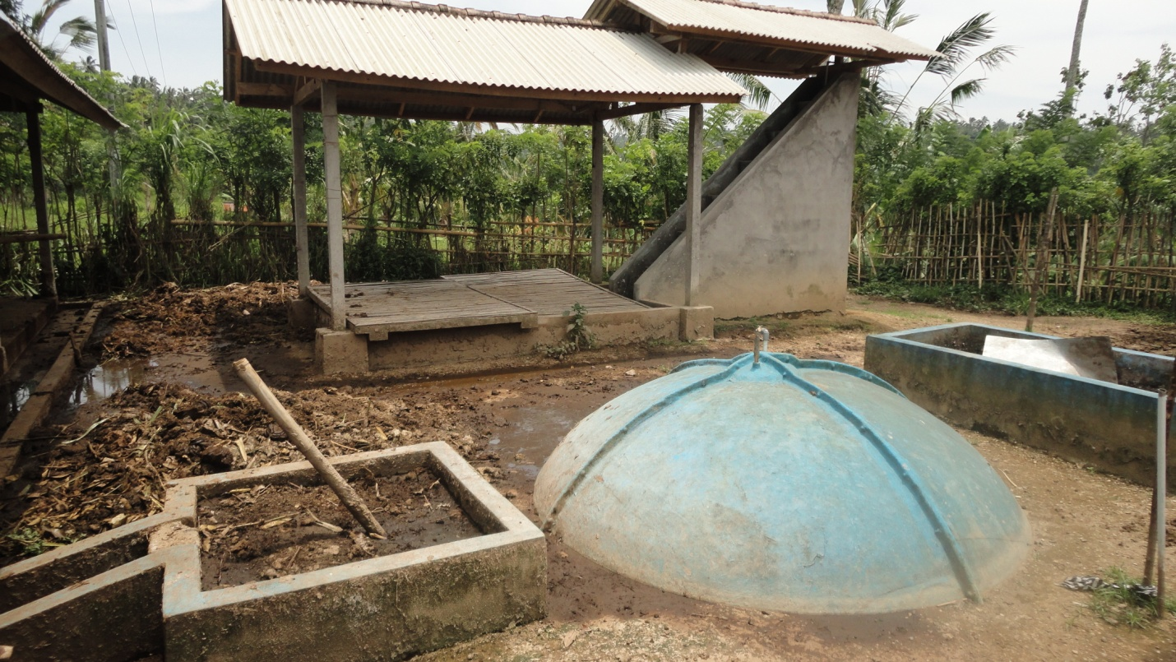
Photo 2: Biourine processing technology in Buahan Kaja
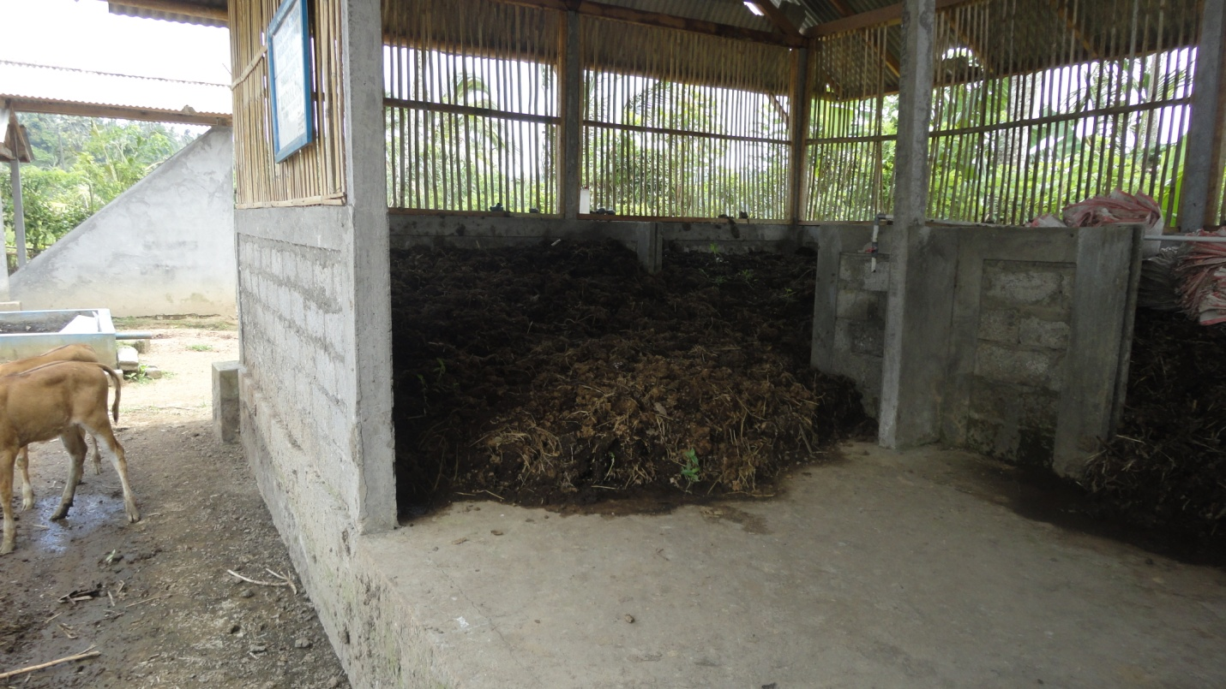
Photo 3 (By Dani Craig): Manure drying shed in Buahan Kaja
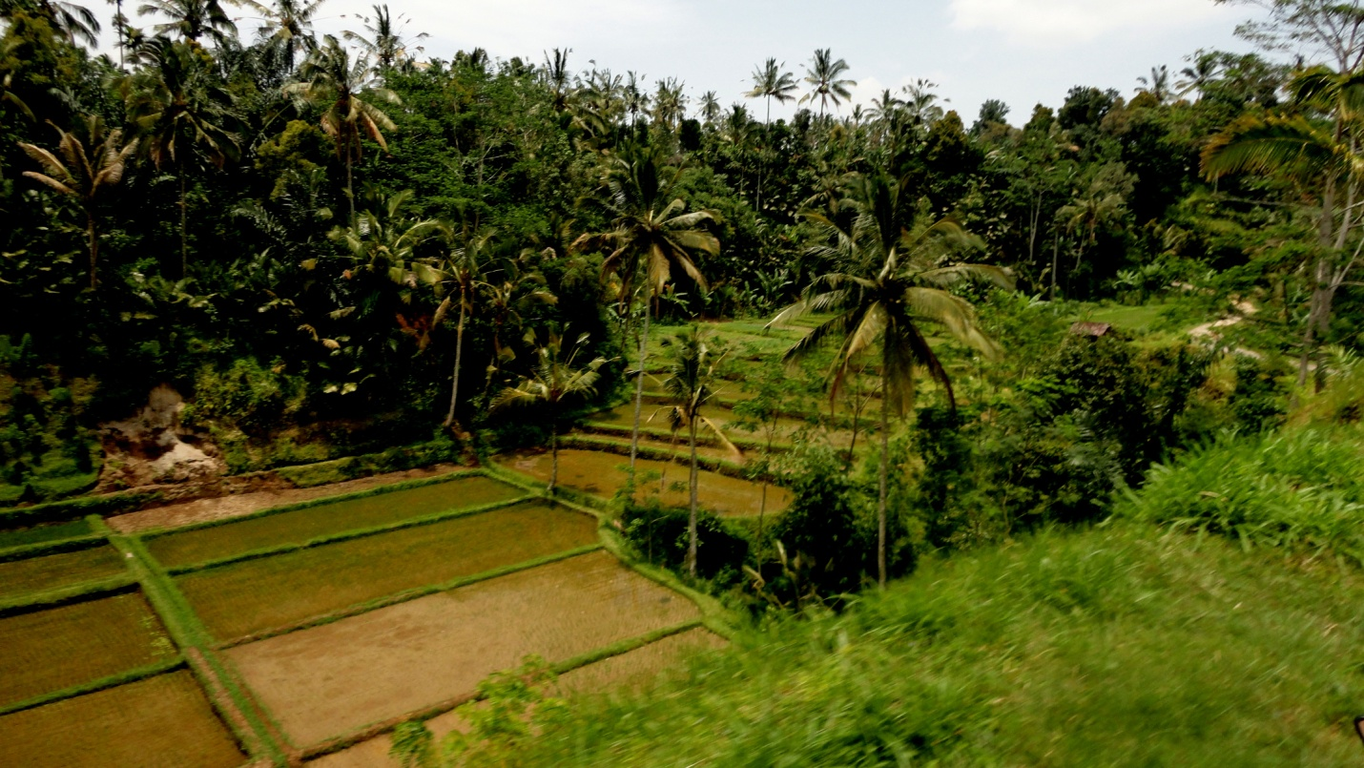
Photo 4 (By Dani Craig): Rice paddy in Buahan Kaja

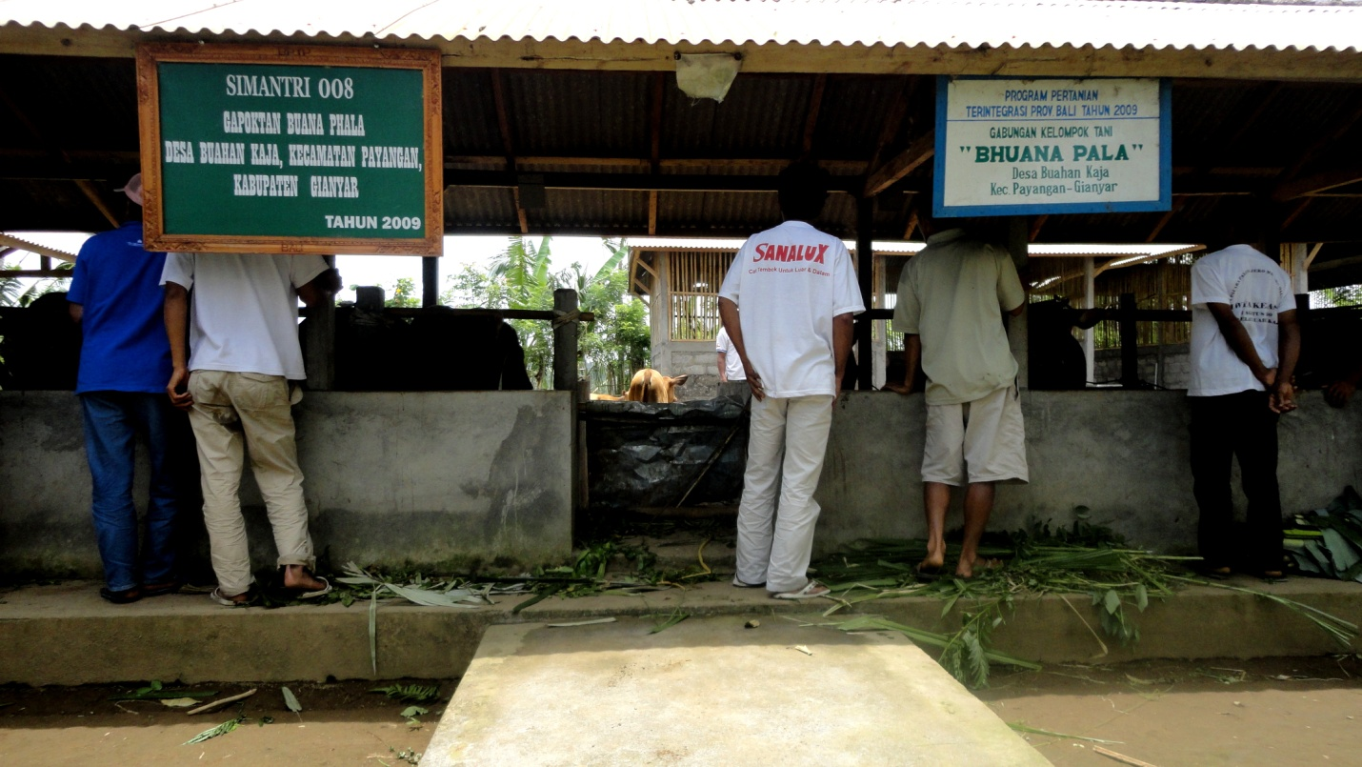
Photo 5 (By Dani Craig): Demonstration plot farmers standing with their cows in Buahan Kaja
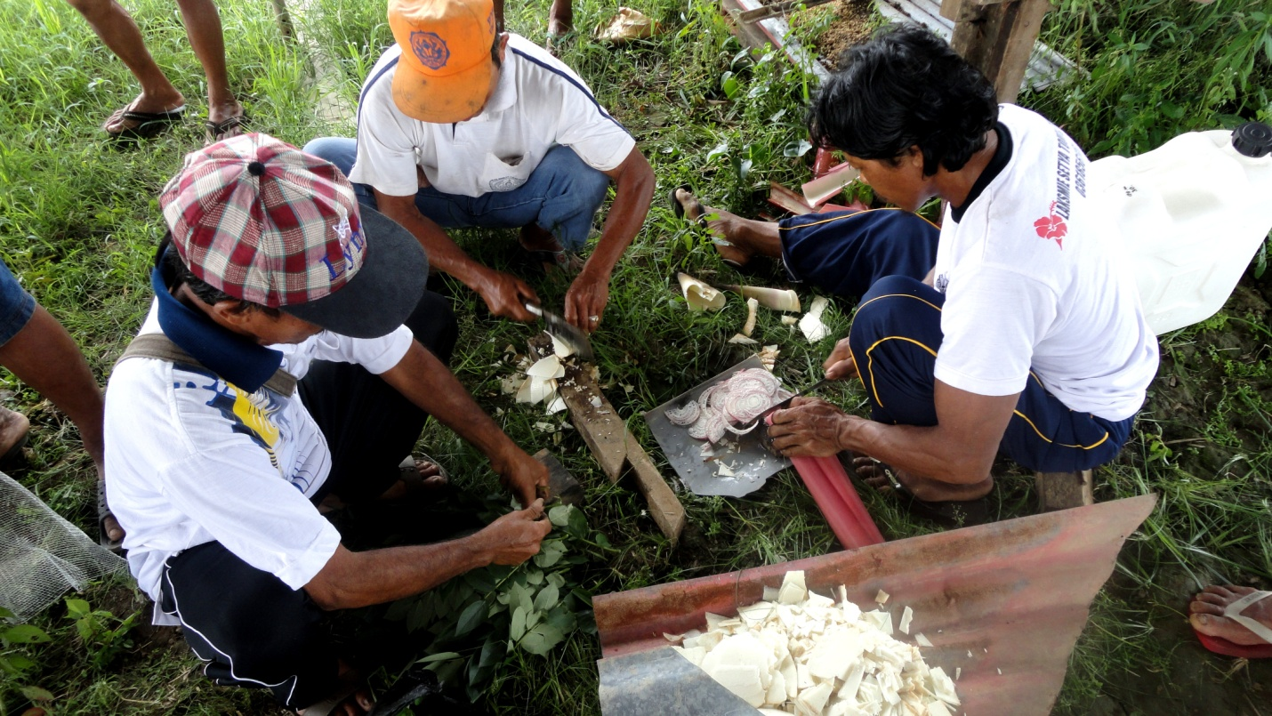
Photo 6 (By Dani Craig): Farmers in Tabanan at eco-resort site mixing MOL at a SRI workshop held by Chakra.

