Wild Seaweed Harvesting
Ways to encourage sustainable exploitation and improve the regulatory framework on wild seaweed in Iceland

Ásta Maack

Supervisor:
Carl Dalhammar

Thesis for the fulfilment of the
Master of Science in Environmental Management and Policy
Lund, Sweden, September 2019

© You may use the contents of the IIIEE publications for informational purposes only. You may not copy, lend, hire, transmit or redistribute these materials for commercial purposes or for compensation of any kind without written permission from IIIEE. When using IIIEE material you must include the following copyright notice: ‘Copyright © Ásta Maack, IIIEE, Lund University. All rights reserved’ in any copy that you make in a clearly visible position. You may not modify the materials without the permission of the author.

Published in 2019 by IIIEE, Lund University, P.O. Box 196, S-221 00 LUND, Sweden,
Tel: +46 – 46 222 02 00, Fax: +46 – 46 222 02 10, e-mail: iiiee@iiiee.lu.se.

ISSN 1401-9191

Acknowledgements
I would like to thank all the stakeholders who offered their time and detailed insights to wild seaweed and the wild harvesting industry. Thank you for providing me with interesting and important discussions and, at times, for not holding back any criticism relating to other aspects of the industry.
My deepest gratitude goes to my supervisor Carl Dalhammar. Thank you for sorting out my own thoughts and adopting the role of a therapist when I bombarded you with incredibly detailed aspects of wild seaweed and everything related to them. Thank you for providing me with additional opinions and aspects of legal requirements and for making me much more interested in environmental law.
Thanks to my mom and dad for providing me with emotional and financial support. Without your help I would not have been able to go for what I want. More importantly, thank you for raising me up to become incredibly interested in the ocean, nature and for not trying to restrain my raw emotions and excitement for small things, such as seaweed.
Thank you to all my batch mates for an unforgettable and demanding year in Sweden. Thank you to Silvia and Madison for countless dinners and pep-talks on life. I cannot wait for Arngunnur to get you know you again and stay with you for weeks on end.
Aron. Thank you for sticking by my side. Thank you for keeping me (relatively) sane throughout this program. Thank you for taking a full year off work to become a stay at home father for a year in a foreign country just so I could follow my aspirations and interests in furthering my career and personal growth. Thank you for being the best father and partner imaginable. Thank you for listening and (at least trying) to act interested in my almost daily related seaweed fun-facts and speeches on wild seaweed harvesting. Thank you for being my holdfast and rubbing my toes and head after a long day. I could write a whole thesis on acknowledgements to you, but this will have to suffice. I love you and cannot wait to marry you.
Arngunnur, rúsínurassgat, thank you for your unlimited amount of energy, incredible adaptability to all circumstances and over all joy of life. Thank you for sleeping almost two hours per day and for teaching me to use my limited alone time much more efficiently. Thank you for getting me out two times per day to experience daily adventures of imitating bees, jumping in puddles and following cats into random backyards.
Lastly, I want to acknowledge myself. Over 60-hour work weeks, childbirth, teething baby, sleepless nights and being a full-time parent along with thesis writing was demanding to say the least. Whenever I get self-doubts on anything again, I want to be able to remind myself of this time and remember that I can do most anything I set my mind to.

Abstract
Brown seaweed or macro-algae are multicellular plant-like organisms that inhabit various shores surrounding West-America and Northern Europe. Seaweed deliver highly important ecosystem services and provide habitats and shelter for other species, serving as a food source and take part in the nutrient recycling of Silica, Phosphorus and Nitrogen on land and in the sea. Seaweed has been harvested for its high alginate content and is increasingly used as fertiliser in agricultural industries, as a thickening agent in cosmetics and pharmaceutical industries, and for human consumption. As the wild seaweed harvesting industry has grown in recent years, experts have called for robust regulations that ensure sustainable exploitation. In direct response to lenient regulations, several organisations have published standards that aim to encourage sustainable exploitation of wild seaweed. These standards include criteria, recommendations and guidelines that harvesting companies are encouraged to follow. Iceland is one of the countries where wild seaweed are harvested, and a regulatory framework on wild seaweed harvesting was recently implemented. The goal of this framework is to promote sustainable utilisation of exploited marine stocks. The purpose of this research was to identify which ecological and economic criteria must be in place to ensure sustainable exploitation of wild seaweed. To this end, standards, the Icelandic seaweed regulatory framework and stakeholders’ interviews were explored. In addition, the author set out to analyse which criteria the Icelandic seaweed regulatory framework includes, and which alterations can be made to ensure continuous sustainable exploitation of wild seaweed in Iceland.
Keywords: Wild Seaweed Harvesting, Wild Seaweed Industry, Criteria, Sustainability, Natural Resource Management, Regulatory Framework

Executive Summary
Seaweed, or macro-algae, are multicellular plant-like organisms that can be found in shores of various depth and substrates in and around West-America and northern European countries. Seaweed provide highly important ecosystem services, such as formation of habitat, shelter, food source and nutrient catalysts for life on land and in the sea. Wild seaweed have been harvested for commercial purposes for several decades but in recent years, seaweed exploitation and its use in various industries has escalated. Currently, wild seaweed are harvested and used as fertilisers in the animal fodder industry, food industry, pharmaceutical, clothing and cosmetics industries.
For the past couple of years, the wild seaweed harvesting sector has grown due to increased use of seaweed in products and as replacement for other materials. This industry growth has led to experts highlighting the importance of robust regulations and laws on sustainable exploitation, as studies have called for improved management and monitoring of wild seaweed harvesting. Studies show that several countries that currently harvest wild seaweed stocks lack successful management of this natural resource. As a response to insufficient management and lenient regulations, several organisations have published standards which include criteria, recommendations, guidelines and best available practices on sustainable exploitation for wild harvesting companies.

Wild seaweed harvesting in Iceland
Wild seaweed have been harvested for the past 900 years in Iceland but harvesting for commercial purposes started in 1975 in Reykhólar, Breiðafjörður. Thorverk is the largest wild seaweed harvesting company in Iceland, which lands approximately 15-20 thousand tonnes of rockweed (Ascophyllum nodosum) and 2-3 thousand tonnes of kelp (Laminaria digitata), per year. The company is located at Reykhólar, a small town with a population of 268 people. One-fifth of this population is estimated to either directly or indirectly derive their livelihoods from Thorverk’s operations, and so the company operations are of great importance to the local economy. In 2018, the regulation on ‘Seaweed harvesting for commercial purposes’ was adopted, with the intention to “Improve the conduct of exploited marine stocks and promote sustainable utilisation that ensure long-term maximum yield for the Icelandic Nation” (‘Lög um umgengni um nytjastofna sjavar’, no 57/1996). The regulation references two national laws and two additional regulations, but all of the documents form the ‘Icelandic Seaweed Regulatory Framework’ (ISRF).

Problem definition and Research questions
The focus of this thesis is on the wild seaweed harvesting sector in Iceland. Three main problems in the industry were identified through literature review and preliminary discussion.
- Current standards that promote sustainable utilisation of wild seaweed have not been compared to see which criteria or factors must be present so that sustainable exploitation can be ensured.
- No study has been conducted to estimate which criteria stakeholders and experts find important to ensure sustainable exploitation of wild seaweed.
- The newly written regulation and implemented regulatory framework on wild seaweed harvesting in Iceland has not been analysed and assessed if it is successful in ensuring sustainable exploitation and utilisation of seaweed.
The research questions, formatted to answer the identified problems, are as follows:
RQ1: Which environmental and economic criteria, must be fulfilled through harvesting activities in Iceland to ensure that the commercial exploitation of wild seaweed resources is sustainable?
RQ2: How have criteria on sustainable exploitation of wild seaweed been represented and codified into the ISRF?
RQ3: How could the ISRF be modified to better promote sustainable harvesting?
Methodology & Research Design
Both quantitative and qualitative data were used in this study. Qualitative data includes reviews and analysis of literature, standards, the ISRF, and stakeholder interviews. Quantitative data consists of statistical data on harvested seaweed volumes, gathered from research institutes and harvesting companies. The research design of the study is comprised of 5 steps.
First, the author conducted a literature review on seaweed and the wild seaweed harvesting industry to obtain a background of the thesis topic. Second, economic and ecological criteria on sustainable exploitation of wild seaweed in eight standards were identified and analysed. Third, the ISRF was analysed to see which identified criteria in the second step were included in the legal framework. Fourth, stakeholders and relevant experts in the wild seaweed harvesting industry in Iceland were identified and interviewed on which criteria must be present for sustainable exploitation. Fifth, identified criteria through standard and the ISRF were compared to criteria mentioned by stakeholders. These five steps were completed to analyse which economic and ecological criteria must be in place to ensure sustainable harvesting of wild seaweed for commercial purposes in Iceland.
Major Findings
Part 1- Criteria from standards & the ISRF
After analysing eight standards (ASC-MSC, Friends of The Sea, Netalgae, PEGASUS, an environmental assessment report, a scoping report, Mara and Natural England) the following eight criteria were identified:
- ‘Monitor & Research’
- ‘Sustainable Harvesting Techniques’
- ‘Regulatory requirements’
- ‘Awareness of environmental changes’
- ‘The conduct of EIA’
- ‘Harvesting to provide economic benefits’
- ‘Collaboration and Communication’
- ‘Certifications and Consultations’.
According to the standards, all eight criteria must be in place to encourage a sustainable exploitation of wild seaweed. After analysing the ISRF, seven out of eight criteria were identified; all but ‘The conduct of EIA’. In addition, the legal framework provided an extra criterion of ‘Incentives’ which none of the standards mentioned. ‘Incentives’ in the legal framework include bans, fines, imprisonment or other punishments harvesting procedures lead to overexploitation of seaweed.
Part 2 Stakeholders
Findings from stakeholder interviews were grouped together in relevant criteria, which all echoed findings from the standard and ISRF reviews. Stakeholders identified all criteria analysed in the standard review, except for ‘Incentives’. In addition, stakeholders mentioned and highlighted the importance of the ‘Positive aspects of wild harvesting’ criterion. Wild harvesting has shown to positively effect growth rates and make seaweed less vulnerable to storms and currents, and wild seaweed harvesting does not need fertilisers, additional water or pesticides as used in many agricultural industries. In addition, if seaweed are added to cattle stock fodder, methane emissions can decrease by a substantial amount.
With the addition of the ‘Positive aspects of wild harvesting’, the final number of criteria needed for sustainable exploitation of wild seaweed was ten (see Figure 6 below. Source: own elaboration).
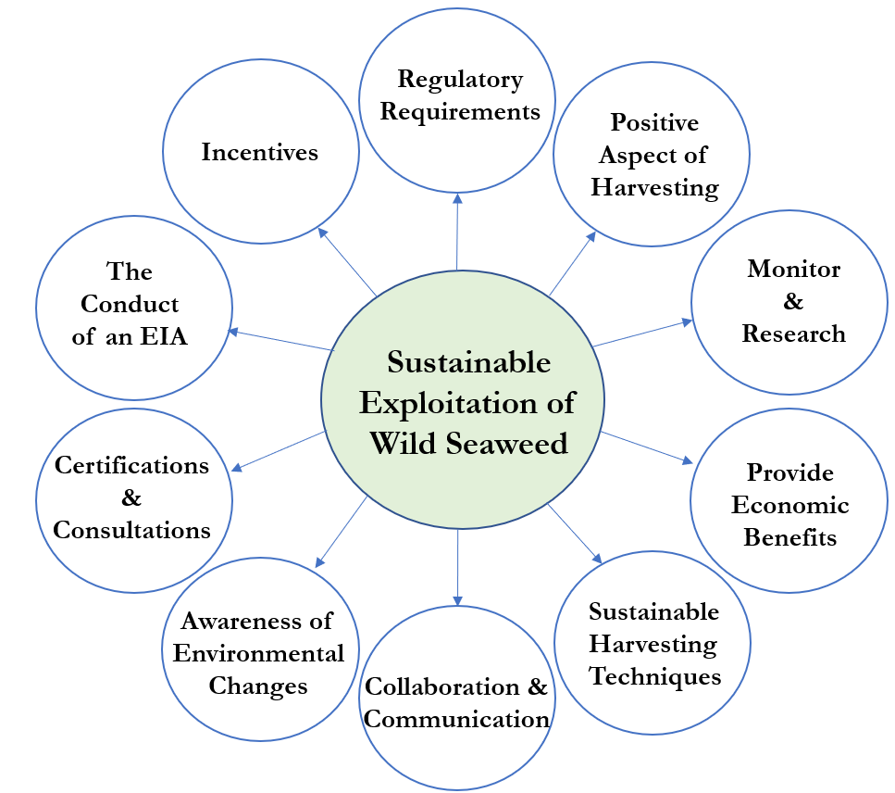
Discussion
The different perspectives of standards, regulatory framework and interviewees provided a rich perspective of the wild seaweed harvesting industry in Iceland. Currently, the exploitation and utilisation of wild seaweed appears to be quite sustainable in Iceland, although the regulatory framework does not fulfil every sustainability criterion. In order to prepare for increasing future exploitation, with the harvesting volumes set to be doubled and foreign companies planning to establish operations in Iceland, the ten final criteria must be kept in mind by regulatory authorities, harvesting companies and other stakeholders.
Although the current framework, implemented in 2018, includes most criteria needed for sustainable exploitation, its existence is not the only factor attributable to sustainable exploitation of wild seaweed. Seaweed have been harvested in Breiðafjörður for the past forty years with little change in seaweed biomass. The experience and operations of seaweed harvesters can be associated with the fact that local businesses plan on harvesting wild seaweed for a long time to come, and so sustainable and continuous harvesting is a must for both company practices as well as economy and ecological factors in Breiðafjörður.
As several stakeholders mentioned, the ISRF led to a positive change in the wild seaweed industry. This include increased recording and reporting of harvested seaweed volumes as well as the introduction of incentives to avoid overexploitation. With this in mind, several improvements of the regulatory framework can be made. As stakeholders mentioned, there is a need for regulatory authorities to recognise that harvesting techniques, areas, depth, surroundings, regrowth rate and other factors related to seaweed differ. This is why regulations must factor in differences between harvested species and company operations, but still remain general enough to be applicable to all harvesting activities in Iceland. In respect to this discussion and to the regulatory framework, which is set to be revised in 2021, the following recommendations were made:
Key recommendations
- Regulations should include a greater emphasis and clarity on the goal of ‘sustainable exploitation’. The regulation on ‘Seaweed harvesting for commercial purposes’ should include a clearer scope on surrounding environment and ecosystems.
- The ISRF should factor in local surroundings, specific seaweed species, and additional harvesting techniques, such as hand-harvesting (which is currently utilised) into account. In addition, regulations should be better suited to wild seaweed exploitation rather than the current practices that are tailored for the fishing industry.
- Regulations must account for the difference between seaweed and fish stock resources. Stakeholders voiced their concerns that current regulations in the seaweed regulatory framework are hard to apply to seaweed weighing and reporting. This leads to stakeholders not fulfilling the regulatory framework on seaweed.
- The natural resource tax, implemented on rockweed, should either be removed or allocated to seaweed research or local development. The current natural resource tax implemented on rockweed clashes with the Icelandic constitution of property rights, as all rockweed grow within landowners’ properties.
- The seaweed regulatory framework should mandate EIAs, to ensure continuous sustainable exploitation in the wild seaweed harvesting industry. A company’s conduct of EIA seems especially important as the MFRI allows doubling of harvested volumes in coming years, and large companies plan to establish operations in Iceland. An EIA would serve as a form of safety net to ensure sustainable exploitation of wild seaweed.
- Regulatory authorities should pay close attention to the ten identified criteria in this thesis, while reassessing and revisiting the regulations in 2021.

Table of Contents
Acknowledgements I
Abstract II
Executive Summary III
List of Figures IX
List of Tables IX
Abbreviations IX
1 Introduction 1
1.1 Wild seaweed harvesting: current regulations and standards 2
1.1.1 Importance and calls for regulations on wild harvesting 3
1.2 Icelandic Context 3
1.3 Marine laws and the Icelandic seaweed regulatory framework 6
1.4 Problem definition 7
1.4.1 Analysis and comparison of standards 8
1.4.2 Analysis and comparison of stakeholder perspectives 8
1.4.3 Analysis of the ISRF 8
1.5 Research objectives and questions 9
1.6 Scope & limitations 9
1.7 Ethical considerations 11
1.8 Intended audience 11
1.9 Disposition 11
2 Methodology and research design 13
2.1 Research methodology 13
2.2 Qualitative data; collection and analysis 13
2.2.1 Collection of literature review 13
2.2.2 Analysis of literature review 14
2.2.3 Collection of standard review 14
2.2.4 Analysis of Standard Review 17
2.2.5 Collection of the Icelandic seaweed regulatory framework 17
2.2.6 Analysis of the Icelandic seaweed regulatory framework 17
2.2.7 Stakeholder interviews 17
2.3 Quantitative data: 19
3 Review of literature, standards and the ISRF 21
3.1 Monitor & Research 22
3.1.1 ISRF; Monitor & Research 22
3.2 Sustainable harvesting techniques 23
3.2.1 ISRF; Sustainable harvesting techniques 24
3.3 Regulatory requirements 24
3.3.1 ISRF: Regulatory requirements 25
3.4 Awareness of environmental changes 25
3.4.1 ISRF; Awareness of environmental changes 27
3.5 The conduct of EIA 27
3.5.1 ISRF; The conduct of EIA 28
3.6 Harvesting to provide economic benefits 28
3.6.1 ISRF; Harvesting to provide economic benefits 28
3.7 Collaboration & Communication 28
3.7.1 ISRF; Collaboration & Communication 29
3.8 Certifications & Consultations 29
3.8.1 ISRF; Certifications & Consultation 29
3.9 Incentives 29
3.10 Summary and own reflections 30
4 Stakeholder reflections 31
4.1 Stakeholder views on sustainability 32
4.1.1 Icelandic stakeholder perspective: sustainability 33
4.2 Identified criteria by stakeholders 33
4.2.1 Monitor & Research 34
4.2.2 Sustainable harvesting techniques 36
4.2.3 Positive aspects of wild harvesting 37
4.2.4 Regulatory requirements 38
4.2.5 Awareness of environmental changes 40
4.2.6 The conduct of EIA 41
4.2.7 Harvesting to provide economic benefits 42
4.2.8 Collaboration & Communications 43
4.2.9 Certifications & Consultations 44
4.3 Summary & own reflections 45
5 Discussion 46
5.1 Monitor & Research 46
5.2 Sustainable harvesting techniques 48
5.3 Positive aspects of wild harvesting 49
5.4 Regulatory requirements 50
5.5 Awareness of environmental changes 51
5.6 The conduct of EIA 51
5.7 Harvesting to provide economic benefits 52
5.8 Collaboration & Communication 53
5.9 Certifications & Consultations 54
5.10 Incentives 55
6 Recommendations 56
6.1 Recommendations for Regulatory authorities in Iceland 56
6.2 Recommendations for wild seaweed harvesting companies 57
7 Conclusions 59
7.1 Addressing RQ1 59
7.2 Addressing RQ2: 60
7.3 Addressing RQ3 61
7.4 Further topics for Research 62
7.5 Personal Reflections from the Author 62
Bibliography 63
Appendix I – Introduction letter in English 67
Appendix II- Introduction letter in Icelandic 68
Appendix III – Synthesis Matrix of Literature 69
Appendix – IV Identification of criteria in analysed standards 70
Appendix V- Identification of criteria in the ISRF 74
Appendix VI – List of Interviewees 75
Appendix VII – Interview Protocol in English 76
Appendix VIII – Interview Protocol in Icelandic 77

List of Figures
Figure 1 Thorverk’s harvesting volumes of rockweed (A.nodosum) from 1975-2018 (Klóþang, n.d.; Á.F., 2019). Source: own elaboration 4
Figure 2 Thorverk’s harvesting volumes of kelp (L. digitata) from 2004-2018 (Á.F., 2019). Source: own elaboration 5
Figure 3 Draft of Stakeholder Selection 18
Figure 4 Analysed standard criteria on sustainable exploitation of wild seaweed (Source: own elaboration) 21
Figure 5 Identified criteria by stakeholders on sustainable exploitation of wild seaweed (Source: own elaboration) 33
Figure 6 All identified criteria in standards, ISRF and stakeholder interviews (Source: own elaboration) 46

List of Tables
Table 1 Main contents in the ‘Seaweed harvesting for commercial purposes’ regulation 7
Table 2 Detailed Description of the following standards: ASC-MSC, Friends of The Sea, Netalgae and PEGASUS 15
Table 3Detailed description of the following standards: EAR, Scoping Report, Mara and Natural England 16
Table 4A simplified list of interviewees and acronyms used for reference (Source: own elaboration) 32

Abbreviations
OTCO - Organic Certification, Organic Farming
EIA - Environmental Impact Assessment
PME - Priority Marine Features
ISRF - Icelandic Seaweed Regulatory Framework
MFRI - Marine & Freshwater Research Institute
SST - Sea Surface Temperatures

Introduction
Macro-algae or seaweed are multicellular plant-like organisms that can be found in cold, nutrient rich and rocky-bottomed shores. Macro-algae are classified into three main groups: red, green and brown algae. Many species within these groups inhabit coasts of West-America and European countries, such as Scotland, Ireland, Iceland, Denmark, Norway and France (Steneck et al., 2002). Seaweed are comprised of photosynthetic microorganisms that are capable of grouping and forming macro-algae. Their size and form differ depending on species, surroundings, depth, warmth and nutrition of the sea (Project Oceanography, 2002). Seaweed play key roles in marine and coastal ecosystems as they provide habitat, shelter and food sources for other species. In addition, seaweed break down Nitrogen and Phosphate from their surroundings and take part in Carbon sequestration and climate regulation while protecting shores from coastal erosion (Barbier et al., 2019b; Harley et al., 2012; Marine Scotland, 2016; Schiener, Black, Stanley, & Green, 2014; Steneck et al., 2002). Seaweed contribute to biodiversity and ecosystem production by supporting complex food webs. Many organisms within these food webs are of great economic importance to marine communities, inter alia fish species, crustaceans, molluscs, eider ducks and more.
As photosynthesising organisms, seaweed absorb carbon dioxide from their surroundings, as oxygen and energy are formed with the help of sunlight. Recent studies show that seaweed cover 2% of the Earth’s surface but are thought to absorb up to 70% of global emitted CO₂ (Barbier et al., 2019b). Additionally, seaweed play a huge role in Silica, Phosphorus and Nitrogen cycles, along with breaking down natural compounds which other organisms are able to use in chemical compounds and processes (Barbier et al., 2019b). Many seaweed species form forests or seaweed beds in intertidal and upper tidal zones of rocky coastal seashores (Margulis & Marine, 2009). Because of their density, the beds can provide coastal protection against erosion along with depositing beach-cast seaweed that provide nutrients to coastal habitats and function as sediment stabilisers (Marine Scotland, 2016; Rebours et al., 2014). Given that seaweed provide numerous natural services, marine and coastal ecosystems are highly dependent on this natural resource as the removal of one seaweed species effects the equilibrium and structure of ecosystems (Bland, 2017; Smale, Burrows, Moore, O’connor, & Hawkins, 2013).
In addition to providing numerous natural services to marine and coastal ecosystems, wild seaweed harvesting generates economic value for many coastal societies. Studies show that harvesting of wild seaweed dates back 14.000 years (Adams, 2016; Gunnarsson et al., 2017; Mac Monagail, Cornish, Morrison, Araújo, & Critchley, 2017; McHugh, 2003). Interestingly, online literature mentions that seaweed harvesting can either “save the world” (Flannery, 2017) or “reverse climate change” (Hancock, 2019) while other articles regard harvesting as immoral and unnecessary act of resource extraction that could lead to ecological disasters (Roseingrave, 2017).
In recent decades, brown-seaweed have been harvested due to their high alginate content; alginates are for example, used as thickening and gelling agents in the food industry, cosmetic industry and agri-food industries (Adams, 2016; Davoult, Engel, Arzel, Knoch, & Laurans, 2011; Ferdouse, Løvstad Holdt, Smith, Murúa, & Yang, 2018; Mac Monagail et al., 2017; Marine Scotland, 2016). Other commercial uses of seaweed include: stabilising and colouring agents in the pharmaceutical industry, waterproofing qualities in the textile industry, treatment of wastewater, fertilisers and ingredients for cattle and animal fodders(Adams, 2016; Davoult et al., 2011; Mac Monagail et al., 2017; Marine Scotland, 2016). In addition, seaweed can provide alternatives for plastic materials in some industries (Bonnin, 2018; Oakes, 2019). In recent years, seaweed have been regarded as the latest ‘superfood’ as some species contain high amounts of vitamins, iodine, proteins, minerals and low fat content (Kubitz, 2015; Barbier et al., 2019b; Ferdouse et al., 2018).
Currently, numerous seaweed species are both harvested from the wild and farmed by aquaculture processes. The wild seaweed harvesting sector accounts for about 5% of global seaweed production. In 2015 just over one million tonnes of wild seaweed were harvested globally, where 23 million tonnes were harvested by aquaculture production (Cottier-cook et al., 2016). In 2016, the total value of the global seaweed industry was estimated to be roughly €8 billion (Barbier et al., 2019b; West, Calumpong, & Martin, 2016). Recent studies show that the global production of products containing seaweed and alginates has increased, but between 2014-2015, this growth was 4% (Barbier et al., 2019b). Additionally, market insights show that global supplements containing seaweed have grown by 10% in the past few years, with drink products containing seaweed increasing by 147% on the European market (Mintel 2016).
Several countries in the Northern-hemisphere currently harvest wild brown-macro algae. These include Canada, Denmark, Iceland, Ireland, Norway, Scotland and Sweden, although production size differs greatly (Gunnarsson et al., 2017; Mac Monagail et al., 2017). According to studies, harvesting of wild brown seaweed have attracted increased interest from new and existing producers and wild harvesting companies. The main harvested brown-seaweed species include rockweed and kelp. Rockweed (Ascophyllum nodosum) are only found in the Atlantic Ocean and habit intertidal rocky bottomed shores or areas that are above water at low tide, but under water at high tide. Rockweed are the main economic resource in the wild harvesting industry in most North-European countries, including Iceland. The seaweed have long and irregular fronds (analogous to leaves) and branches, which are sporadically covered with large air-filled bladders. Rockweed can reach beyond two meters in length and are attached to rocky surfaces via a holdfast. Kelp are macro-algae that are taxonomically diverse and include species in the genera of Laminaria, Ecklonia, Lessonia, Alaria and Eisenia. Kelp within these genera are large brown macro-algae that habit deeper shores of the Atlantic Ocean. Kelp form dense forests or seaweed beds, which are continuously submerged. Individual plants consist of leather like fronds that take up nutrients, long stipe (analogous to plants stalks), and a holdfast which anchors the algae to the seafloor. Individual kelp can grow up to 45 metres in length and grow over 60 cm in a day. This rapid resource repletion is an important aspect of the economic potential of kelp harvesting. Importantly, the degree of contrast and variety between seaweed species has a major bearing on functions of sustainable harvesting, and as such will represent an important consideration of the following analysis.
In this thesis, seaweed farming or aquaculture refers to the practice of growing and harvesting seaweed by managing natural resources, with nets or planting of seaweed, up to controlling whole lifecycles (San, 2012). In turn, wild seaweed harvesting does not entail managing or planting seaweed: but picking, cutting or removing (and gathering) of naturally grown seaweed (Marine Scotland, 2016). Although the wild seaweed harvesting sector is significantly smaller than farmed seaweed, sustainable exploitation of wild seaweed is highly important. This thesis solely addresses the wild seaweed harvesting industry and not farmed or aquaculture processes. The focus is set on wild harvested seaweed, as the industry is less researched than the aquaculture industry, and the author has greater interest in researching natural resource management than farming processes.

Wild seaweed harvesting: current regulations and standards
As harvesting of wild rockweed and kelp has gradually increased in Europe for the past years, several experts and studies have emphasised the importance of regulations and laws to ensure sustainable exploitation of wild seaweed (B.P., 2019; H.T., 2019; F.C., 2019; Mac Monagail et al., 2017; Rebours et al., 2014). In addition to continuous commercial exploitation of wild kelp, research on biomass and distribution is needed (West et al., 2016).

Importance and calls for regulations on wild harvesting
Seaweed harvesting in some European countries is currently regulated by regional authorities or local organisations through various instruments, including inter alia licenses, quotas-authorisation and other methods (NETALGAE, 2012). In recent years, a few European countries have implemented regulations and laws on wild seaweed exploitation, while other countries lack regulatory management on seaweed (Morrison, 2018). Despite applying market-based instruments and local regulations on wild seaweed exploitation, several articles and projects have criticised current efforts. Papers call for stricter regulatory requirements and improved management and monitoring of harvesting operations. Negative consequences attributable to this lack of regulation and management can (and has) led to overharvesting and unsustainable exploitation of seaweed (Barbier et al., 2019b; Mac Monagail et al., 2017; Rebours et al., 2014). One article states that the need “for regulations and the establishment of ‘best practices’ for seaweed harvesting and management […] have been noted and these must be developed and applied” (Radulovich, 2016). Another article mentions that regulations and directives that enable a sustainable exploitation of seaweed must be developed (Cottier-cook et al., 2016). A study states that “Policy makers must develop regulations and directives that enable a sustainable exploitation of the natural resource”. Despite calls for improvement, no research provides detailed information on which aspects current regulations are lacking, and what they should take in to ensure sustainable exploitation (Rebours et al., 2014).
As a response to insufficient management and regulation of wild seaweed harvesting, companies and organisations, such as the ASC-MSC, PEGASUS, Friends of the Sea and Marina have set voluntary standards, guidelines or recommendations to encourage sustainable exploitation of seaweed. Although the standards differ, most focus on sustainable ecology, economy and societal factors related to seaweed harvesting (ASC-MSC Seaweed Standard, 2017; Friends of The Sea Certification Criteria Checklist for Seaweed Products, 2014). The introduction of these standards is very important as articles state that current policies regulating and managing the seaweed industry are in their infancy and most countries lack long-term management plans to ensure sustainable exploitation (Cottier-cook et al., 2016; Rebours et al., 2014). Lastly, to highlight the importance of sustainable exploitation of seaweed, a lack of monitoring and management of wild seaweed harvesting led to overexploitation of wild seaweed in France, Ireland and in a few sites in Nova Scotia in the early years of the industry (Mac Monagail et al., 2017; West et al., 2016; FAO ,1987).

Icelandic Context
Several seaweed species have been harvested in Iceland and used as a food source, as animal fodder and fire feed for at least 900 years (Kristjánsson, 1993). Wild seaweed harvesting for commercial purposes have been attempted several times since 1939, but to no avail (Gunnarsson et al., 2017). In 1975, Thorverk, a wild seaweed harvesting company, was established and built in Reykhólar, Breiðafjörður. Assessments have shown that due to vast shores, shallow incline and a great difference in sea levels between high and low tide (4.4 metres), company operations have been successful. According to scientists roughly half of seaweed-shores in Iceland are located in Breiðafjörður across an equivalent area of approximately 145 km² (Ingólfsson, 1975). Additionally, spawning and migration areas for many fish species that are vital for the Icelandic economy are located within the fjord. Breiðafjörður generates economic benefits to nearby municipalities, as various employed roles in the fjord rely on the utilisation of natural resources.
In 2016, the population of Reykhólar was 268 people in approximately 100 homes. It is estimated that for one-fifth of the population, indirect or direct derivation of livelihood can be attributed to the presence of Thorverk.
Currently, Thorverk is the only large-scale wild seaweed harvester in Iceland. In addition to Thorverk, ‘Íslensk Bláskel & Sjávargróður’ (Icelandic mussels and seaweed), hereafter referred to as ‘Íslensk Bláskel’, harvests similar species but in significantly lower quantities (S.S., 2019). Thorverk employs 18 personnel throughout the year, with six extra staff members during the summer (Á.F., 2018). In past decades the company has harvested rockweed (Ascophyllum nodosum), kelp (Laminaria digitata) and tangle (Laminaria hyperborea). Rockweed are the main economic resource of Thorverk, with an annual harvest of 15-20 thousand kilo tonnes per year (MFWI, 2018). The annual harvest of rockweed can be seen in Figure 1.

Figure 1 Thorverk’s harvesting volumes of rockweed (A.nodosum) from 1975-2018 (Klóþang, n.d.; Á.F., 2019). Source: own elaboration
As Figure 1 shows, the harvesting rate of rockweed has increased in the past decades from 1350 tonnes in 1975 to roughly 19.800 tonnes in 2018. According to the data and Árnason, the CEO of Thorverk, the growth is attributable to increased market interest and the expansion of recommended harvesting volumes set by the MFRI. A decrease in harvested kelp volumes, from 3.700 tonnes to 1.700 tonnes in 14 years, can be seen in Figure 2. Árnason stated that the decline stems from less market interest due to natural heavy metal content within kelp but this is also mentioned in scientific studies (Ferdouse et al., 2018).

Figure 2 Thorverk’s harvesting volumes of kelp (L. digitata) from 2004-2018 (Á.F., 2019).
Source: own elaboration
Currently, Thorverk exclusively harvests seaweed by mechanical harvesting techniques, which cut rockweed without destroying plants’ holdfasts or substrates. Rockweed are then brought to shore, weighed and dried with geothermal heat on location. After that, the seaweed are either ground into seaweed meal or finer particles that serve as the final product for global buyers. Thorverk’s harvesting techniques, production phase and products are certified by Quality Assurance International (QAI), USDA Organic, Organic Farming (OTCO) and Vottunarstofan Tún, as all products are 100% organic and natural (‘Certifications’, n.d.). Thorverk’s products are transported to other industries where they are used as raw material in in animal feed production, as fertilisers and in the food industry. In addition, alginates derived from the seaweed are used in beverages, cosmetics, medicine and in biotechnology (Árnason, 2019).
As mentioned before, Íslensk Bláskel, located in Stykkishólmur and established in 2010, is the only other harvesting company in Iceland. According to the owner, Sturluson, seaweed are caught on lines located in the ocean and then harvested by hand. The seaweed are then dried and processed on site as many products are finalised, shipped and sold to other countries for food and skincare industries. Due to the small scale of the company, mechanical harvesting is not practical due to high start-up costs, maintenance and other factors described later in this thesis. To avoid confusion, the term ‘hand-harvesting’ in this thesis refers to hand-harvesting as described above or manual cutting of wild seaweed with scissors.
In 2017, a project on regional development and strategies within the Westfjords, which includes Breiðafjörður, was launched. According to the project, plans regarding development, promotion and creation of business opportunities and value creation in the Westfjords are able to apply for funding. The purpose of the project is to attract and keep young people within the area, as job opportunities and staff are valuable to the local economy and society (Sóknaráætlun Vestfjarða, 2019). In addition to providing economic benefits of seaweed, both Thorverk and Íslensk Bláskel support local employment, economic and regional development by hiring people from the area. As such, the generation and harvesting of seaweed products is an integrated, native industry in the Westfjords and represents an important source of employment contributing to the region’s economic development.

Marine laws and the Icelandic seaweed regulatory framework
Due to its remote location and natural conditions, the sustainable use of marine resources have been vital for the Icelandic economy, growing GDP and economic independence for many centuries. As the Icelandic herring population collapsed in the 1970s, there was a major reform of national fisheries policies with the expansion of the country’s Exclusive Economic Zone (EEZ) to eventually reach 200 nautical miles in 1979 (‘Útfærsla Landhelgi’. n.d.). These factors and several regulations on fish stocks, management and reporting lead to the implementation of the Fisheries Management Act in 1990. The act entails individual transferable quotas in the Icelandic fisheries with the aim to promote the optimal and efficient utilisation of fish stocks to secure the Icelandic economy and eliminate over-fishing of vital species (‘Lög um stjórn fiskveiða’ no 116/2006). The equitability of the quotas has been criticised, but from an environmental perspective, most regard them as being highly successful in ensuring sustainable exploitation as none of the commercially harvested fish species in Iceland are threatened due to overfishing (OECD, 2017).
In 2016 a global seaweed company showed interest of establishing a seaweed harvesting plant in Breiðafjörður. Due to the interest of the new company, and a relative lack of regulation on seaweed resources in Iceland, a new regulation was written on wild ‘Seaweed harvesting for commercial purposes’ in January 2018 (‘Reglugerð um öflun sjávargróðurs í atvinnuskyni’ no 90/2018). The regulation consists of six articles and references two laws: (1) The ‘Fisheries management act’ (‘Lög um stjórn fiskveiða’) and (2) the law of ‘Conduct of exploitable marine stocks’ (Lög um umgengni um nytjastofna sjavar, no 57/1996), and two regulations: (a) ‘Weighing and registration of marine stocks’ ('Reglugerð um vigtun og skráningu sjávarafla', no 745/2016) and (b) ‘Logbooks of catch statistics’ ('Reglugerð um afladagbækur', no 746/2016). The regulations, pertaining exclusively to mechanical harvesting of wild seaweed, mainly concern companies that harvest seaweed for commercial purposes, or companies that intend to harvest in the future. In addition, the framework includes the interests and rights of landowners and stakeholders related to harvesting activities such as municipalities and their residents. The regulation is set to be revised three years after implementation ('Frumvarp til laga' bill 1107 issue no 697). In the intervening period, data and research outputs regarding various aspects of seaweed utilisation in Breiðafjörður are required to be collated and retained. Table 1 summarises each article of the ‘Seaweed harvesting for commercial purposes’ regulation. It must be noted that Table 1 shows the entire regulation, as no preface, introduction or additional appendices of the regulation exists.
Table 1 Main contents in the ‘Seaweed harvesting for commercial purposes’ regulation
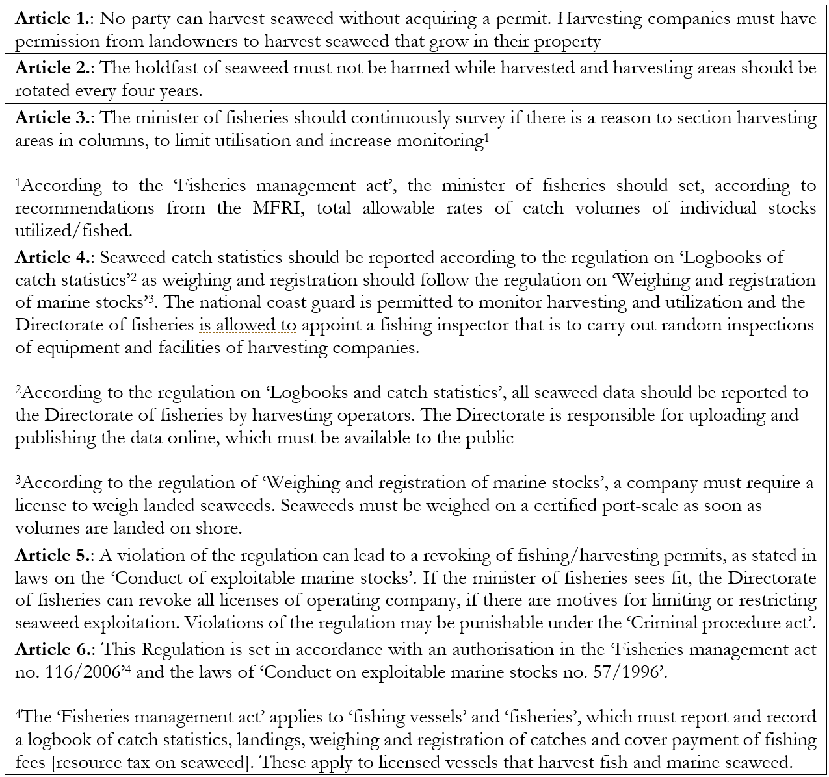
As seaweed was added to existing law of the ‘Conduct of exploitable marine stocks’ the goals remained the same for seaweed and other marine stocks. Those are to: “Improve conduct of exploited marine stocks and promote sustainable utilisation that ensure long-term maximum yield for the Icelandic Nation”('Lög um umgengni um nytjastofna sjavar'). The regulation on ‘Harvesting of seaweed for commercial purposes’ and referenced laws and regulations, will be referred to as ‘The Icelandic Seaweed Regulatory Framework’ or ISRF within this thesis.

Problem definition
Issues within the Icelandic wild seaweed harvesting industry were identified and analysed. Issues were identified through a literature review and preliminary discussions with experts in the industry. Problems identified in literature were applied to the Icelandic wild seaweed harvesting sector and newly implemented regulatory framework. The Icelandic seaweed industry and accompanying framework has not been researched to any extent before, to the best knowledge of the author, and thus this research aims to cover a research gap. Further, the topic of research is of importance for several stakeholders. Although several issues were identified, the author decided to focus on the three biggest issues, due to scope and manageability. The three issues are presented in the subsections below (Chapter 1.4.1, Chapter 1.4.2 and Chapter 1.4.3). By identifying problems related to the industry, a justification for improvements in the ISRF can be made.
Here, ‘standard’ refers to a certain set of mechanisms that entail criteria, recommendations or similar guidelines for sustainable exploitation and utilisation of wild seaweed for harvesting businesses. Legal or mandatory standards are not included in the definition, as the focus is on voluntary participation of wild harvesting companies. Voluntary standards include certification schemes, eco-labels and standards which are developed by standardization bodies and other organisations (Dalhammar, Richter, & Machacek, 2015). In addition, ‘criteria’ will be referred to and used as a synonym for existing and relevant criteria, recommendations, guidelines, best practices for sustainable utilisation of seaweed

Analysis and comparison of standards
The first identified problem involves standards on wild seaweed harvesting and includes three sub-sections. The first identified problem is that current standards on sustainable utilisation of wild seaweed (see Chapter 1.1.2) contains different information, criteria and recommendations for the wild seaweed harvesting industry. This makes it difficult for harvesting operators to identify which ecological and economic criteria are vital for sustainable exploitation of wild seaweed, which are secondary, and which are ‘nice-to-have’ or perhaps economically feasible. Secondly, no standard includes specific recommendations on ecological and economic criteria. This is important to note as Iceland’s economy relies heavily on sustainable utilisation of marine resources and unsustainable exploitation could affect both nature and economy in a negative way. Thirdly, no study has compared and analysed existing standards to see which overarching themes or key-criteria need to be present for sustainable utilisation of wild seaweed. Research Question 1 and findings from Chapter 3, Chapter 4 and Chapter 5 aim to answer this elaborate problem.

Analysis and comparison of stakeholder perspectives
The second problem entails a lack of research and comparison of stakeholders’ opinions on sustainable wild seaweed exploitation for commercial purposes. No study has determined which economic and ecological criteria stakeholders consider to be important for sustainable exploitation. This lack of research can pose a problem as for example, a company in country X could follow consultations and sustainable opinions of stakeholder Y, who may have completely different opinions of sustainable exploitation compared to stakeholder Z. This identified problem presents a research gap regarding the lack of stakeholder inclusion on sustainable wild seaweed exploitation.

Analysis of the ISRF
As mentioned in Chapter 1, the ISRF was implemented in 2018, with the publishing of new regulation: ‘Seaweed harvesting for commercial purposes’. The goal of the regulation is to improve the conduct of exploitable marine stocks and ensure their sustainable utilisation in the long-term future ('Reglugerd um öflun sjávargróðurs í atvinnuskyni', no 90/2018). This relates to the second issue identified by the author: the lack of assessment and analysis of the newly implemented ISRF and identification of success in ensuring sustainable exploitation and utilisation of seaweed. As described in section 1.1.1, robust regulations that ensure sustainable utilisation of wild seaweed are highly important to ensure economic and ecological sustainability. This is applicable to the wild seaweed industry in Iceland as environmental sustainability of seaweed directly relates to increased or stable economic income. In addition, in 2018, the MFRI recommended that harvested volumes of seaweed can be doubled in coming years (Rockweed, 2018). This sudden increase in harvested volumes from 20.000 tonnes to 40.000 tonnes can reasonably be regarded as troublesome if sustainable exploitation is to be ensured. Answers to research question 2 and research question 3 are identified in Chapter 3, Chapter 4 and Chapter 5.
In summary:
- Standards on wild seaweed exploitation are incoherent and it is challenging for seaweed harvesting industries to know which criteria are needed to fulfil sustainable utilisation of wild seaweed. Studies that compare and analyse standards have yet to be conducted.
- Diverse stakeholder opinion on which economic and ecological criteria wild seaweed businesses need to entail in their operations has not been studied or compared.
- The ISRF has not been analysed to see if it fulfils its goal of sustainable exploitation and utilisation of wild seaweed.

Research objectives and questions
In response to the identified problems, this thesis aims to offer a detailed analysis of criteria that harvesting companies need to adhere to in order to ensure sustainable exploitation of wild seaweed. Economic and ecological criteria on sustainable exploitation of wild seaweed are analysed through standards and stakeholder interviews, as social criteria are excluded from the scope of this study. In order to provide answers to all three problems described above (Chapter 1.4) the analysed criteria are then compared to the ISRF, to see if newly implemented regulations are beneficial to both environment and economy.
The justification for this research is the existing research gap related to criteria companies need to fulfil to ensure sustainable harvesting, and the lack of analysis of the ISRF. The author aims to achieve the research objectives by answering the following research questions:
RQ1: Which environmental and economic criteria must be fulfilled through harvesting activities in Iceland to ensure that the commercial exploitation of wild seaweed resources is sustainable?
RQ2: How have criteria on sustainable exploitation of wild seaweed been represented and codified into the ISRF?
RQ3: How could the ISRF be modified to better promote sustainable harvesting?
The aim of these research questions is to provide answers to existing information gaps and the research objectives stated above. In addition, a literature review, standard review, regulation review (see Chapter 3) and stakeholder interviews (see Chapter 4) help to provide answers to the above questions. Chapter 3 entails a detailed description of research methods and other relevant factors.

Scope & limitations
The scope of this thesis is on the wild seaweed harvesting industry in Iceland, the Icelandic regulatory framework and criteria that encourage sustainable exploitation of seaweed in Iceland (See Chapter 1.3). There is mainly one company that harvests wild seaweed in Iceland, and so the limited size of the industry may provide limitations to the generalisability of the findings from industry interviews. The geographical scope within Iceland is set on Breiðafjörður, as the majority of seaweed in Iceland grow in the fjord and both Thorverk and Íslensk Bláskel operate in the fjord. A limitation to the geographical scope is that other existing operations not familiar to the author are out of the scope of the study. However, it is reasonable to conclude that, given the primacy and dominance of the Breiðafjörður area to net production in Iceland, results derived from this region alone are fairly representative of the national picture as a whole.
To arrive at relevant findings, and avoid one-sided perspectives, stakeholders in Iceland, Norway, Denmark, The United Kingdom and the United States were interviewed. Although the scope of the thesis is on the Icelandic wild seaweed industry various stakeholder opinions were gathered to form a better foundation and background of the wild seaweed harvesting industry. To increase objectivity and include relevant views, the author interviewed various stakeholders such as CEOs, academia, certification officers, lawyers and biologists in Iceland as well as experts from several countries located in or near the Atlantic-Ocean. Another limitation relates to the interview protocol constructed and asked by the author. More detailed questions not identified or asked by the interviewer could have led to more specific answers and possible identification of additional information gaps. The author tried to remain unbiased, ask open ended questions and avoid leading questions. A detailed description of questions and interview tactic are in Chapter 2.2.
The scope on literature was set on all available and relevant studies and grey literature on wild seaweed harvesting, kelp and rockweed. More detailed information on keywords used to identify studies on the wild seaweed industry can be found in Chapter 2.2. This paper focuses on harvesting of wild seaweed, so farming or aquaculture processes are not included within the scope of this study. Operations, harvesting techniques and other factors vary between and within the industries, and so the author decided to study management and sustainable exploitation of the wild natural resource. The scope on standards, including criteria on sustainable exploitation was set on all available documents that contribute to sustainable harvesting utilisation or exploitation, as a few standards exist. One of the limitations to literature and standard reviews is that many documents include information on both wild harvesting and aquaculture processes, and so it is hard to separate between information on the two categories. The identified and analysed PEGASUS standard included in the standard review (Chapter 2.2.3 and Chapter 2.2.4.) includes information on both wild seaweed farming and aquaculture practices. The standard included relevant information and background on both industries, but the author did her best to exclude information only applicable to aquaculture processes.
Other limitations to this paper are mainly contributed to availability of data and research. As many countries have recently implemented regulations on wild seaweed harvesting, a limited volume of research could be compared and analysed. To the author’s best knowledge, there have not been any scientific articles written on specific seaweed regulations or regulatory implementations on wild seaweed harvesting. In addition, no comparative studies or policy analysis were found.
‘Sustainable utilisation’ or ‘exploitation’ of seaweed will be referred to as ‘commercial exploitation that does not negatively affect ecological or economic benefits of wild seaweed resources’. The definition excludes social sustainability, which is out with the scope of this study. This broad definition is used and coined by the author for two reasons. First, sustainable utilisation of wild seaweed is not specifically defined in existing literature and second, the scope of the thesis is on economic and ecological importance of seaweed as social aspects are not within scope. The exclusion of social sustainability to wild seaweed harvesting is due to manageability for the author and difficulty of adapting different social perspectives and criteria to the Icelandic industry.
Lastly, the scope of this paper is mainly on rockweed and kelp, although stakeholders mentioned other seaweed species. The author notes that rockweed and kelp are both categorised as brown macro-algae, but the species distribution, harvesting techniques, biology and other factors vary greatly. It is not the author’s intention to categorise all seaweed species as one and the same, but due to simplification and understanding of different readers, rockweed, kelp and other brown seaweed are referred to as ‘seaweed’ within this thesis, unless specifically mentioned.

Ethical considerations
It must be mentioned that Finnur Árnason, the CEO of Thorverk is the author’s father. Interviewees were not notified of the family connection between the author and Árnason as the author felt that stating the connection might result in less frankness and honesty of interviewees. Árnason was not informed of any stakeholder communication, information, findings or any other aspects during the preparations or writing of this thesis. The purpose of writing this thesis is solely due to personal interest in marine biology, seaweed and regulations on environmental resources.
Ethical responsibility to all stakeholders that were interviewed or communicated to, was secured as follows: first, stakeholders were made aware of the purpose and scope of this thesis via introduction letter sent via email (see Appendix I and Appendix II). Secondly, all stakeholders were asked for their consent to be interviewed and whether anonymity was preferred. Thirdly, if the author intended to record the interview through voice recorder, interviewees were asked for their consent. All stakeholders provided consent, but not all interviews were recorded, due to different forms of the interview process. The author guaranteed that all interview recordings would be deleted once this thesis is handed in. Fourthly, in order to ensure accurate findings and discussions, a draft of Chapter 4 ‘Stakeholder Reflections’ was sent to all fourteen stakeholders. Interviewees were asked for the permission to use direct and indirect quotes in the document, but a few stakeholders suggested changes to the text, which the author incorporated into the final document.

Intended audience
This thesis will be the first paper to gather information and compare existing criteria on sustainable harvesting of wild seaweed. In addition, a study of which criteria the existing regulatory framework in Iceland entails and what the framework might lack is suggested by the author. The findings of this study are of importance to seaweed harvesting businesses, academia, stakeholders and people interested in conducting similar studies on seaweed industry elsewhere. The regulation on ‘Seaweed harvesting for commercial purposes’ is set to be reviewed in 2021, and so the recommendations and findings can be of great importance to regulatory authorities in Iceland. In addition, policy makers in other countries that harvest wild seaweed may find this study useful. Stakeholder findings and identification of criteria for sustainable exploitation of seaweed may be useful for wild harvesting industries both in Iceland and in other countries.

Disposition
Following the introduction of ecological and economic benefits of wild seaweed and the Icelandic regulatory framework in Iceland, this first chapter outlines issues associated with wild seaweed harvesting and addressed the research focus of this thesis. The remainder of the thesis is structured as follows:
Chapter 2 contains a description of the research methodology, collection and analysis of quantitative and qualitative data for this research.
Chapter 3 includes a review of literature and identified standards on sustainable utilisation and exploitation of wild seaweed. Identified criteria from the standard review are supported with information from the literature review. Analysed criteria are then compared to the regulation on ‘Seaweed harvesting for commercial purposes’, with the purpose of identifying relevant recommendations to regulatory authorities.
Chapter 4 includes stakeholder interviews and the criteria stakeholders brought up on sustainable exploitation of seaweed. In addition, Icelandic stakeholders discuss the Icelandic regulatory framework, which provided the author with additional information and background for possible recommendations to regulatory authorities.
In Chapter 5 discussion on identified criteria from standards (Chapter 3), are compared to the stakeholder criteria from Chapter 4. In addition, the content of the ISRF are compared to stakeholder findings and criteria identified from the standard review.
Chapter 6 includes recommendations of improvement on the regulation on ‘Seaweed harvesting for commercial purposes’.
Lastly, Chapter 7 includes conclusions of this thesis, answers to research questions (Chapter 1), further topics for research and personal reflections from the author.

Methodology and research design
This chapter outlines and describes the research methodology utilised to answer research questions in Chapter 1, and how quantitative and qualitative data was gathered and analysed. Qualitative data includes reviews of literature, standards, and the Icelandic Seaweed Regulations Framework as well as stakeholder interviews. Quantitative data consists of statistical data pertaining to harvested seaweed volumes and biomass, gathered from research institutes, harvesting companies and the MFRI. Data collection and analysis were conducted to answer research questions in Chapter 1 and fill in information gaps on the wild seaweed industry.

Research methodology
The research methodology consisted of five steps;
- In the first stage a literature review on seaweed and the wild seaweed harvesting industry was conducted to acquire relevant background of this study’s topic.
- The second step involved a review and analysis of criteria within eight standards on commercial exploitation of seaweed.
- The third step involved analysing the ISRF for identified criteria gathered in step two.
- In the fourth step, stakeholders were identified and interviewed to investigate their attitudes and perception of sustainable seaweed exploitation.
- In the fifth step criteria identified through standards were compared to criteria mentioned by stakeholders. This was completed to identify which criteria harvesting companies must comply with to ensure sustainable exploitation of wild seaweed.
Findings and discussions from each step assisted the author to form recommendations of improvement for the ISRF (See Chapter 6). Quantitative data from the MFRI and Thorverk were used to showcase the growth of the industry in harvested seaweed volumes. This data was analysed and visualised in Figure 1 and Figure 2 which can be seen in Chapter 1.2. The following subsections of this chapter provide details and descriptions of each step described in the research methodology.

Qualitative data; collection and analysis
Qualitative data represents findings from literature, standards, regulatory review and stakeholder interviews. Data collection and analysis in each step of the research methodology are described in the following subsections.

Collection of literature review
The literature review was conducted to gather an understanding and a holistic view of the ecological and economic value and benefits of seaweed. The literature review is based on roughly 30 scientific papers, grey literature, governmental reports and documents on regional development and strategies in Breiðafjörður. Articles on harvesting techniques and commercial exploitation of wild seaweed within Europe were analysed, with a focus on Iceland and countries that harvest wild seaweed in the Atlantic Ocean such as The UK and Norway. This scope was set due to availability of documents, language and similarities with the Icelandic wild harvesting industry. This includes newly implemented regulations and harvesting of kelp and rockweed. Although latitudes, growth rates and ecological factors differ between the countries, the scope was widened to gather more information on wild seaweed harvesting.
Academic literature was gathered through ResearchGate, Google Scholar and ScienceDirect and grey-literature, reports and governmental documents were identified via Google search. Additional literature on the wild seaweed harvesting industry in Iceland and quantitative data were retrieved from Árnason, the MFRI and Hilmarsson. Two stakeholders, Helgason and Árnason shared the draft of the regulation on ‘Seaweed harvesting for commercial purposes’, which was drafted in 2016 ('Athugasemdir við frumvarpsdrög um öflun sjávargróðurs í atvinnuskyni'). The draft included numerous stakeholder remarks on the regulation. After analysing the ISRF and identifying relevant alterations, the author of this thesis studied the draft and stakeholder’s remarks for additional recommendations to the ISRF.
With the ecological and economic criteria of wild seaweed harvesting in mind, search words for literature included; ‘macro-algae’, ‘seaweed’, ‘natural value’, ‘natural services’, ‘Carbon storage’ and ‘climate change’ as well as; ‘wild harvesting’, ‘sustainable harvesting’ and ‘wild seaweed industry’. The author notes that most literature dates back only a few years, since increased interest and research has been conducted in the past five years.

Analysis of literature review
Literature was saved and analysed in Mendeley, a reference manager software. In addition, the author developed a synthesis matrix of several articles which helped to identify recurring themes, and conflicts in literature. The synthesis matrix helped to identify information gaps, which in turn helped to form research questions in Chapter 1. A snapshot and a URL to the synthesis matrix can be seen in Appendix III. The knowledge gathered from the literature review supported criteria that were identified and analysed in standard.

Collection of standard review
As explained in ‘Problem Definition’ (Chapter 1.4), a limited number of standards and criteria exist on sustainable commercial exploitation of wild seaweed. The standard review consisted of a synthesis of eight standards, which resulted in the identification and analysis of eight criteria.
Although different standards are applicable to different scenarios, latitudes, seaweed species, countries and other factors, eight general criteria on sustainable exploitation of wild seaweed were identified. The purpose of the standard review was to detect which criteria (according to the standards) must be in place for companies to be able to sustainably exploit wild seaweed. Standards including criteria on sustainable exploitation of wild seaweed were identified via Google search. An initial search of standards and criteria on sustainable wild seaweed harvesting resulted in only two standards. In order to be able to compare criteria and standards and gather all relevant criteria, the scope was broadened to industry recommendations, company guidelines, best practises in harvesting, and similar recommendations. This lead to search words including ‘sustainable exploitation of seaweed’, ‘sustainable criteria on wild seaweed harvesting’, ‘recommendations for businesses on wild seaweed harvesting’, ‘recommendations for authorities on wild seaweed harvesting’, ‘guidelines for sustainable exploitation of wild seaweed’ and ‘best available practices for wild seaweed harvesting’. The author tried to identify all relevant standards and criteria relevant to this study. After several searches, eight final standards, criteria, recommendations, guidelines, best available practices and a code of conduct were identified and analysed. These final eight documents are referred to as ‘standards’ in this thesis and represent the only existing standards on sustainable wild seaweed harvesting. The standards were reviewed as they were thought to provide a broad perspective on which criteria or methods harvesting companies should follow to ensure sustainable exploitation of wild seaweed for commercial purposes. A description of each standard can be seen in Table 2 and Table 3.

Table 2 Detailed Description of the following standards: ASC-MSC, Friends of The Sea, Netalgae and PEGASUS
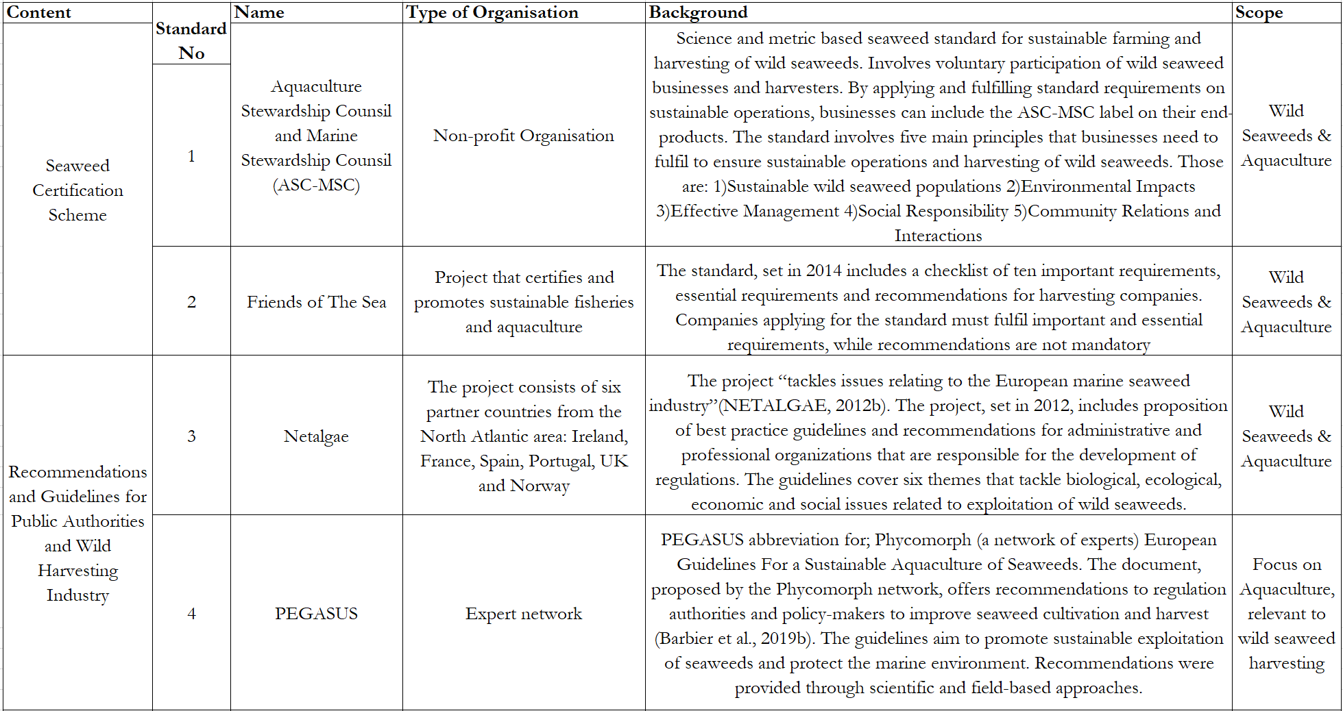

Table 3Detailed description of the following standards: EAR, Scoping Report, Mara and Natural England
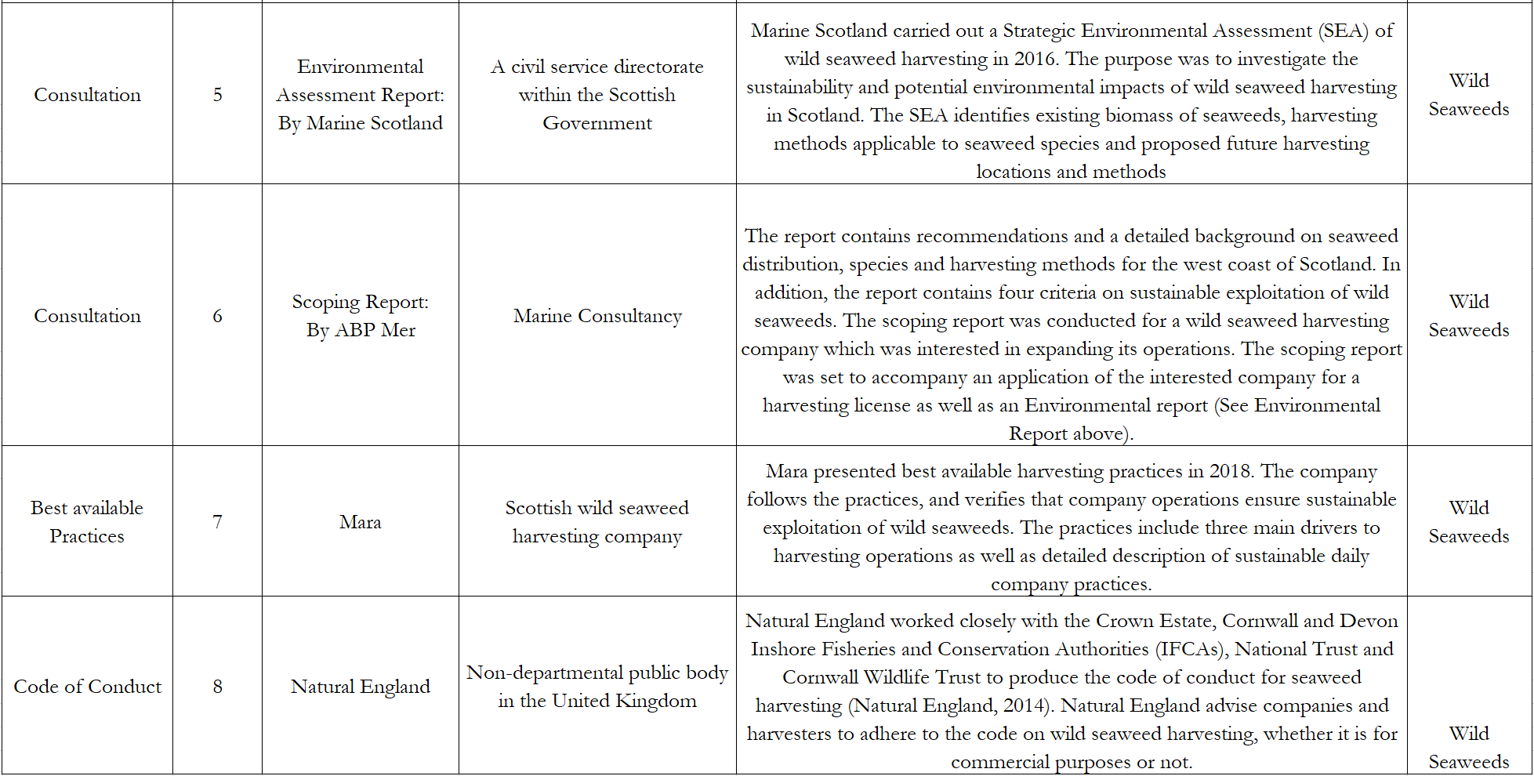

Analysis of Standard Review
Each standard in the standard review was organised and analysed in a single sheet in Microsoft Excel. Each criterion, recommendation or guideline within each standard was arranged in an individual cell (See Appendix IV: Identification of criteria in analysed standards). This organisation method was used to get a detailed overview of all criteria, recommendations and guidelines within the standards. After the organisation, relevant themes and criteria emerging from the standards were identified. Several standards included similar criteria, for example, ‘Research’ and ‘Monitoring’. Similar criteria were given the same abbreviations. For example, criteria relating to research were organised under R or ‘Research’ criterion (See Appendix IV). After an initial inspection, 13 main recurring criteria were identified. In order to simplify the criteria a second analysis was conducted where similar criteria and recommendations were grouped together. For example, the two criteria; communication and collaboration were assembled in ‘Communication & Collaboration’ as they included very similar aspects. This method resulted in eight different criteria (see Figure 4 in Chapter 3). In order to ensure cohesiveness and consistency the author analysed the standards and criteria for a second time to check if the same final criteria were identified. Appendix IV shows the analysis of each standard.

Collection of the Icelandic seaweed regulatory framework
A review of the Icelandic seaweed regulatory framework was conducted to fill in information gaps and answer research question 3 in Chapter 1. In addition, analysed criteria from the standard review were compared to the Icelandic framework, to see if standards and the regulatory framework included similar aspects to sustainable exploitation of wild seaweed. The current Icelandic seaweed regulatory framework consists of three regulations: (1) the Regulation on harvesting of seaweed for commercial purposes, ('Reglugerd um öflun sjávargróðurs í atvinnuskyni’), (2) Regulation on weighing and registration of Marine stocks ('Reglugerð um vigtun og skráningu sjávarafla') and (3) Regulation on logbooks and catch statistics ('Reglugerð um afladagbækur'). In addition, the two laws are of relevance; (a) the Fisheries management act ('Lög um stjórn fiskveiða')and (b) The Conduct of Exploitable Marine Stocks ('Lög um umgengni um nytjastofna sjavar'). The regulations and laws were identified through Google search and the webpage of the Icelandic parliament. For the author of this thesis to be secure that all relevant regulations and laws were analysed for the review, stakeholders were asked to identify relevant regulations and laws on seaweed exploitation. A brief explanation of the most important requirements in the framework can be seen in Chapter 1.3.

Analysis of the Icelandic seaweed regulatory framework
The analysis of the regulatory framework was similar to the standard analysis. All eight criteria identified in the standard review were compared to all paragraphs within the Icelandic regulatory framework. The regulatory framework was printed out and analysed by hand. Appendix V shows identified criteria in the ISRF.

Stakeholder interviews
After reviewing literature, standards and the ISRF, semi-structured interviews were conducted with 14 stakeholders in the wild seaweed harvesting industry. The purpose of the interviews was to check if stakeholder perceptions and opinions of sustainable exploitation of wild seaweed mirrored identified standard criteria. Acquired data provided background of the industry and answers to research question 1 (Chapter 1.5).

2.2.7.1 Selection of stakeholders
In order to select and identify relevant stakeholders, the author drafted a picture of the wild seaweed harvesting industry in Iceland. The draft included academia, regulatory authorities, harvesting companies, municipalities, communities and other actors (see Figure 3). The scope of this thesis is on the Icelandic case of wild seaweed harvesting, but as the Icelandic industry is relatively small, experts from other countries were identified. This was done in order to gather different perspectives from similar industries and stakeholders in other countries and to obtain more empirical material for analysis. The supervisor of this thesis revised the draft and provided additional knowledge. Figure 3 shows the stakeholder draft that was used to identify relevant stakeholders. In addition to Figure 3, interviewees were chosen from literature, relevant companies, and identified through other interviewees.
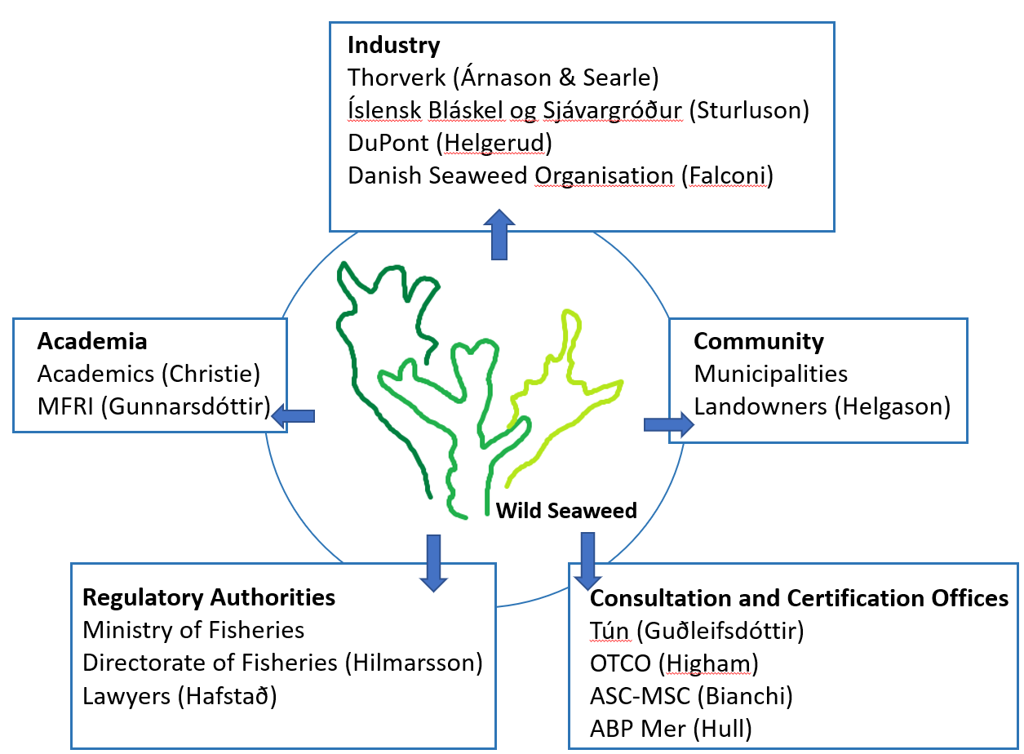
Figure 3 Draft of Stakeholder Selection (Source: own elaboration)
A total of fourteen stakeholders from six countries were interviewed via email, Skype, phone or in person. Seven interviewees are from Iceland, two from Norway, three from the United Kingdom, one from the United States and one from Denmark. A table with the full list of interviewees can be seen in Table 4 (Chapter 4) and the full detailed list of interviewees is in Appendix VI.
An email including introduction letter (See Appendix I and Appendix II) and a request for an interview were sent to each stakeholder. The final list of interviewees was reviewed by the supervisor of this thesis, to confirm that the author contacted relevant and diverse group of stakeholders.
The opinions and experience of the interviewees are relevant and comparable to the Icelandic context due to several factors. The justification and relevance for experts interviewed from the following countries are as follows;
- Denmark: The ‘Danish Seaweed Organisation’ was considered as a relevant stakeholder due to its operations and geographical location in The North-Atlantic Ocean. Currently, the same species are harvested in Denmark and in Iceland. Only one interviewee was identified in Denmark and asked on the economic value and growth of the wild seaweed industry there. The answers provided were very similar to the wild seaweed industry in Iceland.
- United Kingdom: Several Icelandic stakeholders referenced the national ban of mechanically harvested kelp in Scotland and that regulations and laws on wild seaweed exploitation were implemented at a similar time as the ISRF. In addition, The United Kingdom currently harvests rockweed in the North-Atlantic Ocean which is the case for the wild seaweed harvesting industry. Lastly, the company that intended to set up operations in Iceland, showed similar interest in constructing a wild seaweed harvesting plant in the UK, prior to the ban on kelp harvesting.
- Norway: The author decided to include Norwegian academic Christie as an interviewee based on his previous studies on kelp distribution in Norway and other European countries, including Iceland. In addition, Norway relies heavily on marine and coastal resources from the North-Atlantic Ocean, similar as Iceland.
- The United States: Only one stakeholder (OTCO) was contacted and identified by the author. According to Árnason, Thorverk applies for an organic certification label by OTCO, which in turn reviews if Thorverk’s operation are parallel with OTCO’s standards. In addition, Thorverk is owned by the international company DuPont, a chemical company in the U.S., which conducts wild harvesting operations in Norway and Iceland.

2.2.7.2. Interview protocol
An interview guide was constructed with the purpose to answer research questions stated in Chapter 1.5, which were formed according to the ‘Problem definition’ in Chapter 1.4. The interview protocol was influenced by literature review, standard review and initial discussions with stakeholders, as these gave the author a better idea of relevant issues. The author wrote down relevant questions to stakeholders, but the final interview guide was discussed with the thesis supervisor. An interview guide was created both in English and Icelandic. A simplified version of the interview protocol can be seen in Appendix VII—in English and Appendix VIII-in Icelandic.
The stakeholder interviews followed a semi-structured format based on the interview guide. To acquire information and fill in information gaps, interviewees were allowed to elaborate on topics and different themes that emerged during interviews. When interviewees raised important issues or relevant information that the author was unaware of, follow-up questions were asked during interviews. Due to the diverse background and knowledge of each stakeholder, some questions in the interview guide were skipped. In addition, if time allowed, extra questions were asked, that were relevant to the stakeholder discussions and topic of this thesis.
Interviews were conducted from June 18th to July 17th, through phone, Skype, email or in person. Each interview was set to last for half an hour, with stakeholders answering eight to ten questions. Due to interest and in-depth discussions, several interviews lasted up to an hour. The author attempted to remain impartial and to avoid asking leading questions, as partiality has shown to lead to desirable, but biased discussion (Patton, 2002). In addition, stakeholders were asked if their full name, and profession could be included in this thesis. Where permission was given, interviews were recorded via voice recorders through the author’s telephone. Stakeholders were informed that all recordings would be deleted after this thesis process.

2.2.7.3. Interview analysis
After each interview, the thesis author reviewed notes that were written during each interview. When a stakeholder gave permission for audio recording, the author transcribed the interview into to a Microsoft Word document. Not all interviews were recorded due to technical problems and the interview form. Finally, key themes and a summary of each interview were written at the bottom of each Word document. To get a holistic view of emerging themes, all interviews were gathered in one document which was printed out. The thesis’ author drafted notes and criteria abbreviations on the pages that provided helpful for her thought process. This document has now been shredded.
Regarding the interviews, stakeholders were asked questions on the following themes; sustainability, certifications, regulations and economic benefits of wild seaweed. Concluding all fourteen interviews, criteria on sustainable exploitation of seaweed were analysed and other discussion categorised according to themes. This was conducted to obtain an overview of stakeholder’s ideas and opinions on factors within the wild seaweed harvesting industry. In addition, criteria on sustainable exploitation of seaweed were analysed and categorised in the same way as criteria in the standard review. Criteria on sustainable exploitation of seaweed, mentioned by stakeholders were reported in a sheet in Microsoft Excel. Analysed criteria and recommendations were then grouped together to form relevant ‘final-criteria’. Other findings from interviews were analysed and discussed in Chapter 4 ‘Stakeholder Reflections’.
To avoid any misinterpretation and misrepresentations by the author, a document draft of ‘Stakeholder Reflections’ was sent to all interviewees. Interviewees were then asked if all direct references could be included in the final thesis. Some quotes were tweaked by stakeholders, as some information was only bestowed as background information, but not intended for public viewing. All notes by stakeholders were applied to the final format of this thesis. The results and findings from stakeholder interviews are presented in Chapter 4.

Quantitative data:
Quantitative data on harvested rockweed and kelp was gathered from the MFRI. To increase the validity of the statistics, Thorverk was asked for the same data. The gathered documents showed the same numbers of harvested volumes, and so the data was judged as reliable. Seaweed data was analysed in Excel and displayed in graphs, which can be seen in Chapter 1.2. Additional data on available seaweed biomass in Breiðafjörður was gathered from online report, compiled by the MFRI. Information on volumes harvested by Íslensk Bláskel was gathered through an interview with the owner of the company. This data, although verbal, was used in context with harvested seaweed volumes of Thorverk. A more detailed discussion on Íslensk Bláskel’s harvested volumes can be seen in Chapter 4.
The quantitative data gathered from Thorverk and the MFRI were used to assess the trend of rockweed harvesting as well as show the growth of the industry in Iceland. Data aided in filling in information gaps and inform the author of the background of the seaweed harvesting industry in Iceland. In addition, the data provided support for some of the questions in the Interview protocol (Appendix VII and Appendix VIII).

Review of literature, standards and the ISRF
This chapter examines all relevant material found in relation to the thesis topic. Key themes within literature, relevant standards and the Icelandic seaweed regulatory framework were identified and discussed as findings helped answer the research questions in Chapter 1.5. This chapter entails three reviews; the first is a literature review on academic papers, research and other relevant documents (See further details in Chapter 2.2.1 and Chapter 2.2.2). The second review is on existing standards which entail criteria on sustainable exploitation of seaweed for commercial purposes (See Chapter 2.2.3 and Chapter 2.2.4). The third review consists of Icelandic laws and regulations on wild seaweed exploitation in Iceland (Chapter 2.2.5 and Chapter 2.2.6). The purpose of the literature review was to get a holistic view of the wild seaweed harvesting industry and the natural and economic benefits of seaweed. The standard review involved identifying and analysing relevant standards to understand which key-criteria companies must meet in order to harvest seaweed sustainably. Identified criteria from literature and standard reviews were then compared to the regulatory framework, in order to see which criteria the Icelandic framework includes.
Findings from the literature and standard reviews are presented together in the sections below, as they showed similar themes. Identified criteria within the regulatory framework are brought up and discussed in subsections of each criteria. Each section within this chapter entails a discussion on the identified criterion from the standard review but findings are backed up by research and information from the literature and regulatory framework reviews. The information gathered from all three reviews were then compared and summarised at the end of the chapter as well as the author expresses her personal reflections.
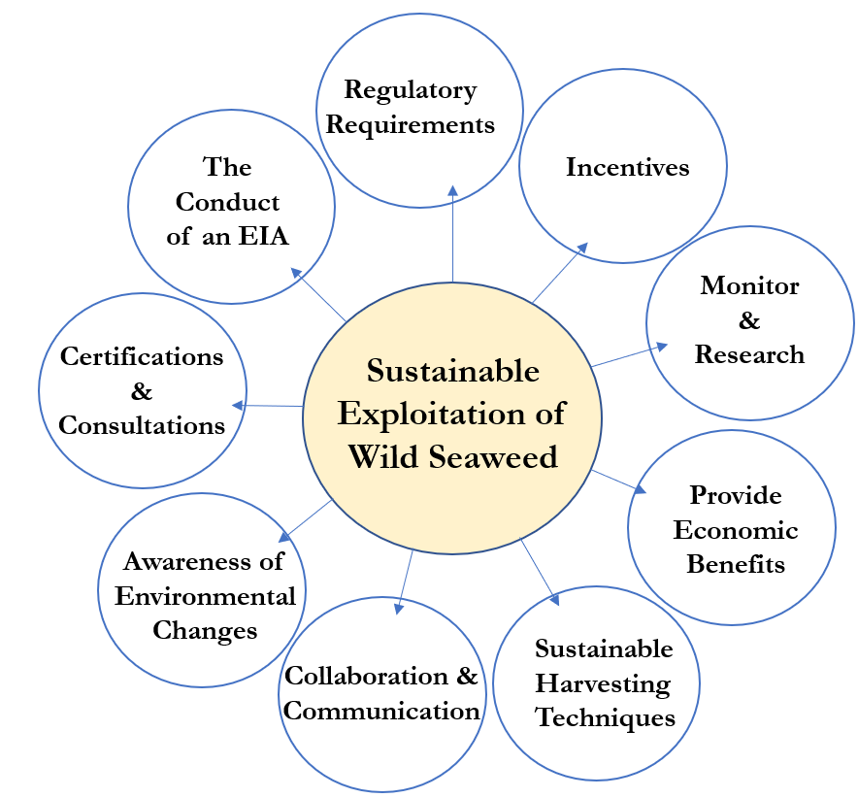
The purpose of the reviews were to get a better understanding and knowledge of the seaweed industry, and for the author to present relevant recommendations for regulatory authorities in Iceland (see Chapter 6). Figure 4 shows identified criteria with the addition of the ‘Incentives’-criterion, identified through the framework review. As the focus of this thesis is on ecological and economic criteria, all identified criteria relating to social aspects were excluded from the analysis.

Figure 4 Analysed standard criteria on sustainable exploitation of wild seaweed (Source: own elaboration)

Monitor & Research
Each standard within the second review included several references of monitoring and research, which highlights the importance of companies to observe harvested wild seaweed. The criterion mandates companies to map harvesting zones, record harvested volumes, develop practical guidelines, research total biomass of different species, rotate harvested areas to allow species ample time for recovery between harvests and use best available data and practices when possible (ASC-MSC Seaweed Standard, 2017; Friends of The Sea Certification Criteria Checklist for Seaweed Products, 2014; Barbier et al., 2019a; Marine Scotland, 2016; Natural England, 2014; NETALGAE, 2012; Oaten et al., 2018; Mara, 2018).All analysed standards highlight the importance of this criterion, as companies should monitor, and research harvested areas to set sustainable harvesting rates accordingly. One standard suggested minimum and maximum quantities of macro-algae landings to be reviewed periodically (NETALGAE, 2012), while two standards stressed the importance of harvesting during active growth and after reproductive seasons for different species (Marine Scotland, 2016; Natural England, 2014). Standards ranged in detail of advice. Mara (2018), and Friends of the Sea (2014) simply recommended “Monitoring”, “Management system” and “Water monitoring” while ABP Mer (2016) provided more detailed descriptions such as “kelp density needs to be 5kg/m³”. PEGASUS was the only standard to point out the importance of continuous and increased need for more research and monitoring of seaweed, harvesting areas and ecosystems, as other standards found monitoring and current research of species to be sufficient for sustainable production (Barbier et al., 2019a).
Academic literature supports the importance of monitoring & research criterion, as some countries who currently harvest wild seaweed lack both data and research on the resource. One paper showed that four out of nine countries (some of which harvest wild kelp in the Atlantic Ocean) were not aware of the current extent on harvested species and five out of nine countries did not have information or data on the density of the same resource (Araujo et al., 2016). The authors expressed their concerns regarding lack of quantitative data on seaweed populations and a lack of seaweed experts in harvesting countries. Iceland was among the countries to be assessed but due to “few experts working on kelp forests [..] or not willing to contribute” the country did not take part, which causes concern (Araujo et al., 2016). Another research paper echoed difficulty in finding consistent data on seaweed production, but the limited data available rarely states if it refers to dry or wet material, which differ vastly in weight and it is therefore hard to compare to other datasets (Barbier et al., 2019b). Furthermore, monitoring & research on available biomass in countries that currently harvest seaweed, is not yet in place (Araujo et al., 2016). The lack of this criterion seems problematic since identifying sustainable harvesting rates can be difficult if total available biomass of seaweed is not known. The absence of monitoring led to over harvesting of seaweed in France and Canada in the last century, and some seaweed species in France are reported to be on the verge of local extinction (Davoult et al., 2011; Mac Monagail et al., 2017; West et al., 2016).

ISRF; Monitor & Research
Regulations and laws in the Icelandic regulatory framework all mention the need for businesses and seaweed harvesters to monitor and report harvested volumes to regulatory authorities. Only one regulation specifically describes how rockweed should be monitored ('Reglugerd um öflun sjávargróðurs í atvinnuskyni') while other regulations group monitoring of seaweed and fish stocks as ‘catch’ ('Lög um stjórn fiskveiða'). Furthermore, seaweed harvesters and fishermen are defined as ‘captains’, which can be confusing as seaweed in Iceland are not harvested on boats or ships (‘Lög um umgengni um nytjastofna sjavar’; ‘Lög um stjórn fiskveiða’; ‘Reglugerð um afladagbækur’; ‘Reglugerð um vigtun og skráningu sjávarafla’). Examples of monitoring practices include harvesting businesses, or captains, to report harvested volumes to the Directorate of Fisheries, rotate harvested areas and weigh landings at local ports within two hours of landing (‘Lög um umgengni um nytjastofna sjavar’; ‘Lög um stjórn fiskveiða’; ‘Reglugerð um vigtun og skráningu sjávarafla’; ‘Reglugerd um öflun sjávargróðurs í atvinnuskyni’). Ports where seaweed are landed must comply with regulation on weighing and registration of marine stocks and monitoring practices within the same regulation (‘Reglugerð um vigtun og skráningu sjávarafla’). In addition, the Directorate of Fisheries must collect and publish data on seaweed landings and make it readily available online (Lög um umgengni um nytjastofna sjávar).
In regard to research, the MFRI and the Icelandic Institute of Natural History should research and monitor seaweed and nearby ecosystems. The organisations should conduct monitoring and utilisation plans in accordance with laws on natural conservations (‘Lög um stjórn fiskveiða’).

Sustainable harvesting techniques
Six out of eight standards mentioned several aspects related to sustainable harvesting techniques of seaweed. The criterion entails a narrow scope and a detailed description of how companies should go about harvesting sustainably. Examples include; cut only tops of rockweed, avoid removing whole rockweed ‘plants’, avoid removing holdfasts and only harvest specific species (ASC-MSC Seaweed Standard, 2017; Friends of The Sea Certification Criteria Checklist for Seaweed Products, 2014; Barbier et al., 2019a; Natural England, 2014; NETALGAE, 2012; Oaten et al., 2018; Mara, 2018)Academic literature shows that ecosystems are quicker to regrow and adapt if only tops of rockweed are cut, and holdfasts are left. Furthermore, sunlight is more easily accessible to juvenile algae when larger seaweed are harvested (Oaten et al., 2018).
The standards recommended different harvesting techniques. Mara and Natural England encouraged hand-harvesting methods stating that the technique is less likely to disrupt or unbalance ecosystems than mechanical harvesting techniques (Natural England, 2014; Mara, 2018). According to Natural England’s standards (2014), “mechanical methods should not be used” by harvesting companies. This can provide confusion, as the standard does not define what ‘mechanical methods’ entail. Both scissors and cutters can arguably be defined as mechanical tools, operated by hand, just as mechanical harvesting machines. Other standards do not mention hand cutting methods, but rather recommend mechanical harvesting techniques. One standard concluded that companies could use trawling methods in a sustainable way while another standard simply encouraged harvesters to use ‘sustainable harvesting techniques’ (NETALGAE, 2012; Oaten et al., 2018). Although ‘sustainable harvesting techniques’ was not described in detail, the techniques should aim to minimise the impact on juvenile macro-algae in order to encourage the regeneration of exploited areas (Barbier et al., 2019b; NETALGAE, 2012).
Academic literature does not come to a single conclusion as to which seaweed harvesting technique provides the least ecological impact. One article mentioned that overexploitation using hand-harvesting methods did occur in a few sites in Nova Scotia in the early years of the industry (FAO, 1987). Literature mentions several mechanical harvesting techniques, intended for different species and areas. Trawling has, for example, been used extensively for the past decades to harvest kelp forests in Norway. A research paper concluded that trawling can avoid irrevocable effects on ecosystems when combined with effective rotation (Morrison, 2018; Vea & Ask, 2011). Rotation is when seaweed is harvested within an area but left to recover and regrow for a sufficient time before harvested again. In the meantime, harvesting continues in another zone with the same or different species. Rotation differs with time, species, harvesting techniques, areas, countries, companies and other factors, although most countries do not harvest within the same area until three to five years later (McHugh, 2003; Ugarte & Sharp, 2012).
Other academic literature mentions that trawling does in fact have a substantial effect on primary and secondary production of ecosystems, concluding that secondary reproduction rates could be reduced by 70-98% within trawled areas, although recovery rates were listed as ‘unknown’ (Mac Monagail et al., 2017). A recent paper noted that although rotation systems are used in kelp trawling, kelp growth within harvested areas was still below pre-harvest levels after the four year rotation system ended, concluding that the time between areas was not enough for ecosystems to recover from trawling (Steen, Norderhaug, & Moy, 2018). According to a research from the MFRI, harvesting techniques have stayed the same in Breiðafjörður since 1970s, but research indicates that the seaweed biomass has grown or remained stable during the same period (Gunnarsson et al., 2017). This indicates that current harvesting techniques do not present harmful impact on seaweed populations in Breiðafjörður (Gunnarsson et al., 2017). This study concludes that additional research on the impact harvesting has on flora and fauna in Breiðafjörður is needed. In conclusion, hand-harvesting seems to be widely accepted as a sustainable harvesting technique although literature does not entail if the technique is possible for larger scale operations and studies show that the method can lead to overexploitation. Although some standards object to mechanical harvesting methods, literature shows that different methods can be sustainable. To summarise, no clear conclusion was reached on which harvesting techniques companies should follow.

ISRF; Sustainable harvesting techniques
The regulatory framework mentions several aspects of sustainable harvesting techniques. As stated in ‘Monitor & Research’ criterion, the seaweed are assumed to be harvested by vessels or boats. According to regulations, “The minister of fisheries may ask those who harvest seaweed for commercial purposes, without the utilisation of ships, to submit a harvesting report to the Directorate of Fisheries” (Lög um stjórn fiskveiða). According to the framework, “seaweed should not be damaged by harvesting techniques [and] […] ships, and prams used for harvesting of rockweed should prevent holdfasts from tearing from the bottom” (Reglugerd um öflun sjávargróðurs í atvinnuskyni). “The percentage of seaweed, where the holdfast is attached to, should not exceed 8%. The remaining stem of the plant should generally not be lower than 25cm, measured from the holdfast” (‘Reglugerd um öflun sjávargróðurs í atvinnuskyni’).
Seaweed harvesting businesses in Iceland need to acquire licenses (see ‘Regulatory requirements’ later in this chapter). According to the framework, conditions can be set in permits, in regard to harvesting methods and other factors (Lög um stjórn fiskveiða). In addition, “[…] temporary bans on harvesting within areas can be applied to allow seaweed time to re-grow after harvesting has occurred” (Lög um stjórn fiskveiða).

Regulatory requirements
All standards mandated the need for regulatory authorities and seaweed harvesters to follow, set or update regulations and laws on wild seaweed to ensure sustainable exploitation. The analysed standards encouraged the wild seaweed industry to follow and respect local, national and international laws and standards as well as not harvesting within conserved or banned marine areas (ASC-MSC Seaweed Standard, 2017; Friends of The Sea Certification Criteria Checklist for Seaweed Products, 2014; Marine Scotland, 2016). Three standards recommended harvesters to require marine licenses, obtained from regulatory authorities, or follow a quota set by similar authorities (NETALGAE, 2012; Oaten et al., 2018; Mara, 2018). These recommendations echo concerns from the ‘Monitor & Research’ section above, as harvesters should know what volumes of seaweed can be harvested without overexploiting the resource. Lastly, one standard brings up the importance of updating existing regulations (for example different threshold values of natural contaminants within seaweed). The same standard states that existing regulations have shown to function as bottlenecks that hamper market development (Barbier et al., 2019a). Regulations on heavy metals may be the biggest hurdle to successful updating, since they impose an artificially low limit for what is perceived as safe consumption. Many regulations do not distinguish between inorganic and organic heavy-metal compounds but most of the heavy metals in seaweed are organic and therefore harmless for humans (Barbier et al., 2019b). For example, the consumption of seaweed is much higher in Asia than in Europe, but there are no detectable negative health effects in either continent regarding seaweed consumption (Barbier et al., 2019b).
Several academic papers echo the need for stricter and more coherent regulations on wild seaweed harvesting. Literature shows that although EU regulations exist on aquaculture and seaweed production (Commission Regulation (EC) No 710/2009), no international regulations exist on wild seaweed harvesting, leading to concerns of overharvesting on a larger scale. In addition, several articles state that current regulations and laws lack structure and are too lenient, without specifically pointing out what needs to be improved (Araujo et al., 2016; Ferdouse et al., 2018; Mac Monagail et al., 2017; Marine Scotland, 2016).

ISRF: Regulatory requirements
As the framework consists of laws and regulations, its existence fulfils the identified standard criterion of ‘Regulatory requirements’. Although the framework applies to businesses that harvest seaweed, articles do not apply to seaweed cultivation, harvesting of dulse or other minor harvesting activities that account for less than ten tons each year (Lög um stjórn fiskveiða). Violation of the legal framework can result in revocation of harvesting licenses or punishment under the Criminal Procedure Act (Reglugerd um öflun sjávargróðurs í atvinnuskyni).
According to the ISRF “No one may engage in commercial seaweed harvesting from ships, including prams [solely used for seaweed harvesting], unless they have received a license granted by the Directorate of Fisheries” (Lög um stjórn fiskveiða). Seaweed harvesting companies must obtain fishing (harvesting) permits from the government to be able to harvest seaweed for commercial use. In addition, companies that harvest over 10 thousand tonnes of seaweed per year must acquire permits for weighing, as all ocean landings (fish, seaweed etc.) have to adhere to regulation on weighing and registration of marine stocks (Reglugerð um vigtun og skráningu sjávarafla). If large seaweed harvesting companies do not obtain both licenses commercial harvesting would not be in accordance with the ISRF.
The need for licenses or certifications from the Directorate of Fisheries are referenced multiple times within the framework and repeatedly in regard to boats or vessels. In addition, companies, authorities and other stakeholders must adhere to the consultations of the MFRI and the Icelandic Institute of Natural History. It must be noted that currently, seaweed are exclusively harvested by prams (Thorverk) or by hand (Íslensk Bláskel) in Iceland. No business or harvesting operation utilises boats or vessels for harvesting.

Awareness of environmental changes
Five out of eight standards mentioned that harvesting companies must be aware of environmental circumstances in relation to sustainable wild seaweed exploitation. Natural England and ABP Mer’s standards recommended that harvesting should be limited within erosion-prone coastal areas as kelp forests dissipate wave energy and that disturbing of wildlife (such as sea urchins, seals and seabirds) should be avoided. Furthermore, ‘check, clean and dry’ biosecurity principles should be followed when going from one harvesting area to the next to insure that invasive species, pests and diseases do not spread to new areas (Marine Scotland, 2016; Natural England, 2014). Other standards entailed harvesting to have a low impact on ecosystems and that they should be allowed to maintain productivity, diversity and structure. Additionally, harvesting companies should avoid significant environmental effects within harvested areas (ASC-MSC Seaweed Standard, 2017; NETALGAE, 2012; Oaten et al., 2018). The importance of keeping various environmental effects in mind are vital for the sustainability of company operations as environmental circumstances differ between and within ecosystems and harvesting areas.
Although limited academic literature exists on sustainable exploitation of wild seaweed, articles on carbon storage of seaweed and rising ocean temperatures show the importance of harvesting businesses to stay mindful of changing seaweed surroundings. The following subsections explore findings from a literature review on Carbon storage and sequestration of seaweed and their reaction to rising ocean temperatures and marine acidification. These sections show that global warming plays an important factor in the distribution and biomass of seaweed, and highlight the fact that businesses need to be aware of environmental surroundings to ensure sustainable exploitation and utilisation of seaweed.

Carbon storage and sequestration
Due to a lack of research, Carbon captured and storage of kelp forests is not considered as part of Carbon that is captured within the world’s marine and coastal vegetation habitats (Bayley, Marengo, & Pelembe, 2017; Harley et al., 2012). Recent articles state that the global standing stock of Carbon held within kelp forests have been greatly underestimated and that the Carbon storage and sequestration of seaweed helps mitigate ocean acidification (Nellemann et al., 2009; Pessarrodona, Moore, Sayer, & Smale, 2018a). Several papers concur over the importance of seaweed in regard to Carbon sequestration. One study states that macro-algae sequester approximately 170 mega tonnes of Carbon each year, with the majority of this sequestration facilitated through transport into the deep sea, forming ‘Carbon sinks’ (Bayley et al., 2017). Bayley et al (2017) revealed that marine habitats capture more overall Carbon annually than habitats on land. McLeod et al (2011) add that “Although their [coastal and marine ecosystems] global area is one to two orders of magnitude smaller than that of terrestrial forests, the contribution of vegetated coastal habitats per unit area to long‐term Carbon sequestration is much greater. This is partly because of their efficiency in trapping suspended matter and associated organic Carbon during tidal inundation”. Surprisingly, ABP Mer’s standard did not agree with these findings, as it concluded that kelp habitats are not effective in acting as long term carbon storages as the accumulation of detritus within kelp habitats is very small (Marine Scotland, 2016).
This discrepancy may be because the studies included Carbon sequestration and storage of several species, in different areas, ecosystems and latitudes whereas ABP Mer only mentioned kelp. The authors of academic literature expressed the need for more research on carbon storage and sequestration in macro-algae (Araujo et al., 2016; Bayley et al., 2017; McLeod et al., 2011).

Rising ocean temperature and acidification
Research that studied the effects of ocean warming and acidification on seaweed show the need for more research and for companies to stay attentive to changes within the environment. One article mentioned that increased acidification and ocean temperatures can both positively and negatively affect seaweed and species that feed on it (Harley et al., 2012). The study predicted that warmer ocean temperatures would negatively affect several lifecycles of seaweed though it would positively affect their natural predators and grazers such as sea urchins. Increased acidification was predicted to have both negative and positive effects on kelp and have a negative impact on grazers and calcified herbivores. The impact of both increased temperatures and acidification (a more realistic climate change scenario than either warming ocean or acidification) remains poorly understood (Harley et al., 2012). Another scientific study stated that “The distributions of seaweed have been changing globally, with increasing SST [Sea Surface Temperatures] being one important driver behind these shifts”(Wilson, Kay, Schmidt, & Lotze, 2015). The study examined physiological response of seaweed in the North-Atlantic, including rockweed which are commercially harvested in Iceland. A simulation of increased ocean surface temperatures up to 29°C showed that “all replicates of L. digitata (rockweed), died at this temperature” (Wilson et al., 2015). The study concludes that increased SST on kelp forests are currently unknown.
Another scientific article showed that primary productivity -such as Carbon storage of seaweed- can be reduced under warmer conditions (Pessarrodona, Moore, Sayer, & Smale, 2018b). Seaweed populations inhabiting warmer areas were reported to store on average 68% less Carbon than the same species at a northern location (Pessarrodona et al., 2018b). In the past decades, some species (including kelp) have undergone a reduction of 250km² of growing area, which is attributable to an increase in ocean temperatures but further losses are expected in correlation with increased ocean warming (Assis, Lucas, Bárbara, & Serrão, 2016). In addition, several studies concluded that wild seaweed populations are diminishing in many European countries (Araujo et al., 2016; Filbee-Dexter & Wernberg, 2018; Mac Monagail et al., 2017). To conclude, increasing ocean temperatures and marine acidification are important for harvesting companies to research and implement considerations of its effect into harvesting plans and represent any potential impacts in their commercial strategies. If companies were to continue harvesting the same volumes of seaweed without monitoring and research, a change in the environment could lead to possible overharvesting.

ISRF; Awareness of environmental changes
The regulatory framework briefly mentions that companies should stay mindful of environmental circumstances. “Permits may be modified or revoked at any time deemed necessary for the protection of the environment” (‘Lög um stjórn fiskveiða’).

The conduct of EIA
Six standards encouraged companies to conduct impact assessments on species and associated communities. Some called for monitoring impact on the environment or for companies to conduct environmental impact assessments (EIAs), either prior-to or before-&-after companies have been approved for wild harvesting (Barbier et al., 2019a; Friends of The Sea Certification Criteria Checklist for Seaweed Products, 2014; Marine Scotland, 2016; NETALGAE, 2012; Oaten et al., 2018). These similar assessments were grouped together under the ‘Conducting of EIA’ criterion, as they all share the same purpose of persuading harvesting companies to check how/whether their operations affect surrounding environment. Literature shows that although some countries, such as Scotland, encourage companies to conduct an EIA before harvesting, most companies are not obliged to carry out environmental impact assessments, - including in Iceland.
A strategic environmental assessment of wild seaweed harvesting was published by Marine Scotland in 2016. This document was produced due to the interest of a company in harvesting wild seaweed within Scotland. The environmental assessment concluded that harvesting could be done in an environmentally sustainable way, but public perception, remarks and private analysis on harvesting operations led to a national ban on mechanical harvesting of kelp in Scotland (Mann, 2018; Philip, 2018).

ISRF; The conduct of EIA
None of the regulations and laws within the seaweed framework mentioned the need for stakeholders to conduct EIA or similar risk evaluations for company productions. Prior to granting permits to harvesting companies, the Directorate of Fisheries does not require documents or information on company and harvesting operations. This could potentially lead to concerning consequences. Discussion and recommendations for regulatory authorities to mandate companies to conduct EIAs before or during harvesting are provided Chapter 6 and Chapter 7.

Harvesting to provide economic benefits
Four of the standards called for harvesting operations to provide economic generation linked to wild harvesting production. Seaweed harvesting businesses are encouraged to consider economic issues prior to exploitation as well as work with local communities and deliver economic benefits to wider societies (NETALGAE, 2012; Oaten et al., 2018). Public authorities are also recommended to recognise seaweed harvesting as an economic activity and to push for equitable use of coastlines in regard to economic priorities (Barbier et al., 2019a; NETALGAE, 2012). Although only four standards mentioned the need of harvesting operations to provide economic benefits, most standards presumably assume that companies only harvest if profit is generated for the harvester. This criterion does not only imply economic benefits generated for operators, but also for the wider community while respecting ecological limits of the resource (Barbier et al., 2019b).
Several articles predict that the wild seaweed industry will grow in coming years as seaweed are increasingly used in the food industry and regarded as the latest ‘superfood’ (Adams, 2016; Bayley et al., 2017; Ferdouse et al., 2018; Mac Monagail et al., 2017). Other articles expressed concerns on regulations getting in the way of increased production and economic value of the resource (Barbier et al., 2019b). Additional articles addressed the socio-economic value of seaweed as harvesting contributes to value within coastal communities by providing jobs and stable incomes (Adams, 2016; Alban, Frangoudes, Prénom, & Fresard, 2011; Bayley et al., 2017; Cottier-Cook et al., n.d.; Marine Scotland, 2016). Literature was coherent in the financial estimation of the wild seaweed industry of €6-8 billion (Barbier et al., 2019b; McHugh, 2003), but a standard mentioned the need for a global market analysis to determine the true economic value of the wild seaweed resource (Barbier et al., 2019b). This is relevant to keep in mind as the growing economic importance and value of seaweed might increase the attention of regulatory authorities to implement tighter regulations on seaweed (Pessarrodona et al., 2018a).

ISRF; Harvesting to provide economic benefits
Economic benefits generated by harvesting operations are mentioned in the Fisheries Management Act. “An authorisation to assessing applicant’s ability, on technical know-hows, financial position, contribution to research on seaweed and coastal ecosystems, and the impact of the proposed activities on communities where prolonged population decline and monotonous economy may be considered” (‘Lög um stjórn fiskveiða’).

Collaboration & Communication
Two standards called for increased cooperation or active engagement of public authorities, academia and other marine users within the seaweed industry (NETALGAE, 2012; Mara, 2018). By encouraging cooperation, public authorities could set up a framework where all parts of the industry and stakeholders can meet, work together, voice their concerns and objectives in a transparent way.
This criterion is echoed by additional literature that states that stakeholders should not work independently, but rather together where industrial operations are made transparent and traceable (Barbier et al., 2019b; Oaten et al., 2018). Limited academic literature exists on collaboration within the wild seaweed sector but one article suggested that experts within Europe should collaborate to develop guidelines and strategies for European seaweed resources (Rebours et al., 2014). This could prevent over harvesting of wild seaweed populations

ISRF; Collaboration & Communication
The importance of collaboration between stakeholders is highlighted within the framework. Prior to obtaining harvesting licenses, companies should communicate and reach an agreement with landowners to be able to harvest rockweed from their property (‘Lög um stjórn fiskveiða’; ‘Reglugerd um öflun sjávargróðurs í atvinnuskyni’). Importantly, companies cannot harvest seaweed without the consent of landowners.
Regulatory authorities can implement bans on harvesting within areas outside of landowner’s jurisdiction. Before making decisions “[…] recommendations from the MFRI and the Icelandic Institute of Natural History and other actors should be followed, such as the committee of Breiðafjörður on utilisation on seaweed (‘Lög um stjórn fiskveiða’).

Certifications & Consultations
The last criterion entails harvesters to acquire third party certifications or consultations for harvesting operations. One standard suggested that companies should consult organisations and local inshore fisheries prior to harvesting (Natural England, 2014). Another standard recommended best company practices of harvesting techniques to follow organic certification standards to ensure sustainable exploitation (Mara, 2018). Two standards recommended companies to meet with consultation offices prior to harvesting, although this is not a requirement (Marine Scotland, 2016; Oaten et al., 2018). Although the standard-review entails twin certification-schemes, neither of those suggest companies to acquire certifications or consultations from third parties prior to harvesting.

ISRF; Certifications & Consultation
The ISRF does not provide chapters on certifications, but companies are urged to follow recommendations and consultations set by the MFRI.

Incentives
This criterion entails financial fines or the revoking of harvesting licenses in the case of overexploitation and unsustainable harvesting of wild seaweed. It is important to mention that neither literature nor standard reviews mentioned the possibility of disincentivising businesses over unsustainable exploitation of seaweed. In comparison, the ISRF entails over 14 articles on bans, payments, imprisonment or other punishments under the Criminal Procedure Act, where overexploitation occurs. Incentives have been used and regarded as market-based instruments that decrease the probability of unsustainable operations. Due to this concept, incentives represent the final criterion that must be in place in order to avoid overharvesting of wild seaweed.
Regarding incentives, the ISRF states that “Permits may be amended or revoked at any time […] in the case of substantial or repeated violations of this Act, other fisheries management laws or license conditions […]. The Directorate of Fisheries shall deprive each vessel of a commercial harvesting/fishing permit which has harvested excess catch quotas” (‘Lög um umgengni um nytjastofna sjávar’).
“[…] In the case of the first offense, the revocation of licenses shall not be less than two weeks and not more than twelve weeks depending on the nature and extent of the offense. In the case of repeated violations, the deprivation shall not be less than six weeks and not more than one year” (‘Lög um umgengni um nytjastofna sjávar’). If a vessel has repeatedly been deprived of a commercial fishing license, the Directorate of Fisheries can allocate an inspector to be on board at the expense of the fishing/harvesting company for a specified period of time. The company must pay all costs incurred by the presence of the inspector, including labour costs (‘Lög um umgengni um nytjastofna sjávar’).
If companies or other actors are to intentionally or unintentionally violate any provisions of the ISRF, they may expect fines. In addition, in the case of large-scale or repeated intentional offenses, violators are subjected to detention or imprisonment for up to six years. “For the first offense, a fine shall not be less than ISK 400,000. (2.900 €) and no more than ISK 4,000,000 (29.000 €) depending on the nature and extent of the offense. In the case of repeated violations, a fine shall not amount to less than ISK 800,000 (Roughly 5.700 €). and not exceeding ISK 8,000,000 (57.500 €), as well as the nature and extent of the offense” (‘Lög um umgengni um nytjastofna sjávar’). Additionally, the Directorate of Fisheries can withdraw the permit needed for weighing seaweed landings if stakeholders, representatives or employees are to violate seaweed regulations (‘Lög um umgengni um nytjastofna sjávar’).

Summary and own reflections
Eight criteria on sustainable utilisation of seaweed were identified and analysed from a list of standards, with the addition of ‘Incentives’, a criterion identified in the ISRF. According to the standard, literature and ISRF reviews, the following criteria should be in place for sustainable exploitation of wild seaweed: (1) ‘Monitor & Research’, (2) ‘Sustainable harvesting techniques’, (3) ‘Awareness of environmental changes’, (4) ‘Regulatory requirements’, (5) ‘Conduct of EIA’, (6) ‘Provide economic benefits’, (7) ‘Collaboration & Communication’, (8) ‘Certifications & Consultations’ and finally (9) ‘Incentives’.
All analysed standards encourage companies to follow ‘Regulatory requirements’ and to ‘Monitor & Research’ wild seaweed. Only four standards mentioned the need for companies to collaborate and communicate with other stakeholders while four standards mentioned the need for company operations to ensure economic benefits for nearby communities. Interestingly, most standards encourage companies to strive for ‘Sustainable harvesting techniques’, although standards have different definitions of the criterion. Because of these differences, no one technique can be recommended to all seaweed harvesting companies as economic feasibility, location, size of the company, species harvested, and other local factor must be acknowledged to encourage sustainable harvesting.
It is surprising that none of the standards or literature mentioned the need for incentives or taxes on the natural resource of seaweed, while the ISRF stated several aspects of bans, fines, withdrawal of permits and incentives. Eight out of nine criteria were identified in the Icelandic regulatory framework, with the exception of ‘Conduct of EIA’. From the author’s perspective, it does seem like an entirely intuitive decision that authorities would require companies to showcase the impact that harvesting operations may have on the environment.

Stakeholder reflections
This chapter contains information and knowledge retrieved from interviews with relevant stakeholders in the wild seaweed harvesting industry. Fourteen stakeholders from Iceland, Norway, The United Kingdom, The United States and Denmark were interviewed in order to gather knowledge and background understanding of the wild seaweed harvesting industry. Table 4 shows a simplified list of interviewees, while appendix VI shows the full detailed list of interviewees, location and other factors. For the purpose of simplification, interviewees will be referenced by their acronyms (Table 4) rather than last names and date of interview. Information gathered from interviews filled in information gaps and provided different perspectives and discussion to complement the literature and standard review in Chapter 3. The findings from stakeholder interviews aid with answering research question 1 and research question 2, which were presented in Chapter 1. Key themes rising from interviews are discussed and explained in this chapter. Themes and discussions provided by stakeholders, on sustainable exploitation of seaweed, showed similarities with identified criteria in the literature and standard review in Chapter 3. Due to these similarities, findings presented in this chapter were organised in the same eight subcategories as criteria from literature and standard reviews in Chapter 3. All eight criteria identified in Chapter 3, with the exception of ‘Incentives’, were mentioned by interviewees. In addition, the criterion of ‘Positive aspects of wild harvesting’ was mentioned by interviewees. This new criterion will be discussed in this chapter, but Figure 5 shows all criteria identified by stakeholder interviews.
As the topic of this thesis concerns the Icelandic wild seaweed harvesting industry and its relevant legal framework, the opinion and discussions of Icelandic stakeholders are addressed and discussed within each criterion. It is important to note that although all interviewees represent stakeholders within specific countries, Richard Searle is considered as a stakeholder in and outside of Iceland. This is because of his personal background as chairman at Thorverk, and managing directive positions of seaweed companies in Australia, Ireland, US and other countries. When Searle is referenced as a stakeholder within the Icelandic industry, personal comments that specifically mentioned the Icelandic case or Thorverk were used. In addition, it must be noted that the MFRI, although included as a stakeholder in this thesis, does not qualify as a stakeholder. The organisation “has no interests to the wild seaweed harvesting industry. The company conducts research and recommendations on seaweed and fish stock utilisation”. (G.L., 2019b). Although the organisation does not represent a stakeholder, interviews with a representative from the MFRI were very beneficial and important to this chapter.

Table 4A simplified list of interviewees and acronyms used for reference (Source: own elaboration)
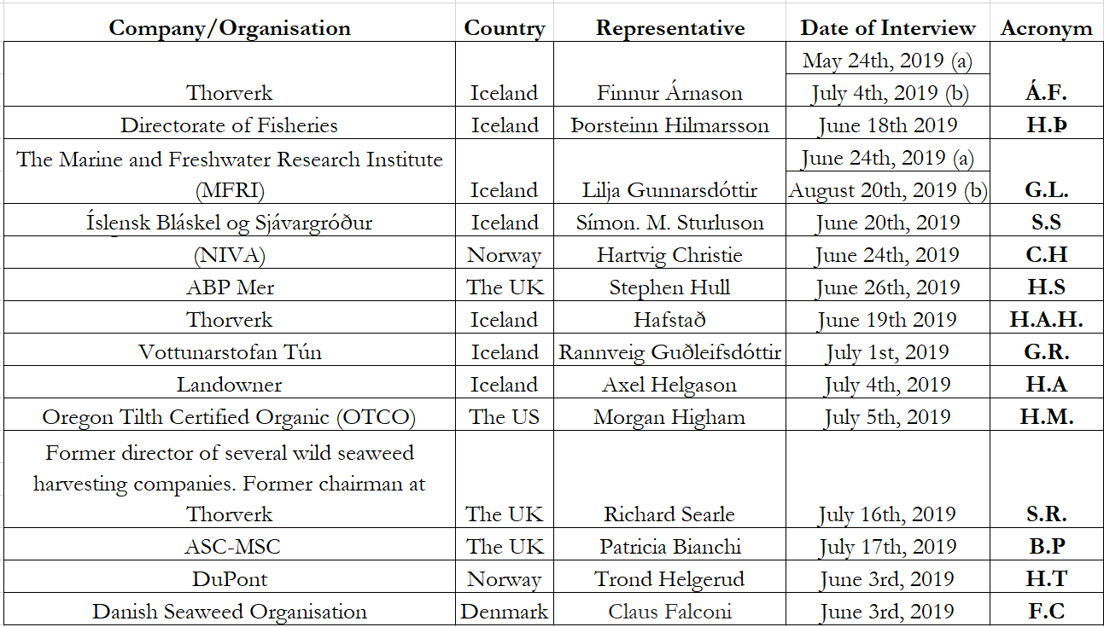

Stakeholder views on sustainability
Before analysing themes and criteria mentioned by stakeholders, it is important to state how interviewees define and describe what the term ‘sustainability’ implies to them. According to Árnason, the definition is clear yet simple. “What is sustainable sustains itself. Harvesting should never be done at a greater pace than it takes the natural resource to grow or recover” (Á.F, 2019a). Other stakeholders did not provide discrete definitions, but all were able to explain and discuss what the term means to them. To summarise stakeholder’s views; sustainable exploitation should not have a long-term effect on a natural resource. This includes the surrounding environment and ecosystems, but the natural resource should be utilised with continuous harvesting in mind without affecting levels of standing stock (H.Þ., 2019; S.S.,2019; C.H., 2019; G.L., 2019a; G.R., 2019).
All interviewees mentioned environmental sustainability of resources, while Hafstað, Higham, Bianchi and Searle mentioned the importance of other aspects, such as social and economic sustainability. Higham highlighted the importance of the three pillars of sustainable agriculture; economic, environment and social. Searle mentioned that harvesting operations must have minimal impact on wider ecosystems, other businesses and the local society (S.R., 2019). Hafstað, echoed the importance of economic sustainability adding that “To me, sustainability does not only apply to determine maximum long-time yields, putting harvesting in an economic context and finding out how to share derived benefits, but also to apply robust methods to reduce the risk of accidents by applying the precautionary principle or approach” (H.A.H., 2019).
Regarding sustainable operations, three interviewees brought up the need for companies to exploit seaweed in a sustainable manner in order to keep business and operations going. “People think differently now than before [...] now they think about the future and sustainability. You would not raise a company for five billion ISK [€ 37 million] with the aim to harvest the total biomass of seaweed within five years’ time” (S.S, 2019). Christie, Hull and Gunnarsdóttir agreed with Sturluson, as unsustainable operations and overharvesting would not economically benefit companies and harvesting plants, since they would run out of business. In addition, Hull mentioned that “some environmental stakeholders consider some practices, such as kelp trawling to be unsustainable because the biodiversity of trawled areas is altered by harvesting and full recovery of biodiversity can take many years. While I don’t agree with that view of sustainability, I think it is important to recognise that different perspectives do exist” (H.S., 2019)

Icelandic stakeholder perspective: sustainability
Icelandic stakeholders that brought up harvesting methods of Thorverk, agreed that current company operations are sustainable (H.Þ., 2019; S.S., 2019; H.A.H., 2019; H.A.,2019). Helgason, stated that “[..] How it [seaweed harvesting] is done now is absolutely sustainable”.

Identified criteria by stakeholders
When asked which criteria harvesting companies need to fulfil to sustainably exploit wild seaweed, stakeholders mentioned similar criteria that came up in the literature and standard review (See Chapter 2). Some criteria mentioned by stakeholders were not addressed by previous reviews, such as ‘Positive aspects of wild harvesting’. Although interviews provided similar themes as the literature and standard reviews, the stakeholders provided greater detail and background information of the industry. Many stakeholders specifically mentioned harvesting rates as an important criterion and several called for more research and assessments of areas, species, ecosystems and biomass than previous reviews. Figure 5 shows criteria mentioned by stakeholders.
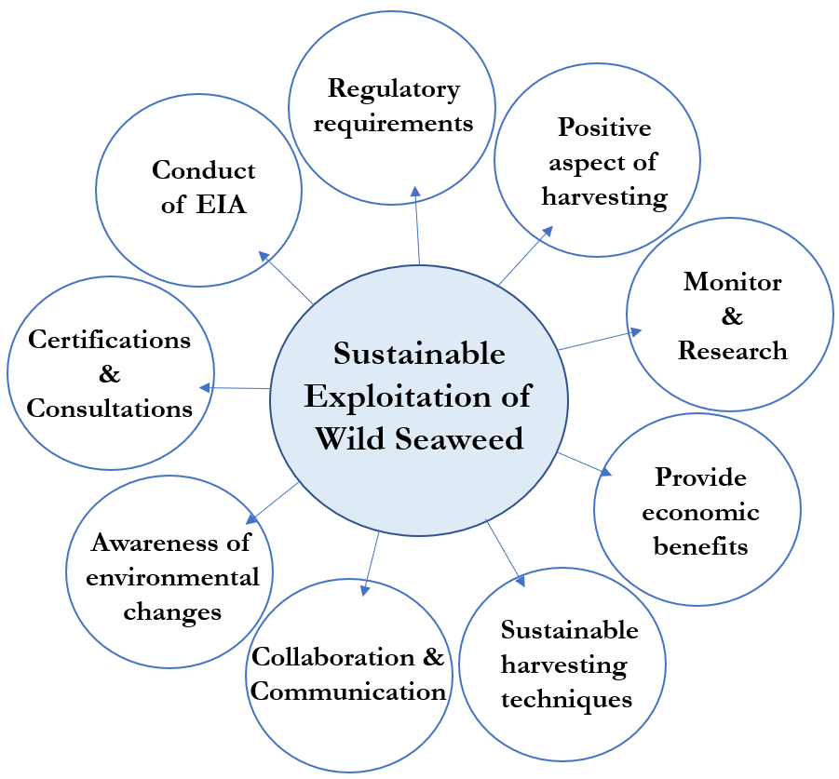
Figure 5 Identified criteria by stakeholders on sustainable exploitation of wild seaweed (Source: own elaboration)
All stakeholders mentioned the need for companies to monitor and research harvested seaweed for sustainable exploitation. Most stakeholders mentioned the need for more research, but stakeholders within Iceland called for a higher need for specie-specific research and assessments on seaweed distribution than stakeholders in other countries. Interviewees provided discussion on sustainable harvesting techniques, but similar to findings within the literature and standard reviews, no one technique is seen as economically feasible for all harvesting operations. Most stakeholders mentioned the need for regulatory requirements in the industry, but relevant stakeholders criticised the Icelandic seaweed regulatory framework. Different critiques are mentioned and discussed in the subsections of this chapter. Stakeholders mentioned similar criteria as ‘Harvesting to provide economic benefits’, ‘Awareness of environmental changes’, ‘Conduct of EIA’ and ‘Certifications & Consultations’. In addition to the eight criteria mentioned above, several stakeholders addressed the fact that wild seaweed harvesting can have beneficial impacts on the surrounding environment. These include increased biomass growth and plants being less vulnerable to ocean currents and storms.

Monitor & Research
All interviewees agreed that monitoring and research are vital for sustainable company operations. Árnason, Gunnarsdóttir, Morgan and Searle agreed that companies must monitor wild seaweed resources on a continuous basis and check if harvested rates stay the same. According to Gunnarsdóttir, if a company gathers similar landings year after year, the exploitation of the resource is most likely sustainable (G.L., 2019a; C.H., 2019). “If harvested volumes drop, then something is not sustainable and needs to be checked or revised” (Á.F, 2019a). One important aspect of effective monitoring, raised by stakeholders, was rotation. Several stakeholders mentioned that well managed and monitored rotation, giving seaweed ample time to recover and regrow between harvesting seasons, should lead to a sustainable rate of exploitation (Á.F, 2019a; 2019; G.L., 2019a; H.S., 2019; S.R., 2019; C.H., 2019).
Most stakeholders mentioned a need for more research and increased financial capital intended for research purposes of seaweed. Several stakeholders mentioned the need for research specific to species. Christie mentioned that increased research efforts could benefit seaweed harvesting operations, production and end-products used in the pharmaceuticals, cosmetic and plastic industries. According to Christie, kelp harvesting is well monitored, but there is a lack of research on how kelp harvesting affects other seaweed species and their recovering rates and reaction. Additionally, there is a lack of research on how kelp harvesting affects fish stocks, habitats and ecosystems for other fauna (C.H., 2019).

Icelandic stakeholder perspective; Monitor & Research
All stakeholders within the Icelandic industry mentioned the need for continuous monitoring and increased research in order to sustainably exploit seaweed.
The MFRI conducted a study roughly 50 years ago, which was recreated in 2017. The results from the original research showed an estimation of 1.200.000 tonnes of seaweed biomass in Breiðafjörður. The latest researched showed similar or growing numbers of 1.400.000 tonnes of seaweed in the same area. According to Árnason, these reports indicate how much available seaweed are in Breiðafjörður, and that the results indicate that harvesting operations of companies do not seem to affect the standing stock of seaweed (Á.F., 2019a). Árnason emphasises the importance of research, stating that some certification schemes require local research on seaweed in order to certify that operations are sustainable. This pushes companies to monitor what they harvest (Á.F., 2019a). Thorverk is starting more detailed monitoring practices on regrowth rate of seaweed and how much biomass is harvested within a given period. In addition, the natural environment is monitored - such as winds, erosion, currents and tides - as it can affect growth and distribution of seaweed. “The company is very aware of not overstepping the natural boundaries of the resource” (Á.F., 2019a). Árnason, as well as other stakeholders believe that current company operations are sustainable (G.L., 2019a; H.A., 2019; S.S., 2019; H.A.H., 2019). Gunnarsdóttir added that although harvesting may be sustainable for rockweed, this does not necessarily mean that all company aspects are sustainable, since more research is needed on other seaweed species (G.L., 2019b).
All stakeholders in the Icelandic industry called for more research on how distribution and harvesting of seaweed affects other species (G.L., 2019a; S.S., 2019; H.Þ., 2019; Á.F., 2019a). Hilmarsson, stated that there is a significant amount of research on fish stocks, but similar data on seaweed is very limited, despite decades of seaweed harvesting (H.Þ., 2019). Regarding increased research, Sturluson called for more research and mapping of Breiðafjörður to determine which seaweed species can be found where. These studies could aid harvesters to obtain an overview of seaweed distribution and utilise additional varieties for production purposes (S.S., 2019). In addition, Sturluson called for research on pollution and heavy metals within Breiðafjörður, as it does not exist (S.S., 2019).
Several Icelandic stakeholders ask for more funding dedicated to seaweed research. According to stakeholders the Icelandic government charges seaweed companies’ taxes for harvesting of wild seaweed (Chapter 1.3). According to Árnason, the draft of the regulation on “Seaweed harvesting for commercial purposes” stated that taxes on the resource were to be earmarked for marine research at the MFRI ('Frumvarp til laga'). In the final version of the regulation, this distribution was not included (Á.F., 2019b).
According to Gunnarsdóttir, research on how seaweed harvesting can impact organisms and standing biomass of seaweed is already underway. Although Árnason and Gunnarsdóttir agree that research on seaweed biomass is needed, the stakeholders disagree how biomass should be assessed. Árnason calls for research on harvestable biomass, while the MFRI research and estimates total biomass within Breiðafjörður. According to Árnason, total biomass shows existing and available biomass of seaweed, but fails to take location, incline, depth, rocky surroundings, harvesting techniques, environment and other important factors into account. Gunnarsdóttir states “All seaweed are harvestable, it just depends on the harvesting technique” (G.L., 2019a). Although hand-harvesting is possible for Thorverk, the method is not economically feasible or beneficial for the company’s operations (Á.F., 2019b). According to stakeholders, current company operations seem sustainable, but some stakeholders argue that with the anticipated increase in harvesting rates (from 20.000 tonnes to 40.000 tonnes) operations may become unsustainable if harvestable biomass is not estimated. Gunnarsdóttir added later that it is possible to study harvestable biomass of seaweed, but it is not the purpose of the MFRI to conduct research on what is suitable for wild seaweed harvesting companies. “Harvesting licenses could be limited, due to which harvesting techniques can be used on a specific portion of seaweed. Then, any research on harvestable seaweed by prams would have to be conducted by the MFRI, and areas could be categorised after which method is suitable; mechanical harvesting, hand-harvesting or not accessible” (G.L., 2019b).
Árnason adds that a research on harvestable biomass is vital for sustainable exploitation, and that consultations from the MFRI lack scientific analysis of local factors. According to Gunnarsdóttir, current harvesting rates in Iceland are tailored by seaweed harvesting rates in Canada, which apply to different environment, ocean temperature, depth, ecosystems and other location specific factors. Because of this, the MFRI builds current harvesting consultations on estimates from other countries. The MFRI studies harvesting rates in other countries but adapts local rates to Icelandic conditions. Árnason, stated that “elsewhere, the percentage [of total allowable catch of seaweed] are based on local research, but here, it is only a ‘best-guess’”. When asked why this is, Árnason posited that this was because of lack of funds or because the research may be too time consuming.

Sustainable harvesting techniques
Stakeholders agreed that seaweed can easily be harvested sustainably for commercial purposes, but no harvesting technique seems applicable to all areas and species as no method seems ‘more sustainable’ than others. According to Christie, kelp trawling has been used extensively in Norway for the past decades while hand-harvesting of rockweed was preferred in Scotland and Ireland. In Iceland, mechanical harvesting techniques are used by Thorverk on rockweed, while hand-harvesting is applicable to smaller scale businesses for the same species (Á.F., 2019b; S.S., 2019). According to Searle, harvesting techniques differ with various factors: “You have to be specific about the species, location, and about the percentage of the total resource […] that is harvested”. This is important as one harvesting technique does not fit all, and species react and grow differently in different areas and latitudes (S.R., 2019). Searle brought up an important discussion in, mentioning that environmental circumstances dislodge whole kelp plants that wash ashore, but wracks and rockweed do not dislodge. The blades of wracks and rockweed tear and rip off in strong currents, but the holdfast usually stay intact. According to Searle, harvesting techniques must take this into account, as all stakeholders recommended that only the tops of rockweed or wracks should be cut with mechanical harvesting techniques or hand-harvesting. If only the tops of rockweed are cut, the plant can regenerate and continue to grow. If too much is cut off individual plants (leaving less than 25cm) or the holdfast is removed rockweed does not recover. Kelp forests on the other hand, can be harvested with trawling which mimics the natural environmental circumstances that dislodge whole plants (S.R., 2019). According to Helgerud, the holdfast of kelp should be integral part of the plants when harvesting. “This is to make sure there is space for new plants to establish on the sea floor. If holdfasts are left they will not grow into new plants, but degrade and eventually disappear. Removing the hold-fast of kelp is recommended by Institute of Marine Research in Norway (IMR)” (H.T., 2019).
Stakeholders provided discussion on hand-harvesting, mechanical harvesting and trawling techniques, as each method can be used for different species and location. Sturluson currently hand-harvests seaweed on a small scale in Iceland and expressed that by using the method the company can charge ten times more for each kg that is hand-harvested, compared to Thorverk’s products which use mechanical harvesting (S.S., 2019). The author asserts that this value increase may be due to increased quality of final product. Searle mentioned that although hand-harvesting is possible in most locations, companies need to be aware of which harvesting techniques are economically feasible for commercial purposes. “There is always the temptation to cut too close [to the ground] and hope nobody will notice and hope that it will grow back” (S.R., 2019). Searle continued by stating that historically, there has been a lot of overharvesting by hand. “It is usually on a small scale because volumes harvested with the technique tend to be small” (S.R., 2019). Searle mentioned that in an area where a person is working by hand they can overharvest rockweed, whereas using mechanical harvesting techniques it would be almost impossible to cut too close to rocks and holdfasts, because cutting gear would be damaged. With mechanical harvesting, “you can cut with a very little danger of cutting below the stem of a plant that continues to grow (S.R., 2019).
Regarding kelp harvesting, trawling is widely used in Norway. Stakeholders highlight that trawling must follow a correct design that does not take up small plants but only larger plants. Trawling should leave the understory and small plants exposed to sunlight, so they can repopulate (C.H., 2019; S.R., 2019). Christie mentions that currently areas are trawled every five years, which provides ecosystems just enough time to recover before they are harvested again. In his opinion, trawling could be done more frequently in the same areas but leave other zones to have natural kelp forests.

Icelandic stakeholder perspective; Sustainable harvesting techniques
The two harvesting companies in Iceland; Thorverk and Íslensk Bláskel echo what previous stakeholders stated in interviews. Both Árnason and Sturluson highlight the importance of not cutting too much of individual rockweed plants, but as stated in Chapter 1, kelp is not harvested as much due to lower market interest. Due to the difference in size between the seaweed companies, hand-harvesting is not possible for Thorverk, and mechanical-harvesting not practical for Íslensk Bláskel.

Positive aspects of wild harvesting
The following discussion on positive environmental aspects of harvesting were not mentioned in literature or standard review but raised by several stakeholders. As some literature hints that wild seaweed harvesting may not be environmentally sustainable, stakeholders mentioned that harvesting can benefit the economy, (society) and the environment.
Many stakeholders compared harvesting of wild rockweed, to farmers cutting or maintaining fields and crops (C.H., 2019; S.R., 2019; S.S., 2019; Á.F., 2019a; G.L., 2019a). Sturluson mentions that cutting of rockweed is similar to farmers cutting grass or thinning forests. Harvesting can encourage growth of juvenile plants as sunlight has more access to the undergrowth than in uncut areas. Searle emphasised that harvesting techniques mimic natural conditions, by removing tops of rockweed and whole kelp plants. “This [biomimicry] is often something that is overlooked in the discussion on seaweed harvesting”. Árnason echoes Searles comments, adding that approximately 8% of seaweed populations are thought be dislodged or weathered-off by natural elements. Compared to the Icelandic industry, natural degradation of seaweed affects more than four times what Thorverk harvests on a yearly basis (Á.F., 2019a). Christie brought up an important discussion, stating that seaweed do not require fertilisers, pesticides or additional water to be able to grow. This makes seaweed harvesting more economically feasible and harvesting operations less harmful compared to some agriculture processes. From an ecological viewpoint, Christie stated that it is more sustainable to harvest resources at lower trophic levels that at higher levels. “It is generally thought to be best to harvest low in the food chain and utilise resources there, rather than harvest high up in the food chain” (C.H., 2019). Christie also references a study that demonstrated that when seaweed is added to cattle fodder, methane emissions have been shown to drop by around 30%. When the author of this thesis looked this up, research showed 38% decrease in greenhouse gas emissions from seaweed fed cattle, with emissions depending on seaweed species (Temple, 2018; Maia, 2016). Seaweed have also been shown to increase milk production in cows, and less area is needed for seaweed production than regular crops intended for animal fodder (Mernit, 2018).

Icelandic stakeholder perspective: Positive aspects of wild harvesting
According to Sturluson and Árnason, seaweed harvesting can have several positive effects on the surrounding environment. Sturluson noticed that when storms and strong currents tare and rip seaweed in Breiðafjörður, plants that were cut for commercial exploitation were not as badly torn. This can be attributed to the decreased in size, which made the plants less vulnerable to currents and tides. Árnason mentioned that when seaweed are not harvested, biomass reaches equilibrium and seaweed growth decreases. If seaweed are harvested, biomass regenerates faster and seaweed tend to grow quicker (Á.F., 2019a).

Regulatory requirements
Most experts expressed the need for authorities to implement regulations and laws for seaweed exploitation to ensure sustainable practises. Icelandic stakeholders were asked for personal opinions on the Icelandic seaweed regulatory framework while others were asked on the importance of regulations in general, where some expressed their concerns and thoughts on EU regulations. Searle provided personal background on seaweed harvesting in Chile and Peru in 1990s. “[Seaweed] were without a doubt being overharvested [...], and at the time there were no regulations. This was because farmers were hand-harvesting beach casts seaweed, cutting whole seaweed, diving and using various techniques. Having said that, in the last ten years this has changed dramatically […] and now they have it under a tight control [...]. This is an example where government is extremely slow to react, to put the right sort of thing in place” (S.R., 2019). When asked how sustainable exploitation was established, Searle stated that control over harvesting rates and licenses were set after universities and ecologists called for a change. Lastly Searle mentioned the importance of regulatory authorities not implementing a ‘one-size-fits-all’ regulation on seaweed. Instead authorities should recognise that various factors such as habitats, growth rates, possible harvesting techniques and other factors differ with seaweed species and species location (S.R., 2019).
Although out of scope, Bianchi expressed similar thoughts on EU regulations on seaweed harvesting. Currently, EU regulations on seaweed farming exist, but none on wild harvesting of seaweed. Bianchi stated that there is an increased push on governments to enforce, develop and create more regulations on wild seaweed harvesting in the EU (B.P., 2019).

4.2.4.1. Icelandic stakeholder perspective: Regulatory requirements
As the scope of this thesis is on the Icelandic seaweed regulatory framework, relevant stakeholders were asked for their opinion of the framework. All stakeholders seemed pleased that seaweed exploitation was finally addressed by regulatory authorities, as no laws or rules existed on the resource prior to 2018. Stakeholders expressed either contentment or concerns that seaweed exploitation was implemented to existing regulations and laws on fish stocks. Sturluson mentioned that “there must be some rules or restrictions on natural resource utilisation, in order to see how much can be harvested” (S.S., 2019). Sturluson and Hilmarsson both mentioned that the legal framework is still under development and it is too soon to tell if it has succeeded in improving the conduct of “[..] exploited marine stocks and promote sustainable utilisation that ensures long-term maximum yield for the Icelandic Nation” ('Reglugerd um öflun sjávargróðurs í atvinnuskyni'). Stakeholders agreed that the framework was written with Thorverk’s operations in mind, but Sturluson stated that the regulations do not apply to his business. “The framework only applies to boats with licenses that harvest rockweed [...] the regulations do not anticipate other harvesting techniques” (S.S., 2019).
When other stakeholders were asked if the framework ensures sustainable exploitation of seaweed, many disagreed. Hafstað, well acquainted with the regulations, stated that the framework does not ensure sustainable exploitation and that the framework does not work as intended. Gunnarsdóttir and Helgason disagreed with Hafstað, mentioning that the framework seems to be functioning well and that harvesting rates could feasibly be increased (G.L., 2019a; H.A., 2019). On the other hand, Gunnarsdóttir states that harvesting rates will not be increased further than 40.000 tonnes in coming years until after the increase has been tried and tested (G.L., 2019b). Hafstað mentioned that the economic context of harvesting must be included in regulations. According to Hafstað, regulations must prioritise harvesting by local companies and societies, as they depend on the resource. Hafstað mentioned a prolonged conflict between the opportunities of different actors to exploit or protect seaweed, as politics could easily support the opinions of conservationists. “This could happen quickly, if ideas of national parks emerge” (H.A.H., 2019). This argument is very relevant, since negative public opinion of wild seaweed harvesting in Scotland in part led to a nationwide ban on commercial harvesting of kelp in 2018 (H.S., 2019). Kelp forests surrounding Scotland were planned to be harvested, but as a result of opposition from (amongst others) environmental campaigners, legislation to ban commercial seaweed harvesting was successfully promoted by a Member of the Scottish Parliament and subsequently adopted by the Scottish Government. “I would not say that it is a particularly rational or evidence-based decision to forego economic benefit of the resource [..], but that was the decision of the Scottish Parliament” (H.S., 2019).
When Hafstað was asked what could be improved in the current Icelandic framework, he stated the following; “[The framework is] missing predetermined utilisation rules that exclude temptation. Scientific recommendations [from the MFRI] have not considered reality, including which areas of utilisation are actually accessible due to natural conditions, conservation and landowners' views. [The current framework] is too much focused on the biological assumptions of the resource but not set in an economic context as a means of accessibility and that the priority of those dependent on this utilisation is properly ensured. Furthermore, research on the effect of utilisation on hatching and breeding sites of important stocks and linking utilisation advice of seaweed to polynomial models should certainly be considered” (H.A.H., 2019).

Gunnarsdóttir mentioned that “it is possible to hand-harvest in all areas where rockweed are located”. This could lead to concern, as Hafstað and Searle mentioned the need for regulations to eliminate the temptation of overexploitation. Árnason states that, “the framework lacks a safety net. In other places, such as Canada, there is a need for companies to provide Environmental impact assessments, which is not mentioned in the Icelandic framework (Á.F., 2019b). Árnason does provide positive discussion on how company operations have changed after the implementation of regulations. “A lot has changed after the regulations, such as taxes, reports, weighing procedures, licenses, recommended catch figures and more”. Although changes have provided more clarity for company productions, some aspects are currently not fulfilled by stakeholders, such as weighing of seaweed landings and availability of online data. According to the legal framework, the Directorate of Fisheries should report data and capture logs and harvesting rates of seaweed to an online database. According to Árnason, Thorverk records all seaweed landings in acquired logbooks and reports the required data to the Directorate of Fisheries on a monthly basis. Due to difficulties in applying seaweed landings to the online database, which is designed for fish stocks or similar problems, online data on seaweed landings are not present (H.Þ., 2019; Á.F., 2019b). In addition, according to Árnason, Thorverk currently does not have a permit to weigh harvested seaweed from the Directorate of Fisheries. According to Árnason, Thorverk applied for a permit, as well as an exemption of weighing seaweed on a certified port-scale, due to difficulties of adhering to regulations. Neither the permit nor the exemption have been approved by the Directorate of Fisheries, presumably due to difficulties of seaweed harvesting falling under regulatory requirements (Á.F., 2019b).

When stakeholders were asked on their opinion of the government adding seaweed to existing regulations and laws on fish stocks and populations, most stakeholders seemed content. “There are obviously good aspects of the Icelandic fish regulations, so these [seaweed regulations and laws] are a good starting point” (Á.F., 2019a). Hilmarsson agreed with Árnason’s comments, adding that it can be complicated to adapt seaweed harvesting to current registration and catch rates modelled after fish stocks (H.Þ., 2019). “It is an astonishing decision to define seaweed as ‘catch’” (H.Þ., 2019). This is likely the reason why online data is not available on seaweed, as Árnason previously mentioned. Hilmarsson and Árnason disagreed on the next revision of seaweed regulatory framework. According to Árnason, it was a good idea to regulate seaweed exploitation in current laws and regulations, but the proceeding steps would be to have a clear separation of seaweed regulations from regulations on fish, as the resources are very different. According to Hilmarsson, existing regulations could be clearer in defining when chapters apply to seaweed rather than fish, though it is not necessary to write new or additional regulations explicitly on seaweed. An important point was raised by Searle, who stated that “harvesting some types of seaweed is more similar to fish than some people realise. There are obviously good aspects of the Icelandic fish regulations, so these are a good starting point” (S.R., 2019). Furthermore, Searle expressed that there is a tendency for “far too many people and agencies to talk about seaweed as they are all the one and the same”. Because of this, regulatory authorities need to include chapters within regulations on different species and harvesting techniques in order to ensure sustainable exploitation (S.R., 2019). According to the Icelandic framework, harvesting of rockweed are specifically mentioned, though no details or information on kelp harvesting or other species are provided.
Another criticised component of the ISRF is the resource tax and ownership of the resource. Currently, Thorverk must acquire permission from landowners to be able to harvest seaweed. After receiving permission, the company harvests and pays the landowners a certain percentage of the value the company generates by selling the seaweed. In addition, Thorverk must pay a resource tax to the government, as seaweed are regarded as a natural resource (Á.F., 2019b; H.Þ., 2019). When Helgason was asked for personal opinions, he replied, “I think this arrangement is crazy. The fact that the government has anything to do with allocating permits to prams that harvest seaweed on a private land, is unbelievable”. Helgason claims that landowners should have ownership of rockweed on their shores, just as farmers own grass on their lawns. In respect of the issue, of landowners’ requirement for a permit from the government to be able to utilise seaweed from their own land, he stated: “It is clear that this counteracts the Icelandic constitution” (H.A., 2019). When prompted, Helgason mentioned that although seaweed can be seen as a natural resource, the entire biomass of rockweed is located within net zones and farmlands. “With the argumentation of seaweed being a natural resource, the government could collect taxes from conventional farmers as they mow their lawns” (H.A., 2019). Hafstað had similar thought on the resource tax on seaweed, stating that “the argument for resource tax on rockweed as a common property should not apply in this case. This arrangement is conducive to the resource tax and confuses matters for those who generally speak for resource fees” (H.A.H., 2019). On a similar note, Hilmarsson, argued that since rockweed grow in upper coastlines and within net zones, seaweed harvesting might be more applicable to agriculture rather than fisheries. When Árnason was asked to comment, he agreed that the natural resource tax on rockweed does not seem right, but should be applicable to kelp forests, as those are located outside of net zones (Á.F., 2019b). In addition, Árnason mentioned that the resource tax collected by the government was intended to be allocated to marine research, including research on seaweed. Árnason called for regulatory authorities to put the collected revenue gained by the resource-tax to research in Breiðafjörður. “There is an interest to open a museum and a research or service centre on seaweed that would provide knowledge and benefits on site. Since the company is the only actor paying taxes on seaweed, the government should leave it behind so it can be used within the district” (Á.F., 2019b).

Awareness of environmental changes
Most stakeholders expressed the need for harvesting businesses to stay mindful of the environment and subsequent changes. It seems evident to most stakeholders that rising sea temperatures and acidification will continue to have increasing effects on wild seaweed populations and their distribution. Christie expressed that, “on the global scale I am concerned because of the decline of kelp forests. An increase in ocean temperature since 1980s has led to a great loss of sugar kelp in southern Norway. There has been a small increase of seaweed in the North of Norway but a decrease of seaweed populations in the South”. (C.H., 2019). “This is because of temperature, [as] a small change can lead to drastic changes in ecosystems” (C.H., 2019). A rise in ocean temperature has not only affected seaweed, but also the distribution and populations of sea urchins and crab species which migrate to colder climates on a season basis. As these natural predators endure less fluctuations in temperature, Christie seems hopeful. “[..] Where sea urchins used to be before, huge forests of saccarina [seaweed specie] are coming back” (C.H., 2019). Global warming has led to new species coming in in the South of Norway, while others die off. In an optimistic sense, “this could bring an opportunity to harvesting wild saccarina and other species of seaweed in during other seasons than before” (C.H., 2019). Christie concludes that in order for businesses to harvest various species, there is a need for more research and regulations to pave the way for alternative industries.

Icelandic stakeholder perspective; Awareness of environmental changes
Searle mentioned that when seaweed are harvested, the natural variability of plants must be considered. Additionally, harvesters must be mindful of the scale of harvesting in relation to the total resource and local quantity. This adds to the discussion of ‘total biomass’ and ‘harvestable biomass’. If only a fraction of total biomass is harvested, overexploitation might still occur if unsustainable harvesting techniques are used or harvesting seems economically feasible within a small area, but not possible elsewhere. “One has to be sensitive to scale as well as to how particular species reproduce, as seaweed growth rates differ between areas” (S.R., 2019). Sturluson stated that commercial operations must be mindful of the environment and that harvesting periods differ with location and change in environment (S.S., 2019). Hull mentioned that the overall structure and function of ecosystems should be maintained if harvesting is to take place. According to Gunnarsdóttir, harvesters need to be aware of local surrounding that may affect the growth rate of various seaweed species. Since temperature, depth, ecological structure, waves, currents and more ecological factors differ in areas and countries, many factors must be considered when setting harvesting rates of wild seaweed (Á.F., 2019a).
Stakeholder opinions of harvesting rates, set by the MFRI, differed greatly. According to Gunnarsdóttir, the increase in recommended seaweed harvesting rates from 20.000 tonnes to 40.000 tonnes, should not negatively affect seaweed populations. Gunnarsdóttir mentions that if unsustainable exploitation were to occur, the volumes could always be reassessed (G.L., 2019a). When asked on future harvesting rates in Iceland, Gunnarsdóttir predicts an even greater increase and Helgason agrees. Árnason did not concur with Gunnarsdóttir and Helgason of the increased harvesting rates. “Thorverk is currently harvesting in the upper limits of the resource, as not nearly all of the estimated 1.4 million tonnes in Breiðafjörður can be reached by current harvesting methods. Although the amount of biomass is this much [in the fjord], we are harvesting very close to what is accessible, as in some places it is not possible to harvest, although the biomass is measured high” (Á.F., 2019b). The increased harvesting rates do not factor in currents, depths, seaweed shapes, location of skerries and islets that hinder harvesting techniques. The same argument was stated by Hull, as it is not economically beneficial for operating companies to venture far to harvest seaweed. Árnason continues, stating that if overexploitation of seaweed were to take place, it would take decades for seaweed populations to adjust or regrow (Á.F., 2019a). The risk of increasing rates, without requiring companies to conduct EIAs, specific research on Breiðafjörður and local seaweed populations, would not be worth taking (Á.F., 2019a).

The conduct of EIA
Only two out of twelve stakeholders mentioned the need for companies to conduct Environmental Impact Assessments prior to harvesting. Hull mentioned that by conducting EIAs, companies could provide scientific support for how a company plans to harvest and which environmental risks are present by company operations (H.S., 2019). While wild seaweed harvesting is not an activity that Hull identified as requiring formal EIA under the EC EIA Directive (2014/52/EU), regulation of seaweed harvesting in Scotland requires that information on the potential environmental impacts of harvesting operations is provided as part of an operator’s marine licence application. This ensures that environmental aspects are taken into account in decision-making.

Icelandic stakeholder perspective; The conduct of EIA
Árnason mentioned the need for Icelandic regulations to require EIA of seaweed harvesting companies. Currently an EIA is not required for seaweed harvesting companies so there is no effective requirement for the industry to show production - or in the Icelandic case, increased harvesting could affect the environment. “[EIA] is not mentioned anywhere in regulations, so there is no safety net. The only safety net within current laws is the fact that the regulatory framework is temporary and set to be revised within three years of implementation” (Á.F., 2019b). This causes concern as new and existing companies only need to acquire licenses before harvesting seaweed, and not much else.

Harvesting to provide economic benefits
Six stakeholders mentioned economic benefits and financial value that can be derived from wild harvested seaweed. In line with the literature review, Christie mentioned trade-offs within wild seaweed harvesting. “We want to take care and protect natural ecosystems [but] seaweed could be used as replacement of plastics, in feed for animals and possible fuel” (C.H., 2019). Christie mentioned a need for greater market development of products that contain seaweed. This development could lead to increased harvesting rates on mores species, resulting in less harvesting pressure on kelp and rockweed. Christie mentioned that seaweed is an ‘up-and-coming’ product, as it is not only used for industrial use, but increasingly in the food, animal and pharmaceutical industries (C.H., 2019).
According to Searle, there is a lack of economic awareness of seaweed at political and governmental levels. Searle mentioned an EU program (Macrofuels, 2018) which issued large research contracts on how kelp could be used as a source of biofuel. “Despite all this money [that was offered], it still hasn’t taken place because they never looked at the economics. It wasn’t really thought through whether it was sensible energy”. Searle mentions that companies need to think things through at the start of a project. “Instead of thinking that seaweed can provide fuel, one has to evaluate if it is economically feasible to use seaweed as a fuel source” (S.R., 2019).
One potential opportunity raised by stakeholders in Iceland, Norway and Scotland was the fact that instead of harvesting seaweed and transporting them as raw materials to separate industries, product development on site could increase economic benefits for local communities. Christie mentions that global companies harvest seaweed species in Norway. “These businesses come each year, take the Norwegian kelp, and not a lot is left for local producers and farmers”. Norwegian kelp harvesting companies harvest kelp forests in nearby areas, ship them to Haugesund where the seaweed are processed and then transported to other countries. According to Christie, a small community at the same Norwegian coast lives off fisheries. “Because of seaweed harvesting, the local’s loose biomass, nurseries and spawning grounds for fisheries and more, while the profit of the seaweed resource ends up elsewhere. In these areas the sea-urchins have affected the kelp forests, and it has taken 40 years to grow back” (C.H., 2019). Helgerud replied that the global company Christie refers to, does in fact employ over 140 people in Norway which most live alongside the coast. In addition, the company engages “a considerable number of people for maintenance of manufacturing operations and boats, and the boats are sourcing fuel and supplies locally along the coast” (H.T., 2019). In addition, “[The company] is paying considerable taxes in Norway” (H.T., 2019).
When stakeholders were asked about current and future trends in the wild seaweed harvesting industry, all had noticed an increase in interest while some expect an increase in harvesting rates. According to Bianchi; “seaweed productions in general is really growing”. Although wild harvest represents only 5% of the total production Bianchi predicted that the percentage will remain the same as total seaweed production increases. “I think there is more and more interest in wild seaweed and cultivation around Europe and around the world” (B.P., 2019). With the increased growth, Bianchi expects that “[...] there will be more industries that arise in cultivation and wild harvest”. According to Helgerud: “wild harvested seaweed have the potential to become the source of very high value products within [...] pharmaceutical, biomedical, nutrition and personal care products”. In addition, “the wild harvesting is expected to grow in Norway”, although not as extensively as farmed seaweed (H.T., 2019). Falconi, echoed Helgerud’s statements, expressing that “the market of wild harvested seaweed is growing, and I think it will indeed grow in coming years” (F.C., 2019).

Icelandic stakeholder perspective; Harvesting to provide economic benefits
Sturluson echoed Christie’s previous comments. “I believe that this [seaweed] will be the next big industry in Iceland. We need to watch out that we won’t become raw material producers, by harvesting seaweed and then ship them out. It is important for the economy and society to make products here [in Iceland]” (S.S., 2019). An important factor raised by Gunnarsdóttir, is that eider ducks feed off invertebrates that live on rockweed. The largest eider duck population in Iceland lives in Breiðafjörður and nests close to shores. Farmers and landowners within the fjord make a profit from collecting down from nests, which can be sold for a relatively high price. Sustainable seaweed resources can therefore benefit local communities and interconnected ecosystems.

Stakeholders in Iceland agreed that there is increased interest of foreign businesses looking to harvest seaweed in Iceland. According to Árnason and Sturluson, there has been a slight and steady increase in seaweed sales for the past years. Sturluson mentioned that increased sales stem from additional interest from the culinary sector and that seaweed have been showcased more in cookbooks than before.

Collaboration & Communications
Some of the interviewees mentioned a greater need for different sectors and stakeholders to increase communication and collaboration. Hull noted that engagement with local communities was important in gaining their acceptance of harvesting activities. These communities may have concerns about the environmental impacts of harvesting activities and its interactions with activities such as fishing. They may also be interested in understanding the economic opportunities for their society which are associated with harvesting activities. Both issues were factors in the opposition experienced in Scotland to an application for commercial scale kelp harvesting.

Icelandic stakeholder perspective; Collaboration & Communications
Only two stakeholders within Iceland mentioned the need for collaboration. Árnason mentioned that currently Thorverk must “spend more effort in having better contact with landowners”. This is important as the company needs to have good communications with farmers since they decide if the company can harvest seaweed on their land (Á.F., 2019).
According to Sturluson, the Icelandic seaweed industry and stakeholders would benefit from large foreign harvesting companies setting up plants and business in Iceland. Sturluson mentions that new companies would bring opportunities and possibilities of collaboration. Sturluson mentions that larger companies would entail scientists and research on seaweed distribution within Breiðafjöður, which could benefit Icelandic companies and relevant stakeholders. According to Sturluson, having a large company as a neighbour could benefit his company, Íslensk Bláskel, by allowing him to dry small amounts of seaweed from time to time, as the company is too small to profit from buying an industrial seaweed dryer.
Gunnarsdóttir mentioned that existing seaweed regulations build on previous academic researchers. “Some of the [current seaweed] regulations build on research that were done to evaluate the seaweed biomass in Breiðafjörður in 2016”. This is important as regulatory authorities seem to study research and communicate and collaborate with MFRI while writing regulations.

Certifications & Consultations
Three interviewees (Bianchi, Higham and Guðleifsdóttir) work for certification offices. According to them, seaweed harvesting companies can voluntarily apply to receive consultations and certifications. The purpose of third-party consultations is to verify whether businesses comply with national regulations and laws. Bianchi, Higham and Guðleifsdóttir follow different regulations and laws when certifying businesses. Bianchi works for the ASC-MSC which certifies if seaweed company operations comply with the ASC-MSC standard. According to Higham, “[OTCO] does not have [..] a detailed plan or criteria that must be met. We operate solely to ensure that practices are meeting the NOP [Nation Organic Program] standards” (H.M., 2019). Lastly, Guðleifsdóttir certifies seaweed companies that fulfil European and Icelandic regulations on organic production. The fact that different certification schemes follow different regulations seems logical, yet intriguing: while seaweed businesses strive for sustainable exploitation, very few follow the same regulations, standards or certifications which in themselves evaluate different criteria and factors.
Other stakeholders outside of Iceland had sceptical perception of third-party certification schemes. Searle expressed that in his opinion, certifications are driven by markets and only relevant if the end customer is interested (S.R., 2019). When asked why seaweed harvesting businesses should apply for certifications, Higham stated that “in general, operations can receive a higher price point for certified organic products than conventional ones”. Higham then agrees with Searle’s comments on end producers, stating that “consumers want to know that what they are buying has been harvested and processed organically”.

Icelandic stakeholder perspective; Certifications & Consultations
According to Searle, who served as a chairman at Thorverk in 1996, the company decided to obtain organic certifications for its operations. Searle mentioned that a customer of Thorverk sold processed seaweed and products to the European market. “That customer asked for organic status, since he could then sell it further” (S.R., 2019). Thorverk got organic certifications on their American and European market. This led to increased customer interest within the soil condition market and animal fodder market. These operations lead to the soil association assessing the seaweed company and its productions (S.R., 2019). “What it came down to was not any change in basic operations but much more clarity on how much they [Thorverk] were harvesting and collecting seaweed” (S.R., 2019). In order to acquire certifications every batch was recorded from the moment it was harvested to the moment it was sold. “This became very important to a range of customers” (S.R., 2019). Another big customer of Thorverk was the alginate industry. “It really made no difference because using it [seaweed] as a raw material in the alginate industry, the customers were not interested in whether it was an organic material or not because it wasn’t in retail or sold to the end customer” (S.R., 2019). Searle’s points can be considered as important in this context. Certification schemes may not be vital to seaweed businesses that do not directly interact with end customers. Notwithstanding, certifications can serve as important tools within and outside of businesses to see if productions fulfil regulations and laws. Schemes charge a various amount of money for certifying operations, and so third-party certifications may not always be economically possible for companies.
According to Árnason, an organic certification gives the company an advantage to competitors in the market, as “the organic certification is significant for the company’s market operations”. “Certifications serve as marketing tools when various companies offer similar products” (Á.F., 2019b). Sturluson echoes Árnason’s comments, although his experience is not as positive as Árnason’s. “If you are not certified, you aren’t a part of the game. Markets do not accept products that aren’t certified” (S.S., 2019). According to Sturluson, Íslensk Bláskel was pressured into obtaining organic certification for their products to stay on the market. These comments echo Searle’s statements, as Sturluson’s company produces end products and is in more frequent and direct communication with end-customers than Árnason’s company.

Summary & own reflections
Fourteen stakeholders within the wild seaweed harvesting industry were interviewed. Stakeholders represented academia, business owners, CEOs, business owner, certification officers, lawyers, researchers, directors and experts from Iceland, Norway, Denmark, The UK and the US. Stakeholders mentioned seven out of eight criteria identified in standard and literature review in Chapter 2, with the exception of ‘Incentives’ and with the addition of ‘Positive aspects of wild harvesting’. Although stakeholders have different backgrounds and knowledge in the wild seaweed harvesting sector, most stakeholders mentioned similar criteria needed for sustainable exploitation of seaweed.
Interestingly, although the ISRF includes eight out of nine criteria identified in the standard review (Chapter 3), stakeholders were not equally content with the framework. All relevant stakeholders in Iceland agreed that the implementation of the ISRF was much needed for increased management and monitoring of wild seaweed harvesting, but some call for adjustments and changes of the framework. Similarly, to the standard review, it was interesting that no stakeholder mentioned the possibility of incentives if unsustainable harvesting were to occur. Lastly, stakeholders provided more detailed background and explanations of ‘Sustainable harvesting techniques’, as no technique is applicable to all species and locations.

Discussion
In this chapter, identified criteria from standards (Chapter 3) and the components of the ISRF (Chapter 1.2 and Chapter 3) are compared to stakeholder reflections and identified criteria through interviews (Chapter 4). The comparison entails discussion on which criteria must be in place to encourage sustainable exploitation of seaweed. The discussion provided in this chapter helps eliminate information gaps that were identified through literature and standard reviews (Chapter 3). In addition, discussion helps to provide answers to all three research questions in Chapter 1.
To provide structure and ease of reading, discussion is provided for each identified criterion analysed in Chapter 3 and Chapter 4. Due to the interconnectedness involved, it was difficult for the author to discuss each criterion as an isolated factor. In order to ensure sustainable exploitation of wild seaweed, the ten criteria presented in this chapter, and Figure 6, should be regarded as a web of interconnected factors, which all need to be in place for commercial exploitation. Discussion and connection between criteria are provided in this chapter.
Figure 6 All identified criteria in standards, ISRF and stakeholder interviews (Source: own elaboration)

Monitor & Research
All standards, literature and stakeholders agreed that continuous monitoring and research is vital for sustainable exploitation of seaweed for commercial purposes. Harvesters must know the current extent of available biomass and how much companies can harvest without risking the density and population size of seaweed. According to reviews and stakeholders, continuous monitoring and increased research on seaweed is currently needed. Literature showed that many countries do not know the current extent and density of seaweed that is harvested, while stakeholders called for more research on specific seaweed species. Although stakeholders within Iceland agree that biomass research is important for sustainable exploitation, actors disagreed on whether assessment of total biomass suffices or if harvestable biomass should be researched and added as a metric.
To the author, research as to the efficacy of total biomass and harvestable biomass as metrics or measures are both needed. Both have positive aspects, although stakeholder interviews show that data on harvestable biomass is important for sustainable exploitation. The MFRI has estimated the total biomass of seaweed in Breiðafjörður on two occasions, but never the harvestable biomass. Several stakeholders demonstrated that utilising total biomass as a metric could lead to possible overexploitation. Total biomass could show that a certain amount of seaweed is available, but in fact only a small fraction could be harvested due to economic feasibility, location, depth, surroundings, skerries, protected areas, need for consensus from landowners and other factors. It is easy to understand argumentation of the importance of estimation of harvestable biomass, but some stakeholders mentioned that the research may be in the hands of Thorverk as it is the only actor within Iceland asking for the research. From the author’s perspective, it does not seem given that Thorverk alone should estimate the harvestable biomass as studies could be conducted independently or by the government. If large companies are to continuously show interest and propositions to start harvesting in Iceland, the increased pressure on the natural resource could lead to overexploitation. With future operations in mind and the growth of the wild seaweed harvesting sector, harvestable biomass must be estimated to ensure sustainable exploitation.
In order to increase research on seaweed, biomass, distribution and species-specific studies, stakeholders stated that more funding is needed. According to the draft of the ‘Seaweed harvesting for commercial purposes’ regulation, the resource tax implemented by the Icelandic government on seaweed was supposed to be earmarked for research on seaweed ('Frumvarp til laga'). In the final and current regulation, this distribution was discarded and so the resource tax derived from wild seaweed is not directly distributed to seaweed research or local development in Breiðafjörður. The idea of earmarking the natural-resource tax to local development, such as research centres, museums, algae-baths etc. and additional research on seaweed seems logical to the author. This is especially relevant since Thorverk is the only actor who pays the resource tax on seaweed.
As literature and stakeholders elucidated, location, depth, ecosystems, temperatures, species, history, acidification, predators and numerous other factors need to be studied before setting or increasing harvesting rates of seaweed. Environmental factors such as an increase in sea urchin populations due to an increase of harvesting rates led to a collapse of kelp forests in Norway in the past century (C.H., 2019). Because seaweed provides numerous environmental services and function as ‘keystone’ species in several ecosystems on land and in the sea, sustainable exploitation is vital. As harvesting rates in Iceland are set to double in coming years, increased research, caution and awareness of changes in the environment are crucial for stakeholders and research institutes to keep in mind in order to avoid overexploitation. More detailed research, considering local surroundings and a gradual increase of harvesting rates, would likely prove to be highly important for the continuous commercial harvesting of wild seaweed in Iceland.
The ISRF obliges harvesting companies to monitor harvested volumes and report to the Directorate of Fisheries, who should subsequently submit data on landings online. Although the framework entails monitoring practices of harvesting companies, no data on seaweed landings can be found on the website of the Directorate of Fisheries. Stakeholders assert that seaweed volumes are reported in a logbook of catch statistics, in accordance with regulations, and sent to the Directorate each month. This goes to show that although the Icelandic regulatory framework does include nine out of ten identified criteria, not all aspects of the framework are fulfilled by regulatory authorities. According to stakeholders, the reason for the absence of online data on seaweed volumes is that seaweed do not fit well with the catch logbooks designed for fish stocks. This also goes to show the importance of seaweed acquiring their own regulations or chapters (See Chapter 6).
According to a few stakeholders ‘Monitoring & Research’ may be the only criterion needed to insure sustainable exploitation. The criterion is closely linked to other factors, needed for sustainable utilisation. Regarding ‘Awareness of environmental changes’, shifts within the environment, natural predators, ocean temperatures and other factors need to be monitored. Monitoring and research need to be in place for companies to provide economic value, as unsustainable exploitation would result in loss of resource and diminished economic value. Seaweed landings, volumes and biomass need to be communicated to other stakeholders, such as consultation offices, regulatory authorities and nearby communities so that commercial exploitation can continue. ‘Monitoring & Research’ of seaweed resources aid with setting harvesting rates in proportion with environmental surroundings. Effective monitoring can show positive aspects of wild harvesting, while ineffective monitoring can lead to disincentives, bans or removal of harvesting licenses.

Sustainable harvesting techniques
Literature and stakeholders agree that different methods must be used to harvest different species, while some standards state that mechanical techniques should not be used, although falling short of indicating what ‘mechanical’ indicates. After analysing literature, standards and stakeholder interviews, the trade-offs of harvesting methods are evident. Hand-harvesting can yield greater economic benefits for smaller companies compared to other methods. This is due to increased value of end products, though there is a risk that individuals cut too much off of rockweed, which has shown to result in overharvesting. Harvesters must be mindful of economic feasibility of hand-harvesting, as larger scale companies may not benefit from the technique, due to difference in operations, scale and end-products than smaller companies. Overexploitation seems practically impossible with mechanical harvesting techniques, as gear will be damaged if seaweed is harvested too close to the marine bottom and other rocky substrates. Unlike hand-harvesting, mechanical harvesting is not possible in numerous areas, due to surroundings, although seaweed biomass may be abundant. Additionally, mechanical harvesting may not be practical for smaller scale companies, due to high start-up costs, maintenance and less financial profit gained compared to hand-harvesting. Finally, trawling can be used to harvest kelp deeper in the ocean, but the method has been criticised by literature and stakeholders due to possibility to have substantial impacts on ecosystems. If rotation and effective monitoring are in place, the method has been regarded as sustainable. In conclusion, all methods can be utilised in a sustainable way, although each technique entails trade-offs for commercial exploitation of seaweed.
Regarding the ISRF, paragraphs entail detailed rules on harvesting techniques for rockweed. Examples include that holdfasts should not be dislodged, seaweed should not be damaged and the remaining stem of plants should not be cut lower than 25cm. No chapters or articles within the framework apply to kelp, dulse or other seaweed species which are currently harvested in Iceland on a smaller scale. According to stakeholders, there is a need for regulations to acknowledge that a ‘one-size fits all’ regulation cannot be applied to seaweed in general. Species differentiation, location and applicable harvesting techniques must be factored-in to ensure sustainable exploitation.
Another concern regarding the Icelandic framework is that mechanical harvesting and ‘fishing’ seem to be the only viable harvesting techniques applicable to seaweed. According to the framework, “No one may engage in commercial seaweed harvesting from ships, including prams, […]”('Reglugerd um öflun sjávargróðurs í atvinnuskyni' ). This can create confusion as prams, used to mechanically harvest wild seaweed, are the only method included in the framework. The regulatory framework leaves out hand-harvesting and other possible methods. This may have potentially substantive ramifications, as hand-harvesting has been shown to result in overexploitation to a greater extent than mechanical harvesting techniques. Although Íslensk Bláskel is regarded as a small business, the company harvests 50 to 70 tonnes annually of various seaweed species, several which are not included in the Icelandic framework. Since hand-harvesting is not mentioned within the regulation’s incentives, consultations, monitoring and other important factors do not apply to the company.
‘Sustainable harvesting techniques’ are connected to the following criteria: ‘Monitoring & research’, ‘Regulatory requirements’, ‘Incentives’, ‘Certification & Consultation’, ‘Harvesting to provide economic benefits’ and ‘Awareness of environmental changes’. The connection to the first two criteria were described in sections 6.1 and 6.2. The ISRF mentions specific aspects of sustainable harvesting and if companies are to violate laws, licenses can be cancelled and company operations incentivised. Harvesting techniques should follow set harvesting rates and consultations from regulatory authorities. If harvesting techniques fail to harvest seaweed in a sustainable way, potential economic benefits can decrease along with the requirement that harvesting techniques must be set in accordance with environmental circumstances to avoid damaging gear and overexploit seaweed.

Positive aspects of wild harvesting
This criterion was not mentioned by standards or literature reviews, but by several stakeholders. A few articles implied that commercial harvesting of wild seaweed should not be regarded as sustainable or worthwhile, and so the mention of this criterion is important.
Stakeholders compared harvesting of seaweed to forest thinning or maintaining gardens or lawns. The stakeholder discussion and explanations seemed reasonable to the author, as similar methods have been shown to benefit forests and other terrestrial ecosystems. Large plants are less vulnerable to storms and currents than smaller ones, as well as juvenile plants grow faster when exposed to more sunlight and increased space. Wild seaweed harvesting does not require pesticides, fertilisers or additional water and harvesting rates within Iceland are significantly lower than the biomass that is consistently removed by natural currents. It seems intuitive that these positive factors need to be highlighted and communicated to other stakeholders and communities. In the author’s opinion, harvesting operations in Scotland may have been regarded more positively by the general public if positive aspects had been raised to regulatory authorities and nearby communities. In addition, the fact that cattle that are fed with seaweed induced fodder, emit less methane emissions could be communicated as something positive to other actors, such as conventional farmers and environmental agencies.
‘Positive aspects of wild harvesting’ connects to: ‘Monitor & research’, ‘Conduct of EIA’, ‘Awareness of environmental changes’, ‘Harvesting to provide economic benefits’, and ‘Collaboration & Communication’. Seaweed are currently used in fodder for cattle stocks, but with increased communication of positive aspects of seaweed on methane emissions from live-stock, economic benefits may increase. If there are any projects within the EU or elsewhere who reward farmers for less environmental impacts or decreased use of fertilisers, water, pesticides or emissions, farmers could financially benefit from inducing seaweed to cattle fodder. This could also lead to greater profits of farmers, as cows have been shown to produce more milk when fed seaweed.

Regulatory requirements
Several academic papers, standards and stakeholders mention the need for stricter and more coherent regulations on wild seaweed harvesting. Although literature asked for updated and less lenient regulations, no paper mentioned which aspects regulatory requirements specifically lack. After analysing stakeholder interviews, literature and the ISRF, it is obvious that improvements can be made. The author’s recommendations include species specificity, harvesting techniques, increased research, allocation of funding, conduct of EIA and overall better distinction between seaweed harvesting and fishing. For further details on improvements of the ISRF, see Chapter 6. Although not all aspects within the legal framework are carefully followed, it is impressive that the ISRF includes almost all identified criteria. According to stakeholders and quantitative data, current harvesting operations in Iceland are sustainable, as seaweed species are not overharvested. This may be attributed to harvesting experience of Thorverk or the newly implemented legal framework. With this said, the reassessments of ISRF is highly important for continuous improvements and sustainable exploitation of seaweed.
‘Regulatory requirements’ on wild seaweed harvesting is an important precondition that needs to be present for sustainable exploitation. Icelandic interviewees concurred that regulations on exploitation of wild seaweed was much needed, and the implementation of seaweed to existing regulatory frameworks on fish stocks seemed reasonable. Despite several positive aspects, stakeholders agreed that a better structure and specific chapters on seaweed exploitation could be added to the ISRF. While analysing the ISRF, it is clear that many of the regulated aspects do not apply to seaweed. Stakeholders that report seaweed volumes expressed confusion when recording volumes to logbooks, which are specifically designed to apply to fish stocks. Differences in volumes, harvesting, weighing, movement and general differences between seaweed and fish stocks are the reasons why online data is not available. It is also interesting to see that chapters within the regulation on weighing and registration of marine stocks entails a specific chapter on lobster, lumpfish, scallops and pelagic fish, but none on seaweed.
Because of numerous complications with weighing, monitoring, recording, reporting and other factors, several stakeholders stated that new regulations should be written and implemented specifically on seaweed. Stakeholders mentioned that regulatory authorities must write chapters on different species and harvesting techniques in order to ensure sustainable exploitation. For example, only one regulation under the current framework mentions the word ‘seaweed’. Other regulations and laws within the framework refer to ‘fish’, ‘landings’, ‘vessels’, ‘boats’, ‘captains’ and other fish related terms.
According to interviews, stakeholders in Iceland do not seem content with the resource tax that the government implemented on rockweed. When several stakeholders compared rockweed harvesting to mowing grass (as both rockweed and grass are located on landowner’s property and cut in similar ways) it is easy to understand farmers’ frustrations over the resource-tax. Although Árnason agreed with landowners, he was content with paying the resource tax. Another issue with the resource tax is the distribution of funding derived from the tax. Since Thorverk is the only stakeholder paying the resource tax on seaweed, a certain percentage of the tax could feasibly be earmarked for seaweed research. This is highly relevant when the economic (and social) benefits provided by Thorverk are considered. A resource tax on other species than rockweed -such as kelp- could also be maintained, since the resource is not within landowners’ properties.
The ‘Regulatory requirements’ criterion relates to several other criteria as harvesting businesses must follow regulations and laws throughout all stages of production and operations to ensure sustainable exploitation.

Awareness of environmental changes
According to standards and stakeholders, company operations must be aware of environmental surroundings for continuous sustainable exploitation. Both studies and stakeholders note that increased ocean acidification and surface temperatures have negatively affected seaweed populations for the past decades. On a global scale, seaweed volumes are decreasing. Environmental factors have shown to negatively affect lifecycles, distribution and growth rates of seaweed and their natural predators. This is not the case everywhere as sea-urchins and a few crab species have declined in Norway, which has resulted in increased seaweed volumes in some areas. Studies also concluded that seaweed distributions have shifted to colder climates in the past decades. This goes to show the importance if the criterion as harvesting operations must stay attentive to changes in localised environmental conditions. For example, if companies are to continuously harvest at the same rate, without considering ocean warming or acidification (which can decrease seaweed volumes) overexploitation may occur. Stakeholders and research papers concur that there should be more research on environmental surroundings of seaweed.
As mentioned in the literature review (Chapter 3), seaweed plays a larger role in Carbon storage than previously thought, even potentially storing more Carbon than terrestrial habitats (Pessarrodona et al., 2018b). This information may increase the economic and ecological value of seaweed to regulatory authorities and increase the importance of setting stricter and clearer regulations on the resource.
Stakeholders mentioned that the natural variability of seaweed, harvesting periods, ecological structure, currents waves and changes within the environment must be considered. This criterion is the only one that relates to all other identified criteria. Connections to ‘Monitor & Research’, ‘Sustainable harvesting techniques’ and ‘Regulatory requirements’ have all been described in previous subsections. If companies were to conduct an EIA, the awareness of environmental changes would have to be factored-in, so these criteria are closely related. For companies to provide economic benefits and positive aspects to surrounding ecosystems, environmental circumstances would have to be considered. If harvesters were to notice differences within the environment, communications with regulatory authorities and academia are highly important. On the same level, if consultations were to omit relevant environmental aspects, overexploitation could occur. If companies do not respect environmental limits, regulations and laws would be violated with possible incentives for company activities.
Regarding the increase of recommended wild seaweed harvesting volumes, stakeholders in Iceland disagreed on whether the increase would negatively affect seaweed populations. This conflict provides interesting discussion, as from the author’s perspective, businesses are usually the actor that pushes for higher productions and profits. In addition, environmental risks and assessments are secondary issues that can be evaluated later on. Academia and research institutes seem to act with more precaution, as environmentally related risks should be assessed prior to company production. From the author’s perspective, these roles may have been reversed as Thorverk has serious doubts on increased rates, regarding sustainable exploitation, while research institutes may plan to increase them even more.

The conduct of EIA
An EIA requires that businesses assess if and how harvesting operations affect the surrounding environment. Several standards mentioned that companies must conduct EIAs, but identical or similar assessments are mandatory for harvesting operations in some countries. Surprisingly, only two stakeholders stated the importance of EIAs prior to harvesting operations. It does seem logical to require companies to evaluate and report possible negative aspects of harvesting on ecosystems, flora and fauna in order to obtain permits for harvesting. According to stakeholders, the Directorate of Fisheries does not require any assessments or reports on company operations prior to granting permits for harvesting. This criterion is the only identified standard criterion that the ISRF does not mention, but currently EIAs are not mandatory prior to harvesting operations in Iceland. From the author’s perspective, EIAs function as one form of a safety net or ‘risk assessment mechanism’ that regulatory authorities, academia, nearby communities and companies need to be aware of. If an assessment demonstrates negative impacts on communities, other species or operations for separate businesses, regulatory authorities could intervene before any damage is done. For example, an EIA conducted by Thorverk could include which effects the company has on eider duck populations in Breiðafjörður, as their down provide nearby communities with financial benefits.
Although EIAs are not mentioned by many standards or stakeholders, the importance of the criterion is still high and vital for sustainable exploitation of seaweed. The criterion is closely related to the following criteria; ‘Monitor & research’, ‘Awareness of environmental changes’, ‘Harvesting to provide economic benefits’, ‘Collaboration & communication’ and ‘Positive aspects of wild harvesting’. An EIA would have to factor in environmental surroundings and provide accurate assessments. This would encourage sustainable exploitation, which in turn could lead to continuous economic benefits of seaweed. The results of EIAs should be communicated to regulatory authorities, academia, local committees, municipalities and other stakeholders to showcase that harvesting would not cause irrevocable harm to surroundings. Lastly, positive aspects of wild harvesting should be mentioned within the assessments in order to showcase what the environment, communities and other actors could benefit from if harvesting would commence.

Harvesting to provide economic benefits
Economic benefits derived from harvesting wild seaweed were mentioned by standards, literature, the ISRF and stakeholders. Seaweed exploitation can directly affect the environment, economy and society within communities. In order to ensure sustainable operations, economic factors and benefits must be kept in mind, just as environmental factors (see ‘Awareness of environmental changes’). Unsustainable exploitation of seaweed would directly affect job security, opportunities and indirectly affect eider down-harvesting in Breiðafjörður. According to stakeholders, the economic benefits of seaweed harvesting, and production often ends up far from the harvesting areas. This is not beneficial for local communities or economy. Stakeholders mention that the economic value of seaweed can both be increased and constrained if end-products are produced on site. Currently, many companies harvest and dry seaweed on site, but transport them as raw materials for product production elsewhere. According to stakeholders, greater economic value can be derived from seaweed-supplements, animal fodder or other products, than milled raw-materials used for the same production elsewhere. This confirms points made earlier, as the value generated by Íslensk Bláskel is greater per ton of rockweed than by Thorverk. As mentioned before, harvesting techniques can affect the price range of products but production can also affect the economic value of products.
Both literature and stakeholders expect the wild seaweed harvesting industry to grow in coming years. Literature mentioned the need to eliminate market barriers as stakeholders called for species-specific research to increase harvesting rates and economic value of products. After interviewing stakeholders, some seem to expect ground-breaking research or drastic changes or product development resulting in seaweed to replace elements in everyday products. One stakeholder even compared seaweed harvesting to expand to the same level as aluminium smelters in Iceland, which generated 27.8% of the total value of products sold from Iceland in 2017 (‘Total Value of Sold Products’, 2019). If this growth is to happen, which is highly unlikely in the short-to-medium term, there is great need for regulatory authorities to implement stricter regulations and laws on the industry. A similar vision was identified in literature, as seaweed harvesting can either seem to save the world from global warming and unsustainable meat consumption or lead to irrevocable ecological damage. A stakeholder mentioned, wild seaweed harvesting does entail trade-offs. Harvesting does affect ecosystems and nearby surroundings, but operations can also lead to lesser ecological footprint as other industries, such as the food, plastic, pharmaceutical and animal fodder industries. Regarding added-value products and finalising products on site, seaweed harvesting plants are often owned by bigger international companies and establishing small scale facilities, that produce added value products on site, may not always be a viable option. With respect to the Icelandic industry, a small-scale facility could be economically feasible as a side-project for seaweed plants to increase economic profits.
The ‘Harvesting to provide economic benefits’ criterion relates to seven other criteria of sustainable exploitation. According to the author, economic benefits that can be derived from seaweed harvesting should be communicated to other stakeholders. This could improve a stakeholder’s opinion of harvesting operations and highlight how harvesting can benefit the Icelandic and local economy. In order for companies to be able to derive economic benefits from seaweed, consultations and recommendations should be followed.

Collaboration & Communication
Communication and collaboration within the seaweed industry entails stakeholders to meet, work together and voice their concerns and objectives in order to ensure sustainable operations. Standards mention that stakeholders should not work independently, but rather together in a transparent work environment. The ISRF requires companies to communicate with landowners and research institutes but according to stakeholder interviews, collaboration can improve.
From the Icelandic perspective, stakeholders could meet and express their worries regarding the industry, increased harvesting rates and other aspects. This includes Thorverk, The MFRI, landowners, committee of Breiðafjörður, academia, regulatory authorities and even stakeholders from other countries that possess experience. This could bring the industry closer together and help settle disputes. Stakeholders and academia from other countries may help with addressing issues and providing different perspectives. Since Thorverk has over 40 years of experience with harvesting and monitoring seaweed, regulation and consultation authorities should acknowledge issues raised by the company as communications and discussions must go both ways.
From the author’s perspective, companies should communicate economic (and social) benefits of harvesting and where appropriate, positive effects on ecosystems to persuade the public over the positive aspects of company operations. Different perspectives on wild seaweed harvesting in Scotland lead to regulatory authorities implementing a ban on harvesting wild seaweed in 2018. According to a stakeholder in Iceland, increased environmental awareness and protection of marine or terrestrial areas could lead to similar circumstances in Iceland. This highlights the importance of increased communication and collaboration within the seaweed industry. Chapter 6 includes more detailed recommendations to the Icelandic wild seaweed industry.
From the authors perspective, if the benefits of seaweed harvesting were brought up and communicated to stakeholders in Scotland, different sectors may have perceived seaweed operations in a more positive light. It must be noted that the author of this thesis cannot verify if positive aspects of wild harvesting were communicated to stakeholders, but online articles show the focus on negative aspects related to wild seaweed harvesting. The harvesting ban in Scotland shows that it is not enough for companies to work in ‘business as usual’. Harvesters must engage, collaborate and communicate with communities and stakeholders to ensure sustainable and continuous company production.
On a positive side, the ISRF does mandate companies to communicate with landowners and other stakeholders. Regulatory authorities clearly communicated and collaborated with academia and harvesting businesses before implementing and writing the framework. This goes to show that regulatory authorities listen to other stakeholders and seem open to discussions.
Communication and collaboration are important for sustainable exploitation of seaweed, but the criterion connects to several other criteria. The connections to ‘Monitor & research’, ‘Positive aspects of wild harvesting’, ‘Regulatory requirements’, ‘Awareness of environmental changes’, ‘Conduct of EIA’, ‘Harvesting to provide economic benefits’ have been explained in this chapter. In addition, ‘Communication and Collaboration’ can be linked to ‘Certifications and consultations’ criterion. Clear and transparent communication between stakeholders can help set sustainable harvesting rates, which are set and recommended by consultation authorities. If consultations are not effectively communicated to all stakeholders, unsustainable exploitation may occur. In addition to this, the lack of transparency and openness to all actors are seen as important factors to democratic processes in themselves, and not only because of possible consequences.
From the perspective of this study’s author, research and collaboration within the industry could help provide stronger regulations and sustainable exploitation of resources. Lastly, Searle mentioned the importance of regulatory authorities not to implement a ‘one-size-fits-all’ regulation on seaweed. Instead authorities should recognise that various factors such as habitats, growth rates, possible harvesting techniques etc. differ with seaweed species and species location (S.R., 2019).

Certifications & Consultations
This criterion requires that harvesters follow consultations and apply for third party certifications on their production or products. The ISRF briefly mentioned that companies must follow harvesting rates set by the MFRI. According to stakeholders, certification labels can increase consumer interest and increase the price of end-products. Some mentioned that if a product is not certified it can face barriers to market entry due to high competition.
Stakeholders provided more insight and information on the importance of third-party certification labels. The role of certification schemes is to check if operation of a company are in-line with regulations. This relates to the problem identified in literature that current regulations and laws are too vague and lenient. According to stakeholders, certification companies can provide more clarity and overview for business operations, though certification companies cannot supersede local regulations. The certificates can therefore never entirely guarantee sustainable operations on their own, especially where regulatory requirements are too imprecise. This goes to show the importance of regulations and laws for sustainable exploitation of seaweed.
Although third party certificates cannot ensure sustainable exploitation of seaweed on their own, the criterion can help with transparent and more organised company operations. This criterion can help companies to see which criterion they fulfil, and which they may lack. The third-party certification may also be important for end-customers, especially if products are purchased from jurisdictions with poor legal framework- although this is not the case for Iceland.
The ‘Certifications & Consultations’ criterion connects to several other factors of sustainable exploitation of seaweed, but all of the connections have been discussed in previous subcategories of this chapter.

Incentives
It was interesting to note that none of the standards, literature or stakeholders mentioned the need for incentives to prevent unsustainable exploitation of seaweed. The ISRF entailed several articles and chapters of bans, fines and other incentives for unsustainable company productions. Incentives are one possible market-based instrument that has been implemented in relation to unsustainable natural resource exploitation. Incentives mentioned in the ISRF could be updated and assigned to realistic harvesting techniques, rather than apply to boats, vessels or captains which are not present in the wild seaweed harvesting industry. Further recommendations can be seen in Chapter 6.

Recommendations
Previous chapters in this thesis helped the author to identify relevant recommendations for the wild seaweed harvesting industry in Iceland. The current ISRF includes promising aspects to seaweed exploitation, though the author has identified some significant room for improvement. This chapter includes recommendations to regulatory authorities and harvesting companies, in the form of bullet points. This presentation method was chosen since Chapter 5 includes detailed discussion of the legal framework.
Several positive aspects of the current ISRF must be expressed, as the legal framework has provided good ground for sustainable exploitation. It is promising that the ISRF was constructed from regulations and laws on fish stocks, as they have been shown to ensure sustainable exploitation of fish stocks. In case of overharvesting, regulatory authorities can implement incentives or revoke harvesting/weighing licenses of companies. This is important to mention as both capacities could feasibly help to prevent overexploitation. Many articles within the legal framework are built on research on Breiðafjörður and recommendations from the MFRI and Thorverk. This is promising as regulatory authorities seem to communicate and take recommendations and criticism from important stakeholders. The recommendations of improvements of the ISRF are as follows:

Recommendations for Regulatory authorities in Iceland
- Regulations should include a greater emphasis and clarity on the goal of ‘sustainable exploitation’. The regulation on ‘Seaweed harvesting for commercial purposes’ should include a clearer scope on surrounding environment and ecosystems, rather than reference other regulation’s goals.
- The seaweed framework should include a greater clarity on ‘sustainable exploitation’ of wild seaweed and take local surroundings, specific seaweed species, and additional harvesting techniques into account, such as hand-harvesting, which is currently excluded from current regulations. In addition, regulations should be better tailored to wild seaweed exploitation rather than reference fish stocks, boats and captains, which are not present in the wild seaweed harvesting industry. New chapters in the current regulatory framework could include the following:
  - Clear goals and definitions of sustainable exploitation of seaweed within the regulation, rather than reference other laws. The goal of sustainable exploitation could include more emphasis on surrounding environment and ecosystems.
  - Chapters on different seaweed species, instead of having a ‘one-size-fits-all’-regulation on rockweed and kelp for which vary in harvesting methods, form, growth rates, location and other factors. In addition, regulations should be applicable to all species that are currently harvested. This includes dulse, red seaweed, tangle, sea lettuce, and other species.
  - Paragraphs on seaweed weighing should be changed or rewritten, since current regulation on ‘Weighing and registration of marine stocks’, included in the seaweed framework, cannot be fulfilled by stakeholders in the wild seaweed industry. The nature of seaweed and fish stocks differ widely, and it is hard to apply the same weighing methods on both resources. Similar issues arise from implementing seaweed to the regulation on ‘logbooks on catch statistics’.
  - Change chapters in the current regulation that overlap with the Icelandic constitution and property rights of landowners. This includes landowners to be able to utilise and harvest rockweed that grow in their property, without having to apply for a license from the Directorate of Fisheries.
  - Regulations must account for the difference between seaweed and fish stock resources. Excluding vocabulary that is directly related to fishing and fish stocks, such as ‘vessels’, ‘boats’, ‘captains’ would be beneficial as they do not apply to the wild seaweed harvesting industry. If these are not excluded, chapters should clearly state if and when paragraphs apply to rockweed, kelp and other seaweed species.
- The natural resource tax, implemented on rockweed, should either be removed or allocated to seaweed research and/ or local development near harvesting operations. The current natural resource tax implemented on rockweed, clashes with the Icelandic constitution of property rights of landowners, as all rockweed grow within landowners’ properties. If the resource tax is not to be removed, a large portion of the revenues should be allocated to seaweed research, assessment of harvestable biomass or funding to the local community. This funding could help establish research centres, museums, projects on added-value products that include seaweed. This is especially relevant, since Thorverk is the only business paying the resource tax.
- The implementation of EIAs to the seaweed regulatory framework is important for continuous sustainable exploitation. A company’s conduct of EIA seems especially important as harvesting rates will be doubled in coming years, and large companies plan to set up operations in Iceland. An EIA would serve as one form of a safety net to ensure sustainable exploitation of wild seaweed.
- Close attention should be paid by regulatory authorities to the ten identified criteria while reassessing the regulations in 2021, as all criteria have been shown to lead to continuous sustainable exploitation. Although the ISRF includes most criteria, not all aspects are fulfilled by stakeholders.
- Regulatory authorities should communicate and collaborate with communities, academia, businesses and committees inside Iceland to make a more detailed and congruous framework on seaweed.

Recommendations for wild seaweed harvesting companies
- To prevent negative public and authoritative opinion of wild harvesting in Iceland, harvesting companies could communicate positive aspects of wild harvesting to nearby communities. Harvesting companies could highlight sustainable operations on their website, which could improve public knowledge and opinion of company productions. This could include information output on:
  - Seaweed replacement for plastics, involving the possibility of decreased methane emissions resulting from added seaweed to cattle fodder and the addition of seaweed in pharmaceutical and cosmetic industries.
  - Highlight that wild harvesting does not require fertilisers, insecticides or additional water.
  - Information that seaweed biomass has not decreased in Breiðafjörður for the past 40 years, and that routine cutting of rockweed results in increased growth rates and less ripping and vulnerability of plants to heavy currents and storms.
  - Companies could produce ‘added-value’ products and final-products on cite to increase public awareness and economic benefits.
- Harvesting companies, the MFRI, regulatory authorities, academia and other stakeholders could communicate to improve traceability and collaboration in the wild seaweed harvesting industry.
- Harvesting companies could pay close attention to the ten identified criteria as they are all relevant and important for sustainable exploitation of wild seaweed.

Conclusions
This study set out to identify which criteria must be present in the wild seaweed harvesting industry of Iceland, such that sustainable exploitation can be ensured. Both quantitative and qualitative data, gathered through literature, standards and stakeholder interviews, helped fill in information gaps and provided answers to research questions introduced in Chapter 1.5. In addition, to providing answers to research questions, this chapter includes further research topics and personal reflections from the author. As a reminder to the reader, the research questions from chapter 1.5 are presented in the beginning of each subsection of this chapter.

Addressing RQ1
The first research question stated in Chapter 1.5 is:
RQ1: Which environmental and economic criteria must be fulfilled through harvesting activities in Iceland to ensure that the commercial exploitation of wild seaweed resources is sustainable?
By comparing and analysing existing voluntary standards on wild seaweed harvesting, the author identified eight criteria needed for sustainable exploitation of wild seaweed (Chapter 3). The justification of the eight criteria was supported by literature review, an analysis of the ISRF and stakeholder interviews (Chapter 4). In addition to the eight identified criteria, the ISRF and stakeholder interviews provided two additional criteria that must be in place for sustainable exploitation. The ten ecological and economic criteria that must be fulfilled through harvesting activities in Iceland are as follows:
Continuous ‘Monitoring & Research’ is highly important for sustainable exploitation of wild seaweed for commercial purposes. Harvesters must recognise the current extent of seaweed biomass and how much companies can harvest without risking the density and standing stock of seaweed. This criterion includes mapping of harvesting zones, recording of harvested volumes, rotation of harvesting areas and increased research on local surroundings and seaweed-specific studies in Breiðafjörður.
‘Sustainable harvesting techniques’ are vital for continuous and sustainable harvesting for commercial purposes. No single technique can be recommended as the best available option for all harvesting companies. Harvested seaweed species, environmental surroundings, economic feasibility, size of the company operations and other factors must be considered for sustainable exploitation.
The ‘Conduct of EIA’ requires wild harvesting businesses to assess if and how harvesting methods affect nearby ecosystems and species of economic importance. Currently, the conduct of an EIA is not required of harvesting companies in Iceland. If the ISRF were to include EIAs, it would help to ensure sustainable exploitation and work as one form of a safety net as harvesting rates are set to be doubled and a large harvesting company intends to set up operations in Iceland in coming years.
Wild harvesting businesses are encouraged to present ‘Positive aspects of wild harvesting’ to municipalities and other stakeholders. This would increase public knowledge of the industry and highlight how seaweed can be used as alternatives for plastics and other products with larger Carbon footprint. This criterion relates to sustainable exploitation, as stakeholder opinions of wild harvesting have had impactful consequences of harvesting industries in other countries.
Comprehensive ‘Regulatory requirements’ on wild seaweed harvesting is a highly important precondition that needs to be present for sustainable exploitation. Regulations must be general enough to be applied in all situations of wild harvesting, but still they must promote flexibility that considers local conditions. The ISRF does include eight out of ten identified criteria, but aspects of the framework need updating (see Chapter 6.1).
Stakeholders in the wild seaweed industry must be ‘aware of environmental changes’ such as ocean warming and acidification, which affect seaweed distribution and biomass. Companies must continuously monitor and be aware of environmental changes, such that harvesting does not affect the standing stock of available seaweed.
In order for businesses to continuously and sustainably exploit wild seaweed, production should ‘provide economic benefits’ to the company and nearby communities. Companies can increase economic benefits by producing ‘added-value’ products on site, which could in turn increase public perception and awareness of seaweed harvesting and business operations.
‘Communication and cooperation’ in the wild seaweed industry requires stakeholders to meet, work together and voice their concerns and objectives in a transparent way, in order to ensure sustainable operations. Stakeholders could collaborate and communicate economic benefits of harvesting and positive effects that operations have on ecosystems and nearby communities. This could highlight the importance of the industry to public and regulatory authorities.
‘Certifications & Consultations’ does not directly lead to sustainable exploitation of wild seaweed as certifications can never ensure sustainable exploitation on their own -especially if regulations are too lenient. However, this criterion can increase clarity and navigation of company practices and seaweed harvesting. Increased clarity has led to better monitoring and management which are important for sustainable exploitation of wild seaweed.
‘Incentives’ are one form of market-based instrument that have been used to prevent unsustainable natural resource exploitation. The ISRF includes several incentives, bans and financial fines which can avert unsustainable exploitation of wild seaweed.

Addressing RQ2:
The second research question stated in Chapter 1.5 is:
RQ2: How have criteria on sustainable exploitation of wild seaweed been represented and codified into the ISRF?
According to the author’s analysis, the ISRF includes eight out of ten criteria that were identified through standard review and stakeholder interviews. The two criteria that the ISRF does not include are ‘Conduct of EIA’ and ‘Positive aspects of wild harvesting’. The prior criterion could be added to the regulatory framework, as the author explains in Chapter 6, but the latter criterion relates principally to harvesting companies rather than a factor that should be included in regulatory frameworks.
At a first glance, the ISRF seems to incorporate most identified criteria on sustainable exploitation of wild seaweed. Following a more detailed analysis and information from stakeholders, the regulatory framework may mention important criteria, but that does not entail that the criteria are being fulfilled. Three examples are provided:
First, the framework states that companies should monitor and report seaweed landings to the Directorate of Fisheries. The regulatory office should in turn upload reported data online, which should be readily available to all. This study shows that although harvesting companies record and report landings to the Directorate of Fisheries, the regulatory framework is considered to be too complicated and selective to fish stocks, rather than to seaweed species. This makes it difficult for stakeholders to follow set regulations and fulfil the ‘Monitor & Research’ criterion.
Second, the framework entails that harvesting companies should weigh seaweed landings on a registered port-scale, as referenced in current laws on fish stocks. Due to the impracticalities of transporting wet seaweed to the nearest port scale, harvesting companies cannot fulfil the regulatory requirements. This makes it difficult for harvesting companies to comply to legal requirements as well as aspects related to the ‘Monitoring & Research’ criterion.
Lastly, the ISRF does not include information on how companies can harvest wild seaweed in a sustainable way, other than with mechanical techniques. No other harvesting technique is mentioned in the framework, which excludes Íslensk Bláskel and all other harvesting techniques, such as hand-harvesting.
In conclusion, the ISRF does include eight out of ten criteria needed for sustainable exploitation, but this does not correlate to all criteria being fulfilled by stakeholders.

Addressing RQ3
The third and final research question stated in Chapter 1.5 is:
RQ3: How could the ISRF be modified to better promote sustainable harvesting?
Several aspects of the current ISRF can be improved to encourage continuous sustainable exploitation of wild seaweed. After analysing the framework and interviewing stakeholders it is clear that seaweed regulations must be general enough to be applied to all situations, but still promote flexibility that is applicable to local conditions. A list of recommendations of improvements can be seen in Chapter 6.1. To summarise, the recommendations include:
- Greater emphasis and clarity on ‘sustainable exploitation’ of wild seaweed and take local surroundings, specific seaweed species, and additional harvesting techniques into account. In addition, regulations should be better tailored to wild seaweed exploitation rather than reference fish stocks, boats and captains, which are not present in the wild seaweed harvesting industry.
- Be aware of the difference of seaweed and fish stocks, as stakeholders voiced concerns that current regulations on ‘Weighing and registration of marine stocks’ and ’Logbooks of catch statistics’ are hard to apply to seaweed weighing and reporting.
- Either remove the natural resource tax implemented on rockweed or allocate a percentage of the revenues to local development or research on seaweed, since the generated revenue comes from Thorverk.
- Incorporate mandatory EIAs to seaweed regulations, as a form of safety of sustainable exploitation of wild seaweed.
- Pay close attention to the ten identified criteria while reassessing the regulations in 2021.

Further topics for Research
Due to limited research and studies on the wild seaweed harvesting industry, several ‘further topics for research’ have been identified. These include further studies on the wild seaweed harvesting industry in Iceland or preliminary studies on other countries that harvest wild seaweed.
One possibility would be to conduct a similar study in Iceland, and include the social criteria related to sustainable harvesting of wild seaweed. This could present a more detailed research that would take in all factors relevant to sustainable harvesting of wild seaweed.
Another possibility would be to repeat this study in a country of different latitudes, which harvests different seaweed species. Different surroundings, harvested species, latitudes, regulation frameworks, company size and operations must be considered when assessing sustainable operations. It would be interesting to see if similar or different criteria would surface from a similar study conducted in different surroundings.

Personal Reflections from the Author
This study demonstrated the ecological and economic importance of seaweed and the wild seaweed harvesting industry in Iceland. Seaweed have the ability to replace materials that include larger Carbon footprint (such as plastics derived from oil), help decrease methane emissions from cattle stocks, serve as a less-energy intensive food source and serve as ingredients in pharmaceutical and cosmetic industry. For a continuous or increased use of seaweed, sustainable exploitation is vital.
The ten identified criteria in this thesis highlight which factors must be in place for sustainable exploitation of wild seaweed in Iceland. An analysis of the Icelandic wild seaweed harvesting industry shows that various interviewees and stakeholders already fulfil most of the identified criteria, which has resulted in sustainable utilisation. Although sustainable exploitation may have been established by Thorverk, since the company started harvesting in 1975, the implementation of the ISRF in 2018, was an important milestone for wild seaweed harvesting in Iceland. The introduction of the regulatory framework resulted in increased monitoring and reporting of seaweed volumes, incentives for unsustainable harvesting and other important factors. Although the current framework includes nearly all identified key criteria, some alterations are needed on the framework to ensure continuous sustainable utilisation of wild seaweed.
One important theme that rose from interviews is that regulations must disregard a ‘one-size-fits-all’ regulation on seaweed. Instead, regulations must include local surroundings, possible harvesting methods, growth rates, habitats and difference between seaweed species. With this in mind, regulations should not be too detailed either, as they must be general enough to apply to all situations of wild seaweed harvesting in Iceland, but still adaptable enough to factor in local conditions and differences.

Bibliography
Adams, J. M. M. (2016). An overview on seaweed uses in the UK: past, present and future. Retrieved from http://www.nrn-lcee.ac.uk/documents/Adams2016seaweedresources_P16-P21only.pdf
Alban, F., Frangoudes, K., Prénom, M., & Fresard, M. (2011). Introduction Kelp harvesting fleet dynamics and the fleet’s dependence on Laminaria forests in the Iroise Sea. Retrieved from http://application.sb-roscoff.fr/download/fr2424/documentation/guyard/MS13-mmar-Alban.pdf
ASC-MSC Seaweed Standard. (2017). Retrieved from https://www.asc-aqua.org/wp-content/uploads/2017/11/ASC-MSC-Seaweed-Standard.pdf
Araujo, R. M., Assis, J., Aguillar, R., Airoldi, L., Barbara, I., Bartsch, I., … Strain, E. M. (2016). Status, trends and drivers of kelp forests in Europe: an expert assessment. Biodiversity Conservation, 25, 1319–1348. https://doi.org/10.1007/s10531-016-1141-7
Assis, J., Lucas, A. V., Bárbara, I., & Serrão, E. Á. (2016). Future climate change is predicted to shift long-term persistence zones in the cold-temperate kelp Laminaria hyperborea. Marine Environmental Research, 113, 174–182. https://doi.org/10.1016/j.marenvres.2015.11.005
Athugasemdir við frumvarpsdrög um öflun sjávargróðurs í atvinnuskyni. (2016). https://doi.org/10.3929/ethz-b-000238666
Barbier, M., Charrier, B., Araujo, R., Holdt, S., Jacquemin, B., & Rebours, C. (2019a). PEGASUS. Retrieved from: http://www.phycomorph.org/doc/PEGASUS_CONCLUDING_RECOMMENDATIONS.pdf
Barbier, M., Charrier, B., Araujo, R., Holdt, S. L., Jacquemin, B., & Rebours, C. (2019b). PEGASUS Phycomorph European Guidelines for a Sustainable Aquaculture of Seaweeds. https://doi.org/10.21411/2c3w-yc73
Bayley, D. T. I., Marengo, I., & Pelembe, T. (2017). Giant kelp ‘Blue carbon’ storage and sequestration value in the Falkland Islands. https://doi.org/10.13140/RG.2.2.31988.24966
Bland, A. (2017). As Oceans Warm, the World’s Kelp Forests Begin to Disappear. Retrieved from: https://e360.yale.edu/features/as-oceans-warm-the-worlds-giant-kelp-forests-begin-to-disappear
‘Certifications’. (n.d.). Retrieved from: https://www.thorverk.is/products_certifications/certifications/
Commission Regulation (EC) No 710/2009. Retrieved from https://eur-lex.europa.eu/LexUriServ/LexUriServ.do?uri=OJ:L:2009:204:0015:0034:EN:PDF
Cottier-Cook, E.J., Nagabhatla, N., Badis, Y., Campbell, M., Chopin, T, Dai, W, Fang, J., He, P, Hewitt, C, Kim, G. H., Huo, Y, Jiang, Z, Kema, G, Li, X, Liu, F, Liu, H, Liu, Y, Lu, Q, Luo, Q, Mao, Y, Msuya, F. E, Rebours, C, Shen, H., Stentiford, G. D., Yarish, C, Wu, H, Yang, X, Zhang, J, Zhou, Y, Gachon, C. M. M. (2016). Safeguarding the future of the global seaweed aquaculture industry. United Nations University (INWEH) and Scottish Association for Marine Science Policy Brief. ISBN 978-92-808-6080-1
Davoult, D., Engel, C. R., Arzel, P., Knoch, D., & Laurans, M. (2011). Environmental factors and commercial harvesting: exploring possible links behind the decline of the kelp Laminaria digitata in Brittany, France. Retrieved from http://application.sb-roscoff.fr/download/fr2424/documentation/guyard/MS10-mmar-davoult_.pdf
FAO. (1987). Case studies on seven commercial seaweed resources. (Report No. 281). Rome: Italy. Food and Agriculture Organisation of the United Nations.
Ferdouse, F., Løvstad Holdt, S., Smith, R., Murúa, P., & Yang, Z. (2018). The global status of seaweed production, trade and utilization. FAO Globefish Research Programme, 124, 120.
Filbee-Dexter, K., & Wernberg, T. (2018). Rise of Turfs: A New Battlefront for Globally Declining Kelp Forests. 68(2). https://doi.org/10.1093/biosci/bix147
Flannery. T. (2017). Can Seaweed Save the World? Retrieved from: https://www.abc.net.au/catalyst/can-seaweed-save-the-world/11017106
Friends of The Sea Certification Criteria Checklist for Seaweed Products. (2014). Retrieved from: https://friendofthesea.org/wp-content/uploads/FOS_aquaculture_seaweed_19032014_en.pdf
Frumvarp til laga. (2016). Retrieved from: https://www.althingi.is/altext/146/s/0379.html
Gunnarsson, K., Burgos, J., Gunnarsdóttir, L., Egilsdóttir, S., Georgsdóttir, G. I., & Madrigal, V. F. P. (2017). Klóþang í Breiðafirði: útbreiðsla og magn. Retrieved from: https://www.althingi.is/altext/erindi/146/146-1208.pdf
Hancock. K. (2019). Can Seaweed Farming Reverse Climate Change?. Retrieved from: https://khoryhancock.com/can-seaweed-save-the-world/
Harley, C. D. G., Anderson, K. M., Demes, K. W., Jorve, J. P., Kordas, R. L., Coyle, T. A., & Graham, M. H. (2012). Effects of Climate Change On Global Seaweed Communities. Journal of Phycology, 48(5), 1064–1078. https://doi.org/10.1111/j.1529-8817.2012.01224.x
Kristjánsson. (1993). Íslenzkir sjávarhættir I, 19080, 4th edition, Reykjavík: Mál og Menning.
Kubitz, L. (2015). Three things you may not know about seaweed: Superfood or spectacle. Retrieved from: https://foodinsight.org/3-things-you-may-not-know-about-seaweed-superfood-or-spectacle/
Lög um stjórn fiskveiða no 116/2006. Retrieved from: https://www.althingi.is/lagas/nuna/2006116.html
Lög um umgengni um nytjastofna sjavar no 57/1996. Retrieved from: https://www.althingi.is/lagas/nuna/1996057.html
Mac Monagail, M., Cornish, L., Morrison, L., Araújo, R., & Critchley, A. T. (2017). Sustainable harvesting of wild seaweed resources. European Journal of Phycology, 52(4), 371–390. https://doi.org/10.1080/09670262.2017.1365273
Macrofuels. (2018). Retrieved from: https://www.macrofuels.eu/
Maia, M. R. G. et al. (2016). The Potential Role of Seaweed in the Natural Manipulation of Rumen Fermentation and Methane Production. Sci. Rep. 6, 32321; doi: 10.1038/srep32321
Mann, J. (2018). Kelp harvesting ban backed by Scottish Government. Retrieved from: https://theferret.scot/scottish-government-kelp-harvesting-ban/
Mara Seaweed. (2018). Sustainable Seaweed Harvesting; This is How We Do It. Retrieved from: https://maraseaweed.com/blogs/news/sustainable-seaweed-harvesting-this-is-how-we-do-it
Margulis, L., & Marine, M. J. C. (2009). Kingdom Prodoctista. Academic Press. p.117-230. https://doi.org/10.1016/B978-0-12-373621-5.00002-7
Marine Scotland. (2016). Wild Seaweed Harvesting: Strategic Environmental Assessment Environmental Report. Retrieved from Marine Scotland’s website: https://www.gov.scot/publications/wild-seaweed-harvesting-strategic-environmental-assessment-environmental-report/
McHugh, D. J. (2003). A guide to the Seaweed Industry. In FAO. https://doi.org/ISBN 92-5-104958-0
McLeod, E., Chmura, G. L., Bouillon, S., Salm, R., Björk, M., Duarte, C. M., … Silliman, B. R. (2011). A blueprint for blue carbon: Toward an improved understanding of the role of vegetated coastal habitats in sequestering CO2. Frontiers in Ecology and the Environment, 9(10), 552–560. https://doi.org/10.1890/110004
Mernit, J. L. (2018). How Eating Seaweed Can Help Cows to Belch Less Methane. Retrieved from: https://e360.yale.edu/features/how-eating-seaweed-can-help-cows-to-belch-less-methane
Mintel. (2016). Seaweed flavoured food and drink launches increased by 147% in Europe between 2011 and 2015. Published on March 9th, 2016. Retrieved from: http://www.mintel.com/press-centre/food-and-drink/seaweed-flavoured- food-and-drink-launches-increased-by-147-in-europe-between-2011-and-2015
Morrison, A. (2018). Kelp harvesting. (November). Retrieved from https://sp-bpr-en-prod-cdnep.azureedge.net/published/2018/11/12/Kelp-harvesting/SB 18-75.pdf
Natural England. (2014). Seaweed Harvesting Natural England’s Advice. https://doi.org/10.1016/j.meatsci.2009.04.022
Nellemann, C., Corcoran, E., Duarte, C. M., Valdés, L., Young, C. De, Fonseca, L., & Grimsditch, G. (2009). Blue carbon. Retrieved from Research gate: https://www.researchgate.net/publication/304215852_Blue_carbon_A_UNEP_rapid_response_assessment
NETALGAE. (2012). Seaweed Industry in Europe: A Guide to Better Practice - An Output of the Netalgae Project. Retrieved from: https://www.bmrs.ie/media/k2/attachments/NETALGAEZ-ZBestZPracticeZGuidelinesZforZtheZEuropeanZSeaweedZIndustry.pdf
Oaten, J., Hull, S., Roberts, C., Brooks, T., Martin, E., & Smedley, M. (2018). Wild Seaweed Harvesting Scoping Report. Retrieved from: http://marine.gov.scot/sites/default/files/r3007_wild_seaweed_harvesting_scoping_report_17july2018lr_0.pdf
OECD. 2017. Sustaining Iceland’s fisheries through tradeable quotas; Country Study. Retrieved from: https://www.oecd.org/environment/resources/Policy-Paper-Sustaining-Iceland-fisheries-through-tradeable-quotas.pdf
Pessarrodona, A., Moore, P. J., Sayer, M. D. J., & Smale, D. A. (2018a). Carbon assimilation and transfer through kelp forests in the NE Atlantic is diminished under a warmer ocean climate. Global Change Biology, 24(9), 4386–4398. https://doi.org/10.1111/gcb.14303
Project Oceanography. (2002). Kelp forests. Retrieved from: https://www.marine.usf.edu/pjocean/packets/sp02/sp02u1p4.pdf
Radulovich, R. (2016). Farming of seaweeds 2015. In Seaweed production and use in perspective. https://doi.org/10.1016/B978-0-12-418697-2/00017-9
Rebours, C., Marinho-Soriano, E., Zertuche-González, J. A., Hayashi, L., Vásquez, J. A., Kradolfer, P., … Robledo, D. (2014). Seaweeds: An opportunity for wealth and sustainable livelihood for coastal communities. Journal of Applied Phycology, 26(5), 1939–1951. https://doi.org/10.1007/s10811-014-0304-8
Reglugerð um afladagbækur no 746/2016. Retrieved from: https://www.reglugerd.is/reglugerdir/allar/nr/746-2016
Reglugerd um öflun sjávargróðurs í atvinnuskyni no 90/2018. Retrieved from: https://www.reglugerd.is/reglugerdir/eftir-raduneytum/atvinnuvega--og-nyskopunarraduneyti/nr/0090-2018
Reglugerð um vigtun og skráningu sjávarafla no 745/2016. Retrieved from: https://www.reglugerd.is/reglugerdir/eftir-raduneytum/atvinnuvega--og-nyskopunarraduneyti/nr/20213
Rockweed. (2018). Retrieved from: https://www.hafogvatn.is/static/extras/images/thang2018318234.pdf
Roseingrave. L. (2017). Report: Will mechanical harvesting of seaweed lead to ecological disaster?. Retrieved from: https://www.irishexaminer.com/lifestyle/features/report-will-mechanical-harvesting-of-seaweed-lead-to-ecological-disaster-448276.html
San, M. De. (2012). The Farming of Seaweeds. Retrieved from: http://www.fao.org/3/a-bl759e.pdf
Schiener, P., Black, K. D., Stanley, M. S., & Green, D. H. (2014). The seasonal variation in the chemical composition of the kelp species Laminaria digitata, Laminaria hyperborea, Saccharina latissima and Alaria esculenta. Journal of Applied Phycology, 27(1), 363–373. https://doi.org/10.1007/s10811-014-0327-1
Smale, D. A., Burrows, M. T., Moore, P. J., O’connor, N., & Hawkins, S. J. (2013). Threats and knowledge gaps for ecosystem services provided by kelp forests: A northeast Atlantic perspective). Threats and knowledge gaps for ecosystem services provided by kelp forests: A northeast Atlantic perspective. Ecology and Evolution (Vol. 3). Retrieved from http://ro.ecu.edu.au/ecuworks2013/697
Sóknaráætlun Vestfjarða. (2019). Retrieved from: https://www.vestfirdir.is/static/files/Soknaraaetlun/soknaraaetlun-vestfjarda-lokautgafa-7.okt-2016.pdf
Steen, H., Norderhaug, K. M., & Moy, F. E. (2018). Tareundersøkelser i Nordland i 2018. 4536, 55. Retrieved from https://www.imr.no/resources/TareundersokelserNordland2018.pdf
Steneck, R., Graham B J Bourque D Corbett J M Erlandson, M. H., Graham, M. H., Bourque, B. J., Corbett, D., Erlandson, J. M., … Tegner, M. J. (2002). Kelp Forest Ecosystems: Biodiversity, Stability, Resilience and Future. Environmental Conservation, 29(4), 436–459. https://doi.org/10.1017/S0376892902000322
Temple, J. (2018). Seaweed could make cows burp less methane and cut their carbon hoofprint. Retrieved from: https://www.technologyreview.com/s/612452/how-seaweed-could-shrink-livestocks-global-carbon-hoofprint/
“Total value of sold products”. (2019). Retrieved from: https://px.hagstofa.is/pxis/pxweb/is/Atvinnuvegir/Atvinnuvegir__idnadur__idnadur/IDN01000.px/table/tableViewLayout1/?rxid=c0ce17b9-dcf2-42ea-ac5b-1c810ce96a28
Ugarte, R., & Sharp, G. (2012). Management and production of the brown algae Ascophyllum nodosum in the Canadian maritimes. Journal of Applied Phycology, 24(3), 409–416. https://doi.org/10.1007/s10811-011-9753-5
Vea, J., & Ask, E. (2011). Creating a sustainable commercial harvest of Laminaria hyperborea in Norway. 489–494. https://doi.org/10.1007/s10811-010-9610-y
West, J., Calumpong, H. P., & Martin, G. (2016). Seaweeds (Chapter 14). The First Global Integrated Marine: Assessment World Ocean Assessment I, 1–10. Retrieved from http://www.un.org/Depts/los/global_reporting/WOA_RegProcess.htm
Wilson, K. L., Kay, L. M., Schmidt, A. L., & Lotze, H. K. (2015). Effects of increasing water temperatures on survival and growth of ecologically and economically important seaweeds in Atlantic Canada: implications for climate change. Marine Biology, 162(12), 2431–2444. https://doi.org/10.1007/s00227-015-2769-7

Appendix I – Introduction letter in English
Dear Mr./s.

My name is Ásta Maack and I am a master’s student at Environmental Management and Policy at the International Institute of Industrial Environmental Economics (IIIEE) at Lund University, Sweden. The purpose of this email is to request your participation in an interview to support my final thesis.
Iceland is one of the countries that newly implemented regulations and laws on wild seaweed harvesting, while keeping sustainability as the main goal. Seaweed are very important to ecosystems both on land and on sea, and so the sustainable use of this resource is vital.

My thesis project will focus on which criteria need to be present in order to ensure sustainable harvesting of seaweed, as well as look into what existing regulations and laws in Iceland, entail in order to establish sustainable use of seaweed.

I plan on interviewing the main stakeholders in the seaweed industry in Iceland, as well as experts in the field, in both Iceland and other countries. An interview with you would help to get a holistic view of the industry, but the interview could be anonymous if that is preferred. I plan on conducting the interviews through phone or skype from June 15th- July 15th, but each interview should not take longer than 30 minutes to an hour. Full disclosure is guaranteed.

If you have any questions about my thesis please feel free to contact me through email or telephone; 00 354 846 8804, or my thesis supervisor Carl Dalhammar in email; carl.dalhammar@iiiee.lu.se
Thank you very much, and I look forward to the opportunity to talk to you.
Best regards,
Ásta Maack

Appendix II- Introduction letter in Icelandic

Sæl/ll
Ég heiti Ásta Maack og er mastersnemi í Environmental Management & Policy við International Institute of Industrial Environmental Economics (IIIEE) við háskólan í Lundi, í Svíþjóð. Ég sendi þennan póst til þess að óska eftir eftir viðtali varðandi lokaritgerðina mína.

Ísland er meðal þeirra landa sem hafa nýlega sett lög og reglugerðir um öflun sjávargróður í atvinnuskyni, með sjálfbærni í fyrirrúmi. Þang og þari skipta vistkerfi í sjó og á landi verulegu máli og er sjálfbær nýting þessara auðlinda mikilvæg.

Lokaritgerðin mín mun fjalla um hvaða forsendur (e. criteria) þurfi að liggja fyrir til þess að tryggja sjálfbæra nýtingu á þangi og þara á Íslandi, sem og athuga hvernig nýlegar reglugerðir og lög hér á landi er ætlað að tryggja sjálfbæra nýtingu á þangi og þara.

Ég stefni að því að taka viðtöl við helstu hagsmunaaðila innan geirans, svo sem Hafrannsóknarstofnunar, Fiskistofu, Thorverks, Sjávarútvegsráðuneytisins og fleiri fyrirtækja, sem og sérfræðinga á Íslandi og í öðrum löndum (Kanada, Noregi og fl.). Mögulegt viðtal við þig myndi hjálpa mér mikið að fá heildstæða mynd á sjávargróðurs-iðnaðinn á Íslandi, en viðtalið gæti verið nafnlaust ef því er óskað eftir. Stefnt er að því að taka viðtölin í gegnum síma eða Skype á tímabilinu 15.júní til 5.júlí, eða í persónu um miðjan ágúst. Hvert viðtal mun líklegast standa yfir í hálftíma til klukkutíma, en ég ábyrgist fullan trúnað.

Ég hlakka til þess að fá að ræða við þig en ef einhverjar spurningar vakna, ekki hika við að hafa samband annaðhvort í tölvupósti eða í gegnum síma: 00 354 846 8804

Ef óskað er eftir því að hafa samband við deildina; vinsamlegast hafið samband við leiðbeinandan minn Carl Dalhammar í tölvupósti; carl.dalhammar@iiiee.lu.se

Bestu kveðjur,
Ásta Maack

Appendix III – Synthesis Matrix of Literature
The synthesis matrix constructed by the author does not fit on a few pages, so readers are encouraged to follow the link presented below. The link references and online google sheet which includes the entire synthesis matrix. A screenshot of a secluded section of the matrix is presented below, to showcase its detail and focus.
Link to the online version of the synthesis matrix: https://docs.google.com/spreadsheets/d/14dg-OFsmVJQNpVd6UtJjfoSwDyCPXCeCTlQTL4AcggM/edit?usp=sharing
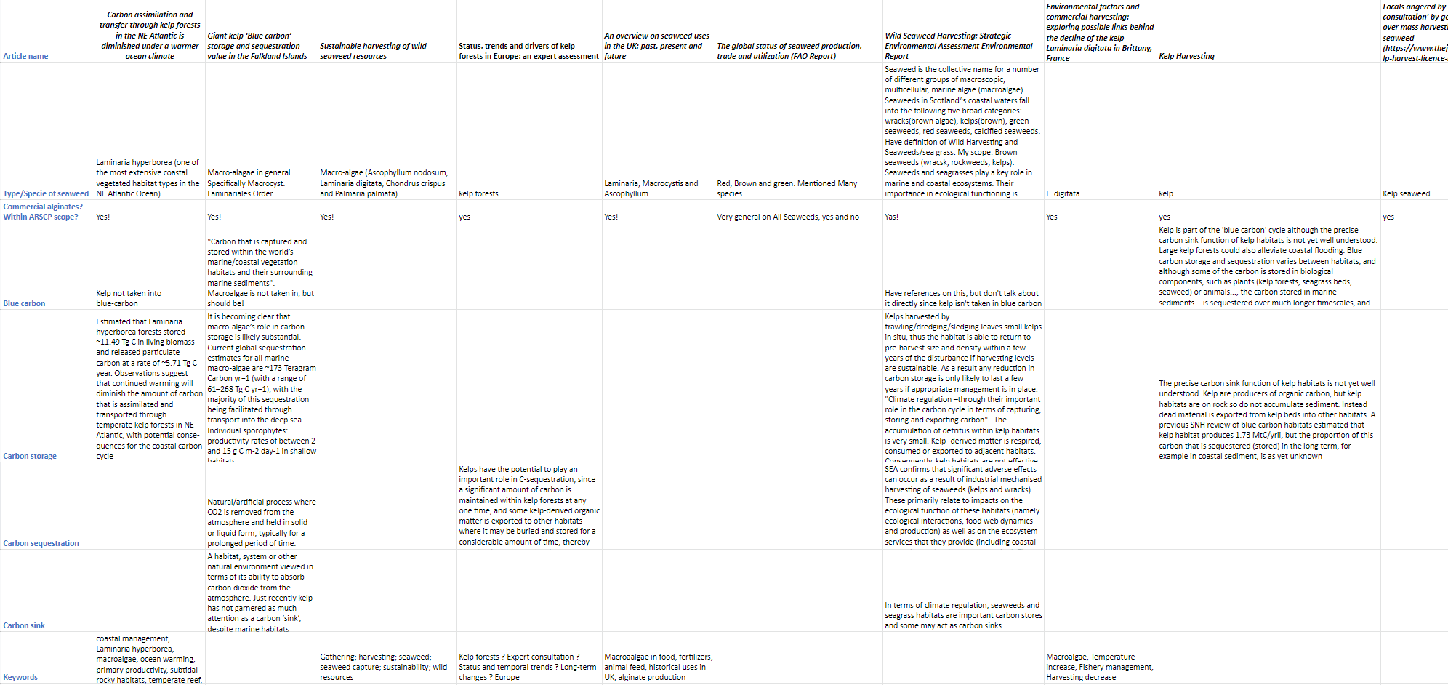
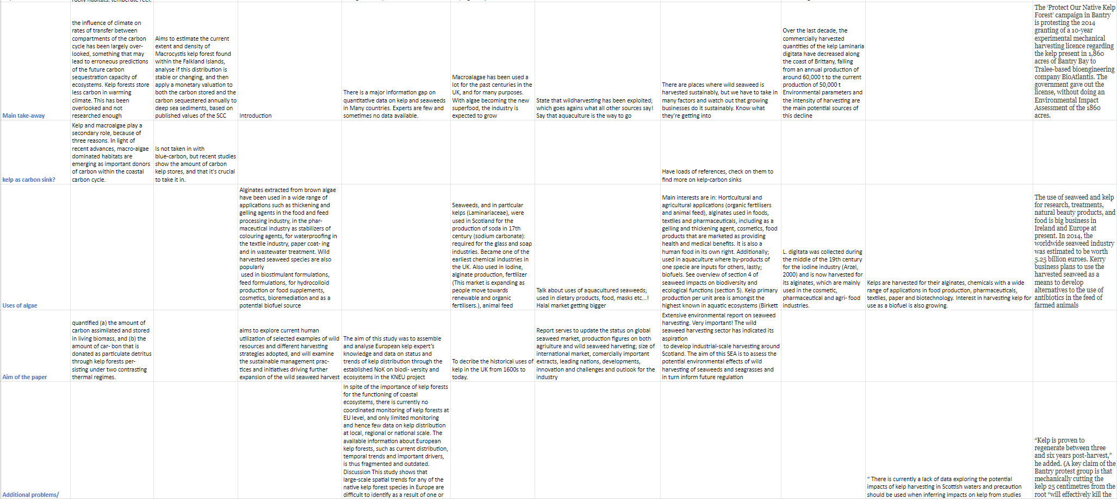

Appendix – IV Identification of criteria in analysed standards
The table below shows the abbreviations for identified criteria in the following standards:
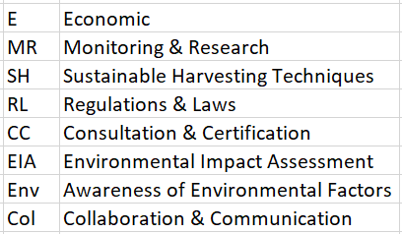
- Standard: ASC-MSC
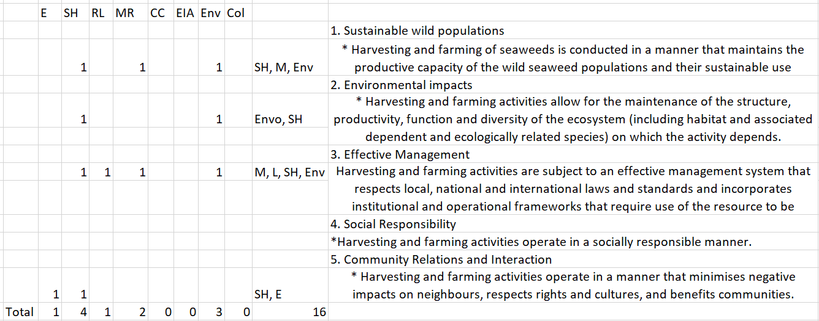
- Standard: Friends of the Sea
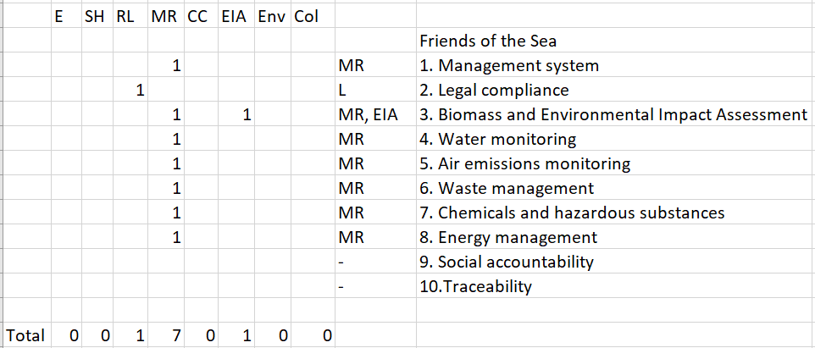

- Standard: Netalgae
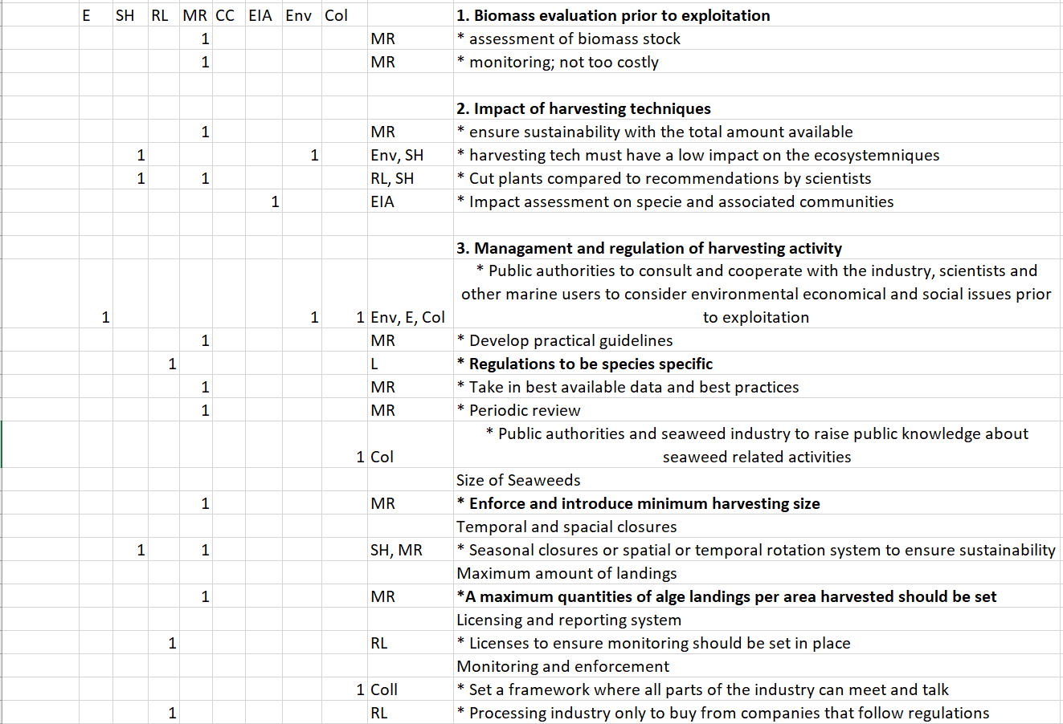
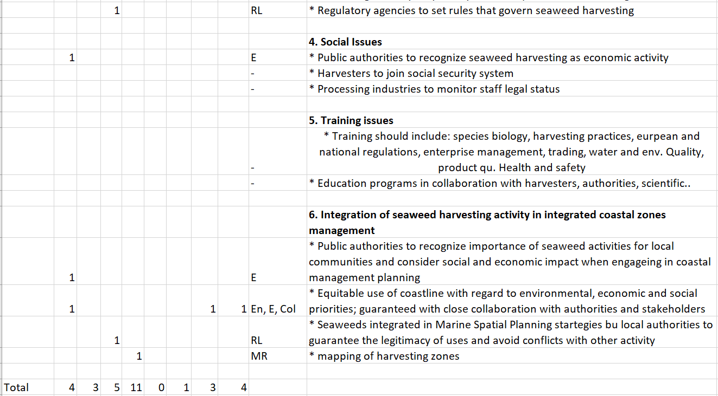

- Standard: PEGASUS
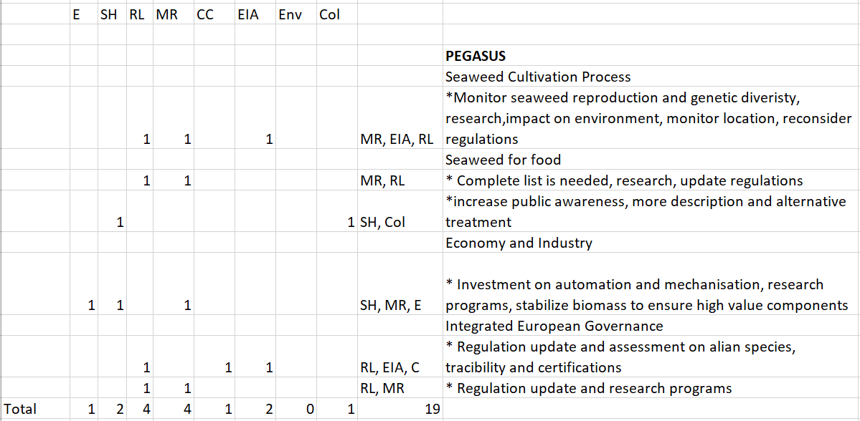
- Standard: Environmental Assessment Report (Marine Scotland)
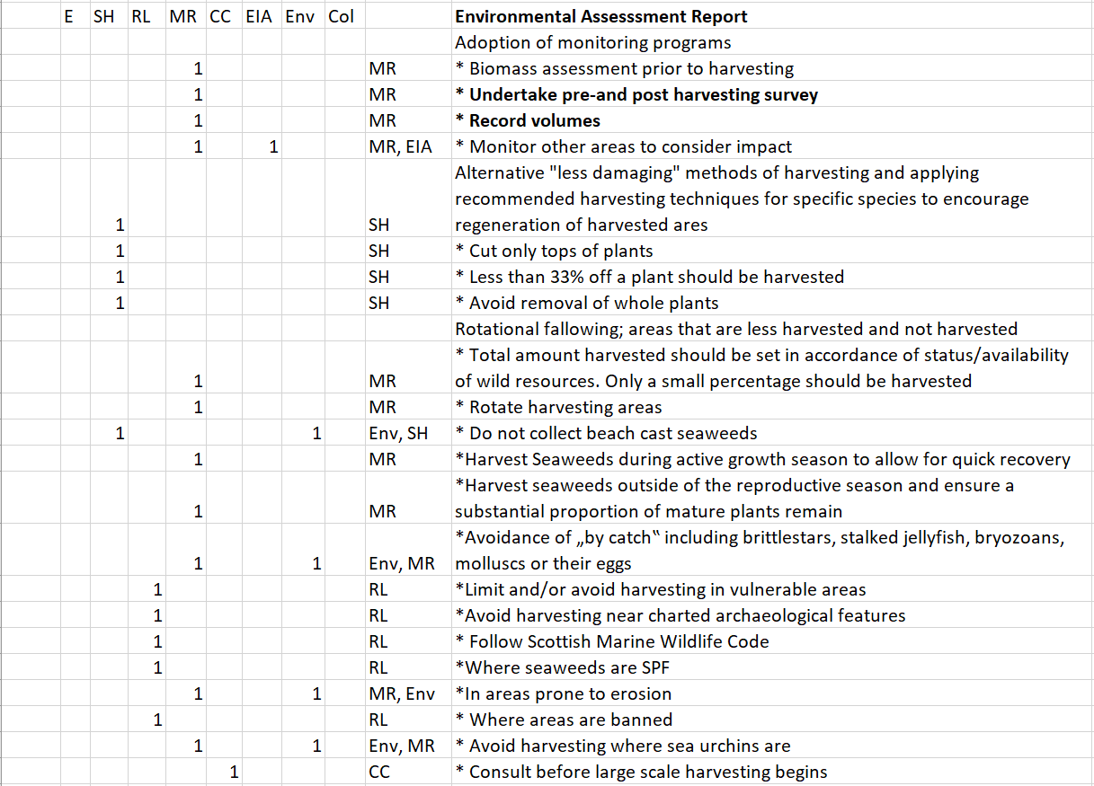
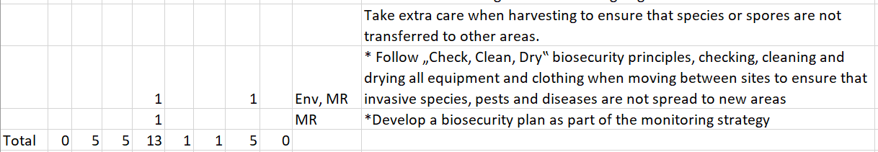
- Standard: Scoping Report (ABP Mer)
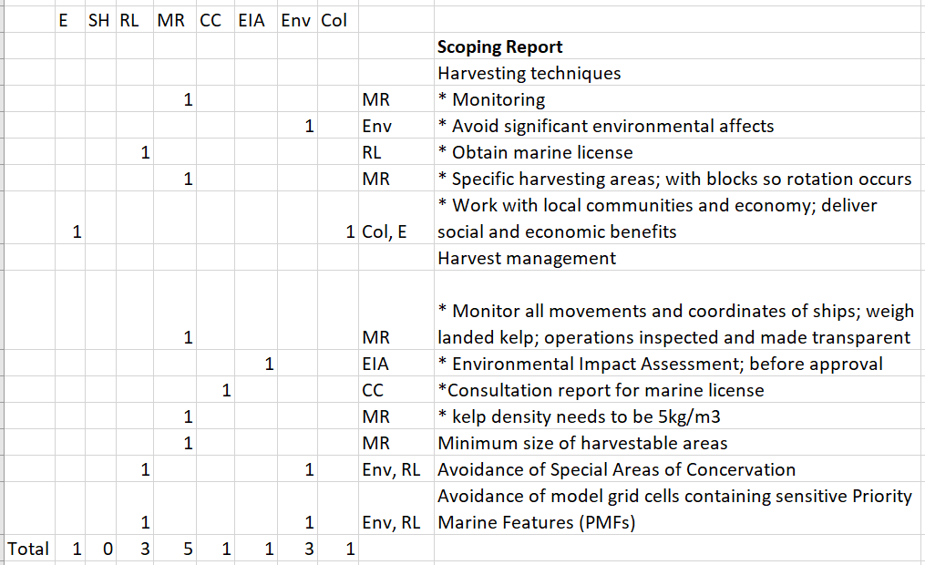
- Standard: Best Practices (Mara)
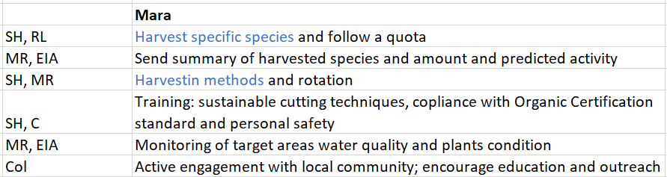
- Natural England (Code of Conduct)
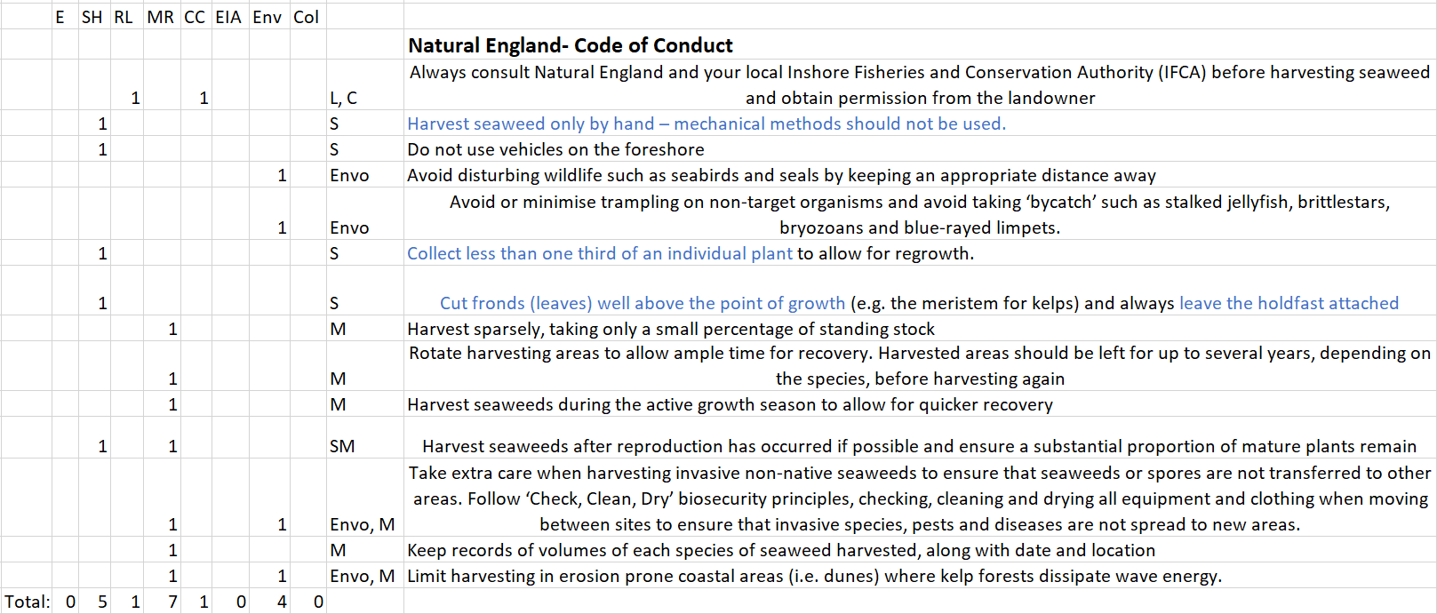

Appendix V- Identification of criteria in the ISRF
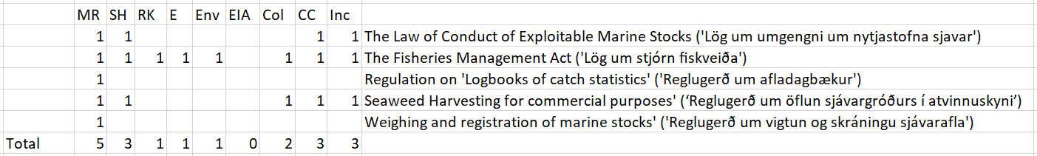

Appendix VI – List of Interviewees
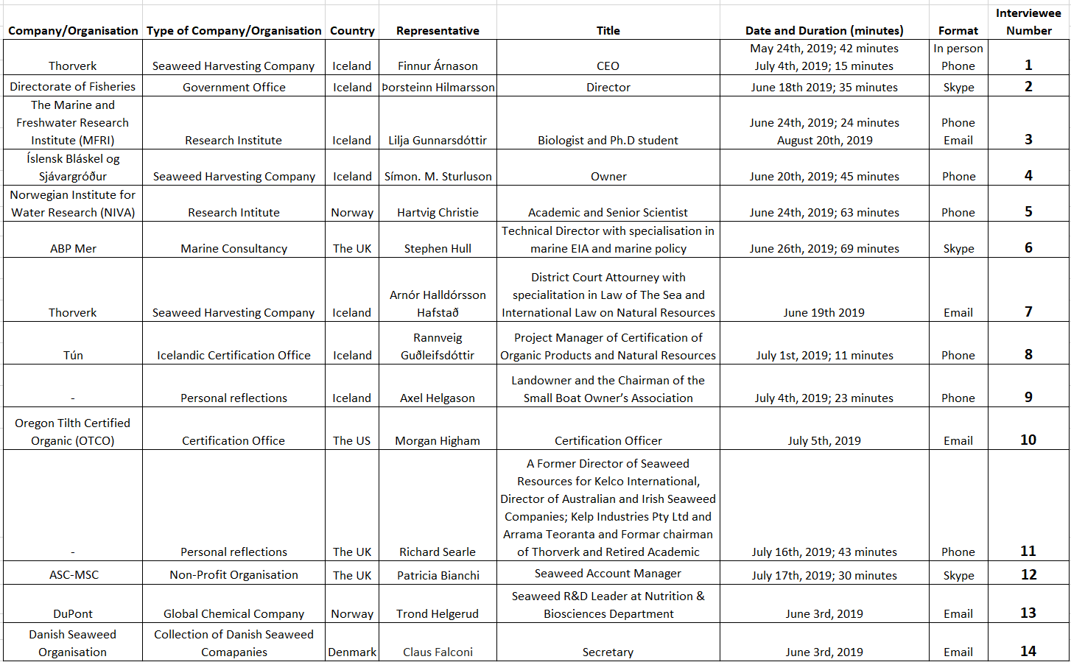

Appendix VII – Interview Protocol in English
Background and Sustainability
- What is your background and connection to the wild seaweed harvesting industry?
- What does sustainable exploitation of wild seaweed entail to you?
- Are there any main criteria that wild seaweed harvesting companies should include, to ensure sustainable utilisation and exploitation of wild seaweed?
- In your experience, have you perceived any change in interest in wild seaweed harvesting in the past years?
- If yes, has this interest lead to any change in sales?
- (If applicable) In your opinion, what do you think the trend of wild seaweed harvesting will look like in coming years?
Icelandic Regulations (Applicable to Icelandic interviewees)
- Are you aware or acquainted to the newly implemented regulation on “Öflun Sjávargróðurs í atvinnuskyni” and other interconnected regulation and laws on wild seaweed harvesting?
If so, in your opinion:
- What is your take on existing laws/regulations?
- Has the regulatory framework led to changes in daily operations on wild seaweed harvesting?
- Has the framework helped with ensuring sustainable exploitation?
- Is there anything you would like to see added or changed to the framework?

Economic distribution of wealth, generated by wild seaweed harvesting (Applicable to Icelandic interviewees)
- Are you aware of the property rights of landowners and the resource tax implemented on wild seaweed harvesting, by the Icelandic government?
  - Do you have any opinions on the property rights of landowners?
  - Do you have any opinions on the resource tax implemented on seaweed by the Icelandic government?
  - Do you have thoughts on the economic distribution of value generated by wild seaweed harvesting?

Standards and certifications
- Are you familiar with the ASC-MSC criteria or similar third-party certification labels?
  - Do you have opinions on third-party certification schemes in the wild seaweed industry?
  - Are there any standards that wild harvesting businesses should follow or keep in mind to fulfil sustainable exploitation?
Concerns
- Do you have any concerns regarding wild seaweed exploitation?
Closure
- Lastly, is there anything you would like to add before concluding this interview?

Appendix VIII – Interview Protocol in Icelandic

Bakgrunnur og sjálfbærni
- Getur þú gert grein fyrir tengslum og persónulegum bakgrunni þegar kemur að þang- og þara iðnaði og skurði á íslandi?
- Hvað merkir sjálfbær nýting á þangi og þara fyrir þér?
- Eru ákveðnar forsendur sem fyrirtæki ættu að hafa í huga við slátt á þangi og þara, svo að sjálfbær nýting geti átt sér það?
- Samkvæmt þinni reynslu, hefur þú tekið eftir einhverjum breytingum á áhuga þegar kemur að þang- og þara á síðustu árum?
- Ef já, hefur þessi áhugi leitt til aukinnar sölu á sjávarfangs-vörum?
- Heldur þú að ferill sjávarfang-iðnaðar muni breytast á komandi árum?
Íslenskar reglugerðir (Applicable to Icelandic interviewees)
- Þekkir þú til reglugerðarinnar “Öflun sjávargróðurs í atvinnuskyni”?
Ef já:
- Hefur þú skoðanir á reglugerðinni?
- Hefur þú tekið eftir breytingum í daglegum rekstri með tilkomu reglugerðarinnar?
- Hefur reglugerðin ýtt undir sjálfbæran slátt á þangi og þara?
- Eru einhverjar breytingar eða bætur sem þú myndir vilja sjá gerðar á regulugerðinni?

Efnahagsleg dreifing á auð, tengt nýtingu á þangi og þara (Applicable to Icelandic interviewees)
- Þekkir þú til rétta landeigenda og auðlindagjalds sem íslenska ríkið rukkar þang-og þara verksmiðjur?
  - Hefur þú skoðanir á rétti landeigenda?
  - Hefur þú skoðanir á auðlindagjaldi sett á þang og þara?
  - Hefur þú skoðanir á efnahagslegri dreifingu á auð sem varðar nýtingu á þangi og þara?

Standards and certifications
- Þekkir þú til ASC-MSC-staðalsins eða svipaðra staðla á þang-og þara?
  - Hefur þú skoðanir á þessum eða svipuðum stöðlum?
  - Eru ákveðnir staðlar fyrir þér sem fyrirtæki ættu að hafa í huga við nýtingu á þangi og þara?
Concerns
- Hefur þú einhverjar áhyggjur sem nýtingu á þangi og þara?
Closure
- Er eitthvað sem þú vilt koma á framfæri áður en viðtalinu líkur?

