Risk factors for dyspneic morbidity and mortality;

studies in the emergency department and in the population

Risk factors for dyspneic morbidity and mortality;

studies in the emergency department and in the population

Torgny Wessman

LundUniv_ENG_C2line_Black

DOCTORAL DISSERTATION

by due permission of the Faculty of Medicine, Lund University, Sweden.  
To be defended at Agardh salen CRC Malmö. Date 8 Oct 2021 9.00 am.

*Faculty opponent*Therese Djärv, Docent, Karolinska Institutet

|  |  |  |  |
| --- | --- | --- | --- |
| **Organization**  LUND UNIVERSITY | | **Document name** | |
|  | | **Date of issue** | |
| Author(s) | | Sponsoring organization | |
| **Title and subtitle**  Risk factors for dyspneic morbidity and mortality; studies in the emergency department and in the population | | | |
| **Abstract**  Dyspnea is caused in most cases by cardiovascular or lung diseases that have a high mortality. In this dissertation, we want to identify and shed light on various risk factors for increased morbidity and mortality in acute dyspnea patients, which should be considered in an emergency department, to improve both acute care and follow-up. In this thesis I will present 4 scientific papers. Three papers deal with risk factors for premature mortality in acute dyspnea patients. The 4th paper highlights the possibility of predicting morbidity in heart failure and COPD, mortality in CVD, cancer, pulmonary diseases as well as all-cause mortality in a middle-aged normal population. The first project was a retrospective medical record review study that showed increased mortality in dyspnea patients living in the immigrant-dense areas of Malmö, areas which also were linked to low annual average income. The second project was based on analysis of a subgroup from the ADYS cohort. This project showed associations between premature mortality in acute dyspnea patients and low annual income, ongoing or previous smoking, previous history of serious infection, anemia and hip fracture, high medical triage priority according to METTS, and severe dyspnea. However, there was no increased mortality among patients living in the immigrant-dense half of Malmö. The third project was based on the same subgroup of patients from the ADYS cohort as in project n:o two. In this project we examined the relationship between increased mortality and a standardized biomarker score consisting of a panel of 11 cardiovascular biomarkers, each of which was associated with a high comorbidity burden. The biomarker score, but not the comorbidity score, was strongly associated with mortality risk. In the fourth project we wanted to investigate whether a biomarker score could predict new-onset of CHF and COPD, as well as predict deaths in CVD, cancer, pulmonary diseases, as well as all-cause mortality in a middle-aged normal population. We used data from the individuals included in the cardiovascular cohort of the Malmö Diet and Cancer Study (MDC-CC). We partly compared the outcome in MDC-CC for the same 11 biomarkers from work 3, and partly created a new biomarker score of 12 biomarkers strongly associated with the Charlson Comorbidity Index as registered in the MDC-CC, with a follow-up period of almost 23 years. The biomarker score unique to the MDC-CC, could significantly predict both the future onset of CHF and COPD, as well as predict future deaths from CVD, cancer, respiratory diseases as well as all-cause mortality. Thus, a blood sample analyzing a score of biomarkers can be used as a risk stratification both in an emergency setting for patients with acute dyspnea, and to identify individuals at risk among a healthy middle-aged normal population. In an emergency setting with a seriously ill patient, it can be difficult to have the time or opportunity to take a medical history and get information for risk assessment. A simple blood test can be an effective complement to help make decisions about emergency care and treatment as well as follow-up. Within preventive medicine, a blood test can similarly help identify individuals at future risk of developing some common dyspnea diseases, as well as death from cancer, CVD, and lung disease as well as total mortality. | | | |
| **Key words:** Dyspnea; Comorbidity; Biomarker; Risk factor; Mortality; Emergency department; | | | |
| Classification system and/or index terms (if any) | | | |
| Supplementary bibliographical information | | | **Language:** English |
| **ISSN and Key title:** 1652-8220, Lund University, Doctoral Dissertation Series 2021:96 | | | **ISBN 978-91-8021-103-1** |
| Recipient’s notes | **Number of pages:** 76 | | Price |
|  | Security classification | | |

I, the undersigned, being the copyright owner of the abstract of the above-mentioned dissertation, hereby grant to all reference sources permission to publish and disseminate the abstract of the above-mentioned dissertation.

Signature Date 2021-09-02

Risk factors for dyspneic morbidity and mortality;

studies in the emergency department and in the population

Torgny Wessman

LundUniv_ENG_C2line_Black

|  |
| --- |
| Cover photo by Torgny Wessman  Copyright Torgny Wessman  Paper 1 © Open Access Emergency Medicine, Dovepress  Paper 2 © Open Access Emergency Medicine, Dovepress  Paper 3 © Internal and Emergency Medicine, Springer  Paper 4 © by the Authors (Manuscript unpublished)  Lund University, Faculty of Medicine Doctoral Dissertation Series 2021:96  ISSN 1652-8220  ISBN 978-91-8021-103-1  Printed in Sweden by Media-Tryck, Lund University  Lund 2021 |

***To patients, students, and beloved ones***

“Language is a prerequisite for communication. Speech is a prerequisite for verbal language. Breathing is a prerequisite for speech. Conditions that impair breathing thus impair the possibilities for communication.”

# Table of Contents

Abbreviations 10

List of papers 11

Svensk populärvetenskaplig sammanfattning 12

Inledning 12

Befolknings och patientregister 12

Delarbete 1 14

Delarbete 2 15

Delarbete 3 16

Delarbete 4 19

Sammanfattning 21

Introduction 22

Preface 22

Context of thesis 24

Rationale 25

General introduction 26

Risk factors 28

Population and patient registers 29

Aims 31

Material, methods, and design 32

Study 1 32

Study 2 33

Study 3 34

Study 4 36

Results 40

Study 1 40

Study 2 41

Study 3 45

Study 4 46

Discussion 50

Study 1 50

Study 2 51

Study 3 52

Study 4 54

Overall discussion 54

Limitations 56

Future research 58

Acknowledgements 59

Supplementary material 61

References 69

## Abbreviations

ADAPT Adaptive Process Triage

ADYS Acute Dyspnea Study

AF Atrial fibrillation

BMI Body Mass Index

BSADYS Biomarker Score ADYS

BSC Biomarker Score of Comorbidity

BSMDC Biomarker Score Malmö Diet Cancer

CAD Coronary artery disease

CCI Charlson Comorbidity Index

CI Confidence Interval

CVD Cardiovascular disease

CHF Congestive heart failure

COPD Chronic obstructive pulmonary disease

CS Comorbidity Score

ED Emergency Department

EU European Union

HF Heart failure

HR Hazard Ratio

ICD 10 International Classification of Diseases version 10

ICU Intensive Care Unit

IDUD Immigrant Dense Urban Districts

IQR Interquartile range

MDC Malmö Diet Cancer Study

MDC-CC Malmö Diet Cancer Study, the Cardiovascular Cohort

METTS Medical Emergency Triage and Treatment System

NO2 Nitrogen dioxide

NYHA New York Heart Association

PCI Percutaneous Coronary Intervention

SCB Statistiska Centralbyrån, the state agency for Statistics Sweden

SD Standard Deviation

SDUD Swedish-born Dense Urban Districts

SES Socioeconomic Status

SoS Socialstyrelsen, the Swedish National Board of Health and Welfare

SUS Skånes Universitets Sjukhus, University Hospital of Skane

## List of papers

This thesis is based on the following papers:

1. **Torgny Wessman**, Rafid Tofik, Klas Gränsbo, Olle Melander.Increased mortality among acute respiratory distress patients from immigrant dense urban districts. Open Access Emerg Med. 2019 Mar 11; 11:43-49. doi: 10.2147/OAEM.S187686.
2. **Torgny Wessman**, Rafid Tofik, Thoralph Ruge, Olle Melander. Socioeconomic and clinical predictors of mortality in patients with acute dyspnea. Open Access Emergency Medicine 2021:13 107–116. doi:10.2147/OAEM.S277448.
3. **Torgny Wessman**, Rafid Tofik, Thoralph Ruge, Olle Melander. Associations between biomarkers of multimorbidity burden and mortality risk among patients with acute dyspnea. Internal and Emergency medicine 2021. Doi: 10.1007/s11739-021-02825-6.
4. **Torgny Wessman**, Rafid Tofik, Thoralph Ruge, Olle Melander. Relationships between comorbidity-burden associated biomarkers and outcomes among participants in the Malmö Diet and Cancer Study. Manuscript by authors.

## Svensk populärvetenskaplig sammanfattning

### Inledning

Denna avhandling handlar om riskfaktorer för död hos patienter med akut andnöd, samt riskfaktorer för andnödsrelaterade sjukdomar och död hos en frisk normalbefolkning. Avhandlingen är i huvudsak epidemiologisk. Epidemiologi är vetenskapen om distribution, mönster och determinanter för hälsa och sjukdom i en definierad population. Epidemiologiska studier och analyser är hörnstenar inom folkhälsan och grundläggande för evidensbaserad medicin och praxis. Det är viktigt att identifiera riskfaktorer för sjukdom, för att kunna arbeta förebyggande. Andnöd är en subjektiv känsla av att få för lite luft, och regleras genom ett samspel mellan signaler från hjärnan, kemo-receptorer för syre och koldioxid, och från receptorer i luftvägar och bröstkorgsmuskler. Sjukdomar som hjärtsvikt, kroniskt obstruktiv lungsjukdom (KOL) eller lunginflammation är exempel på sjukdomar som orsakar andnöd (1). Även andra sjukdomar som t.ex. blodbrist, astma, propp i lungorna, och psykiska orsaker kan ge andnöd. På akutmottagningen vid Skånes Universitetssjukhus i Malmö är andnöd den tredje vanligaste kontaktorsaken och utgör ca 7% av alla besök. Sjukdomar som ger andnöd ökar med åldern (2-5) och innebär ofta risk för förtidig död. Det är viktigt att ta reda på patientens tidigare sjukdomar, dels för att dessa kan påverka den akuta sjukdomen, dels för både tidigare och pågående sjukdom påverkar risk för framtida sjuklighet och död. Samsjuklighet kan värderas med ett så kallat komorbiditetsindex (6-13). Utifrån svårighetsgrad av symtom och vitalparametrar beslutar man dels om medicinsk prioritet, dels vilka akuta undersökningar, prov och utredning som behövs för att få en uppfattning om orsak och diagnos, samt ställningstagande till behandling och uppföljning. För denna första medicinska prioritets bedömning används standardiserade utvärderade medicinska triage system. I mina första tre vetenskapliga arbeten har jag velat identifiera och undersöka olika riskfaktorers betydelse avseende förtidig död och svårare sjuklighet, inklusive biomarkörer i blodet. I mitt fjärde arbete har jag velat undersöka hos en frisk normalbefolkning om en liknande panel av biomarkörer som i arbete 3, kan förutsäga insjuknande i KOL och hjärtsvikt, så väl som död i hjärtkärlsjukdomar, maligniteter, andningsorganens sjukdomar så väl som total dödlighet.

### Befolknings och patientregister

**ADYS** eller ”Akut DYspne Studien” initierades av Olle Melander och Klas Gränsbo. I studien inkluderades patienter över 18 år som besökte akutmottagningen på Skånes Universitetssjukhus i Malmö pga. andnöd mellan mars 2013 och januari 2019. Totalt 1900 patient besök inkluderades i studien (figur 1). Efter att vi korrigerat för multipla besök och felaktigheter kvarstod 1745 unika patienter med fullständigt personnummer.

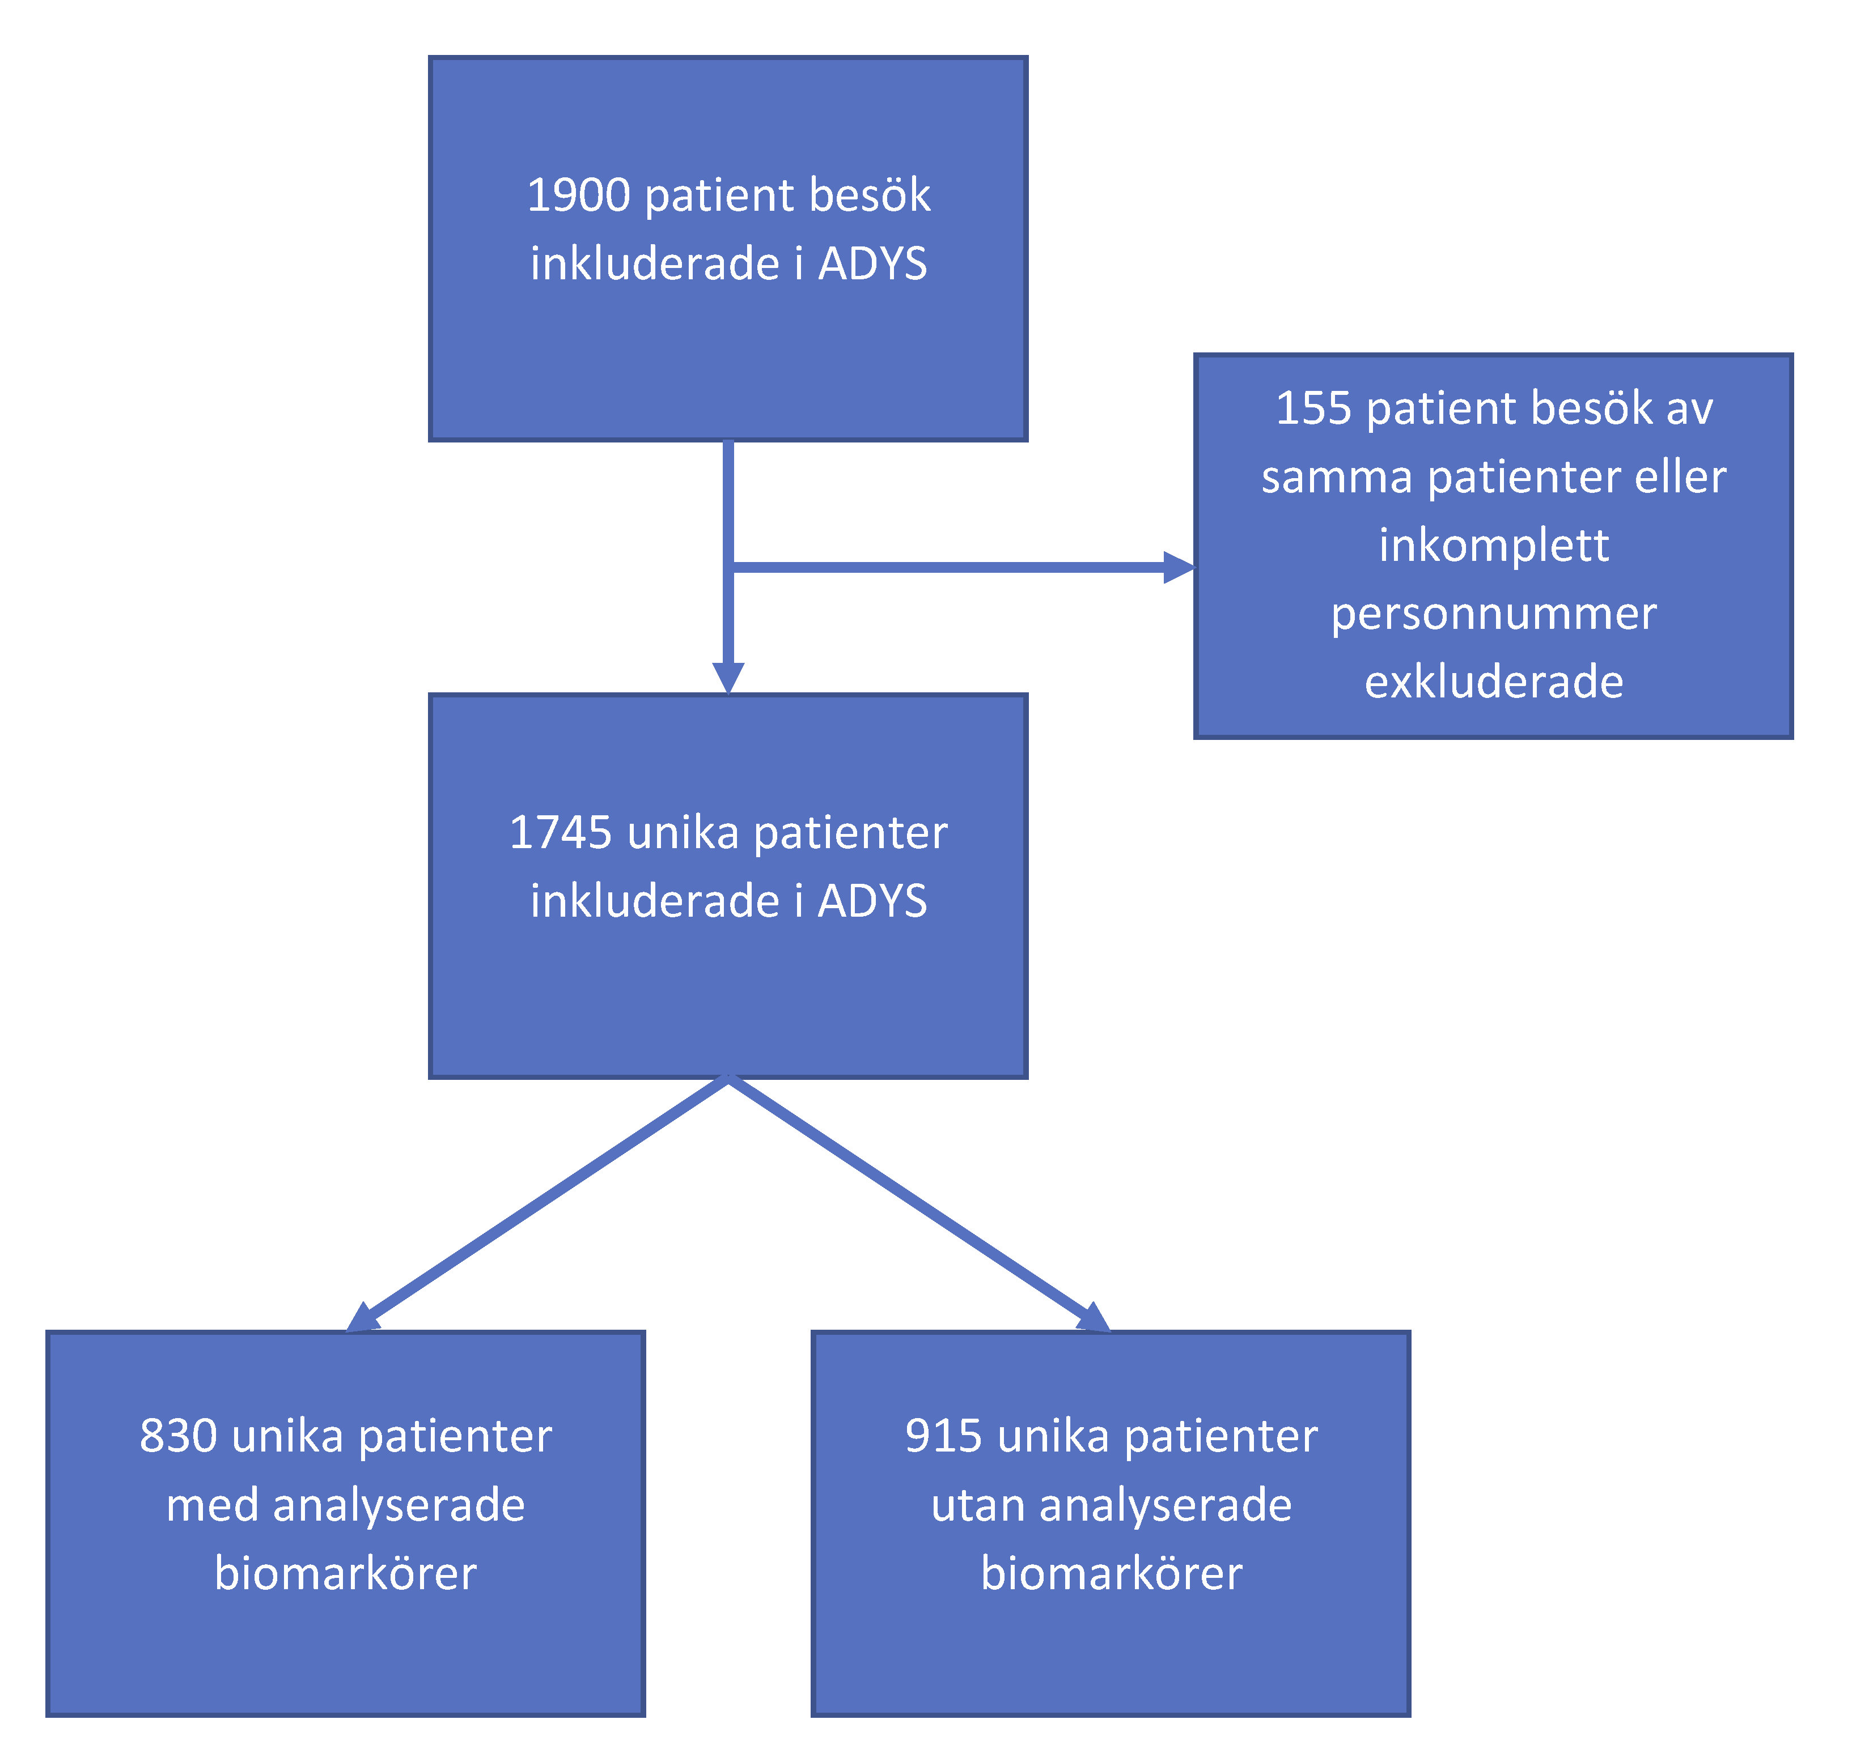

Figur 1: Flödesschema ADYS kohorten

**MKC** eller ” Malmö Kost Cancer studien” startades i början av 1990-talet på initiativ av Cancerfonden (14). Studien leddes i början av professor Göran Berglund (internmedicin) och professor Lars Janzon (epidemiologi). Man ville med studien studera sambandet mellan kosten och uppkomsten av cancer hos befolkningen. Studien omfattar 30 447 män (födda 1923–1945) och kvinnor (födda 1923–1950). En undergrupp på 6 094 av dessa individer (figur 2) inkluderades i en hjärtkärl-sjukdomsstudie (kardiovaskulära kohorten) för att studera sambandet mellan kost, halspulsåderförkalkning undersökt med ultraljud och risken för att utveckla hjärt-kärlsjukdomar i befolkningen.

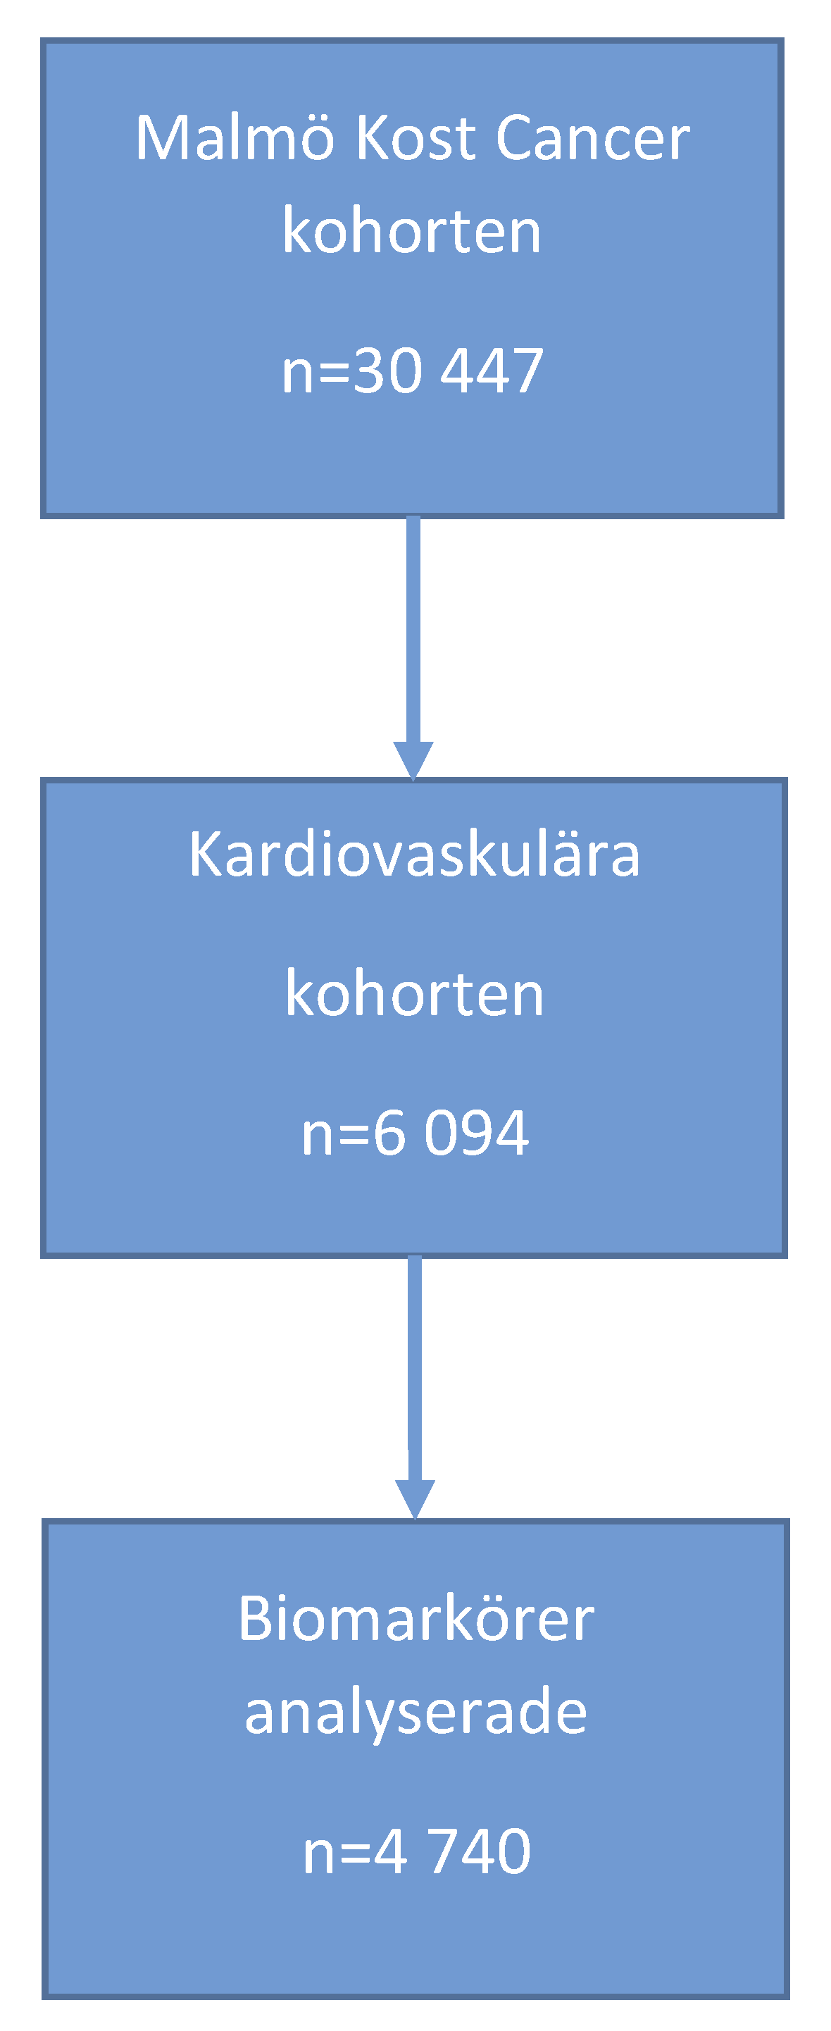

Figur 2: Flödesschema MDC-CC

### Delarbete 1

Syftet med delarbete 1 var att identifiera socioekonomiska och kliniska riskfaktorer för mortalitet bland patienter med akut dyspné som sökte akutmottagningen i Malmö 2007. Studien var en så kallad retrospektiv journalgranskningsstudie (15). Patientjournaler från 184 patienter över 18 års ålder som besökte akutmottagningen under 2007, SUS Malmö valdes ut. Malmö bestod 2007 av 10 stadsdelar med mycket varierande socioekonomiska förutsättningar, varav 36% av befolkningen var första eller andra generationens invandrare (16, 17). Invandrare från länder utanför EU hamnar ofta i områden med lågt socio-ekonomisk status (SES) och rapporterar tre till fyra gånger så ofta att de lider av dålig eller mycket dålig hälsa (18). Lågt SES är kopplat till ökad risk för många sjukdomar (19) (20) (21, 22). Eftersom antalet studerade patienter var så få, valde vi att dela kohorten i endast två grupper, den invandrar täta halvan (IDUD) respektive den icke-invandrartäta halvan (SDUD) av Malmö. Totalt dog 94 (51%) av de 184 patienterna under den 5-åriga uppföljningstiden. Vi såg en 65% ökad risk för död hos patienterna från IDUD jämfört med SDUD, efter justering för kön och ålder. Vi fann en dubbelt så hög risk för 5-årig dödlighet hos patienter med årsinkomst i den lägsta kvartilen jämfört med de med årsinkomst i högsta kvartilen, justerat för IDUD, kön och ålder. Justerat för ålder, kön, IDUD, årsinkomst, förekomsten av både hjärt- och lungsjukdomar samt medicinsk prioritet vid ankomst, såg vi en ökad dödsrisken på 79% för de patienter som bodde i IDUD, 127% för patienter med årsinkomst i den lägsta kvartilen jämfört med de med årsinkomst i högsta kvartilen, 76% för patienter med både hjärt- och lungsjukdomar samt 73% för patienter med den högsta medicinska prioriteten jämfört med mellan och låg medicinsk prioritet.

### Delarbete 2

Syftet med denna studie var att värdera vissa socioekonomiska och kliniska riskfaktorers betydelse för mortalitet hos patienter med akut dyspné. Denna studie var en longitudinell observationsstudie baserad på data från de första 798 patienterna som ingick i ADYS-kohorten och som inkluderades mellan 2013 och 2016 (figur 3) (23).

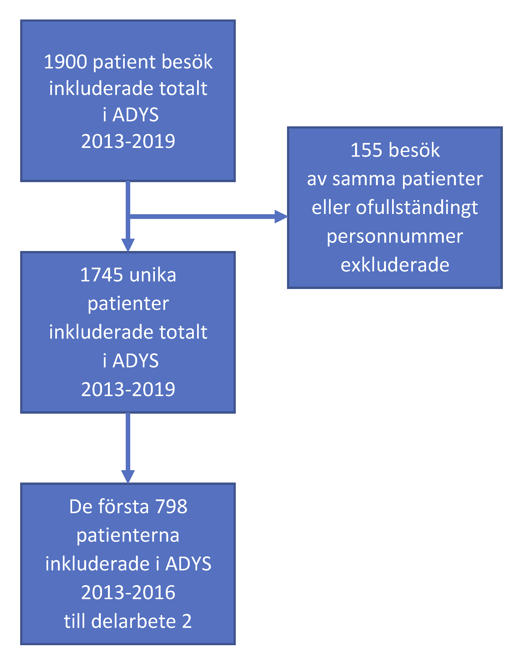

Figur 3: Flödesschema ADYS delarbete 2

För att undersöka årsinkomstens betydelse snarare än invandrarbakgrund som riskfaktor delades denna kohort på 789 patienter upp i 5 inkomstgrupper (kvintiler), avseende disponibel inkomst året innan besöket på akuten. Vi valde att registrera stadsdelstillhörighet utifrån samma stadsdelsindelning som 2007, dvs tiden för den första studien, även om Malmö hade infört en ny stadsdelsindelning med 5 stadsdelar 2013. Vi registrerade individens födelse-ursprungsområde, komorbiditet (samsjuklighet), rökvanor, medicinsk triage prioritet samt graden av andnöd vid ankomst till akutmottagningen. Under uppföljningstiden i denna studie som var 2,2 ± 1,3 år, dog 334 (40%) av patienterna. De tre huvudsakliga dödsorsakerna under denna uppföljningstid var kardiovaskulära (40%, inklusive stroke), cancersjukdomar (21%) samt KOL och andra lungsjukdomar (19%, inklusive lunginflammation). Justerat för kön och ålder, med den högsta inkomstkvintilen som referens, fanns vi för den näst högsta inkomstkvintilen en signifikant ökad dödlighet på 48%, för medelinkomstkvintilen på 63%, för den näst lägsta inkomstkvintilen på 61% och i den lägsta inkomstkvintilen en 74% ökad dödlighet. Det fanns inga statistiska skillnader i dödsrisk mellan IDUD och SDUD, eller mellan födelse-ursprungsområde. Föregående eller pågående rökning ökade risken för död med 57%.Förekomst av följande tidigare eller samtidigt pågående sjukdomar var också var och en oberoende av varandra associerat till ökad dödsrisk; lunginflammation eller annan allvarlig infektion, anemi, diabetes, njursjukdom, höftfraktur, kranskärlssjukdom, hjärtsvikt, KOL, restriktiv lungsjukdom och annan övrig lungsjukdom. För patienter med den högsta medicinska prioriteten enligt METTS (24), ökade risken med 265%, och för den näst högsta medicinska prioriteten med 205%. För patienter med dyspne i vila ökade risken med 217%, för patienter med dyspne vid lätt ansträngning ökade risken med 127%, och för patienter med dyspne vid tung ansträngning ökade risken med 55%. Justerat för kön och ålder, samt för samtliga variabler som var signifikanta i föregående modell, kvarstod en ökad dödlighet med 64% för lägsta inkomst kvintilen, 43% för tidigare eller pågående rökning, 40% för tidigare eller pågående lunginflammation eller annan allvarlig infektion, 53% för tidigare eller pågående anemi, 83% för tidigare eller pågående höftfraktur, 120% för patienter med näst högst METTS prioritet och med 77% för patienter med dyspné i vila.

Vi kunde med arbete 2 visa att låg årsinkomst, rökning, kliniska faktorer i form av sjukdomens/symtomens allvarlighetsgrad mätt som medicinsk triage prioritet och svår andnöden samt närvaro eller tidigare förekomst av vissa sjukdomar oberoende av varandra var signifikanta riskfaktorer för död vid 2,2 års uppföljning hos patienter med akut dyspné.

### Delarbete 3

Denna studie var en fördjupning, förlängning och fortsättning på delarbete 2, med ett tillägg avseende analyser av biomarkörer. Vi ville med denna studie undersöka om en panel av biomarkörer i blodet på ett säkert sätt, kunde tillföra information om risk avseende förtidig död hos patienter med akut andnöd. Biomarkörer har analyserats på de första 830 patienterna som ingick i ADYS (figur 4). I detta arbete undersökte vi 774 av dessa patienter, som hade kompletta analyserade blodprov avseende 80 biomarkörer.

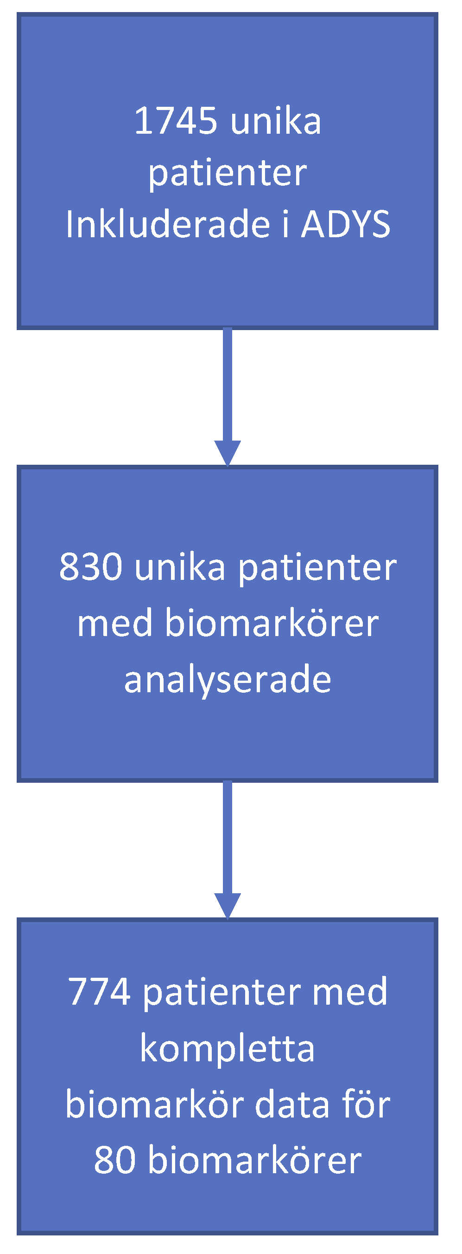

Figur 4: Flödesschema delarbete 3 ADYS

Biomarkörer är biologiska ämnen som cirkulerar i blodet, varav vissa kan användas som indikatorer på hälsorelaterade tillstånd (25-44). Vi registrerade förekomst av 22 olika tidigare sjukdomar, som summerades till en komorbiditetspoäng. Vi identifierade sedan de 11 biomarkörer som hade en stark association till komorbiditetspoäng (tabell 1).

Tabell 1: Biomarkörer med association till komoriditetspoäng

|  |  |  |  |
| --- | --- | --- | --- |
|  | **betakoefficient** | **Std Error** | **P-value** |
| **NTproBNP**, N-terminal prohormone of brain natriuretic peptide | 0.494 | 0.091 | <0.0001 |
| **FGF23**, Fibroblast growth factor | 0.438 | 0.088 | <0.0001 |
| **FABP4**, Fatty Acid Binding Protein 4 | 0.333 | 0.101 | 0.001 |
| **CCL20**, C-C motif chemokine 20 | 0.286 | 0.076 | 0.0002 |
| **SCF**, Stem cell factor | 0.271 | 0.077 | 0.0004 |
| **REN**, Renin | 0.266 | 0.071 | 0.0002 |
| **LEP**, Leptin | 0.254 | 0.077 | 0.001 |
| **MMP12**, Matrix Metallo-proteinase | 0.206 | 0.078 | 0.008 |
| **IL27A**, Interleukin 27A | -0.207 | 0.076 | 0.006 |
| **PECAM1**, Platelet endothelial cell adhesion molecule | -0.212 | 0.069 | 0.002 |
| **GAL**, Galanin peptides | -0.285 | 0.076 | 0.0002 |

Under uppföljningstid på 2,4 ± 1,5 år dog 348 (45%) patienter. Justerat för ålder och kön, sågs en signifikant ökning av dödsfall per standarddeviation (SD) av biomarkör-poängskalan med 60% och för komorbiditets-poängskalan 43%. Justerat för ålder och kön med biomarkör-poängskalan och komorbiditets-poängskalan i samma modell, var ökningen av dödsrisken per varje SD-ökning avseende biomarkör-poängskalan på 59% och för komorbiditets-poängskalan på 18%. Justerat för ålder, kön, biomarkör-poängskalan, komorbiditets-poängskalan, triage prioritering enligt METTS, svårighetsgrad av dyspné, årsinkomst och rökning, fann vi en signifikant oberoende ökning av dödsrisken för biomarkörspoängen med 55% per SD-ökning, medan poängen för ren komorbiditet inte var signifikant relaterad till dödlighet. Vi gjorde också analyser avseende död vid 3 månader efter akutbesöket, då 94 (12%) av patienterna hade dött. Biomarkörspoängskalan i denna fullt justerade modellen förutspådde signifikant en 98% ökning av korttidsdödlighet per varje SD-ökning, medan komorbiditets-poängskalan inte alls var relaterad till 3 månaders dödlighet. I analyser av biomarkörpoäng kvartiler i en fullt justerad modell fanns en signifikant linjär trend mellan biomarkören poängkvartiler och mortalitet vid både lång och kort (3 månader) uppföljning. Patienterna som hade biomarkörpoäng i den övre jämfört med den nedre kvartilen hade en 2,3 gånger ökad risk för dödsfall under lång och en 4,2 gånger ökning av korttids dödlighet

Vi tror att den information som finns i blodet vid ett akut insjuknande med dyspné ger mycket bättre information avseende sjukdomens allvarlighetsgrad beräknat som risk för förtidig död både vid korttids- och långtidsuppföljning, än information om samsjuklighetsbörda. Sambandet är starkast vid korttidsuppföljning. Sammanfattningsvis är biomarkör-poängskalan mycket starkt associerat med förtidig död vid både lång och kort uppföljning. Så är inte fallet avseende komorbiditets-poängskalan.

### Delarbete 4

Syftet med denna studie var att utvärdera om två olika biomarkör-poängskalor, båda associerade med samsjuklighet, kan förutsäga framtida insjuknande och död i vissa dyspné relaterade sjukdomar hos en medelålders normal befolkning. Vi utgick från individerna i den kardiovaskulära kohorten (MDC-CC) från ”Malmö Kost Cancer” studien (Malmö Diet and Cancer Study, MDC). (figur 5).

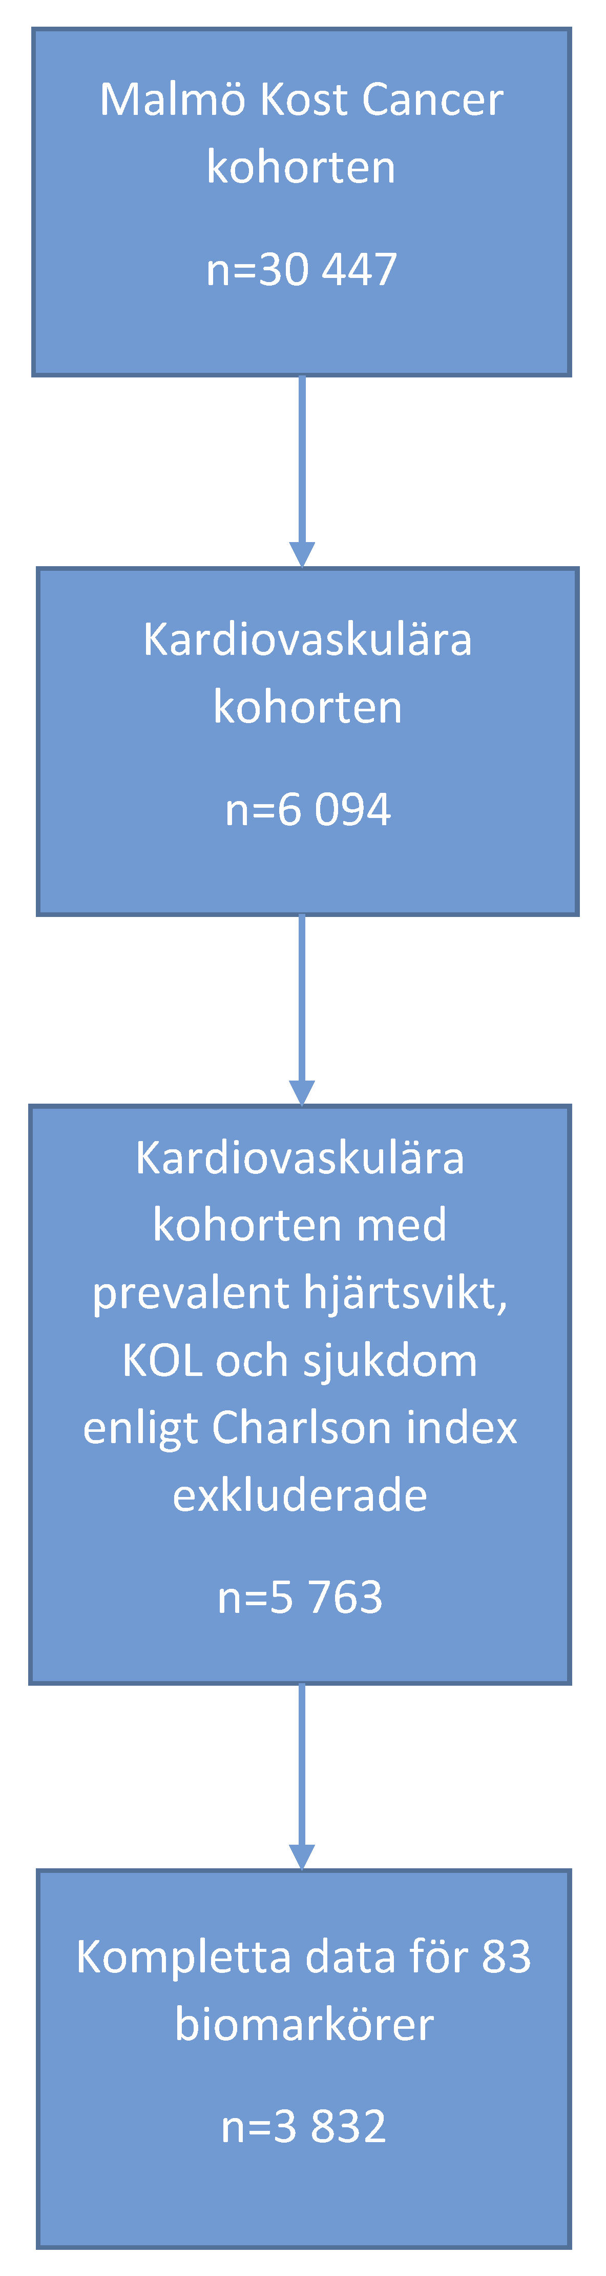

Figur 5: Flödesschema MDC-CC delarbete 4

Det finns kompletta biomarkör data för 83 biomarkörer hos 4 740 individer i MDC-CC (se supplement 4). I MDC finns information om förekomsten av samsjuklighet registrerat som Charlson Comorbidity Index (CCI) (12, 13). I MDC-CC hade 4% av individerna minst en registrerad CCI-sjukdom. På samma sätt som i delarbete 3 ville vi hitta de biomarkörer som hade en stark association till samsjukslighet definierat som CCI. Vi hittade 12 oberoende biomarkörer med sådan association (tabell 2).

Tabell 2: Biomarkörer med association till samsjuklighet enligt CCI

|  |  |  |  |
| --- | --- | --- | --- |
|  | **betakoefficient** | **Std Error** | **P-value** |
| **GDF-15**, Growth/differentiation factor 15 | 0,026 | 0,005 | <0,001 | |
| **MMP12**, Matrix Metallo-proteinase | 0,025 | 0,004 | <0,001 | |
| **TRAIL**, TNF-related apoptosis-inducing ligand | -0,024 | 0,004 | <0,001 | |
| **IL-6**, Interleukin-6 | 0,016 | 0,003 | <0,001 | |
| **NtproBNP**, N-terminal prohormone of brain natriuretic peptide | 0,012 | 0,003 | <0,001 | |
| **REN** , Renin | 0,010 | 0,003 | 0,003 | |
| **Gal-3**, Galectin-3 | -0,013 | 0,004 | 0,001 | |
| **TIM**, Thrombomodulin | 0,012 | 0,004 | 0,001 | |
| **FS**, Follistatin | -0,014 | 0,004 | 0,001 | |
| **HGF**, Hepatocyte growth factor | 0,012 | 0,005 | 0,011 | |
| **CASP-8**, Caspase-8 | -0,010 | 0,004 | 0,005 | |
| **CXCL6**, C-X-C motif chemokine 6 | 0,006 | 0,004 | 0,111 | |

Från dessa 12 biomarkörer skapade vi en biomarkör-poängskala som vi döpte till ”Biomarker Score Malmö Diet Cancer” (BSMDC). Vi ville också i MDC-CC värdera samma 11 olika biomarkörer som vi använde oss av för den ADYS relaterade biomarkör panelen i arbete 3. Denna poängskala döpte vi till ”Biomarker Score ADYS” (BSADYS). Vi ville utvärdera om dessa två biomarkör-poängskalor kunna förutsäga nyinsjuknande i hjärtsvikt, nyinsjuknande i kroniskt obstruktiv lungsjukdom (KOL), död i hjärt-kärlsjukdom, död i cancersjukdom, död i andningsorganens sjukdomar samt total dödlighet hos en frisk medelålders normal befolkningen. Vi hade kompletta data för respektive biomarkör-poängskala för 3832 individer, och som inte hade registrerade sjukdomar enligt CCI, dvs var friska vid studiens start. Medelvärdet för ålder vid studiens start på 1990-talet var 57,6 år. Uppföljningstiden fram till 2018-12-31 var 23,2 ± 5,1 år med undantag för de patienter med nyinsjuknande i KOL som hade en uppföljning fram till 2016-12-31 på 21,4 ± 4,9 år. Totalt dog 2430 (39%) individer, varav 405 dödsfall på grund av hjärtkärlsjukdom, 493 dödsfall på grund av cancer och 94 dödsfall på grund av andningssjukdomar. Under hela uppföljningstiden fram till 2018-12-31 hade 267 individer insjuknat i hjärtsvikt. Under uppföljningstiden fram till 2016-12-31 hade 355 individer insjuknat i KOL. Justerat för ålder, kön, diabetes, blodtrycksmedicinering, systoliskt blodtryck, rökning (tidigare eller pågående), rökning, body mass index (BMI), förekomst av tidigare kranskärlssjukdom, separat för varje respektive biomarkörskala, fann vi avseende nyinsjuknande i hjärtsvikt en signifikant ökning på 26% för varje SD-ökning på BSADYS skalan och 57% för varje SD-ökning på BSMDC skalan. I samma modell fann vi en signifikant ökning på 65% för varje SD-ökning på BSMDC skalan avseende nyinsjuknande i KOL, men inget samband med BSADYS skalan. Vi fann en signifikant ökning på 8% för varje SD-ökning på BSADYS skalan och med 42% för varje SD-ökning på BSMDC skalan för total mortalitet. Avseende död i hjärt-kärlsjukdom fann vi en signifikant ökning på 15% för varje SD-ökning på BSADYS skalan och med 38% för varje SD-ökning på BSMDC skalan. Endast BSMDC skalan var associerat med död i cancersjukdomar med en risk ökning på 37%, och med död i respiratoriska sjukdomar med risk ökning på 69% för varje SD-ökning på BSMDC skalan. Justerat för ålder, kön, alla kliniska variabler ovan, samt båda biomarkör-poängskalor, förblev BSMDC skalan robust och oberoende associerat med alla 6 utfall, medan BSADYS skalan endast var signifikant relaterad till nyinsjuknande i hjärtsvikt och död i hjärtkärlsjukdom.

### Sammanfattning

Mitt forskarintresse och mitt avhandlingsarbete började med en omsorg om och intresse för invandrargruppers situation och hälsa, och möjlighet till en jämlik vård om man sökte för akut dyspne på akutmottagningen i Malmö. I delarbete 1 såg vi en ökad dödlighet hos dyspné patienter från Malmös invandrartäta halva. I delarbete 2 konstaterade vi att skillnader i dödlighet nog snarare berodde på skillnader i inkomst än invandrarbakgrund och stadsdelstillhörighet, samt förekomst av rökning, kliniska faktorer i form av sjukdomens/symtomens allvarlighetsgrad mätt som medicinsk triage prioritet och svår andnöden samt närvaro eller tidigare förekomst av vissa sjukdomar. I delarbete 3 såg vi att en panel av olika analyserade biomarkörer i blodet är överlägset för att förutsäga risk för död, jämfört med våra andra undersökta variabler. I delarbete 4 har vi visat att en sådan panel av biomarkörer i blodet även kan hjälpa till att hos en medelålders normal befolkning identifiera individer med framtida risk att utveckla hjärtsvikt, KOL, såväl som dödsfall från cancersjukdomar, hjärt-kärlsjukdomar och lungsjukdomar samt total dödlighet.

Ett blodprov med analys av vissa biomarkörer kan i framtiden vara ett effektivt komplement för att snabbt fatta beslut om akutvård och behandling samt uppföljning. Ett sådant blodprov kan visa sig vara en bättre riskmarkör än uppgifter om tidigare sjukdomar, antalet tidigare sjukdomar definierat som samsjuklighetspoäng, invandrarbakgrund, inkomst, rökning, medicinsk prioritet och svårighetsgrad av dyspné.

# Introduction

## Preface

My interest in people, and especially people from other cultures began when I in my early teens for the first time travelled to Italy by car through Europe with my parents. I was captivated by Italy that summer, somewhere between Venice, Rome, Tuscany, Pompeii, Capri, the Amalfi coast, and Sorrento, among olive groves and lemon trees. My interest in taking part of people's life stories, understand and try to help, led me to medical school. After finishing medical school at Lund University in 1982, and finishing my internship in 1984, I got my doctor’s license. My first employment as a young doctor, was at the Vellinge health centre, Scania, Sweden where I did my specialist training in general medicine. I got my specialist diploma in 1989. After that I worked for many years as a family doctor at the same health centre in Vellinge. In those times the health centre besides the village of Vellinge, had a catchment area including the villages of Östra Grevie, Västra Ingelstad, Höllviken, Ljunghusen, Skanör and Falsterbo. In all these places there hardly lived any immigrants. If so, immigrant patients mainly were of European origin and very well integrated in the Swedish society.

I can´t remember ever having met a patient together with an interpreter during my years in Vellinge. In 2003 I left Vellinge and started a new career as a school doctor in Malmö with the medical responsibility for the school health care for several thousands of pupils, and also medical advisor for eleven school nurses in two urban districts in Malmö, Sweden (Västra Innerstaden and Hyllie). The schools of Västra Innerstaden mainly had pupils with the same situation and background as in Vellinge, i.e., mostly Swedish-born with good socioeconomic status (SES). On the other hand, Hyllie had a couple of schools with almost only pupils with immigrant background, which meant parents and children with another mother tongue than Swedish. Some parents and children had come as refugees from countries and areas in the world with war and poor socioeconomic conditions. During those 6 years as a school doctor in Malmö I experienced the big differences in conditions for the Swedish-born contra the immigrant children, conditions that not only affected education and future outlooks after school, but also health. I believe that a prerequisite for a good future and a healthy social development is to succeed in school, and some of those kids and parents were having a hard time. I became very much aware of the difficulties in creating a common platform for creative meetings and communication, if you do not master the same language understanding and belief models, verbally, culturally, or religiously. In the beginning of 2009, I returned to work in primary health care as a family doctor at the health centre of Södervärn in Malmö. When it comes to migration Södervärn health centre was a big contrast to the health centre in Vellinge. In 2009 Malmö had 39 % first- and second-generation immigrants, and the urban district of Södra Innerstaden where Södervärn health centre was situated had 44% first- and second-generation immigrants (45). I had several patients-visits at the health centre every week with the help of an interpreter. I got even more aware of how difficult it can be to provide health advice, discuss lifestyle changes and prescribe drugs, and with compliance problems if you fail in creating a creative platform for conversation, and a genuine meeting between a doctor and a patient speaking a common language. I believe a common language as well as a common basic understanding is a prerequisite for good communication. After 2 years at Södervärn health centre I got the opportunity to work at the Emergency Department (ED) at Skåne University Hospital in Malmö. The ED in those times was overflowing with patients which in fact belonged to the primary health care and not the specialist emergency medical care at the hospital. The current head of the ED decided to hire me, a specialist in general medicine, to take care of those patients who incorrectly sought emergency medical care, and thus burdened the ED. Very soon it was decided to let me stay and I was given a specialist education and became a specialist in emergency medicine. As a part of the specialist education for doctors in Sweden, you are supposed to write a scientific work. For this work you are supposed to have a PhD supervisor. At the beginning of 2013, I contacted doctor Klas Gränsbo (PhD) (46-48), who at that time worked at the department of Internal Medicine at SUS, Malmö. Besides, I had already met him some years before, when Södervärn health centre were going to open heart failure clinics within primary care collaborating with the Department of Internal Medicine. Doctor Gränsbo talked to me about his collaboration with professor Olle Melander, on patients with shortness of breath visiting the ED and suggested that a scientific work for me on dyspnea patients perhaps could be interesting and suitable. Professor Melander and doctor Gränsbo were about to start a large study on dyspnea at the ED, the Acute DYspnea Study (ADYS). We decided that my scientific work during my specialist training was going to be a small retrospective medical record review study on dyspneic patients. With respect to my previous experiences and my interest in cultural differences, I was to look at differences between immigrants and Swedish-born acute dyspneic patients. Variables concerning urban districts in Malmö and ethnicity were added by professor Melander and doctor Gränsbo to the ADYS research questionnaire.

Dyspnea, communication difficulties and immigration are in some ways related. Language is a prerequisite for communication. Speech is a prerequisite for verbal language. Breathing is a prerequisite for speech. Conditions that affect and impair breathing thus also impair the possibilities for communication. Patients with shortness of breath who also have a communication difficulty due to another mother tongue, poor knowledge of the Swedish language, other cultural background, other belief systems regarding health, illness and risk factors for ill health are at greater risk of being misunderstood or at least have more difficulties establishing a patient-doctor relationship and a mutual communicative platform for the exchange of information, advice, prescriptions and follow-up regarding their symptoms and illness.

Thus my interest in other people, and especially people from other cultures with other languages and communication problems was a starting point for the journey towards my dissertation.

## Context of thesis

I will in this section describe how one context led to another, and how the focus of interest changed during my PhD student years, from immigration, socio-economy to blood proteins and biomarkers, and from acute dyspneic patients to a healthy middle-aged population.

My PhD studies started as I have said, with an interest and concern in dyspneic immigrant patients and ended up with an interest in biomarkers and blood proteins. During my years as a family and school doctor, when I for some years was the responsible manager of Vellinge health centre, I was reminded of and frustrated by the society´s limited financial resources to develop healthcare. Decision-makers constantly must make choices. I believe that people who work in healthcare and research also must try to help and show hard facts to highlight important areas of development. My impressions and experiences meeting children, adolescents, and adult patients with different socio-economic standard (SES), made me aware of that certain urban areas within Malmö have a greater need for health investment and development than others. I started my scientific work with a wish to bring out facts in an attempt to make the situation better for immigrants and Swedish-borne alike, living in areas in Malmö with poorer socioeconomic and health conditions. The first study proved very truly a large excess mortality among the population living in the immigrant dense half in Malmö. Hand in hand with immigration also went worse economy and lower annual income. In the second study instead of immigration we chose annual income as a starting point, but still adjusted for Malmö's immigrant-dense half, as well as well as country of birth, certain clinical factors, comorbidity, and smoking. Between study 1 and study 2, almost 10 years had passed, and during those years the infrastructure of Malmö had changed. The urban-districts division had changed from 10 to five urban districts. Many new residential areas had been built. In previous areas with lower SES new houses have been built, which required a better economic condition among the residents, and thereby improving the area's SES. This made it difficult and improper to compare SES statistics for the urban districts from study 1 and study 2. Maybe also to some extent immigrants in 10 years have time to integrate into society and get an employment and better economic conditions. Perhaps it is both these factors that explain that in study 2 we no longer saw an increased risk of excess death for individuals from Malmö's immigrant-dense half. Instead individuals with low annual incomes, bad health condition in form of serious medical priority on arrival, and severe shortness of breath, smoking as well as the occurrence of certain comorbidities had the worst outcome. This led us in study 3, besides income, medical priority, dyspnea severity, smoking, to focus on comorbidity burden, but above all to validate the results on cardiovascular biomarker analyses from blood samples taken from patients in the ADYS cohort. Eleven biomarkers with the highest association to comorbidity burden were individually standardized and weighted, and then added to form a standardized biomarker score. This standardized biomarker score associated with comorbidity burden was much better at predicting poor outcome than the sum of comorbidities as well as all other covariates, both at short- and long-term follow-up. It has been shown in other scientific works that a large burden of comorbidity is a clear risk factor for morbidity and premature death (49) (50) (51). However, in the shorter time courses as in study 3, with 3 months as well as for 2.4 years of follow-up, the processes reflected in blood proteins tend to tell us much more about the health risks rather than the burden of comorbidities and information on income, medical priority, dyspnea severity and smoking. The presence of previous or ongoing chronic diseases and health factors obviously are important over time, while biomarkers better reflect acute processes and short-term health risks. This led us to study 4, we used the Malmö Diet and Cancer study (MDC) (14) (52) to see if the same type of standardized biomarker scores associated with comorbidities, could predict the future development of the two most common dyspneic diseases (congestive heart failure and COPD) as well as deaths in cardiovascular, cancer and respiratory diseases as well as all-cause mortality. MDC has studied health processes over a very long period. The individuals included in MDC were a randomized, normal average of a middle-aged population in Malmö in the 1990s.

## Rationale

The main reason and rationale for this thesis is based on the importance and significance of early detection and identification of risk factors for worse outcome in acute dyspnea patients at an ED. At an ED there is a large flow of patients, were the majority of patients in the eyes of an emergency physician are not so seriously ill. It is a challenge to find those perhaps 5-10 % of the patients with a potential life-threatening condition and a worse both immediate and delayed outcome. If possible, it is important to identify risk factors for worse outcome as early as possible after arrival at the ED, to be able to improve both immediate emergency care as well as follow-up. Early identification will also help the physicians and nurses to emphasize to the patient the importance of preventive strategies and more appropriate medical and other treatments. This will improve the situation and health for dyspneic patients.

Another rationale is to validate if a blood test concerning a score of biomarkers which can be used in a healthy middle-aged population to identify individuals at risk of developing CHF, COPD, and death from CVD, cancer, and pulmonary diseases as well as all-cause mortality. It is an important issue within preventive medicine to prevent development of diseases (primary prevention) and to promote and preserve good health in the individual.

## General introduction

Shortness of breath is a subjective sensation of not getting enough air. The process of breathing is regulated by an interaction between signals from the brain, from oxygen and carbon dioxide sensitive chemoreceptors in the brainstem and from receptors in the airways and the chest muscles. A chemoreceptor is a receptor in the human body with the ability to detect variations in the chemical environment of the blood and sending signals to the central nervous system. Elevated levels of carbon dioxide as well as too low levels of oxygen in the blood cause shortness of breath. Shortness of breath caused by low oxygen levels and / or high carbon dioxide levels is an attempt by the body to compensate, by breathing deeper and faster and thereby raising oxygen levels, respectively lowering the carbon dioxide level. Diseases such as congestive heart failure (CHF), chronic obstructive pulmonary disease (COPD) or pneumonia are examples of diseases that cause shortness of breath due to the effect of low oxygen and high carbon dioxide levels in the blood. The oxygen supply to the red blood corpuscles and the evaporation of carbon dioxide from the blood take place in the lungs. The blood contains the blood corpuscles and is pumped by the heart, and thus transports the oxygen to the body cells. Both the lungs, the heart and the blood circulation are of uttermost importance for oxygen transportation in the body. It is therefore common that diseases affecting the lungs, the heart and the blood circulation give shortness of breath as a symptom. In the case of anaemia and low haemoglobin-count, the ability of the blood to transport oxygen is diminished, thus causing shortness of breath. In the case of asthma the constriction of airways together with an increase of airway resistance cause the shortness of breath. In the case of pulmonary embolism, the shortness of breath is caused by the increase of pressure in the lung arteries and in the right atrium of the heart. Breathing can also be controlled by the power of will. Mental stress and other psychological conditions can cause a sensation of not getting enough air, without a genuine lack of oxygen. In case of anxiety, it can be difficult to distinguish between the shortness of breath caused by proper lack of oxygen and the sensation of not getting enough air caused by the actual anxiety itself. The medical term for shortness of breath is dyspnea. Dyspnea is a common cause for visiting the health care system, both in primary health care as well as in hospital health care (1, 53). Within primary health care 2-4% of all visits are caused by dyspnea. At the Emergency Department at Skåne University Hospital in Malmö dyspnea is the third most common symptom cause (7% of all visits) which is similar in other ED: s in Europe (54). Presence of dyspnea and diseases causing dyspnea increases with age (2-5). The most common causes of dyspnea are cardiovascular diseases (CVD) and diseases of the respiratory system (1, 53). Dyspnea caused by cardiovascular and respiratory diseases often imply an increase of mortality risk (55) (56) (57, 58).

Most patients seek emergency care with one or more symptoms, rather than the patient already on arrival having a correct perception of the cause and the diagnosis. At the doctor's and nurses' initial care of the patient, the patient´s symptoms are evaluated in relation to the vital parameters, i.e., level of blood pressure, heart rate, respiratory rate, blood oxygenation, temperature, and alertness. Based on the severity of the initial symptoms and vital parameters, it is decided on medical priority, i.e., in what order the patient, in relation to other patients in the emergency room, should receive medical assessment and care, as well as which acute examinations, tests and investigation are needed to get an idea of cause and diagnosis, and decision on treatment and follow-up. For this initial medical assessment standardized evaluated medical triage systems are used (59-62). There are various such evaluated and validated systems for triage. At the time of the first study, the ADAPT medical triage system was used. ADAPT stands for adaptive process triage and was at that time the medical triage system used in Region Skåne but also used by Stockholm County Council (63) (64). At the moment at the ED in Malmö, as at ED: s in the rest of Sweden, and at the time for the inclusion of patients in ADYS, we use the Medical Emergency Treatment and Triage System (METTS) (63) (24, 65).

Taking medical history regarding the presence of previous and ongoing illnesses is a cornerstone for the validation and the management of the acute situation in an emergency department, and for determining the level of care and follow-up after returning home from the hospital. The presence of individual previous or ongoing illnesses can lead the emergency physician to the probable cause of an acute event and worsening. But in the relatively short time it can be difficult to get a complete picture of past and current illnesses and diseases, and the time too short to study all previous medical records from primary health care and other hospitals in detail. The patient may also be too ill to tell the story himself. Language is a prerequisite for communication, speech is a prerequisite for verbal language, and breathing is a prerequisite for speech. Conditions that affect and impair breathing thus also impair the conditions for communication.

Medical history is also a cornerstone in risk stratification related to the total burden of comorbidity in the form of a so-called comorbidity index, which can also be useful as risk stratification to predict future morbidity and mortality (8-12, 49-51, 66).

Besides medical history, measuring vital parameters, validating medical triage priority and other clinical factors, blood tests etc., it is important to identify a variety of as many risk factors as possible indicating more serious illness and disease and premature death in order to better determine the level of both the acute investigation and treatment as well as follow-up in outpatient care after the visit to the emergency room. In this thesis we have identified and validated smoking, annual income, some comorbidities, comorbidity burden, as well as elevated levels of some blood biomarkers as risk factors. When it comes to comorbidity burden, this can be expressed in a comorbidity index. One of the most widely used comorbidity indices is the Charlson Comorbidity Index (CCI) (12, 13) (51, 67), which was registered in study 4.

## Risk factors

This thesis is essentially epidemiologic. Epidemiology is the science of distribution, patterns and determinants of health and disease in a specific defined population (68). Epidemiologic studies and analyses are cornerstones within public health and a condition for evidence-based medicine and practice. It is important to identify risk factors for diseases and illnesses to be able to address these and work for preventive measures. A risk factor is a factor that increases the risk of bad health and disease among the population in a society. A risk factor should be causally related to the disease, ie if you treat the risk factor, the risk is also reduced, A risk factor is not necessarily mandatory. For example, smoking is a risk factor for the development of lung cancer and cardiovascular disease in the population. However not all individuals who smoke do develop lung cancer or cardiovascular disease, i.e., smoking is not a determinant that inevitably leads to disease but increases the relative risk of a group of individuals developing disease.

Statistical methods are usually used to evaluate the degree of connection and association between a risk factor and an outcome (69). To describe the degree of connection, one can use the term relative risk, for example that smokers are 15 to 30 times more likely to get lung cancer than non-smokers. The relative risk thus describes how much more dangerous it is to be a smoker compared to being a non-smoker over time. With a short time-perspective of perhaps a year, the differences between smokers and non-smokers are not so big, while the absolute risk increases significantly in a longer perspective. In scientific studies, we usually instead use the term hazard ratio to evaluate the degree of connection between a risk and an outcome. Mathematically, hazard ratio and relative risk are not the same thing. The hazard ratio is calculated when we use the statistical analysis method Cox regression. If we want to evaluate the risk of developing lung cancer during a certain period (i.e. time to the event), for each smoker or non-smoker expressed as a hazard or risk, a hazard ratio of for example 1.0 means that the risk of lung cancer is equally high in both groups, regarding time to event. A hazard ratio of 2.0 means that the exposed group has a doubled risk, i.e., 100% greater risk with regard to "time to event".

A disease usually has several causes and factors that together or separately increase the risk of developing the disease. Certain factors can directly cause the disease. Some factors work by giving rise to other diseases or conditions that in turn cause the disease. Causal relationships can therefore be more or less direct, i.e., there may be a chain of intermediate causes. For this we usually use the term confounding. A confounder is a factor that can give rise to static relationships between different variables without there being a direct causal relationship between a variable and the outcome. For example, you need money to be able to buy cigarettes to be able to smoke. Statistically, therefore, there is a link between money and lung cancer. But it is not the money itself that causes cancer. The money is a prerequisite for buying cigarettes. Just because you buy cigarettes, you do not get cancer, but you also must smoke the cigarettes to get a risk of developing lung cancer. In order to evaluate which factors constitute the actual risks in epidemiological studies, we therefore usually in statistical analyzes adjust for the factors that each has a connection with the outcome, to find factors that only have an indirect connection with the outcome. We also usually consider risk factors to be either modifiable or non-modifiable. For example, age, gender, and genetic factors are not modifiable, while smoking, exercise and dietary factors can be influenced. Both from a public health perspective and for the individual, we want to be able to identify modifiable factors that involve an increased risk of ill health, illness, and death.

### Population and patient registers

**ADYS** or the "Acute Dyspnoea Study" was designed and created by Professor Olle Melander and Klas Gränsbo (MD and PhD), Department of Clinical Sciences, Faculty of Medicine, Lund University, Sweden. The study included patients who visited the emergency department at Skåne University Hospital, Malmö Sweden, due to shortness of breath between March 2013 and January 2019. A total of 1900 patient visits were included in the ADYS cohort (Figure 6). Of these visits, some visits were made by the same patients who were re-included in different visits, or by patients without complete or incorrect social security numbers, or backup numbers. We chose to include patients with multiple visits only once. After we corrected for multiple visits and inaccuracies, 1,745 unique patients with full social security numbers remained.

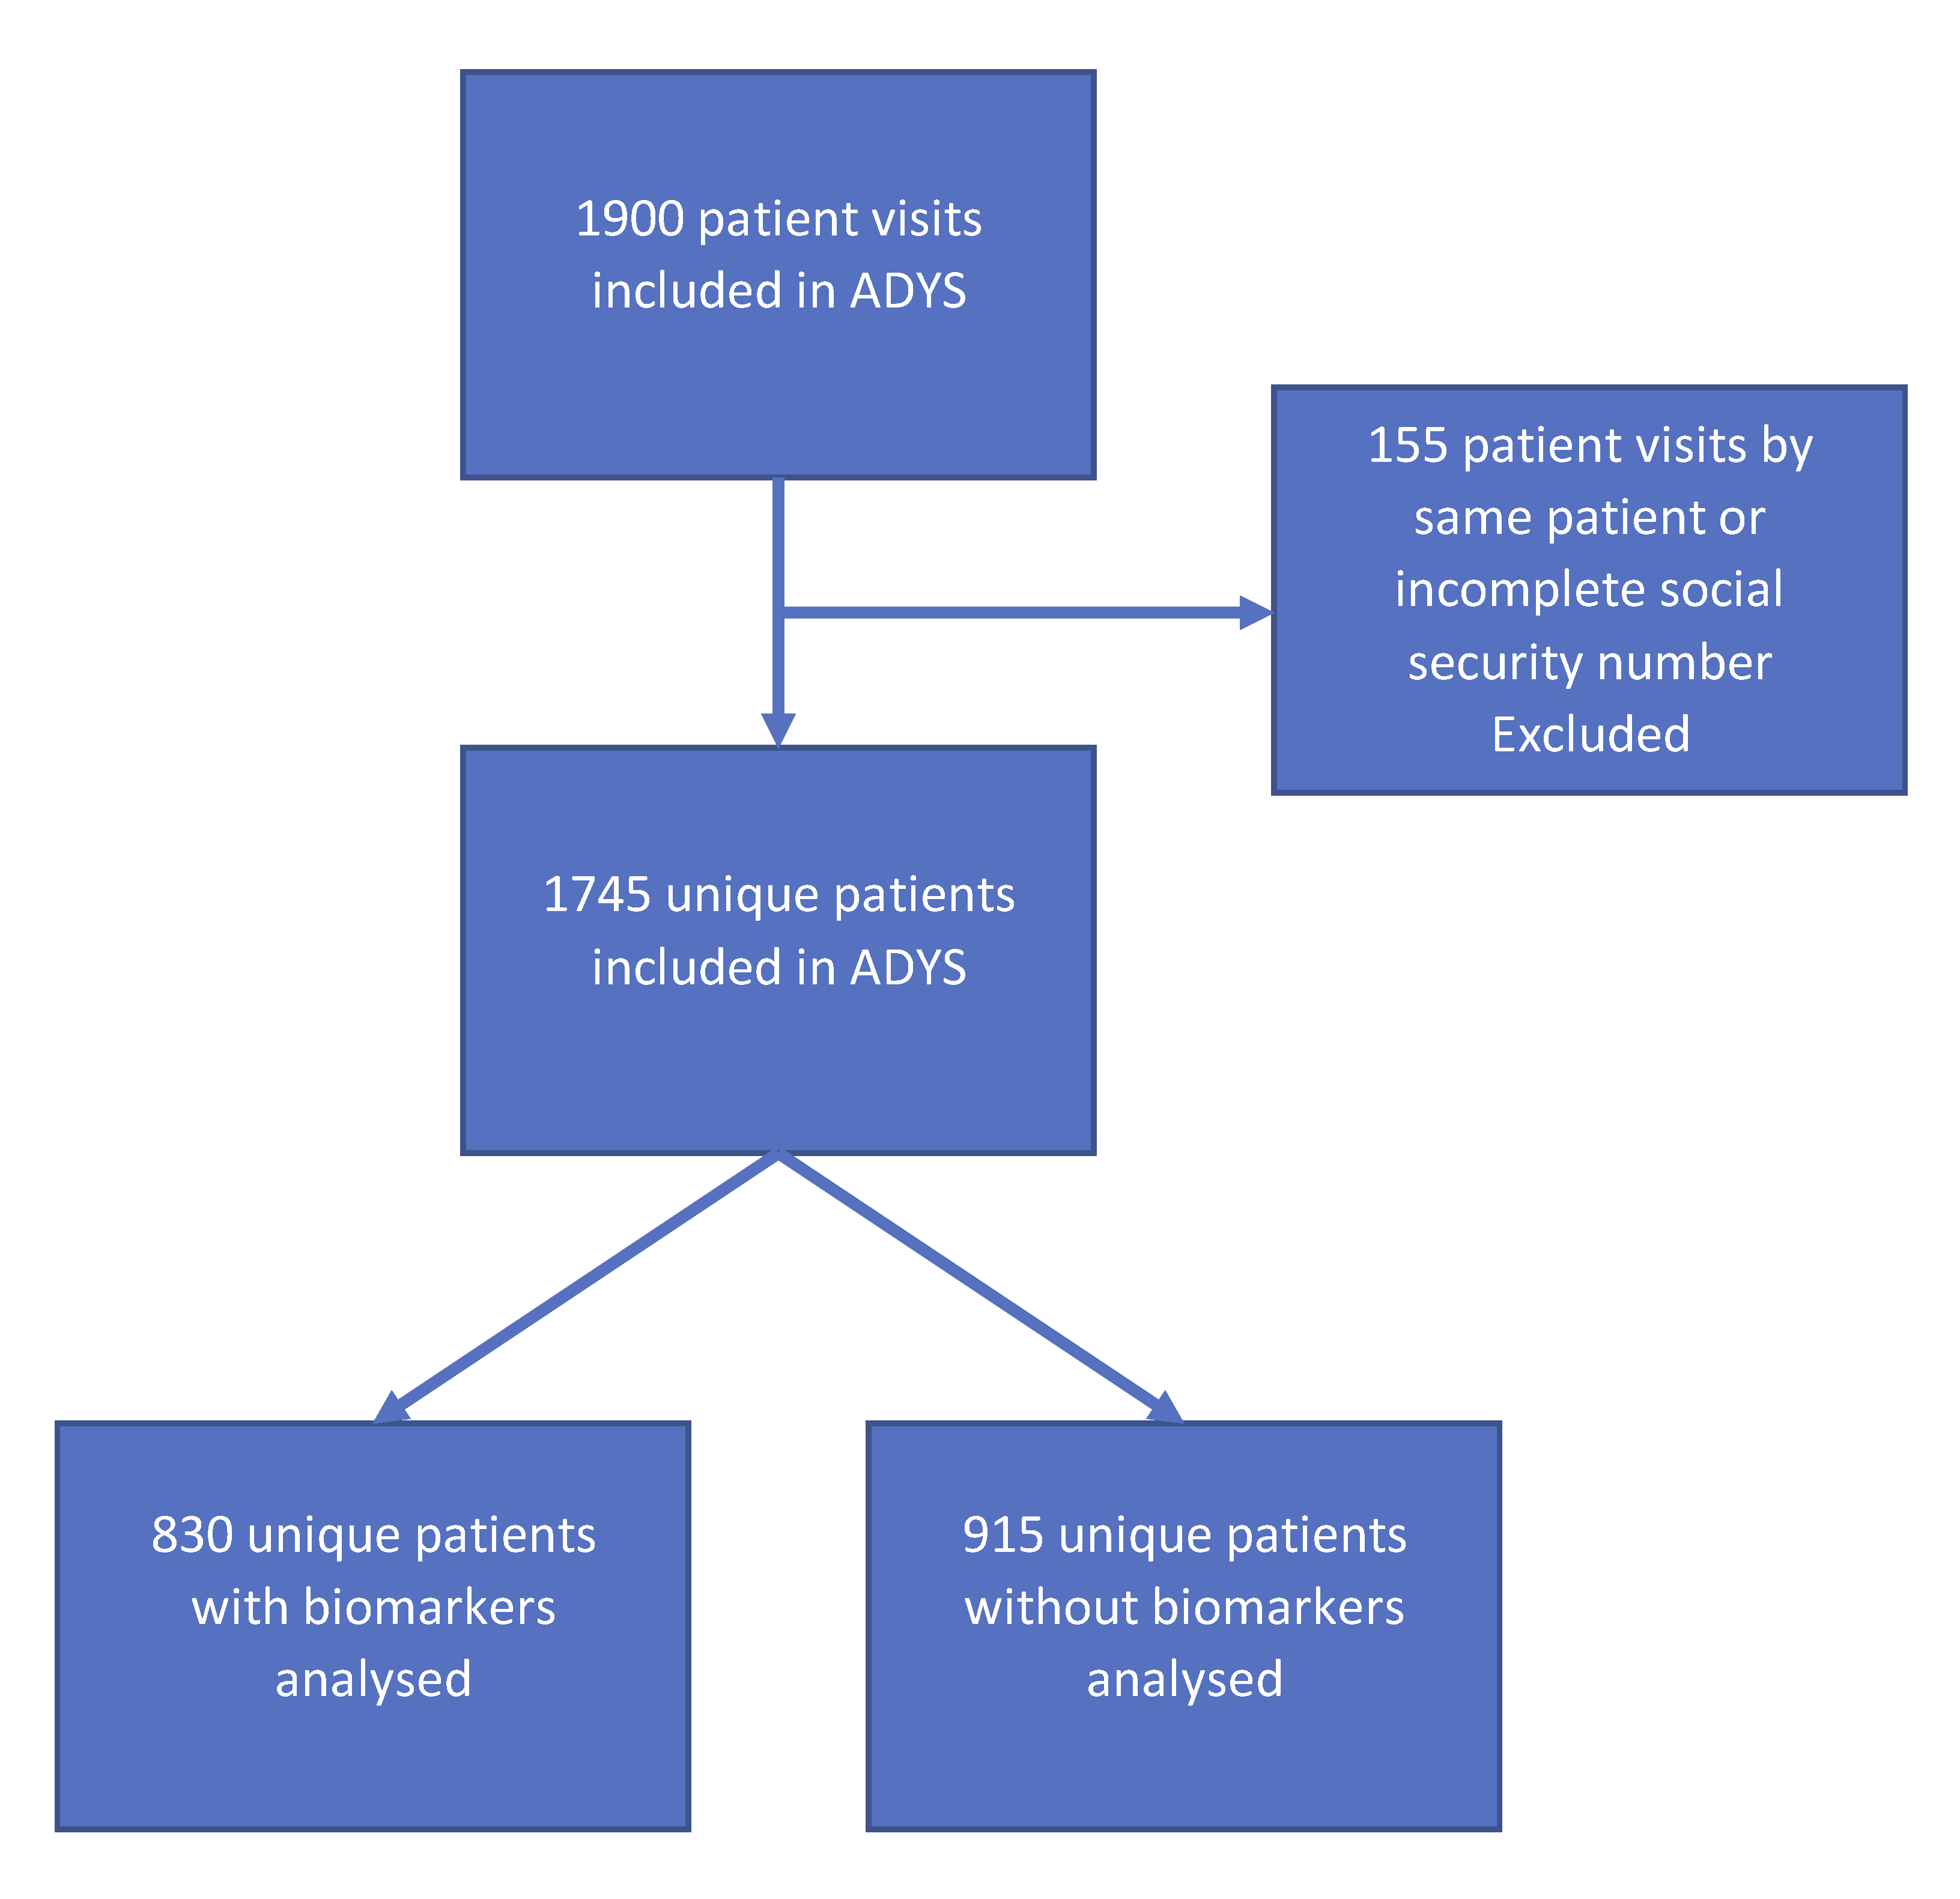

Figure 6: Flow-chart ADYS

Patients over the age of 18 who were admitted to the emergency department with shortness of breath during office hours on weekdays, were informed and asked by a research nurse about participating in the study. After written informed consent the patients were interviewed by a research nurse according to a standardized questionnaire, e.g. about previous illnesses, medications, and the patient's degree of experience of shortness of breath (see supplement: “ADYS questionnaire basis for patient interview”). The research nurse supplemented with information from the patient's previous medical record. Blood samples were taken partly for customary blood analyses, partly blood was frozen and saved in a biobank for later analysis of biomarkers. The patients were examined for so-called vital parameters, ie pulse, blood pressure, respiratory rate, oxygenation in the blood, temperature, and degree of consciousness. Patients were assigned a medical priority based on symptoms and vital parameters according to METTS (Medical Triage and Treatment System) (63 65) (24 58). All data was entered into a database. The database was then supplemented with information on annual income, country of origin and level of education from Statistics Sweden. Information was obtained from the National Board of Health and Welfare about all visits to outpatient and inpatient care, including diagnoses, dates of death and cause of death, cancer diagnoses, as well as prescriptions and medication withdrawals from pharmacies.

**MDC** or the "Malmö Diet Cancer Study" was started in the early 1990s on the initiative of the Cancer Foundation (14 64). The study was initially led by Professor Göran Berglund (Internal Medicine, Faculty of Medicine, Lund University; Sweden) and Professor Lars Janzon (Epidemiology, Faculty of Medicine, Lund University; Sweden). The MDC wanted to study the origin of cancer and cardiovascular disease in the population (Figure 7).

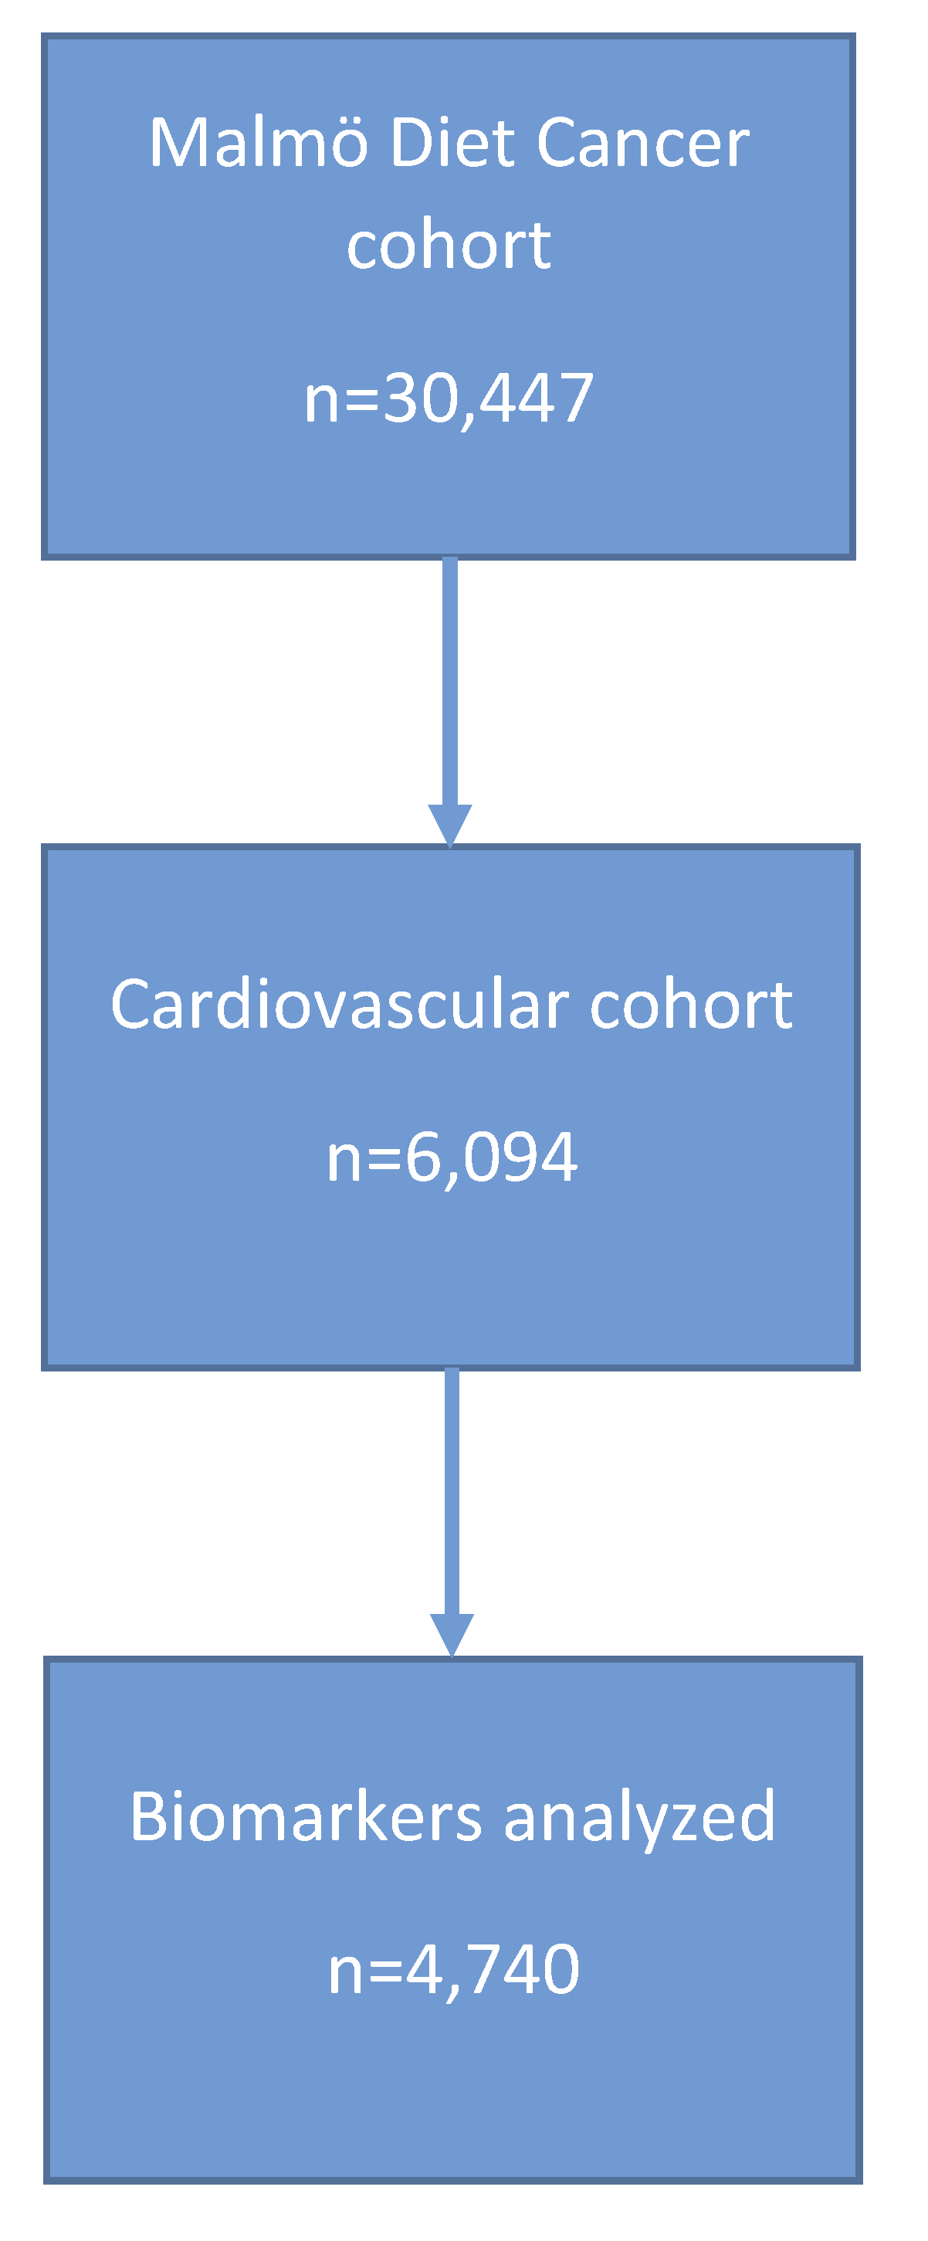

Figure 7: Flow-chart MDC-CC

The study is a so-called prospective population-based cohort study comprising 30,447 randomly selected men (born 1923–1945) and women (born 1923–1950). The subjects in the study underwent an initial health examination with blood sampling between 1991 and 1996. The blood samples were frozen and saved for later examination with biochemical and genetic analysis. Just over 6,000 of the individuals were also included in a cardiovascular disease study, the MDC cardiovascular cohort (MDC-CC). The original purpose of this sub-cohort was to study the relationship between diet and the risk of developing cancer. The MDC study has formed the basis for a large number of scientific works and dissertations (52).

## Aims

The overall aim of this theses was to identify and validate different risk factors for developing severe disease and premature death among patients with acute shortness of breath, visiting the Emergency Department, Skåne University Hospital, Malmö, but also among the middle-aged healthy MDC normal population.

The specific aims for each study were:

To investigate the relationships between survival and living in the immigrant dense half of Malmö, annual income, disease severity measured as medical triage priority, cardiovascular and pulmonary diseases, among acute dyspnea patients for a cohort of patients visiting the ED in 2007 **(Study 1)**.

To investigate the relationships between survival and annual income, living in the immigrant dense half of Malmö, country of birth, smoking habits, certain comorbidities, disease severity measured as medical triage priority and dyspnea severity for patients included in the ADYS study 2013 to 2017, with a 2,2 years’ follow-up time (**Study 2)**.

To investigate if certain biomarkers reflecting high burden of comorbiditites could add information as regards to the relationships between survival and comorbidities, annual income, smoking habits, disease severity measured as medical triage priority and dyspnea severity for patients, included in the ADYS study 2013 to 2017 with a 2,4 years’ follow-up time **(Study 3)**.

To investigate if certain biomarkers associated partly with comorbidity burden from study 3, and partly with diseases as defined in Charlson Comorbidity Index could add information as regards to future development of congestive heart failure (CHF) and chronic obstructive pulmonary disease (COPD), deaths in cardiovascular diseases (CVD), deaths in cancer and deaths in respiratory diseases, as well as all-cause mortality among individuals in the cardiovascular sub cohort of the Malmö Diet Cancer cohort **(Study 4)**.

# Material, methods, and design

This is a summary of design and methods used and patients participating in studies 1 to 4. More detailed information can be found in each paper.

## Study 1

Study 1 was a retrospective patient record review study (15).The study was approved by the Region Ethical Review Board in Lund (ref 2014/82). The aim was to identify socio-economic and clinical risk factors for mortality among patients with acute dyspnea who applied to the emergency department in Malmö in 2007. Medical records from 184 patients >18 years of age, of a total of 4,179 visiting the ED, SUS Malmö in 2007 because of acute shortness of breath, were randomly selected and data were collected from the records. We registered information about residential address, vital parameters, ICD-10 diagnoses (70, 71)and the medical triage priority according to Adaptive Process Triage (ADAPT) (64) (63) which was the triage system used at that time.

From The City of Malmö we received information about the amount of first and second generation immigrants in each urban district of Malmö as well as the average annual income for an individual living in each urban district of Malmö (17). From the Swedish Tax agency we received information on each individual´s annual income. In 2007, Malmö consisted of 10 districts with very different socio-economic conditions. Some districts in Malmö in 2007 had a very high proportion of first- and second-generation immigrants, while other districts had a high proportion of Swedish-born inhabitants (17).

The main exposures were living in the immigrant dense half (IDUD) of Malmö, low average annual income for the urban district, low individual annual income, the presence of both cardiovascular and pulmonary diseases as well as ADAPT medical triage priority. Because the number of patients studied was so small, we chose to divide the cohort into only two groups. The immigrant-dense half of Malmö (Immigrant Dense Urban District = IDUD) was compared to that half of Malmö with the most Swedish-born individuals (Swedish Born Urban District = SDUD). To calculate risk as a hazard ratio for death within 5 years, Cox regressions were used.

## Study 2

This study was a longitudinal observation study based on data from the first 798 patients included in the ADYS cohort (23). The aim of this study was partly to in the ADYS cohort validate the same socioeconomic and clinical risk factors as in study 1. We also wanted to investigate the importance of country of birth and smoking habits as risk factors for premature death among the acute dyspnea patients. The study was approved by the Region Ethical Review Board in Lund (ref 2011/537, 2012/762, 2016/138 and 2017/301). A total of 1745 patients with acute dyspnea admitted to the ED of SUS Malmö were included in the “Acute DYspnea Study” (ADYS) cohort between March 2013 and January 2019.

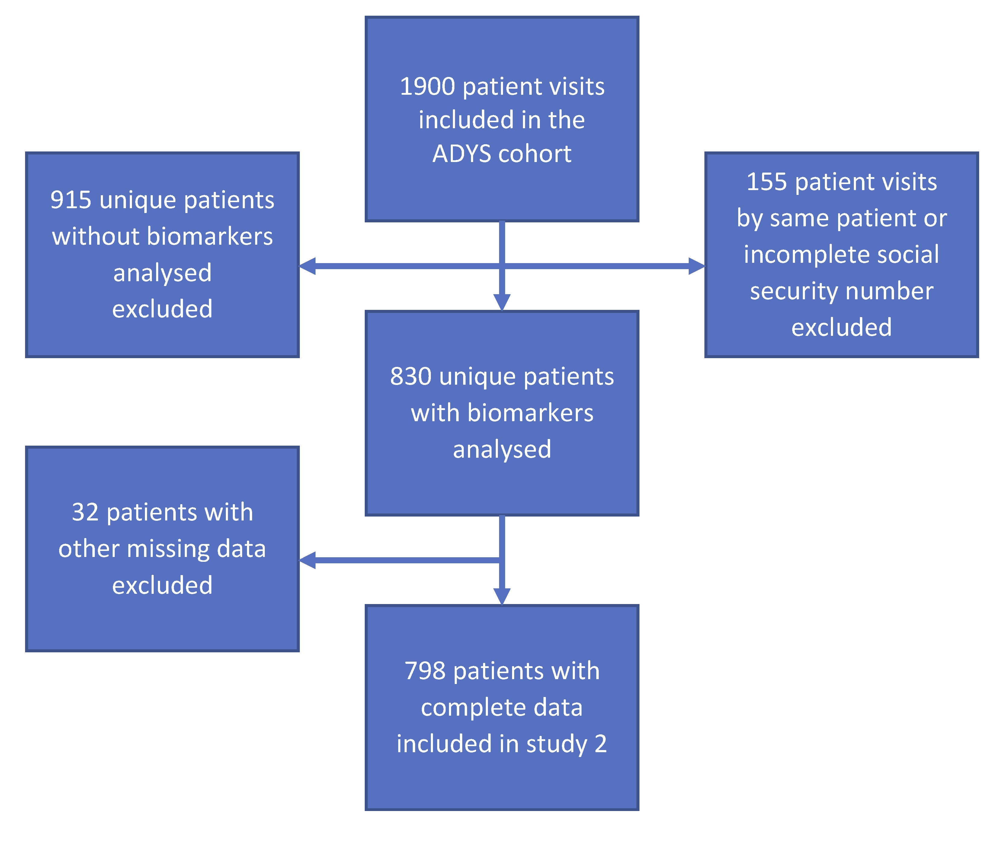

Figure 8: Flow-chart ADYS study 2

Patients who were more than 18 years old, with acute dyspnea as their primary complaint on arrival, were informed and asked for written consent to take part in the dyspnea study. Patients were included daytime working days. Research nurses interviewed the patients following a standardized questionnaire, about their health, medication, symptoms, country of birth, etc. We supplemented with information from patients' medical records. Vital parameters were registered (blood pressure, pulse, breathing frequency, oxygen saturation, temperature, level of consciousness) as were medical triage priority level according to the validated Medical Emergency Triage and Treatment System (METTS) (63) (24) and dyspnea severity using a scale similar to the modified NYHA classification (72). We received information about each individual´s annual income from the Statistics Sweden (Statistiska Centralbyrån), and about date of death from the Swedish National Board of Health and Welfare (Socialstyrelsen).

## Study 3

This study was an extension and continuation of the longitudinal observation study from the ADYS cohort and our study 2, with an addition of analyses of biomarkers. The aim of this study was to evaluate whether biomarkers can add information on risk of death in addition to knowledge about income, comorbidity, severe dyspnea, medical triage priority and smoking among patients with acute respiratory distress. In this work, we studied the first 774 patients from the ADYS study with complete analyzed blood samples for certain blood biomarkers (Figure 9).

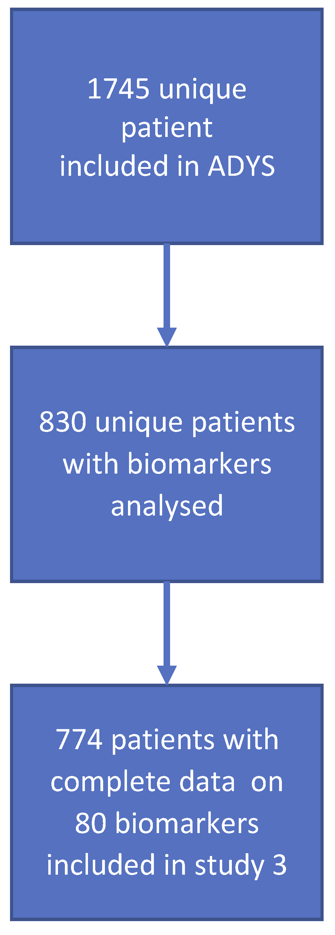

Figure 9: Flow chart of study 3 ADYS

On the day that the patients were included in the ADYS cohort blood samples were drawn by the research nurses within an hour of presentation to the ED and then frozen. For this study we chose to investigate blood samples for 92 cardiovascular biomarkers using Olink Proseek® Multiplex Cardiovascular I96X96 kit (<http://www.olink.com/>).

Biomarkers are biological substances that circulate in the blood and are usually made of different proteins. They can consist of enzymes or hormones and are often linked to biological processes in the body. Some can be used as indicators of health-related conditions (25, 27-29, 33, 36, 37, 42-44, 73-78). We wanted to investigate whether some of the biomarkers we had analyzed could provide information on risk of premature death in patients with acute shortness of breath, in addition to knowledge of the patient's annual income, comorbidity, severity of shortness of breath, medical triage priority and smoking.

All patients were asked on the presence or previous occurrence of 22 different diseases. Each such comorbidity gave a score in a calculation model (comorbidity score, CS). The patient could thus get between 0 and 22 points regarding comorbidities. This score was then standardized. We had complete analysis results for a sufficient number of patients on only 80 of 92 biomarkers. To find the biomarkers that had a strong association with a high comorbidity burden, we performed a statistical “linear stepwise regression” for these 80 biomarkers, adjusted for age, gender and with the comorbidity score as the dependent variable. We found 11 independent biomarkers, all of which were associated with a high comorbidity score (Table 3).

Table 3: Biomarkers associated with high comorbidity score

|  |  |  |  |
| --- | --- | --- | --- |
|  | **betakoefficient** | **Std Error** | **P-value** |
| **NTproBNP**, N-terminal prohormone of brain natriuretic peptide | 0.494 | 0.091 | <0.0001 |
| **FGF23**, Fibroblast growth factor | 0.438 | 0.088 | <0.0001 |
| **FABP4**, Fatty Acid Binding Protein 4 | 0.333 | 0.101 | 0.001 |
| **CCL20**, C-C motif chemokine 20 | 0.286 | 0.076 | 0.0002 |
| **SCF**, Stem cell factor | 0.271 | 0.077 | 0.0004 |
| **REN**, Renin | 0.266 | 0.071 | 0.0002 |
| **LEP**, Leptin | 0.254 | 0.077 | 0.001 |
| **MMP12**, Matrix Metallo-proteinase | 0.206 | 0.078 | 0.008 |
| **IL27A**, Interleukin 27A | -0.207 | 0.076 | 0.006 |
| **PECAM1**, Platelet endothelial cell adhesion molecule | -0.212 | 0.069 | 0.002 |
| **GAL**, Galanin peptides | -0.285 | 0.076 | 0.0002 |

We then made a linear regression analysis adjusted for gender and age, for the standardized values of the biomarkers. From this linear regression we recorded the beta coefficient for each standardized biomarker. We then created a summarized total biomarker score for comorbidity by adding the values of the beta-coefficients of all 11 standardized biomarkers. This summed up biomarker-comorbidity score (BSC), was subsequently standardized and then used in a Cox regression models for mortality at full follow-up time of 2.4 years.

## Study 4

The aim of this study was to evaluate whether two different biomarker-scores, both associated with comorbidity burden, could predict future morbidity and mortality in certain dyspnea-related diseases in a middle-aged normal population. Our outcomes were the future development of congestive heart failure (CHF), future development of chronic obstructive pulmonary disease (COPD), deaths in cardiovascular disease (CVD), deaths in cancer, future deaths in pulmonary diseases, and all-cause mortality in the Malmö Diet Cancer cohort (MDC). We chose new-onset of congestive heart failure and COPD, as these are the two most common dyspneic diseases. MDC was started in the mid-1990s to investigate the link between diet and the risk of developing cancer in a healthy middle-aged normal population from Malmö (Figure 10). Over 30,000 individuals were included in the study. Of these, just over 6,000 were included in a cardiovascular disease cohort (MDC-CC).

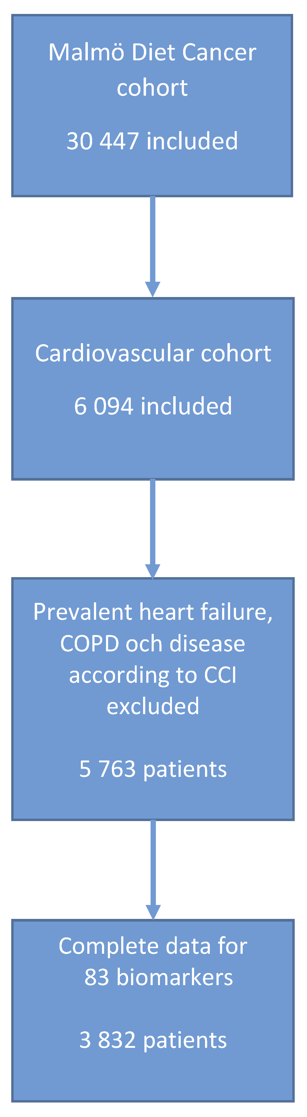

Figure 10: Flow chart MDC-CC study 4

For this study we used the individuals that were included in MDC-CC. The people included had their blood samples taken at baseline in the 1990s. Blood samples were later analysed for the same biomarkers as were analysed in ADYS, i.e. Olink Proseek® Multiplex Cardiovascular I96X96 kit (<http://www.olink.com/>).

Of the 92 different biomarkers on the Olink CVD panel, complete data were available for only 83 biomarkers. 82 of these biomarkers come from the Olink panel of a total of 92 cardiovascular biomarkers. Complete data for Olink's NTproBNP were missing. However, since NTproBNP is an important biomarker for validating dyspnea and severity of heart failure, we wanted to include NTproBNP in our study. We instead, analyzed NTproBNP separately for the same individuals at Dade Behring Holdings, Inc. (within Siemens Healthcare Diagnostics 2007) using “Stratus® CS Acute Care” NT proBNP analysis, giving us complete data on 83 biomarkers. We wanted to investigate partly a score of the same comorbidity associated biomarkers as we used for study 3, partly a score of new biomarkers that were strongly associated with comorbidities registered at inclusion in the MDC-CC in the form of the Charlson Comorbidity Index (CCI) (12, 13) (67). Of the patients in MDC-CC 4% had one or more diseases defined according to the CCI at inclusion, i.e. prevalent disease. In the same way as in study 3, we performed a statistical “linear stepwise regression” for these 83 biomarkers, adjusted for age, sex with the occurrence of comorbidity defined as any disease as defined according to CCI as a dependent variable. We obtained 12 independent biomarkers that were associated with the occurrence of disease according to CCI, i.e. 4% of the participants in MDC-CC.

Table 4: Biomarkers with association to disease according to CCI

|  |  |  |  |
| --- | --- | --- | --- |
|  | **betakoefficient** | **Std Error** | **P-value** |
| **GDF-15**, Growth/differentiation factor 15 | 0,026 | 0,005 | <0,001 | |
| **MMP12**, Matrix Metallo-proteinase | 0,025 | 0,004 | <0,001 | |
| **TRAIL**, TNF-related apoptosis-inducing ligand | -0,024 | 0,004 | <0,001 | |
| **IL-6**, Interleukin-6 | 0,016 | 0,003 | <0,001 | |
| **NtproBNP**, N-terminal prohormone of brain natriuretic peptide | 0,012 | 0,003 | <0,001 | |
| **REN** , Renin | 0,010 | 0,003 | 0,003 | |
| **Gal-3**, Galectin-3 | -0,013 | 0,004 | 0,001 | |
| **TIM**, Thrombomodulin | 0,012 | 0,004 | 0,001 | |
| **FS**, Follistatin | -0,014 | 0,004 | 0,001 | |
| **HGF**, Hepatocyte growth factor | 0,012 | 0,005 | 0,011 | |
| **CASP-8**, Caspase-8 | -0,010 | 0,004 | 0,005 | |
| **CXCL6**, C-X-C motif chemokine 6 | 0,006 | 0,004 | 0,111 | |

In the same way as in study 3, we then made a linear regression analysis for these 12 biomarkers in relation to CCI, with the biomarkers standardized, in order to obtain a comparable beta coefficient for each biomarker. We then created a summed total biomarker score by multiplying the outcome for each biomarker by its beta coefficient, to weight / adjust the biomarkers against each other, so that each 1 standard deviation increment in comorbidity score corresponds to a beta-coefficient weighted increase of each biomarker. We called this biomarker score the "Biomarker Score Malmö Diet Cancer" (BSMDC).

We also wanted to compare and evaluate the same 11 biomarkers that we used for the ADYS-related biomarker score from study 3. Based on the beta- coefficients from the linear stepwise regression for these 11 comorbidities associated biomarkers from study 3, a new "ADYS-adjusted" biomarker score was created for study 4. We called this score for the “Biomarker Score ADYS” (BSADYS). For the statistical analyses we finally filtered out the 4% of the individuals with disease already at baseline (i.e. presence of one or more CCI points), which we had used to create our biomarker score, as we were interested in new-onset disease and mortality in a population that were relatively healthy at baseline. We thus ended up with a cohort of 3,832 individuals with complete biomarker data on 83 biomarkers.

In order to be able to adjust for the most common causes of cardiovascular disease and COPD, we registered the incidence of diabetes, antihypertensive medication, systolic blood pressure, smoking (previous or ongoing), body mass index (BMI) and the incidence of previous coronary heart disease (i.e. previously treated Percutaneous Coronary Intervention PCI, without having developed a heart attack and thus not registered with a CCI diagnosis).

# Results

This is a summary of the results for studies 1 to 4. More detailed information can be found in each paper.

## Study 1

In study 1 the primary endpoint was all-cause mortality. There was a total of 94 deaths (51%) among the 184 patients, during the 5-year follow-up time. Since age and gender are established factors that influence the mortality rate, we adjusted all our statistical Cox regression mortality analyses for both age and gender.

In the first Cox regression model adjusted for age and gender, we related exposure of living in the IDUD half of Malmö to mortality adjusted for age and gender, there was a significant increase in the risk of 5-year mortality for patients from the immigrant dense half of Malmö (IDUD) (HR=1.65, 95% CI 1.09–2.49). The IDUD half of Malmö also happened to be the half of Malmö with the lowest annual income on a group level (Table 2).

In the second Cox regression model for mortality, besides adjusting for age, gender, we adjusted for both IDUD and the individual’s annual income (comparing the lowest income quartile with the highest). In this model there was a significant increase in the risk of 5-year mortality for patients from IDUD (HR=1.69, 95% CI 1.11–2.56) as well as for low annual income (HR=2.00, 95% CI 1.06–3.79).

In the third model we adjusted for age, gender, IDUD, annual income (lowest quartile versus highest), the presence of both cardiovascular and pulmonary diseases (double diagnoses) as well as ADAPT priority (highest priority versus middle and low priority). In this model there was still an independent significant increase in the risk of 5-year mortality for patients from IDUD (HR=1.79, 95% CI 1.15–2.78), low annual income (HR=2.27, 95% CI 1.18–4.35), double diagnoses (HR=1.76, 95% CI 1.10–2.82) and for high medical ADAPT triage priority (HR=1.73, 95% CI 1.10–2.75).

Table 2: 5-year mortality in IDUD with SDUD as reference

|  |  |  |  |
| --- | --- | --- | --- |
|  | **Hazard Ratio** | **95 % CI** | **P-value** |
| **Model 1 Adjusted for age and sex** |  |  |  |
| IDUD | 1.65 | 1.09–2.49 | 0.019 |
| **Model 2 Adjusted for age, sex and annual income** |  |  |  |
| IDUD | 1.69 | 1.11–2.56 | 0.015 |
| Annual income (Q1 versus Q4) | 2.00 | 1.06–3.79 | 0.032 |
| **Model 3: Adjusted for age, sex, annual income, DD and ADAPT** |  |  |  |
| IDUD | 1.79 | 1.15–2.78 | 0.010 |
| Annual income (Q1 versus Q4) | 2.27 | 1.18–4.35 | 0.014 |
| DD | 1.76 | 1.10–2.82 | 0.018 |
| ADAPT (3 & 2 versus 1) | 1.73 | 1.10–2.75 | 0.019 |

IDUD=Imigrant dense urban districts; DD=Double diagnoses (respiratory & cardiovascular disease); ADAPT=Adaptive Process Triage

## Study 2

With an end of follow-up time on the 26 July 2017, we had a mean follow-up time of 2.2 ±1.3 years. The primary endpoint was all-cause mortality. As the patients living in the IDUD part of Malmö in study 1 also were the patients with the lowest income, we decided in this study to start by dividing the cohort of 798 individuals into quintiles of annual income. Baseline characteristics showed that the mean age was 69 years with 66% of patients being above 65 years of age. 46% were male and 72% were born in Sweden. Individuals belonging to the lowest and highest income quintiles had the lowest age in comparison with the three central quintiles. Moreover, the percentage of males increased in the quintiles with higher income. At baseline 43% of the patients had a present or previous diagnosis of hypertension, 33% congestive heart failure (CHF), 31% coronary heart disease (CHD), 29% chronic obstructive pulmonary disease (COPD) and 28% atrial fibrillation (AF). During the follow-up time until July 2017, a number of 320 (40%) patients had died. But since the Swedish cause of death register (79) at the National Board of Health and Welfare is updated more slowly than the death register, we only had access to the specific causes of death until 2015–12–31 i.e. for 222 patients. The three main causes of death during this follow-up period were cardiovascular (40%, including stroke), cancer (21%) and COPD and other lung diseases (19%, including pneumonia).

In the first Cox regression model we validated each variable separate for mortality at full follow-up time, adjusted for age and gender (Table 3). With the highest income quintile as a reference there was a significantly increase in mortality risk for the middle-income quintile (HR=1.63; 95% CI 1.082–2.452), for the second lowest income quintile (HR=1.61; 95% CI 1.052–2.460) and for lowest income quintile (HR=1.74; 95% CI 1.119–2.703). The relationship between income and mortality risk was linear. There was a significant association with mortality and smoking (HR=1,57; 95% CI 1.207–2.042). The presence of several affirmed comorbidities were associated with premature mortality (infection, anaemia, diabetes, renal disease, hip fracture, CAD, CHF, COPD, restrictive pulmonary disease, and other pulmonary diseases). As expected, with the lowest priority as a reference, red METTS triage priority (HR=3.64; 95% CI 1.732–7.674) and orange METTS priority (HR=3.08; 95% CI 1.506–6.298) had a significant, linear association with premature death. In the same way, with no dyspnea as a reference, the dyspnea severity level had a significant, linear association with premature death, with slight dyspnea (HR=1.55; 95% CI 1.069–2.255), heavy dyspnea (HR=2.26, 95% CI 1.514–3.390) and dyspnea at rest (HR=3.17; 95% CI 2.177–4.616). There were no statistical differences in mortality risk between either the IDUD vs. SDUD parts of Malmö or between country of birth.

Table 3: Cox regression for mortality at full follow-up time, adjusted for age and gender (n=798)

|  |  |  |  |
| --- | --- | --- | --- |
|  | **Hazard Ratio** | **95 % CI** | **P-value** |
| **IDUD** |  |  |  |
| SDUD | 1.0 | ref. |  |
| IDUD | 0.829 | 0.657–1.048 | n.s. |
| Other UD (outside Malmö+missing) | 1.073 | 0.740–1.558 | n.s. |
| **Country of birth** |  |  |  |
| Born in Sweden | 1.0 | ref. |  |
| Born in EU but not Sweden | 1.041 | 0.785–1.379 | n.s. |
| Born outside of the EU | 0.668 | 0.352–1.265 | n.s. |
| **Yearly income quintiles** |  |  |  |
| Highest income | 1.0 | ref. |  |
| Second highest income | 1.476 | 0.974–2.236 | n.s. |
| Middle income | 1.629 | 1.082–2.452 | 0.019 |
| Second lowest income | 1.609 | 1.052–2.460 | 0.028 |
| Lowest income | 1.739 | 1.119–2.703 | 0.014 |
| **Smoking** |  |  |  |
| Ever smoke (present or previous) | 1.570 | 1.207–2.042 | 0.001 |
| **Comorbidities** |  |  |  |
| Pulmonary embolism | 0.923 | 0.667–1.278 | n.s. |
| Infection | 1.667 | 1.329–2.090 | <0.0001 |
| Anaemia | 1.673 | 1.310–2.138 | <0.0001 |
| Cancer | 1.163 | 0.897–1.507 | n.s. |
| Obesity | 0.812 | 0.612–1.077 | n.s. |
| Diabetes | 1.347 | 1.036–1.751 | 0.026 |
| Hypertension | 0.945 | 0.756–1.181 | n.s. |
| Stroke | 1.118 | 0.817–1.531 | n.s. |
| Dementia | 1.064 | 0.632–1.790 | n.s. |
| Anxiety | 0.969 | 0.531–1.771 | n.s. |
| Depression | 1.434 | 0.876–2.346 | n.s. |
| Renal disease | 1.689 | 1.242–2.299 | 0.001 |
| Hip fracture | 1.775 | 1.116–2.823 | 0.015 |
| Coronary artery disease | 1.282 | 1.021–1.609 | 0.033 |
| Congestive heart failure | 1.548 | 1.233–1.944 | 0.0002 |
| Atrial fibrillation | 1.159 | 0.922–1.456 | n.s. |
| COPD | 1.474 | 1.178–1.846 | 0.001 |
| Asthma | 1.006 | 0.694–1.459 | n.s. |
| Restrictive pulmonary disease | 1.590 | 1.047–2.416 | 0.030 |
| Other pulmonary disease | 2.169 | 1.148–4.099 | 0.017 |
| Neuromuscular disorder | 1.163 | 0.288–4.699 | n.s. |
| Rheumatic disorder | 0.871 | 0.547–1.386 | n.s. |
| **METTS priority on arrival** |  |  |  |
| METTS priority 4 | 1.0 | ref. |  |
| METTS priority 3 | 1.577 | 0.768–3.239 | n.s. |
| METTS priority 2 | 3.079 | 1.506–6.298 | 0.002 |
| METTS priority 1 | 3.645 | 1.732–7.674 | 0.001 |
| **Dyspnea level on arrival** |  |  |  |
| Unaffected | 1.0 | ref. |  |
| Slight dyspnea | 1.553 | 1.069–2.255 | 0.021 |
| Heavy dyspnea | 2.265 | 1.514–3.390 | <0.0001 |
| Dyspnea at rest | 3.170 | 2.177–4.616 | <0.0001 |

SDUD=Swedishborn-dense urban districts; IDUD=immigrant-dense urban districts; Other UD=other urban district (outside of Malmö or missing); METTS priority 1=highest priority, immediately to resuscitation room; METTS priority 2=unstable or potentially unstable vital parameters; METTS priority 3=currently stable vital parameters; METTS priority 4=lowest priority, stable patient.

In the second Cox regression model for mortality at full follow-up time (table 4), we adjusted for age, gender and all covariates significant in the first model (annual income, smoking, CHF, COPD, restrictive pulmonary disese, infection, other pulmonary dises, aneamia, diabetes, renal failure, CAD, hip fracture, dyspnea severity level and METTS priority).

Table 4: Cox regression for mortality at full follow-up, adjusted adjustments for all covariates (n=798)

|  |  |  |  |
| --- | --- | --- | --- |
|  | **Hazard Ratio** | **95 % CI** | **P-value** |
| Age | 1.052 | 1.041–1.064 | <0.0001 |
| Gender | 0.799 | 0.620–1.030 | n.s. |
| **Yearly income quintiles (Q)** |  |  |  |
| Highest income | ref |  |  |
| Second highest income | 1.297 | 0.845–1.990 | n.s. |
| Middle income | 1.220 | 0.790–1.885 | n.s. |
| Second lowest income | 1.374 | 0.877–2.152 | n.s. |
| Lowest income | 1.644 | 1.038–2.603 | 0.034 |
| **Comorbidities** |  |  |  |
| Congestive heart failure | 1.243 | 0.969–1.595 | n.s. |
| COPD | 0.986 | 0.771–1.261 | n.s. |
| Restrictive pulmonary disease | 1.465 | 0.951–2.256 | n.s. |
| Infection | 1.400 | 1.106–1.773 | 0.005 |
| Other pulmonary disease | 1.745 | 0.884–3.446 | n.s. |
| Anaemia | 1.529 | 1.185–1.971 | 0.001 |
| Diabetes | 1.205 | 0.914–1.589 | n.s. |
| Renal failure | 1.363 | 0.976–1.903 | n.s. |
| Coronary artery disease | 0.952 | 0.736–1.230 | n.s. |
| Hip fracture | 1.827 | 1.131–2.952 | 0.014 |
| **Smoking** |  |  |  |
| Previous and ongoing | 1.432 | 1.087–1.885 | 0.011 |
| **Dyspnea level** |  |  |  |
| Unaffected | ref |  |  |
| Slight dyspnea | 1.053 | 0.712–1.556 | n.s |
| Heavy dyspnea | 1.464 | 0.958–2.237 | n.s |
| Dyspnea at rest | 1.774 | 1.154–2.727 | 0.009 |
| **METTS priority** |  |  |  |
| METTS priority 4 | ref |  |  |
| METTS priority 3 | 1.334 | 0.64–2.756 | n.s |
| METTS priority 2 | 2.200 | 1.057–4.580 | 0.035 |
| METTS priority 1 | 2.092 | 0.951–4.601 | n.s |

METTS priority 1=highest priority, immediately to resuscitation room; METTS priority 2=unstable or potentially unstable vital parameters; METTS priority 3=currently stable vital parameters; METTS priority 4=lowest priority, stable patient.

Patients belonging to the lowest income quintile had a significant independent increase in mortality risk (HR=1.64; 95% CI 1.038–2.603). When it comes to present or previous comorbidities, pulmonary infections or other serious infections requiring hospitalization (HR=1.40; 95% CI 1.106–1.773), anaemia (HR=1.53; 95% CI 1.185–1.971), and hip fractue (HR=1.83; 95% CI 1.131–2.952) were significant independently associated with premature death. Previous or ongoing smoking also increased the risk of death at follow-up (HR=1.43; 95% CI 1.087–1.885), as did dyspnea at rest (HR=1.77; 95% CI 1.154–2.727) and orange METTS priority (HR=2.20; 95% CI 1.057–4.580).

## Study 3

In study 3 the endpoint was all-cause mortality. During the follow-up period of 2.4 ± 1.5 years, 348 (45%) patients died.

In the first Cox-regression model, we related the plain comorbidity score and the biomarker-comorbidity score adjusted for age and gender to mortality during long-term follow-up (table 5). There was a significant increase in death for each SD increment of BSC (HR=1.76; 95% CI 1.532–2.028), but also for the CS, although smaller (HR=1.43; 95% CI 1.275–1.597).

Table 5: Cox regression for different follow-up times (full follow-up and 90-days) , with Comorbidity core and Biomarker-comorbidity score in single\*, partly\*\* and fully\*\*\* adjusted models (n=774)

|  |  |  |  |
| --- | --- | --- | --- |
|  | **HR** | **95 % CI** | **P-value** |
| **Long term follow-up** |  |  |  |
| **Single model:** |  |  |  |
| Comorbidity score | 1.427 | 1.275–1.597 | <0.0001 |
| Biomarker-comorbidity score | 1.763 | 1.532–2.028 | <0.0001 |
|  |  |  |  |
| **Single model partly adjusted:** |  |  |  |
| Comorbidity score | 1.180 | 1.035–1.346 | 0.013 |
| Biomarker-comorbidity score | 1.588 | 1.348–1.871 | <0.0001 |
|  |  |  |  |
| **Fully adjusted model:** |  |  |  |
| Comorbidity score | 1.105 | 0.965–1.266 | n.s. |
| Biomarker-comorbidity score | 1.533 | 1.299–1.810 | <0.0001 |
|  |  |  |  |
| **90-days follow-up** | **HR** | **95 % CI** | **P-value** |
| **Single model:** |  |  |  |
| Comorbidity score | 1.179 | 0.945–1.471 | n.s. |
| Biomarker-comorbidity score | 1.847 | 1.407–2.425 | <0.0001 |
|  |  |  |  |
| **Single model partly adjusted:** |  |  |  |
| Comorbidity score | 0.883 | 0.681–1.146 | n.s. |
| Biomarker-comorbidity score | 1.998 | 1.456–2.742 | <0.0001 |
|  |  |  |  |
| **Fully adjusted model:** |  |  |  |
| Comorbidity score | 0.843 | 0.641–1.109 | n.s. |
| Biomarker-comorbidity score | 1.979 | 1.428–2.743 | <0.0001 |

\*Adjusted for age and gender; \*\*Adjusted for age, gender, BCS and CS independently; \*\*\*Adjusted for age, gender

In the second model adjusted for age, gender and both the BSC and the CS entered simultaneously, the mortality risk at full follow-up per SD increment of the BCS (HR=1.59, 95% CI 1.348–1.871) was even better compared to CS (HR=1.18, 95% CI 1.035–1.346) for predicting death during long term follow-up.

In the third fully adjusted Cox regression multivariate model, we adjusted for age and gender, BCS, CS and all the significant variables from our previous study on the ADYS cohort independently (METTS triage priority, dyspnea level, annual income, and smoking) during long term follow-up. There was a significant increase of mortality risk for the BCS (HR=1.53; 95% CI 1.299–1.810) per SD increment, whereas the CS was not significantly related to mortality.

As a secondary outcome we investigated the association between the BCS and death during 3 months follow-up. The BCS in the fully adjusted model significantly predicted an increase of 3 months mortality (HR=1.98; 956% CI 1.428–2.743) per each SD increment, whereas the CS was not significantly related to mortality. In analyses of quartiles in a fully adjusted model, there was a significant linear trend between the BCS quartiles (uncategorized) and mortality during at full follow-up time, 3 months as wells as for 1 month follow-up. With BCS categorized patients in the top vs bottom quartile had a 2.3-fold increased risk of death during the full follow-up time and a 4.2-fold increase in 3 months mortality.

## Study 4

The mean age at the start of the study in the 1990s was 57.6 years. The follow-up period until 31/12/2018 was 23.2 ± 5.1 years with data concerning deaths from the Swedish Cause of deaths register (79), concerning new-onset heart failure from the from the Swedish Inpatient Registry (80), and with the exception of the patients with new-onset COPD who had a follow-uptime only until 31/12/2016 of 21.4 ± 4.9 years with data from the Swedish Inpatient Registry (81). A total of 2430 (39%) individuals died, of which 405 deaths were due to CVD, 493 deaths due to cancer and 94 deaths due to respiratory diseases. During the entire follow-up period until 2018-12-31, 267 individuals had developed new-onset heart failure. During the follow-up period until 31/12/2016, 355 individuals had developed new-onset COPD.

In the first Cox regression models, done separately for each biomarker score, we adjusted for age, gender, and all covariates (diabetes, blood pressure medication, systolic blood pressure, smoking (previous or ongoing), ever smoking, body mass index (BMI), and occurrence of previous coronary heart disease). In the second Cox regression models we analysed both biomarker scores simultaneously adjusted for age, gender, and all other co-variables.

For new onset of COPD in model one, independent of all other variables we found a significant association for each 1 SD increment only with the BSMDC score (HR=1,649; 95% CI 1,487–1,829) (Table 11). In model two where we also adjusted for the other biomarker score this association got a little bit stronger ((HR=1, 667; 95% CI 1,499–1,853).

Table 11: Cox regressions of BSADYS and BSMDC with new-onset COPD as outcome, follow-up time 31/12/2016

|  |  |  |  |
| --- | --- | --- | --- |
| **Incident COPD** | **HR** | **95 % CI** | **P-value** |
| BSMDC score (adjusted for age, gender and covariates) | 1,649 | 1,487–1,829 | <0,0001 |
| BSMDC score (adjusted for age, gender, covariates and BSADYS) | 1,667 | 1,499–1,853 | <0,0001 |
| BSADYS score (adjusted for age, gender and covariates) | 1,063 | 0,960–1,176 | n. s |
| BSADYS score (adjusted for age, gender, covariates and BSMDC) | 0,947 | 0,837–1,072 | n.s. |

For new-onset of heart failure in model one, we found significant association for both each 1 SD increment of the BSADYS (HR=1,257; 95% CI 1,191–1,326) and the BSMDC (HR=1,568; 95% CI 1,381–1,781) (Table 12). In model two adjusted also for the other biomarker score, there still were significant associations with each 1 SD increment for both the BSADYS (HR=1,211; 95% CI 1,141–1,287) and the BSMDC (HR=1,487; 95% CI 1,305–1,694).

Table 12: Cox regressions of BSADYS and BSMDC with new-onset heart failure as outcome, follow-up time 31/12/2018

|  |  |  |  |
| --- | --- | --- | --- |
| **Incident heart failure** | **HR** | **95 % CI** | **P-value** |
| BSMDC score (adjusted for age, gender and covariates) | 1,568 | 1,381–1,781 | <0,0001 |
| BSMDC score (adjusted for age, gender, covariates and BSADYS) | 1,487 | 1,305–1,694 | <0,0001 |
| BSADYS score (adjusted for age, gender and covariates) | 1,257 | 1,191–1,326 | <0,0001 |
| BSADYS score (adjusted for age, gender, covariates and BSMDC) | 1,211 | 1,141–1,287 | <0,0001 |

For all-cause mortality we found a significant increase with each 1 SD increment in model one for the BSADYS score (HR= 1,083; 95% CI 1,037–1,131) and the BSMDC score (HR= 1,423; 95% CI 1,345–1,506) (Table 13). In model two there were only an association for the BSMDC (HR= 1,416; 95% CI 1,337–1,501).

Table 13 Cox regressions of BSADYS and BSMDC with all-cause mortality as outcome, follow-up time 31/12/2018

|  |  |  |  |
| --- | --- | --- | --- |
| **All-cause deaths** | **HR** | **95 % CI** | **P-value** |
| BSMDC score (adjusted for age, gender and covariates) | 1,423 | 1,345–1,506 | <0,0001 |
| BSMDC score (adjusted for age, gender, covariates and BSADYS) | 1,416 | 1,337–1,501 | <0,0001 |
| BSADYS score (adjusted for age, gender and covariates) | 1,083 | 1,037–1,131 | 0,0003 |
| BSADYS score (adjusted for age, gender, covariates and BSMDC) | 1,021 | 0,970–1,074 | n.s. |

Regarding deaths in cardiovascular disease, in model one we found a significant increase with each SD increment for the BSADYS score (HR= 1,152; 95% CI 1,083–1,225) and the BSMDC score (HR= 1,423; 95% CI 1,345–1,506) (Table 14). In model two there were similar associations for both the BSADYS score (HR= 1,108; 95% CI 1,033–1,188) and the BSMDC score (HR= 1,342; 95% CI 1,204–1,495).

Table 14: Cox regressions of BSADYS and BSMDC with deaths in cardiovascular diseases as outcome, follow-up time 31/12/2018

|  |  |  |  |
| --- | --- | --- | --- |
| **Deaths in cardiovascular diseases** | **HR** | **95 % CI** | **P-value** |
| BSMDC score (adjusted for age, gender and covariates) | 1,379 | 1,241–1,533 | <0,0001 |
| BSMDC score (adjusted for age, gender, covariates and BSADYS) | 1,342 | 1,204–1,495 | <0,0001 |
| BSADYS score (adjusted for age, gender and covariates) | 1,152 | 1,083–1,225 | <0,0001 |
| BSADYS score (adjusted for age, gender, covariates and BSMDC) | 1,108 | 1,033–1,188 | 0,004 |

Regarding deaths in cancer disease, there were only in increased risk for the BSMDC score, in model one (HR=1,373; 95% CI 1,250–1,510) for each 1 SD increment of the BSMDC score, and in model two (HR=1,384; 95% CI 1,256–1,524) (Table 15).

Table 15: Cox regressions of BSADYS and BSMDC with deaths in cancer diseases as outcome, follow-up time 31/12/2018

|  |  |  |  |
| --- | --- | --- | --- |
| **Deaths in cancer diseases** | **HR** | **95 % CI** | **P-value** |
| BSMDC score (adjusted for age, gender and covariates) | 1,373 | 1,250–1,510 | <0,0001 |
| BSMDC score (adjusted for age, gender, covariates and BSADYS) | 1,384 | 1,256–1,524 | <0,0001 |
| BSADYS score (adjusted for age, gender and covariates) | 1,032 | 0,945–1,128 | n.s. |
| BSADYS score (adjusted for age, gender, covariates and BSMDC) | 0,964 | 0,869–1,070 | n.s. |

Likewise regarding deaths in respiratory diseases only the BSMDC score indicated increased risk, in model one (HR=1,690; 95% CI 1,375–2,078) as well as in model two ((HR=1,707; 95% CI 1,383–2,107) for each SD increase on the BSMDC scale (Table 16).

Table 16: Cox regressions of BSADYS and BSMDC with deaths in respiratory diseases as outcome, follow-up time 31/12/2018

|  |  |  |  |
| --- | --- | --- | --- |
| **Deaths in respiratory diseases** | **HR** | **95 % CI** | **P-value** |
| BSMDC score (adjusted for age, gender and covariates) | 1,690 | 1,375–2,078 | <0,0001 |
| BSMDC score (adjusted for age, gender, covariates and BSADYS) | 1,707 | 1,383–2,107 | <0,0001 |
| BSADYS score (adjusted for age, gender and covariates) | 1,065 | 0,869–1,305 | n.s. |
| BSADYS score (adjusted for age, gender, covariates and BSMDC) | 0,947 | 0,732–1,224 | n.s. |

# Discussion

## Study 1

The key finding in Study 1 was that living in the half of Malmö with the highest density of first- and second-generation immigrants, that also happened to be the half of Malmö with the lowest annual income on a group level, was an independent risk factor for increased mortality for patients with acute respiratory distress during a follow-up time of 5 years. In Malmö 2007, 36% of the inhabitants were first or second generation immigrants. In 2007 Malmö consisted of 10 urban districts with different socio-economic status (SES). Compared to some other countries and areas of the world, Sweden and Malmö have relatively low levels of social inequalities. The Swedish Social Welfare System diminishes lack of amenities for all inhabitants also for immigrants. However even so, differences in amenities could clearly be a factor explaining differences in mortality. Still Malmö in many ways is a segregated city with differences between different urban areas. Some districts as shown have a very high proportion of first- and second-generation immigrants, while other districts have a high proportion of Swedish-born inhabitants. Many immigrants in Malmö come from the Nordic countries or northern Europe, with similar socio-cultural conditions as for Swedish-born people. Many with a background in southern Europe and the former Yugoslavia have lived in Malmö for many years and are well integrated into society. Others such as immigrants from Iraq, Afghanistan, Somalia, and the Middle East have lived in Malmö for a shorter time and have not yet had the time to get the same possibilities concerning education, jobs, and integration into society. Many of these new arrivals have ended up in the immigrant-dense half of Malmö, which also is the half of Malmö with the worst SES. But even Swedish-born people living in the IDUD part of Malmö have poorer SES. Many immigrants have from their home country retained previous smoking and dietary habits, socio-cultural orientation, and beliefs regarding both religion and views on health and illness, which can affect their health.

Scientific studies have shown that areas with a very high proportion of first- and second-generation immigrants report three to four times as often as areas with Swedish-born people poor or very poor health (18). Scientific studies have shown that different areas in Malmö, for example, have differences in incidence and mortality in heart attacks (82). It is well known that poorer SES is linked to an increased risk of many diseases, including diseases of the cardiovascular system (19) (20) (21, 22, 83, 84). There has also been an increased prevalence of type 2 diabetes in some areas of Malmö, both Swedes and immigrants from Iraq (85).

Environmental differences within Malmö such as differences in exposures to pollution might be possible confounders to different mortality outcomes when comparing different neighborhood areas in Malmö. There have been made studies on the effect of air pollution and some respiratory diseases for Malmö and for the southern Sweden area. It was shown that living within 100 m of a road with >10 cars/minute was associated with an increased prevalence of asthma diagnosis, COPD diagnosis, as well as asthma symptoms and symptoms of chronic bronchitis symptoms (86-89). The annual level of NO2for different socioeconomic groups, countries of birth and educational levels have also been analyzed for the region. There was no consistency in how individuals in different socioeconomic classes were exposed to air pollutants. It was also shown that the measured level of air pollution is higher in the center of Malmö rather than that in the suburban areas, where most immigrants and inhabitants with lower SES live, i.e. contrary to our findings. Interestingly the mortality risk linked to IDUDs was independent of several other risk factors which also significantly affected survival such as age, male gender, medical triage priority, low individual annual income and having double diagnoses with both cardiovascular and respiratory diseases. We therefore believe that the association probably is multifactorial and very complex and not only due to immigration per se. However, we believe that SES per se could be a stronger factor than immigration status (20, 21, 82, 85, 90).

The implication of this first study could be to stronger emphasize existing inequalities in health within Malmö, for both immigrants and Swedish-born. The society needs to raise issues concerning inequalities when it comes to education, employment, lifestyle habits, and health factors in a socially diverse and multi-ethnic city like Malmö, even if such factors are difficult to counteract, and to aim for better health education, medical treatment, patient compliance and better follow up within the Health Care System for all kinds of patients especially from urban districts affected by high mortality.

## Study 2

Following the results of Study 1, we wanted to investigate whether the individual´s annual income per se were more strongly associated with death rather than immigrant background, among dyspnea patients visiting the ED in Malmö. The key findings in this study were that SES in the form of low annual income, as well as clinical factors as previous smoking, certain comorbidities, high illness severity measured as METTS priority and increased dyspnea level all were independent risk factors for increased mortality among acute dyspnoea patients. Many population-based studies have examined and showed relationships between low SES and increased mortality (91) (92) (90) (93) (94) (95) (96). Whereas, to the best of our knowledge, our two first studies were the first studies when published, to show a link between low annual income and mortality in patients with acute dyspnea. The definitive mechanisms behind the association between income and mortality, both at the population level and in acutely ill patients, are poorly understood. Actual financial capacity can affect health, for example, in the ability to buy and access prescribed medication, as well as various kinds of follow-up visits. However, it is more likely that it reflects a multifactorial background in which, in addition to financial capacity, health is affected by many other factors, for example, education, dietary habits and other lifestyle factors that we did not measure. Interestingly we did not find in this study that living in the immigrant-dense area of Malmö (IDUD) was a risk factor for mortality. This could possibly partly be explained by the huge demographic changes in Malmö during the almost 10 years separating the studies. New urban areas were being built, mixing populations with different SES within the previously defined IDUD/SDUD. Many of the refugees from the Middle East, Afghanistan and Africa who arrived in Malmö during the refugee crisis in 2015 were younger people, not affected by dyspneic diseases. The patients in the ADYS study have a mean age of 69 years, and thus not affected by that wave of younger immigrants. Country of birth as registered in this study was not associated with an increased overall mortality risk, possibly because we did not register the country of origin in question regarding immigrants outside the EU. Previous and ongoing smoking were risk factors for premature death. In 2018 proportion of the general population in Sweden who smoke daily had decreased to 7% (97). Even so, differences in smoking frequencies are still seen between different groups based on gender, education and income level, country of birth and employment. A higher proportion of people who stated daily smoking have been reported among people born in another European country and among people with the low income (98-100). Nevertheless, we believe that information on income, as well as multiple comorbidities~~,~~ smoking, high METTS priority and high level of dyspnea provide important clinical information that can guide ED physicians to recommend closer monitoring, and possibly a higher level of care in an acute setting, as well as closer follow-up in longer-term settings, in the same way as current diagnoses, level of dyspnea and triage priority. Importantly, although the effect size of each of the independent risk factors for mortality which we describe confer rather high relative risks, they should not be evaluated separately. Instead with the results from Study II we suggest that clinical decision-making may be helped and improved if several risk factors cluster together, which also has been shown by others (101) . However, the addition of information on annual income in this kind of clustering obviously improve the overall risk prediction.

## Study 3

To investigate baseline characteristics we stratified the cohort based on comorbidities instead of income. Interestingly the baseline characteristics for the different quartiles of the number of comorbidities show a linear association both with age, red priority according to METTS, the severest dyspnea level (72), and an inverse linear association with earned income. This finding is not so surprising, as the more comorbidity burden the patients have when they seek emergency care, the older and more severe acutely ill the patients probably are. The older patient with more comorbidity burden also have less possibility to work and thus have a lower income.

The main finding is that the standardized biomarker score (BSC) consisting of the 11 different biomarkers associated with comorbidity burden, was much better at predicting poor outcome than a standardized sum of comorbidities (CS), both at short- and long-term follow-up. These biomarkers probably are related to a broad range of physiological and pathophysiological processes such as hemodynamics, inflammation, metabolism, and tissue repair. Variations in these biomarkers probably in the event of an acute illness with dyspnea provide much better information regarding the severity of the disease calculated as the risk of premature death in both short-term and long-term follow-up than information on the comorbidity burden. The connection is strongest with short-term follow-up. It is a challenge in the ED to in a fast, safe, and correct way identify the most seriously ill patients. Combining different methods has proven safer. Usually combinations of medical history, examinations, medical triage, vital parameters, and blood tests are used. Knowledge of the patient´s comorbidity burden is of course important partly regarding immediate decisions on diagnosis, treatment, and care, partly concerning risk assessments needed for decisions on future medications, health preventions and follow-up. Partly the knowledge of the burden of comorbidities is also a cornerstone in risk assessment for future health. In the relatively short time the doctors and nurses have in an ED, for interviewing and examining patients who more or less affected by disease, it can be difficult to get a complete history of all comorbidities. Sometimes the patient is too ill to answer or correctly remember all previous diseases and illnesses. Sometimes you simply do not have the time in the ED to obtain a systematic review of the patients’ previous medical records from other hospitals and the primary health. The presence of previous or ongoing chronic diseases are important as risk factors for morbidity and mortality in the long run over time. In a shorter time perspective the processes reflected in blood proteins seemingly tell us more about the risks rather than the burden of comorbidities. Interestingly information on smoking habits did not contribute to risk stratification in this study. Smoking is a known risk factor for developing cardiovascular diseases, but according to our results once the patient has the presence of an acute dyspnea causing disease, knowledge on smoking habits in an emergency setting does not give further information of neither short nor long term death risk on top of knowledge on biomarkers, comorbidities, income, and illness severity.

This study shows that the processes reflected in blood proteins in the form of the BSC tend to tell us more about both the short- and long term the risks than the CS. This suggests that blood sampling in the ED setting, for testing of a biomarkers score associated with high comorbidity burden, together with information about annual income, medical triage and dyspnea severity could not only be a tool regarding immediate decisions on diagnosis, treatment, and care but also for determining short- and long-term mortality risk. Such a blood test could be a quick and safe way to help the physician in the immediate decision making as well as for risk assessments in the long run.

## Study 4

The main finding is that both the BSADYS score and the BSMDC score many years in advance could significantly predict future onset of CHF, COPD, deaths from CVD as well as all-cause mortality in a healthy middle-aged population. The BSMDC score could also significantly predict deaths in malignancies and respiratory diseases, while the BSADYS score could not. We believe that it is important that a blood test analysing a score of biomarkers significantly could predict future onset of dyspnoeic disease and deaths such a long time in advance with a follow-up time of 22.7 ± 5.7 years. The effect sizes of the BSMDC score in relation to outcomes, which was trained to identify the few individuals with previous diseases (i.e. presence of CCI) in a middle-aged fairly healthy population, were generally much stronger than the BSADYS score, which had been trained to identify comorbidity burden in patients with acute dyspnea. Still, both scores predicted incident CHF and cardiovascular mortality independently of each other and of all clinical covariates. This suggests that for prediction of CHF and cardiovascular mortality the two scores may give complementary information on top of each other and on top of clinical risk factors. Moreover, the derivation of the BSADYS score from a patient cohort with acute dyspne logically explains why the BSADYS score in the population-based setting was associated with CVD deaths and new-onset CHF, but not with the other outcomes, as many of the patients in the ADYS cohort are patients with dyspnea caused by CHF. This study implies that a screening with a blood test in the middle-aged normal population could help find people at risk for developing dyspnea morbidities and possibly be used to prevent mortality in cardiovascular, pulmonary, and malignant diseases as well as-all-cause mortality. Such a blood test could prove to be an important tool within preventive medicine. Hopefully, it will also be possible to reverse the course of action with early preventive measures, thus preventing dyspnea diseases as CHF and COPD before the diseases even have seriously started, as well as preventing deaths in CVD, cancer, and pulmonary diseases. This remains to be shown in future research.

## Overall discussion

In an emergency department working with more or less severely acutely ill patients, we need methods to quickly find the most seriously ill patients and safely be able to prioritize the patients. We need methods for providing information and a basis for decisions regarding emergency care, immediate examinations, and acute treatments. We also need to identify risk factors that may indicate poorer future health and risk of premature death, to be able to plan for follow-up in outpatient/primary health care and possible continued medications. In an emergency department we have a very short and limited contact with the patient in terms of time. We must first and foremost focus on the acute serious conditions and processes.

It is important and not considered controversial to take medical history concerning past and present illnesses, allergies, current medications, social situation, smoking, and alcohol. We validate a patient´s symptoms using a systematic medical triage and treatment system, examine the patient regarding vital parameters and otherwise make a physical examination. We also analyse appropriate for the ED various blood tests, as well as doing various examinations such as ECG, X-ray, computed tomography, clinical-physiological examinations, etc. A compilation of all this information will help the physician make immediate decisions.

For overall risk stratification, especially on a group level but also on an individual level, information about socio-economic factors like education level, employment status, income, immigration, and country of origin are important. However, patients and relatives may perceive that we are violating privacy in an emergency context to ask such private questions. It may even be perceived as highly inappropriate when the patient is suffering and bothered by acute symptoms. There may also not be the time or possibility for a deeper interview about education and employment relationship at the ED. Even so, information about the social situation, not only regarding smoking and alcohol, but also about annual income and origin, is important for risk stratification, although it may seem to be of less value for the emergency care.

New scientific methods have recently made it possible to find and examine a large amount of proteins in the blood, which we hitherto have not had so much knowledge about. The superiority of biomarker scores of comorbidity versus comorbidity indices (6) in predicting death, partly can be explained by the dynamic nature of blood biomarkers. Biomarkers probably more immediately are affected by acute disease states. The various pathways involved and expressed in the biomarker scores, presumably better reflect the complex and multifactorial nature of acute dyspnea than the comorbidities present in such patients.

It may seem unexpected that the same type of biomarker panel, which is associated with comorbidities, can predict the onset of certain dyspnea diseases, as well as death in dyspnea diseases and all-cause mortality in a middle-aged normal population. It seems that the broad range of physiological and pathophysiological processes such as hemodynamics, inflammation, metabolism, and tissue repair, which are reflected in our biomarker scores, are affected many years before diagnoses of CHF and COPD as well as break out of diseases leading to deaths in CVD, cancer, and pulmonary diseases as well as all-cause deaths. Again the biomarker scores probably reflect the complex and multifactorial nature of dyspneic diseases and malignancies many years in advance. There are high expectations and hopes within the scientific society of finding such novel biomarkers that in the future can prove important in various ways. We hope that such new biomarkers may provide important information about biological processes and be used for the diagnostic purposes or for grading of diseases and disease severity. Perhaps we through these novel biomarkers even can find new treatment paths and methods of treatment.

# Limitations

Study 1 was based on a relatively small sample of patients which is a limitation. The collection of data was retrospective, as the data was collected after both the baseline and the follow-up period. We could not determine whether the relationships shown were casual or not. It was a limitation that we did not have access to individual level data on being or not being immigrant as well as having to generalize to IDUD and SDUD halves of Malmö. The IDUD half was inhabited by several different immigrant groups as well as native Swedes with very different levels of SES. Another limitation was that we did not have information on smoking habits, educational, occupational status, or other lifestyle habits. In all the first 3 studies we could not account for differences in compliance nor to medication or follow up within the Health Care System, which is limitations, each of which could have affected the results.

In study 2 and 3 patients were included only office hours working days, due to the working hours of our research nurses. Patients with high acuity or deranged consciousness either went directly to the ICU or were too ill get informed and thus could not give informed consent, and therefore not included. It could be that a greater number of patients with less acuity tend to seek ED care during the day, whereas patients with high acuity seek ED care at all hours. This may have caused a lower representability of patients. We however believe that the regardless the most severely ill and unconscious patients would usually get high medical attention and high level of care. It is a greater challenge to find the patients with serious illness among the less obviously ill patients.

In ADYS we did not register the actual country of birth (patient’s own or parents´). Different countries have different distribution of average income, particularly low for many countries outside of EU. This would surely influence the morbidity and mortality of an immigrant, even in the host country. Thus, the actual country of birth is probably a better risk indicator than just the levels of origin as recorded in ADYS, i.e., being born in Sweden, in the EU or outside the EU.

We do not have any information on the educational level of our patients, which may be a mediator between low income and mortality. Even though both study 2 and study 3 included around 800 patients, an even larger study cohort would be desirable to be able to detect exposures with smaller effect sizes. The presence of comorbidities (past or present) where asked for, and check-up from medical records at our hospital, but not checked upon from the national patient visit register at the Swedish National Board of Health, thus leaving uncertainties because of forgetfulness in the patients when it comes to hospital- and healthcare visits outside of the Region of Skane.

A limitation in study 4 is that very few people at baseline had a registered disease according to CCI definition. Even so, the number seems sufficient for finding significant associations with some biomarkers. We underline that despite strong and statistically independent relationships between the BSMDC and all 6 outcomes, the observational nature of our study does not allow any conclusions regarding causality. On the other hand, from a clinical standpoint, where risk stratification is the key aim, the findings are equally important regardless of whether the underlying biomarker vs outcome relationships are causal or not.

# Future research

We plan to do many further studies on the ADYS cohort. In 2021 we have received new data concerning the ADYS cohort from Statistics Sweden concerning annual income for each individual in the complete cohort from 2012 until 2019, the individual and parents’ country of birth and the individual´s highest educational level. From the National Board of Health we have received new data from 2013 until 2019 from the cancer register, death register (concerning both date of death and cause of death), patient´s register concerning visits in both in-hospital and out-patient´s health care (including diagnoses), and from the national prescribed drug register. These new data gives us longer follow-up time which makes it interesting to repeat certain studies. The new data will also enable us to investigate the relationships between educational level, actual country of birth and outcomes in ADYS. This will also enable us to investigate the relationships between prescribed drugs, drug intake and outcome.

A further research step would be the testing of a multimodal risk factor score in a prospective study, based on the risk factors from our studies, on a small cohort of dyspneic patients in the emergency room, and to validate if such a score can help and predict outcome, a prospective study.

An even further step would be to produce a combined point-of-care test with a selection of biomarkers, which identifies cut-off values of clinical significance, perhaps graded in quartiles. Such a point-of-care test, which could for example provide results for example low risk, intermediate risk, high risk and extremely high risk, to a lower cost than analyzing 11-12 individual biomarker concentrations. It could be interesting to perform a study in which patients are randomized to either such a point-of-care biomarker or to standard care, to validate if such a point-of care test can contribute to better diagnostics, care and follow-up for dyspneic patients.

# Acknowledgements

First and most of all I want to thank **Olle Melander**, my professor and main supervisor at the Department of Clinical Sciences in Malmö, Lund University. You have been a great inspiration for me and eye opener to the scientific field of research and made me believe that I had the capacity to do a PhD and a doctoral dissertation. Without your inspiration and encouragement, I would never have dared to even think this was possible. ……

I want to thank my co-supervisor and colleague **Rafid Tofik** MD, PhD, the first specialist in Emergency Medicine at the Emergency department at Skåne University Hospital in Malmö with a PhD degree. You have contributed to my work and papers and being a role model in trying to combine clinical and scientific work.

I want to thank my second co-supervisor and colleague **Thoralph Ruge** MD, PhD, also at the Emergency department at Skåne University Hospital in Malmö, also for contributing to my work and papers, also being a role model in trying to combine clinical and scientific work, and for your enthusiasm and energy…...

**Klas Gränsbo** because you initiated the ADYS study together with professor Melander and because you contributed to my first papers.

**Lena Tegnér**, **Marjaneh Peyman** and **Maria Bengtsson Toni**, former research nurses at the Emergency Department SUS Malmö, for all the hard and extensive work including patients in ADYS, interviewing the patients, collecting all the data, and taking blood samples and creating the large ADYS databank needed for this work.

**Gunilla Hughes Wulkan,** research administrator at the Clinical Research Centre, Lund University,for your help, your optimistic and friendly enthusiasm, for taking care of logistic issues and your always big and happy smile.

**Peter Almgren,** former statistician, Department of Clinical Sciences in Malmö, Lund University for your initial help with statistics and **Anders Dahlin,** statistician, department of Internal Medicine, Lund University, for later help with statistics.

**Lars Stavenow** former department manager at the Emergency Department at Skåne University Hospital in Malmö for giving me employment at the Emergency Ward in the first place, thus opening my eyes for the fantastic specialty of Emergency Medicine.

**Maria Ohlson Andersson**, former department manager, **Oskar Hammar**, present department manager, **Matthias Wielock** and **Per Wihlborg** former section managers and **Daniel Thorfinn Janson** present section manager at the Emergency Department Skåne University Hospital, Malmö Sweden, who at various stages contributed with their support and made my scientific work and dissertation possible.

I also want to thank my parents **Stig Wessman** and **Majken Wessman** who unfortunately is not with us anymore. Without your unconditional love, support and concern for me and my beloved ones nothing would have been possible. Without my loving sisters **Inger Mårtenson** and **Marianne Salö** I definitely would not have been such a happy and lucky person.

My fantastic children **Theo Wessman** and **Bella Wessman** with apologies for having worked too much and not always being present when you needed me.

My former husband **Leif Persson** for his dedicated and hard work trying to make the world a better place, amongst other things in terms of counselling and giving support for HIV positive patients/people.

My present husband **Eli Wessman** for your love, concern, tenderness, and patience, taking care of our home, gardens, and dog, thus giving me time and opportunity to concentrate on my clinical and scientific work.

# Supplementary material

Supplementary table 1: ADYS questionnaire-basis for patient interview

|  |  |
| --- | --- |
|  |  |
| 1 | Living in Malmö: 1-Yes, 2-No, 9-Unknown |
| 2 | If Malmö, which suburban district: 1-Centrum, 2-Södra Innerstaden, 3-Västra Innerstaden, 4-Limhamn Bunkeflo, 5-Hyllie, 6-Fosie, 7-Oxie, 8-Rosengård, 9-Husie, 10-Kirseberg, 11-Unknown |
| 3 | Preliminary symptom at arrival/cause of visit: 1-Dyspnea, 2-CHF, 3-CAD, 4-COPD/Asthma, 5-Pneumonia, 6-Tromboembolic disease, 7- Anxiety, 8-Other diagnosis, 9-Unknown. |
| 4 | Manner of visit:1- Own initiative, 2-Referral from Primary health care, 3-Referral from other, 9-Unknown |
| 5 | If referral from other, state whom: |
| 6 | Civil status: 1- married/partner, 2- partner with separate accommodation, 3-single, 9-unknown |
| 7 | Heredity: 1-cardiovascular disease, 2-pulmonary disease, 3- rheumatic disease, 4-cancer, 5-other, 9-unknown |
| 8 | State profession: |
| 9 | Home medical health care: 1-yes, 2-no, 9-unknown |
| 10 | Home care: 1-yes, 2-no, 9-unknown |
| 11 | Technical aids in the home: 1-yes, 2-no, 9-unknown |
| 12 | Nursing home: 1-yes, 2-no, 9-unknown |
| 13 | Close relative in Scania: 1-yes, 2-no, 9-unknown |
| 14 | Need for interpreter: 1-yes, 2-no, 9-unknown |
| 15 | Ethnical background; born in: 1-Sweden, 2-Europe both not Sweden, 3-Outside of Europe |
| 16 | Smoker: 1-never smoked, 2-previous smoker, terminated >1 month, 3-smoker (party smoker) > 1month, 9-unknown |
| 17 | Passive smoker: 1-yes, 2-no, 3-prior > 1 month, 9-unknown |
| 18 | Amount of alcohol per week:1-none, 2-less than 4 glasses (20 cl) wine (or corresponding amount beer/liquor) per week, 3- more than 4 glasses (20 cl) wine (or corresponding amount beer/liquor) per week, 4-somatic signs of alcoholism, 9-unknown |
| 19 | Drug abuse: 1-yes, 2-no, 9-unknown |
| 20 | Need for social care planning: 1-yes, 2-no, 9-unknown |
| 21 | Previous/ongoing coronary heart disease (CHD): 1-yes, 2-no, 9-unknown |
| 22 | Previous/ongoing congestive heart failure (CHF): 1-yes, 2-no, 9-unknown |
| 23 | Previous/ongoing atrial flutter/fibrillation: 1-yes, 2-no, 9-unknown |
| 24 | Previous/ongoing Chronic Obstructive Pulmonary Disease (COPD): 1-yes, 2-no, 9-unknown |
| 25 | Previous/ongoing Asthma: 1-yes, 2-no, 9-unknown |
| 26 | Previous/ongoing Restrictive pulmonary disease: 1-yes, 2-no, 9-unknown |
| 27 | Previous/ongoing Other pulmonary disease: 1-yes, 2-no, 9-unknown |
| 28 | Previous/ongoing Neuromuscular disease (post-polio syndrome included): 1-yes, 2-no, 9-unknown |
| 29 | Previous/ongoing Rheumatic disease: 1-yes, 2-no, 9-unknown |
| 30 | Previous/ongoing Pulmonary embolus/thromboembolic disease: 1-yes, 2-no, 9-unknown |
| 31 | Previous/ongoing Pneumonia or other serious infections requiring hospitalization: 1-yes, 2-no, 9-unknown |
| 32 | Previous/ongoing Anaemia (women Hb<115g/L, men <130g/L): 1-yes, 2-no, 9-unknown |
| 33 | Previous/ongoing Cancer: 1-yes, 2-no, 9-unknown |
| 34 | Previous/ongoing Obesity (BMI>30 kg/m2): 1-yes, 2-no, 9-unknown |
| 35 | Previous/ongoing Diabetes mellitus: 1-yes, 2-no, 9-unknown |
| 36 | Previous/ongoing Hypertension: 1-yes, 2-no, 9-unknown |
| 37 | Previous/ongoing Stroke or Transitory Ischemic Attack: 1-yes, 2-no, 9-unknown |
| 38 | Previous/ongoing Dementia: 1-yes, 2-no, 9-unknown |
| 39 | Previous/ongoing Anxiety disorder: 1-yes, 2-no, 9-unknown |
| 40 | Previous/ongoing Depression: 1-yes, 2-no, 9-unknown |
| 41 | Previous/ongoing Parenchymatic Kidney Disease: 1-yes, 2-no, 9-unknown |
| 42 | Previous/ongoing Hip Fracture: 1-yes, 2-no, 9-unknown |
| 43 | State previous/ongoing other disease: |
| 44 | Medication with ACE inhibitor: 1-yes, 2-no, 9-unknown |
| 45 | Medication with anticoagulant: 1-yes, 2-no, 9-unknown |
| 46 | Medication with A2 inhibitor: 1-yes, 2-no, 9-unknown |
| 47 | Medication with antipsychotics: 1-yes, 2-no, 9-unknown |
| 48 | Medication with antidepressant: 1-yes, 2-no, 9-unknown |
| 49 | Medication with acetyl salicylic acid: 1-yes, 2-no, 9-unknown |
| 50 | Medication with other platelet inhibitor (i.e. Clopidogrel): 1-yes, 2-no, 9-unknown |
| 51 | Medication with betablocker: 1-yes, 2-no, 9-unknown |
| 52 | Medication with calcium inhibitor: 1-yes, 2-no, 9-unknown |
| 53 | Medication with insulin: 1-yes, 2-no, 9-unknown |
| 54 | Medication with oral diabetic medication: 1-yes, 2-no, 9-unknown |
| 55 | Medication with digitalis: 1-yes, 2-no, 9-unknown |
| 56 | Medication with diuretics: 1-yes, 2-no, 9-unknown |
| 57 | Medication with aldosterone inhibitor: 1-yes, 2-no, 9-unknown |
| 58 | Medication with pulmonary inhalators: 1-yes, 2-no, 9-unknown |
| 59 | Medication with corticosteroids: 1-yes, 2-no, 9-unknown |
| 60 | Medication with levothyroxin: 1-yes, 2-no, 9-unknown |
| 61 | Medication with long-acting nitroglycerin: 1-yes, 2-no, 9-unknown |
| 62 | Medication with anxiolytics: 1-yes, 2-no, 9-unknown |
| 63 | Medication with analgesics: 1-yes, 2-no, 9-unknown |
| 64 | State name of medications if other relevant medication: |
| 65 | State total number of drugs: |
| 66 | How/in what way is the medication administered: 1- self, 2-relative,3-other, 4-unknown |
| 67 | If other, state whom (e.g. district nurse): |

Supplementary table 2: ADYS registered variables

|  |  |
| --- | --- |
|  |  |
| 1 | Visit date (yyyy-mm-dd): |
| 2 | Social security number: |
| 3 | Birth date (yyyy-mm-dd): |
| 4 | Gender: 1-Male, 2-Female |
| 5 | Arrival by ambulance: 1-yes, 2-no, 9-unkown |
| 6 | Ambulance alarm: 1-yes, 2-no, 9-unkown |
| 7 | METTS priority: 1-red, 2-orange, 3-yellow, 4-green, 9-unknown |
| 8 | If previous CHF, was echo ever performed: 1-yes, 2-no, 9-unkown |
| 9 | If previous echo, what was the result of EF:1-normal (>50%), 2-slightly impaired (40-49%), 3-moderately impaired (30-39%), 4-severely impaired (<30%), 9-unknown |
| 10 | If previous echo, sign of diastolic dysfunction: 1-yes, 2-no, 9-unkown |
| 11 | Height (m): |
| 12 | Weight (kg): |
| 13 | Body Mass Index (kg/m2): |
| 14 | Systolic blood pressure (mmHg): |
| 15 | Diastolic blood pressure (mmHg): |
| 16 | Heart rate (bpm): |
| 17 | Pulse oximetry (%): |
| 18 | If oxygen treatment, state how many liters: |
| 19 | Respiratory rate (per minute): |
| 20 | Body temperature (Co): |
| 21 | Pulmonary auscultation:1-normal, 2-abnormal |
| 22 | Level of shortness of breath/dyspnea: 1-unaffected, 2-mild shortness of breath, 3-shortness of breath on exertion, 4-shortness of breath at rest |
| 23 | ECG taken at the ED: 1-yes, 2-no, 9-unkown |
| 24 | ECG rhythm: 1-sinus rhythm, 2-atrial fibrillation/flutter, 3-other, 9-unknown |
| 25 | ECG QRS: 1-normal, 2-pacemaker, 3-left bundle branch block, 4-Q-wave, 5- right bundle branch block, 6-other, 9-unknown |
| 26 | ECG STT: 1-normal, 2-ST-elevation, 3-ST-depression, 4-pathological T-wave, 5-other, 9-unknown |
| 27 | Medication at ED newly introduced and/or temporary treatment; diuretics: 1-yes, 2-no, 9-unkown |
| 28 | Medication at ED newly introduced and/or temporary treatment; digitalis:1-yes, 2-no, 9-unkown |
| 29 | Medication at ED newly introduced and/or temporary treatment; nitrates:1-yes, 2-no, 9-unkown |
| 30 | Medication at ED newly introduced and/or temporary treatment; oxygen:1-yes, 2-no, 9-unkown |
| 31 | Medication at ED newly introduced and/or temporary treatment; continuous positive airway pressure:1-yes, 2-no, 9-unkown |
| 32 | Medication at ED newly introduced and/or temporary treatment; bronchodilator inhalations:1-yes, 2-no, 9-unkown |
| 33 | Medication at ED newly introduced and/or temporary treatment; corticosteroids:1-yes, 2-no, 9-unkown |
| 34 | Medication at ED newly introduced and/or temporary treatment; theophylline:1-yes, 2-no, 9-unkown |
| 35 | Medication at ED newly introduced and/or temporary treatment;beta-2-stimulant injection:1-yes, 2-no, 9-unkown |
| 36 | Medication at ED newly introduced and/or temporary treatment; blood transfusion: 1-yes, 2-no, 9-unkown |
| 37 | Medication at ED newly introduced and/or temporary treatment; antibiotics:1-yes, 2-no, 9-unkown |
| 38 | Medication at ED newly introduced and/or temporary treatment;  if other relevant medication state which: |
| 39 | Examination at the ED performed; X-ray:1-yes, 2-no, 9-unkown |
| 40 | Examination at the ED performed; if chest x-ray state the result:1-normal, 2-congestion, 3-pleural effusion, 4-parenchymal infiltration (incl. suspect TB & malignancy)5- pneumothorax, 6-other, 9-unknown |
| 41 | Examination at the ED performed; echo:1-yes, 2-no, 9-unkown |
| 42 | Examination at the ED performed; if echo state the result of EF :1-normal (>50%), 2-slightly impaired (40-49%), 3-moderately impaired (30-39%), 4-severely impaired (<30%), 9-unknown |
| 43 | Examination at the ED performed; if echo, was the pressure in the pulmonary arteries elevate:1-yes, 2-no, 9-unkown |
| 44 | Examination at the ED performed; if echo, signs of diastolic dysfunction:1-yes, 2-no, 9-unkown |
| 45 | Examination at the ED performed; computer scan of thorax:1-yes, 2-no, 9-unkown |
| 46 | Examination at the ED performed; if computer scan of thorax, state the main result: 1-normal, 2-congestion, 3-pleural effusion, 4-malignancy, 5-pneumonia, 6-pulmonary embolus, 7-pneumothorax, 8-other pulmonary disease, 9-unknown |
| 47 | Examination at the ED performed; pulmonary scintigraphy:1-yes, 2-no, 9-unkown |
| 48 | Examination at the ED performed; if pulmonary scintigraphy, state the result: 1- probable pulmonary embolism, 2-other diagnose (incl. pulmonary embolism cannot be ruled out), 9-unknown |
| 49 | Examination at the ED performed; stress test of the heart:1-yes, 2-no, 9-unkown |
| 50 | Examination at the ED performed; if stress test of the heart, which: 1-exertion test, 2- myocardial scintigraphy, 3-stress echocardiography |
| 51 | Examination at the ED performed; if stress test of the heart, state the result: 1-normal, 2-pathological, 3-not assessable, 9-unknown |
| 52 | Examination at the ED performed; x-ray/angiography of coronaries:1-yes, 2-no, 9-unkown |
| 53 | Examination at the ED performed; if other relevant examinations state what: |
| 54 | CRP (mg/L): |
| 55 | Haemoglobin count (g/L): |
| 56 | White blood cells (leukocytes) count (x10 9/L): |
| 57 | Sodium (mmol/L) |
| 58 | Potassium (mmol/L) |
| 59 | Creatinine (umol/L) |
| 60 | Ionized calcium (mmol/L) |
| 61 | Troponin T (ng/L) |
| 62 | Glucose (mmol/l) |
| 63 | Venous pH |
| 64 | Venous pCO2 (kPa) |
| 65 | Venous base excess (mmol/l) |
| 66 | Lactate (mmol/L) |
| 67 | Total carbon dioxide (mmol/l) |
| 68 | Is arterial blood gas taken: 1-yes, 2-no, 9-unkown |
| 69 | Biobank blood samples taken: 1-yes, 2-no, 9-unkown |
| 70 | Biobank DNA test taken: 1-yes, 2-no, 9-unkown |
| 71 | Admitted to hospital in ward: 1-yes, 2-no, 9-unkown |
| 72 | If admitted to ward, what type: 1-internal medicine ward, 2-intensive care unit, 3-emergency ward, 4-cardiology ward, 5-pulmonary ward, 6-infection ward, 78-other ward, 9-unknown |
| 73 | If other ward, state which: |
| 74 | If discharged from hospital, to where: 1-independent living, 2-temporary other accommodation, 3-permanent other accommodation, 4-another healthcare clinic, 5-other, 9-unknown |
| 75 | Deceased during ED stay: 1-yes, 2-no, 9-unkown |
| 76 | First diagnose at discharge from ED: 1-CHF, 2-acute coronary syndrome, 3-COPD/asthma, 4-pneumonia/other serious infection, 5-thromboembolic disease, 6-malignancy, 7-anxiety disorder, 8-other disease, 9-unknown |
| 77 | If other first diagnose, state which: |
| 78 | Second diagnose at discharge from ED: 1-CHF, 2-acute coronary syndrome, 3-COPD/asthma, 4-pneumonia/other serious infection, 5-thromboembolic disease, 6-malignancy, 7-anxiety disorder, 8-other disease, 9-unknown |
| 79 | If other second diagnose, state which: |
| 80 | Third diagnose at discharge from ED: 1-CHF, 2-acute coronary syndrome, 3-COPD/asthma, 4-pneumonia/other serious infection, 5-thromboembolic disease, 6-malignancy, 7-anxiety disorder, 8-other disease, 9-unknown |
| 81 | If other third diagnose, state which: |
| 82 | Fourth diagnose at discharge from ED: 1-CHF, 2-acute coronary syndrome, 3-COPD/asthma, 4-pneumonia/other serious infection, 5-thromboembolic disease, 6-malignancy, 7-anxiety disorder, 8-other disease, 9-unknown |
| 83 | If other fourth diagnose, state which: |
| 84 | If other relevant diagnose at discharge from ED, state which? |
| 85 | Deceased during care in the hospital ward: 1-yes, 2-no, 9-unkown |
| 86 | First diagnose at discharge from hospital ward: 1-CHF, 2-acute coronary syndrome, 3-COPD/asthma, 4-pneumonia/other serious infection, 5-thromboembolic disease, 6-malignancy, 7-anxiety disorder, 8-other disease, 9-unknown |
| 87 | If other first diagnose, state which: |
| 88 | Second diagnose at discharge from hospital ward: 1-CHF, 2-acute coronary syndrome, 3-COPD/asthma, 4-pneumonia/other serious infection, 5-thromboembolic disease, 6-malignancy, 7-anxiety disorder, 8-other disease, 9-unknown |
| 89 | If other second diagnose, state which: |
| 90 | Third diagnose at discharge from hospital ward: 1-CHF, 2-acute coronary syndrome, 3-COPD/asthma, 4-pneumonia/other serious infection, 5-thromboembolic disease, 6-malignancy, 7-anxiety disorder, 8-other disease, 9-unknown |
| 91 | If other third diagnose, state which: |
| 92 | If other relevant diagnose at discharge from hospital ward, state which: |

EF=ejection fraction; echo=echocardiogram; ECG=electrocardiogram; ED=emergency department; bpm=beats per minute; CHF=congestive heart failure;

Supplementary table 3: Cardiovascular panel from Olink Proteomics AB; n=80 biomarkers

|  |  |
| --- | --- |
|  |  |
| AGRP | Agouti-related protein |
| AM | Adrenomedullin |
| CA125 | Ovarian cancer-related tumor marker CA 125 |
| CASP8 | Caspase-8 |
| CCL20 | C-C motif chemokine 20 |
| CCL4 | C-C motif chemokine 4 |
| CD40 | Tumor necrosis factor receptor superfamily member 5 |
| CD40L | CD40 ligand |
| CHI3L1 | Chitinase-3-like protein 1 |
| CSF1 | Macrophage colony-stimulating factor 1 |
| CSTB | Cystatin-B |
| CTSD | Cathepsin D |
| CTSL1 | Cathepsin L1 |
| CX3CL1 | Fractalkine |
| CXCL1 | C-X-C motif chemokine 1 |
| CXCL16 | C-X-C motif chemokine 16 |
| CXCL6 | C-X-C motif chemokine 6 |
| Dkk1 | Dickkopf-related protein 1 |
| ECP | Eosinophil cationic protein |
| EGF | Epidermal growth factor |
| ESM1 | Endothelial cell-specific molecule 1 |
| FABP4 | Fatty acid-binding protein, adipocyte |
| FAS | Tumor necrosis factor receptor superfamily member 6 |
| FGF23 | Fibroblast growth factor 23 |
| FS | Follistatin |
| GAL | Galanin peptides |
| Gal3 | Galectin-3 |
| GDF15 | Growth/differentiation factor 15 |
| GH | Growth hormone |
| HBEGF | Heparin-binding EGF-like growth factor |
| HGF | Hepatocyte growth factor |
| hK11 | Kallikrein-11 |
| HSP27 | Heat shock 27 kDa protein |
| IL8 | Interleukin-8 |
| IL16 | Interleukin-16 |
| IL18 | Interleukin-18 |
| IL1ra | Interleukin-1 receptor antagonist protein |
| IL27A | Interleukin-27 subunit alpha |
| IL6 | Interleukin-6 |
| IL6RA | Interleukin-6 receptor subunit alpha |
| KLK6 | Kallikrein-6 |
| LEP | Leptin |
| LOX1 | Lectin-like oxidized LDL receptor 1 |
| MB | Myoglobin |
| MCP1 | Monocyte chemotactic protein 1 |
| MMP10 | Matrix metalloproteinase-10 |
| MMP12 | Matrix metalloproteinase-12 |
| MMP7 | Matrix metalloproteinase-7 |
| MPO | Myeloperoxidase |
| NEMO | NF-kappa-B essential modulator |
| NTproBNP | N-terminal pro-B-type natriuretic peptide |
| OPG | Osteoprotegerin |
| PAPPA | Pappalysin-1 |
| PAR1 | Proteinase-activated receptor 1 |
| PDGFsubunitB | Platelet-derived growth factor subunit B |
| PECAM1 | Platelet endothelial cell adhesion molecule |
| PIGF | Placenta growth factor |
| PRL | Prolactin |
| RAGE | Receptor for advanced glycosylation end products |
| REN | Renin |
| RETN | Resistin |
| SCF | Stem cell factor |
| SELE | E-selectin |
| SIRT2 | SIR2-like protein 2 |
| SPON1 | Spondin-1 |
| SRC | Proto-oncogene tyrosine-protein kinase Src |
| ST2 | ST2 protein |
| TF | Tissue factor |
| TIE2 | Angiopoietin-1 receptor |
| TIM | TIM-1, T-cell immunoglobulin and mucin domain |
| TM | Thrombomodulin |
| TNFR1 | Tumor necrosis factor receptor 1 |
| TNFR2 | Tumor necrosis factor receptor 2 |
| TNFSF14 | Tumor necrosis factor ligand superfamily member 14 |
| tPA | Tissue-type plasminogen activator |
| TRAIL | TNF-related apoptosis-inducing ligand |
| TRAILR2 | TNF-related apoptosis-inducing ligand receptor 2 |
| UPAR | Urokinase plasminogen activator surface receptor |
| VEGFA | Vascular endothelial growth factor A |
| VEGFD | Vascular endothelial growth factor D |

Supplementary table 4: Cardiovascular panel from Olink Proteomics AB och Dade Behring Holdings Inc.; n=83 biomarkers

|  |  |
| --- | --- |
|  |  |
| AGRP | Agouti-related protein |
| AM | Adrenomedullin |
| CASP8 | Caspase-8 |
| CCL3 | C-C motif chemokine 3 |
| CCL4 | C-C motif chemokine 4 |
| CCL20 | C-C motif chemokine 20 |
| CD40 | Tumor necrosis factor receptor superfamily member 5 |
| CD40L | CD40 ligand |
| CHI3L1 | Chitinase-3-like protein 1 |
| CSF1 | Macrophage colony-stimulating factor 1 |
| CSTB | Cystatin-B |
| CTSD | Cathepsin D |
| CTSL1 | Cathepsin L1 |
| CX3CL1 | Fractalkine |
| CXCL1 | C-X-C motif chemokine 1 |
| CXCL6 | C-X-C motif chemokine 6 |
| CXCL16 | C-X-C motif chemokine 16 |
| Dkk1 | Dickkopf-related protein 1 |
| ECP | Eosinophil cationic protein |
| EGF | Epidermal growth factor |
| ESM1 | Endothelial cell-specific molecule 1 |
| FABP4 | Fatty acid-binding protein, adipocyte |
| FAS | Tumor necrosis factor receptor superfamily member 6 |
| FGF23 | Fibroblast growth factor 23 |
| FS | Follistatin |
| GAL | Galanin peptides |
| Gal3 | Galectin-3 |
| GDF15 | Growth/differentiation factor 15 |
| GH | Growth hormone |
| HBEGF | Heparin-binding EGF-like growth factor |
| HGF | Hepatocyte growth factor |
| hK11 | Kallikrein-11 |
| HSP27 | Heat shock 27 kDa protein |
| IL6 | Interleukin-6 |
| IL6RA | Interleukin-6 receptor subunit alpha |
| IL8 | Interleukin-8 |
| IL16 | Interleukin-16 |
| IL18 | Interleukin-18 |
| IL27A | Interleukin-27 subunit alpha |
| ITGB1BP2 | Melusin |
| KLK6 | Kallikrein-6 |
| LEP | Leptin |
| LOX1 | Lectin-like oxidized LDL receptor 1 |
| MB | Myoglobin |
| MCP1 | Monocyte chemotactic protein 1 |
| MMP1 | Matrix metalloproteinase-1 |
| MMP3 | Matrix metalloproteinase-3 |
| MMP7 | Matrix metalloproteinase-7 |
| MMP10 | Matrix metalloproteinase-10 |
| MMP12 | Matrix metalloproteinase-12 |
| MPO | Myeloperoxidase |
| NEMO | NF-kappa-B essential modulator |
| NTproBNP | N-terminal pro-B-type natriuretic peptide |
| OPG | Osteoprotegerin |
| PAPPA | Pappalysin-1 |
| PAR1 | Proteinase-activated receptor 1 |
| PDGFsubunitB | Platelet-derived growth factor subunit B |
| PECAM1 | Platelet endothelial cell adhesion molecule |
| PIGF | Placenta growth factor |
| PRL | Prolactin |
| RAGE | Receptor for advanced glycosylation end products |
| REN | Renin |
| RETN | Resistin |
| SCF | Stem cell factor |
| SELE | E-selectin |
| SIRT2 | SIR2-like protein 2 |
| SPON1 | Spondin-1 |
| SRC | Proto-oncogene tyrosine-protein kinase Src |
| ST2 | ST2 protein |
| TF | Tissue factor |
| TIE2 | Angiopoietin-1 receptor |
| TIM | TIM-1, T-cell immunoglobulin and mucin domain |
| TM | Thrombomodulin |
| TNFR1 | Tumor necrosis factor receptor 1 |
| TNFR2 | Tumor necrosis factor receptor 2 |
| TNFSF14 | Tumor necrosis factor ligand superfamily member 14 |
| tPA | Tissue-type plasminogen activator |
| TRAIL | TNF-related apoptosis-inducing ligand |
| TRAILR2 | TNF-related apoptosis-inducing ligand receptor 2 |
| TRANCE | TNF-related activation-induced cytokine |
| U-PAR | Urokinase plasminogen activator surface receptor |
| VEGF-A | Vascular endothelial growth factor A |
| VEGF-D | Vascular endothelial growth factor D |

# References

1. DeVos E, Jacobson L. Approach to Adult Patients with Acute Dyspnea. Emerg Med Clin N Am. 2016;34(1):129-+.

2. Marengoni A, Winblad B, Karp A, Fratiglioni L. Prevalence of chronic diseases and multimorbidity among the elderly population in Sweden. Am J Public Health. 2008;98(7):1198-200.

3. Calderon-Larranaga A, Vetrano DL, Onder G, Gimeno-Feliu LA, Coscollar-Santaliestra C, Carfi A, et al. Assessing and Measuring Chronic Multimorbidity in the Older Population: A Proposal for Its Operationalization. J Gerontol A Biol Sci Med Sci. 2017;72(10):1417-23.

4. Torres M, Moayedi S. Evaluation of the acutely dyspneic elderly patient. Clin Geriatr Med. 2007;23(2):307-+.

5. Roger VL. Epidemiology of Heart Failure. Circulation Research. 2013;113(6):646-59.

6. Sharabiani MT, Aylin P, Bottle A. Systematic review of comorbidity indices for administrative data. Med Care. 2012;50(12):1109-18.

7. Menendez ME, Neuhaus V, van Dijk CN, Ring D. The Elixhauser comorbidity method outperforms the Charlson index in predicting inpatient death after orthopaedic surgery. Clin Orthop Relat Res. 2014;472(9):2878-86.

8. Elixhauser A, Steiner C, Harris DR, Coffey RM. Comorbidity measures for use with administrative data. Med Care. 1998;36(1):8-27.

9. Fernando DT, Berecki-Gisolf J, Newstead S, Ansari Z. Effect of comorbidity on injury outcomes: a review of existing indices. Ann Epidemiol. 2019;36:5-14.

10. Molto A, Dougados M. Comorbidity indices. Clin Exp Rheumatol. 2014;32(5 Suppl 85):S-131-4.

11. Diederichs C, Berger K, Bartels DB. The measurement of multiple chronic diseases--a systematic review on existing multimorbidity indices. J Gerontol A Biol Sci Med Sci. 2011;66(3):301-11.

12. Charlson ME, Pompei P, Ales KL, MacKenzie CR. A new method of classifying prognostic comorbidity in longitudinal studies: development and validation. J Chronic Dis. 1987;40(5):373-83.

13. St-Louis E, Iqbal S, Feldman LS, Sudarshan M, Deckelbaum DL, Razek TS, et al. Using the age-adjusted Charlson comorbidity index to predict outcomes in emergency general surgery. J Trauma Acute Care Surg. 2015;78(2):318-23.

14. Berglund G, Elmstahl S, Janzon L, Larsson SA. The Malmo Diet and Cancer Study. Design and feasibility. J Intern Med. 1993;233(1):45-51.

15. Wessman T, Tofik R, Gransbo K, Melander O. Increased mortality among acute respiratory distress patients from immigrant dense urban districts. Open Access Emerg Med. 2019;11:43-9.

16. Malmö statistisk årsbok 2007. In: Department of Planning CEO CoM, editor. Malmö: Department of Planning CEO, City of Malmö. ; 2007.

17. Incegül N. Statistics Malmö. In: Wessman T, editor. Malmö: Malmö Statistics; 2013.

18. Hjern A. Health in Sweden:The National Public Health Report 2012.

Chapter 13, Migration and Public Health. . In: Health. NBo, editor. 2012.

19. Pujades-Rodriguez M, Timmis A, Stogiannis D, Rapsomaniki E, Denaxas S, Shah A, et al. Socioeconomic deprivation and the incidence of 12 cardiovascular diseases in 1.9 million women and men: implications for risk prediction and prevention. PLoS One. 2014;9(8):e104671.

20. Coady SA, Johnson NJ, Hakes JK, Sorlie PD. Individual education, area income, and mortality and recurrence of myocardial infarction in a Medicare cohort: the National Longitudinal Mortality Study. BMC Public Health. 2014;14:705.

21. Sorlie PD, Backlund E, Keller JB. US mortality by economic, demographic, and social characteristics: the National Longitudinal Mortality Study. Am J Public Health. 1995;85(7):949-56.

22. Arokiasamy P, Uttamacharya U, Jain K, Biritwum RB, Yawson AE, Wu F, et al. The impact of multimorbidity on adult physical and mental health in low- and middle-income countries: what does the study on global ageing and adult health (SAGE) reveal? BMC Med. 2015;13:178.

23. Wessman T, Tofik R, Ruge T, Melander O. Socioeconomic and clinical predictors of mortality in patients with acute dyspnea. Open Axcess Emergency Medcine, Dove Press. 2021;2021:13:107-16.

24. Widgren BR, Jourak M. Medical Emergency Triage and Treatment System (METTS): a new protocol in primary triage and secondary priority decision in emergency medicine. J Emerg Med. 2011;40(6):623-8.

25. Avan A, Tavakoly Sany SB, Ghayour-Mobarhan M, Rahimi HR, Tajfard M, Ferns G. Serum C-reactive protein in the prediction of cardiovascular diseases: Overview of the latest clinical studies and public health practice. J Cell Physiol. 2018;233(11):8508-25.

26. Bayes-Genis A, Ordonez-Llanos J. Multiple biomarker strategies for risk stratification in heart failure. Clin Chim Acta. 2015;443:120-5.

27. Berntsson J, Smith JG, Nilsson PM, Hedblad B, Melander O, Engstrom G. Pro-atrial natriuretic peptide and prediction of atrial fibrillation and stroke: The Malmo Preventive Project. Eur J Prev Cardiol. 2017;24(8):788-95.

28. Carlsson AC, Wessman T, Larsson A, Leijonberg G, Tofik R, Arnlov J, et al. Endostatin predicts mortality in patients with acute dyspnea - A cohort study of patients seeking care in emergency departments. Clin Biochem. 2020;75:35-9.

29. Eckart A, Hauser SI, Kutz A, Haubitz S, Hausfater P, Amin D, et al. Combination of the National Early Warning Score (NEWS) and inflammatory biomarkers for early risk stratification in emergency department patients: results of a multinational, observational study. BMJ Open. 2019;9(1):e024636.

30. Gori CS, Magrini L, Travaglino F, Di Somma S. Role of biomarkers in patients with dyspnea. Eur Rev Med Pharmacol Sci. 2011;15(2):229-40.

31. Ho JE, Lyass A, Courchesne P, Chen G, Liu C, Yin X, et al. Protein Biomarkers of Cardiovascular Disease and Mortality in the Community. J Am Heart Assoc. 2018;7(14).

32. Ibrahim NE, Januzzi JL, Jr. Established and Emerging Roles of Biomarkers in Heart Failure. Circ Res. 2018;123(5):614-29.

33. Jia X, Sun W, Hoogeveen RC, Nambi V, Matsushita K, Folsom AR, et al. High-Sensitivity Troponin I and Incident Coronary Events, Stroke, Heart Failure Hospitalization, and Mortality in the ARIC Study. Circulation. 2019;139(23):2642-53.

34. Kahn F, Tverring J, Mellhammar L, Wetterberg N, Blackberg A, Studahl E, et al. Heparin-Binding Protein as a Prognostic Biomarker of Sepsis and Disease Severity at the Emergency Department. Shock. 2019;52(6):e135-e45.

35. Richter B, Koller L, Hohensinner PJ, Zorn G, Brekalo M, Berger R, et al. A multi-biomarker risk score improves prediction of long-term mortality in patients with advanced heart failure. Int J Cardiol. 2013;168(2):1251-7.

36. Schomburg L, Orho-Melander M, Struck J, Bergmann A, Melander O. Selenoprotein-P Deficiency Predicts Cardiovascular Disease and Death. Nutrients. 2019;11(8).

37. Smith JG, Newton-Cheh C, Almgren P, Struck J, Morgenthaler NG, Bergmann A, et al. Assessment of conventional cardiovascular risk factors and multiple biomarkers for the prediction of incident heart failure and atrial fibrillation. J Am Coll Cardiol. 2010;56(21):1712-9.

38. van Kimmenade RR, Januzzi JL, Jr., Ellinor PT, Sharma UC, Bakker JA, Low AF, et al. Utility of amino-terminal pro-brain natriuretic peptide, galectin-3, and apelin for the evaluation of patients with acute heart failure. J Am Coll Cardiol. 2006;48(6):1217-24.

39. Wang CY, Zhang CP, Li BJ, Jiang SS, He WH, Long SY, et al. MMP-12 as a potential biomarker to forecast ischemic stroke in obese patients. Med Hypotheses. 2020;136:109524.

40. Wang TJ, Wollert KC, Larson MG, Coglianese E, McCabe EL, Cheng S, et al. Prognostic utility of novel biomarkers of cardiovascular stress: the Framingham Heart Study. Circulation. 2012;126(13):1596-604.

41. Yu XL, Zhang J, Zhao F, Pan XM. Relationships of COX2 and MMP12 genetic polymorphisms with chronic obstructive pulmonary disease risk: a meta-analysis. Mol Biol Rep. 2014;41(12):8149-62.

42. Soler A, Hunter I, Joseph G, Hutcheson R, Hutcheson B, Yang J, et al. Elevated 20-HETE in metabolic syndrome regulates arterial stiffness and systolic hypertension via MMP12 activation. J Mol Cell Cardiol. 2018;117:88-99.

43. Hu W, Wei R, Wang L, Lu J, Liu H, Zhang W. Correlations of MMP-1, MMP-3, and MMP-12 with the degree of atherosclerosis, plaque stability and cardiovascular and cerebrovascular events. Exp Ther Med. 2018;15(2):1994-8.

44. Roman J. On the "TRAIL" of a Killer: MMP12 in Lung Cancer. Am J Respir Crit Care Med. 2017;196(3):262-4.

45. Incegül N. Statistics Malmö. In: Wessman T, editor. Personal communication ed. Malmö: Necmi Incegül, Malmö Statistics ed: Statistics Malmö; 2020.; 2020.

46. Gransbo K, Melander O, Wallentin L, Lindback J, Stenestrand U, Carlsson J, et al. Cardiovascular and Cancer Mortality in Very Elderly Post-Myocardial Infarction Patients Receiving Statin Treatment. Journal of the American College of Cardiology. 2010;55(13):1362-9.

47. Gransbo K, Almgren P, Sjogren M, Smith JG, Engstrom G, Hedblad B, et al. Chromosome 9p21 genetic variation explains 13% of cardiovascular disease incidence but does not improve risk prediction. Journal of Internal Medicine. 2013;274(3):233-40.

48. Gransbo K, Almgren P, Nilsson PM, Hedblad B, Engstrom G, Melander O. Risk factor exposure in individuals free from cardiovascular disease differs according to age at first myocardial infarction. European Heart Journal. 2016;37(25):1977-81.

49. Alonso-Moran E, Nuno-Solinis R, Onder G, Tonnara G. Multimorbidity in risk stratification tools to predict negative outcomes in adult population. Eur J Intern Med. 2015;26(3):182-9.

50. Bahrmann A, Benner L, Christ M, Bertsch T, Sieber CC, Katus H, et al. The Charlson Comorbidity and Barthel Index predict length of hospital stay, mortality, cardiovascular mortality and rehospitalization in unselected older patients admitted to the emergency department. Aging Clin Exp Res. 2019;31(9):1233-42.

51. Olsson T, Terent A, Lind L. Charlson Comorbidity Index can add prognostic information to Rapid Emergency Medicine Score as a predictor of long-term mortality. Eur J Emerg Med. 2005;12(5):220-4.

52. Manjer J, Carlsson S, Elmstahl S, Gullberg B, Janzon L, Lindstrom M, et al. The Malmo Diet and Cancer Study: representativity, cancer incidence and mortality in participants and non-participants. Eur J Cancer Prev. 2001;10(6):489-99.

53. Guder G, Stork S. COPD and heart failure: differential diagnosis and comorbidity. Herz. 2019;44(6):502-8.

54. Mockel M, Searle J, Muller R, Slagman A, Storchmann H, Oestereich P, et al. Chief complaints in medical emergencies: do they relate to underlying disease and outcome? The Charite Emergency Medicine Study (CHARITEM). Eur J Emerg Med. 2013;20(2):103-8.

55. Almagro P, Calbo E, Ochoa de Echaguen A, Barreiro B, Quintana S, Heredia JL, et al. Mortality after hospitalization for COPD. Chest. 2002;121(5):1441-8.

56. Kelly AM, Keijzers G, Klim S, Graham CA, Craig S, Kuan WS, et al. An Observational Study of Dyspnea in Emergency Departments: The Asia, Australia, and New Zealand Dyspnea in Emergency Departments Study (AANZDEM). Acad Emerg Med. 2017;24(3):328-36.

57. Halpin DMG, Celli BR, Criner GJ, Frith P, Varela MVL, Salvi S, et al. The GOLD Summit on chronic obstructive pulmonary disease in low- and middle-income countries. Int J Tuberc Lung D. 2019;23(11):1131-41.

58. Braunwald E. Shattuck lecture - Cardiovascular medicine at the turn of the millennium: Triumphs, concerns, and opportunities. New Engl J Med. 1997;337(19):1360-9.

59. Moll HA. Challenges in the validation of triage systems at emergency departments. J Clin Epidemiol. 2010;63(4):384-8.

60. Zachariasse JM, Seiger N, Rood PPM, Alves CF, Freitas P, Smit FJ, et al. Validity of the Manchester Triage System in emergency care: A prospective observational study. Plos One. 2017;12(2).

61. Van Spall HGC, Atzema C, Schull MJ, Newton GE, Mak S, Chong A, et al. Prediction of Emergent Heart Failure Death by Semi-Quantitative Triage Risk Stratification. Plos One. 2011;6(8).

62. Bilben B, Grandal L, Sovik S. National Early Warning Score (NEWS) as an emergency department predictor of disease severity and 90-day survival in the acutely dyspneic patient - a prospective observational study. Scand J Trauma Resus. 2016;24.

63. Triage och flödesprocesser på akutmottagningen-En systematisk litteraturöversikt. In: Assessment) SSbfmuSCoHT, editor. Stockholm, Sweden: SBU, Box 3657, 103 59 Stockholm; 2010.

64. Nordberg ML, S. Castrén, M. The Validity of the triage system ADAPT. Scand J Trauma Resusc Emerg Med. 2010;18.

65. Wireklint SC, Elmqvist C, Parenti N, Goransson KE. A descriptive study of registered nurses' application of the triage scale RETTS(c); a Swedish reliability study. Int Emerg Nurs. 2018;38:21-8.

66. Brusselaers N, Lagergren J. The Charlson Comorbidity Index in Registry-based Research. Methods Inf Med. 2017;56(5):401-6.

67. Sundararajan V, Henderson T, Perry C, Muggivan A, Quan H, Ghali WA. New ICD-10 version of the Charlson comorbidity index predicted in-hospital mortality. J Clin Epidemiol. 2004;57(12):1288-94.

68. Björk J. Praktisk epidemiologi: för medicin, vård och folkhälsa. 1 ed: Liber; 2019 2019-09-05. 427 p.

69. Kirkwood BS, JAC. . Essential Medical Statistics: Wiley; 2003 2010-09-16. 512 p.

70. (WHO) WHO. International Classification of Diseases, 10th Edition (ICD-10). In: National Center for Health Statistics CfDCaP, editor.: Geneva Switzerland; 2016.

71. Janisch W. [The 10th revision of the International Classification of Diseases]. Zentralbl Allg Pathol. 1990;136(7-8):723-7.

72. NYHA. Classes of Heart Failure. Functional Classification Nomenclature and criteria for diagnosis of diseases of the heart and great vessels 9th ed. Boston, MA, USA: Lippincott Williams and Wilkins; 1994; 1994.

73. Ottosson F, Smith E, Melander O, Fernandez C. Altered Asparagine and Glutamate Homeostasis Precede Coronary Artery Disease and Type 2 Diabetes. J Clin Endocrinol Metab. 2018;103(8):3060-9.

74. Lind L, Gigante B, Borne Y, Feldreich T, Leppert J, Hedberg P, et al. Plasma Protein Profile of Carotid Artery Atherosclerosis and Atherosclerotic Outcomes: Meta-Analyses and Mendelian Randomization Analyses. Arterioscler Thromb Vasc Biol. 2021;41(5):1777-88.

75. Jónsdóttir BE, G. von Wowern, F. Nilsson, J. Orho-Melander, M. Melander, O. Growth Differentiation Factor 15 predicts incidence of Chronic Obstructive Pulmonary Disease (COPD) in the general population. In: Department of Clinical Sciences MFoMLUS, editor. GDF-15 was positively associated with new-onset COPD. GDF-15, ST2 and IL-8 all showed a significant association with mortality, although GDF-15 showed the strongest association. ed2021.

76. Nowak C, Carlsson AC, Ostgren CJ, Nystrom FH, Alam M, Feldreich TR, et al. Multiplex proteomics for prediction of major cardiovascular events in type 2 diabetes. Diabetologia. 2018;61:S65-S.

77. Lind L, Arnlov J, Lindahl B, Siegbahn A, Sundstrom J, Ingelsson E. Use of a proximity extension assay proteomics chip to discover new biomarkers for human atherosclerosis. Atherosclerosis. 2015;242(1):205-10.

78. Stenemo M, Nowak C, Byberg L, Sundstrom J, Giedraitis V, Lind L, et al. Circulating proteins as predictors of incident heart failure in the elderly. European Journal of Heart Failure. 2018;20(1):55-62.

79. Brooke HL, Talback M, Hornblad J, Johansson LA, Ludvigsson JF, Druid H, et al. The Swedish cause of death register. Eur J Epidemiol. 2017;32(9):765-73.

80. Ingelsson E, Arnlov J, Sundstrom J, Lind L. The validity of a diagnosis of heart failure in a hospital discharge register. Eur J Heart Fail. 2005;7(5):787-91.

81. Inghammar M, Engstrom G, Lofdahl CG, Egesten A. Validation of a COPD diagnosis from the Swedish Inpatient Registry. Scand J Public Health. 2012;40(8):773-6.

82. Tyden P, Hansen O, Janzon L. Intra-urban variations in incidence and mortality in myocardial infarction. A study from the myocardial infarction register in the city of Malmo, Sweden. Eur Heart J. 1998;19(12):1795-801.

83. Wilkinson RG. Socioeconomic determinants of health - Health inequalities: Relative or absolute material standards? Brit Med J. 1997;314(7080):591-5.

84. Zhang X, Cook PA, Jarman I, Lisboa P. Area effects on health inequalities: The impact of neighbouring deprivation on mortality. Health Place. 2011;17(6):1266-73.

85. Bennet L, Johansson SE, Agardh CD, Groop L, Sundquist J, Rastam L, et al. High prevalence of type 2 diabetes in Iraqi and Swedish residents in a deprived Swedish neighbourhood--a population based study. BMC Public Health. 2011;11:303.

86. Lindgren A, Stroh E, Montnemery P, Nihlen U, Jakobsson K, Axmon A. Traffic-related air pollution associated with prevalence of asthma and COPD/chronic bronchitis. A cross-sectional study in Southern Sweden. Int J Health Geogr. 2009;8:2.

87. Lindgren A, Stroh E, Nihlen U, Montnemery P, Axmon A, Jakobsson K. Traffic exposure associated with allergic asthma and allergic rhinitis in adults. A cross-sectional study in southern Sweden. Int J Health Geogr. 2009;8:25.

88. Montnemery P, Bengtsson P, Elliot A, Lindholm LH, Nyberg P, Lofdahl CG. Prevalence of obstructive lung diseases and respiratory symptoms in relation to living environment and socio-economic group. Respir Med. 2001;95(9):744-52.

89. Stroh E. The use of GIS in exposure-response studies, a regional study of ait pollution and noise in southern Sweden. ; 2019(18/2/2019):[Regional study of air-pollution av noise pp.]. Available from: <http://www.med.lu.se/content/download/27331/192793/file/Emilie:stroh_lic.pdf>.

90. Ben-Shlomo Y, White IR, Marmot M. Does the variation in the socioeconomic characteristics of an area affect mortality? BMJ. 1996;312(7037):1013-4.

91. Bosworth B. Increasing Disparities in Mortality by Socioeconomic Status. Annu Rev Public Health. 2018;39:237-51.

92. Chandola T, Mikkilineni S, Chandran A, Bandyopadhyay SK, Zhang N, Bassanesi SL. Is socioeconomic segregation of the poor associated with higher premature mortality under the age of 60? A cross-sectional analysis of survey data in major Indian cities. BMJ Open. 2018;8(2):e018885.

93. Kaplan GA, Pamuk ER, Lynch JW, Cohen RD, Balfour JL. Inequality in income and mortality in the United States: analysis of mortality and potential pathways. BMJ. 1996;312(7037):999-1003.

94. Wilkinson RG. Income distribution and life expectancy. BMJ. 1992;304(6820):165-8.

95. Zhang XC, PA. Jarman, I. Lisboa, P. Area effects on health inequalities: the impact of neighbouring deprivation on mortality. Health Place. 2011;17(6):1266–73.

96. Kennedy BK, I. Prothrow-Stith D. Income distribution and mortality: cross sectional ecological study of the Robin Hood index in the United States. BMJ. 1996;312(7037:1004–7.

97. Nationella folkhälsorapporten 2018. In: Folkhälsomyndigheten, editor. Solna + Östersund Sweden: Folkhälsomyndigheten; 2018.

98. Nierkens V, de Vries H, Stronks K. Smoking in immigrants: do socioeconomic gradients follow the pattern expected from the tobacco epidemic? Tob Control. 2006;15(5):385-91.

99. Nierkens V, Stronks K, Klazinga NS. Influences of acculturation and socio-economic status on smoking behaviour among Turkish immigrants in the Netherlands. Ethnic Health. 2004;9:S47-S8.

100. Nierkens V, Stronks K, van Oel CJ, de Vries H. Beliefs of Turkish and Moroccan immigrants in The Netherlands about smoking cessation: implications for prevention. Health Educ Res. 2005;20(6):622-34.

101. Bottle A, Aylin P, Majeed A. Identifying patients at high risk of emergency hospital admissions: a logistic regression analysis. J R Soc Med. 2006;99(8):406-14.