Agenda 2030 and education: the potential value of Art and Music Schools

The fourth Sustainable Development Goal (SDG 4) stipulates ensuring “inclusive and equitable quality education and promote lifelong learning opportunities for all” (UN, 2023). In congruence with SDG 4, The Swedish Art and Music School Council (2023) strives to make the activity inclusive, equitable and of high quality. Swedish Art and Music Schools (SAMS) is a publicly funded, extracurricular activity founded in the 1940s, aiming to provide affordable instrumental teaching for all children in Sweden. Previous research shows that extra-curricular music education may contribute to building a ‘growth mindset’ (Dweck, 2016), confidence, and could have a transfer effect to compulsory school subjects.

In my doctoral project I investigate how teachers from the classical instrumental tradition in SAMS teach groups of children. In my latest study, I found that even though the teachers were unable to verbally report exactly how they worked with democracy in class, they all showed clear democratic ambitions. For example, the teachers were concerned with all children’s wellbeing in class, they provided equal (and generous) space to speak, and they let the students actively contribute to shaping the teaching. The pace of progress was adjusted so that even the weaker students could succeed; the teachers actively worked against a ‘survival of the fittest’ approach. The children learn that everyone (boys and girls) is equally important for a successful musical result; they learn to accept each other’s different abilities while working towards a musical goal, creating a sense of belonging. For that reason, an investigation of instrumental music teachers’ democratic teaching could be useful also for education institutions globally.

The attached table shows the connection between music education and five of the SDGs. It would be interesting to get input from other disciplines; how does a non-musician scholar perceive the potential value of instrumental music group teaching for children from an Agenda 2030 perspective?

Table 1. The sustainable development goals connected to music education.
Goal | How music education can contribute according to the Center for music ecosystems (2023)  (excerpts chosen by author) | Suggestions from the author on how instrumental music education is connected to the SDGs
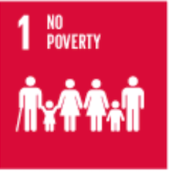 | Music can engage youth and expands expression. After school music programmes therefore need to be established everywhere. | Engaging in a music programme could lead to empowerment and building resilience.
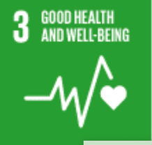 | Music helps us live longer and reduces stress. | Mindfully playing an instrument could reduce stress. Feeling a sense of belonging in a music group could enhance students’ wellbeing.
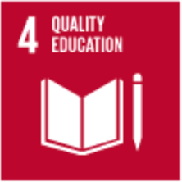 | Music education improves all education, develops cognitive strength, improves memory capacity, and verbal intelligence. Music education should therefore be mandatory. | Building confidence through extra-curricular music education may contribute to building a ‘growth mindset’ (Dweck, 2016). Engaging in after school music programmes could have a transfer effect to compulsory school subjects.
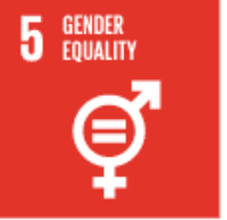 | Providing more educational opportunities for women and girls through music education. | Even though classical music instruments carry some inherent gender division, it is decreasing. Contrary to sports where boys and girls compete separately, when playing music together they cooperate on equal terms.
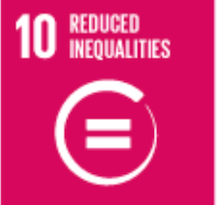 | Music can be a tool to amplify marginalized voices. | Access for all, giving every (young) citizen opportunity to express themselves aesthetically is a democratic right. Music education needs public funding and thus political ambitions are crucial.

“Sustainable Development Goals” by United Nations is licensed under CC BY-NC 4.0
Modified by the author: excerpts taken.

References

Burnard, P., & Dragovic, T. (2015). Collaborative creativity in instrumental group music learning as a site for enhancing pupil wellbeing. Cambridge Journal of Education, 45(3), 371–392.

Center for music ecosystems. (2023). Your guide to music and the SDGs. Retrieved June 30, 2023 from https://www.centerformusicecosystems.com/sdgs

Dweck, C. (2016). What having a “growth mindset” actually means. Harvard business review, 13(2), 2–5.

Swedish Art and Music School Council [Kulturskolerådet]. (2023). Verksamhetsplan 2023. Retrieved 2023-08-12 from https://www.kulturskoleradet.se/wp-content/uploads/2023/04/kulturskoleradet-verksamhetsplan-2023.pdf

Treacy, D. (2020). Imagining possibilities: Musician-teachers co-constructing visions in the Kathmandu Valley. [Doctoral dissertation. Sibelius Academy of the University of the Arts Helsinki]. Studia Musica 80. https://www.uniarts.fi/en/people/danielle-treacy/

United Nations. (2023). Topics. Education. Retrieved 2023-08-12 from https://sdgs.un.org/topics/education

See for example Treacy (2020).
See for example Burnard & Dragovic (2015).

