Effectiveness of Low-impact development for mitigating the risk of pluvial flooding – A case study in Trelleborg, Sweden
A Asif Rifat*, S Mobini**, K Karagiorgos ***, L Nyberg****
*Division of Water Resources Engineering, Lund University, Lund, Sweden Email: ab7511as-s@student.lu.se
** Division of Water Resources Engineering, Lund University, Lund, Sweden, Email: shifteh.mobini@tvrl.lth.se
*** Risk and environmental studies, Centre for Societal Risk Research, Centre of Natural Hazards and Disaster Risk Science, Karlstad University, Sweden. Email: konstantinos.karagiorgos@kau.se
****Risk and environmental studies, Centre for Societal Risk Research, Centre of Natural Hazards and Disaster Risk Science, Karlstad University, Sweden. Email: lars.nyberg@kau.se

Abstract: Increasing imperviousness in urban areas, and changes in rainfall intensity and return periods because of climate change increase urban flood risk. This study utilizes the hydraulic model Mike+ to assess the multifunctional use of existing roads and parking lots, which could serve to either retain or detain stormwater and accommodate trees, plants, and vegetation as part of a low-impact development (LID) system. The results from the study demonstrate its success in reducing urban flood risk, including the risk of basement flooding, surface runoff, discharge rates, and flow velocity at the outlet of the studied area.

Keywords: pluvial flooding; hydraulic modelling; water-wise city

Climate change poses a challenge for many cities to face more frequent and heavier rainfall, which is already evident. These cities are facing pluvial flooding resulting in economic, health, and environmental losses. In this context, it is emerging to reform and transform cities into water-wise smart cities by ensuring the reuse of natural resources and multipurpose use of existing space.
The underlying concept of this study was to investigate the potential of existing road lanes and parking lots to retain stormwater and reduce the risk of pluvial flooding. A district in Trelleborg, located in the South of Sweden, was selected to investigate the feasibility of implementing low-impact development (LID). The area has experienced frequent basement flooding damage in recent years. The study area features both combined and separate sewer systems.
Hydraulic modelling of the drainage system with the implementation of two LID systems was done with Mike+. The study assessed the effectiveness of LID systems, specifically Bioretention Cells and Pervious Pavements in Mike+ in combination with two rainfall scenarios to evaluate their impact on reducing basement flooding. Scenario 1 involved a synthetic rainfall event with a 10-year return period, while scenario 2 simulated a real rainfall event equivalent to a 50-year event occurrence. A unit is an individual LID structure defined by its surface area, volume, and hydraulic parameters. Each unit was constructed with a subgrade layer using the existing roads and parking lots, which was replaced with high-porosity materials to serve as a storage layer. The top impervious surface was replaced, either with vegetation or pervious pavement, to allow stormwater to pass through. The surface area and depth of these units were chosen depending on available road, pedestrian and bike lanes in each catchment and the volume needed to accommodate root zones for trees and plants (Hamers, E.M et al., 2023). The number of units in each catchment was selected depending on available impervious space and to store enough stormwater to prevent basement flooding in the study area. Drainage parameters for the units were configured to detain an adequate volume of stormwater and release it in a controlled manner after the rainfall event.
The model results were observed in terms of water level in the pipe network, distribution of stormwater in different phases, hydrograph for discharge rate and flow velocity in the outlet pipe, both for the existing drainage system and the proposed LID system. And then compared between results for the existing and proposed drainage system. The results of the study are presented below in Figure 1.1. Cases 1 and 3 represent the existing drainage system with scenarios 1 and 2 respectively and cases 2 and 4 represent the proposed LID system with the same scenarios. Calculations were performed to determine the amount of existing pervious surface that needs to be replaced with LID systems to reduce surface runoff by 50% in scenario 1. The result in Figure 1.2 indicates that only 14% replacement is needed to achieve this goal.

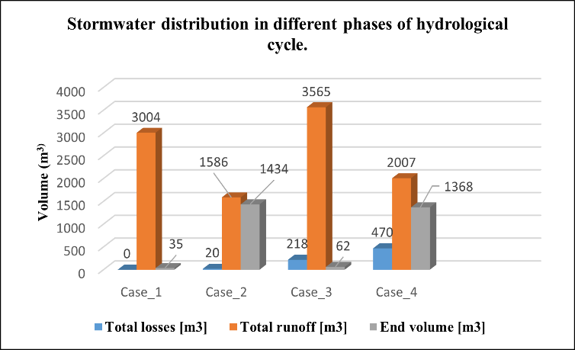 Figure 1.1 Stormwater distribution in different phases of  the hydrological cycle in different scenarios. | 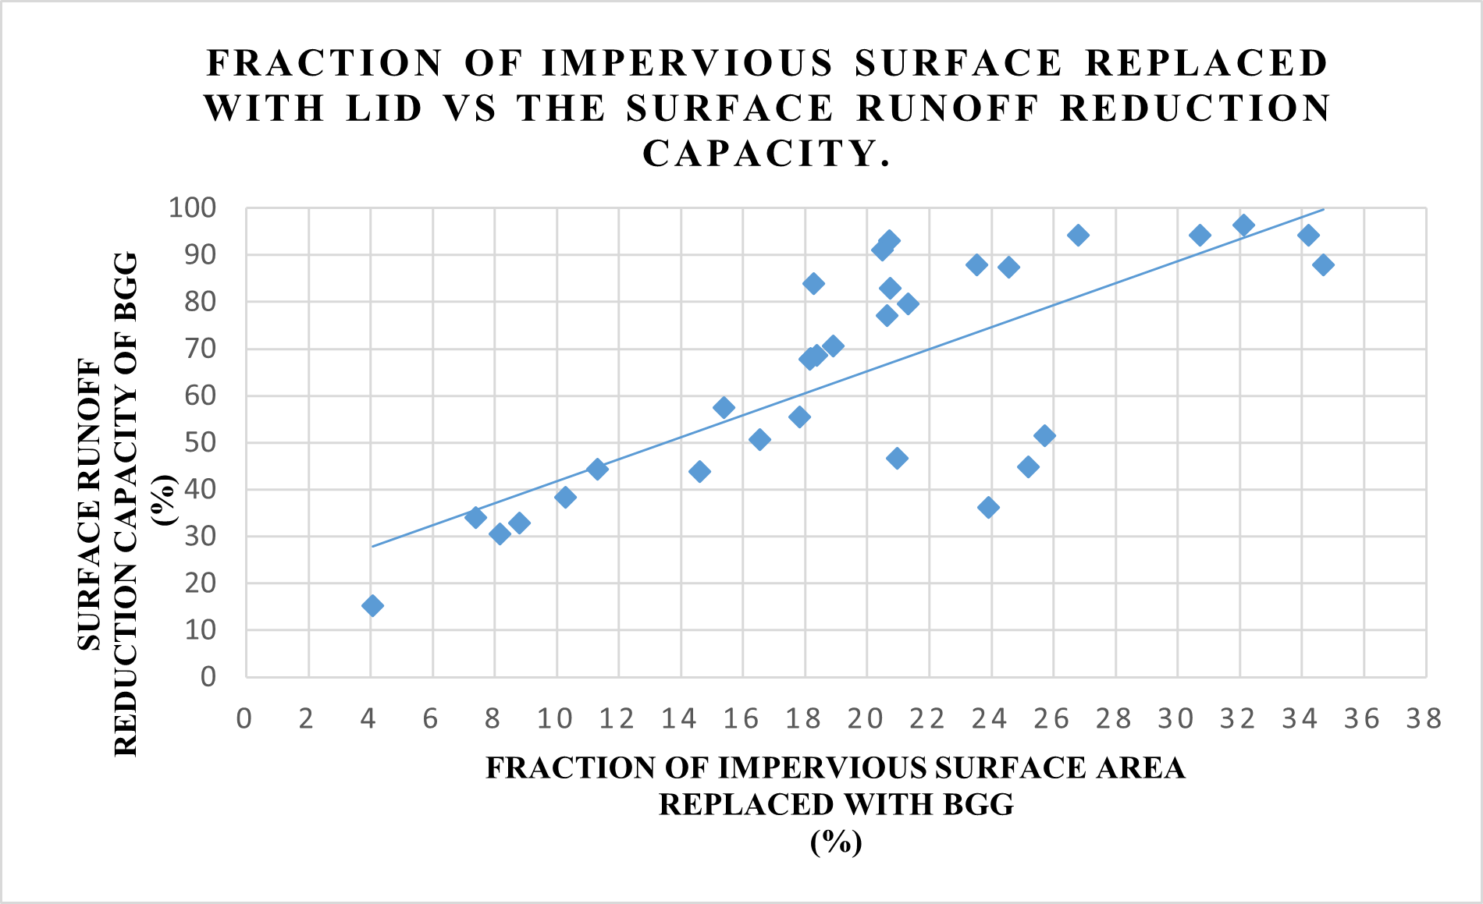  Figure 1.2 Fraction of existing impervious surface replaced  with LID required to reduce the surface runoff.
For both scenarios, the proposed LID system reduced surface runoff by 48%, a significant reduction of loads in the existing drainage network. The results also indicated that there would be no more basement flood risk in the study area. The decreased water volume in the drainage network led to a significant reduction in drainage discharge rates and flow velocity in the outlet pipe, thereby reducing flood risk and pollution in the downstream network and recipient. Simultaneously, the proposed LID system eliminates the need for new spaces dedicated to flood risk reduction in a developed urban area.
Many cities around the world are already implementing various sustainable drainage systems to manage stormwater but they often face challenges related to space availability. The use of bioretention cells also functions as a carbon sink and ensures greener space in urban areas. This study provides a potential solution that can guide the decision-making process for the inclusion of sustainable solutions to reduce the pluvial flood risk.

REFERENCES
Hamers, E.M., Maier, H. R., Zecchin, A. C., & Van Delden, H. (2023). Effectiveness of Nature-Based Solutions for Mitigating the Impact of Pluvial Flooding in Urban Areas at the Regional scale. Water, 15(4), 642. https://doi.org/10.3390/w1504064

