Significant emissions of methane and nitrous oxide
following clear-cutting of a boreal forest stand

Patrik Vestin¹, Meelis Mölder¹, Elin Sundqvist¹, Margareta Hellström¹, Anders Båth¹,
Leif Klemedtsson², Anders Lindroth¹
¹ Department of Earth and Ecosystem Sciences, Lund University, Sweden
² Department of Plant and Environmental Sciences, Gothenburg University, Sweden

Clear-cutting and subsequent site preparation is common forest management practice in Sweden. According to the Swedish National Forest Inventory, an average of 196 000 ha were clear-cut annually during the period 2005-2009. The net effects of final fellings on greenhouse gas fluxes are not well understood. Increased substrate availability for decomposers following harvest may result in higher carbon dioxide (CO₂) emissions from soils and in increased nitrogen mineralization. This may be further enhanced by increased soil temperatures after site preparation. In addition, removal of trees causes reduced evapotranspiration and subsequently a raised ground water table, which may have consequences for methane (CH₄) and nitrous oxide (N₂O) fluxes. The net effects of clear-cutting on CH₄, N₂O, CO₂ and H₂O fluxes were studied at Norunda forest in central Sweden. Micrometeorological measurements (i.e. flux-gradient and eddy covariance) allowed for quantification of CO₂, CH₄, N₂O and H₂O fluxes at two different plots on a new clear-cut. Measurements of CH₄, CO₂ and H₂O fluxes started in May 2010 while N₂O flux measurements begun in June 2011. Soil chamber measurements (CO₂, CH₄ and H₂O) were carried out in the adjacent forest stand during the main growing season of 2010 and at the clear-cut during October-November 2010. The clear-cut became waterlogged after harvest (more pronounced at plot 1) and preliminary results indicate a switch from a weak CH₄ sink to a significant CH₄ source at both plots. Daily average fluxes during the period 20 May through 30 November 2010 were of the order of -6.3 – +142.5 µmol m⁻²h⁻¹ (Fig.1) with mean values of 39.0 µmol m⁻²h⁻¹ (plot 1) and 16.3 µmol m⁻²h⁻¹ (plot 2). The preliminary results also indicate enhanced CO₂ emissions and increased soil temperatures at disturbed microsites. Raw N₂O data imply N₂O fluxes of the order of 1-10 µmol m⁻²h⁻¹ during daytime (well-mixed) conditions. Available data, including 2011, will be further analyzed and presented at the conference.

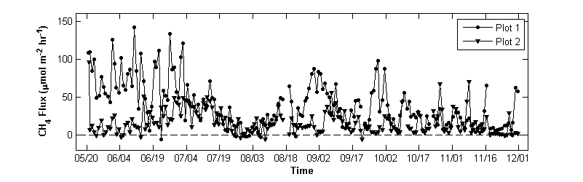
Figure 1. Daily average CH₄ fluxes at plot 1 (circles) and plot 2 (triangles) measured with the flux-gradient technique at the Norunda clear-cut during the period 20 May – 30 November 2010. Both plots are, on average, significant CH₄ sources. The decreasing trend from mid-June through late July coincides with a period with low amounts of precipitation and decreasing soil water content.

