The Earth’s magnetic field and visual landmarks steer migratory flight behaviour in the nocturnal Australian Bogong moth

David Dreyer^{1*}, Barrie Frost², Henrik Mouritsen³, Anja Günther³, Ken Green⁴, Mary Whitehouse⁵, Sönke Johnsen⁶, Stanley Heinze¹, Eric Warrant^{1*}

¹Lund Vision Group, Department of Biology, University of Lund, Lund, Sweden
²Department of Psychology, Queens University, Kingston, Ontario, Canada
³Institute for Biology and Environmental Sciences, University of Oldenburg, Oldenburg, Germany
⁴New South Wales National Parks and Wildlife Service, Jindabyne, NSW, Australia
⁵CSIRO, Australian Cotton Research Institute, Narrabri, NSW, Australia
⁶Department of Biology, Duke University, Durham, NC 27708, USA

*Correspondence to: David.Dreyer@biol.lu.se, Eric.Warrant@biol.lu.se (Lead Contact)

Highlights
• The Australian Bogong moth, a nocturnal migrant, possesses a magnetic sense
• Bogong moths correlate visual and magnetic cues to steer migratory flight behaviour
• When these cues are placed in conflict, moths become disoriented after a few minutes
• Bogong moths use the Earth’s magnetic field and visual landmarks to steer flight

eTOC Blurb
The nocturnal Bogong moth performs a highly directed long-distance migration to and from alpine caves in the Australian Alps. Dreyer et al. show that this moth senses the Earth’s magnetic field and uses it together with visual landmarks to steer migratory flight behaviour. The geomagnetic field might thus be used as a compass during migration.

Summary

Like many birds [1], numerous species of nocturnal moths undertake spectacular long-distance migrations at night [2]. Each spring, billions of Bogong moths (Agrotis infusa) escape hot conditions in different regions of southeast Australia by making a highly directed migration of over 1000 km to a limited number of cool caves in the Australian Alps, historically used for aestivating over the summer [3,4]. How moths determine the direction of inherited migratory trajectories at night and locate their destination (i.e. navigate) is currently unknown [5-7]. Here we show that Bogong moths can sense the Earth’s magnetic field and use it in conjunction with visual landmarks to steer migratory flight behaviour. By tethering migrating moths in an outdoor flight simulator [8], we found that their flight direction turned predictably when dominant visual landmarks and a natural Earth-strength magnetic field were turned together, but that the moths became disoriented within a few minutes when these cues were set in conflict. We thus conclude that Bogong moths, like nocturnally migrating birds [9], can use a magnetic sense. Our results represent the first reliable demonstration of the use of the Earth’s magnetic field to steer flight behaviour in a nocturnal migratory insect.

Keywords: migration, navigation, insect vision, magnetic sense, Bogong moth, Agrotis infusa

Results and Discussion

Many species of nocturnal moths undertake seasonal migrations of hundreds or thousands of kilometres to favourable new habitats, which are typically broad geographic regions, to take advantage of suitable temperatures and more abundant food, and to reduce the risk of predators and infectious diseases [2]. When the season turns, one or more descendant generations of these original migrants then return. In contrast, newly eclosed Bogong moths make a highly directed spring migration, from the mostly flat arid plains of their breeding areas in southeast Australia to a geographically restricted assemblage of high mountain caves in the Australian Alps, more than 1000 km away (and thus well beyond their visual and olfactory range: Figure 1A). Once in the mountains, Bogong moths enter a period of 3-4 months of dormancy (aestivation) [3,4]. At the beginning of autumn, the same individuals make a return migration to their breeding grounds to reproduce and die.

The natural migratory directions of Bogong moths

To study these forward and return migrations, we light-trapped Bogong moths during their southward spring migration near Narrabri in northern New South Wales, and during the return autumn migration in the Australian Alps near Adaminaby in southern New South Wales (see Figure 1B). Captured moths were tethered and flown outdoors for 10 minutes within a modified Mouritsen-Frost flight simulator [8], a cylindrical Perspex arena placed vertically on a table. Moths were tethered at the centre of the arena to the end of a vertical shaft connected to an encoder that continuously measured the instantaneous orientations of steadily flying moths that were free to turn in any azimuthal direction under natural night skies (see Figures S1-S2 for details of experimental sites and the simulator). Natural migratory directions of tethered moths in each location were as expected (Figure 1B): spring migrants on average flew geographic SSW (geographic south is 180° in the plot) towards the Australian Alps (n=18, Mean vector (MV) =214°, 95% confidence interval 176°-238°, R*=1.624, p<0.001), while autumn return migrants flew NNW (n=36, MV=337°, 95% confidence interval 290°-353°, R*=1.668, p<0.001). Since the breeding grounds of Bogong moths stretch from western Victoria to southeast Queensland [10] (grey arrows Figure 1B), we did not expect the autumn migratory direction to be the exact reverse of the Narrabri spring migratory direction.

The Earth’s magnetic field and visual landmarks steer migratory flight behaviour

Which sensory compass cues are used by Bogong moths to steer migration in the correct forward and return directions? Radar studies reveal that migrating moths generally exploit favourably directed winds, adopting optimal flight headings that partially correct for crosswind drift to maximise distance travelled in their preferred inherited direction [5,11], a feat requiring an internal directional compass sense [5,6]. However, the nature of this compass remains enigmatic [5-7].

Visual cues, including celestial cues (such as the stars or the moon) and terrestrial landmarks, are obvious candidates, although these tend to be less reliable due to their changing positions (and/or prominence) over time. A more reliable compass cue is the Earth’s magnetic field. While the importance of a magnetic compass for long-distance migration in birds [9], sea turtles [12] and fish [13] has been long established, its role in long-distance migration in insects is unknown. Tentative evidence suggests that some migratory moths may sense magnetic fields [14-16], as may some butterflies [17,18] such as the diurnal long-distance migratory Monarch butterfly Danaus plexippus [18], although in many of these studies very strong (unnatural) magnetic fields were used to show affects and the evidence is also conflicting [7,19]. Hitherto studied migratory butterflies instead appear to rely primarily on a sun compass [7,20-22] and it remains unclear how, or if [19], they use the Earth’s magnetic field for navigation in natural circumstances.

To test whether Bogong moths use a magnetic compass, the flight simulator was placed outdoors within a pair of single-axis Helmholtz coils that could turn the azimuthal direction of a natural Earth-strength magnetic field clockwise by about 120° without changing the field’s strength or inclination angle (Figure S1B-F). In initial experiments over two experimental seasons, newly captured migratory moths, tethered in the simulator, were subjected to a 120° azimuthal field change to test whether they changed their flight direction accordingly (as occurs in birds hopping in an Emlen funnel during a similar stimulation paradigm [e.g. 23]). Unlike birds, moths either failed to react or reacted in an unpredictable manner, suggesting they do not rely solely on a magnetic compass. Since many nocturnal insects have exquisite dim-light vision [24], remaining weak visual orientation cues within the flight simulator (that we had attempted to minimise) may have confounded the experiment (see Materials and Methods). We thus lined the interior of the simulator arena with featureless white felt and introduced two dominant moveable visual landmarks (Figure 2, see Materials and Methods for justification): a triangular black “mountain” above a lower black “horizon” within the flight simulator arena, and a black stripe on a rotatable circular UV-transmissive diffuser above the moth (the diffuser’s angular extent removed all remaining visual landmarks above the arena walls). These landmarks were chosen to be visible in most parts of the moth’s visual field since we had no a priori knowledge of which visual field areas are used for analysing landmarks.

To investigate whether Bogong moths use both magnetic and visual cues to navigate, tethered moths, captured during their autumn migration near Adaminaby, were subjected to two five-phase experiments (Experiment 1 and 2) in which these cues were placed in congruent and conflicting configurations (Figure 2A,B, left columns). In each phase moths flew for 5 min (i.e. a total continuous flight of 25 min). In Phase A of Experiment 1 (Figure 2A, upper panels), the magnetic field was aligned towards magnetic North (mN – the putative migratory direction, see Figure 1B), but the visual landmarks were aligned 60° further east to detect whether one cue was dominant over the other. In Phase B the field and the landmarks maintained their relative positions, but were both moved clockwise by 120° (with landmarks now at 180°, mS). In Phase C₁ the landmarks remained at mS but the field was returned to mN (cues now in conflict). To study the effect of this conflict over time, Phase C₁ was continued for a further 5 min (Phase C₂). In Phase D, a quality control, the conditions of Phase A were repeated – to be included in the analysis, a moth was required to return to a flight direction in Phase D that was not significantly different to that in Phase A (see Methods). Experiment 2 (Figure 2B) repeated Experiment 1 but with different visual and magnetic starting conditions: in Phase A, landmarks were again aligned at 60° but magnetic field direction was at 120°. Moreover, an anti-clockwise (rather than clockwise) 120° shift of both cues occurred between Phases A and B.

In Experiment 1, moths were significantly oriented in a direction close to the landmarks in Phase A (p<0.001 – see Mean vector (MV) for each phase in Figure 2), indicating that in our experiment moths preferred to align with visual rather than magnetic cues. That moths did not orient in their inherited migratory direction (as they did in Figure 1B) was likely an artefact [25] of using an unnatural single set of aligned and disproportionately salient visual beacons in an otherwise visually impoverished arena (in the wild, moths would experience an entire panorama of naturally salient celestial and terrestrial visual cues). In Phase B, moths turned on average by 120° in response to the 120° rotation of both cues (p<0.001), and still remained oriented towards the landmarks. In Phases C₁ and C₂, when magnetic and visual cues were in conflict, moths became disoriented (C₁: 0.05<p<0.1; C₂: 0.5<p<0.9), although initially they continued to fly towards the visual landmarks (as seen by the longer MV in C₁ – Figure 3). In Phase D, when cues were again returned to their initial conditions, moths returned to the landmark-directed orientation of Phase A. To control for the possibility that fatigue led to the disorientation seen in Phases C₁ and C₂, a 25-min control experiment that twice repeated Phase B (Phases B₁, B₂) was performed (Figure 2B). The only difference between Phases C₁/C₂ and B₁/B₂ is the direction of the magnetic field. Moths remained significantly oriented towards the landmarks in Phases B₁ and B₂ (Figures 2B, 3) indicating that the disorientation seen in Phases C₁ and C₂ was due to the altered direction of the magnetic field, and not fatigue. Despite different cue starting conditions, the same results and conclusions were obtained from Experiment 2 (Figure 2C), and in one further experiment where visual and magnetic cues were initially both aligned towards mN (Figure S3). The few individual highly-directed moths that flew in directions well outside the population average in Phase A of Experiments 1 and 2 also usually reacted to changes in visual and magnetic stimuli, but not in ways typical of the rest of the tested population (Figure S4A).

Landmark fidelity is rechecked with the magnetic sense every few minutes

In the absence of other cues, Bogong moths thus appear to require correlated visual and magnetic cues for orientation, becoming disoriented when these cues are placed in conflict. Even though their preferred visual landmarks remain unchanged and clearly visible upon entering Phase C₁, moths nonetheless become incapable of orienting towards them (Figure 2). Interestingly, this incapacity is not instantaneous – moths continued flying for some time towards the visual landmarks before detecting the conflicting magnetic field and becoming disoriented. The time course of disorientation was revealed by analysing the directedness (via the R* value, Figures 4A,B) and direction (Figures 4D,E) of moth flight tracks in Experiments 1 and 2 as a function of time during the transition from Phase B to Phases C₁ and C₂. Moths were significantly directed towards the landmarks in Phase B in both experiments (significance = R* ≥ ≈1 – horizontal dashed lines in Figure 4A-C), and initially remained so even in Phase C₁. Eventually, however, R* fell permanently below 1 (at a “time to confusion” t_{c}), after which moths became disoriented until the onset of Phase D (t_{c} ≈ 3.5 min and 1.5 min in Experiments 1 and 2, respectively: Figures 4A,B). Moths also began to deviate significantly from their Phase B mean direction (t_{c} ≈ 3.5 min and 2.0 min: Figures 4D,E). In the control, R* remained greater than 1 in all phases (Figure 4C), and flight direction was maintained (Figure 4F).

These results suggest that moths used visual landmarks as an orientation beacon, but calibrated landmark fidelity using a magnetic sense. The fact that it took around 2-3 minutes for moths to detect a conflict between visual and magnetic cues suggests that either the magnetic sense is reliable and relatively noise-free and checks the directional fidelity of a landmark once every few minutes, or that it is relatively noisy and unreliable and must continuously accumulate data every few minutes for reliable calibrations. Either way, the calibration mechanism appears to be periodic.

Is the Earth’s magnetic field used as a compass in conjunction with visual landmarks to steer migration?

Our results show that the steering directions of Bogong moths during flight is the result of an interaction between visual landmarks and the Earth’s magnetic field, providing the first indication that insects could use magnetic and visual cues in combination to navigate during long-distance nocturnal migration. However, since in some of our experiments (Figures 2, S3), the moths did not fly in their natural migratory direction (Figure 1) – due to the dominating effect of our visual landmarks – we are unable to say at this stage with certainty whether Bogong moths integrate magnetic and visual information to follow an inherited migratory trajectory.

Nonetheless, the Bogong moth’s magnetic sense could potentially allow the Earth’s magnetic field to be used as a compass to select and hold an inherited migratory direction, as found in nocturnally migrating birds [26]. Since our results indicate that geomagnetic and visual cues are used in conjunction to steer flight behaviour, a compass-selected migratory direction could be then aligned with a visual landmark in a nearby direction – a dark feature on the nocturnal horizon, one or more stars, or the moon. Such a landmark could be then used as a temporary orientation cue, with the directional fidelity of the landmark regularly affirmed by the magnetic compass. When the landmark becomes obscured (by the terrain or clouds), or moves over time (such as the moon), the entire process could then be repeated with a new landmark. Such a strategy – which could even involve generating a sequence of temporary multisensory navigational “snapshots” [27] of the visual and magnetic “scene” – would have the advantage that it does not require time compensation to hold an accurate bearing using the variable and comparatively unreliable disk of the moon as a celestial cue. Such a strategy would of course require that the Bogong moth uses the Earth’s magnetic field as a magnetic compass, and further experiments using more naturalistic visual stimuli (terrestrial panoramas and projected starry skies) are needed to confirm whether this is indeed the case.

The Earth’s magnetic field is arguably the most stable cue for nocturnal long-distance migration, and our results indicate that Bogong moths, like birds [9,26], have a magnetic sense. Moreover, our results also provide the first reliable demonstration of the use of the Earth’s magnetic field to steer flight behaviour in a nocturnal migratory insect. It is possible that other nocturnal moths also rely on a magnetic sense, although this – and the hitherto unknown sensory mechanisms responsible for sensing and analysing the Earth’s magnetic field [28-31] – remain enticing topics for future research.

Acknowledgements: We are grateful to James Warrant, the University of Oldenburg, and Lars Fredriksson (University of Lund), for manufacturing experimental apparatus, to Liv de Vries, Olle Claesson, David Szakal, Sandra Chaib, Sanjay Sane, Jochen Zeil and Waltraud Pix for help in the field, to the Australian Cotton Research Institute in Narrabri and James Farris (NSW National Parks and Wildlife Service) for logistical support. We are grateful to Ted Edwards (Australian National Insect Collection) for his advice on Bogong moths, Ajay Narendra (photograph in Figure 1), Aislinn Pearson (moth tethering techniques), and Martin York (optical encoder software), Sanjay Sane and Jochen Zeil for helpful discussions and Marie Dacke and Basil el Jundi for critically reading the manuscript. The authors are also indebted to the US Air Force Office of Scientific Research (FA9550-14-1-0242), the Swedish Foundation for International Cooperation in Research and Higher Education (2012-2033), the Royal Physiographic Society of Lund, the Swedish Research Council (621-2012-2205), the Volkswagen Stiftung and the Natural Sciences and Engineering Research Council of Canada (353-2009). The authors have no competing interests. All data are shown in the main paper and in the Supplementary Materials.

Author Contributions: E.W. and B.F. conceived the project; K.G. contributed detailed knowledge of Bogong moth ecology and aestivation sites and provided critical logistical support in the Australian Alps; M.W. provided crucial logistical and experimental support in Narrabri; E.W., B.F., D.D., H.M, A.G. and S.J. designed the experiments, manufactured the experimental apparatus, and executed the experiments; D.D. calibrated the magnetic stimulation apparatus and wrote the MATLAB scripts to control it; D.D., E.W. and B.F. analysed the results; D.D. and E.W. made the figures; S.H. made intellectual contributions to the interpretation of the results; E.W. and D.D. wrote the initial version of the manuscript and all authors made significant contributions to the final version.

Declaration of interests: The authors declare that they have no competing interests.

References

- Berthold, P. (2001). Bird Migration: A General Survey (Oxford University Press).
- Chapman, J.W., Reynolds, D.R., and Wilson, K. (2015). Long-range seasonal migration in insects: mechanisms, evolutionary drivers and ecological consequences. Ecol. Lett. 18, 287-302.
- Common, I.F.B. (1954). A study of the ecology of the adult Bogong moth Agrotis infusa (Boisd.) (Lepidoptera: Noctuidae), with special reference to its behaviour during migration and aestivation. Aust. J. Zool. 2, 223-263.
- Warrant, E.J. Frost, B., Green, K., Mouritsen, H., Dreyer, D. Adden, A., Brauburger, K., Heinze, S. (2016). The Australian Bogong moth Agrotis infusa: A long-distance nocturnal navigator. Front. Behav. Neurosci. 10, 77.
- Chapman, J.W., Reynolds, D.R., Mouritsen, M., Hill, J.K., Riley, J.R., Sivell, D., Smith, A. D., Woiwod, I.P. (2008). Wind selection and drift compensation optimize migratory pathways in a high-flying moth. Curr. Biol. 18, 514-518.
- Chapman, J.W. Reynolds, D.R., Hill, J.K., Sivell, D., Smith, A.D., Woiwod, I.P. (2008). A seasonal switch in compass orientation in a high-flying migrant moth. Curr. Biol. 18, R908-R909.
- Carde, R.T. (2008). Animal migration: Seasonal reversals of migrant moths. Curr. Biol. 18, R1007-R1009.
- Mouritsen, H., and Frost, B.J. (2002). Virtual migration in tethered flying Monarch butterflies reveals their orientation mechanisms. Proc. Nat. Acad. Sci. USA 99, 10162-10166.
- Wiltschko, W., and Wiltschko, R. (1972). Magnetic compass of European robins. Science 176, 62-64.
- Green, K. (2008). Migratory Bogong moths (Agrotis infusa) transport arsenic and concentrate it to lethal effect by gregariously aestivating in alpine regions of the Snowy Mountains of Australia. Arct. Antarc. Alpine Res. 40, 74-80.
- Chapman, J.W. Nesbit, R.L., Burgin, L.E., Reynolds, D.R., Smith, A.D., Middleton, D.R., Hill, J.K. (2010). Flight orientation behaviors promote optimal migration trajectories in high-flying insects. Science 327, 682-654.
- Lohmann, K.J., and Lohmann, C.M.F. (1993). A light-independent magnetic compass in the leatherback sea turtle. Biol. Bull. 185, 149–151.
- Bottesch, M., Gerlach, G., Halbach, M., Bally, A., Kingsford, M.J., and Mouritsen, H. (2016). Coral reef fish larvae can use a magnetic compass that might help them return to their natal reef. Curr. Biol. 26, R1266-R1267.
- Baker, R.R., and Mather, J.G. (1982). Magnetic compass sense in the large yellow underwing moth, Noctua pronuba L. Anim. Behav. 30, 543–548.
- Gao, Y.-B., Hu, G., and Zhao, B.-P. (2014). The effect of converted magnetic fields on orientation behavior of armyworm moths Mythimna separata (Walker). Chin. J. Appl. Entom. 51, 899-905.
- Xu, J., Pan, W., Zhang, Y., Li, Y., Wan, G., Chen, F., Sword, G.A., and Pan, W. (2017). Behavioral evidence for a magnetic sense in the oriental armyworm, Mythimna separata. Biol. Open 6, 340-347.
- Srygley, R.B., Dudley, R., Oliveira, E.G., and Riveros, A.J. (2006). Experimental evidence for a magnetic sense in Neotropical migrating butterflies (Lepidoptera: Pieridae). Anim. Behav. 71, 183–191
- Guerra, P.A., Gegear, R.J., and Reppert, S.M. (2014). A magnetic compass aids monarch butterfly migration. Nat. Commun. 5, article 4164.
- Stalleicken, J., Mukhida, M., Labhart, T., Wehner, R., Frost, B., and Mouritsen H. (2005). Do monarch butterflies use polarized skylight for migratory orientation? J. Exp. Biol. 208, 2399-2408.
- Oliveira, E.G., Srygley, R.B. and Dudley, R. (1998). Do Neotropical migrant butterflies navigate using a solar compass? J. Exp. Biol. 201, 3317–3331.
- Froy, O., Gotter, A.L., Casselman, A.L., and Reppert, S.M. (2003). Illuminating the circadian clock in monarch butterfly migration. Science 5623, 1303-1305.
- Heinze, S., and Reppert, S.M. (2011). Sun compass integration of skylight cues in migratory monarch butterflies. Neuron 69, 345–358.
- Hein, C.M., Zapka, M., Heyers, D., Kutzschbauch, S., Schneider, N.-L. and Mouritsen, H. (2010). Night-migratory garden warblers can orient with their magnetic compass using the left, the right or both eyes. J. Royal. Soc. Interface 7, S227-S233.
- Warrant, E.J. (2017). The remarkable visual capacities of nocturnal insects: vision at the limits with small eyes and tiny brains. Phil. Trans. Roy. Soc. Lond. B 372, 20160063
- Osorio, D., Srinivasan, M.V., and Pinter, R.B. (1990). What causes edge fixation in walking flies? J. Exp. Biol. 149, 281-292.
- Mouritsen, H. (2015). Magnetoreception in birds and its use for long-distance migration. In Sturkie’s Avian Physiology, C. Scanes, ed. (Elsevier), pp. 113-133.
- El Jundi, B., Foster, J.J., Khaldy, L., Byrne, M.J., Dacke, M., and Baird, E. (2016). A snapshot-based mechanism for celestial orientation. Curr. Biol. 26, 1456-1462.
- Johnsen, S., and Lohmann, K.J. (2005). The physics and neurobiology of magnetoreception. Nature Rev. Neurosci. 6, 703-712.
- Mouritsen, H., Heyers, D., and Güntürkün, O. (2016) The neural basis of long-distance navigation in birds. Annu. Rev. Physiol. 78, 133-154.
- Hiscock, H.G. Worster, D., Kattnig, R., Steers, C., Jin, Y., Manolopoulos, D.E., Mouritsen, H., and Hore P.J. (2016). The quantum needle of the avian magnetic compass. PNAS 113, 4634–4639.
- Hore, P.J., and Mouritsen, H. (2016). The radical pair mechanism of magnetoreception. Ann. Rev. Biophys. 45, 299-344.
- Cochran, W.W., Mouritsen, H., and Wikelski, M. (2004). Migrating songbirds recalibrate their magnetic compass daily from twilight cues. Science 304, 405-408.
- Muheim, R., Phillips, J.B., and Åkesson, S. (2006). Polarized light cues underlie compass calibration in migratory songbirds. Science 13, 837-839.
- Sjöberg, S., and Muheim, R. (2016). A new view on an old debate: Type of cue conflict manipulation and availability of stars can explain the discrepancies between cue-calibration experiments with migratory songbirds. Front. Behav. Neurosci. 10, 29.
- Engels, S.S., Schneider, N.L., Lefeldt, N., Hein, C.M., Zapka, M., Michalik, A., Elbers, D., Kittel, A., Hore, P.J., and Mouritsen, H. (2014). Anthropogenic electromagnetic noise disrupts magnetic compass orientation in a migratory bird. Nature 509, 353-356.
- Schwarze, S., Schneider, N.L., Reichl, T., Dreyer, D., Lefeldt, N., Engels, S., Baker, N., Hore, P.J., and Mouritsen, H. (2016). Weak broadband electromagnetic fields are more disruptive to magnetic compass orientation in a night-migratory songbird (Erithacus rubecula) than strong narrow-band fields. Front. Behav. Neurosci. 10, 55.
37. Kirschvink, J.L. (1992). Uniform magnetic fields and double-wrapped coil systems: improved techniques for the design of bioelectromagnetic experiments. Bioelectromag. 13, 401-411.
38. Batschelet, E. (1981). Circular Statistics in Biology (Academic Press).
39. Moore, B.R. (1980). A modification of the Rayleigh test for vector data. Biometrika 67, 175-180.
40. Zar, J.H. (1999). Biostatistical Analysis, Fourth Edition (Prentice Hall Inc.).

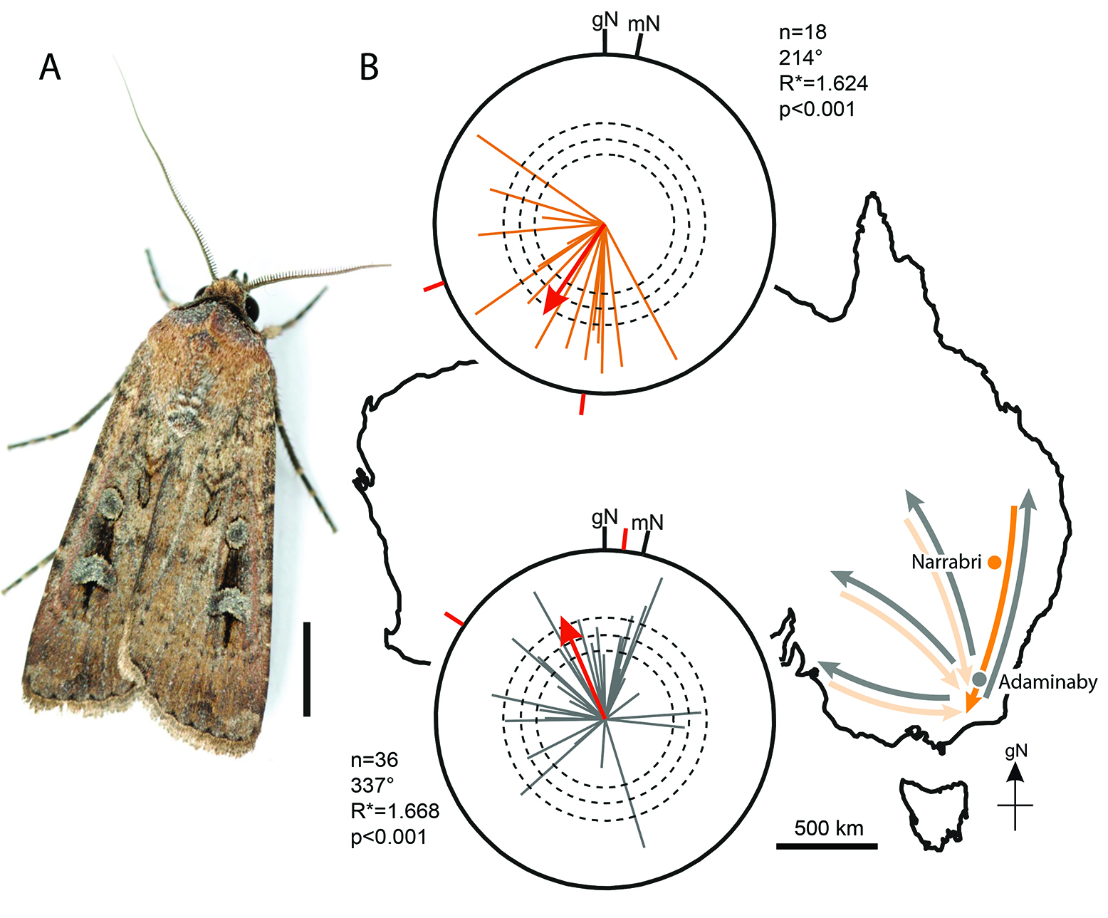
Figure 1. Natural migratory orientations of Bogong moths
A. A male Bogong moth (scale bar = 5 mm). Photo: Ajay Narendra. B. Moths caught during the spring migration near Narrabri (n=18, orange vectors, upper plot) and the autumn return migration near Adaminaby (n=36, grey vectors, lower plot) headed in their seasonally appropriate migratory directions (map: heavy orange and grey arrows). The directedness (length) of each individual moth vector is given by its r value (0 ≤ r ≤ 1), where outer radius of plots corresponds to r = 1. Each red Mean Vector (MV) results from weighting the mean directions and mean directedness (vector lengths) of all individual moths (Moore’s modified Rayleigh test – see Materials and Methods). Directedness of MV given by R* value. Dashed circles: required R* value for statistical significance: p<0.05, p<0.01 and p<0.001, respectively for increasing radius. Outer radius of plots: R*=2.5. Red radial dashes: 95% confidence interval. gN = geographic North. mN = magnetic North. A Mardia-Watson-Wheeler test confirmed that the spring and autumn migratory directions differ significantly (W=21.661, p=1.98E-5). See also Figures S1 and S2.

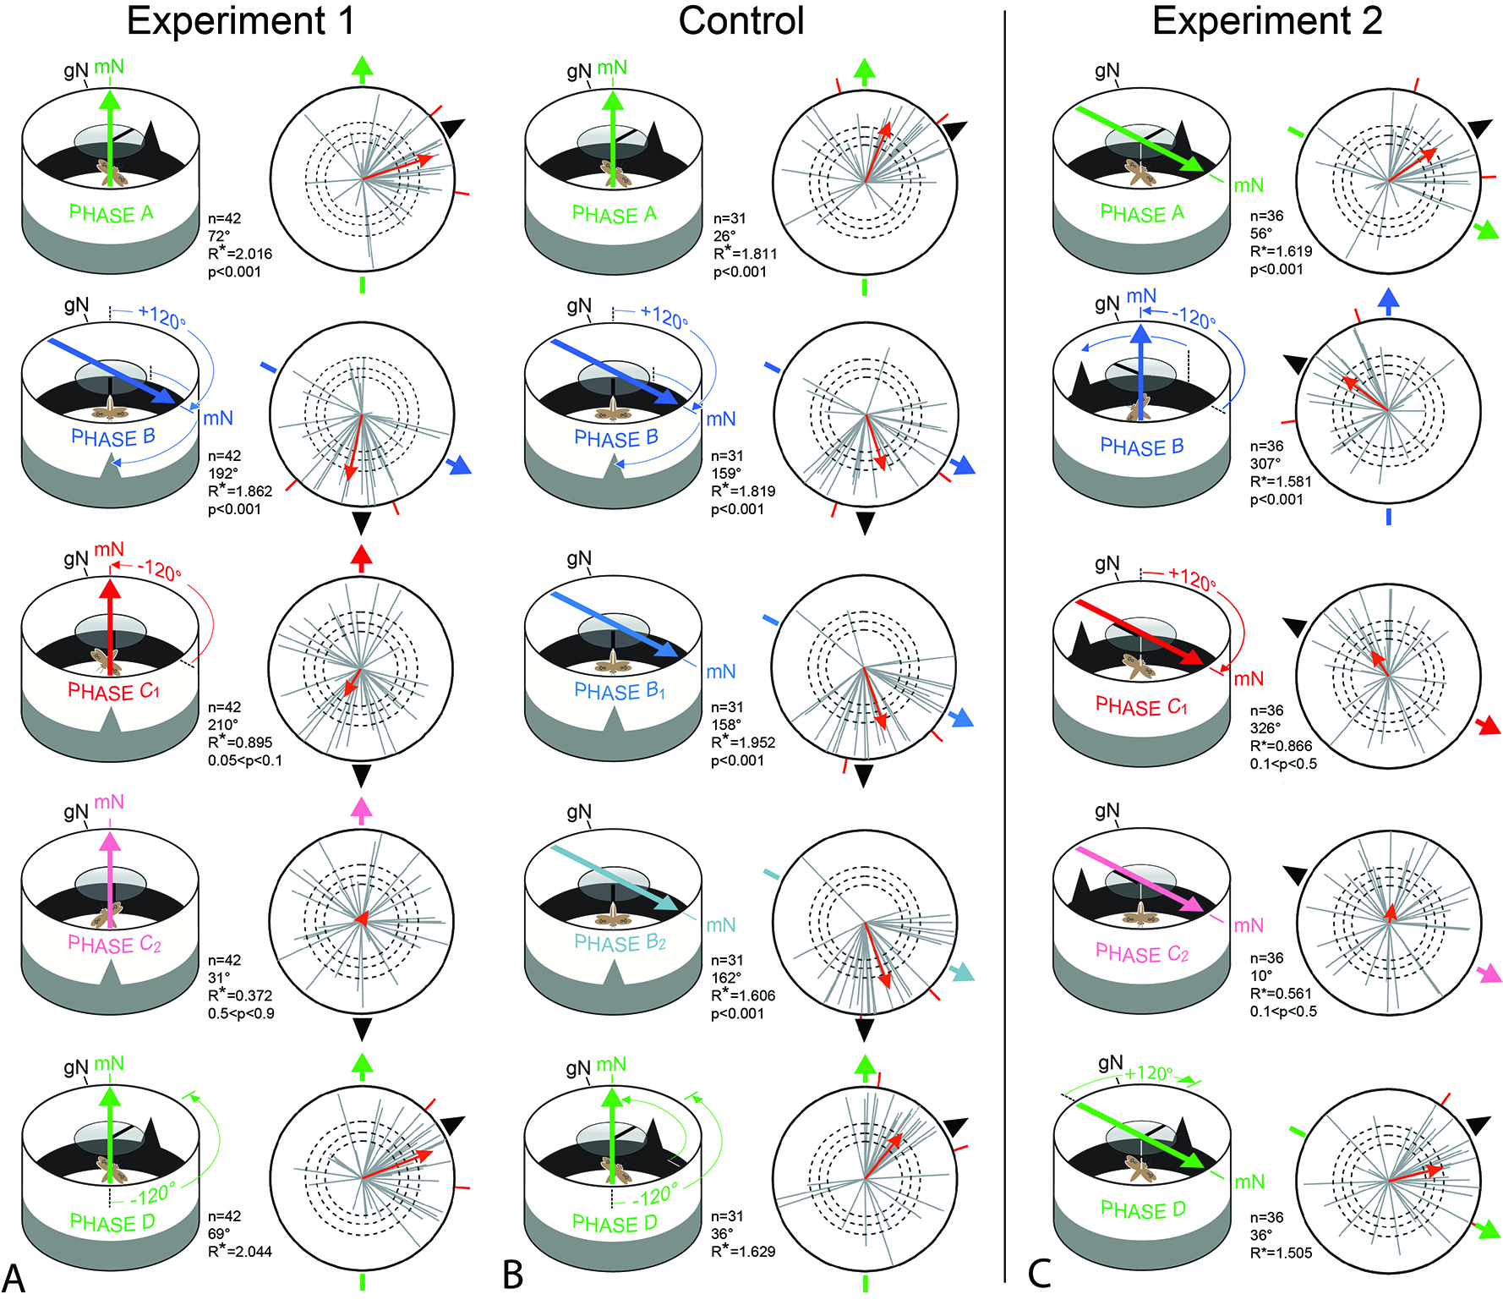

Figure 2. Magnetic and visual cues steer migratory flight behaviour in Bogong moths
A. Experiment 1. When the positions of the magnetic field (coloured arrows) and visual landmarks (black triangular “mountain” and dorsal stripe) are correlated (Phases A, B and D) moths (n=42, grey vectors) are significantly oriented near the landmarks (p<0.001). When the two cues are in conflict (Phase C₁/C₂), moths become disoriented (C₁: 0.05<p<0.1; C₂: 0.5<p<0.9). B. In a control of Experiment 1 for fatigue, where the magnetic field is not placed in conflict (Phase B₁/B₂), moths remain oriented. C. Experiment 2. As for Experiment 1 (a), with landmarks again initially at 60°, but with magnetic field direction at 120°. Moreover, an anti-clockwise (rather than clockwise) shift of cues occurs between Phases A and B. The magnetic field and visual landmarks are again correlated in Phases A, B and D and moths (n=36, grey vectors) are once more significantly oriented (p<0.001). When both cues are in conflict (Phase C₁/C₂), moths are again disoriented (C₁: 0.05<p<0.1; C₂: 0.1<p<0.5). Each Phase = 5 min flight. Other plot conventions as in Figure 1. Vector data for flight trajectories in selected individual moths from Experiment 1 are shown in Figure S4B. Histograms showing the distributions of flight direction and flight trajectory directedness (given by the r-value) for the 42 moths of Experiment 1 are shown in Figure S4C. These indicate that most moths were quite directed in all five Phases (r ≥ 0.5), irrespective of the direction they flew, indicating that a loss of orientation in Phases C₁ and C₂ was not necessarily associated with a simultaneous loss in directedness. See also Figures S1-S4.

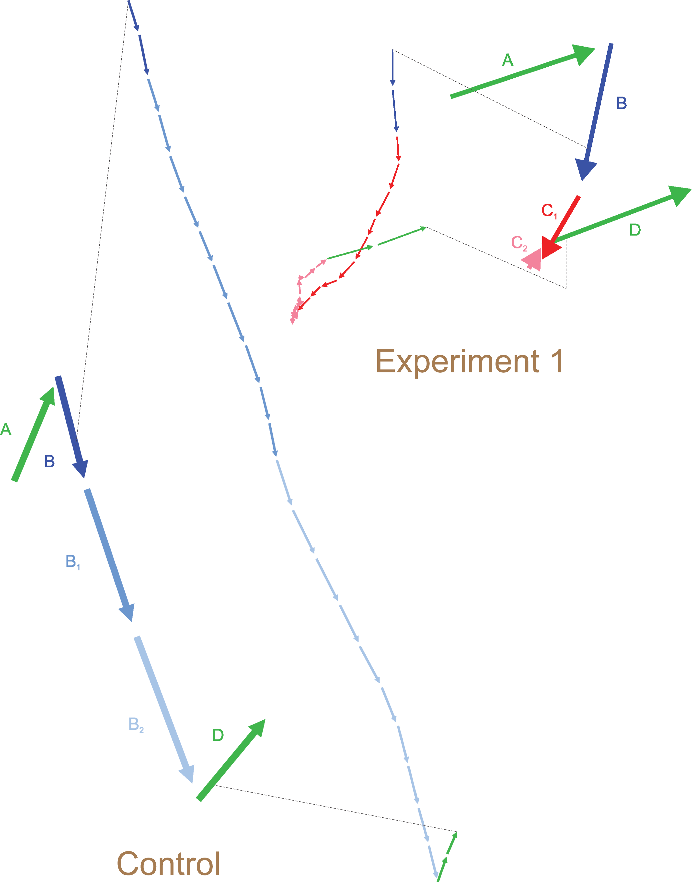

Figure 3. Vector data for Bogong moth flight trajectories in Experiment 1 and the control (from data given in Figure 2)
Plots show average vectors (of correct length and direction) throughout each Phase as well as an expanded view of these vectors where each is dissected into ten 30-second vector segments (i.e. 5 min total). When moths entered Phase C₁ in Experiment 1, moths initially continued to orient towards the landmarks but vector segments eventually began to shorten (indicating a declining directedness) and change direction. By Phase C₂ vector segments were very short and oriented in random directions (i.e. moths were totally disoriented). In the control, in contrast, vector segments in Phases B₁ and B₂ remained long (i.e. moths were highly oriented) and vector direction was maintained towards the landmarks (as in Phase B). Colour code for Phases as in Figure 2. See also Figures S2 and S4.

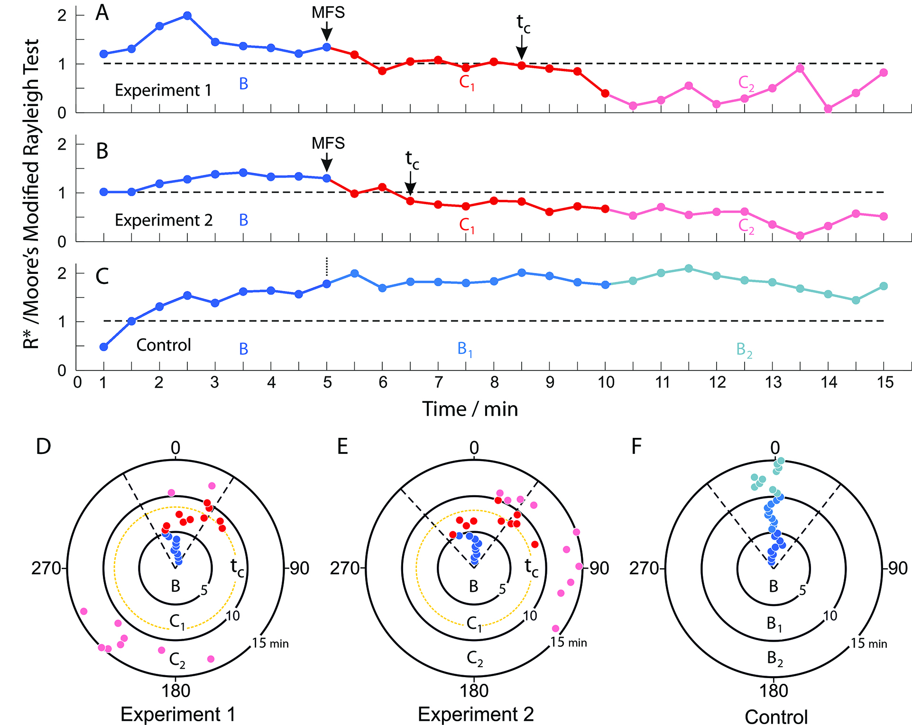

Figure 4. The time course of navigational disorientation during cue conflict
The directedness (R* value, A-C) and mean directions (D-F, 0° = mean direction in Phase B) of moths in Phases B (blue dots), C₁ (red dots) and C₂ (pink dots) of Experiments 1 (A,D) and 2 (B,E), and in Phases B, B₁ (light blue dots) and B₂ (pale blue dots) of the control (B,F), as a function of time (t=0: beginning of Phase B). Dashed lines (A-C): significance level for directedness (p<0.05: R*≥1.011 (A), R*≥1.015 (B), R*≥1.016 (C)). Dashed lines (D-F): 95% confidence intervals (as in Figure 2 but with MV=0° to aid comparison). t_{c} = “time to confusion”: time after the Phase C₁ magnetic field shift (MFS) when R* permanently falls below significance (A-C), or time after MFS when MV first deviates significantly from MV in Phase B (D-F). Data from Figure 2. See also Figure S2.

STAR Methods

CONTACT FOR REAGENT AND RESOURCE SHARING

Further information and requests for resources and reagents should be directed to and will be fulfilled by the Lead Contact, Eric Warrant (Eric.Warrant@biol.lu.se).

EXPERIMENTAL MODEL AND SUBJECT DETAILS

Male and female Bogong moths (Agotis infusa, Lepidoptera: Noctuidae) were caught in the wild during their migration using a powerful (1000 W) vertical beam search light (model GT175, Ammon Luminaire Company, Shanghai, China), and a suspended white sheet at ground level, during their natural southerly spring migration in October 2012 on Mt. Kaputar (near Narrabri, northern NSW, Australia (elevation 1489 m): Google Maps coordinates: 30.281°S, 150.151°E) and during their return autumn migration in March 2015, 2016 and 2017 on a mountain pass in the Australian Alps close to Thredbo (Dead Horse Gap (elevation 1580 m), southeast NSW, Australia: Google Maps coordinates: 36.524°S, 148.260°E). Each captured moth was transferred to its own small plastic container to isolate it from the influences of other moths, fed with 10% honey solution (in water) and stored in a cool and sheltered place (but with exposure to the natural light cycle) to recover from stress induced by capture. Following capture, the moths were transported 74 km to the testing site near Adaminaby, NSW (Google Maps coordinates: 36.038°S, 148.863°E).

METHOD DETAILS

Objectives of the study

The objectives of the study were (1) to determine whether nocturnal Bogong moths (Agrotis infusa) possess a magnetic sense, and if so (2) to determine how information from the Earth’s magnetic field might be used with other sensory information (in particular visual information) to steer long-distance migration in the inherited migratory direction at night. To achieve these objectives, wild Bogong moths were captured during their autumn migration, tethered within a flight simulator and subjected to controlled azimuthal changes of a natural Earth-strength magnetic field and correlated visual landmarks (placed in congruent and conflicting configurations).

Attachment of tethering stalks on moths

Before attachment of tethering stalks, moths were chilled in a freezer for 5-10 minutes in order to immobilize them. The scales on the moth’s dorsal thorax were removed by suction using a micro-vacuum pump (custom built by B.F.). Afterwards a thin vertical tungsten stalk (which is ferromagnetic free), fashioned at its end to create a small circular footplate, was glued to their dorsal thorax using contact cement while being restrained by a weighted-down plastic mesh (Figure S2C). Each moth was transferred to its own clear UV-transmissive Perspex container (not airtight), given a drop of 10% honey solution on cotton wool and stored in a cool outdoor location with a natural light cycle. Moths were tested on the day of stalk attachment. Shortly before sunset, containers holding moths were placed on an elevated location (such as a rock) and provided with a clear view of the western sky and the setting sun (and the skylight polarisation pattern), in case these cues were important for calibrating the magnetic compass (as found in birds [32-34]). After sunset moths could also see the stars (and the celestial rotation). On cold nights (<10°C), the containers holding moths were placed in a warmed plastic box to maintain ambient temperature at ≈20°C and prevent them from cooling.

Behavioural apparatus

Two ferromagnetic-free modified Mouritsen-Frost flight simulators [8] (built from aluminium, plastic and UV-transmissive Perspex) were used to continuously record the heading directions of tethered migratory Bogong moths. Briefly, each flight simulator consisted of a cylindrical Perspex arena (diameter 50 cm, height 35 cm), placed vertically on an aluminium table (Figure S2A). The table top was made of clear Perspex. The two flight simulators (and their tables) were placed around 8 m apart. For tethering, the tungsten stalk of the moth was attached to the bottom end of a second long, fine vertical tungsten rod (the encoder shaft) using a short length of thin rubber intravenous medical tubing (see below). The encoder shaft was connected to an optical encoder suspended at the centre of the open top end of the arena by a thin horizontal Perspex arm. The encoder instantaneously measured the moth’s heading and allowed us to reconstruct its virtual flight path, thus tracking the heading of the flying moth relative to magnetic north (mN) in the presence or absence of induced sensory cues.

The modification to the simulator consisted of incorporating an optic-flow system below the moths to produce sustained stable flight and to provide them with the appearance of forward progress over terrain. For each flight simulator, a projector (Philips PicoPix PPX3610 or BENQ GP2/3), a mirror placed at 45° and neutral density filters (optical density between 4 and 5 log units), were used to produce a very dim bitmap image of the Earth’s surface near Narrabri (at approximately 800m altitude) that was back-projected onto a tracing paper screen placed below the arena (Figure S2A). Custom written software (Martin York, Queens University, Canada), that controlled the direction of movement of the image (but not its orientation), was coupled to the encoder system (USB1, USB4: US Digital, Vancouver, WA, USA) via a feedback loop. This feedback ensured that the resultant ventral flow-field image always moved 180° relative to the moth’s heading (i.e. backwards from nose to tail), creating a visual sensation of forward movement irrespective of which direction the moth flew, instantaneously turning with the moth as it changed flight direction. The average light intensities of the optic flow at the moth were 1.31 x 10⁻³ cd m⁻² (Flight Simulator 1) and 6.70 x 10⁻⁴ cd m⁻² (Flight Simulator 2) and in both simulators it moved continuously at 10 mm s⁻¹. From their position in the centre of an arena, the moths could see a 2D 120° sector of sky (equivalent to a 3D solid angle of 3.5 steradians). Great care was taken to ensure that landmarks external to the arena, such as trees or other structures, could not be seen by moths while they were performing navigational flight behaviour in the simulator.

All experiments were conducted outdoors, after sunset, during the migratory periods in the Australian spring (test sites 1 and 2 (October): Australian Cotton Research Institute, Narrabri, NSW (Google Maps coordinates: 30.200°S, 149.612°E; magnetic declination +10°53’) and a helipad in Mount Kaputar National Park, Narrabri, NSW (Google Maps coordinates: 30.279°S, 150.174°E) and autumn (test site 3 (March): “Glenhare”, Adaminaby, NSW (Google Maps coordinates 36.042°S, 148.862°E; magnetic declination +12°29’). Background levels of radio-frequency disturbances were measured at the experimental sites using a Rohde and Schwarz FSV7 Signal and Spectrum Analyser and a calibrated passive loop antenna (ETS Lindgren, Model 6511). The experimental sites were in very rural locations, and measured noise levels were extraordinarily low and similar to the screened conditions under which the magnetic compass of night-migratory songbirds is not disturbed [35,36] (Figure S1A).

All moths that were tested to determine their general migratory direction (see Figure 1) at testing sites 1, 2 and 3, were tested under ambient local magnetic field conditions. To prevent unnoticed stray light generated by the electronic equipment (such as battery indicators) entering the experimental arenas, the interior walls of the testing arenas were initially covered with black cardboard. Even though all efforts were made to remove visual landmark cues from the interior of the arena, defects in the cardboard (such as slight buckles and seams) may have provided confounding visual cues during later initial experiments using magnetic field manipulation alone. For the main experiments reported in this paper, the cardboard lining was replaced with a very even felt (see below).

For the cue conflict experiments (performed at Adaminaby on migratory moths returning from the Australian Alps: Figure 2), the outside of each arena was covered with black cardboard, while the inside of the arena was covered with a white and very even felt glued to the arena wall. At the bottom of the arena wall, a strip (12 cm high) of black felt was glued over the white felt in order to create the visual sensation of a “dark horizon” against a “less dark” sky. In order to check for a putative role of landmarks during compass orientation, a triangular-shaped (isosceles) piece of cardboard-supported black felt (height 12 cm, base width 10.5 cm)) was connected to the top edge of the arena wall by a thin strip of diffusing paper, superimposed on the horizon to provide a dominant (“mountain-like”) landmark. To ensure that the moths were not able to use celestial cues (or the optical encoder arm) for compass orientation, the sky was occluded by a rotatable 15 cm diameter disc made (for rigidity) from a layer of translucent UV-transmissive diffusing filter paper (Lee Filters 251 1/4 white diffuser) centred above the moths such that its angular subtense at the moth diffused all visual details above the top of the arena walls. A thin (1 cm) strip of black cardboard extending from the centre of the disc to its edge served as a secondary landmark. As we had no a priori knowledge of which visual field areas moths used for analysing landmarks, the two landmarks were chosen so that they were visible in most parts of the dorsal and frontal visual fields (or even in the lateral or posterior visual fields if tethered moths turned away from the mountain-like landmark). During some experimental nights in which the moon was visible in the sky, large garden parasols made from thick fabric were positioned to shade the arenas, thus preventing direct moonlight from interfering with the experiment. All light-generating components of the equipment (such as laptops and magnetic coil power supplies) were positioned at a distance behind a tarpaulin wall in a tent that served as a visual “hide” (Figure S2B).

Magnetic field shifts

During cue conflict experiments, the azimuthal direction of mN in a natural Earth-strength magnetic field was turned within each flight simulator arena by a computer controlled, double-wrapped [37] Helmholtz two-coil system (custom built by the workshops of the University of Oldenburg) placed around each arena with its long axes 60° relative to mN (Figure S2A). The azimuthal direction was turned clockwise by ~120° (120.4°) without significantly altering the field’s strength or inclination (Figure S1B-F). A switchbox (also custom built by the workshops of the University of Oldenburg) placed between the power-supplies and the coils, enabled the current to be directed in the same (or parallel) direction through the double wound coils, or in opposite (or antiparallel) directions. In the antiparallel configuration the magnetic field produced by the coils cancels out so that only the Earth’s natural magnetic field remains (Natural Magnetic Field, NMF). In the parallel mode, the current sent through the coils was carefully adjusted to create a resultant magnetic field vector similar to the natural local magnetic field vector but with mN deflected to a clockwise azimuth of ~120° (30° south of the actual (real) magnetic East: Changed Magnetic Field, CMF). Control of the magnetic field shifts in CMN was enabled by a High-Speed USB Carrier (USB-9162, National Instruments) connected between a laptop computer (see below) and the constant-current power supplies feeding the coil-systems (Kepco, BOP 50-2M). Fine adjustment of the magnetic fields was controlled by a custom-written code in MATLAB (Mathworks, Natick, MA). Before each experimental session, the local magnetic field parameters at the experimental site and at the centres of the two flight simulator arenas were measured using a Meda FVM-400 magnetometer.

At test sites 1 and 2 (Narrabri), the electrical power required to run the coil systems (and all other devices) was provided by a portable petrol-powered generator (Honda, EU2000i) displaced from the experimental area by at least 30 m using extension cables. Access to the local power grid was provided at test site 3 (Adaminaby).

Experimental procedures

An individual moth was taken out of its container by using a pair of forceps (a haemostat) to grasp the stalk attached to its dorsal thorax. The stalk was then inserted into a small section of intraveneous tubing attached to the encoder shaft, thus enabling the moth to rotate freely around its yaw axis and choose a direction that its conspecifics would choose in the wild.

Each moth was first aligned by hand to mN and the encoder reset to zero to calibrate the system. The instantaneous heading directions (relative to mN) for each individual moth were recorded as angles by the encoder system at a sampling rate of 1 kHz (with a horizontal resolution of 3°) and saved as text files on the hard drive of a notebook (Dell Latitude E6430ATG). Using the recording software (USB1, USB4: US Digital), we sampled 5 heading directions per second. The encoder software featured a graphical rotary dial interface, enabling the experimenter to continuously monitor the current heading direction of the moth in the arena.

Moths chosen for analysis were required to fulfil three ante hoc and, in the case of the cue conflict experiments (Figure 2), one post hoc criterion (see below). The three ante hoc criteria were: (1) the tethering stalk was perfectly vertical, (2) wing flapping was vigorous and its amplitude was large and equal for both wings (indicating that the contact cement had not interfered with the wings), and (3) that the moth flew continuously for 10 min (Figure 1) or 25 min (Figure 2). In the case of the third ante hoc criterion, an individual tethered moth would generally start vigorously flapping its wings (creating a faint noise), “flying” for many minutes. If a moth stopped flying, the arena was gently tapped in order to stimulate the moth to continue flight behaviour. A moth that stopped flying 4 times was rejected and the recording aborted. Likewise, moths that flew in continuous spirals (usually an indication of a non-vertical stalk) were also rejected. If a moth was suspected of having stopped flying, the arena was approached from below to check acoustically if the animals were truly flying – the sound of powered flight is easily distinguished from gliding. Headlamps with dim red LEDs were used while the moths were handled to keep them in a dark-adapted state.

In cue-conflict experiments, moths were subjected to two five-phase experiments, each phase requiring the moth to fly for 5 min (25 min total). In Experiment 1 (Figure 2A), the two landmarks in Phase A were displaced from the magnetic field vector by 60° towards the East (with the magnetic field vector at natural mN (NMN) = 0°). At the transition to Phase B, the triangle at 60° was manually flipped from the inside to the outside of the arena wall, while as quickly as possible a second triangle (located at 180° at mS) was flipped from the outside to the inside. The stripe on the diffusing landmark disc was likewise rotated 120° towards mS. At the same time, the magnetic coil system was remotely switched from anti-parallel to parallel, which caused a shift of the magnetic field vector from NMN (0°) to CMN (120°). Thus, in Phase B the magnetic field azimuth and the two landmarks remained correlated in position (and unchanged from the moth’s perspective). In Phase C₁ and C₂, the magnetic field direction was shifted back to NMN (0°), while the landmarks remained at 180°, misaligning visual and magnetic cues and creating a cue conflict. Phases C₁ and C₂ were together 10 min long in order to see the effect of the cue conflict in detail over time. In Phase D, partly to ensure that moths performed robustly, the magnetic field was left at NMN (0°), while the landmarks were manually returned to 60°. Thus, Phase D is a repeat of Phase A.

Experiment 2 (Figure 2C) was the same as Experiment 1, apart from the initial starting conditions for correlated visual and magnetic cues in Phase A. Here landmarks were again at 60°, but the magnetic coil system was switched to parallel, meaning that the magnetic field direction started at CMN (120°). At the transition to Phase B, the magnetic coil system was switched to anti-parallel, causing an anti-clockwise shift of the field by 120° to mN (NMN), and landmarks were removed from the 60° position, and shifted anti-clockwise by 120° by insertion at the 320° (-60°) position – from the moth’s point of view, the relative positions of the magnetic field and visual landmarks remained correlated. The rest of Experiment 2 proceeded according to the same logic as Experiment 1.

During the course of an evening, Experiments 1 and 2 were alternated randomly on the two flight simulators (i.e. any systematic bias on either experiment due to the apparatus itself could thus be excluded).

A control experiment (Figure 2B) was performed to check whether the disorientation seen for the cue conflict during Phases C₁ and C₂ in the two experiments was simply due to fatigue. This control was identical to Experiment 1 except that the cue conflict of Phases C₁ and C₂ was not included in the control. Instead, in the control, Phase B was repeated a further two times (Phases B₁ and B₂). The only difference between the control and Experiment 1 was the magnetic field direction in Phases C₁ and C₂, which was turned by 120° (from 0° (mN) in Phase B) to break its correlation with the visual landmarks – in Phases B₁ and B₂ the field direction remained unchanged at 0°.

In Experiments 1 and 2 and the control, one further post hoc performance criterion was applied: to be included in the analysis, moths were required to return to the same direction in Phase D as they had in Phase A, that is, to a direction within the natural spread of directions (i.e. within 99% confidence limits) experienced by moths that continuously flew in Phase A conditions for 25 minutes (i.e. were not subject to changes in the direction of the magnetic field or the position of landmarks – see Figure S3B). We also excluded a small number of moths that entirely failed to react to changes in the visual and magnetic stimuli (2, 15 and 5 moths tested in Experiment 1, Experiment 2 and the control, respectively). However, even if these moths are included, they make little difference to the significance levels of the results and no difference to the conclusions (in Phase B of Experiment 2, and in Phases B, B₁ and B₂ of the control, the p-value changes from p<0.001 to p<0.005). Of 84, 80 and 42 moths tested in Experiment 1, Experiment 2 and the control, respectively, 42, 36 and 31 moths fulfilled all three ante hoc criteria mentioned above as well as the post hoc criterion.

QUANTIFICATION AND STATISTICAL ANALYSIS

Data analysis

Since the manual change of landmarks at the beginning of Phases B and D caused a temporary disturbance to the moth, the first 30 seconds of each track in each of the five Phases was removed from the analysis (except for the analysis in Figure 2). Oriana (KCS, Pentraeth, UK) and custom written code (MATLAB, MathWorks, Natick, MA, including the Circular Statistics Toolbox version 1.21 by P. Berens, and Excel (Microsoft, Redmond, WA)) was used to analyse the recorded tracks and to calculate a mean vector for the flight trajectory of each moth.

Each grey vector (or orange – Figure 1B) in the circular plots (Figures 1 & 2) encodes the mean orientation direction θ of a moth’s individual recorded flight path as well as its r value (i.e. length, or directedness, of the flight path vector). To take advantage of the extra information in our data arising from the fact that the flight trajectories of moths not only had a mean direction (as used for a classic Rayleigh test [38]) but also a mean directedness (vector length), we applied Moore's modified Rayleigh test [39,40] (Oriana, KCS, Pentraeth, UK). To paraphrase Moore [39], this tests the null hypothesis that a set of N independent vectors (r_{n}, θ_{n}) has been drawn from a uniform circular distribution. To keep the test non-parametric, vectors are ranked according to their length, r_{n}, with the vector of lowest rank given a length r =1, that of second rank r =2, …, and that of highest rank r =N. The resulting set of transformed numbered vectors, for notational simplicity, will then have polar coordinates (n, θ_{n}), with n = 1, 2, …N. These transformed vectors are summed by vector addition to create a resultant Mean Vector (MV) that encodes the mean direction of the group. Thus:

$$X=\sum_{n=1}^{N}{n cos} θ_{n}, Y=\sum_{n=1}^{N}{n sin} θ_{n}, R^{2}=X^{2}+Y^{2}, R^{*}=R/N^{3/2}$$

where X and Y are the X- and Y-components of the MV and R is its length. The R* value encodes the directedness of a population of N tested moths and reveals the likelihood that the combined flight direction of these moths – each with its own direction and directedness – differs significantly from random. For N = 42 (Experiment 1), 36 (Experiment 2) and 31 (Control), the R* value for 95% likelihood (p=0.05) is 1.011, 1.015 and 1.016, respectively [39]. For 99% likelihood (p=0.01), the corresponding values are 1.243, 1.244 and 1.245, and for 99.9% likelihood (p=0.001), 1.504, 1.503 and 1.502 [39]. These values are shown as the radii of the dashed circles in Figures 1 & 2, and the 95% likelihood values are shown as dashed lines in Figure 3A-C.

Since the highest recorded R* value was 2.044 (Experiment 1, Phase D), for ease of comparison we normalised the lengths of all MVs and their significance levels (dashed circles) within circular plots of radius R*=2.5.

For moths tested to determine their general migratory directions during spring in Narrabri and during autumn in Adaminaby (see Figure 1), a Mardia-Watson-Wheeler test [38] (Oriana, KCS, Pentraeth, UK) was used to confirm that the two distributions of moth flight directions were significantly different.

Time course of cue conflict disorientation

Resultant vectors for tethered moths were calculated over 30 s bins throughout Phases B, C₁ and C₂ (Experiments 1 and 2) and Phases B, B₁ and B₂ (control). The directedness (R* value, Figure 3A-C) and direction (Figure 3D-E) of these 30-second resultant vectors were calculated. R* values were plotted as a function of experimental time for Experiments 1 and 2 (Phases B, C₁ and C₂) and the control (B, B₁ and B₂). R* values below the level required for significant orientation of the moth population at the 95% level (dashed lines in Figure 3A-C, see above) indicated disorientation.

Deviations in heading direction were calculated for each 30-second resultant vector, in both experiments and the control, relative to the MV direction in the corresponding Phase B (this direction was set at 0° for easy comparison). Deviations were plotted outwards on a circular diagram representing time t, with the centre of the circle defined as t=0 (start of Phase B). Deviations were plotted as a function of experimental time for Experiments 1 and 2 (Phases B, C₁ and C₂) and the control (B, B₁ and B₂).

DATA AND SOFTWARE AVAILABILITY

Data availability

The authors declare that the data supporting the findings of this study are available within the paper and its supplementary information files. Individual data files used to generate the figures in the paper are available from the corresponding authors upon reasonable request (Eric.Warrant@biol.lu.se, David.Dreyer@biol.lu.se).

Code availability

Custom-written MATLAB software (code) used in the analysis of data files generated using the recording software USB1 and USB4 (US Digital) is available from the corresponding authors upon reasonable request (Eric.Warrant@biol.lu.se, David.Dreyer@biol.lu.se).

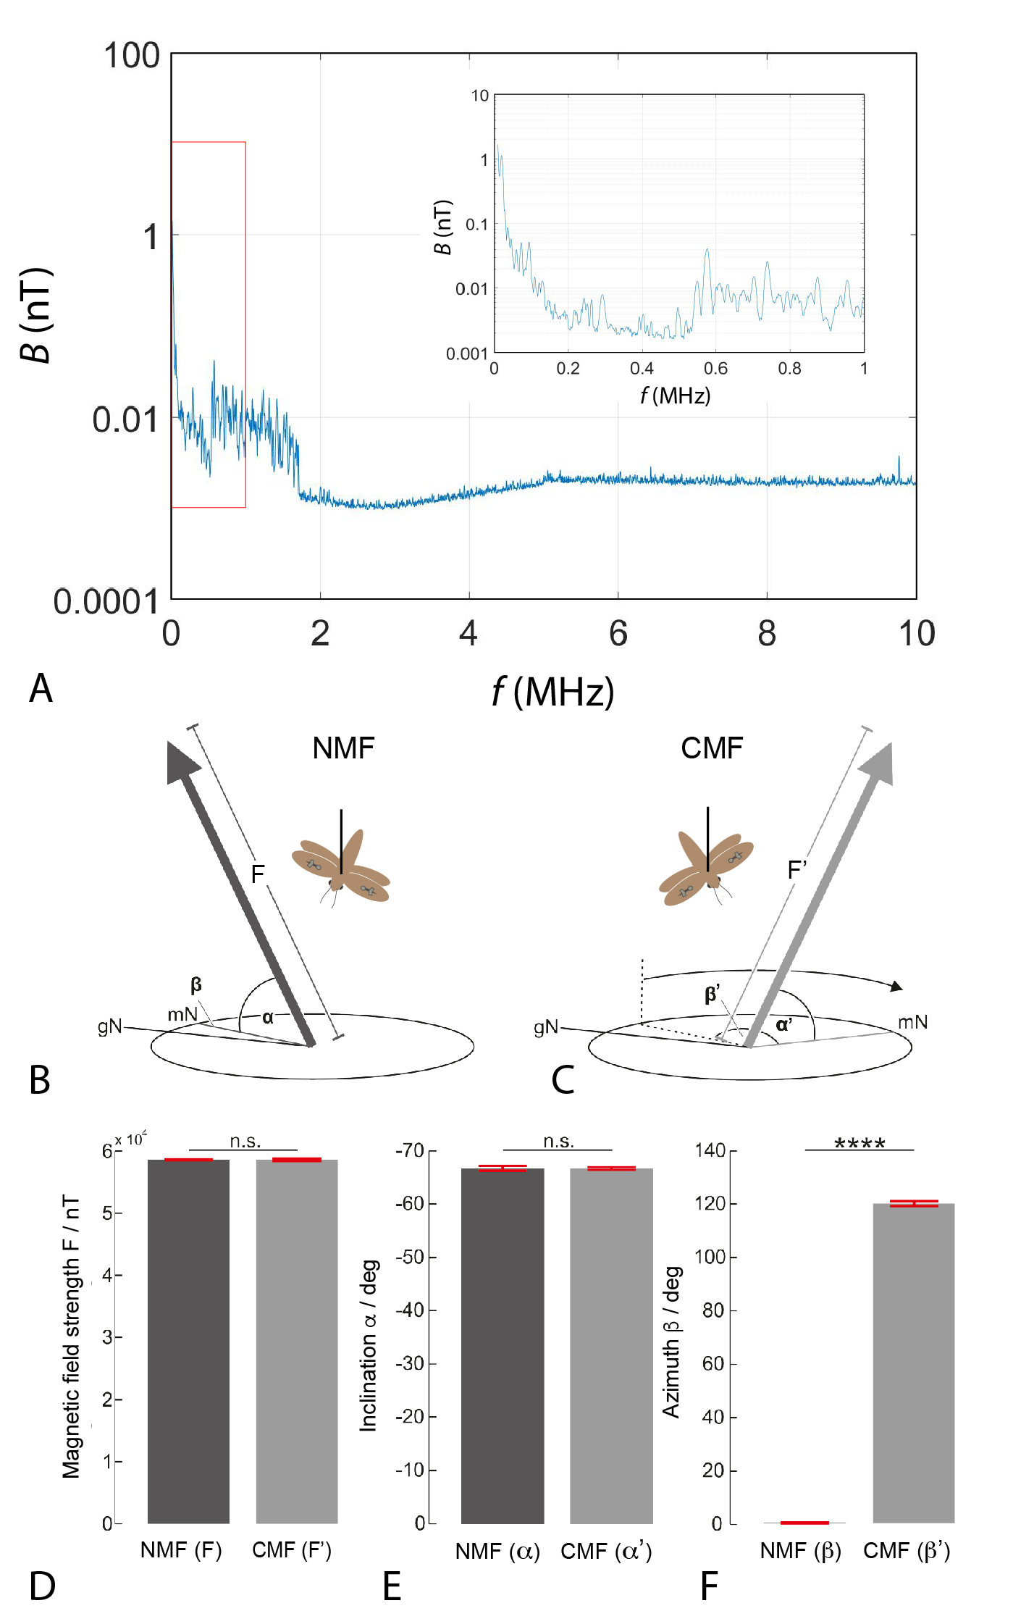

Figure S1. Experimental magnetic conditions
Related to Figures 1 and 2. A. Minimal anthropogenic electromagnetic noise was recorded at the experimental site outside Adaminaby (36.038°S, 148.863°E). Measurements of the magnetic component B of the time-dependent electromagnetic field (in nT), over a bandwidth of 10 kHz, as a function of frequency f (in MHz). The plotted measurement – made using a Rohde and Schwarz FSV7 Signal and Spectrum Analyser and a calibrated passive loop antenna (ETS Lindgren, Model 6511) – is the maximum value observed during a 40-min measuring period [1]. The red box shows the subsection of the main plot reproduced in the inset plot for f between 0 and 1 MHz. Similarly low levels of anthropogenic electromagnetic noise were also measured at the Mt. Kaputar experimental site near Narrabri (30.281°S, 150.151°E). B-F. Visualization of the experimental magnetic field shift between Phase A (normal magnetic field condition, NMF) and Phase B (changed magnetic field condition, CMF) in Experiment 1. (B, C) The magnetic coils were used to tilt the magnetic field vector (bold arrows) to locally shift magnetic north (mN) from its natural azimuth in the normal magnetic field (NMF, B) to an azimuth (β) approximately 120° clockwise in the changed magnetic field (CMF, C). The inclination angle (α) and the magnetic field strength (F) were kept constant in all phases of the experimental procedure (compare the projections (thin grey lines) of the magnetic field vector within the circles in B and C). The magnetic field strength F (D), the inclination angle α (E) and the azimuth β (F) of the local magnetic field were measured within the apparatus at the beginning of each experimental session (n=37). Note that during the shift from NMF to CMF, only the azimuth (or mN) of the magnetic field changed significantly (two-sample t-test; p=7.17x10⁻¹⁰¹) from 0° (0.05° ± 0.2°) to 120° (120.4° ± 0.9°). Red error bars = SD.

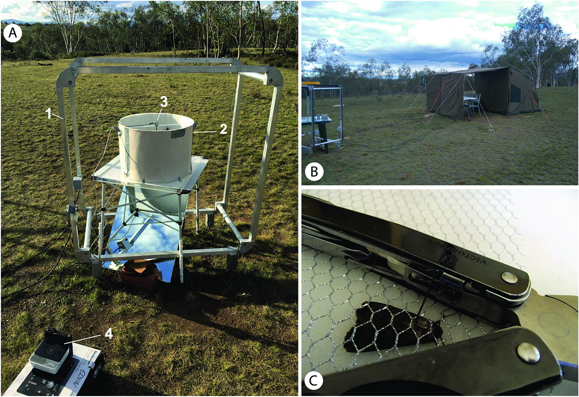

Figure S2. Experimental site and stalking method for Bogong moths
Related to Figures 1-4. The experimental site in Adaminaby seen during the day (although experiments were performed at night). A. One experimental set-up as it was used during the cue conflict experiments. A single-axis Helmholtz magnetic coil (1) was used to deflect the azimuth of magnetic North from 0° to 120°. The cylindrical Mouritsen-Frost experimental arena (2) was located within the centre of the coils. The sensor unit of the encoder system was positioned above the tethered flying moth at the centre of the open top of the arena (3). Optic flow was provided by a projector (4) equipped with neutral density filters. Optic flow was projected horizontally onto a 45° mirror that reflected the optic flow upwards to a sheet of diffusing paper taped over the clear Perspex top of the table (which thus created the arena floor). B. A tarpaulin wall was erected to prevent stray light generated by the equipment from interfering with the experiments. A tent was erected to keep the equipment safe and dry. C. A fresh moth with a vertical tungsten stalk glued to its dorsal thorax. During stalking, the moth was kept still by weighting a constraining mesh with the handles of a pair of pliers.

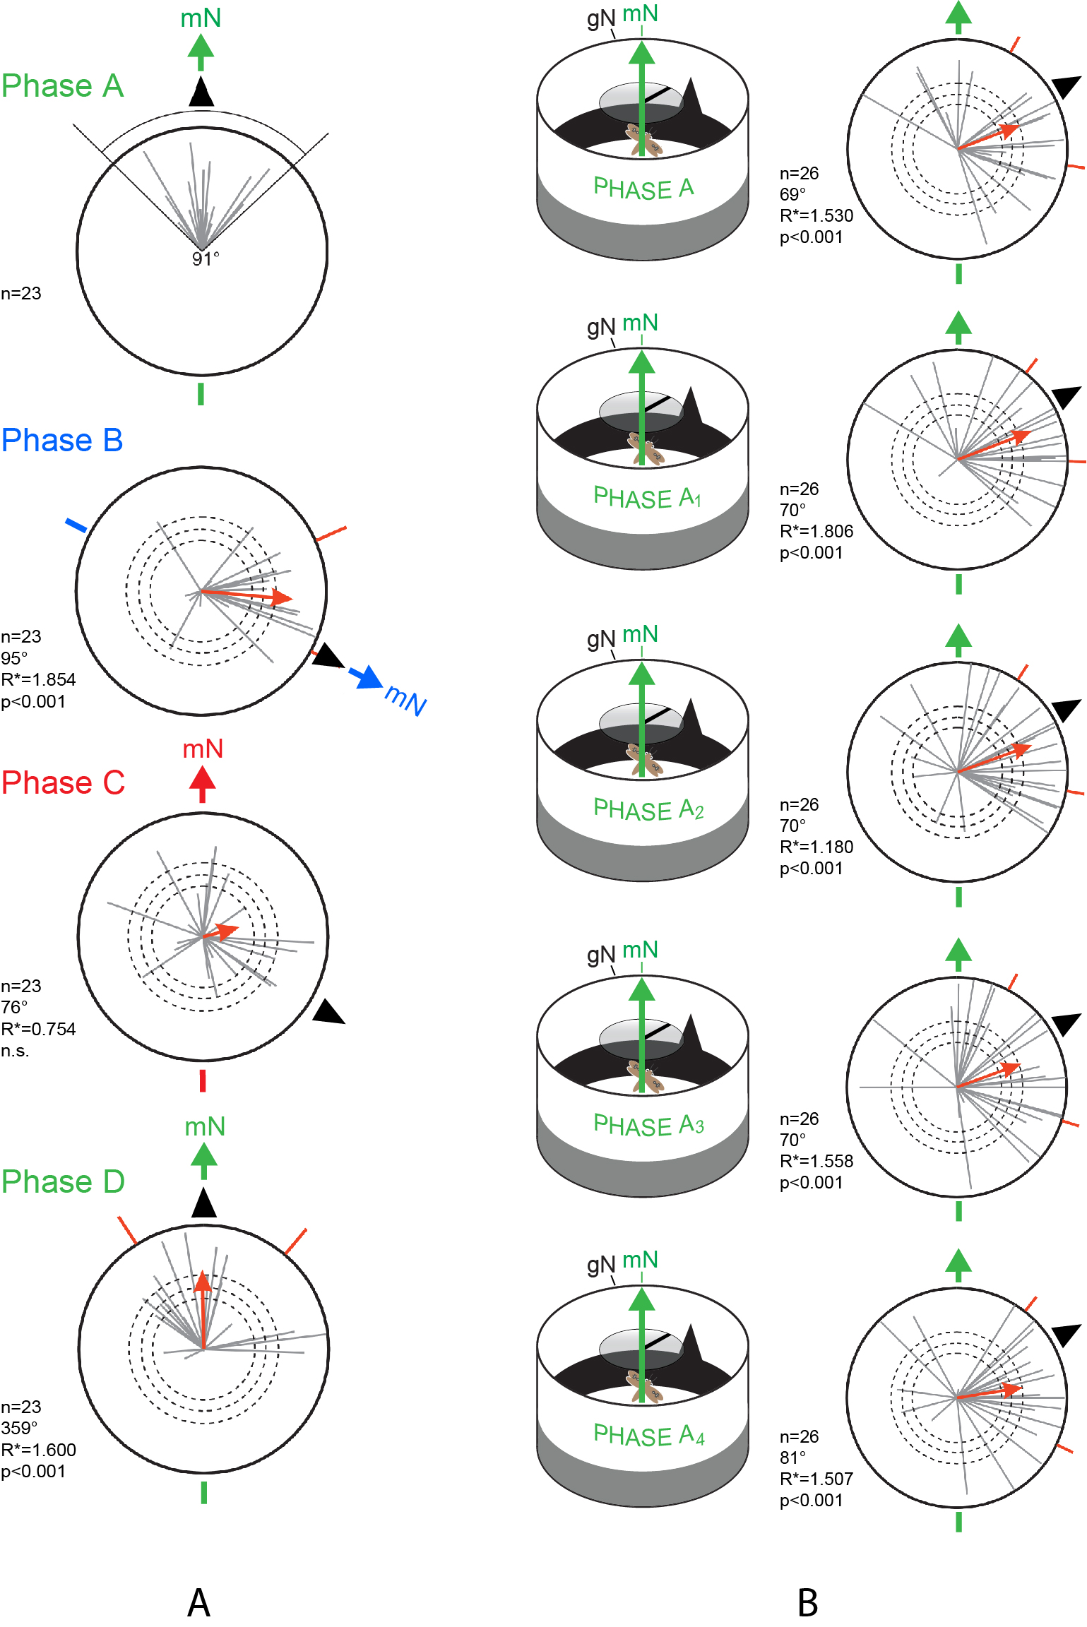
Figure S3. Magnetic and visual cues steer Bogong moth navigation when magnetic and visual cues are initially aligned
Related to Figure 2. A. Plots show the results of migratory Bogong moths subjected to a four-phase initial experiment (5 min flight in each Phase, 20 min flight time in total). The logic of the experiment was the same as for Experiments 1 and 2 (with cue conflict – and disorientation – introduced in Phase C), although the experimental procedure had not yet been perfected and our current statistical methods could not be applied. Of 82 moths tested, 23 (grey vectors in Phase A) showed flight towards the landmarks within an angular spread (91°) that was later found to be representative of high performance migratory moths flying without interruption or manipulation (angular spread was calculated as the average of the 99% confidence intervals for data shown in each Phase in panel B). As for moths in Experiments 1 and 2, these moths failed to orient towards the visual landmarks (black triangle) when a conflict between the previously correlated (in this case aligned) visual and magnetic cues had been introduced (coloured arrows indicate direction of mN). Red vectors: Mean vectors (MV). Dashed circles: directedness of MV required for statistical significance (Moore's modified Rayleigh test: p<0.05, p<0.01 and p<0.001, respectively for increasing radius). Red radial lines: 95% confidence interval. B. A control experiment for flight directedness in the absence of sensory manipulation. The directions of the magnetic field (green arrows) and visual landmarks (black triangular “mountain” and dorsal stripe) were placed in the Experiment 1 - Phase A configuration (Main Paper Figure 2A) and were not altered for the duration of the experiment. Tethered moths flew for 25 minutes and thus experienced Phase A five times (A, A₁ … A₄). Moths (n=26, grey vectors) were significantly oriented near the landmarks (p<0.001) for the entire 25 min, but were spread around the red mean vector (MV) (95% confidence intervals vary between 69° and 81° - red dashes). Note: 99% (and not 95%) confidence limits for the data shown in B were used to define a selection criterion in A. Selection criteria, statistics and plotting conventions as for Main Paper Figure 2.

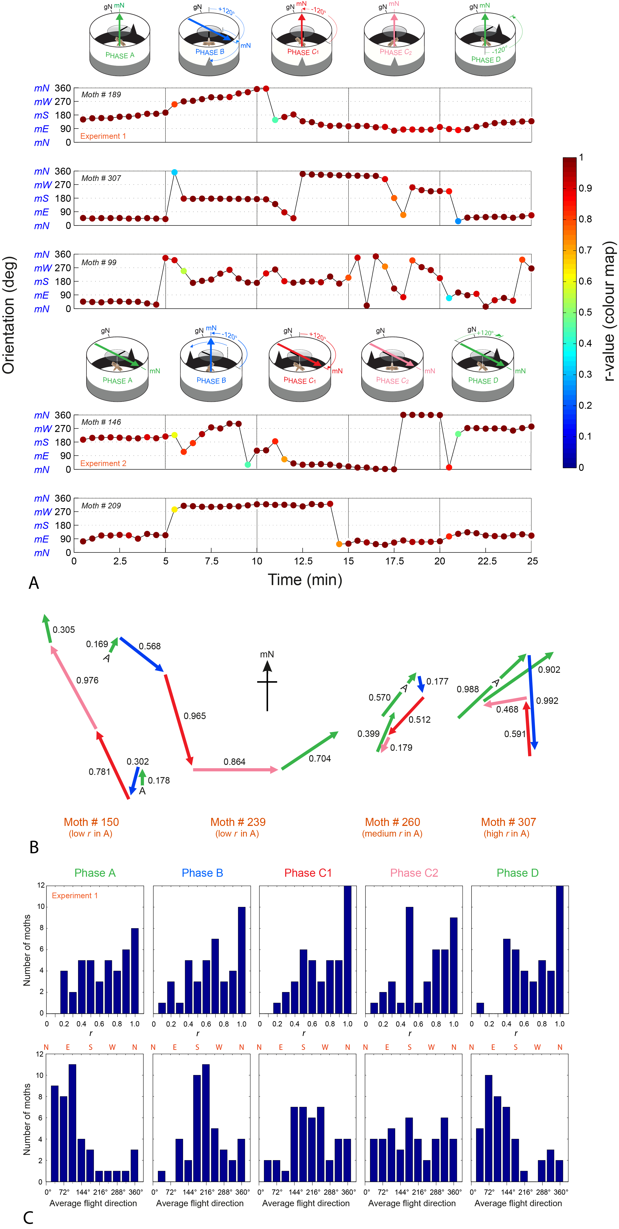

Figure S4. Flight tracks of individual moths
Related to Figures 2 and 3. A. The flight behaviour of three well-directed moths that flew in directions well outside the population average in Phase A of Experiments 1 and 2 (moths 146, 189 and 209) compared to two moths that flew in directions well inside the population average (moths 99 and 307). Moths 146, 189 and 209 are well-directed moths that remained well-directed throughout the experiment, and in most cases reacted to changes in visual and magnetic stimuli, but not in ways typical of the large proportion of the tested population. For example, in Phase A moth 209 chose a direction close to the direction of the magnetic field (rather than the landmark chosen by the population as a whole). It then changes to a new consistent direction in Phase B but not by the 120° change induced in the experiment (the change was around 200°) – this new direction is now close to the position of the landmark. It maintained this direction in Phase C₁ before returning to the Phase A (magnetic field) direction in Phases C₂ and D. Moth 209 thus seemed to react to the experimental changes but not in the manner typical of the rest of the population – instead it vacillated between the directions of the magnetic field and the visual landmarks. Moths 99 and 307 are examples of well oriented moths that flew close the population mean direction in Phase A, and changed their direction by 120° in Phase B. Both moths sooner or later lost the Phase B direction in Phases C₁ and C₂ before regaining the Phase A direction in Phase D. These moths reflect the trend of the population as a whole. B. Vector data relative to mN for flight trajectories in four individual moths from Experiment 1. Moths were chosen having different r-values in Phase A (and thus different levels of flight directedness as indicated by the different Phase A vector lengths). Vector colour code as in Figure 3 (green: Phases A (marked with “A”) and D; blue: Phase B; red: Phase C₁; pink: Phase C₂), with r-value for each vector also indicated. Highly directed moths in Phase A (e.g. #307) typically reflected the trend of the population as a whole, with oriented flights in the expected directions in Phases A, B and D and disorientation in Phases C₁ and C₂ (compare with Experiment 1 vector plot in Figure 3). This clear trend declines for moths less and less directed in Phase A, and at lowest r, moths behaved somewhat unpredictably in the different phases (although there were few such moths). C. Histograms showing the distributions of flight direction (lower row, with compass directions N, S, E and W given above each chart) and flight trajectory directedness (given by the r-value: upper row) for the 42 moths of Experiment 1 in each of the 5 phases (columns). Flight directions reflect the data shown in Figure 2: most moths flew close to the visual landmarks in Phases A, B and D but showed only a slight orientation preference for these landmarks in Phase C₁ and no preference in Phase C₂. In terms of flight trajectory directedness, most moths were quite directed in all phases (r ≥ 0.5), irrespective of the direction they flew, indicating that a loss of orientation in Phases C₁ and C₂ was not necessarily associated with a simultaneous loss in directedness.

Supplemental reference

- Engels, S.S., Schneider, N.L., Lefeldt, N., Hein, C.M., Zapka, M., Michalik, A., Elbers, D., Kittel, A., Hore, P.J., and Mouritsen, H. (2014). Anthropogenic electromagnetic noise disrupts magnetic compass orientation in a migratory bird. Nature 509, 353-356.

