Paper for Frontiers in Physiology, section Invertebrate Physiology

Bogong moths are well camouflaged by effectively decolourized wing scales

Doekele G. Stavenga¹, Jesse R.A. Wallace², Eric J. Warrant^{2,3}
¹ Surfaces and thin films, Zernike Institute for Advanced Materials, University of Groningen, NL-9747 AG Groningen, the Netherlands
² Research School of Biology, Australian National University, Canberra, ACT 2601, Australia
³ Lund Vision Group, Department of Biology, University of Lund, Sölvegatan 35, S-22362 Lund, Sweden

ORCIDs: 0000-0002-2518-6177 (DGS); 0000-0001-7480-7016 (EJW)

Abstract
Moth wings are densely covered by wing scales that are assumed to specifically function to camouflage nocturnally active species during day time. Generally, moth wing scales are built according to the basic lepidopteran Bauplan, where the upper lamina consists of an array of parallel ridges and the lower lamina is a thin plane. The lower lamina hence acts as a thin film reflector having distinct reflectance spectra that can make the owner colourful and thus conspicuous for predators. Most moth species therefore load the scales’ upper lamina with variable amounts of melanin so that dull, brownish colour patterns result. We investigated whether scale pigmentation in this manner indeed provides moths with camouflage by comparing the reflectance spectra of the wings and scales of the Australian Bogong moth (Agrotis infusa) with those of objects in their natural environment. The similarity of the spectra underscores the effective camouflaging strategies of this moth species.

Keywords: Agrotis infusa, colouration, wing patterning, melanin, reflectance spectra, scale anatomy

Introduction
Bogong moths (Agrotis infusa) are night-flying moths, well-known for their highly directional, biannual long-distance seasonal migrations to and from the Australian Alps (Common 1954, Warrant et al. 2016), a feat which requires the Earth’s magnetic field and visual landmarks as navigational cues (Dreyer et al. 2018). The adults aestivate over the summer in cool alpine caves in the mountains of southeast Australia, including the Brindabella Ranges of the Australian Capital Territory, the Snowy Mountains of New South Wales and the Bogong High Plains in Victoria. Following this period of aestivation, the same individuals that arrived in the mountains months earlier leave the caves and return to their breeding grounds (a journey of up to 1000 km) to mate, lay their eggs and die. The Bogong moth is culturally important for the Aboriginal people, who used the moths as a significant source of protein and fat during their annual summer gatherings in alpine areas (Flood 1980, Flood 1996).
The moths’ name, bogong, is derived from the Aboriginal word bugung, meaning “brown moth” (from the extinct Dhudhuroa language of northeast Victoria), which aptly describes their colouration. The moth’s brown colours presumably serve background matching (Stevens and Merilaita 2009), i.e., to make the moths inconspicuous to other predators during the day, both during their migration across the plains and following arrival in the mountains (when they can be preyed upon by the Mountain pygmy possum (Gibson et al. 2018) and various species of birds, among other predators). The classical example of camouflage is the peppered moth (Biston betularia), which developed a darker wing scale colour as trees became covered in industrial soot and via the forces of natural selection induced by predatory birds (Majerus et al. 2000, Cook et al. 2012). Light-coloured moths, resting in the daytime on dark-brown trees, are easily recognisable prey, so that dark-brown coloured moths have a higher chance of survival.
The colour of lepidopteran insects (moths and butterflies) is determined by the lattice of scales that cover the wings like shingles on a roof (Nijhout 1991, Kinoshita 2008). The chitinous wing scales are organized into two laminae, i.e., a thin, more or less flat lower lamina, and a highly structured upper lamina which consists of rows of parallel ridges with inter-linking cross-ribs that leave more or less open windows. The upper lamina is connected to the lower lamina by trabeculae, pillar-like elements serving as mechanical struts and spacers (Ghiradella 1991, Ghiradella 1998, Ghiradella 2010).
Commonly, the colour of the individual scales has a pigmentary (or chemical) origin. If the scale contains a considerable amount of pigment, incident light reflected and scattered by the scale structures is then selectively filtered, dependent on the pigment’s absorption spectrum, so that a distinct pigmentary colour remains. Various pigment classes are expressed in lepidopteran wing scales. Pterins are the pigments generally encountered in pierid butterflies (Descimon 1975, Wijnen et al. 2007), kynurenine and its derivatives, the ommochromes, are generally identified in nymphalids (Nijhout 1997, Wilts et al. 2017), and the papilionids are coloured by papiliochrome pigments (Umebachi 1985, Nijhout 2010, Nishikawa et al. 2013, Wilts et al. 2014). Some papilionids, as well as the Geometrinae and other moths, use blue-green bile pigments, neopterobilins (Choussy et al. 1973, Barbier 1986). Within the Geometrinae a novel green pigment type, geoverdin, has also been reported (Cook et al. 1994). But undoubtedly the commonest pigment found in the Lepidoptera, and certainly in moths, is melanin, a broadband-absorbing pigment responsible for most brown and black colours.
A wing scale’s colour can also have a structural (or physical) basis. Regularly arranged, nanosized scale structures cause wavelength-dependent light interferences, as for instance is the case in intense blue Morpho butterflies, where the building blocks of the scale ridges, the lamellae, form a stack that functions as an optical multilayer (Vukusic and Sambles 2003, Giraldo et al. 2016). The lower lamina can also create a structural colour, because its thickness is of the order of 100-200 nm. It hence acts as an optical thin film, causing a distinct reflectance in a restricted wavelength range, critically depending on the precise thickness of the thin film and angle of illumination or view. The lower lamina can thus determine the scale colour in the specific case that the scale is unpigmented (Stavenga et al. 2014). The highly convoluted upper lamina commonly acts as a broad-band light diffuser that spreads light in a wide spatial angle, resulting in less angle dependence of the iridescent colours (e.g. Stavenga et al. 2014).
The anatomical organisation and pigmentation of the scales and wing colours resulting from the lattice of scales have been investigated in only a few moth species, and mostly in those featuring conspicuous colours, as in the extremely colourful day-flying swallowtail moths Urania fulgens and U. leilus (Onslow 1923, Süffert 1924, Lippert and Gentil 1959). A particularly exuberantly coloured species is the sunset moth Chrysiridia ripheus (Uraniinae), which applies advanced multilayer optics in sometimes strongly curved scales, resulting in distinct colour mixing and polarisation effects (Yoshioka and Kinoshita 2007, Yoshioka et al. 2008). The scales of the basal moth Micropterix aureatella, which like the diurnally active uraniines is a day-flying moth, have a fused upper and lower lamina. The thickness of the resulting single thin film varies slightly, thus causing metallic gold, bronze and purple colours (Kilchoer et al. 2018). The similarly day-active palm borer moth Paysandisia archon has brownish forewings with prominently orange coloured hindwings due to a cover of ommochrome-pigmented scales (Stavenga et al. 2018). The nocturnal moth Eudocima materna (Noctuidae) has similarly ommochrome-pigmented hindwings with sparkling effects caused by patches with mirror scales (which have a thin film reflector in their lower lamina; Kelley et al. 2019). However, moths are generally dull coloured, due to high concentrations of melanin in their scales, presumably for suppressing possible structural colouration. Here we focus on the Bogong moth, to investigate how dull-brown moths organize their appearance by variously expressing melanin in their wing scales.

Materials and Methods

Specimens
Bogong moths used in this study were bred in Lund from adults captured in Australia. We furthermore collected pieces of granite from a Bogong moth aestivation cave (South Ramshead, Kosciuszko National Park, elevation 1860 m), as well as a variety of bark samples taken from: Coastal tea-tree (Leptospermum laevigatum), River bottlebrush (Callistemon sieberi), Crimson bottlebrush (Callistemon citrinus), River oak (Casuarina cunninghamiana), Brittle gum (Eucalyptus mannifera), Argyle apple (Eucalyptus cinerea), Silver-leaved ironbark (Eucalyptus melanophloia), Mountain gum (Eucalyptus cypellocarpa), Scribbly gum (Eucalyptus rossii), Snow gum (Eucalyptus pauciflora), Weeping snow gum (Eucalyptus lacrimans), Narrow-leaved Sally (Eucalyptus moorei), Parramatta red gum (Eucalyptus parramettensis), and Eucalyptus sp. aff. notabilus. These tree species were chosen because they are likely to be encountered along the migratory route as well as upon arrival in sub-alpine areas where moths feed for some weeks before ascending to their aestivation caves at higher elevation (Supplementary Material, Table 1). We have not given attention to sexual differences, as there is no marked sexual dimorphism. We have to note that the moths do come in many shades of brown; particularly males can (although not always) be much lighter in colour than females.

Scanning electron microscopy
Wing pieces and isolated scales were prepared for scanning electron microscopy by sputter-coating with gold (Cesington 108 auto, 45 s, 20 mA). The preparations were viewed using a scanning electron microscope (SEM; Hitachi SU3500) at 5 kV.

Spectrophotometry
Reflectance spectra of different areas of the Bogong moth wings, as well as of the granite and bark samples, were measured with a bifurcated reflection probe (Avantes FCR 7-UV-200), using an AvaSpec 2048-CCD detector array spectrometer (Avantes, Apeldoorn, the Netherlands). The light source was a deuterium-halogen lamp (AvaLight-D(H)-S), and the reference was a white diffuse reflectance tile (Avantes WS-2). Reflectance spectra of isolated scales, attached to a glass micropipette using Bison glass kit (hardening under UV light), were measured with a microspectrophotometer (MSP). The MSP was a Leitz Ortholux microscope (Leitz, Wetzlar, Germany) with an Olympus 20x objective, NA 0.46 (Olympus, Tokyo, Japan). A xenon arc lamp was used as a light source. The area measured with the MSP was a square with edge length 5-10 µm, determined by a square diaphragm in the microscope’s image plane, which was in turn imaged at the entrance of an optical fibre connected to the detector array spectrometer; the white diffuse reflectance tile was also here used as a reference. Due to the glass optics in the microscope, the MSP spectra were limited to wavelengths >350 nm. Absorbance spectra of isolated scales were also measured with the MSP, while the scales immersed in immersion oil (n = 1.515) in order to reduce scattering.

Imaging scatterometry of single wing scales
For investigating the spatial reflection characteristics of the scales, we performed imaging scatterometry (Stavenga et al. 2009, Wilts et al. 2009). A scale attached to a glass micropipette was positioned at the first focal point of the ellipsoidal mirror of the imaging scatterometer. The scatterograms were obtained by focusing a white light beam with a narrow aperture (< 5º) at a small circular area (diameter 13 µm), and the spatial distribution of the far-field scattered light was then monitored. The exposure times of the scatterograms were appropriately adjusted so as to obtain an image of maximal contrast.

Modelling the reflectance spectra of thin films
The reflectance spectra of chitinous optical thin films in air were calculated for normally incident light using an expression derived from the classical Airy formula (Stavenga 2014).

Results

Wing colours and reflectance spectra
Bogong moths have brown bodies and wings. The dorsal forewings are dark-brown with black patches, which cover (when resting) the more or less uniformly light brown dorsal hindwings and the intermediate brownish thorax and abdomen (Fig. 1a). The ventral wing edges are light brown. As an example of the differences in saturation, Fig. 1b shows reflectance spectra of local areas of the dorsal fore- and hindwing. In both cases, the reflectance increases monotonically with increasing wavelength, which is characteristic of a melanin-pigmented tissue (Fig. 1b).

Scale structures
The wings have a cover of numerous scales, and thus the wing colouration will be determined by how the scales reflect incident light. The primary determinant of the scale reflectance is melanin pigment, as suggested by Figure 1b. Yet, a crucial contributing factor can be the scales’ fine-structure, which was investigated by performing scanning electron microscopy. The size of the wing scales appears to be rather variable, but the structure adheres to the classical format. The upper side is an array of ridges that are connected by cross-ribs, which leave minor open windows (Fig. 2a-c), and the underside features a more or less flat, slightly wrinkled plane (Fig. 2d).
The ridges of lepidopteran wing scales consist of overlapping lamellae, but the overlap of the ridge lamellae in Bogong moth scales is very minor, so that a possible structural colouration of the scales’ upper lamina can be neglected. As is universally the case in lepidopteran scales, the lower lamina will act as a thin film reflector, and thus some structural colouration contributions can be expected.

Scale pigmentation, reflection, and scattering
To first check whether the scales contain a melanin-like pigment, we performed transmission-microspectrophotometry on single scales immersed in oil (Fig. 3). At all scale locations, the transmittance increased monotonically with increasing wavelength, which is indeed the hallmark of melanin. The transmittance strongly varied along the length of the scale, however. Near the root, the transmittance was high, i.e. at this location the scale is almost transparent (Fig. 3, #1), but near the tip the transmittance was hardly more than ~10% across the whole visible wavelength range (Fig. 3, #3).
How this steep gradient in melanin pigmentation might affect scale colouration was then investigated by epi-illumination microscopy. This revealed that the colouration of the lattice of scales on the forewing is far from uniform (Fig. 4a). When observing isolated, single scales, the diverse colouration was particularly apparent, as shown in the example of Fig. 4b-d. The under (or adwing) side features a diverse colour pattern, from blue near the root to purplish in the center and tip area, which indicates that the lower lamina of the scales, acting as a thin film reflector, has a variable thickness (Fig. 4b). The upper, abwing side is blue-greenish at the root but reddish-brown at the tip (Fig. 4c). In transmitted light, the scale showed a dull, brown colour, as expected from the scale’s melanin pigmentation (Fig. 4d).
The colour differences in the reflection patterns obtained from both scale sides is readily explained from the gradient in pigmentation. The adwing bottom area, near the root (Fig. 4b), has a similar blue-green colour as the abwing bottom area (Fig. 4c), although the colour of the latter is slightly more diffuse. The explanation is similar to that of the colouration of a transparent, unpigmented scale (Stavenga et al. 2014). When incident light enters an unpigmented scale from above, from the abwing side, a major fraction of it will pass the upper lamina and reach the lower lamina, where it will be partly reflected, depending on the thin film’s reflectance spectrum. A major fraction of this reflected light will then pass again to the upper lamina, and thus, in the absence of a pigment filter, the colour of the reflected light will be equal to the colour of the adwing reflected light.
However, the middle and tip areas of the upper lamina do contain a major amount of melanin pigment – these areas will then act as a gradual spectrally long-pass brown filter. Consequently, incident light that enters the pigmented scale areas from the abwing side will suffer from the pigment filter before it reaches the lower lamina. There it is subsequently reflected, and the resulting light flux will have to pass again through the pigment filter on its way back before it leaves the scale at the abwing side. An increasingly brown colour thus results, proportionally with the pigment density (Fig. 4c,d).
We further investigated the structural colouration by applying imaging scatterometry, using a narrow aperture illumination beam. The scatterogram of a blue area on the adwing side featured a local blue spot, meaning a strongly directional, spatially restricted reflection, confirming the action of a specular thin film reflector (Fig. 4e). On the other, abwing side, of the scale, the scatterogram showed a striking diffraction pattern (Fig. 4f). This can be immediately understood, because the upper lamina of the scales consists of an array of parallel ridges, which acts as a diffraction grating. We finally applied a wide-angled illumination beam to the abwing scale side (central area #4 of Fig. 4c), which yielded the scatterogram of Fig. 4g. Clearly, the cumulative diffraction patterns created by the large-aperture illumination then superimpose, resulting in a diffuse scatterogram. The overall brown colour demonstrates that the backscattered light is effectively filtered by the considerable amount of melanin pigment.
To further ascertain that the lower lamina acts as a thin film, we used a microspectrophotometer to measure reflectance spectra from the lower lamina in locations #1 and 2 of Fig. 4b (Fig. 5a,b, solid curves). Except for a background offset, the spectra closely resemble the reflectance spectra of thin films with thickness 230 and 290 nm, respectively (Fig. 5a,b, dotted curves). The reflectance offset can be easily understood, because a major fraction of the applied light is transmitted by the thin film and subsequently will be partly backscattered by the upper lamina. A large fraction of that light flux will be subsequently transmitted by the lower lamina and thus contribute to the reflected light. Painstaking transmission electron microscopy will be necessary to confirm the derived thicknesses of the scale’s lower lamina.
The reflectance spectra measured from the abwing scale side are rather different (Fig. 5c). In the spectrum of the blue-green coloured root area (Fig. 4c, #3), the contribution of the underlying thin film can be recognized, but the reflectance spectra of the more distal areas (Fig. 4c, #4, 5) are dominated by melanin filtering (Fig. 5c).
In the scale lattice on the wing, the scales strongly overlap, so that only the most distal part is exposed. Therefore, the reflectance spectra of intact wings (Fig. 1b) will have the monotonically rising form characteristic of melanin-pigmented tissue (as seen in Fig. 5c, #5). In conclusion, because the tip area is fully exposed in intact moths, the thin film reflections that are intrinsic to the lower lamina are effectively removed in that area by a high concentration of melanin pigment.

Reflectance spectra of granite and bark
Due to the melanin pigmentation and its effective blocking of the thin film reflections, the colouration of Bogong moths is not particularly striking, especially on their dorsal forewings. An obvious reason for the dull colours is to achieve suitable background matching when the moth is resting with the forewings covering the body. To underscore this view, we assembled a variety of objects –granite from their aestivation caves and the bark of several trees that are potential resting places for the moths (Table 1)– and measured their reflectance spectra (Figs. 6,7, Supplementary Material, Fig. S1). The reflectance spectrum of the granite has a slight hump in the green part of the spectrum, presumably due to a thin algal coating arising from the moist conditions of the cave, while bark samples from the species of trees tested have a clear brown colour. The greenish surface of the cave granite is clearly less well matched to the Bogong moth’s wing colour than the trees’ bark, although some degree of camouflage will be nonetheless provided (Fig. 6, 8a,b). The reflectance spectra of the bark of trees that are likely resting places vary considerably, but the reflectance spectra of the forewings of the rather dark female Bogong moths we were using vary in the same range (Fig. 7). Less darkly-coloured specimens will still be able to achieve background matching on trees having higher spectral reflectance. Whether Bogong moths actively select resting places that precisely match the reflectance of the background (as has been noted in other moths, e.g. Sargent 1966), will be the theme of a future study.

Discussion
The gradient of melanin expressed in the wing scales of the Bogong moth is very sensible, because the high melanin concentration in the distal, exposed part of the scales filters the reflections of the scales’ lower lamina, so that only the long-wavelength part of the lower lamina’s reflectance spectrum contributes to the total wing reflectance. Several butterfly species do use the lower lamina’s thin film properties to create a distinct scale colour, for instance the strikingly iridescent wing scales of the Mother-of-pearl, Salamis parhassus (Onslow 1923) and the pigmentless blue scales of nymphalines (Stavenga et al. 2014). In most butterflies, however, the wing colours are due to pigments, which are expressed in the upper lamina and absorb selectively in a restricted wavelength range, thus resulting in a scale reflectance spectrum in the complementary wavelength range. Remarkably, the reflectance spectra of lower and upper lamina are often tuned, so that their summed reflections create bright scale colours (Stavenga et al. 2015, Wilts et al. 2015). On the other hand, most butterflies also have black scales, frequently marking the wing margin, which is caused by very dense melanin pigmentation that fully suppresses the lamina reflections (e.g. Stavenga et al. 2014).
Butterflies are admired for their striking, colourful appearances, but interestingly, many butterfly species have ventral wings that are darkly coloured, for example the nymphaline Peacock butterfly Aglais io and the Admiral Vanessa atalanta (e.g. Stavenga et al. 2014). When at rest, their wings are closed and then they are camouflaged owing to their inconspicuous ventral colouration. The iconic Morpho butterflies have dorsal wings that have a bright-blue structural colour, but their ventral wings are only mildly coloured by pigmented scales and patterned by modest eyespots. As for Vanessa, the ventral wings of Morpho will provide camouflage when these butterflies are not on the wing. Other remarkable cases of background matching are offered by some lycaenids: the scales at the ventral wing sides of the Green Hairstreak, Callophrys rubi, have highly sophisticated gyroid cuticular structures that create a green reflectance matching that of leaves (Michielsen et al. 2010), and the variable thin films of the ventral scales of the Angled Sunbeam, Curetis acuta, act as silvery reflectors that radiate the green colours of the leaves on which the butterflies have landed (Wilts et al. 2013).
In the Bogong moth’s wings, a dense melanin filter blocks the lower lamina reflections and thus prevents the danger of conspicuousness. The correspondence of the moth’s colouration with that of the objects in its habitat underscores the hypothesis that the dull colours of this moth (and others) function for camouflage through background matching (Thayer 1909, Cott 1940). The measured reflectance spectra from the bark samples are well matched to the spectra measured from the moth’s wings (Figs. 7,8), thus suggesting that visual camouflage from diurnal predators has been a major selective pressure during the evolution of Bogong moth colouration, and most likely that of many other species of nocturnal moths that need to find concealing shelter during daytime hours (e.g. Thayer 1909; Cott 1940; Sargent 1966). Indeed, many species of moths are even capable of optimizing their orientations and locations on tree bark to maximize this camouflage (Sargent, 1966; Endler 1984, Kang et al. 2012).
Interestingly, the melanin pigment is deposited preferentially in the tip of the wing scale, suggesting that this is an optimization of production costs. A study on the brown coloured-satyrine butterfly Pararge aegeria concluded that melanisation of the wing scales is indeed costly (Talloen et al. 2004). The wing scales of moths have a high melanin content, the cost of which is necessary to block the thin film reflections of the lower lamina and to obtain a camouflaging brown colour. How the pigmentation is locally controlled is an emerging question that is not only intriguing but at the same time complex, since melanin synthesis is co-regulated with scale structure as was revealed in another satyrine, Bicyclus anynana (Matsuoka and Monteiro 2018).
The melanisation of the Bogong moths’ wing scales is not uniform in a single scale (Fig. 3), but it is also rather variable among the different scales of the wings’ cover (Fig. 1a). This serves to give resting moths a mottled appearance, which may add to matching the background of similarly inhomogeneously coloured tree bark (Endler 1984, Kang et al. 2012). Furthermore, the moth’s contours, together with the more or less striped wing patterning, may endow the moths with a potentially disruptive colouration, thus further enforcing camouflage (e.g. Schaefer and Stobbe 2006, Stevens and Merilaita 2009). The dark spots on the forewings may act as distractive markings or for surface disruption (Stevens and Merilaita 2009, Cuthill 2019).
The scales are very densely packed and overlap each other multifold. The dense scale cover may, however, not primarily function for (in)visibility, as it has additional functions. For instance, by providing thermal insulation, the moths can migrate over long distances during cold nights and withstand up to four months of dormancy in their high-altitude aestivation caves where nighttime temperatures, even in summer, can fall to several degrees Celsius below zero. The wing scales of moths can also have an acoustical function, by absorbing sound frequencies corresponding to the calls of echo-locating bats, thus reducing echo power (Zeng et al. 2011). Furthermore, scale attachment in sockets on the wings is sufficiently loose that the scales are shed when their owner becomes caught in a spider web, hence allowing the moth to escape (Eisner 2003).
Whereas the Bogong moths are well matched to a bark background, the colour of the granite rock in their caves deviates by not providing as good a match. However, the moths tile tightly (with up to 17,000 individuals per square metre; Common 1954), thus fully carpeting the cave walls so well and so extensively that the granite cave wall is only seen at the periphery of these moth carpets (Fig. 8c). In other words, although the reflectance spectra of granite and moths may somewhat differ, within the interior of such a carpet, the moths are camouflaged against themselves.

Acknowledgements
This study was financially supported by the Air Force Office of Scientific Research/European Office of Aerospace Research and Development AFOSR/EOARD (grant FA9550-15-1-0068, to DGS and grant FA9550-14-1-0242 to EJW). EJW and JRAW are grateful for funding from the European Research Council (Grant No. 741298), the Swedish Research Council (Grant No. 2016-04014) and the Royal Physiographic Society of Lund. EJW holds Scientific Permits for collection and experimental manipulations of Bogong moths in several alpine national parks and nature reserves (NSW: Permit SL100806; Vic: Permit 10008966). JRAW is thankful for the support of an Australian Government Research Training Program (RTP) Scholarship. We thank Drs Ken Green, Ola Gustafsson and Hein Leertouwer for essential collaboration and Dr Bodo Wilts for valuable comments at the manuscript. We are grateful for the constructive comments of two anonymous reviewers.

References
Barbier M (1986) Butterfly and moth neopterobilins: sarpedobilin as a natural metachromatic pigment. Comp Biochem Physiol 84B:619-621
Choussy M, Barbier M, Rüdiger W, Klose W (1973) Preliminary report on the neopterobilins, blue-green pigments from Lepidoptera. Comp Biochem Physiol 44B:47-52
Common IA (1954) A study of the ecology of the adult Bogong moth Agrotis infusa (Boisd.) (Lepidoptera: Noctuidae), with special reference to its behaviour during migration and aestivation. Austral J Zool 2:223–263
Cook MA, Harwood LM, Scoble MJ, McGavin GC (1994) The chemistry and systematic importance of the green wing pigment in emerald moths (Lepidopera: Geometridae, Geometrinae). Biochem Syst Ecol 22:43-51
Cook LM, Grant BS, Saccheri IJ, Mallet J (2012) Selective bird predation on the peppered moth: the last experiment of Michael Majerus. Biol Lett 8:609–612
Cott HB (1940) Adaptive coloration in animals. Meuthuen, London, UK.

Cuthill IC (2019) Camouflage. J Zool 308:75–92
Descimon H (1975) Biology of pigmentation in Pieridae butterflies. In: Pfleiderer W (ed) Chemistry and biology of pteridines. De Gruyter, Berlin, pp 805-840
Dreyer D, Frost BJ, Mouritsen H, Green KP, Whitehouse M, Heinze S, Warrant EJ (2018) The Earth's magnetic field and visual landmarks steer migratory flight behavior in the nocturnal Australian Bogong moth. Curr Biol 28:2160-2166
Endler JA (1984) Progressive background matching in moths, and a quantitative measure of crypsis. Biol J Linn Soc 22:187-231

Eisner T (2003) For love of insects. Harvard University Press, Cambridge MA
Flood JM 1980. The moth hunters. Australian Institute of Aboriginal Studies, Canberra.
Flood JM 1996. Moth hunters of the Australian Capital Territory. Clarendon, Lewisham, NSW.
Ghiradella H (1991) Light and color on the wing: structural colors in butterflies and moths. Appl Optics 30:3492-3500
Ghiradella H (1998) Hairs, bristles, and scales. In: Locke M (ed) Microscopic anatomy of invertebrates, Vol 11A: Insecta. Wiley-Liss, New York, pp 257-287
Ghiradella H (2010) Insect cuticular surface modifications: scales and other structural formations. Adv Insect Physiol 38:135-180
Gibson RK, Broome L, Hutchison MF (2018) Susceptibility to climate change via effects on food resources: the feeding ecology of the endangered mountain pygmy-possum (Burramys parvus). Wildlife Res 45:539-550
Giraldo MA, Yoshioka S, Liu C, Stavenga DG (2016) Coloration mechanisms and phylogeny of Morpho butterflies. J Exp Biol 219:3936-3944
Kang CK, Moon JY, Lee SI, Jablonski PG (2012) Camouflage through an active choice of resting spot and body orientation in moths. J Evol Biol 25:1695-1702.
Kelley JL, Tatarnic NJ, Schröder-Turk GE, Endler JA, Wilts BD (2019) A dynamic optical signal in a nocturnal moth. Curr Biol 29:2919-2925
Kilchoer C, Steiner U, Wilts BD (2018) Thin-film structural coloration from simple fused scales in moths. J Roy Soc Interface Focus 9:20180044
Kinoshita S (2008) Structural colors in the realm of nature. World Scientific, Singapore
Lippert W, Gentil K (1959) Über lamellare Feinstrukturen bei den Schillerschuppen der Schmetterlinge vom Urania- und Morpho-Typ. Z Morph Oekol Tiere 48:115-122
Majerus M, Brunton C, Stalker J (2000) A bird's eye view of the peppered moth. J Evol Biol 13:155-159
Matsuoka Y, Monteiro A (2018) Melanin pathway genes regulate color and morphology of butterfly wing scales. Cell Rep 24:56-65
Michielsen K, DeRaedt H, Stavenga DG (2010) Reflectivity of the gyroid biophotonic crystals in the ventral wing scales of the Green Hairstreak butterfly, Callophrys rubi. J R Soc Interface 7:765-771
Nijhout HF (1991) The development and evolution of butterfly wing patterns. Smithsonian Institution Press, Washington
Nijhout HF (1997) Ommochrome pigmentation of the linea and rosa seasonal forms of Precis coenia (Lepidoptera: Nymphalidae). Arch Insect Biochem Physiol 36:215-222
Nijhout HF (2010) Molecular and physiological basis of colour pattern formation. Adv Insect Physiol 38:219-265
Nishikawa H, Iga M, Yamaguchi J, Saito K, Kataoka H, Suzuki Y, Sugano S, Fujiwara H (2013) Molecular basis of wing coloration in a Batesian mimic butterfly, Papilio polytes. Sci Rep 3:3184
Onslow H (1923) On a periodic structure in many insect scales, and the cause of their iridescent colours. Phil Trans R Soc Lond B 211:1-74
Sargent TD (1966) Background selections of geometrid and noctuid moths. Science 154:1674–1675.
Schaefer HM, Stobbe N (2006) Disruptive coloration provides camouflage independent of background matching. Proc R Soc B 273:2427–2432
Stavenga DG (2014) Thin film and multilayer optics cause structural colors of many insects and birds. Mat Today Proc 1S:109-121
Stavenga DG, Leertouwer HL, Pirih P, Wehling MF (2009) Imaging scatterometry of butterfly wing scales. Opt Express 17:193-202
Stavenga DG, Leertouwer HL, Wilts BD (2014) Coloration principles of nymphaline butterflies - thin films, melanin, ommochromes and wing scale stacking. J Exp Biol 217:2171-2180
Stavenga DG, Leertouwer HL, Meglič A, Drašlar K, Wehling MF, Pirih P, Belušič G (2018) Classical lepidopteran wing scale colouration in the giant butterfly-moth Paysandisia archon. PeerJ 6:e4590
Stavenga DG, Matsushita A, Arikawa K (2015) Combined pigmentary and structural effects tune wing scale coloration to color vision in the swallowtail butterfly Papilio xuthus. Zool Letters 1:14
Stevens M, Merilaita S (2009) Animal camouflage: current issues and new perspectives. Phil Trans Roy Soc 364:423-427
Süffert F (1924) Morphologie und Optik der Schmetterlingsschuppen, insbesondere die Schillerfarben der Schmetterlinge. Z Morphol Oekol Tiere 1:171-308
Talloen W, Dyck HV, Lens L (2004) The cost of melanization: butterfly wing coloration under environmental stress. Evolution 58:360-366
Thayer GH (1909) Concealing-coloration in the animal kingdom. Macmillan, New York
Umebachi Y (1985) Papiliochrome, a new pigment group of butterfly. Zool Sci 2:163-174
Vukusic P, Sambles JR (2003) Photonic structures in biology. Nature 424:852-855
Warrant EJ, Frost BJ, Green KP, Mouritsen H, Dreyer D, Adden A, Brauburger K, Heinze S (2016) The Australian Bogong moth Agrotis infusa: A long-distance nocturnal navigator. Front Behav Neurosci 10:77
Wijnen B, Leertouwer HL, Stavenga DG (2007) Colors and pterin pigmentation of pierid butterfly wings. J Insect Physiol 53:1206-1217
Wilts BD, Vey AJ, Briscoe AD, Stavenga DG (2017) Longwing (Heliconius) butterflies combine a restricted set of pigmentary and structural coloration mechanisms. BMC Evol Biol 17:226
Wilts BD, IJbema N, Stavenga DG (2014) Pigmentary and photonic coloration mechanisms reveal taxonomic relationships of the Cattlehearts (Lepidoptera: Papilionidae: Parides). BMC Evol Biol 14:160
Wilts BD, Leertouwer HL, Stavenga DG (2009) Imaging scatterometry and microspectrophotometry of lycaenid butterfly wing scales with perforated multilayers. J Roy Soc Interface 6:S185-S192
Wilts BD, Pirih P, Arikawa K, Stavenga DG (2013) Shiny wing scales cause spec(tac)ular camouflage of the angled sunbeam butterfly, Curetis acuta. Biol J Linn Soc 109:279-289
Wilts BD, Matsushita A, Arikawa K, Stavenga DG (2015) Spectrally tuned structural and pigmentary coloration of birdwing butterfly wing scales. J R Soc Interface 12:20150717
Yoshioka S, Kinoshita S (2007) Polarization-sensitive color mixing in the wing of the Madagascan sunset moth. Opt Express 15:2691-2701
Yoshioka S, Nakano T, Nozue Y, Kinoshita S (2008) Coloration using higher order optical interference in the wing pattern of the Madagascan sunset moth. J R Soc Interface 5:457-464
Zeng J, Xiang N, Jiang L, Jones G, Zheng Y, Liu B, Zhang S (2011). Moth wing scales slightly increase the absorbance of bat echolocation calls. PLoS One 6: e27190

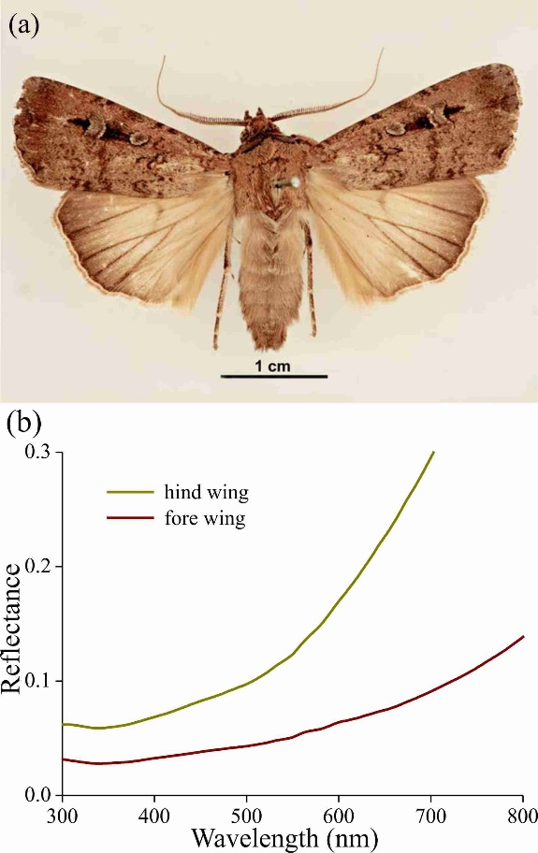

Fig. 1. Bogong moth colouration. (a) A pinned specimen with exposed fore and hind wings (from http://www.padil.gov.au/pests-and-diseases/pest/main/136308/5837#; source Lucinda Gibson and Ken Walker, Museum Victoria, Australia). Image available for free use under a Creative Commons Attribution 3.0 Australia License, CC BY 3.0 AU.
(b) Reflectance spectra of the upper sides of the hind and fore wing measured with a bifurcated reflection probe.
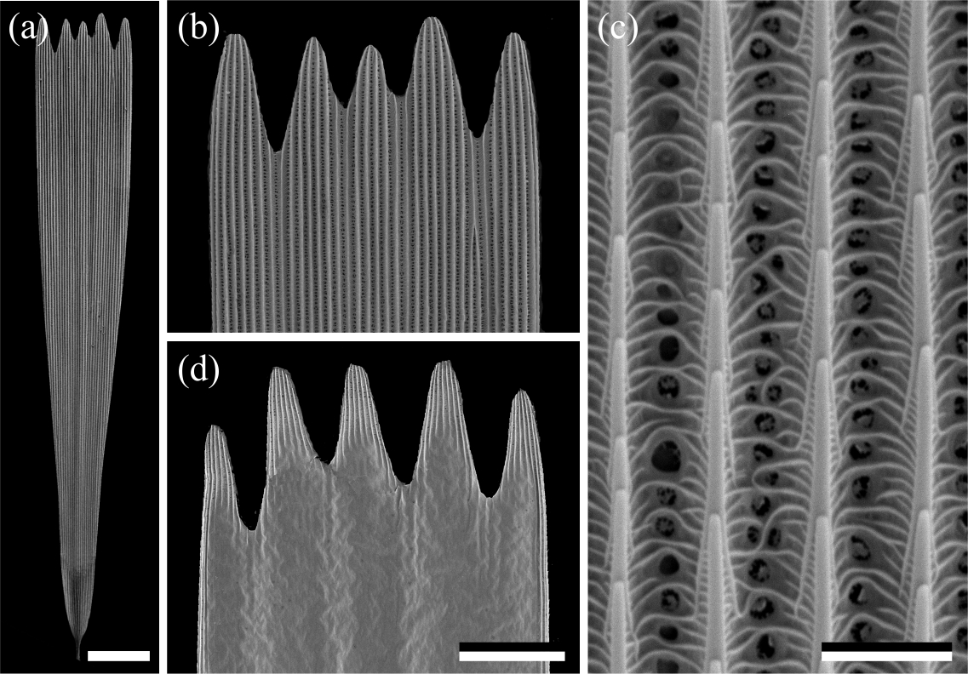

Fig. 2. Scanning electron micrographs of a forewing scale. (a) An isolated scale with dented tip area and on the other end the root. (b) Magnified view of the abwing (upper) side of the tip area of (a). (c) The scale ridges, consisting of slightly overlapping lamellae and connected by cross-ribs, which leave minor open windows. (d) The adwing (under) side of a tip area. Scale bars: (a) 50 µm, (b, d) 25 µm, (c) 2.5 µm.
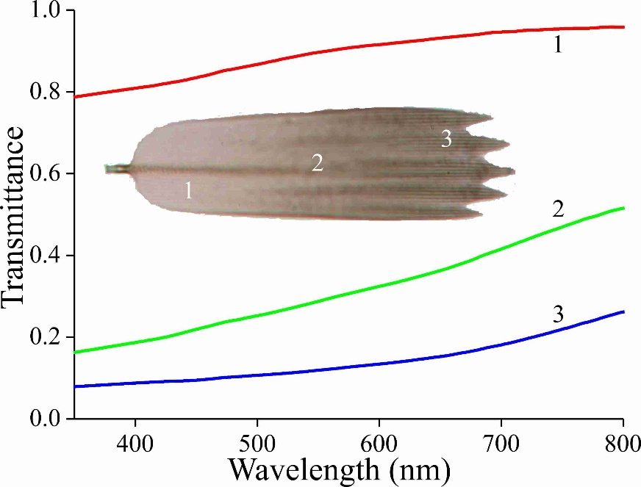

Fig. 3. Transmittance spectra of an isolated forewing scale immersed in immersion oil, in the root (1), middle (2) and tip (3) area, measured with a microspectrophotometer.
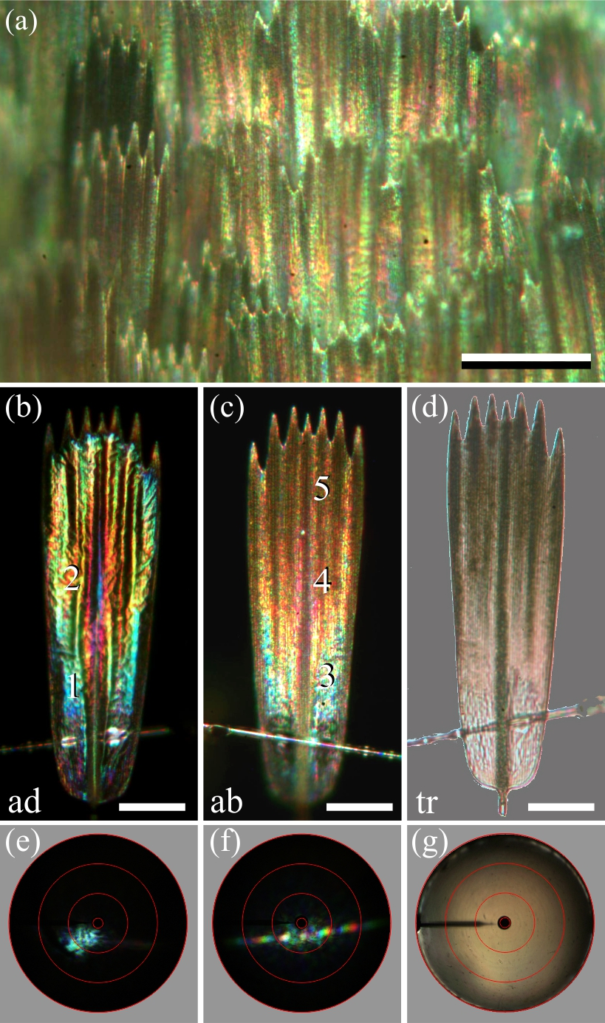

Fig. 4. Spectral and spatial characteristics of Bogong moth scales. (a) Epi-illumination micrograph of the scale pattern, locally in the forewing. (b) Epi-illumination of the adwing side of an isolated forewing scale glued to a glass micropipette. (c) Same as (b) except for the abwing side. (d) Same as (b) but with transmitted light. (e) Scatterogram of area 1 of (b) with narrow-aperture illumination. (f) Scatterogram of area 4 of (c) with narrow-aperture illumination. (g) Scatterogram of area 4 of (c) with wide-aperture illumination. Scale bars: (a) 100 µm, (b-d) 50 µm. The red circles in (e-g) indicate reflection angles of 5º, 30º, 60º, and 90º. For reflectance spectra measured at locations numbered 1-5, see Fig. 5.
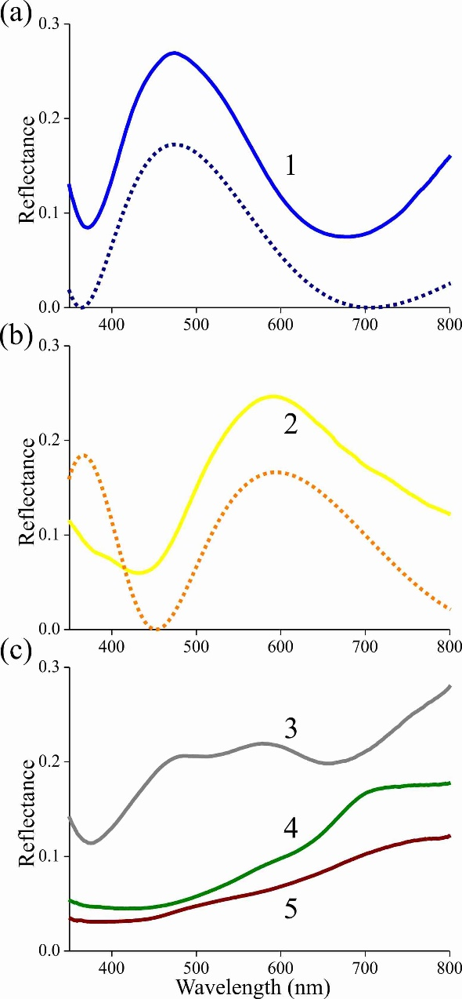

Fig. 5. Reflectance spectra of an isolated scale measured with a microspectrophotometer. (a) Solid curve: reflectance spectrum of area 1 of Fig. 4b (adwing); dashed curve: modelled reflectance spectrum for a chitinous thin film in air with thickness 230 nm. (b) Solid curve: reflectance spectrum of area 2 of Fig. 4b (adwing); dashed curve: modelled reflectance spectrum for a chitinous thin film in air with thickness 290 nm. (c) Reflectance spectra of areas 3-5 of Fig. 4c (abwing).
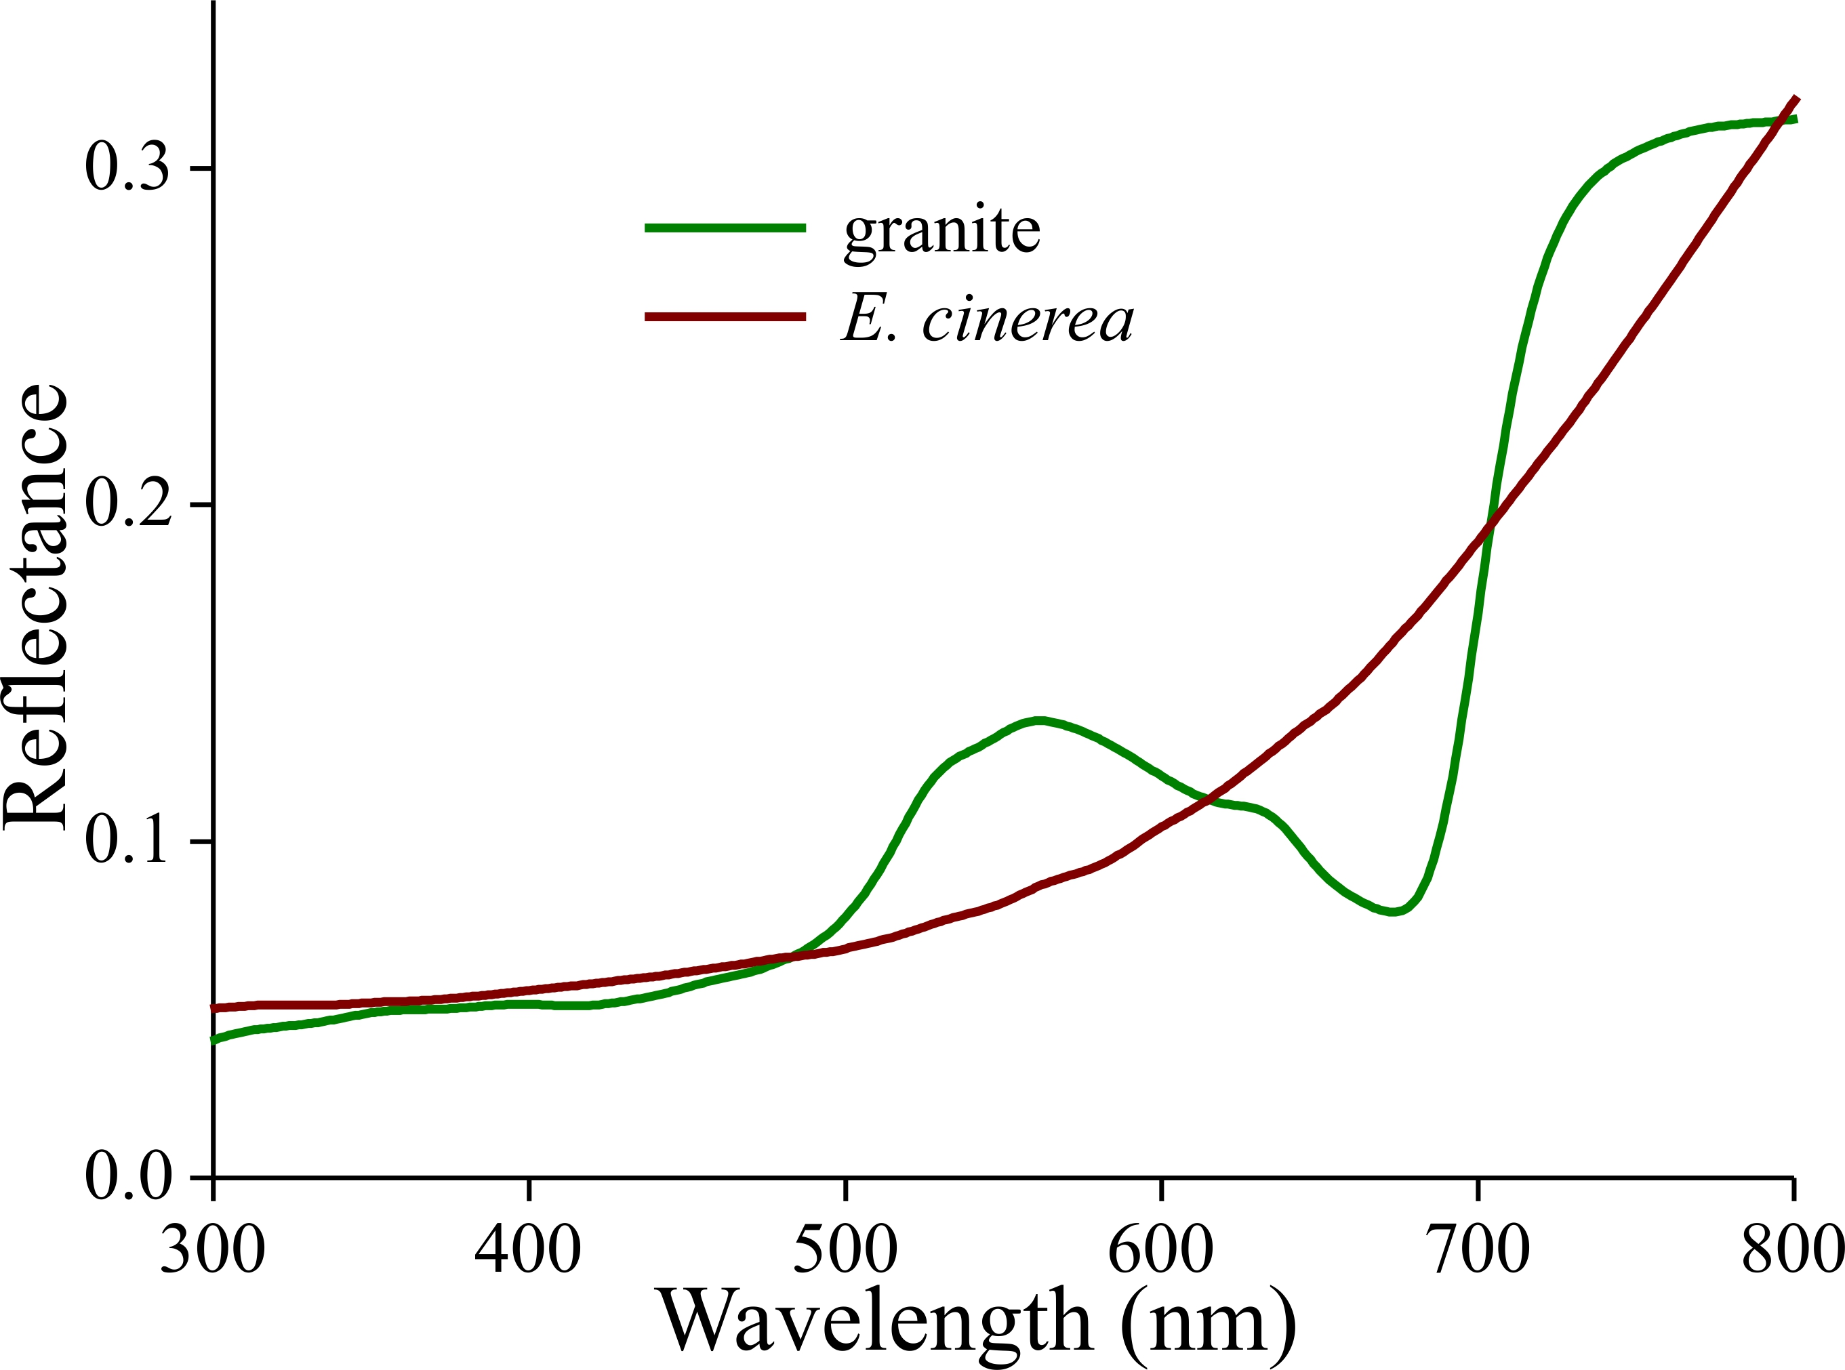

Fig. 6. Reflectance spectra of a piece of cave granite and a piece of bark from the Argyle apple tree (Eucalyptus cinerea).
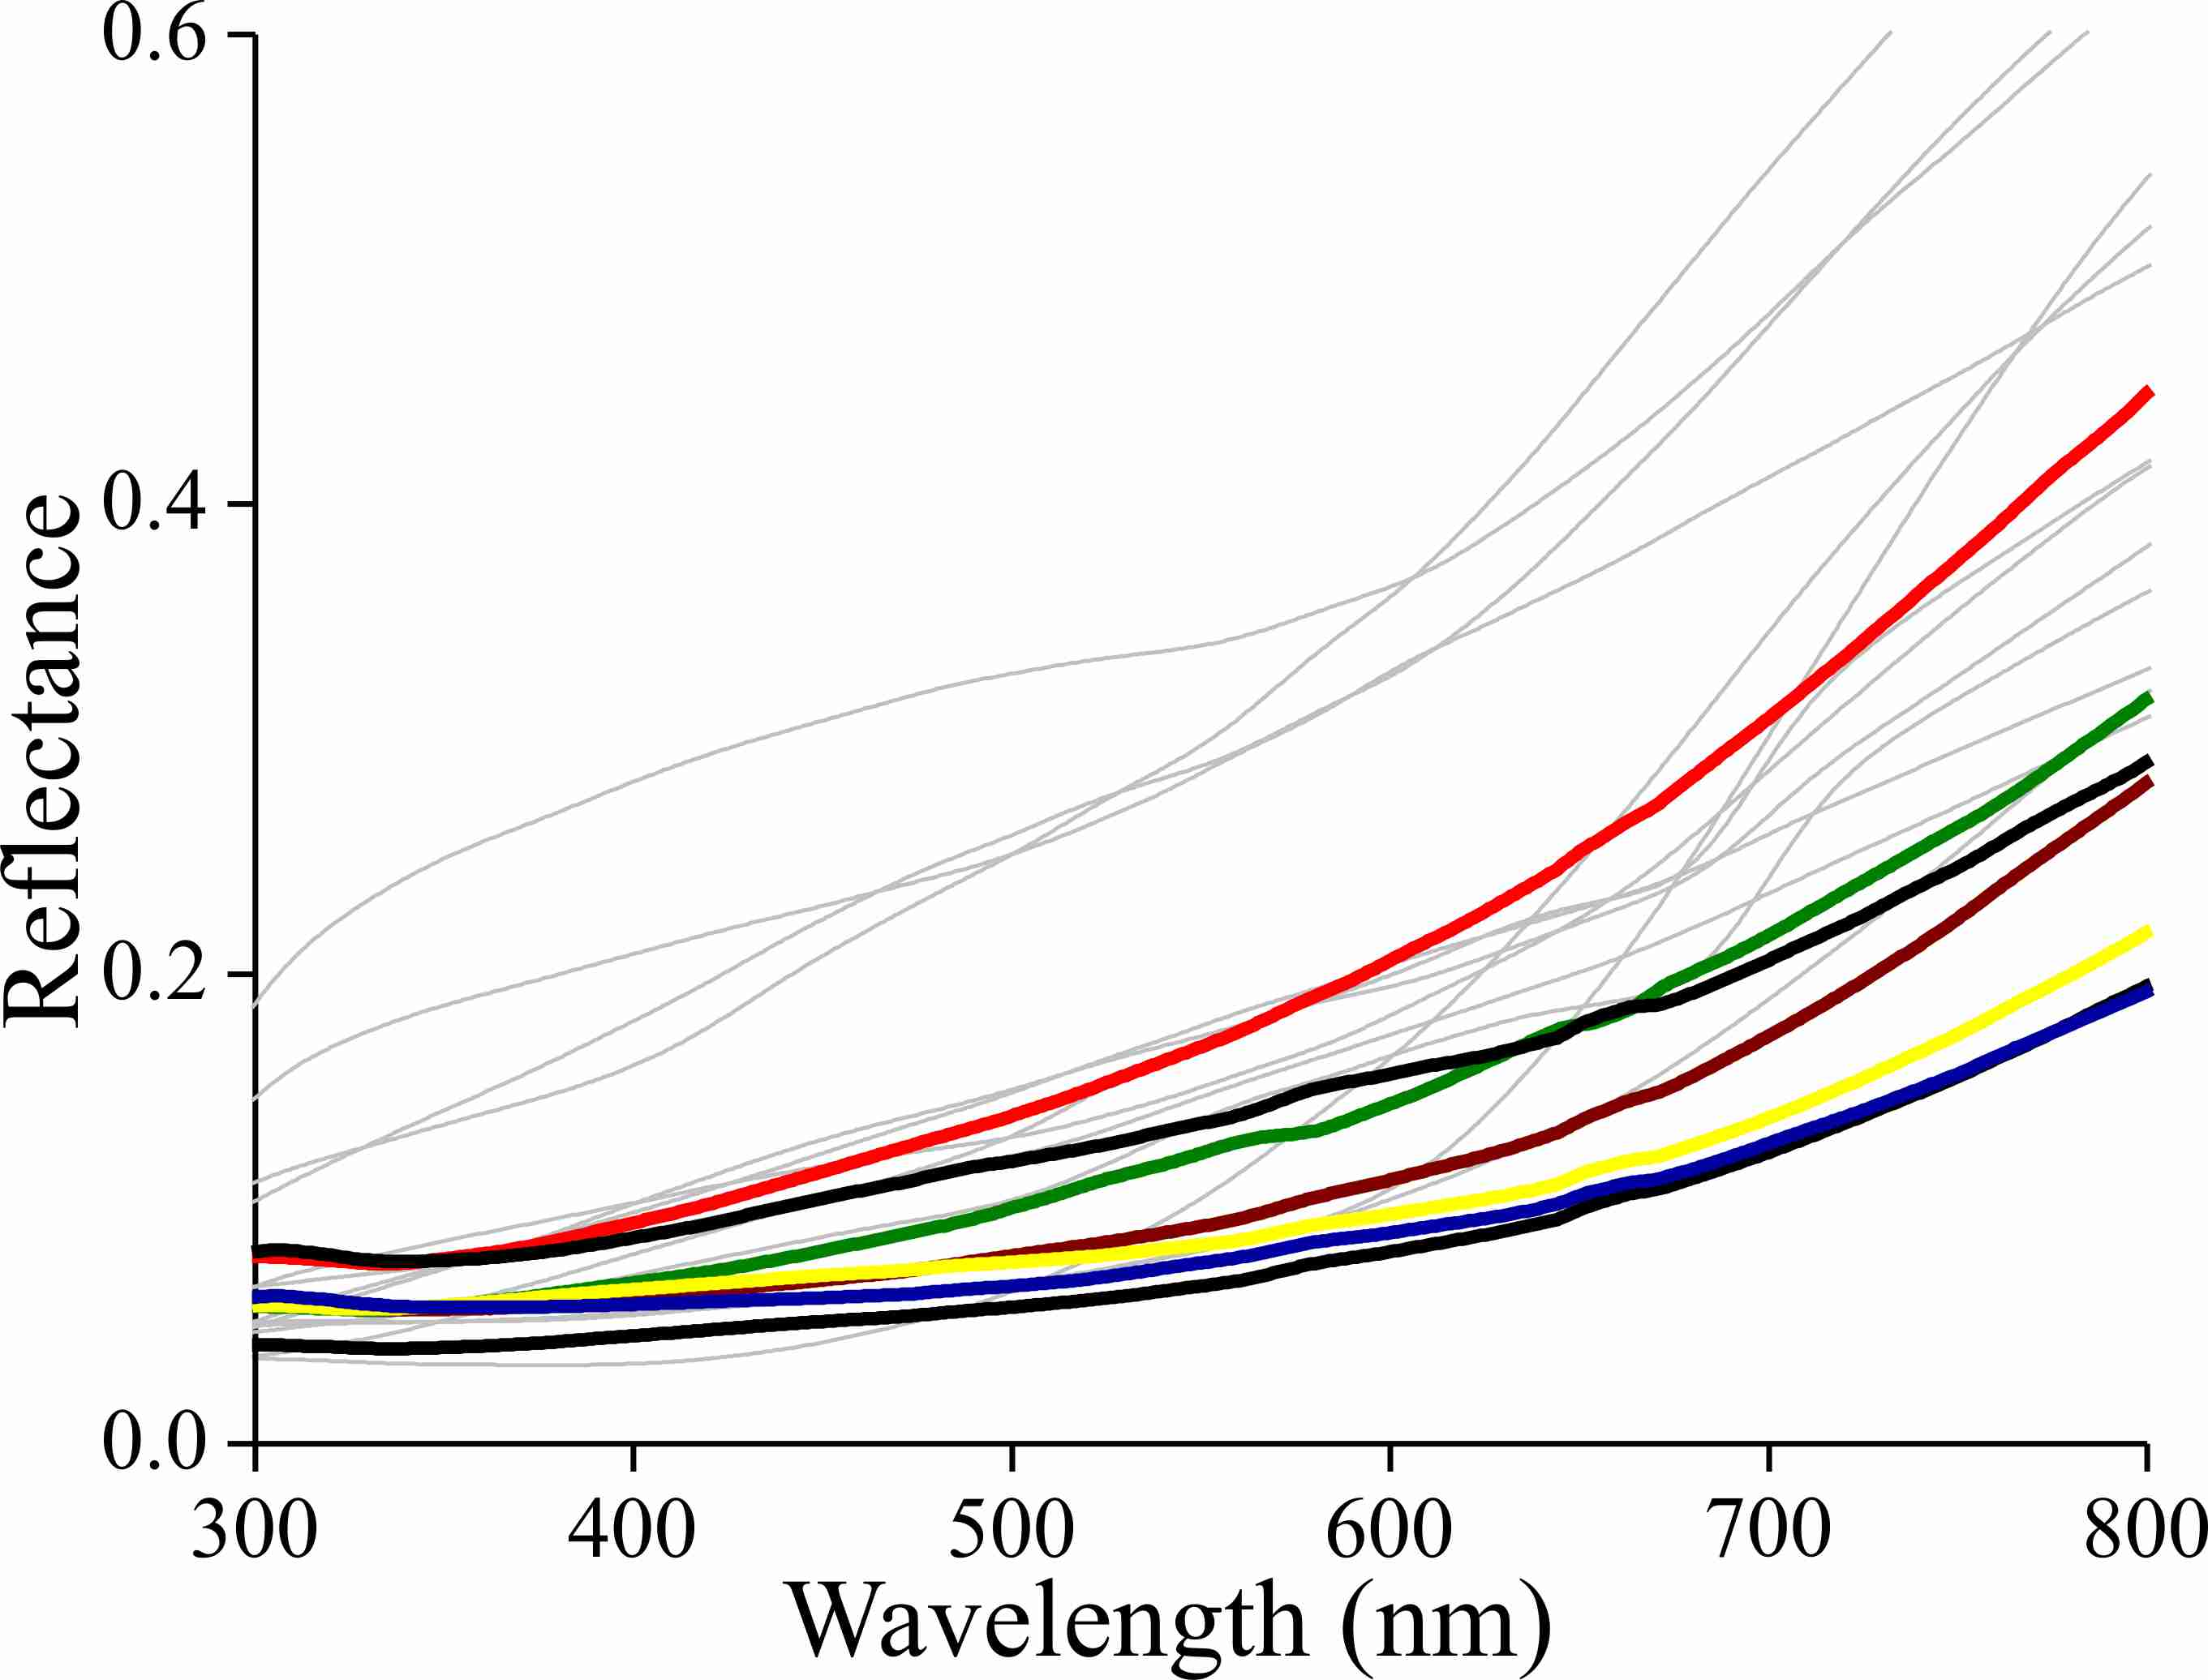

Fig. 7. Reflectance spectra of the bark of the trees listed in Table 1 as likely resting spots (thin lines) and reflectance spectra of various places on the forewings of a few Bogong moths (bold lines).
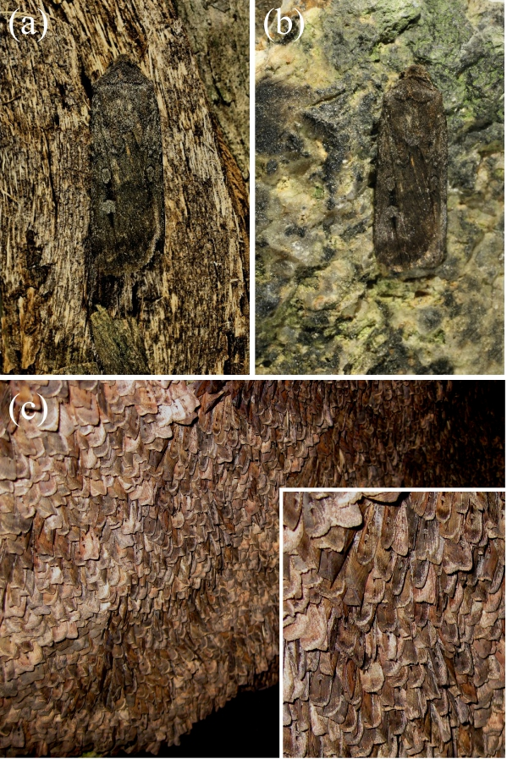

Fig. 8. Bogong moth camouflage on bark of the Argyle apple (Eucalyptus cinerea) (a), and on a small piece of granite (b) taken from the wall of an aestivation cave at South Ramshead in the Kosciuszko National Park, New South Wales (elevation 1860 m). (c) Bogong moths aestivating in the same cave from which the granite sample was taken in (b). Inset: close-up. (Photographs taken by EJW on December 23rd 2010).

Supplementary Material

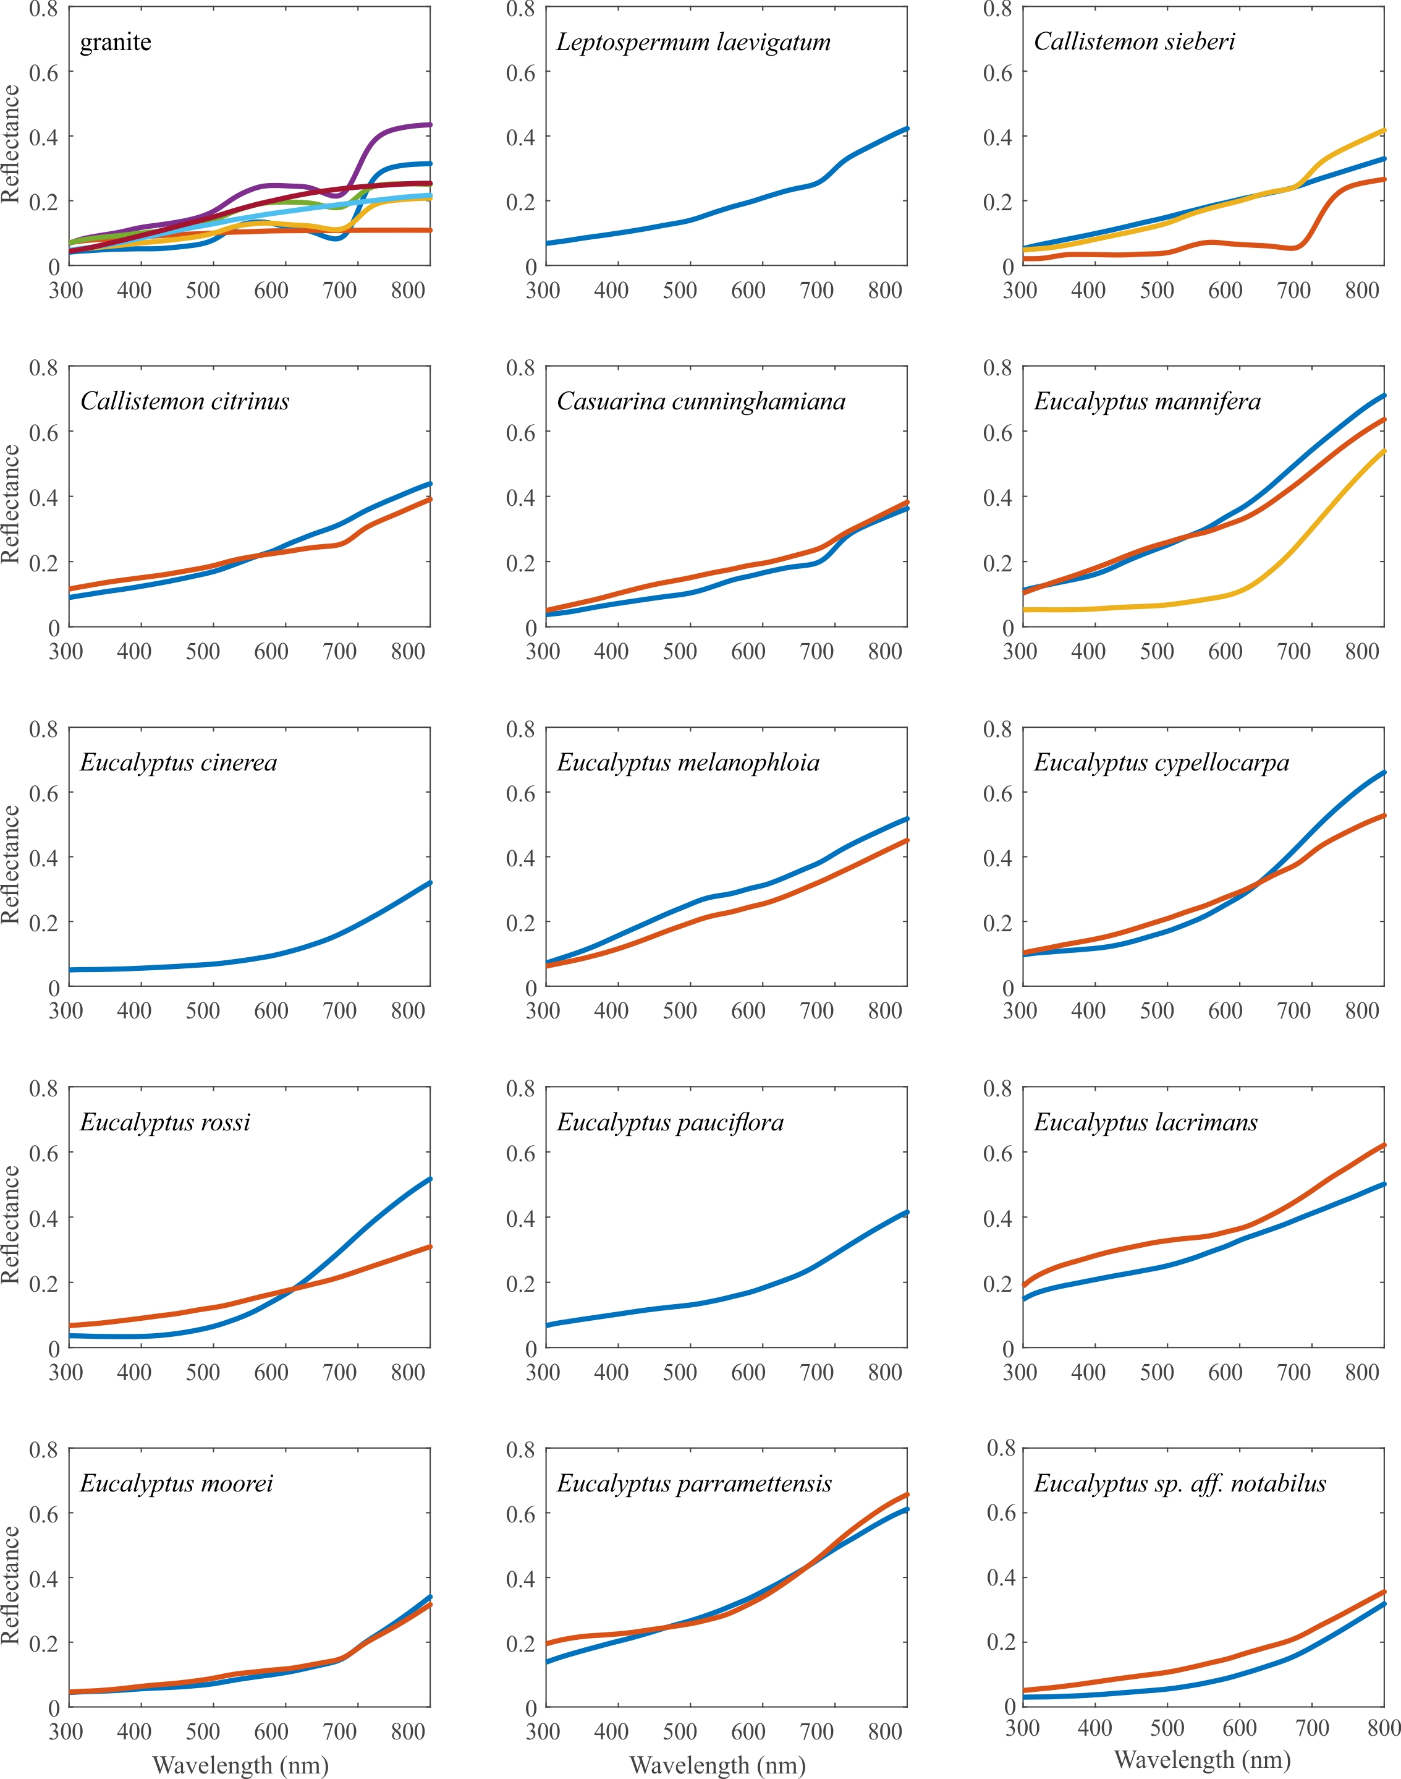

Fig. S1. Reflectance spectra of aestivation cave wall granite and tree bark measured with a bifurcated reflection probe. When the bark colour was rather uniform, only one spectrum is shown. Several spectra are included when the surface colouration was varied.
Table 1. The distributions of Australian trees species used for bark spectra measurements (Fig. S1) and their likelihood of being encountered by migrating Bogong moths

Species | Likely resting spot? | Notes¹
Eucalyptus sp. aff. notabilus | No | Distribution is predominantly east of the Great Dividing Range
Leptospermum laevigatum | No | Distribution confined to coastal habitats. Bogong moths may be found here, but it is not where most are coming from
Eucalyptus moorei | No | Distribution is predominantly east of the Great Dividing Range
Eucalyptus parramattensis | No | Relatively localised around the Sydney region
Eucalyptus mannifera | Yes | Widespread and abundant in south-eastern NSW
Callistemon sieberi | Yes | Widespread and abundant in eastern NSW
Callistemon citrinus | No | Distribution mostly east of Great Dividing Range
Casuarina cunninghamiana | Yes | Widespread and abundant across eastern NSW and QLD
Eucalyptus cinerea | Yes | Locally abundant just north of the NSW Snowy Mountains; also occurs in VIC
Eucalyptus melanophloia | No | Distributed across northern NSW as well as QLD
Eucalyptus cypellocarpa | No | Occurs in wet forest in sheltered valleys, eastern slopes of the Great Dividing Range
Eucalyptus rossii | Yes | Widespread and abundant in eastern NSW, although these would not provide adequate hiding places for Bogong moths due to their light colour; another moth, Ogmograptis scribula, in contrast, highly favours them
Eucalyptus pauciflora | Yes | Widespread and dominant across eastern NSW, and throughout VIC and TAS (occurs in alpine areas); Bogong moths have been observed feeding on them
Eucalyptus lacrimans | Yes | Subalpine species, restricted to the Adaminaby region of the NSW Snowy Mountains

¹ NSW: New South Wales; VIC: Victoria; QLD: Queensland; TAS: Tasmania

