Generation, characterisation and deposition of spherical and agglomerated
metal aerosol particles for protein corona and toxicological studies.

C. Svensson¹, J. Rissler¹, M. Messing², K. Deppert², T. Cederwall³,
S. Linse³, K. Broberg⁴, M. Bohgard¹, J. Pagels¹

¹Ergonomics & Aerosol Technology, Lund University, 221 00, Lund, Sweden
²Div. Solid State Physics, Lund University, 221 00, Lund, Sweden
³Div. Biochemistry, Lund University, 221 00, Lund, Sweden
4 Div. Occupational and Environmental Medicine, Lund University, 221 00, Lund, Sweden

Keywords: Metal, Particle Morphology, In-vitro, Proteins

Nanoparticles of metals such as gold are of increased use in a large array of nanotechnology applications. At the same time there is a concern regarding exposures and adverse health effects of metal particles. To further advance our understanding on how to exploit nanotechnology in a safe and sound way, there is a need to develop methods to generate well defined (size, structure, surface composition etc) pure metal particles suitable for in-vitro cell toxicity studies and studies of the biomolecular corona (Cederwall et al. 2007) coating the particles once deposited in the respiratory tract.
The aim of this work is to describe a novel procedure consisting of particle generation from the gas-phase, detailed on-line aerosol characterisation, direct particle deposition from the gas-phase onto either protein solutions or cells at the air-liquid interface.
Gold nanoparticles were generated using either a high temperature (HT) oven or a spark discharge generator (SDG) (Messing et al. 2009). Agglomerates with a close to monodisperse mobility diameter were selected using a differential mobility analyzer (DMA). Compact particles could be generated using a second oven and the reduced mobility diameter after compaction was determined using a second DMA and an electrometer. The mass of agglomerated and compact particles as a function of the mobility diameter was determined using an Aerosol Particle Mass Analyzer (APM). The primary particle size was determined from Transmission Electron Microscopy samples collected with an Electrostatic Precipitator (ESP). From this, the number of primary particles per aggregate and the particle surface area was estimated along with aerosol physical properties such as dynamic shape factor and mass-mobility exponent (Dfm).
The particles were deposited directly from the gas-phase onto protein solutions (Albumin and homocystein). Particles suspended in the liquid were characterised using Dynamic Light Scattering (DLS). Porcine blood serum and lungfluid was added to the samples and the corona of proteins attaching to the particle surfaces was determined using SDS-PAGE (Sodium dodecyl sulphate polyacrylamide gel electrophoresis).
Figure 1 shows TEM-images of agglomerated and compacted particles of the same mass generated with the SDG technique. The average primary particle diameter in the aggregates is 5.5 nm. Upon sintering the particle mass remains constant while the mobility diameter decreases from 60 to 31 nm, indicating that particle transport and deposition is strongly altered. At the same time the surface area (per mass unit) estimated from the mass and primary particle size decreases by about a factor of 6.

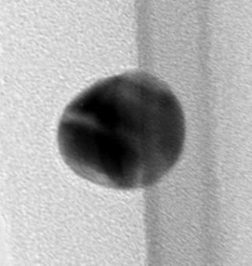
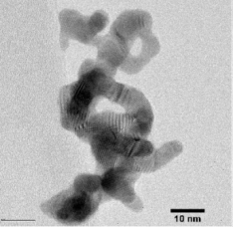

Fig. 1. Gold nanoparticles of the same mass (0.24 fg) before (left) and after sintering (right). The mobility diameter decreased from 60 to 31 nm upon sintering.

Dynamic Light Scattering showed that when gold particles were deposited into protein solutions, the suspensions were stable for several days. Analysis of the proteins from biological fluids binding to the nanoparticles is in progress. It is likely that both the protein corona (which is what the cell sees) and the properties of the bare particles are determinants of the particle toxicity.
In future studies the set-up will be interfaced with a novel deposition chamber at the air-liquid interface for particle cell exposure studies (including whole genome expression and proteomics).

This work was supported by the Nanometer Structure Consortium at Lund University and the Swedish research council FAS.

Cedervall, T; Lynch, I; Lindman, S, et al. (2007)
PNAS, 7, 2050-2055.
Messing, ME, Dick, KA, Wallenberg, LR, et al.
(2009) Gold Bull. 42, 20-26.

