Print Print all articles
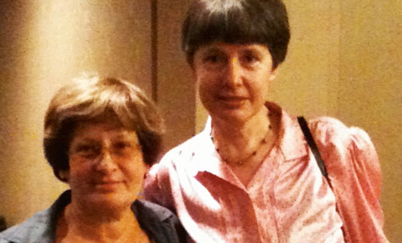
Meeting about nano. Nina Dawidowicz, Senior Research Officer, Formas, together with researcher Lidia Morawska from Australia.

World Conference on Healthy Buildings:

Airborne nanoparticles are a health risk
By Anders Gudmundsson, Mats Bohgard and Nina Dawidowicz
Large scale epidemiological studies confirm the relationship between exposure to airborne particles and mortality in cardiopulmonary diseases. Increased application of nanotechnology for new materials, with very attractive mechanical, electrical, magnetic and optical properties, increases the concentration of nanoparticles in the air in different environments and thus also increases health risks. Our knowledge is incomplete, but the smallest particles are probably the most dangerous.
Increased attention is directed at airborne nanoparticles (or ultrafine particles) in our indoor environments. One reason for this is the increased application of nanotechnology for new materials of very attractive mechanical, electrical, magnetic and optical properties. A large increase in such materials could, when they are handled, give rise to an increase in the concentration of nanoparticles in air in different environments. There is concern that there is a risk of health effects when humans inhale these particles.
The air in different environments already contains varying concentrations of different kinds of small airborne particles that are regarded as pollutants. In the urban environment we may, for example, have particles from internal combustion engines and tyre-road abrasion. There are many kinds of sources for airborne particles in working environments, ordinary indoor environments and in the atmosphere. Large epidemiological studies demonstrate the relationship between exposure to airborne particles and morbidity/mortality in both respiratory and cardiovascular diseases. Much of the attention today concentrates on nanoparticles produced by engineering processes. There is however reason to remember the many old sources that release nanoparticles into air.

International conference on nano
At the conference Healthy Buildings in Syracuse, USA, last year, a forum was arranged on nanoparticles in indoor environments. This forum was organised by Formas and Queensland University of Technology, Brisbane, together with the Department of Ergonomics and Aerosol Technology at Lund University. This enabled delegates to the conference to discuss and formulate knowledge needs regarding airborne nanoparticles in the indoor environment in order to create the basis for future research strategies.
There was great interest in this seminar. Around sixty people from business, society and research institutes in all parts of the world attended, some of whom stood along the walls of the crowded room. From Sweden there were delegates from Lund University, SP, Chalmers, Skanska and Gävle University College.
Lidia Morawska and Mats Bohgard gave the background to the known incidence of nanoparticles in indoor environments and their relevance to biological effects, including a discussion of what nanotechnology could provide. There was lively discussion, and the delegates agreed that we need much more knowledge. Usual views were that we need many different technical methods to characterise airborne particles in indoor environments and their interaction with gaseous components. Several delegates emphasised the need to note that elevated ozone contents in outdoor air can give rise to complex chemical reactions when the ozone enters buildings along with ventilation air and meets the gases and particles in indoor air. The toxicity of the reaction products is at present largely unknown. We need to have a better grip on the exposure situation in different environments. We must also know about the potential effects of particles that can be emitted when products made of nanotechnolocogical materials are handled. We do not know whether there is a great difference between the reactivities of pollutant particles and these new materials.

No threshold limit values in the home
We already know quite a lot about pollutant particles. It is reasonable that development of knowledge should proceed from what we know of known exposures. In working life, for instance, exposure to airborne particles has occurred for a very long time (silica dust, asbestos fibres, welding fumes, carbon black, soot and so on). The toxicological mechanisms of a lot of particles are known – others we know less about. We must develop general knowledge so that we can make hazard assessments of new materials. It was also pointed out that in working life there are threshold limit values while in environments that usually have inferior ventilation, such as housing, day care centres, schools, homes for the elderly and vehicles, there are in general no such limits. From the construction industry it was pointed out that it was highly desirable that material producers should supply better data on emissions and toxicity, so that safe indoor environments may be guaranteed.
The following are electron microscope photographs of particles that are relatively common in the indoor air in housing environments.
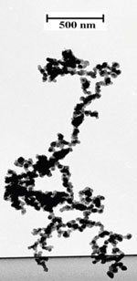
Photograph 1. Particle from a kerosene lamp. The particle has been formed through the coagulation of small spherical particles into an aggregate. Photograph: Arash Gharibi
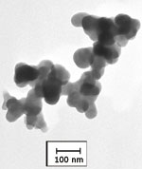
Photograph 2. Particle formed through abrasion between tyre and carriageway. Photograph. Arash Gharibi
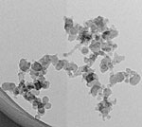
Photograph 3. This shows a small particle formed by burning a stearin candle. The particle is an aggregate formed by coagulation of particles of a few nanometres diameter. Photograph: Joakim Pagels and Lisa Karsson
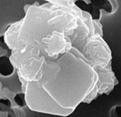
Photograph 4. This shows a particle released into air from textiles washed with a detergent containing zeolites of low solubility which had stuck to the textile. The particle became airborne when the textile was handled. Relatively high concentrations of airborne particles have been measured when textiles are handled. The diameter of the particle is 2-3 micrometres – it is thus larger than the particles from the stearin candle and the kerosene lamp, but is nevertheless small enough to penetrate deep into the airways when inhaled. Photograph: Anders Gudmundsson and Jakob B. Wagner

Small particles worst
Our knowledge is at present incomplete for the hazard assessments we must make, and we know that the air environment's dynamics and mechanisms of action on biological organisms are complex. There are, for example, studies which show that the effect of gaseous terpenes is more serious in the presence of particles, as pointed out by Professor John Spengler of Harvard School of Public Health, Boston. It was also found that in certain cases it is extreme peak values that trigger pathogenic mechanisms. In other cases it is medium exposure over a long time. With the greatest certainty, it is number concentration (number of particles per unit volume of air), together with the chemical composition for certain exposures, that is significant for health effects. For others it is surface area concentration (total surface area of particles per unit volume) or mass concentration (mass of particles per unit volume) that is most relevant for health effects. It is probable that different properties are important for different kinds of particles and for different kinds of effects.
We can say that properties such as size distribution, chemical composition, surface properties, solubility in body fluids, hygroscopicity, morphology and shape are properties that may have significance for physiological effects. What we know is that, for a given mass concentration, a material will normally be more reactive and toxic the smaller particles it is divided into. The reason is that there are more particles, the tissues on which the particles are deposited are exposed to a larger contact surface, and that a reduced radius of curvature as such gives considerably higher reactivity.
If we summarise the research needs from the many points of view put forward by researchers and industry representatives, we have a long list. We need
- better methods for characterising airborne particles with regard to the properties that may have significance for physiological effects,
- use of state-of-the-art technology for chemical analysis of single particles. For example, aerosol-mass spectrometry, which could advance knowledge in this area, is available today
- generally better knowledge of the properties of particles in different indoor environments,
- better knowledge and control of the sources of particles, both traditional ones and new ones that may come about with the increased applications of nanotechnology, studies that include technical and medical competence, collaboration between industrial developers and academic researchers,
- better clinical methods for studying effects on people in the field,
- better biological markers for inflammation, oxidative stress (ability of particles to oxidise biological tissues), and other effects (for example gene expression, i.e. the way exposure affects translation of information encoded in a gene into protein production in organisms)
- better theories to explain what happens when different kinds of particles reach the tissues of the airways, and their cardiovascular effect
- simple monitors for health relevant parameters in air in different environments
- better knowledge of the interaction between gaseous components in air and particles.
Apart from knowledge of the mechanisms behind the effects of particles, we also need technical development and knowledge of how, with the help of e.g. new building technology, improved maintenance of buildings, more effective ventilation, layouts that take account of daily indoor activities, and air filtration to create better indoor environments, we can protect ourselves from both external environmental impacts and what is emitted by various activitiers in our indoor environments. Those attending the forum emphasised the need for an international scientific workshop that focuses on the specific issues formulated during the forum.

Author :
Anders Gudmundsson D. Tech, is senior lecturer at the Department of Ergonomics and Aerosol Technology, Lund University
Mats Bohgard is professor at the Department of Ergonomics and Aerosol Technology, Lund University
Nina Dawidowicz is Senior Research Officer at Formas

