**Evidence for a southward autumn migration of nocturnal noctuid moths in central Europe**

**David Dreyer1*, Basil el Jundi2, Dmitry Kishkinev3, Carina Suchentrunk4, Lena Campostrini4, Barrie J Frost5, Thomas Zechmeister4 and Eric J Warrant1\***

*1Department of Biology, Lund University, Sweden*

*2Chair of Behavioural Physiology and Sociobiology, University of Würzburg, Germany*

*3School of Natural Sciences, Bangor University, United Kingdom*

*4Biological Field Station Illmitz, Austria*

*5Department of Psychology, Queen's University, Canada*

*\*Authors for correspondence (e-mail: david.dreyer@biol.lu.se, eric.warrant@biol.lu.se)*

**Summary statement**

During autumn in central Europe, the red underwing and the large yellow underwing (noctuid moths) were found to make an oriented southward nocturnal migration, although on foggy evenings the latter species becomes disoriented.

**Abstract**

Insect migrations are spectacular natural events and resemble a remarkable relocation of biomass between two locations in space. Unlike the well-known migrations of daytime flying butterflies, such as the Painted lady *(Vanessa cardui)* or the Monarch butterfly (*Danaus plexippus*), much less widely known are the migrations of nocturnal moths. These migrations – typically involving billions of moths from different taxa – have recently attracted considerable scientific attention. Nocturnal moth migrations have traditionally been investigated by light trapping and by observations in the wild, but in recent times a considerable improvement in our understanding of this phenomenon has come from studying insect orientation behaviour, using vertical looking radars. In order to establish a new model organism to study compass mechanisms in migratory moths, we tethered each of two species of central European Noctuid moths in a flight simulator to study their flight bearings: the red underwing (*Catocala nupta*) and the large yellow underwing (*Noctua pronuba*). Both species had significantly oriented flight bearings under an unobscured view of the clear night sky and in the Earth's natural magnetic field. Red underwings oriented south-southeast, while large yellow underwings oriented southwest, in both cases directions suggesting a southerly autumn migration towards the Mediterranean. Interestingly, large yellow underwings became disoriented on humid (foggy) nights while red underwings remained oriented. We found no evidence in either species for a time-independent sky compass mechanism as previously suggested for the large yellow underwing.

Key words: insect migration, moth migration, noctuid, orientation, navigation, compass sense

**Introduction**

The suggested evolutionary benefits of energetically costly insect migrations (Rankin and Burchsted, 1992) are manifold and a matter of healthy debate (e.g. Holland et al., 2006, Chapman et al., 2015). The following benefits are usually mentioned in the literature: (i) an increase in the production of offspring via exploitation of "*green waves*" of vegetation, (ii) the avoidance of severe weather conditions during winter time and (iii) the avoidance of predators and/or parasites (Chapman et al., 2015). Moth migrations additionally incur a considerable agricultural (Porter et al., 1991; Drake and Gatehouse, 1995) as well as ecological (Green, 2011; Hu et al., 2016) impact. In the case of the migration of the Australian Bogong moth (*Agrotis infusa*), the resulting transportation of biomass from the Australian plains into the Snowy Mountains provides a remarkable inflow of nutrients and energy into this harsh alpine environment, a vital resource for the survival of many animal (and presumably even plant) species (Green, 2011; Warrant et al., 2016). Similar to what is known from birds (e.g. Hein et al., 2011; Richardson, 1990), the migratory behaviour of flying insects is influenced by weather conditions, and this has been documented in a wide variety of species (e.g. Drake, 1994; Brattström et al., 2008).

In European moths, the most convincing evidence for truly migratory behaviour, involving southward autumn migrations and northward spring migrations, comes from the British Isles (Sotthibandhu and Baker, 1979; Baker and Mathers, 1982; Chapman et al., 2010). In continental Europe, nocturnal species like the Silver Y moth (*Autographa gamma*) and the Dark sword-grass (*Agrotis ipsilon*) are mentioned as "very definite migrants", with seasonally dependent migratory directions (Williams, 1958). However, apart from this, little is known about the migratory behaviours of continental moth species.

The external compass cues used as orientation references by nocturnally migrating insects have also been little explored, although recent work suggests that the Australian Bogong moth relies on the Earth’s magnetic field and visual landmarks during migration (Dreyer et al., 2018). In contrast, much more is known about the compass cues used by insects migrating during the day – these migrants rely primarily on celestial cues for orientation, such as the sun and the celestial polarization pattern (e.g. Reppert et al. 2016; Homberg, 2015).

Since seasonally dependent migratory orientations in the large yellow underwing (LYU) have previously been described by Chapman and colleagues (Chapman et al., 2010), with a northward orientation in spring and a southward orientation in autumn, we hypothesized that noctuid moths captured during autumn in central Europe would show a similar pattern, with a southbound migration towards the Mediterranean. In this study, we tethered moths within a computer-interfaced flight simulator (Mouritsen and Frost, 2002) to investigate the autumn migratory orientations of two species of noctuid moths - the large yellow underwing (*Noctua pronuba*) and the red underwing (*Catocala nupta,* RU). We also tested which weather conditions were associated with directional migration behaviour. These studies were performed at a migratory nodal point in central Europe (Fig. 1A) – the Biological Station Lake Neusiedl, located within the Austrian National Park Seewinkel near the eastern foothills of the European Alps. The wetlands and saline lakes of this area provide an important stopover location for many migratory bird species and also act as an important refuge for waterfowl. Nightly light trapping of insects also revealed a similar richness in migratory moth species.

**Materials and methods**

**Preparations and Rearing Conditions**

All moths tested in the present study were caught using light traps at the Biological Field Station Lake Neusiedl during the first half of September 2016. The captured moths were transferred into plastic containers before they were stored in a sheltered place to recover from the stress induced by capture and were fed with 10% honey solution. The moths were usually tested between 1-3 days after being captured. Prior to tethering, the moths were immobilized in a refrigerator for up to 5 minutes. The scales on a moth’s pterothorax were removed using a micro-vacuum pump. Afterwards, a vertical tungsten stalk was glued to their dorsal thorax using contact cement while restrained by a weighted plastic mesh. The moths were then placed individually in clear plastic containers and provided with a clear view of the sky prior to their experimental night. Since insulating scales were removed from the pterothorax, and the glued Tungsten stalk could potentially cool the animal down, we put the animals in a box that was warmed by hot water bottles wrapped in towels prior to the experiments. All animals were released one day after they were tested.

**Flight Simulators**

Ferromagnetic free, modified Mouritsen-Frost flight simulators (Mouritsen and Frost, 2002) were used to continuously record the heading directions of moths (see Fig. 1). The circular arena had a diameter of 50 cm and a height of 36 cm; the inner wall of the arena was covered with black cloth.

A moth equipped with a vertical tungsten stalk was connected with a piece of thin rubber tubing (inner diameter slightly smaller than diameter of the stalk for a tight fit, length: 1.5 cm) to a vertical tungsten rod (Ø: 0.5 mm, length: 15.3 cm) that was attached very tightly via a very small grub screw to the centre of an optical encoder (US Digital, Vancouver, WA, USA), located at the centre of the upper opening of the arena (Fig. 1C). This optical encoder continuously recorded the rotations of the tungsten rod assembly (between 0° and 360°). Thus, the attached moths were able to flap their wings and freely choose any flight direction around the yaw axis while their heading directions were recorded relative to magnetic North with a sampling rate of 5 Hz and a horizontal resolution of 3°. Using a projector (BENQ, GP3), a mirror and neutral density filters, a very dim moving image (a bitmap satellite image of the local region from Google Earth) was back-projected onto a tracing paper screen (mounted on a clear Perspex sheet below the arena - a hole with the same diameter of the arena was cut into the table top). A custom-written software controlling the movement direction of the image was coupled to the encoder system (USB4; US Digital, Vancouver, WA) via a feedback loop. The resultant ventral flow-field image, which was always moving 180° relative to the moth’s heading (i.e. from head to tail), created the visual sensation of a ventral ground moving below the moth during forward flight, irrespective of which direction the moth flew in, because it was continuously updated by the moth’s own flight direction. The average luminance of the optic flow was 6.7 x 10-4 cd m-2.

**Experimental procedure**

Moths were tethered and allowed to fly for several minutes. In order to allow a meaningful comparison of the recorded tracks, only the first 10 minutes were used for the analysis (except large yellow underwing #13 which flew for 7.3 min). Since the red underwing (RU) moths were caught less frequently (~1-2 per catch) we were only able to record the orientation choices of 14 individuals. 11 out of 14 individuals flew over the full recording time of 10 min, 1 individual flew 20 min, and 2 individuals stopped flying after 7.7 and 9.5 min respectively. The 36 large yellow underwing (LYU) moths (usually ~5-15 were caught per night) flew for at least 10 min within the arena. In the case when a moth continuously spiralled after it was attached to the encoder (putatively due to a skewed stalk), or showed a faltering flight behaviour (characterized by several stops in a row), the experiment on this individual was immediately aborted and the data excluded from the analysis.

**Experimental conditions**

While the moths were performing in the flight simulator, they experienced a clear view of the sky (viewing angle ~120°: see Fig. 1C,D). A paddock close to the biological field station was chosen as an experimental site (47°46'05.0"N, 16°46'05.5"E). Great care was taken to position the arena at a sufficient distance from putative landmarks (e.g. trees) to remove the possibility that moths might see them. The simulator arena was placed on a wooden table that was given a different orientation each experimental night. The arena itself was rotated by about 90° after each individual experiment. A small camping table (aluminium) and two camping chairs (plastic) were deployed about ~5 m from the arena. Three sides of the experimental table were covered with black cloth to prevent stray light, reflected by the mirror beneath the table, from influencing the behaviour of the tested moths. One side remained uncovered to allow the projection of optic flow onto the mirror (see above). All artificial light sources were either covered with several layers of duct tape or with red filter film. Headlamps, equipped with red LEDs were used while the moths were being handled.

The experiments were conducted on seven nights between September 1st and 13th 2016. All experiments were conducted after sunset, under more or less clear and windless conditions, and under a natural magnetic field. The moon’s disc was not visible to the moths in any of the experiments.

**Weather conditions**

The first three experimental nights were dry and clear. Due to slight showers on September 4th, the experiments were put on hold. On the following two nights, the weather changed dramatically with a temperature drop from 29.4°C on the 4th to 21.7°C and 16.3°C (maximum temperatures) respectively on the 5th and 6th which was accompanied by moderate winds (17 and 20 km/h) and rain. Likely due to the resulting sogginess of the surrounding fields, considerable changes in humidity were noticed on the experimental nights that followed the rainy nights (see Fig. 3).

The experimental nights of the 7th, 8th, 9th and 12th of September were quite foggy and moisture condensed noticeably on our gear. The atmospheric pressure and the air temperature varied between the first three experimental days and the last four, but the most notable difference was related to the relative humidity and the dew-point spread (difference between the air temperature and the dew-point). Changes in the dew-point spread give some indication of whether fog will gather or not; the lower the spread, the higher the chance of fog formation. Fog and high humidity were observed on the last four experimental nights, but not on the first three. All meteorological measurements derive from meteorological stations in Andau and Eisenstadt (Burgenland, Austria, both around 20 km from the experimental site) which are available online (kachelmannwetter.com, wetter.com) and from personal notes taken during the experiments.

**Statistical analysis**

Data analysis was conducted using custom written MATLAB scripts (2010b, 2013a; MathWorks Inc.) and Oriana (4.01; Kovach Computing Services). Since the analysis of the orientation choice of each individual moth gives a mean vector in which the r-value encodes the magnitude of the mean vector (the longer the mean vector the higher is the concentration of the data around the mean direction), and the direction of the vector is the mean direction, we were able to conduct second order statistics, using the non-parametric Moore's Modified Rayleigh Test (MMR; Moore, 1980; Zar, 1998). This test involves different weightings of the respective mean angles according to their respective r-values. The test assumes the null hypothesis that the means of the tested sample are uniformly distributed around the circle. A low p value (conventionally p< 0.05) indicates that the data are distributed non-uniformly and that the tested sample had a preferred migratory direction. The length of the black arrow encodes the R* value (score of Moore's Modified Rayleigh Test). The dashed circles in the circular diagrams encode the critical R* values needed for statistical significance: inner circle, p<0.05; middle circle, p<0.01; outer circle, p<0.001. A black arrow crossing a respective dashed circle indicates statistical significance at the corresponding level.

In order to compare the orientations of the respective groups, we used the non-parametric Mardia-Watson-Wheeler Test (MWW; Fisher, 1993; Mardia and Jupp, 2000; Batschelet, 1981) and a Moore's Paired Test (MPT; Zar,1999), to test against the null hypothesis of identical distributions. All orientation choices with an r-value lower than r<0.2 were not included in the evaluation since we assume that the moths were either performing behaviours other than migratory behaviour (see Nesbit et al., 2009) or that the stalk was not attached correctly to the moth’s thorax, or that the stalking process had interfered with flight performance by introducing wing beat asymmetries (due for example to glue spill).

**Celestial cues**

To compare our results with those of Sotthibandhu and Baker (1979), we used the open-source program *Stellarium* (Version 0.14.0) to reproduce the stellar constellations of the night sky over Manchester in 1977 (Sotthibandhu and Baker, 1979), and Illmitz during September 2016 at 22:30 and 01:30 local time, according to the experimental time mentioned in Figure 9 of Sotthibandhu and Baker (1979). To avoid confusion, we want to stress that this procedure was simply part of a *post-hoc* data analysis - *Stellarium* was not used during the actual experiments. Unfortunately, Sotthibandhu and Baker (1979) did not provide precise dates and locations for their experiments (on moths tested under moonless starlit conditions), apart from the fact that the experiments took place in July 1977 in Manchester or Bristol. We thus chose Manchester on July 15th for the reconstruction of the night sky. On a clear night in Manchester, the bright star Arcturus – a possible orientation cue – would have been visible throughout July. The orientation angle of each moth was compared to the time the experiments were conducted using linear regression (Fig. 4G), performed using the Data statistics Toolbox in MATLAB (MATLAB 2010b, MathWorks Inc.). Because the "starting angle" of the visible celestial bodies at the beginning of each experimental night changed only marginally between the experimental nights (1/9-13/9 2016), and because their rate of rotation is constant, the slight angular differences between the experimental nights included in Figure 4G for the data recorded in Illmitz (2016) are negligible versus the respective time of the night.

**Results**

**Red underwings**

The red underwings (RUs) oriented south-southeast when provided with a clear view of the starry sky and while experiencing the natural magnetic field of the Earth (Fig. 2A). According to the Moore's modified Rayleigh Test (MMR), the tested sample was statistically significantly directed towards 146° (α) relative to magnetic North (95% CI: 119°, 169°; r: 0.49; R*: 1.71, p< 0.001, n=12). Since most of the RUs (n=8) were tested during four foggy nights, the orientation of this species was evidently not affected by the weather conditions prevalent on these final four experimental nights.

**Large yellow underwings**

The preferred mean direction of all tested large yellow underwings (LYU, Fig. 2B) was significantly towards south-southwest (α: 201°; 95% CI: 141°, 257°, r: 0.173, R*: 1.1, p< 0.05, n=36). We also analysed the orientation choices of the LYU against the presence or absence of fog. A lower dew-point spread (Fig. 3) is associated with an increased presence of water particles in the air, and an increasing chance of fog. From experimental day 4 onwards, the dew-point spread dropped severely, indicating a much higher likelihood of fog during our experiments (and fog was noticed).

Interestingly, as a group large yellow underwings were significantly oriented on clear nights (Fig. 2C; α: 205°, 95% CI: 167°, 260°, r: 0.275, p< 0.01, n=19), but not in a groupwise analysis on foggy nights (Fig. 2D; α: 160°, r: 0.083, R*: 0.381, 0.5 < p < 0.9, n= 17).

In addition, the mean directions of the RUs and the LYUs were significantly different (MWW, p: 0.007, W: 9.826; MPT, p<0.01, R': 1.291; all LYU data used for comparison), suggesting that these two species have different migratory directions (Figs. 2A,B).

In order to test for a time dependent "shift" of the heading directions of moths over the course of a night, as detected by Sotthibandhu and Baker (1979), we plotted the heading directions of moths as a function of the experimental time (see Fig. 4; slopes for, RU: -1,29; LYU in Illmitz: -14,8; LYU in Manchester: 16,95). The implications of this analysis for migratory headings measured in our moths will be explored in the Discussion.

**Discussion**

**Orientation in red underwings**

RUs have previously been reported to be "occasional vagrants" (Skinner, 2009), and have been considered to merely expand their distribution by invading other territories during favourable seasons (Fox et al., 2011). In Austria, members of the genus *Catocala* are thought to regularly invade the country from the Mediterranean region (Malicky et al., 2000). We found that when tested in a flight simulator during September in southeast Austria, RUs demonstrated a highly concentrated south-southeast orientation. A plausible explanation for this behaviour could be that RUs perform a roughly southbound autumn migration towards the Mediterranean (possibly to as yet unknown wintering grounds), and that we recorded the orientation choices of individuals that were undertaking this migration. According to this hypothesis, one could assume that we caught individuals that had flown into the National Park from locations to the north or northwest of the study site. This assumption is supported by a quantitative sampling of RUs until late August in Lower Bavaria using bait traps (Sturm, 2002) – released RUs were never subsequently re-captured, strongly suggesting a lack of site fidelity. Thus, we conclude that the directedness of our tested RUs does not simply reflect dispersal movements (i.e. expansion of the species distribution) but rather a regular autumn southbound migration from central Europe towards regions of the Mediterranean (e.g. Greece: Kailidis, 1964). Judging from the recorded mean direction of the tested RUs, one might draw the conclusion that their conspecifics in the wild would fly farther into the Balkans.

**Orientation in large yellow underwings**

The LYU is listed as a migratory moth species in Central Europe and migratory movements have been reported in regions spanning from Britain to the Caucasus (Chapman et al., 2010; Poltawski, 1982). The south westerly orientation of the LYUs recorded in Illmitz seems to be seasonally appropriate and in agreement with the data obtained in southern Britain (see *brown arrow* in Fig. 2; Chapman et al., 2010). This suggests that LYUs, similar to RUs, perform an annual roughly-southbound autumn migration passing through Illmitz and heading towards their wintering grounds situated to the south. The exact wintering locations are, however, still unknown.

**Putative influence of the weather on orientation behaviour**

The influence of wind and temperature on the behaviour of insects is extensively described in the literature (e.g. Pedgely 1990; Taylor and Carter, 1991; Gregg et al., 1994; Marchand and McNeil 2000; Chapman et al., 2016). The "minimum temperature threshold" required for migratory flights in two medium-sized noctuid moth species (wingspan: 30-40 mm) was estimated to be ~8°C (Taylor and Carter, 1961). We conducted our experiments on practically windless nights, with air temperatures distinctly above 8°C, so if the weather influenced our experiments at all, wind and air temperature are presumably only of secondary importance for the interpretation of our data.

RUs have been reported at bait traps even in bad weather conditions (ongoing rain, strong winds and temperatures less than 15°C: Sturm, 2002). This observation is in line with our results indicating that the orientation of RUs was evidently not influenced by the weather. In contrast, we noticed that a subsample of LYUs tested under foggy conditions was less oriented (in fact random, Fig. 2B) compared to a subsample that was highly significantly oriented under clear conditions. Both species readily flew in the arena, so the motivation to fly was not necessarily reduced due to the weather conditions. However, in the case of the LYUs the motivation to perform oriented migratory flights in the arena might have been reduced due to unfavourable weather conditions (e.g. lack of favourable initiation factors for migration).

The presence of fog might technically explain this phenomenon since the lower visibility could negatively influence the moth’s ability to orient during migration by obscuring a clear view of the sky. However, we never observed the arena veiled in thick fog. As mentioned earlier, the most dramatic meteorological factors that accompanied foggy nights are changes in the relative humidity and the dew-point spread. However, in a quantitative long-term study in northern New South Wales (Australia), a positive correlation was observed between the local relative humidity and the numbers of migratory moths caught (Gregg et al., 1994). This implies that these particular Australian moth species preferred higher humidity while in flight. Unfortunately, that study did not provide any data on the presence or absence of fog.

Factors that could explain the reduced directedness of LYUs on foggy nights compared to RUs might include an unfavourable presence of water particles in the air, a slightly reduced outside temperature and/or a smaller body size. If water particles in the air moistened the bodies of LYUs, this could have led to an overall critical decrease in their body temperature and a reduced motivation to migrate.

Moreover, in our experiments, the moths were tethered to a tungsten rod and performed flight behaviour within an arena that was located ~1 m above the ground. Thus, the conditions under which our tested moths performed were quite different to those experienced by their conspecifics in the wild. Besides the obvious limitations that were introduced by our experimental setup, we also wish to stress a less obvious factor that might have influenced the results: we removed the dorsal scales of the pterothorax in order to glue the tungsten shaft to the animal. The "coats of hair" of moths are an "excellent insulator" (Church, 1960), and in noctuids an intact layer of scales contributes to maintaining up to 90% of the insect’s internal temperature while in flight (Church, 1960). If during our experiments the tungsten shaft collected water particles due to the fog, and was fanned by the air current generated by the beating wings of the moth (with a damaged layer of scales), this could have decreased the overall body temperature due to evaporative chill, thereby reducing the motivation of the moth to migrate. The smaller LYU may have been much more susceptible to such a situation than the considerably larger RU. Another putative explanation would be that a humid evening simply resembles an unfavourable trigger for a migratory flight for the smaller LYU.

**Putative compass cues and compass mechanisms**

During the daytime, insects can rely on obvious and reliable celestial cues such as the position of the sun’s disc and the polarization pattern of the sky to navigate (e.g. Wehner and Müller, 2006; Homberg, 2015), whereas the compass cues which are utilized for long-distance movements at night are still comparatively little studied. Two obvious directional cues at night are stars (Foster et al., 2018) and/or the Earth's magnetic field (e.g. Baker and Mather 1982; Guerra and Reppert, 2015; Dreyer et al., 2018). Indeed, birds that migrate at night are capable of using both of these cues for compass orientation (Emlen 1967; Wiltschko and Wiltschko 1972). In addition, the light conditions are about 1 million-fold dimmer at night and this might have an impact on the cue hierarchy used during migration (el Jundi et al., 2015). Taken together, using the sky at night-times might require a more dynamic compass system that is different to the one in diurnaly orienting insects.

A moth fixed in our flight arena would have experienced an apparent movement (due to the rotation of the Earth) of celestial bodies from east to west at a constant rate, depending on their distance to Polaris. In Figure 9 and Table V of Sotthibandhu and Baker (1979), the authors presented orientation directions of LYUs (see Fig. 4 A,B) recorded on a moonless starry night in England (using a different orientation apparatus) and suggested that it *"seems likely"* this species uses celestial cue(s) for compass orientation. Since all tested individuals showed a shift in orientation of about 16° per hour from east to west between ~22:00 and ~01:00 o'clock local time, and coupled to the fact that both samples were significantly directed, the authors concluded that all individuals used "*the azimuth positions of* *particular stars or star groups*" to orient (Sotthibandhu and Baker, 1979). The stars or star groups could be (estimated from the shift of 16° per hour) located *"at a position about 95° away from the pole star"* (Sotthibandhu and Baker, 1979). The star constellation *Boötes*, featuring *Arcturus* (α boo) as the *"most radiant star of the Northern Hemisphere"* (Kaler, 2002),roughly fulfils these requirements, and should have been visible with the naked eye during the experiments conducted in England during 1977 (see Fig. 4D). During our experiments in 2016, at the more southerly experimental location in Illmitz, one constellation would have been clearly visible as well: *Aquila* featuring *Altair* as its brightest element. Regardless of which celestial body (or bodies) the tested individuals in Sotthibandhu and Baker (1979) might have used (if any), they clearly exposed a positive ~50° shift of the group’s mean vector. If the hypothesis that stellar orientation drove this shift was correct, then the English moths obviously did not show any form of time-compensation (see Fig. 4F) as has been found for instance in the Monarch butterfly (Mouritsen and Frost, 2002). Without the ability to time-compensate for the rotation of celestial bodies, moths would continuously hold a constant angle relative to celestial cues, meaning that their flight trajectories would change direction over time (i.e. become curved: Fig. 4E). If Sotthibandhu’s and Baker’s hypothesis is correct, and their moths indeed relied on stars for orientation, then they must have used a non-time-compensated celestial compass (as discussed in Nesbit et al. (2009) for the day-active Painted lady, *V. cardui*). This would imply that these moths would not have had the ability to maintain a constant migratory bearing over the course of a night. This is indeed what their data suggest (*black solid line* in Fig. 4G).

If the LYUs tested in our flight simulators used a particular celestial cue as a reference point, such as the star constellation *Aquila* or the *Milky Way* (or some other constellation of stars), and like the English moths did not apparently compensate for the celestial rotation, their bearing should systematically change over the course of an evening. However, our data did not find any indication of such a systematic change in the bearing of LYUs (*orange solid line* in Fig. 4G), nor indeed in the bearing of RUs (*red solid line* in Fig. 4G). A couple of explanations for this difference in our results from those of Sotthibandhu and Baker might be as follows (not an exhaustive list): (i) the Austrian moths did not use the stars as a compass cue, or (ii) they did use the stars as a compass cue but were capable of time compensation. An obvious major difference between our experiments and those described in Sotthibandhu and Baker (1979) is that we did not test our animals twice at different times of the night and this, together with the degree of "noise" in our data, may have masked any systematic change in bearing in the Austrian moths.

Another potential directional cue is the geomagnetic field, and a magnetic compass sense was reported in the large yellow underwing by Baker and colleagues (1982). Additionally, the day-flying Monarch butterfly has been suggested to use a light driven inclination compass (Guerra et al., 2014, but see Mouritsen and Frost, 2002 and Stalleicken et al., 2005). Moreover, a magnetic compass sense has very recently been implicated in the highly directed migration of the nocturnal Australian Bogong moth (Dreyer et al., 2018). Since we used a ferromagnetic-free experimental apparatus, it is at least plausible that our moths used the undisturbed magnetic field of the Earth for navigation.

In conclusion, we believe that our study provides an ideal baseline for further investigations of compass mechanisms used for nocturnal orientation during long-distance moth migration. The two European moth species we have investigated – the red underwing (*Catocala nupta*) and the large yellow underwing(*Noctua pronuba*) – are ideal for studying the navigational mechanisms that steer nocturnal insect migrations, and to investigate the roles of navigational cues proposed in earlier studies using different techniques. Follow-up studies using computerized three-dimensional Helmholtz Coil systems (in order to manipulate the experimental magnetic field within the arena) and top projections of the starry sky are planned already.

**Authors contributions:**

DD, BEJ, CS and LC conducted the experiments. TZ and DK helped catching experimental animals. TZ helped to organize the experiments, determine the animal species and provided the local infrastructure. DD, BJF and EJW designed the experiments. DD wrote the first version of the manuscript and analysed the data. EJW, BJF, DK, TZ and BEJ revised the manuscript.

**Acknowledgments:**

The authors are deeply indebted to the US Air Force Office of Scientific Research (Grant number FA9550-14-1-0242), the Swedish Foundation for International Cooperation in Research and Higher Education (STINT, Grant number 2012-2033), the Royal Physiographic Society of Lund and the Swedish Research Council (Vetenskapsrådet, Grant number 621-2012-2205), for their ongoing support. Financial support to DK was provided from the Leverhulme Trust (ECF-2016-378). We thank the kind and helpful staff of the Biological Field Station in Illmitz for their technical support.

**Competing interests:**

The authors declare that they have no affiliations with or involvement in any organization or entity with any financial interest, or non-financial interest in the subject matter or materials discussed in this manuscript.

**References**

**Baker, R. R., and Mather G. J.** (1982) Magnetic compass sense in the Large yellow underwing moth, *Noctua pronuba* L. Animal Behaviour, 30(2): 543-548.

**Batschelet, E.** (1981) Circular statistics in biology. Academic Press, London.

**Brattström, O., Kjellén, N., Alerstam, T., and Åkesson, S.** (2008) Effects of wind and weather on red admiral, *Vanessa atalanta*, migration at a coastal site in southern Sweden. Animal Behaviour, 76(2): 335-344.

**Chapman, J. W., Reynolds, D. R., Wilson, K.** (2015) Long‐range seasonal migration in insects: Mechanisms, evolutionary drivers and ecological consequences. Ecology Letters, 18(3): 287-302.

**Chapman, J. W., Nesbit, R. L., Burgin, L. E., Reynolds, D. R., Smith, A. D., Middleton, D. R., and Hill, J. K.** (2010) Flight orientation behaviors promote optimal migration trajectories in high-flying insects. Science, 327(5966): 682-685.

**Chapman, J. W., Nilsson, C., Lim, K. S., Bäckman, J., Reynolds, D. R., and Alerstam, T.** (2016) Adaptive strategies in nocturnally migrating insects and songbirds: contrasting responses to wind. Journal of Animal Ecology, 85(1): 115-124.

**Church, N. S.** (1960) Heat loss and the body temperatures of flying insects. Journal of Experimental Biology, 37(1): 186-212.

**Drake, V. A., and Gatehouse, A. G.** (1995) Insect migration: tracking resources through space and time. Cambridge University Press

**Drake, V. A.** (1994) The influence of weather and climate on agriculturally important insects: an Australian perspective. Crop and Pasture Science, 45(3): 487-509.

**Dreyer D., Frost B.J., Mouritsen H., Günther A., Green K., Whitehouse M., Johnsen S., Heinze S., Warrant E.J.,** (2018) The Earth's Magnetic Field and Visual Landmarks Steer Migratory Flight Behavior in the Nocturnal Australian Bogong Moth. Current Biology, 28 (13): 2160-2166.

**el Jundi B., Warrant E. J., Byrne M. J., Khaldy L., Baird E., Smolka J., Dacke M. (2015)**

Encoding celestial cue preference for celestial orientation. Proceedings of the National Academy of Sciences **112 (36) 11395-11400.**

**Emlen, Stephen T.** (1967) Migratory orientation in the indigo bunting, *Passerina cyanea*: part i: evidence for use of celestial cues. The Auk 84(3),: 309-342.

**Fox, R., Randle, Z., Hill, L., Anders, S., Wiffen, L., and Parsons, M. S.** (2011) Moths count: recording moths for conservation in the UK. Journal of Insect Conservation, 15(1-2): 55-68.

**Green, K.** (2011)The transport of nutrients and energy into the Australian Snowy Mountains by migrating Bogong moths *Agrotis infusa*. Austral Ecology, 36(1): 25-34.

**Gregg, P. C., Fitt, G. P., Coombs, M., and Henderson, G. S.** (1994) Migrating moths collected in tower-mounted light traps in northern New South Wales, Australia: influence of local and synoptic weather. Bulletin of Entomological Research, 84(01): 17-30.

**Guerra, P. A., and Reppert, S. M.** (2015) Sensory basis of lepidopteran migration: focus on the monarch butterfly. Current opinion in neurobiology, 34: 20-28.

**Guerra, P. A., Gegear, R.J., and Reppert, S.M.** (2014) A magnetic compass aids monarch butterfly migration. Nat. Commun., 5, 4164..

**Hein, C. M., Zapka, M. and Mouritsen H.** (2011) Weather significantly influences the migratory behaviour of night-migratory songbirds tested indoors in orientation cages. Journal of Ornithology, 152(1): 27-35.

**Homberg, U.** (2015) Sky Compass Orientation in Desert Locusts—Evidence from Field and Laboratory Studies. Frontiers in behavioral neuroscience, 9.

**Holland, R. A., Wikelski, M. and Wilcove, D. S.** (2006) How and why do insects migrate? Science 313,(5788): 794-796.

**Hu, G., Lim, K. S., Horvitz, N., Clark, S. J., Reynolds, D. R., Sapir, N. and Chapman, J. W.** (2016) Mass seasonal bioflows of high-flying insect migrants. Science, 354(6319): 1584-1587.

**Kailidis, D. S.** (1964) Beobachtungen über Pappelschädlinge in Griechenland." Anzeiger für Schädlingskunde, 37(5): 65-68.

**Kaler J.B.** (2002) Arcturus. In: "The Hundred Greatest Stars". ISBN: 0-387-95436-8. Springer, New York, NY.

**Malicky, M., Hauser, E., Huemer, P., and Wieser, C.** (2000) Verbreitungsatlas der Tierwelt Österreichs: Noctuidae sensu classico. Biologiezentrum des Oberösterr. Landesmuseums.

**Marchand, D., McNeil J. N.,** (2000) Effects of wind speed and atmospheric pressure on mate searching behavior in the aphid parasitoid *Aphidius nigripes* (Hymenoptera: Aphidiidae). Journal of Insect Behavior,13(2): 187-199.

**Mardia, K.V. and Jupp, P.E.** (2000). Statistics of directional data. John Wiley and Sons, Chicester.

**Moore, Bruce R.** (1980) A modification of the Rayleigh test for vector data. Biometrika: 175-180.

**Mouritsen, H. and Frost, B. J.** (2002) Virtual migration in tethered flying monarch butterflies reveals their orientation mechanisms. Proceedings of the National Academy of Sciences, 99(15),: 10162-10166.

**Nesbit, R. L., Hill, J. K., Woiwod, I. P., Sivell, D., Bensusan, K. J., and Chapman, J. W.** (2009) Seasonally adaptive migratory headings mediated by a sun compass in the painted lady butterfly, *Vanessa cardui*. Animal Behaviour, 78(5): 1119-1125.

**Pedgley, D. E., Scorer, R. S., Purdom, J. F. W., Simpson, J. E., Wickham, P. G., Dickison, R. B. B., and Drake, V. A.** (1990) Concentration of flying insects by the wind [and discussion]. Philosophical Transactions of the Royal Society of London B: Biological Sciences, 328(1251): 631-653.

**Poltawski, A. N.** (1982) Wanderungen von Noctuidae im Nordkaukasus und in Kalmykien 1979. Atalanta, 8 (1).

**Porter, J. H., M. L. Parry, T. R. Carter.** (1991) The potential effects of climatic change on agricultural insect pests. Agricultural and Forest Meteorology, 57(1),: 221-240.

**Rankin, M. A., Burchsted, J. C. A.** (1992) The cost of migration in insects. *Annual review of entomology*, 37(1): 533-559.

**Reppert, S. M., Guerra, P. A., and Merlin, C.** (2016) Neurobiology of monarch butterfly migration. Annual review of entomology, 61: 25-42.

**Richardson W. J.** (1990) Timing of Bird Migration in Relation to Weather: updated Review. Bird Migration: pp 78-101

**Skinner, B.** (2009) Colour identification guide to moths of the British Isles: (Macrolepidoptera). Apollo Books.

**Sotthibandhu, S. and Baker, R. R.** (1979) Celestial orientation by the Large yellow underwing moth, *Noctua pronuba* L. Animal Behaviour, 27: 786-800.

**Sparks, T. H., Roy, D. B. and Dennis, R. L. H.** (2005) The influence of temperature on migration of Lepidoptera into Britain. Global Change Biology, 11(3): 507-514.

**Stalleicken, J., Mukhida, M., Labhart, T., Wehner, R., Frost, B. and Mouritsen, H.** (2005) Do monarch butterflies use polarized skylight for migratory orientation? J. Exp. Biol. 208, 2399-2408.

**Stefanescu, C., Páramo, F., Åkesson, S., Alarcón, M., Ávila, A., Brereton, T. and Hill, J. K.** (2013) Multi‐generational long‐distance migration of insects: studying the painted lady butterfly in the Western Palaearctic. Ecography, 36(4): 474-486.

**Sturm, R.** (2002) Zum Vorkommen von Catocala nupta (Linnaeus, 1767) im Raum Straubing", Niederbayern. Nachr Bl. bayer. Ent., 51 (1/2).

**Taylor, L. R., Carter, C. I.** (1961) The analysis of numbers and distribution in an aerial population of Macrolepidoptera. Transactions of the Royal Entomological Society of London, 113(12): 369-386.

**Warrant, E.J., Frost, B.J., Green, K.P., Mouritsen, H., Dreyer, D., Adden, A., Brauburger, K. and Heinze, S.** (2016) The Australian Bogong moth *Agrotis infusa*: A long-distance nocturnal navigator. *Frontiers in Behavioral Neuroscience*, 10: 77.

**Wehner, R., and Müller, M.** (2006) The significance of direct sunlight and polarized skylight in the ant’s celestial system of navigation. Proceedings of the National Academy of Sciences, 103(33): 12575-12579.

**Williams, C. B.** Insect migration. (1958).

**Wiltschko, W., Wiltschko, R.** (1972) Magnetic compass of European robins. Science, 176(4030): 62-64.

**Zar, J.H.** (1999) Biostatistical analysis. 5th. Pearson Education India.

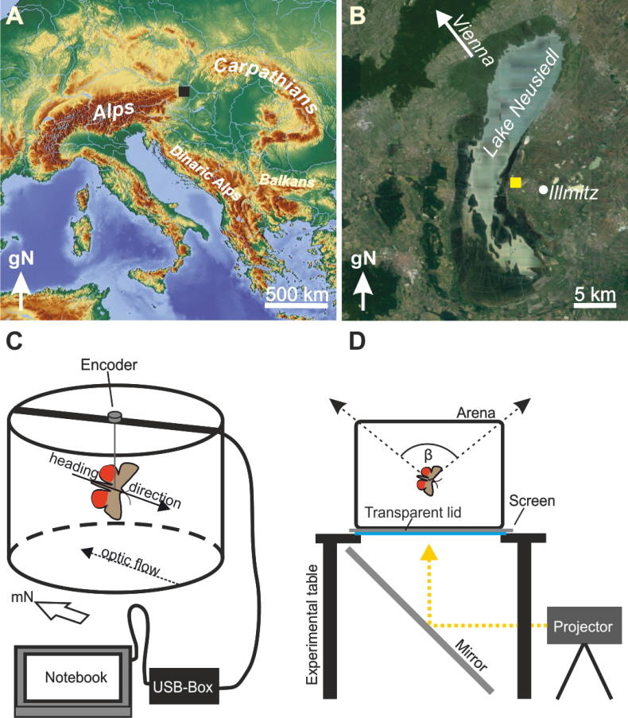

**Figure 1. The experimental site and flight arena.** **A, B.** The National Park Neusiedler See is located between the Eastern foothills of the Alps and the northwest foothills of the Carpathians (*black* and *yellow squares* in A and B respectively mark the location of the Biological field station) Towards the southeast, the landscape widens into the Hungarian plain. This specific geographical location represents a migratory hotspot for smaller migratory animals that generally tend to avoid flying directly across high mountain crests. Map in A: adapted from maps-for-free.com (2017); Map in B: adapted from Google Maps (2017). **C.** While a moth performs orientation behaviour in the arena, the direction of the optic flow (*dashed arrow*) is automatically and instantaneously updated, and always flows in a direction opposite to the heading direction (*continuous arrow*). **D.** Schematic diagram of the apparatus used in this study. The dorsal viewing angle (*dashed arrows*, β) of the sky was restricted to ~100°. The arena rested on a translucent projection screen supported by a transparent Plexiglass table top. The optic flow (in closed loop) was projected onto the bottom of the screen via a 45° mirror.

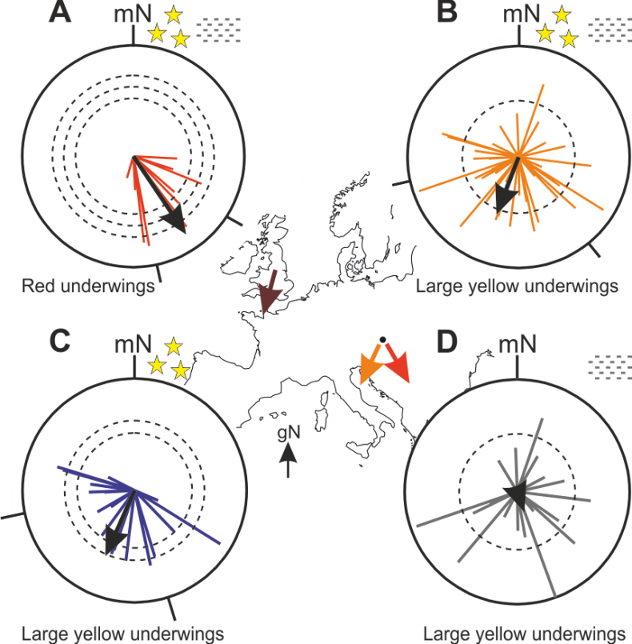

**Figure 2.** The orientation of Red and large yellow underwings relative to magnetic North plotted as circular diagrams. The virtual flight of each moth is represented by a single vector (*radial lines*) whose mean direction is represented by the vector’s direction. The lengths of the *black arrows* within the circular diagrams represent the R* value according to the Moore's Modified Rayleigh Test, and this value reveals the direction and directedness of the moths as a group. The radii of the *dashed circles* indicate the significance levels required for directional significance (Moore's Modified Rayleigh Test; from *inner* to *outer dashed circle*; p < 0.05, p < 0.01, p< 0.001). The *black lines* left and right of the arrows encode the 95% confidence interval. While the red underwings were well-oriented in clear and foggy weather (**A**, data from all experimental nights pooled, p<0.001), the large yellow underwings (**B**, data from all experimental nights pooled; p < 0.05) were oriented on clear nights (**C**, p<0.01) – on foggy nights they were not oriented as a group (**D**, p=n.s.). The *black dot* on the map of continental Europe in the centre of the figure marks the approximate location of the experimental site, and the *red* and *orange arrows* encode the mean directions of the two moth species relative to geographic North. The mean orientation direction for Austrian large yellow underwings matches the seasonally appropriate orientation for the same species in southern Britain (*brown arrow*, after Chapman et al., 2010). Symbols: *stars*= clear nights; *fog patches*= foggy nights.

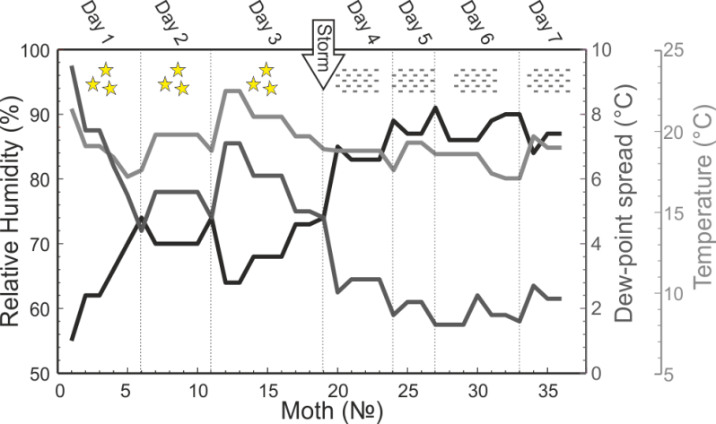

**Figure 3.** **The putative effect of humidity and dew point on moth orientation.** The development of the relative humidity (*black line*), the dew-point spread (*dark grey line*) and the temperature (*light grey line*) over the course of the experimental period. Note that the dew-point spread decreases to less than 3°C on day 4. A dew-point spread of less than 3°C is an indicator for fog. On days 1-3, the orientation data depicted in Figure 2C were recorded, while days 4-7 correspond to the data in Figure 2D. Symbols: *stars* = clear night; *fog patch* = foggy night (fog was indeed observed on nights 4-7).

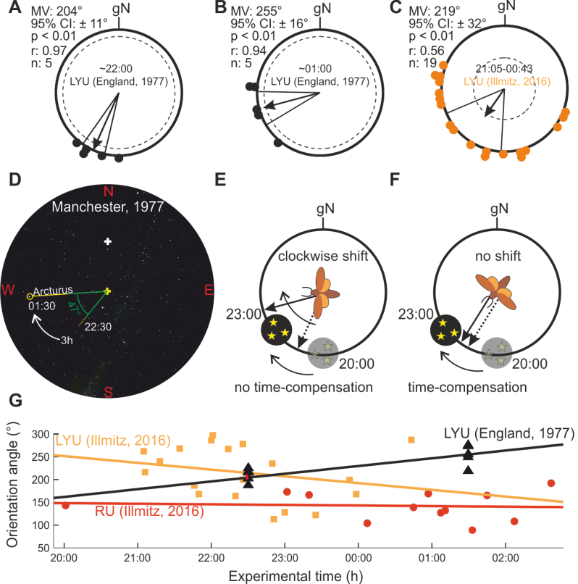

**Figure 4. Clockwise shift in orientation of large yellow underwings, as shown in Sotthibandhu & Baker (1979), revisited.** **A**, **B**. The mean orientation angles listed in Table V in Sotthibandhu & Baker (1979) were plotted relative to geographic North (gN) as circular diagrams. The data were pooled according to the experimental time (**A**. animals tested at ~22:00, **B**. same animals as in **A**, but tested at ~01:00). **C**. Orientation data for LYUs recorded in Austria in 2016 (data from Fig. 2C) but plotted as in 4A,B to allow comparison. *Black arrows* in A,B,C, E and F: mean vector (MV). *Solid lines* flanking the arrows= 95% confidence intervals (CI). *Dashed circles*: level of significance for p<0.01 according to the Rayleigh test. **D**. A Stellarium reconstruction of the starry sky over Manchester on July 15th 1977 at 01:30 with special focus on the position of the star *Arcturus* over the course of this night. *Solid yellow line* in D: position of a particular star at 01:30. *Stippled yellow line* in D: position of a particular star at 22:30. *Yellow cross* in D: Celestial zenith, as seen by a virtual spectator looking vertically upwards into the sky. *White cross* in D: the star Polaris, the centre of celestial rotation*. Green angles* in D: angular difference in the apparent movement of a particular star over the course of 3h relative to the position of a virtual spectator looking vertically upwards into the sky. **E**. Scheme demonstrating a non-time-compensated star compass mechanism. A non-time-compensated star compass mechanism was suggested for the orientation behaviour of some LYUs in Sotthibandhu & Baker (1979) and argued in the Discussion. **F**. Scheme demonstrating the putative orientation behaviour of a moth as would be expected if a time compensated star compass mechanism was operating. *Solid radial arrows* in E and F: putative heading direction of a moth at 23:00. *Stippled radial arrows* in E and F: putative heading direction of moth at 20:00. *Faded/dark sky symbols* in E and F: position of putative navigational cues at 20:00 and 23:00. **G**. The orientation angles of moths plotted as a function of the experimental time. Linear regressions of the particular datasets of angles are represented by the *orange*, *black* and *red lines*. Note that neither the *orange* (LYUs) nor the *red regression lines* (RUs; both species tested in Illmitz, Austria, 2016) have a positive slope like that of the *black regression line* (LYUs tested in England, 1977).